[By - Suraj Singh Chauhan & Shivani Balyan ]

[DATA-ANALYSIS]

[This document is part of the project of price prediction software for Al Arab real estates , this document contains the data analysis of the data provided to developers.]

**AL_ARAB_HOUSING_DATA_ANALYSIS**

**DATA_ANALYSIS_AL_ARAB_HOUSING_DATA**

- BY *Suraj Singh Chauhan* & *Shivani Balyan*

**1 ) Lookup to Data , how it looks like .**

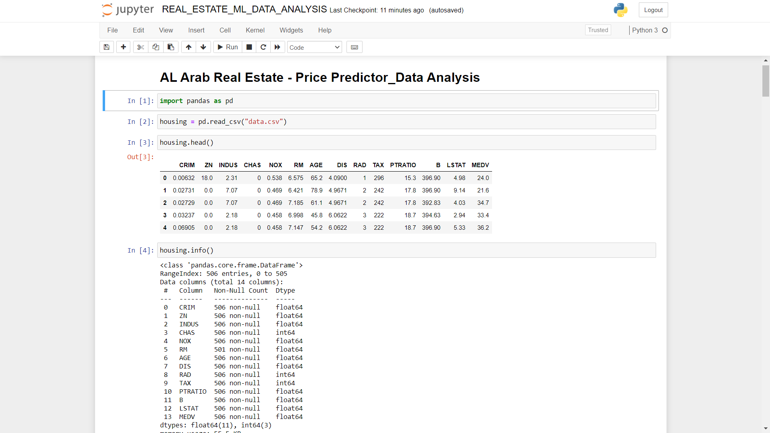

1. Checking the count of data and analysing the data.

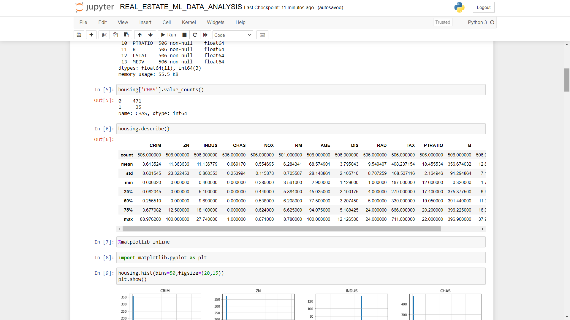

1. Seeing the data graphically for a better picture.

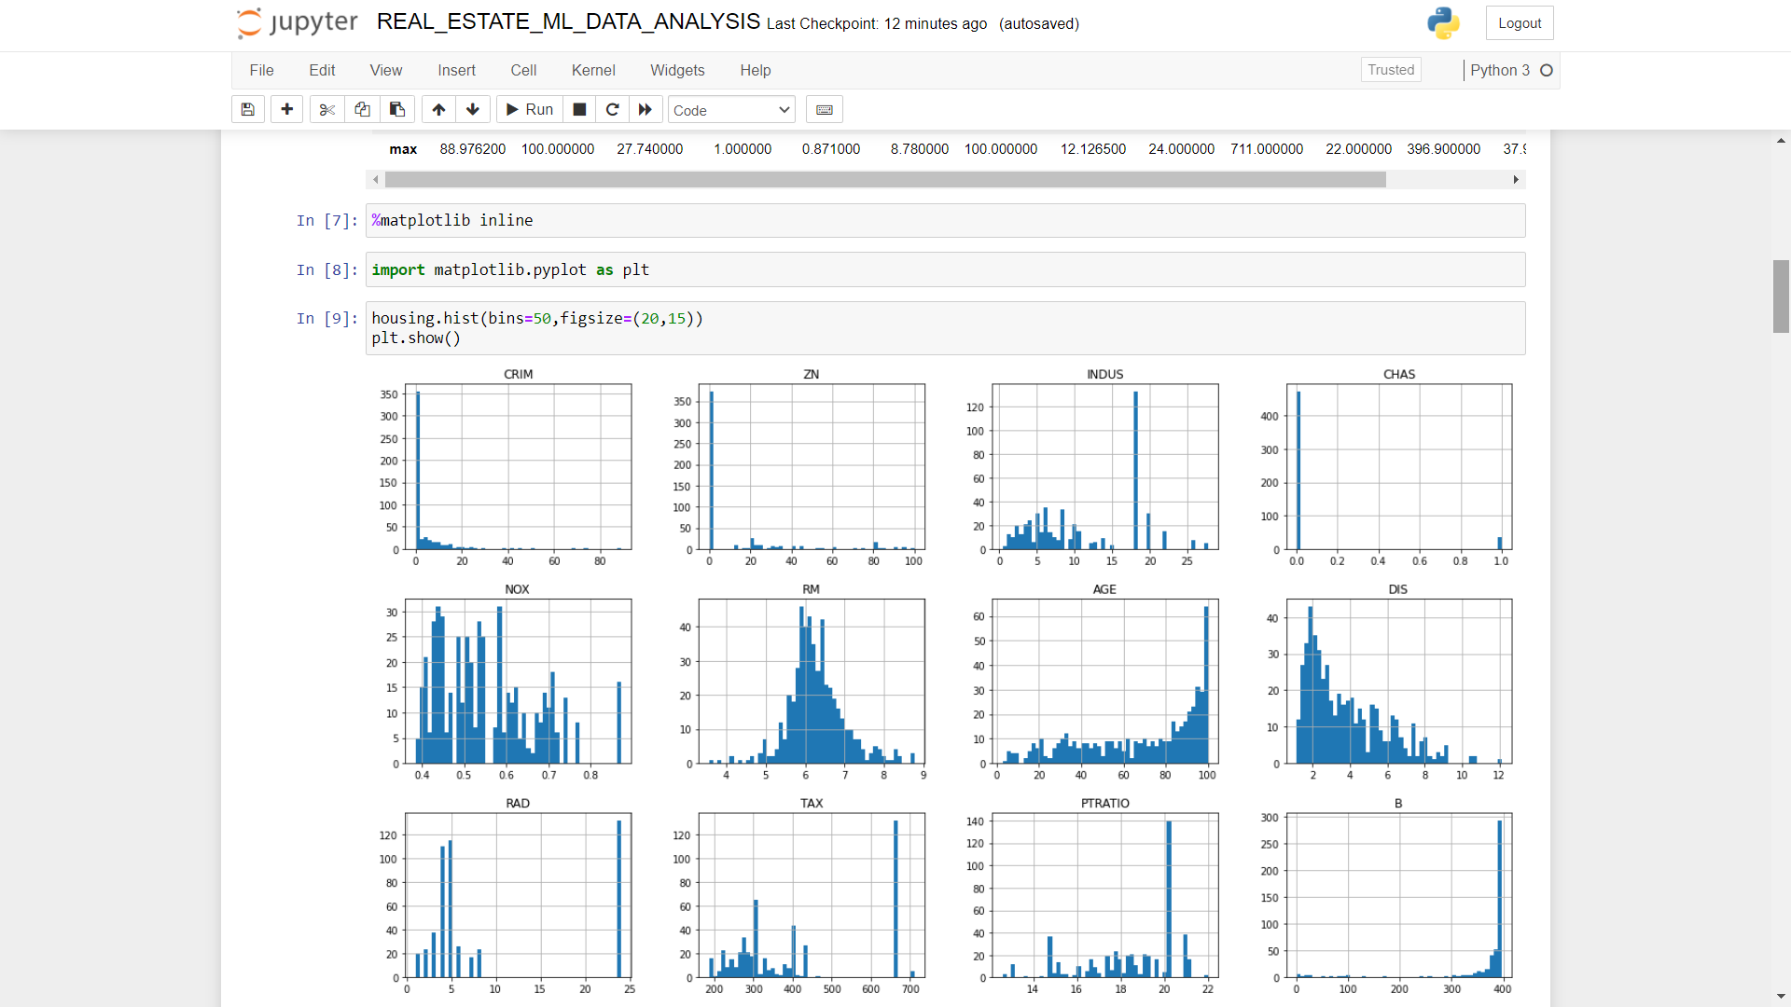

1. Spliting Data into two parts one for training and one for testing purpose.

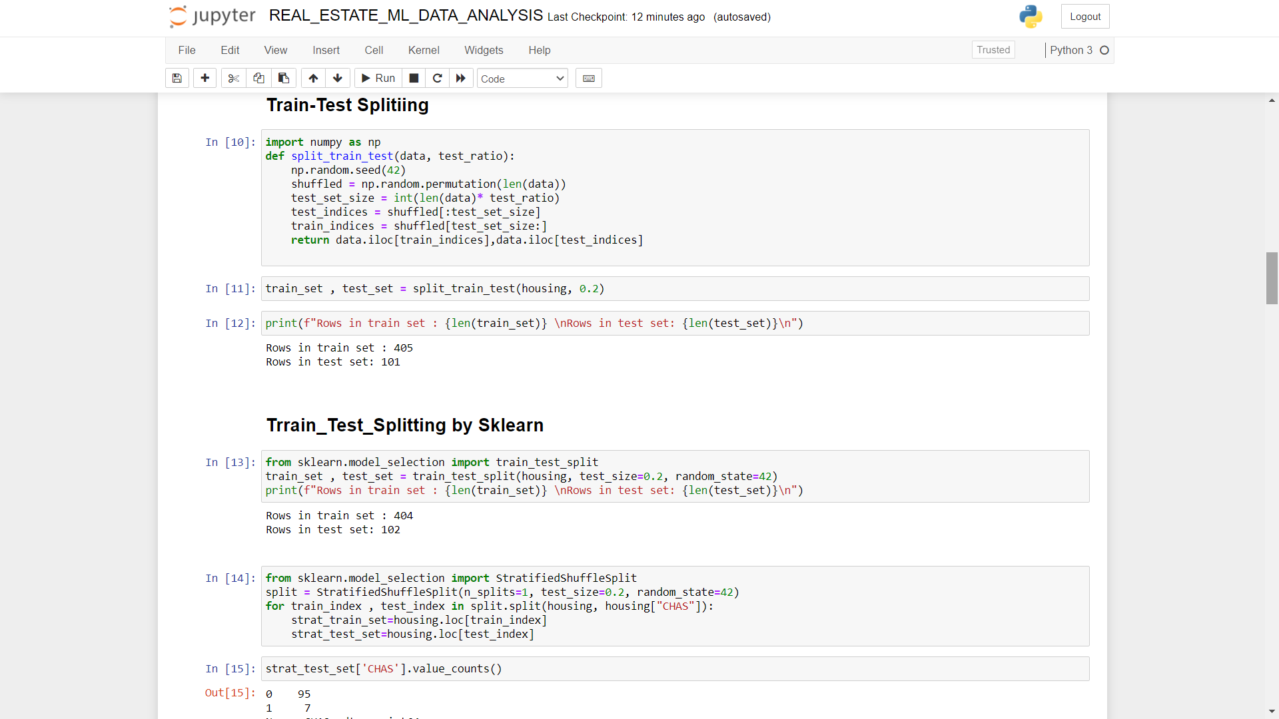

1. Looking for coorelations between data entities.

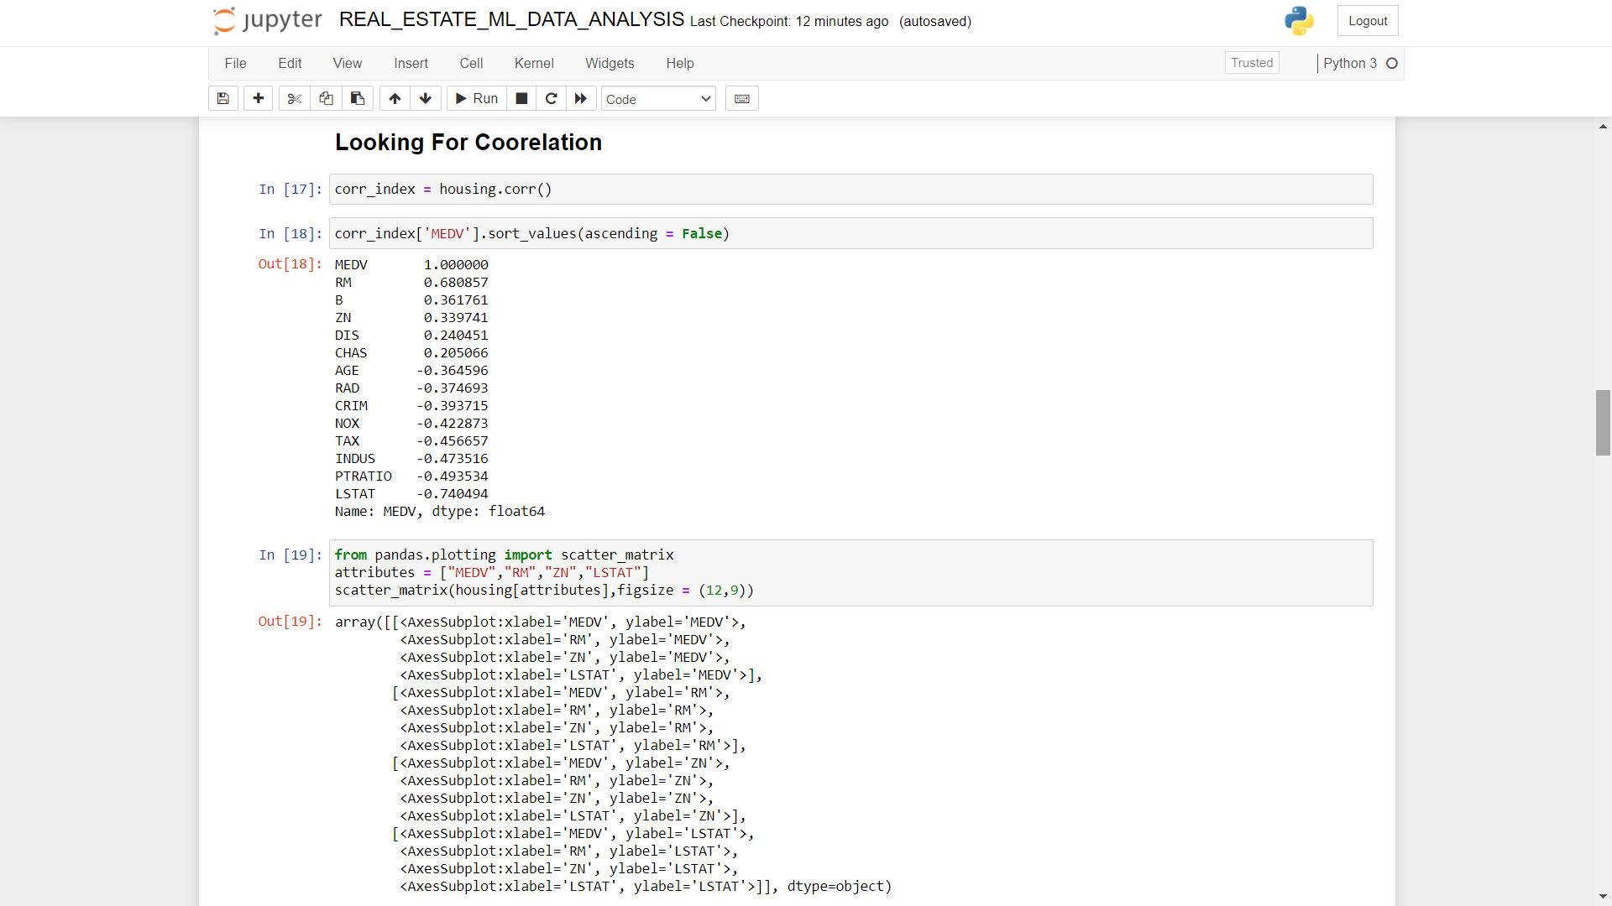

1. Graphical form of correlation between entities.

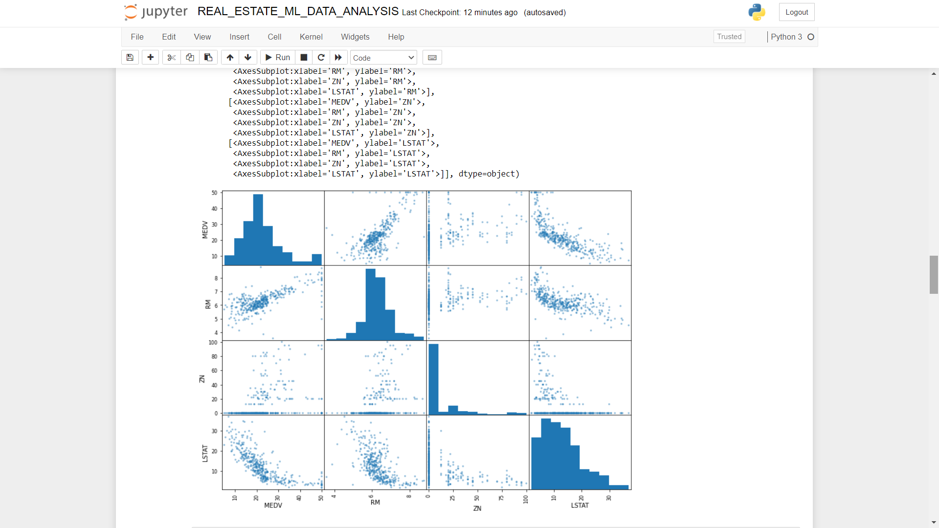

1. Ploting a scatter plot of highly correlated entities.

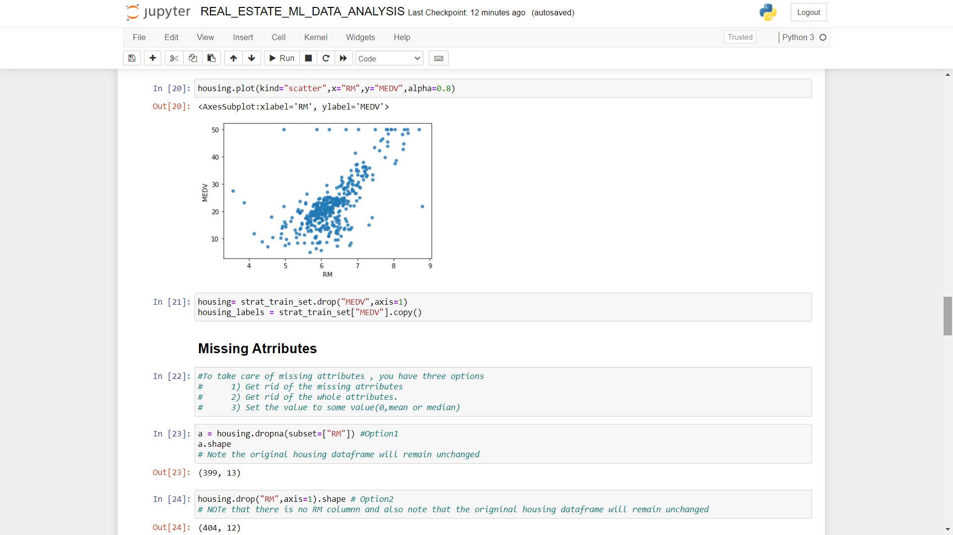

1. Finding out Missing Attributes .

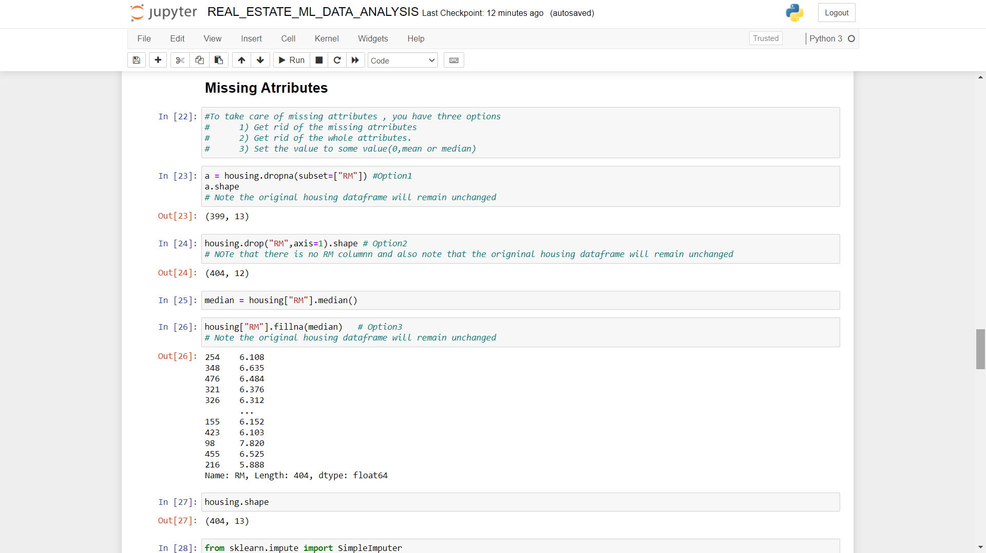

1. Using Imputer to fill missing values.

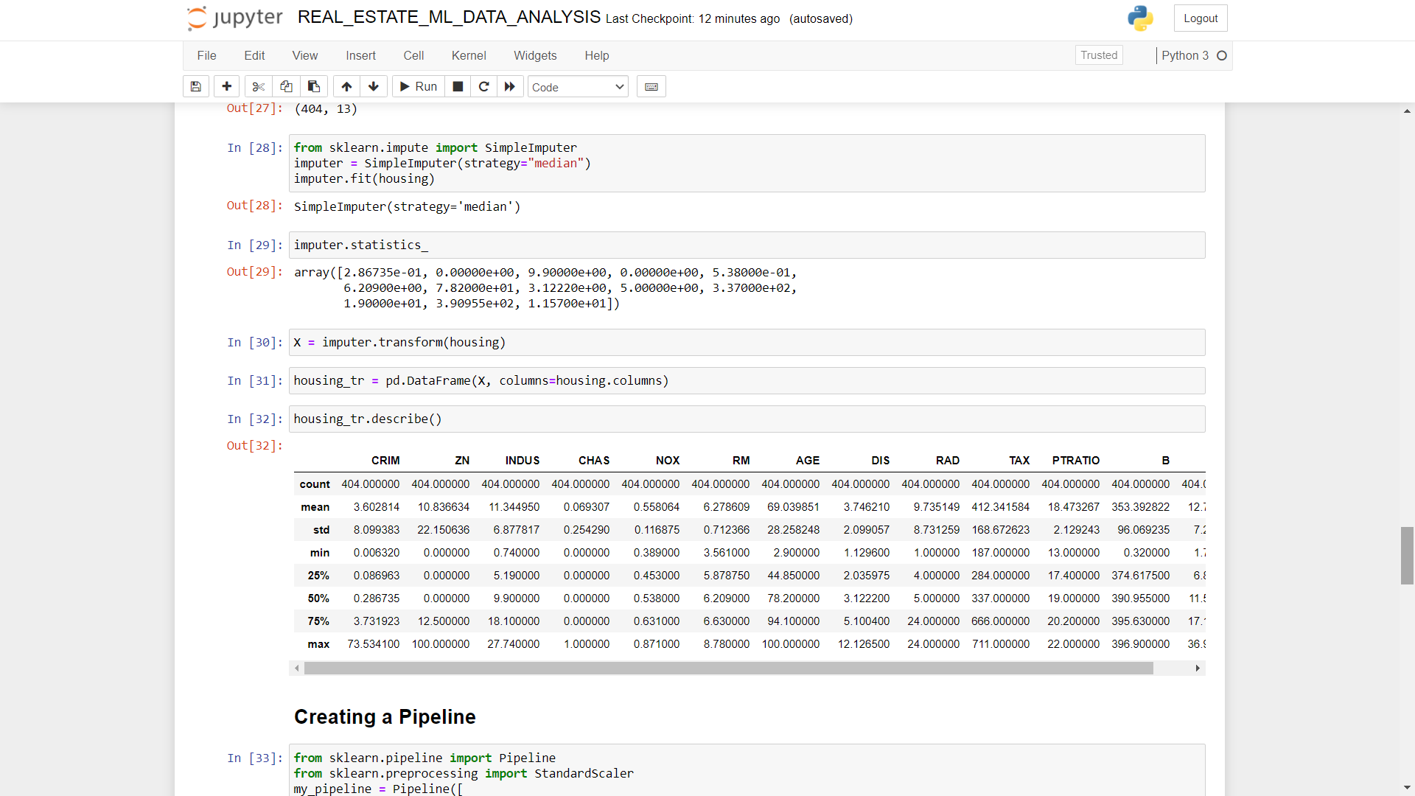

1. Using Pipelining And selecting a desired model.

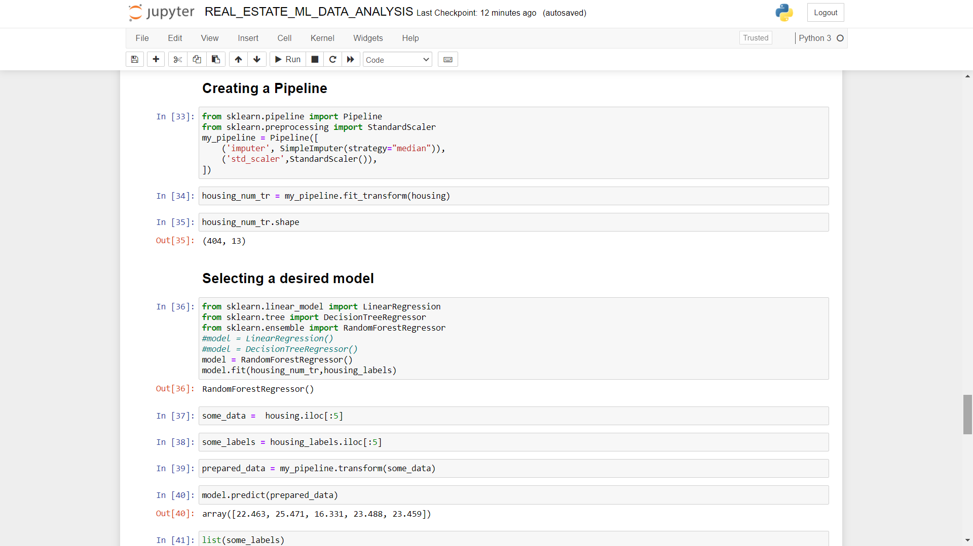

1. Checking Error in the model And making it better by cross validating it.

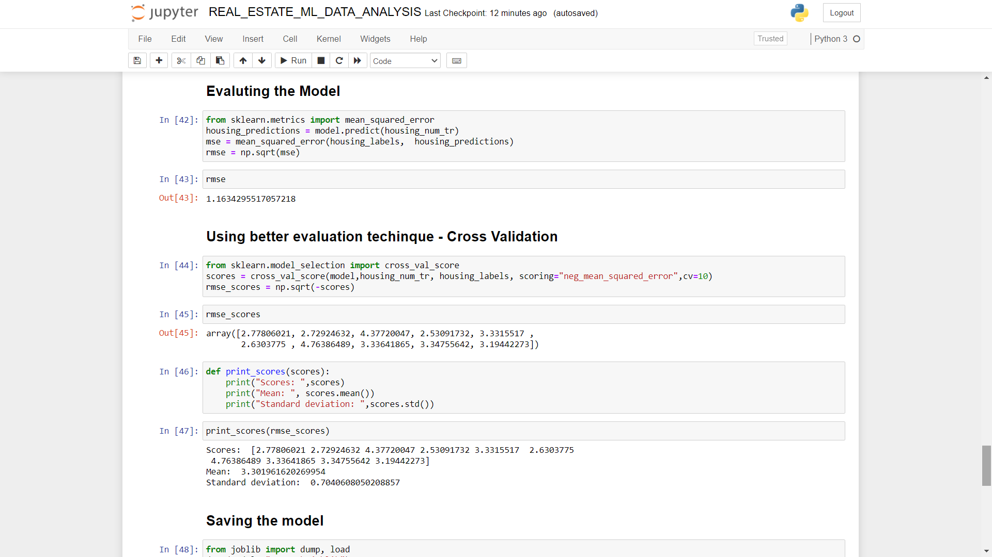

1. Saving the model and testing it on test data.

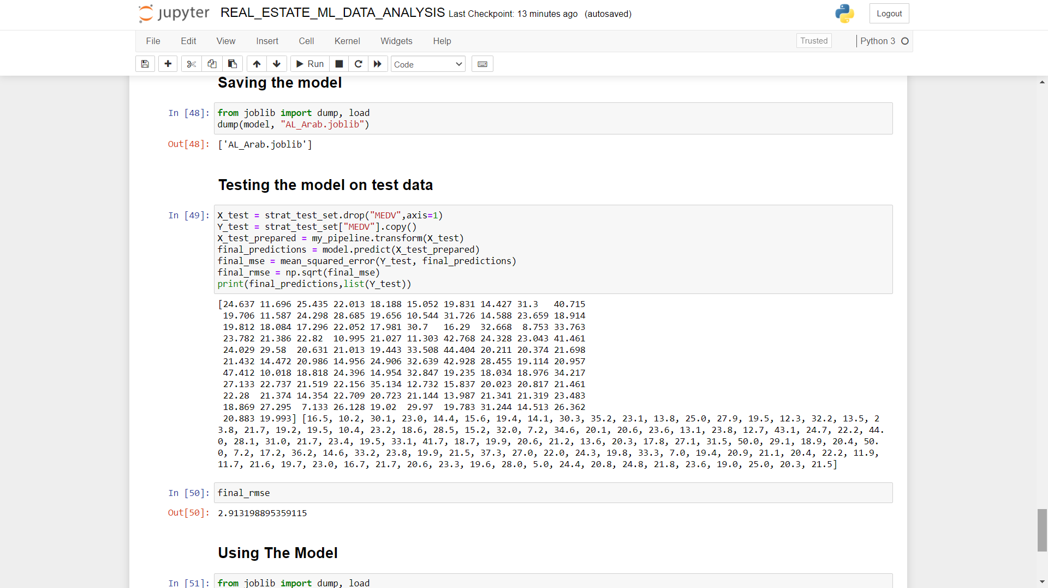

1. Dumping and Using the model.



