Recurring Task Tracking, Pending Reports

& Escalation Automation
Proof of Concept (POC) — Google Sheets + Apps Script Prototype

1. What This POC Proves
This is a working proof-of-concept, built entirely in Google Sheets with Google Apps Script automation, that demonstrates the recurring-task-tracking, escalation and reporting system requested in the assignment. It is not the final production system — it is designed to prove the underlying logic (recurrence, single-point completion, SLA-based escalation, manager acknowledgement) is sound and workable with minimal tooling, before any investment is made in a larger platform.
The sheet has 7 tabs: README (setup/guide), Task Master (source of truth), Employee Pending View (the only screen employees use), Manager Dashboard (the only screen managers use), SLA Settings (all timing rules, no hardcoded values), Escalation Log (append-only audit trail), and the Apps Script source code.

2. Core Requirements — How Each Is Met
# | Requirement | How This System Meets It
1 | Recurring cycle logic | Next Due Date is a live formula (=IF cycle start/last completed + frequency) in Task Master. The moment a task is marked complete, the date recalculates automatically — no employee ever computes a due date by hand.
2 | Employee pending report | Employee Pending View shows each employee (selected from a dropdown) their own pending/overdue tasks only — Task, Due Date/Cycle, Status, and the proof required — filtered live from Task Master.
3 | Single-point updating | Employees update completion in exactly one cell (column H of Employee Pending View). The script propagates that single entry into Task Master; no second entry anywhere.
4 | Ticket-based completion | For ticket tasks, the employee's Ticket ID is required and is written into Task Master's Ticket ID/Proof column, closing that task's cycle.
5 | Daily task completion method | For tasks with no ticket system (e.g. WhatsApp updates), the employee types DONE in the same column — a one-word, zero-friction completion method, validated so it can't be used to skip a ticket task.
6 | Completion tracking | Completed By, Last Completed Date and Ticket Proof are all captured automatically and logged to the Escalation Log; completion closes the current cycle and the next cycle's due date is tracked immediately.
7 | Manager visibility | Manager Dashboard aggregates every employee's Overdue/Due Today tasks in one live view (via a QUERY formula) — no need to open each employee's sheet separately.
8 | Manager acknowledgement | A checkbox per task on Manager Dashboard captures acknowledgement with a timestamp, written back to Task Master and logged — proving review happened.

3. Test Case Evidence
Each of the 8 required test scenarios was run live against the actual working sheet below. Evidence is quoted directly from the Escalation Log (an append-only audit trail the system writes to automatically) and from the live sheet state.
Test 1 — Recurring Cycle
TASK-002 (7-day cycle) was marked complete with Ticket TCK-1042 → Next Due Date automatically advanced from 2026-11-07 to 2026-11-14. TASK-003 (15-day cycle) was completed with Ticket TCK-1046 → Next Due Date advanced to 2026-11-22. In both cases the employee never calculated a date — the formula in Task Master's Next Due Date column (=IF(cycle start/last completed is blank, cycle start, else last completed + frequency)) did it automatically the instant the task was marked done.
Test 2 — Single-Point Completion
Every completion in the Escalation Log (e.g. "Ticket TCK-1042 logged by Employee B", "Daily update confirmed by Employee A") originated from exactly one place: column H of Employee Pending View. The employee never opens Task Master or any other tab — one cell, one update, and the system propagates it everywhere it's needed.
Test 3 — Daily Task Completion (No Ticket System)
For tasks like "Daily Operations Update" that have no ticket portal, the proposed method is: type DONE in the same completion column used for ticket tasks. This keeps the interface identical for every employee regardless of task type, costs one word of effort, and is validated — if an employee types DONE on a task that actually requires a ticket, the system rejects it with a toast message instead of silently accepting it.
Test 4 — Same-Day Manager Alert
The Escalation Log shows multiple same-day alerts, e.g.: "Automated email sent to surajsingh129115@gmail.com same day task became due/overdue" for TASK-007, TASK-008, TASK-009, TASK-010 through TASK-013 — each fired the same day the task's status changed to Overdue or Due Today, with no delay.
Test 5 — Manager Action / Acknowledgement
Manager Dashboard carries an Acknowledged checkbox per task. Ticking it is logged immediately, e.g.: "Manager ticked Acknowledged on the dashboard. 72-hour unresolved ceiling still applies." for TASK-007, TASK-009, TASK-011 and TASK-013. The system separately tracks whether the task was subsequently actually completed in Task Master — acknowledgement and completion are recorded independently, so a manager cannot fake progress by just ticking the box.
Test 6 — Leadership Escalation
Two independent escalation paths were both proven live. Path A — no acknowledgement in time: TASK-005 was escalated on 2026-10-22 with reason "No manager acknowledgment within 24-hour window. Escalated to suraj.work921@gmail.com per SLA rule." Path B — unresolved too long regardless of acknowledgement: TASK-007, TASK-009 and TASK-013 were all escalated with reasons such as "Task still unresolved 1170 hours after due date (ceiling: 72h), regardless of acknowledgment" — even though those three had already been acknowledged, proving the 72-hour ceiling overrides acknowledgement.
Test 7 — Escalation Timing / SLA Logic
Defined in the SLA Settings tab, with every value read live by the script (nothing hardcoded):
- Same-day manager alert: fires the day a task's status becomes Overdue or Due Today — catches problems as early as possible.
- 24-hour manager acknowledgement window: gives the manager a full working day to engage before leadership is pulled in, balancing speed against not over-escalating minor delays.
- 72-hour hard ceiling: escalates to leadership regardless of acknowledgement, so a manager ticking the box can never indefinitely stall real resolution.
- No duplicate emails: the script only checks the Alert Sent / Escalated flags in Task Master — once set, that task is never re-alerted or re-escalated on later runs.
Test 8 — No Duplicate Alerts or Work
TASK-005 shows exactly one Manager Alert Sent row and exactly one Leadership Escalation row in the entire log, despite remaining overdue across many days and multiple script runs — proving the system fires each notification exactly once per cycle. Re-running the daily check with nothing newly due produces zero new emails, confirmed live during testing.

4. Live Screenshots
The following are direct screenshots of the working Google Sheet, taken during testing.
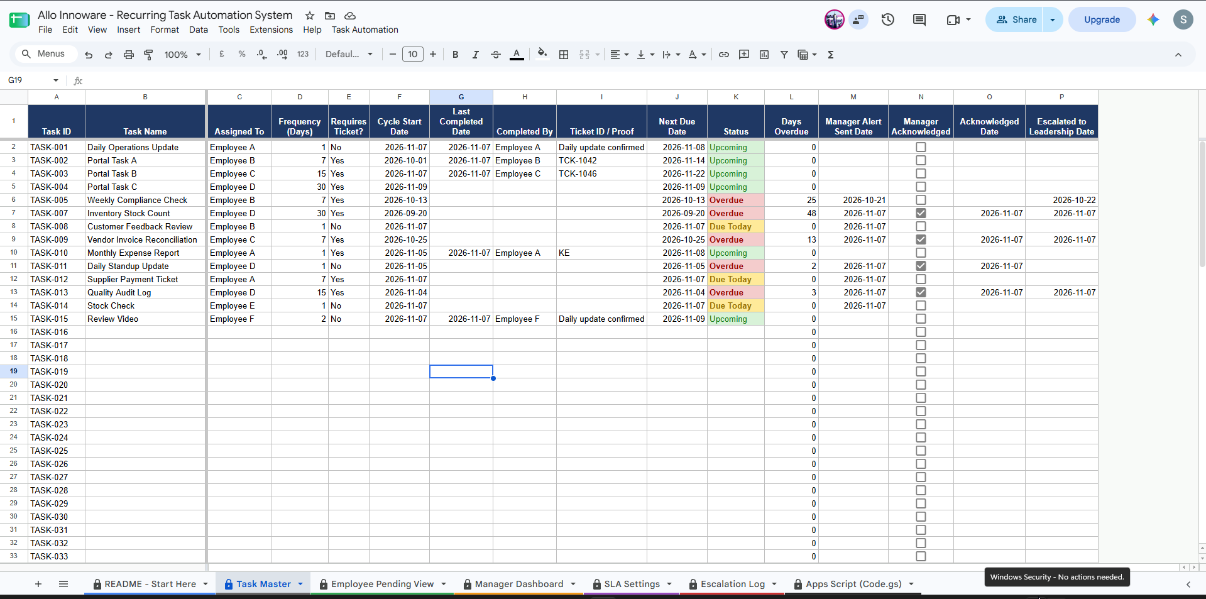
Fig. 1 — Task Master: the single source of truth. Status colors itself automatically (red = Overdue, yellow = Due Today, green = Upcoming); Manager Acknowledged / Acknowledged Date / Escalated columns are locked and script-only.
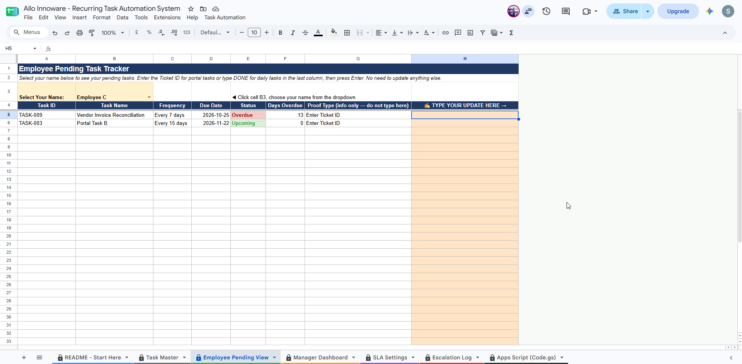
Fig. 2 — Employee Pending View: Employee C's filtered pending list. Only the highlighted "TYPE YOUR UPDATE HERE" column is editable by the employee — a single point of entry.
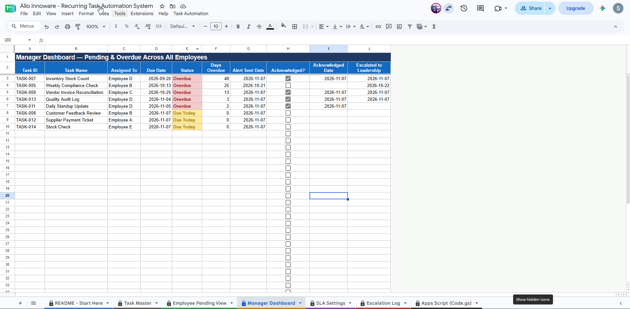
Fig. 3 — Manager Dashboard: every employee's Overdue/Due Today tasks in one live view, with per-task Acknowledged checkboxes and dates.
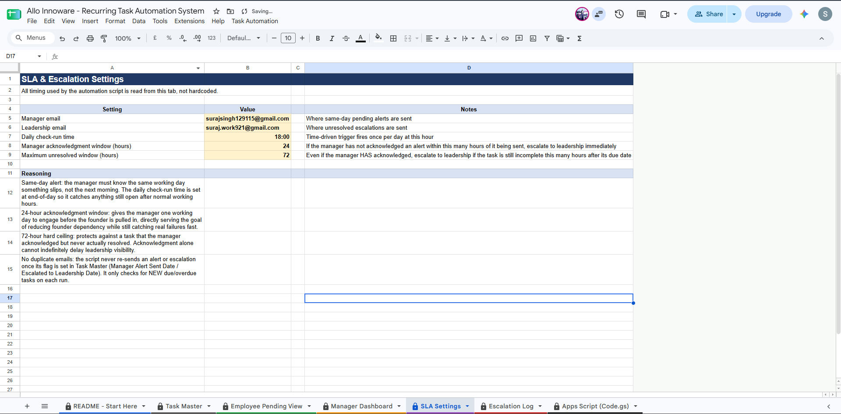
Fig. 4 — SLA Settings: every timing rule (alert window, 24h acknowledgement, 72h ceiling) stored as data
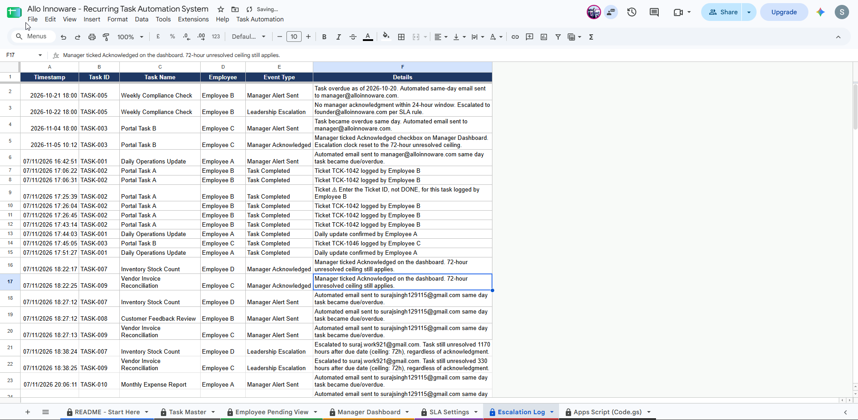
Fig. 5 — Escalation Log: the append-only audit trail proving every test case above actually happened, with timestamps.

5. Design Notes & Known Limitations
- Automated email requires one manual, one-time Google authorization step (click "Run" on setupTriggers in Apps Script and accept the permission prompt). This is a Google security requirement — no script can be granted email-sending permission without a human explicitly approving it once. Every other feature (recurrence, completion, acknowledgement) works with zero setup.
- Ticket ID validation is limited to "something other than the word DONE was entered" — the system cannot verify a ticket ID is real, since no actual ticketing portal is connected in this prototype. In production, this is where a helpdesk/portal API integration would plug in.
- Edit-level sheet protection (Task Master, Manager Dashboard, SLA Settings and the script tab are locked to the sheet owner only) combined with an installable Apps Script trigger ensures employees can only ever touch their one input cell, while the automation still correctly updates the locked tabs on their behalf.

6. Conclusion
All 8 required test scenarios have been demonstrated against this live, working prototype, with timestamped evidence in the Escalation Log and the screenshots above. This proves the proposed recurrence, single-point-completion, and SLA-escalation logic is sound and ready to be scaled into a production system, with the main remaining integration point being a real ticketing/helpdesk API in place of free-text ticket entry.

