Done by:
SURAJ SHUKLA
ADITYA KANDETH

Documentation Smart Traffic Light System .
1.Reference Papers (pg-1)
2.Setting up pi (pg-2)
3.Installing Rpi3 + opencv + python (pg-4)
4.PROJECT (pg-13)

References:
http://sci-hub.tw/http://ieeexplore.ieee.org/document/8275131/
http://docsdrive.com/pdfs/medwelljournals/jeasci/2017/6076-6082.pdf
https://pdfs.semanticscholar.org/ef4c/7a36c7518d367b703de9481faf0f0d9368fa.pdf

Setting Up PI :
Reference:https://www.raspberrypi.org/documentation/installation/installing-images/

NOOBS
New Out Of Box Software (NOOBS) is an easy operating system installation manager for the Raspberry Pi.
How to get NOOBS
BUY A PRE-INSTALLED SD CARD
SD cards with NOOBS preinstalled are available from many of our distributors and independent retailers, including Pimoroni, Adafruit, and Pi Hut.

DOWNLOAD
Alternatively, NOOBS is available for download on the Raspberry Pi website: raspberrypi.org/downloads

HOW TO INSTALL NOOBS ON AN SD CARD
Once you've downloaded the NOOBS zip file, you'll need to copy the contents to a formatted SD card on your computer.
To set up a blank SD card with NOOBS:
Format an SD card which is 8GB or larger as FAT. See the instructions given below.
1.Download and extract the files from the NOOBS zip file.
2.Copy the extracted files onto the SD card that you just formatted, so that this file is at the root directory of the SD card. Please note that in some cases it may extract the files into a folder; if this is the case, then please copy across the files from inside the folder rather than the folder itself.
3.On first boot, the "RECOVERY" FAT partition will be automatically resized to a minimum, and a list of OSes that are available to install will be displayed.
HOW TO FORMAT AN SD CARD AS FAT
WINDOWS
If you are a Windows user, we recommend formatting your SD card using the SD Association's Formatting Tool, which can be downloaded from sdcard.org. Instructions for using the tool are available on the same site.
MAC OS
The SD Association's Formatting Tool is also available for Mac users, although the default OS X Disk Utility is also capable of formatting the entire disk. To do this, select the SD card volume and choose Erase with MS-DOS format.

INSTALLING OPERATING SYSTEM IMAGES
You will need another computer with an SD card reader to install the image.
Download NOOBS, which is designed to be very easy to use.
Download the image
Official images for recommended operating systems are available to download from the Raspberry Pi website Downloads page.
https://www.raspberrypi.org/downloads/
Get the image file (.img) to write to your SD card.
Writing an image to the SD card
You will need to use an image writing tool to install the image you have downloaded on your SD card.
Etcher is a graphical SD card writing tool that works on Mac OS, Linux and Windows, and is the easiest option for most users. Etcher also supports writing images directly from the zip file, without any unzipping required.

To write your image with Etcher:
1.Download Etcher and install it.
2.Connect an SD card reader with the SD card inside.
3.Open Etcher and select from your hard drive the Raspberry Pi .img or .zip file you 4.wish to write to the SD card.
5.Select the SD card you wish to write your image to.
6.Review your selections and click 'Flash!' to begin writing data to the SD card.

HOW TO INSTALL OPENCV+RASPBERRY PI3
Reference :-https://www.pyimagesearch.com/2016/04/18/install-guide-raspberry-pi-3-raspbian-jessie-opencv-3/

Step #1: Expand filesystem
You should do is expand your filesystem to include all available space on your micro-SD card:
$sudo raspi-config
Once prompted, you should select the first option, “1. Expand File System”, hit Enter on your keyboard, arrow down to the “<Finish>” button, and then reboot your Pi:
After this reboot Rpi3 by following Command
$ sudo reboot
After rebooting, your file system should have been expanded to include all available space on your micro-SD card. You can verify that the disk has been expanded by executing df -h and examining the output:

As you can see, my Raspbian filesystem has been expanded to include all 8GB of the micro-SD card.
OpenCV, along with all its dependencies, will need a few gigabytes during the compile, so you should delete the Wolfram engine to free up some space on your Pi type:

$ sudo apt-get purge wolfram-engine
After removing the Wolfram Engine, you can reclaim almost 700mb!

Step #2: Install dependencies
I’ve also included the amount of time it takes to execute each command so you can plan your OpenCV + Raspberry Pi 3 install accordingly (OpenCV itself takes 1h 12m to compile).

The first step is to update and upgrade any existing packages:
$ sudo apt-get update
$ sudo apt-get upgrade
Timing: 1m 26s

We then need to install some developer tools, including CMake, which helps us configure the OpenCV build process:
$ sudo apt-get install build-essential cmake pkg-config
Timing: 40s
Next, we need to install some image I/O packages that allow us to load various image file formats from disk. Examples of such file formats include JPEG, PNG, TIFF, etc.:
$ sudo apt-get install libjpeg-dev libtiff5-dev libjasper-dev libpng12-dev
Timing: 32s

Just as we need image I/O packages, we also need video I/O packages. These libraries allow us to read various video file formats from disk as well as work directly with video streams:
$ sudo apt-get install libavcodec-dev libavformat-dev libswscale-dev libv4l-dev
$ sudo apt-get install libxvidcore-dev libx264-dev
Timing: 34s

The OpenCV library comes with a sub-module named highgui which is used to display images to our screen and build basic GUIs. In order to compile the highgui module, we need to install the GTK development library:
$ sudo apt-get install libgtk2.0-dev
Timing: 3m 6s

Many operations inside of OpenCV (namely matrix operations) can be optimized further by installing a few extra dependencies:
$ sudo apt-get install libatlas-base-dev gfortran
Timing: 46s

These optimization libraries are especially important for resource constrained devices such as the Raspberry Pi.

Lastly, let’s install both the Python 2.7 and Python 3 header files so we can compile OpenCV with Python bindings:
$ sudo apt-get install python2.7-dev python3-dev
Timing: 45s

If you skip this step, you may notice an error related to the Python.h header file not being found when running make to compile OpenCV.

Step #3: Download the OpenCV source code
Now that we have our dependencies installed, let’s grab the 3.1.0 archive of OpenCV from the official OpenCV repository. (Note: As future versions of openCV are released, you can replace 3.1.0 with the latest version number):
$ cd ~
$ wget -O opencv.zip https://github.com/Itseez/opencv/archive/3.1.0.zip
$ unzip opencv.zip

Timing: 1m 26s

We’ll want the full install of OpenCV 3 (to have access to features such as SIFT and SURF, for instance), so we also need to grab the opencv_contrib repository as well:
$ wget -O opencv_contrib.zip https://github.com/Itseez/opencv_contrib/archive/3.1.0.zip
$ unzip opencv_contrib.zip
Timing: 43s

You might need to expand the command above using the “<=>” button during your copy and paste. The .zip in the 3.1.0.zip may appear to be cutoff in some browsers. The full URL of the OpenCV 3.1.0 archive is:

https://github.com/Itseez/opencv_contrib/archive/3.1.0.zip

Step #4: Python 2.7 or Python 3?
Before we can start compiling OpenCV on our Raspberry Pi 3, we first need to install pip , a Python package manager:
$ wget https://bootstrap.pypa.io/get-pip.py
$ sudo python get-pip.py
Timing: 20s
I’ll also be assuming that you have both virtualenv and virtualenvwrapper installed throughout the remainder of this guide.
So, given that, what’s the point of using virtualenv and virtualenvwrapper ?

First, it’s important to understand that a virtual environment is a special tool used to keep the dependencies required by different projects in separate places by creating isolated, independent Python environments for each of them.

In short, it solves the “Project X depends on version 1.x, but Project Y needs 4.x” dilemma. It also keeps your global site-packages neat, tidy, and free from clutter.

If you would like a full explanation on why Python virtual environments are good practice, absolutely give this excellent blog post on RealPython a read.

It’s standard practice in the Python community to be using virtual environments of some sort, so I highly recommend that you do the same:
$ sudo pip install virtualenv virtualenvwrapper
$ sudo rm -rf ~/.cache/pip

Timing: 9s

Now that both virtualenv and virtualenvwrapper have been installed, we need to update our ~/.profile file to include the following lines at the bottom of the file:
# virtualenv and virtualenvwrapper
export WORKON_HOME=$HOME/.virtualenvs
source /usr/local/bin/virtualenvwrapper.sh

You should simply use cat and output redirection to handle updating ~/.profile :

$ echo -e "\n# virtualenv and virtualenvwrapper" >> ~/.profile
$ echo "export WORKON_HOME=$HOME/.virtualenvs" >> ~/.profile
$ echo "source /usr/local/bin/virtualenvwrapper.sh" >> ~/.profile

Now that we have our ~/.profile updated, we need to reload it to make sure the changes take affect. You can force a reload of your ~/.profile file by:

1.Logging out and then logging back in.
2.Closing a terminal instance and opening up a new one
Or my personal favorite, just use the source command:

$ source ~/.profile
Note: I recommend running the source ~/.profile file each time you open up a new terminal to ensure your system variables have been setup correctly.

Creating your Python virtual environment
$ mkvirtualenv cv -p python2
This command will create a new Python virtual environment named cv using Python 2.7.

If you instead want to use Python 3, you’ll want to use this command instead:
$ mkvirtualenv cv -p python3

cv Python virtual environment is entirely independent and sequestered from the default Python version included in the download of Raspbian Jessie. Any Python packages in the global site-packages directory will not be available to the cv virtual environment. Similarly, any Python packages installed in site-packages of cv will not be available to the global install of Python. Keep this in mind when you’re working in your Python virtual environment and it will help avoid a lot of confusion and headaches.

How to check if you’re in the “cv” virtual environment
If you ever reboot your Raspberry Pi; log out and log back in; or open up a new terminal, you’ll need to use the workon command to re-access the cv virtual environment. In previous blog posts, I’ve seen readers use the mkvirtualenv command — this is entirely unneeded! The mkvirtualenv command is meant to be executed only once: to actually create the virtual environment.

After that, you can use workon and you’ll be dropped down into your virtual environment:

$ source ~/.profile
$ workon cv

Installing NumPy on your Raspberry Pi
Assuming you’ve made it this far, you should now be in the cv virtual environment (which you should stay in for the rest of this tutorial). Our only Python dependency is NumPy, a Python package used for numerical processing:
$ pip install numpy
Timing: 9m 39s
Note: Another question I’ve often seen is “Help, my NumPy installation has hung and it’s not installing!” Actually, it is installing, it just takes time to pull down the sources and compile. Be patient. The Raspberry Pi isn’t as fast as your laptop/desktop.

Step #5: Compile and Install OpenCV
We are now ready to compile and install OpenCV! Double-check that you are in the cv virtual environment by examining your prompt (you should see the (cv) text preceding it), and if not, simply execute workon :
$ workon cv
Once you have ensured you are in the cv virtual environment, we can setup our build using CMake:
$ cd ~/opencv-3.1.0/
$ mkdir build
$ cd build
$ cmake -D CMAKE_BUILD_TYPE=RELEASE \
-D CMAKE_INSTALL_PREFIX=/usr/local \
-D INSTALL_PYTHON_EXAMPLES=ON \
-D OPENCV_EXTRA_MODULES_PATH=~/opencv_contrib-3.1.0/modules \
-D BUILD_EXAMPLES=ON ..

Finally, we are now ready to compile OpenCV:

$ make -j4
Timing: 1h 12m

Compiling OpenCV in 72 minutes on the Raspberry Pi 3 is a 24% improvement over the previous 95 minutes for the Raspberry Pi 2. That extra 300MHz makes a big difference!

The -j4 command controls the number of cores to leverage when compiling OpenCV 3. The Raspberry Pi 3 has four cores, thus we supply a value of 4 to allow OpenCV to compile faster.

However, due to race conditions, there are times when make errors out when using multiple cores. If this happens to you, I suggest starting the compilation over again and using only one core:
$ make clean
$ make
$ sudo make install
$ sudo ldconfig
Timing: 52s

Step #6: Finish installing OpenCV on your Pi
We’re almost done — just a few more steps to go and you’ll be ready to use your Raspberry Pi 3 with OpenCV 3.

For Python 2.7:
$ ls -l /usr/local/lib/python2.7/site-packages/
$ ls -l /usr/local/lib/python2.7/site-packages/

Our final step is to sym-link the OpenCV bindings into our cv virtual environment for Python 2.7:
$ cd ~/.virtualenvs/cv/lib/python2.7/site-packages/
$ ln -s /usr/local/lib/python2.7/site-packages/cv2.so cv2.so

For Python 3:
After running make install , your OpenCV + Python bindings should be installed in /usr/local/lib/python3.4/site-packages . Again, you can verify this with the ls command:

To test CV
$ source ~/.profile
$ workon cv
$ python
>>> import cv2
>>> cv2.__version__
'3.1.0'
>>>
OpenCV 3 has been successfully installed on my Raspberry Pi 3 + Python 2.7 environment:

PROJECT

The smart traffic management system aims at the automation of traditional
traffic management system. The traditional traffic systems are working on
fixed algorithms and requires human support. The smart traffic
management system aims at regulating the signal in such a way that
maximum traffic could be cleared off in lesser amount of time.

To develop a technique that can be used for traffic control using image processing and IOT. In such a system, the traffic density of lanes is calculated using image processing which is done on images of lanes that are captured using a digital camera. According to the traffic densities on all roads, our proposed model will allocate smartly the time period of green light for each road by assigning priorities based on the traffic density. Image processing can be used for the calculation of traffic density as cameras are very much cheaper than other devices such as sensors.

The algorithm being used will also work in corner cases including heavy vehicles like trucks and small vehicles like bikes since it matches purely based on traffic densities and not on the count of vehicles on the road.
Surveillance camera is used to implement the algorithm and give priority.
The system also has the capability to store data on a ThingSpeak cloud server which will help with data storage and further data analysis.

This system replaces existing traffic management solutions such as:
- RFID tags on vehicles to count the number of vehicles and assign signals accordingly. Recognition of vehicles using RFIDs by installing the RFIDs on all the vehicles. RFIDs are very accurate and also require very less amount of energy for working. RFIDs are also easy to install but looking at thelevel of implementation using RFIDs is expensive as well as time taking process.The vehicular congestion is the biggest issue faced by the traffic authorities and it has been increasing day by day. The number of vehicles on the road is directly proportional to the population growth and hence are both increasing at a great rate from a long time.
- Using Ultrasonic sensors to get a vehicle count.

These existing implementations are expensive whereas our proposed system makes use of existing CCTV cameras which are already set up in most metropolitan cities for surveillance.
PROBLEM STATEMENT
The number of vehicles using the road is increasing exponentially every day.
Inefficient management of traffic causes wastage of invaluable time, pollution, wastage of fuel, cost of transportation and stress to drivers, etc.
Hence, a system has to be designed to avoid the above casualties thus preventing accidents, collisions, and traffic jams.
In some situations, emergency vehicles like ambulances and fire-engines are not able to pass through because of heavy traffic congestion. This delay can be fatal and lead to a loss of lives.
- There are a number of factors contributing to the increased congestion in traffic in the previous years; a few of them are listed below.
1. The slow speeds of freight vehicles.
2. There is a 9.08% annual increase in freight volume and 10.76% increase in other vehicles, but the increase of roads is only by 4.01%.
3. The extra waiting time on signals even when no congestion.
With so many factors contributing to the increase in congestion it is important to think of new and efficient methods of clearing congestions. The traditional signaling system is not having a major effect in curbing congestion of vehicular traffic.

The steps involved in implementing the proposed system are given as follows:
Video Acquisition
Split video into frames
Image Pre-Processing
1 .Image Resizing
2. Grayscaling
- Canny Edge Detection
- Template matching:

Based on the results of the template match, store the count of cars in each frame.
Adjust the signal light according to the number of cars detected.
The data is sent to the ThingSpeak cloud dynamically.
IMAGE ACQUISITION:
Image acquisition is the process of acquiring the image from a suitable source. In this project the source is a camera( preferably CCTV, to avoid additional setup). The image is obtained by converting a video into multiple frames and processing each frame at a time. The image resolution can vary from 720*480p to 1280*720p based on the camera used.

IMAGE RESIZING:
The acquired image is scaled down from the original resolution into 400*300p. This increases the frame rate of the image acquisition and hence helps the system avoid latency issues. Image scaling brings a level of consistency to the images acquired by converting input from all camera sources into a single resolution. It reduces the number of edges detected by ignoring minute details. Image resizing is primarily required when the systems processor cannot handle a large density of pixels at high speeds. Based on the algorithm that is used, image scaling can produce highly differentiated results as compared to a non-resized image.

RGB to GRAYSCALE:
A grayscale image is one where each pixel depicts only its intensity. Hence the colors of each pixel are restricted to shades of gray ranging from white to black. The image is converted from RGB to grayscale during the acquisition process. Grayscaling refers to the process of converting an image from RGB into black and white. Multiple functions in OpenCV can work only if a grayscale image is passed as a parameter. Canny Edge detection also uses grayscale images. The edge detection algorithm returns white for all detected edges and black for the rest of the image.

RGB to GRAYSCALE algo
OpenCV uses the following formula to convert a pixel from RGB to grayscale:
Yß0.299R+0.587G+0.114B

Canny edge detection:
We choose it since Canny edge detection has optimal quality , is Simple and Single edge point response .
The Canny edge detection algorithm consist of the following basic steps:
i.input image with Gaussian filter to remove noise and unwanted details and texture.
ii. Compute the gradient magnitude and angle images.
iii. Apply non-maxima suppression to the gradient magnitude image.
iv. Hysterisis

Template Matching:
Template matching is a technique for finding areas of an image that match (are similar) to a template image (patch).Its is a brute force method where we compare two images pixel by pixel along height and width of an image .
Algorithm:
i. Obtain source and template image.
ii. Sliding: Move the template image pixel by pixel in both x and y directions.
iii. Calculate a metric at each location
iv. Using this metric, deduce how good or a bad of a match is formed between the images.
v. The brightest location indicates the best matches

Match_percentage():

1.The match_percent function is used to calculate the match percentage of two input images.
2.It takes the reference image and the camera input as parameters. Usually image of empty road with no vehicle is reference image .
3.Image captured by camera , consisting vehicles on road at current instance is path image .
Both the images are converted to grayscale and the resolution is reduced to 400*300 .
4.Gray scale ensures an image is in black/white and no other colour. Dimension 400*300 ensure both image is similar in terms of row and column .
5.Canny edge detection algorithm is used to detect edges in both images. The number of edges in the reference image are represented by white pixels in the image.
6.In the sample image, the number of white pixels of the cars are calculated by finding the total white pixels in the image excluding the white pixels present in the reference image.
7.The match percentage is found and returned by calculating the ratio between the white pixels in the reference image and the white pixels in the sample image. This ratio is then multiplied by 100 to obtain the final match percentage.

Match % = ( _a )/( _a+_b ) *100
_a = edges part of sample image and not part of reference image )
_b = Total edges in reference image

The algorithm being used will also work in corner cases where we have a single heavy vehicles like trucks and otherside single small vehicles like bikes or hatchback cars , priority should be given to smaller once since its its logical cars or bike take less time and they occupy less space.The match is purely based on traffic densities and not on the count of vehicles on the road.
We obtain desity of all the sides.Surveillance camera is used to implement the algorithm and give priority.The system also has the capability to store data on a ThingSpeak cloud server which will help with data storage and further data analysis.

Circuit Diagram for 2 lanes :

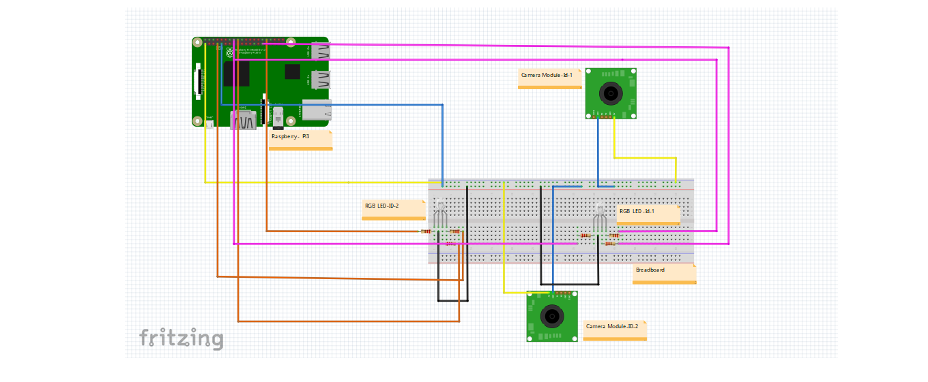

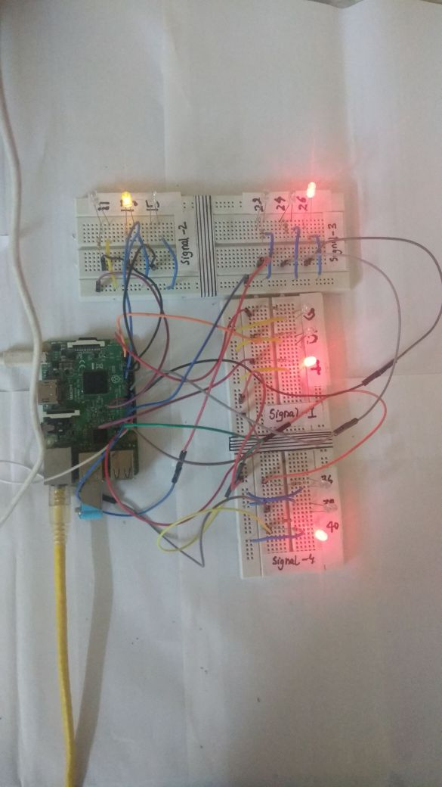

SOFTWARE REQUIREMENTS
OpenCV:
OpenCV (Open Source Computer Vision) is a library of programming functions mainly aimed at real-time computer vision. Originally developed by Intel, it was later supported by Willow Garage then Itseez (which was later acquired by Intel). The library is cross-platform and free for use under the open-source BSD license.
OpenCV supports the deep learning frameworks TensorFlow, Torch/PyTorch and Caffe.
OpenCV runs on the following desktop operating systems: Windows, Linux, macOS, FreeBSD, NetBSD, OpenBSD. OpenCV runs on the following mobile operating systems: Android, iOS, Maemo, BlackBerry 10.The user can get official releases from SourceForge or take the latest sources from GitHub. OpenCV uses CMake.

Python
Python is an interpreted high-level programming language for general-purpose programming.Python has a design philosophy that emphasizes code readability, notably using significant whitespace. It provides constructs that enable clear programming on both small and large scales.
Python features a dynamic type system and automatic memory management. It supports multiple programming paradigms, including object-oriented, imperative, functional and procedural.
Python interpreters are available for many operating systems. CPython, the reference implementation of Python, is open source software and has a community-based development model, as do nearly all of its variant implementations. CPython is managed by the non-profit Python Software Foundation.
IPWebcam
Ipwebcam is an open sourc application that provides a service to host the surveillance camera on internet .Webcam can be accessed using Ip assigned to it with permitted ports and authorization.

ThingSpeak Cloud
- ThingSpeak Cloud

ThingSpeak is an IoT analytics platform service that allows you to aggregate, visualize and analyze live data streams in the cloud. ThingSpeak provides instant visualizations of data posted by your devices to ThingSpeak. With the ability to execute MATLAB® code in

ThingSpeak you can perform online analysis and processing of the data as it comes in.

Some of the key capabilities of ThingSpeak include the ability to:

Easily configure devices to send data to ThingSpeak using popular IoT protocols. Visualize your sensor data in real-time.

Aggregate data on-demand from third-party sources.

Use the power of MATLAB to make sense of your IoT data.

Run your IoT analytics automatically based on schedules or events.

Prototype and build IoT systems without setting up servers or developing web software. Automatically act on your data and communicate using third-party services like
Twilio® or Twitter®.

The following services are provided by the ThingSpeak cloud which makes it super suitable for my idea:
- Send sensor data privately to the cloud.

There are sensors all around—in our homes, smart phones, automobiles, city infrastructure, and industrial equipment. Sensors detect and measure information on all sorts of things like temperature, humidity, and pressure. And they communicate that data in some form, such as a numerical value or electrical signal.
- Analyze and visualize your data with MATLAB.

Storing data in the cloud provides easy access to your data. Using online analytical tools, you can explore and visualize data. You can discover relationships, patterns, and trends in data. You can calculate new data. And you can visualize it in plots, charts, and gauges.
- Trigger a reaction.

Acting on data could be something as simple receiving a tweet when the temperature you are measuring goes above 70° F. Or you could set up a more intricate action such as turning on a motor when the water level in your water tank drops below a specified limit. You can even remotely control devices, such as battery-operated door locks, using the TalkBack app.

Flow chart for Image Processing

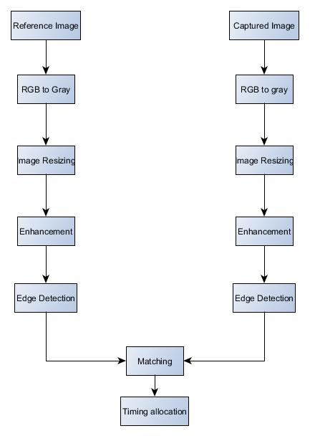

FLOWCHART FOR RPI
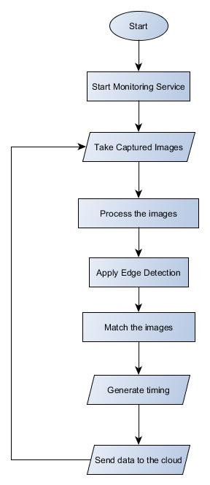

HARDWARE REQUIREMENTS

- Raspberry Pi 3
- Pi Camera
- Jumper Wires
- RGB LED
- PSU for the raspberry pi

MODULES:
1. Raspberry Pi
The Raspberry Pi is a series of small single-board computersdeveloped in the United Kingdom by the Raspberry Pi Foundation to promote the teaching of basic computer science in schools and in developing countries. Here we are using Raspberry Pi 3B+ model for controlling the traffic lights according to the data collected from
Surveillace camera .

2.PI-Camera
The Raspberry Pi Camera Module v2 is a high quality 8 megapixel Sony IMX219 image sensor custom designed add-on board for Raspberry Pi, featuring a fixed focus lens.
It's capable of 3280 x 2464 pixel static images, and also supports 1080p30, 720p60 and 640x480p60/90 video. 8 megapixel native resolution sensor-capable of 3280 x 2464 pixel. static images Supports 1080p30, 720p60 and 640x480p90 video.
The board itself is tiny, at around 25mm x 23mm x 9mm. It also weighs
just over 3g. It connects to Raspberry Pi by way of a short ribbon cable.We are using
it here to use it as Surveillance Camera.

3. Power Adapter
Raspberry Pi is a single board small computer which can be
powered using this power adapter which a normal phone charger.

4. RGB LED
Light emitting diode (LED) are the small lights which require low energy to light up are here used to resemble the traffic signals to demonstrate the real time regulation of signals according to vehicle data from microcontroller.

5. Data Cables
Data cables are used to transfer the data from the Surveillance camera to the Raspberry Pi.Camera is tethers to the pi allowing it to host webcam server on port:8080.

IMPLEMENTATION DETAILS

Initially GPIO pins of Rpi is connected to the Red,yellow,and green colour LED lights , which indicate stop,start and go signal of a single traffic light.We have 4 traffic signal for 4 individual lane at intersection of roads.

Hardware Side :-
These are connected to pin :-
signal 1 ->GPIO 2,5,37
signal 2 ->GPIO 15,13,11
signal 3 ->GPIO 26,24,22
signal 4 ->GPIO 40,38,36

All signal are connected are grounded.
.
Their are 4 Survelliance camera is connected via usb cable to Rpi3 and tethered to it .It can also be connected to wifi instead of tethering.Camera captures image of a single lane and sends it to pi for processing and calculation.

Software Side:-
We have used our mobile camera that uses Ipwebcam Application host webcam service locally.We have taken reference image as image of empty road.Python script is written to find out percentage of match between image rendered from surveillance camera to reference image.

We designed an algorithm where we first take the reference image and second path image and resize it equivalent height of 400h and 300w .We perform grayscale and canny edge detection.We perform template matching over region of image and count matching pixels. By following above we get percentage match for all the 4 lanes . We can easily prioritize the lane with large density of vehicles and operate the LED signals accordingly.

Data obtained by percentage of match is sent to cloud.The python script uses write key generated by cloud to perform an connection . Http request and using POST method send values of feild1,feild2,feild3,feild4,feild5,feild6 to the thingspeak cloud server.Server listens to the request and stores it .Thingspeak provides us with mathlab tools to perfom analytics , draw graph and also covert data to json,csv and xml , any format.

Pros:

- Installation Cost of our system: It is very less comparatively because we require the live feed which is easily accessible from the surveillance cameras present at each traffic junction. Most of major cities and the traffic junction where traffic remains high have cameras already installed.

- Use of Data analytics: Use of technology in Traffic management is a known thing. However, it is the use of data from different sources in real-time and processing information to take immediate decisions that is the key to a successful traffic management in our cities. It is the need of the hour to leverage enormous amount of data around us and create a more meaningful and smooth living for us. So, a lot of hardware cost is cutoff, at max some cameras would require to be repositioned or adjusted.

- Saving of Fuel: Our model reduces the wastage of fuel while sticking in traffic jams by reducing the amount of traffic congestion and jams. Our model smartly tackles traffic and thus saves fuel which is need of the hour.

- Maintenance Cost: of our system is virtually negligible as our system does not include any additional hardware components as compared to the other traffic monitoring systems which employ pressure mats which normally suffer the problem of wear and tear due to their placement on roads where they are subjected to immense pressure constantly.

- Distance among Vehicles: One great feature is that traffic always remains at a distance. If we look at the density of vehicles at all lanes in dynamic algorithm mode and compare it to hard coded, we could see a drastic difference which would reduce congestion by almost 4 to 5 times and all vehicles can move spaciously.

ISSUES FACED BY THE SYSTEM
- NIGHT VISION:
Standard cameras cannot process images during night. Since there are no external sources of light unlike daytime, where the light of the sun provides enough light for the camera to record videos. An alternative to this problem is to use a night vision camera which works on the principle of infrared light. IR lights turn on when the external light level is low. IR light is not visible to the naked eye so it floods an area in light that only the camera can see. Another advantage of IR light is that it is usually monochrome hence the conversion to grayscale is a lot less expensive than daylight imagery. Also, most CCTV cameras and security cameras that are setup in traffic signals come inbuilt with IR lights.

- WEATHER ISSUES:
Rain can create a severe hamper on the edge detection process since the algorithm will also consider the kinetic motion of raindrops as an edge. Hence, the system has to either be able to filter out rain drops and only allow the required image to pass through or remove them using a post processing technique. The best way to remove rain drop edges is using an NMF filter to remove low frequency rain streaks and the canny edge detection algorithm which can remove high frequency rain streaks.

Reference image on lane 1:
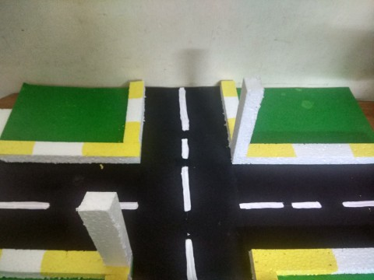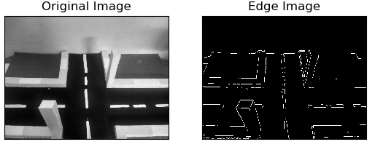

Sample-1
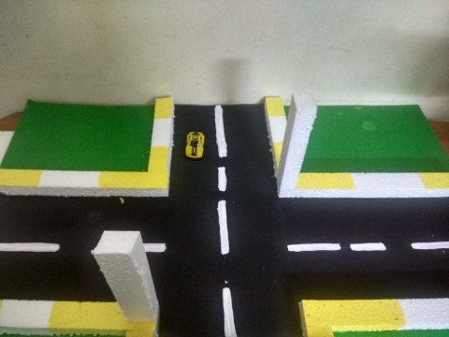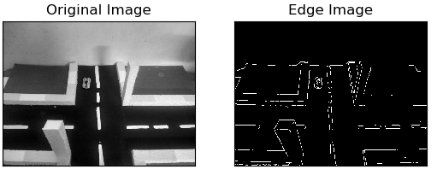

('No of whites in reference image =', 3428)
('No of whites part of path image but not in reference image =', 3489)
('Ratio =', 0.5044094260517565)
('Percentage of match =', 50.44094260517566)

Sample-2

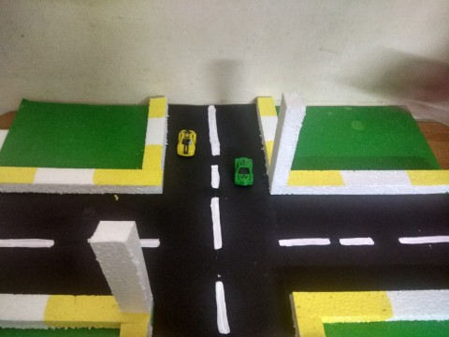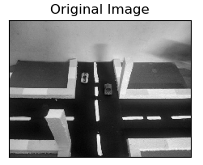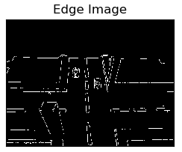

('No of whites in reference image =', 3305)
('No of whites part of path image but not in reference image =', 3428)
('Ratio =', 0.5091341155502748)
('Percentage of match =', 50.91341155502748)

Sample-3

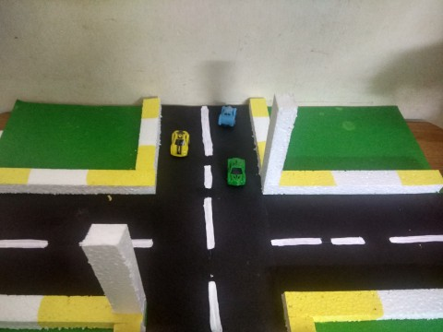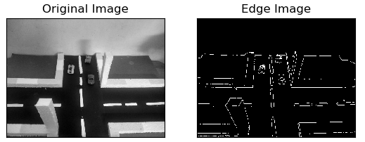
('No of whites in reference image =', 3215)
('No of whites part of path image but not in reference image =', 3428)
('Ratio =', 0.4839680867078127)
('Percentage of match =', 48.39680867078127)

Sample-4
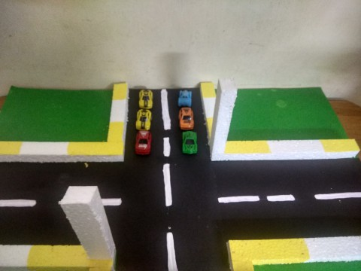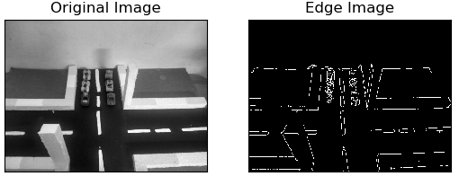

('No of whites in reference image =', 3428)
('No of whites part of path image but not in reference image =', 3649)
('Ratio =', 0.5156139607178183)
('Percentage of match =', 51.56139607178183)

sample

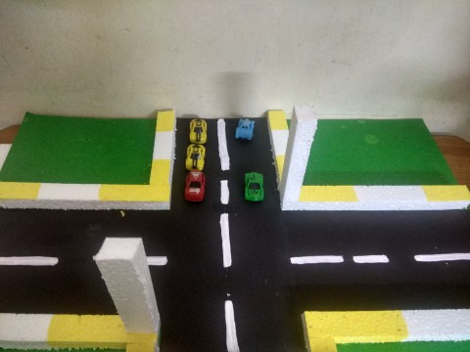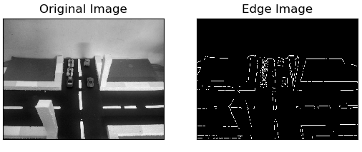
('No of whites in reference image =', 3428)
('No of whites part of path image but not in reference image =', 3565)
('Ratio =', 0.5097955097955098)
('Percentage of match =', 50.97955097955098)

