**AWS ETL SETUP**

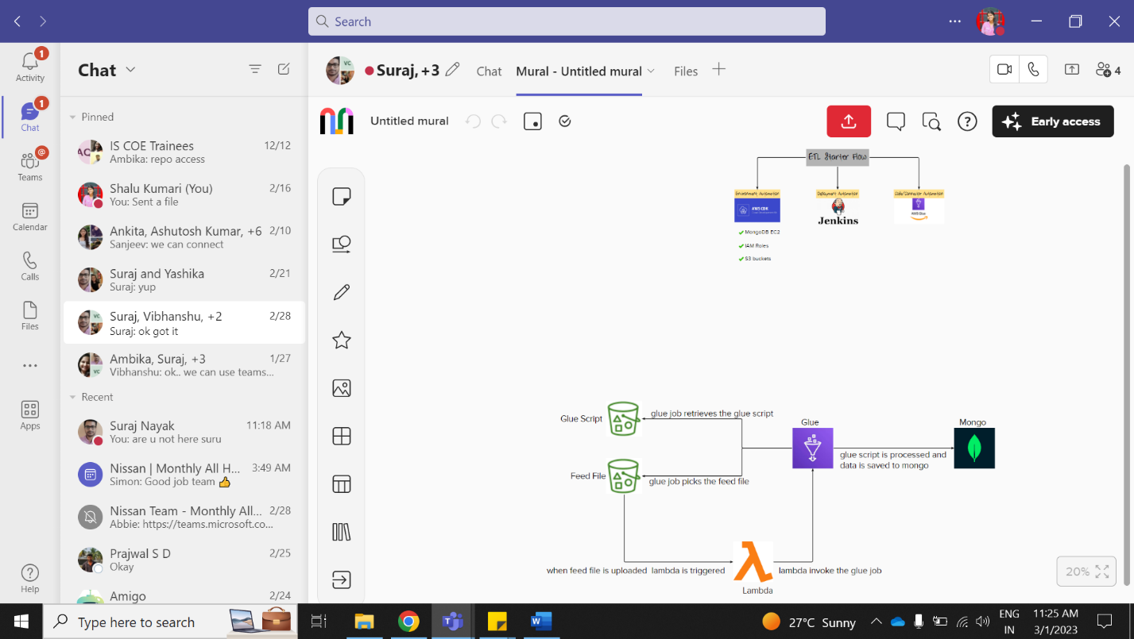

**1. S3 -> LAMBDA**

1. Create a S3 Bucket (link: <https://youtu.be/i4YFFWcyeFM>)

->must be publicly accessible

1. Create a Lambda function (link: <https://youtu.be/6RmCH6KOLpA>)

->add the required IAM role (lambda to glue and s3 full access)

->connect to s3 and connect to glue

->get the bucket and key name from the event

->invoke the glue job by passing the name

1. Trigger the Lambda when a file is uploaded in the S3 bucket

->In lambda console go to ADD TRIGGER

->select a source (S3 bucket)

->select bucket name, event type (all objects create events), acknowledge and add.

**2.LAMBDA -> GLUE**

1. Create a GLUE

* Choose a source (S3) and destination (choose later)
* Click on create then choose
  + S3 source type (S3 location)
  + Give S3 URL
  + Choose Data format
  + Choose an IAM role (permission of s3 and connecting db)
  + Language (python)
* After giving details Save the job
* In the script, add the mongo dB details as code

host ="3.84.239.167"

port ="27017"

database="mongo-data"

collection="first-collection"

mongo-URL = 'mongodb://'+host+':'+port

mongo-Client = MongoClient(mongo-URL)

mongo-dB= mongo-Client[database]

mongo-Collection = mongo-dB[collection]

data=[{"item":"lol","qty":8},{"item":"lolipop","qty":80}]

for i in data:

Save= mongo-Collection.insert_one(i)

**3.S3 -> Glue**

s3 = boto3.resource('s3')

bucket = s3.Bucket('demoglueebucket')

for obj in bucket.objects.all():

key = obj.key

body = obj.get()['Body'].read()

print("Body : ",body)

**4.GLUE -> EC2 -> MONGODB**

1. Create an EC2 (link: <https://youtu.be/oqHfiRzxunY>)( https://awswithatiq.com/setup-mongodb-server-in-aws/)

* In the Instance Security Group add Inbound Rules (add rule for Custom TCP from port 27017, anywhere ipv4
* Go to the EC2 Dashboard, check the instance, and click on connect.
* Connect to instance will open, connect / connect using putty using ppk file
* create editor file using vi (command: vi /etc/yum.repos.d/mongodb-org-4.2.repo)
* An editor will open, press I to insert then paste the code.

[mongodb-org-4.2]

name=MongoDB Repository baseurl=https://repo.mongodb.org/yum/amazon/2013.03/mongodb-org/4.2/x86_64/

gpgcheck=1

enabled=1 gpgkey=https://www.mongodb.org/static/pgp/server-4.2.asc

* Then press esc, then :wq
* Install mongodb using sudo yum install -y mongodb-org
* Start MongoDB service usingsudo service mongod start
* Start MongoDB on reboot using sudo chkconfig mongod on
* Connect to mongo shell using mongosh
* use demo-db to create db
* db.collection.insert({"SampleValue1" : 255, "SampleValue2" : "randomStringOfText"}) to create collection
* After these steps keep note of EC2 private key URL, database name, collection name, port of mongo
* sudo vi /etc/mongod.conf to change the bind ip to 0.0.0.0

**CDK**

Link: <https://www.youtube.com/watch?v=I2cXlYYoQqQ>

https://docs.aws.amazon.com/cdk/v2/guide/work-with-cdk-python.html

Steps to provide Access Key: -

1. Click on IAM Role
2. Create a User with its name and give full Administrator Access in policy
3. Click on Create and go to security credentials then create access key.

Prerequisite:

1.npm

2.python

3.aws cli

4.python -m ensurepip --upgrade

5.python -m pip install --upgrade pip

6.python -m pip install --upgrade virtualenv

7.npm install -g aws-cdk

8. pip install --upgrade aws-cdk.core

9. cdk init sample-app --language python

10. source .venv/bin/activate

11. python -m pip install -r requirements.txt

10.cdk ls

11.cdk synth

12.cdk bootstrap

13.cdk deploy

**Folder Structure**

Here the all the folders are arranged in order

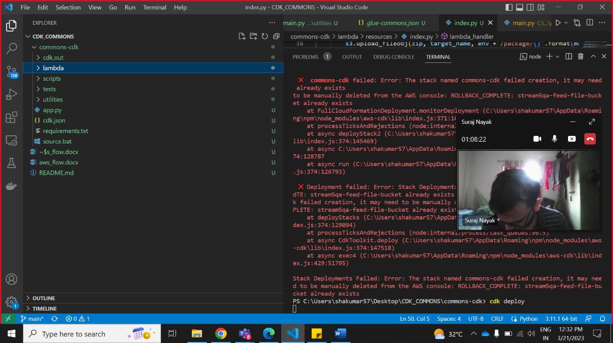

Here the scripts contains the script.sh where installation of mongo in ec2 is given and in utilities folder roles folder contain the roles used in aws services and build_parameter.json contains all the values for parameter store

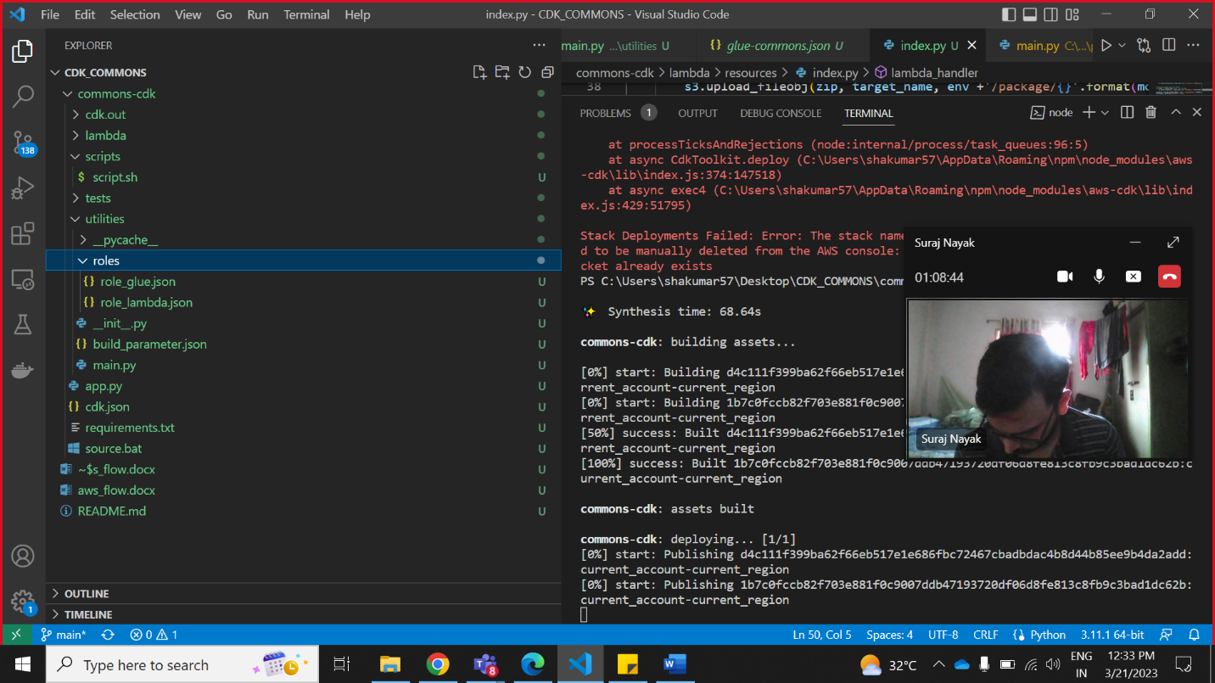

Here the lambda folder contains the resources folder which have config folder for validating eventkey and providing which database used.

It also contains glue_script.py for performing glue job operation and index.py is the code for lambda

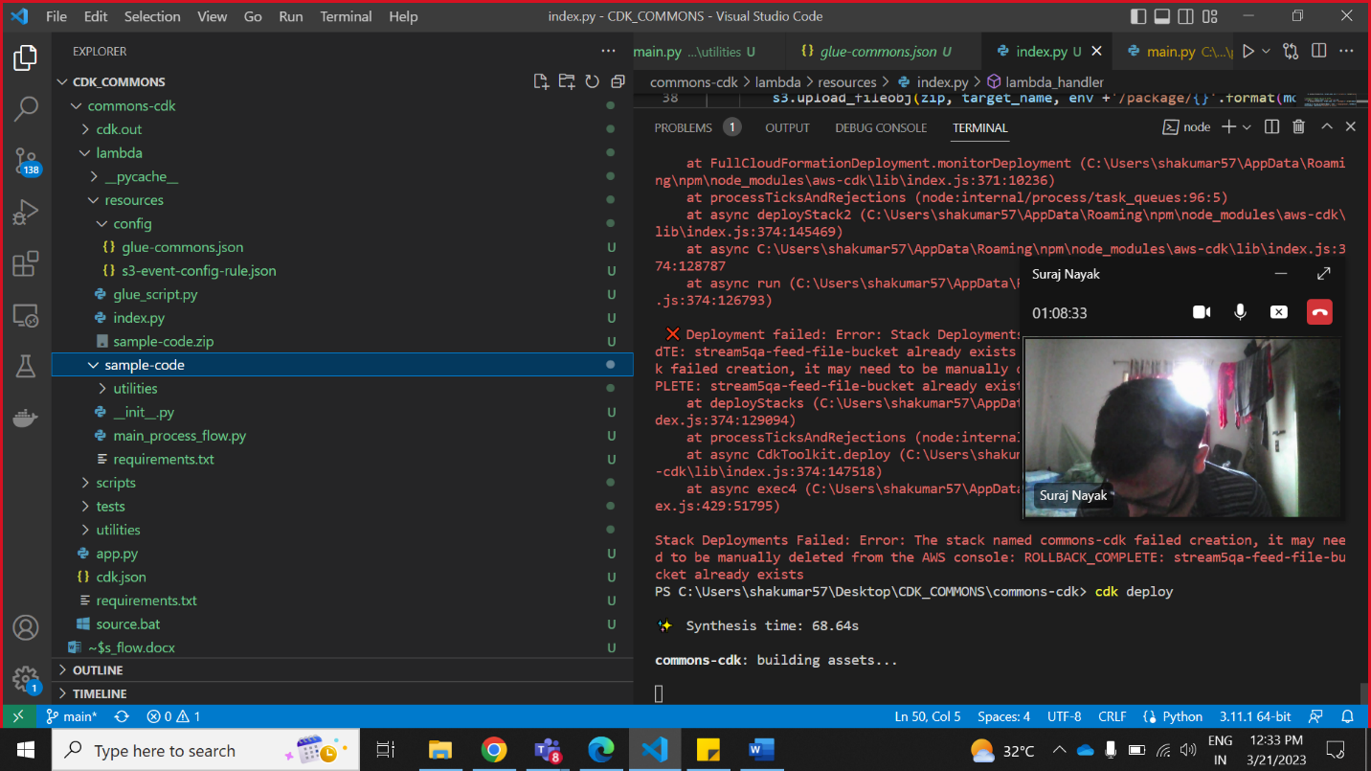

Creating S3 bucket

bucket_script=s3.Bucket(self,"ScriptBucket",bucket_name=env+"-"+script_bucket)

Create lambda function

s3_gluelambda = _lambda.Function(self,

                                         "lambda_func",

                                         function_name=env + "_etl_func",

                                         runtime=_lambda.Runtime.PYTHON_3_7,

                                         handler="index.lambda_handler",

                                         code=_lambda.InlineCode(s3func_code),

                                         timeout=Duration.seconds(60),

                                         environment=dict(

                                             BUCKET=bucket_feed.bucket_name),

                                         role=lambda_job_role

                                         )

Put data in lamda

try:

            with open("serverless_stacks/lambda_src/s3togluefunc.py", mode="r") as f:

                s3func_code = f.read()

        except OSError:

            print("Unable to Read")

IN the s3togluefunct.py the lambda code is present

Create trigger to lambda through s3

 bucket.add_object_created_notification(

            notify.LambdaDestination(s3_gluelambda)

        )

Create glue job

glue_job = _glue.CfnJob(self,'demoGlueJob',role=glue_job_role.role_name,glue_version="2.0",

name=env+"_demoGlueJob",max_retries=0,no_of_workers=10,worker_type="G.1X",

default_arguments={'--extra-py-files': "s3://"+bucket_script.bucket_name+"/commons/pace-glue-commons.zip"},

command=_glue.CfnJob.JobCommandProperty(name='glueetl',

python_version=os.getenv('PYTHON_VERSION',"3"),

script_location=f"s3://"+bucket_script.bucket_name+"/glue_script.py"))

Adding iam role to lambda

with open(roles[0], mode="r") as f:

            lambda_policy = json.load(f)

        poli1 = list(lambda_policy["Action"])

        rsc1 = list(lambda_policy["Resource"])

        policy_statement1 = iam.PolicyStatement(actions=poli1, resources=rsc1)

        lambda_job_role = iam.Role(

            self,

            env+'-lambda-job-role',

            assumed_by=iam.ServicePrincipal('lambda.amazonaws.com'))

        lambda_job_role.add_to_policy(policy_statement1)

Adding iam role to glue

with open(roles[1], mode="r") as f:

            glue_policy = json.load(f)

        policy = list(glue_policy["Action"])

        rsc = list(glue_policy["Resource"])

        policy_statement = iam.PolicyStatement(

            actions=policy,

            resources=rsc)

        glue_job_role = iam.Role(self,

                                 f'{env}-glue-job-role',

                                 assumed_by=iam.ServicePrincipal('glue.amazonaws.com'))

        glue_job_role.add_to_policy(policy_statement)

VPC

ETL_VPC = ec2.Vpc(self, "ETLVpc", max_azs=3)

SECURITY GROUPS

        ETL_SG = ec2.SecurityGroup(self, 'web-server-sg',

                                   vpc=ETL_VPC,

                                   allow_all_outbound=True,

                                   description='security group for a web server'

                                   )

ADDING INBOUND PERMISSIONS

ETL_SG.add_ingress_rule(

            ec2.Peer.any_ipv4(),

            ec2.Port.tcp(22),

            description='allow SSH access from anywhere',

        )

MACHINE IMAGE

amz_linux_ami = ec2.MachineImage.latest_amazon_linux(

            generation=ec2.AmazonLinuxGeneration.AMAZON_LINUX_2,

            edition=ec2.AmazonLinuxEdition.STANDARD,

            storage=ec2.AmazonLinuxStorage.EBS,

            virtualization=ec2.AmazonLinuxVirt.HVM

        )

KEY PAIR

cfn_key_pair = ec2.CfnKeyPair(self, "MyCfnKeyPair",

                                      key_name=env + "_etl_key"

                                      )

EC2 INSTANCE LAUNCH

web_server = ec2.Instance(

                self,

                "myInstance1",

                instance_type=ec2.InstanceType(

                    instance_type_identifier="t2.micro"),

                instance_name=env + "_etl_instance",

                machine_image=amz_linux_ami,

                vpc=ETL_VPC,

                security_group=ETL_SG,

                key_name=env + "_etl_key",

                vpc_subnets=ec2.SubnetSelection(

                    subnet_type=ec2.SubnetType.PUBLIC

                ),

                user_data=ec2.UserData.custom(user_data)

            )

Points to remember For the use of User data while launching: -

1. #!/bin/bash- is mandatory for automation
2. Don’t use sudo because these are executed in root.
3. Use -y to avoid user interference
4. As it is executed in root we can’t find the user data execution in non-root site as we have to enter to the root by cmd- “sudo -i” then the execution can be find.
5. Open vi editor and write data

echo"data needed to write"> /etc/yum.repos.d/mongodb-org-6.0.repo

PARAMETER STORE

 publicIPParam = ssm.StringParameter(self, 'ec2publicip',

 parameter_name='/'+env + '/myapp/ec2cdk',

 string_value=web_server.instance_public_ip,

 description='this is used to get the public ip of ec2',

 type=ssm.ParameterType.STRING,

 tier=ssm.ParameterTier.STANDARD )

CALLING PARAMETER STORE

parameter = ssm.get_parameter(Name='/'+env+'/myapp/gluejob',WithDecryption=True)

glueJobName= parameter ['Parameter']['Value']

IAM ROLE FILE FORMAT

{

    "Effect": "Allow",

    "Action": [],

    "Resource": [],

}

LOCAL SETUP FILE

[

    {

        "ParameterKey": "env",

        "ParameterValue": "stream5qa"

    }

]

SETUP FUNCTION

def read_setup_file():

->local setup file has parameter key and value mentioned.

->the file is read by read setup function.

->it loads all the data in list and separately send to the main file

ADD GITIGNORE FILE

->touch .gitignore

->inside that file add the files u need to ignore and then push the code again

->If u need to ignore a file add file.extension and if directory then add dir/ or if a extension then *.extension

IMPLEMENTING PYTHON LIB PATH

🡪 This code used to add the python lib path through cdk in aws glue

default_arguments={'--extra-py-files': “give the s3 bucket location of your file”}

example:-default_arguments={'--extra-py-files': "s3://"+bucket_script.bucket_name+"/commons/pace-glue-commons.zip"}

🡪 Import the .py file to be used inside the glue_script.py

🡪 Call the function you want to implement inside the .py file

🡪 If your library only consists of a single Python module in one .py file, you do not need to place it in a .zip file.

ADD FILES TO A FOLDER IN S3 BUCKET

with open("path of file to be uploaded", "rb") as file:

     client.upload_fileobj(file,bucket_name,file_name)

if u need to create directory then in the file_name then add the path and then the file_name

example: '/folders/{}'.format("file_name"))

HOW TO AUTOMATICALLY ZIP A FOLDER

shutil.make_archive("output_file_name","extension","input_file_name")

**docker inspect --format '{{ .NetworkSettings.IPAddress }}' mongodb**

## pip install -U -r requirements.txt

**CREATE GLUEJOB, ADD PYTHON LIB PATH & SCRIPT LOCATION**

**IAM ROLES,CREATE POLICY, ASSIGNING ACTIONS & RESOURCES**

**CREATE GLUE JOB ROLE & ASSIGN POLICY**

**CREATE EC2 WITH CUSTOM USER DATA(CONTAINS COMMANDS TO INSTALL MONGO**

**CREATE VPC,SECURITY GROUPS WITH REQUIRED ACCESS, AMI IMAGE & KEY PAIR**

**CREATE DYNAMO**

**TABLE**

**CREATE BUCKET**

**CREATE DATABASE**

## from pip._internal import main

## main(['install','pymongo','--target','/tmp'])

## sys.path.insert(0,'/tmp')

## **docker inspect --format '{{ .NetworkSettings.IPAddress }}' mongodb**