A ) Write git commands to

1. Clone a remote repo
2. Create a new branch dev
3. Modify a file ,commit changes
4. Merge them into main
5. Push the merged main branch to the remote repository
6. Create one folder.
7. Open Git Bash and go to that folder.

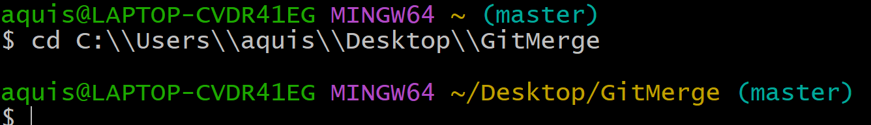

1. Initialize git



1. Check status

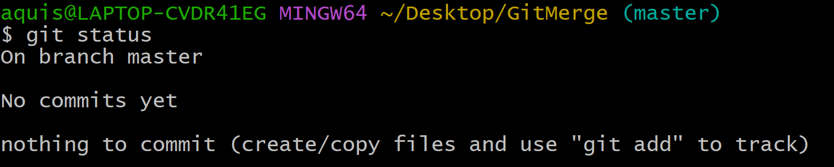

1. Create on text file using touch command or vim editor.

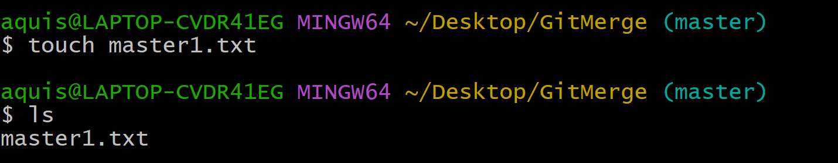

1. Check status

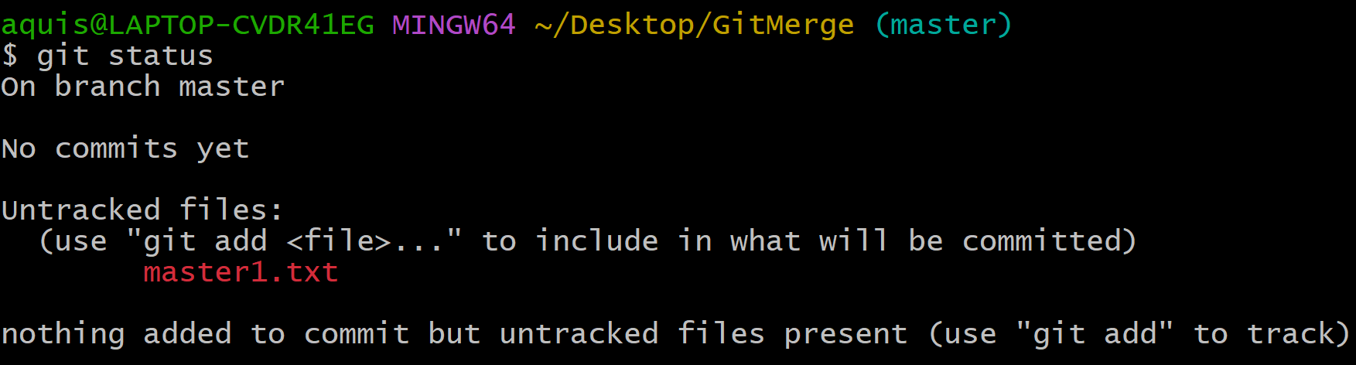

1. Go to vim and add some content to file.

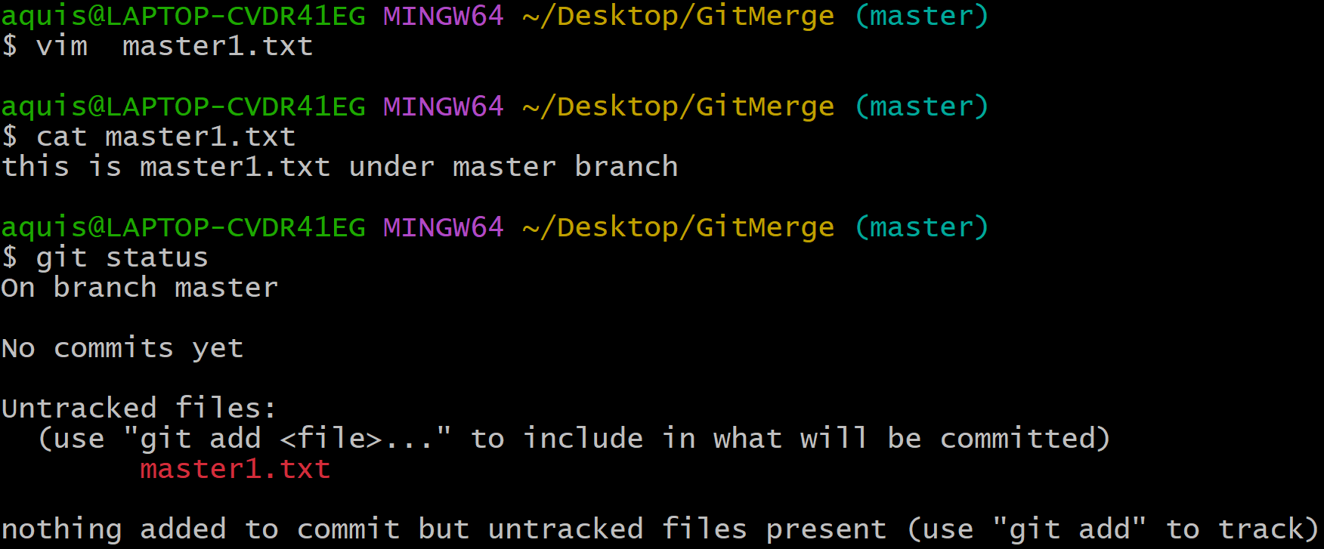

1. Convert the file from modified state to staged state and check the status.

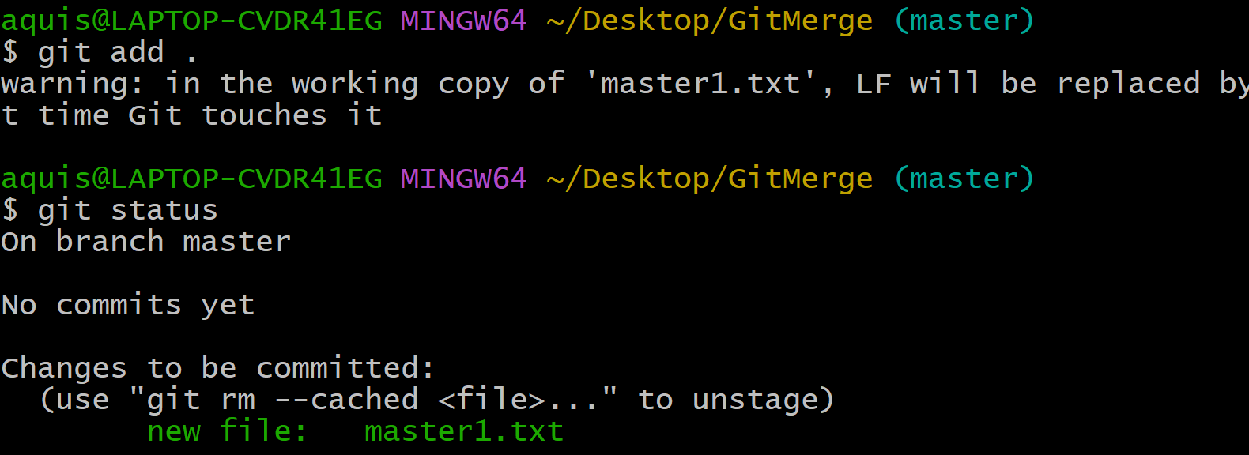

1. Perform commit operation.

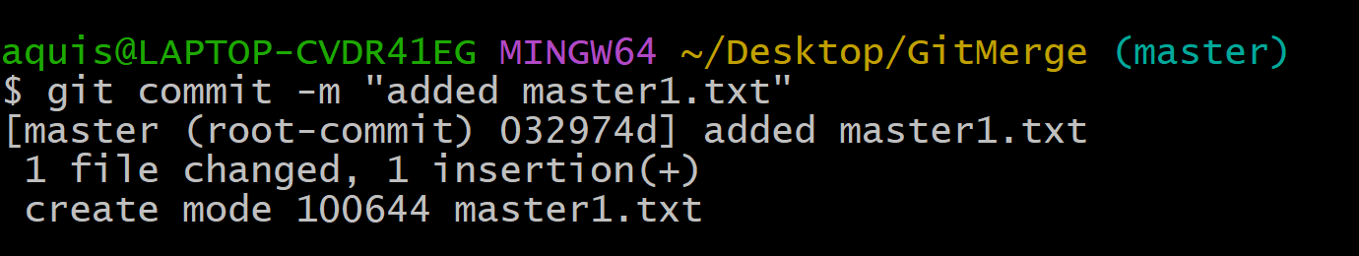

1. Now, Create new branch say “hiray”.

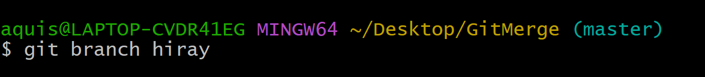

1. Switch to hiray branch by using a command 🡪 checkout

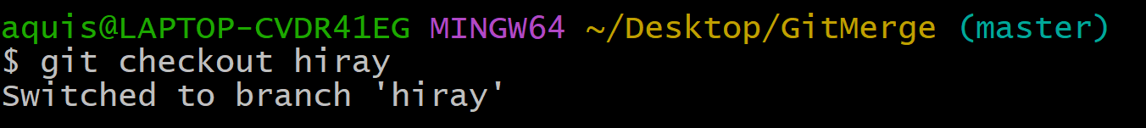

1. Check status

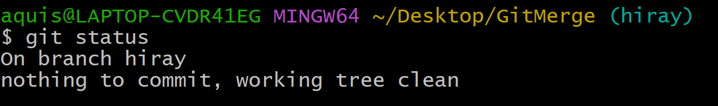

1. Create new text file as “hiray.txt” and check status.

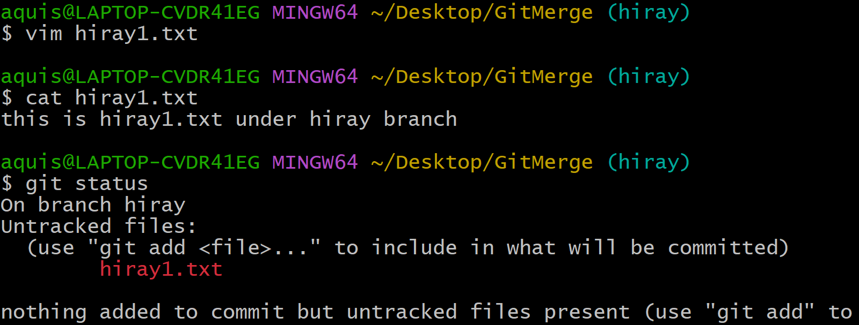

* Showing untracked file.

1. Add the file, perform commit operation and check the status.

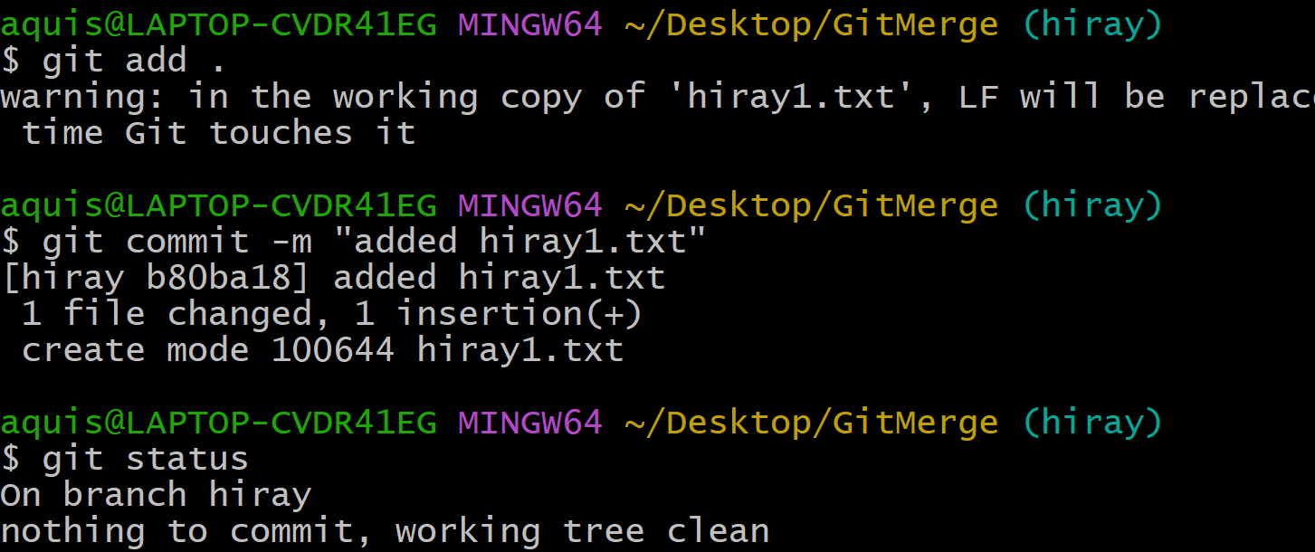

* You can see both files (master1.txt and hiray1.txt ) in GitMerge folder.

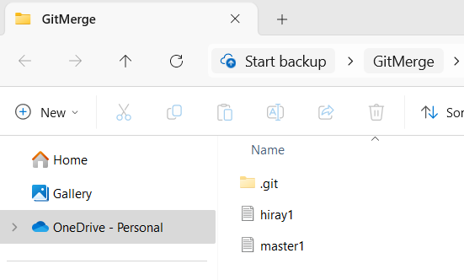

1. Check log 🡪 (it will show two commits)

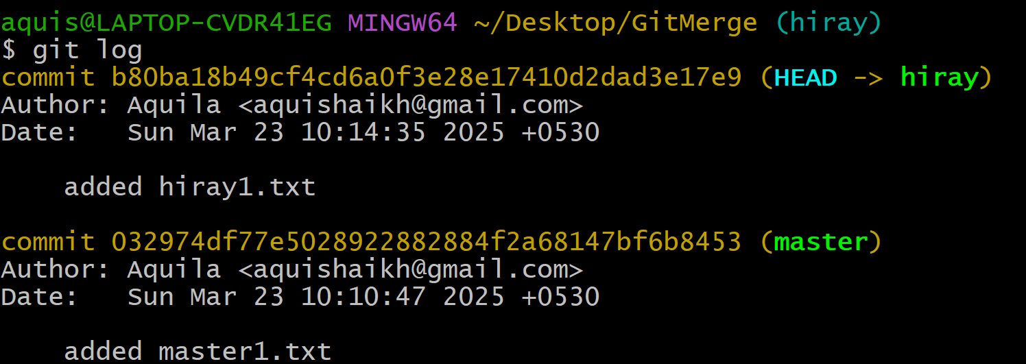

1. Switch to Master branch.

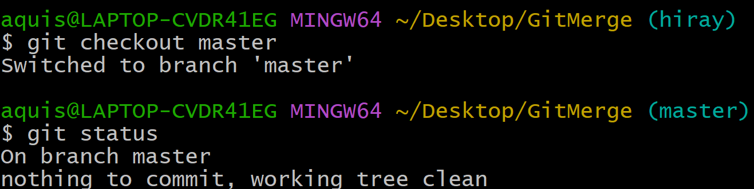

1. If you switch to master branch, you won’t be able to see “hiray1.txt” in the folder.

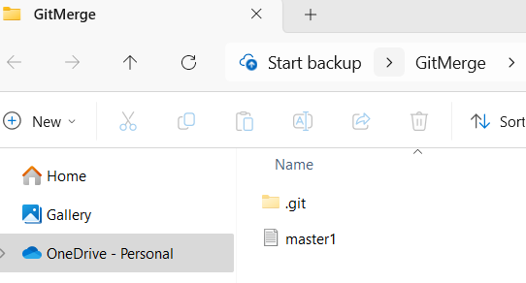

1. Let’s create one more text file at master branch

* Perform add and commit and check log (you will be able to see two commits at master branch)

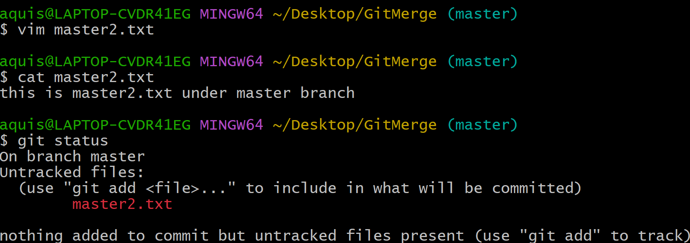

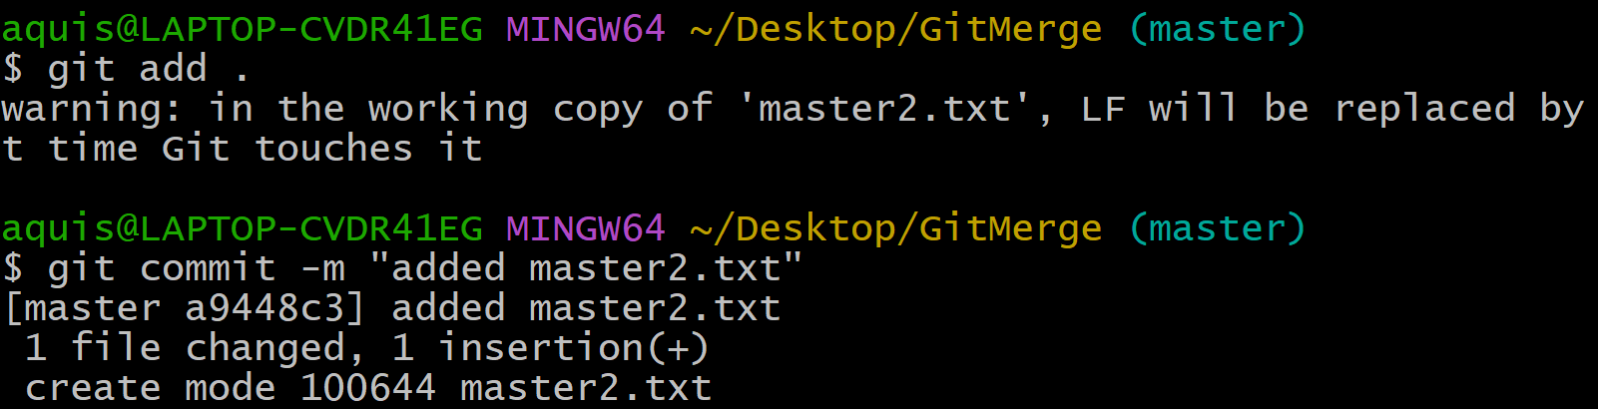

1. Suppose at this point the changes have happened at master branch are relevant to hiray branch
2. And we want to get all changes from master branch to hiray branch.
3. **There are two options: Git merge and Git rebase**
4. Checkout to hiray branch and perform merge operation.

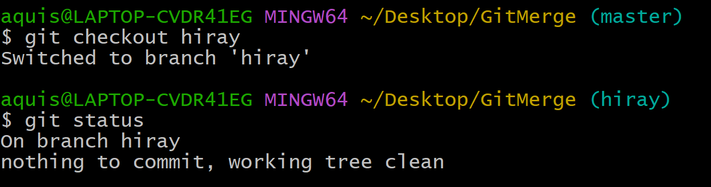

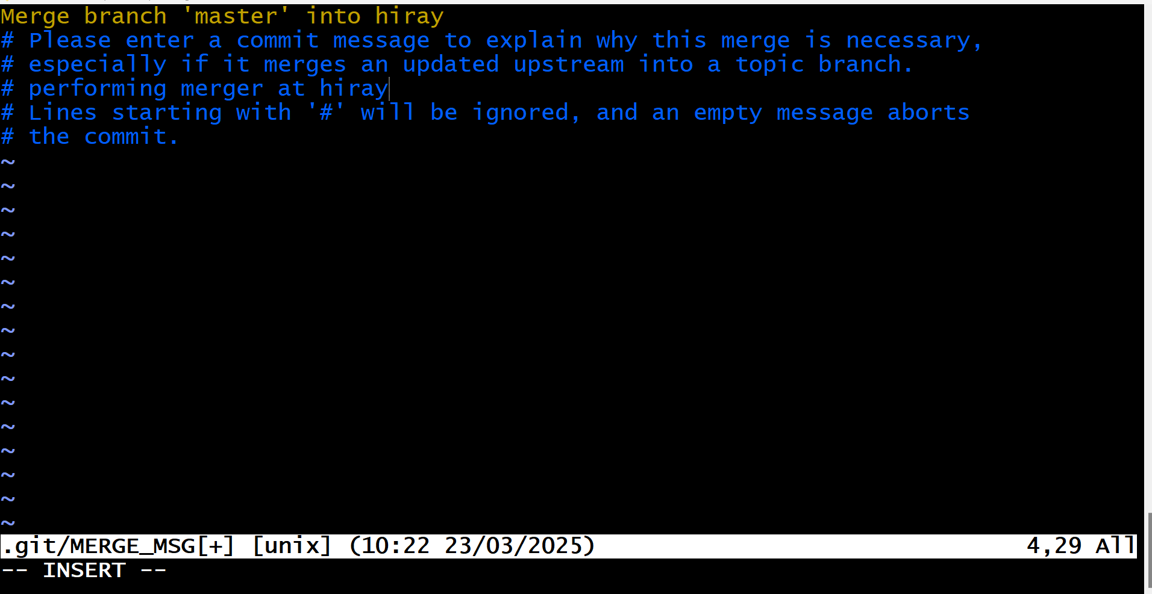

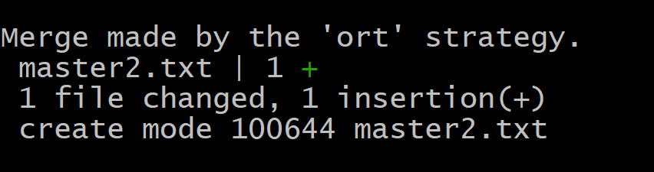

1. Check log

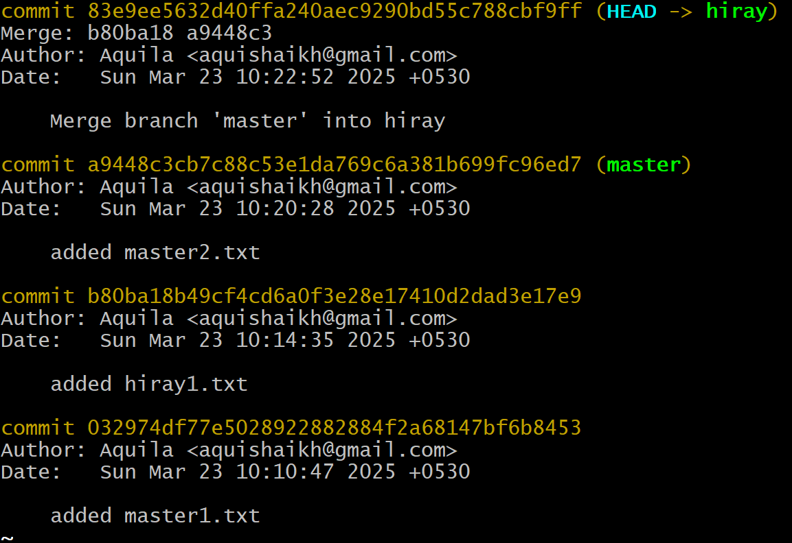

1. Check GitMerge folder🡪 you can see all 3 files.

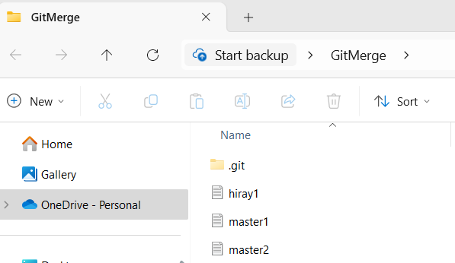

B) Write a simple application. build and share the image to Docker hub.

creating hello world image

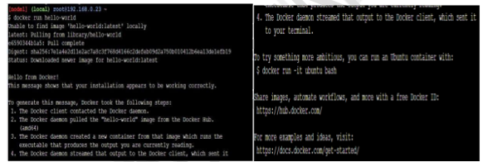

docker container ls

lists all running Docker containers on your system.



docker container ls –a

lists all Docker containers on your system — both running and stopped.

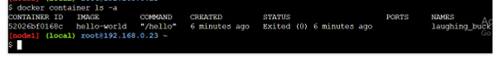

docker container start laughing_buck

This command starts an already created and exited container named laughing_buck.

Docker confirms it by echoing back the container name.

**docker images**

