Title:
Retail Sales Analysis & Reporting Dashboard

Submitted By:
Suraj Aggarwal

Course Name:
Data Analytics

Tools Used:
- Excel
- Python (Google Colab)
- Power BI

Date:
28/07/2026

Table of Contents:
1. Introduction
2. Dataset Overview
3. Data Cleaning
4. Data Analysis
5. Python Analysis
6. Power BI Dashboard
7. Key Insights
8. Conclusion
9. Tools And Technologies
10. Future Improvements

1. Introduction
In today’s data-driven world, businesses rely heavily on data analysis to make informed decisions. This project focuses on analysing a retail dataset to understand sales performance, profitability, and customer trends.
The main objective of this project is to extract meaningful insights from the data and present them through an interactive dashboard. By using tools like Excel, Python, and Power BI, the project demonstrates how raw data can be transformed into actionable insights that help improve business performance.

2. Dataset Overview
The dataset used in this project is the Superstore Sales Dataset, which contains transactional data of a retail company.
- Total Rows: 9994
- Total Columns: 21
Key Columns:
- Order ID, Order Date, Ship Date
- Customer Name, Segment
- Country, City, State, Region
- Product Category, Sub-Category
- Sales, Quantity, Discount, Profit, Profit Margin
Each row in the dataset represents a single product transaction within an order, meaning one order can have multiple rows.
This dataset provides a complete view of business operations including sales, profit, customer segments, and geographical performance.

3. Data Cleaning
Data cleaning is an essential step before analysis to ensure data accuracy and reliability.

Steps Performed:
- Checked for Missing Values:
No blank or missing values were found in the dataset.
- Checked for Duplicate Records:
Duplicate Order IDs were observed, but they represented different products within the same order. Therefore, they were valid and not removed.
- Data Type Verification:
Ensured that dates, numbers, and text fields were correctly formatted.
- Error Checking:
Verified that there were no inconsistencies or incorrect entries.
After cleaning, the dataset was confirmed to be accurate and ready for further analysis.
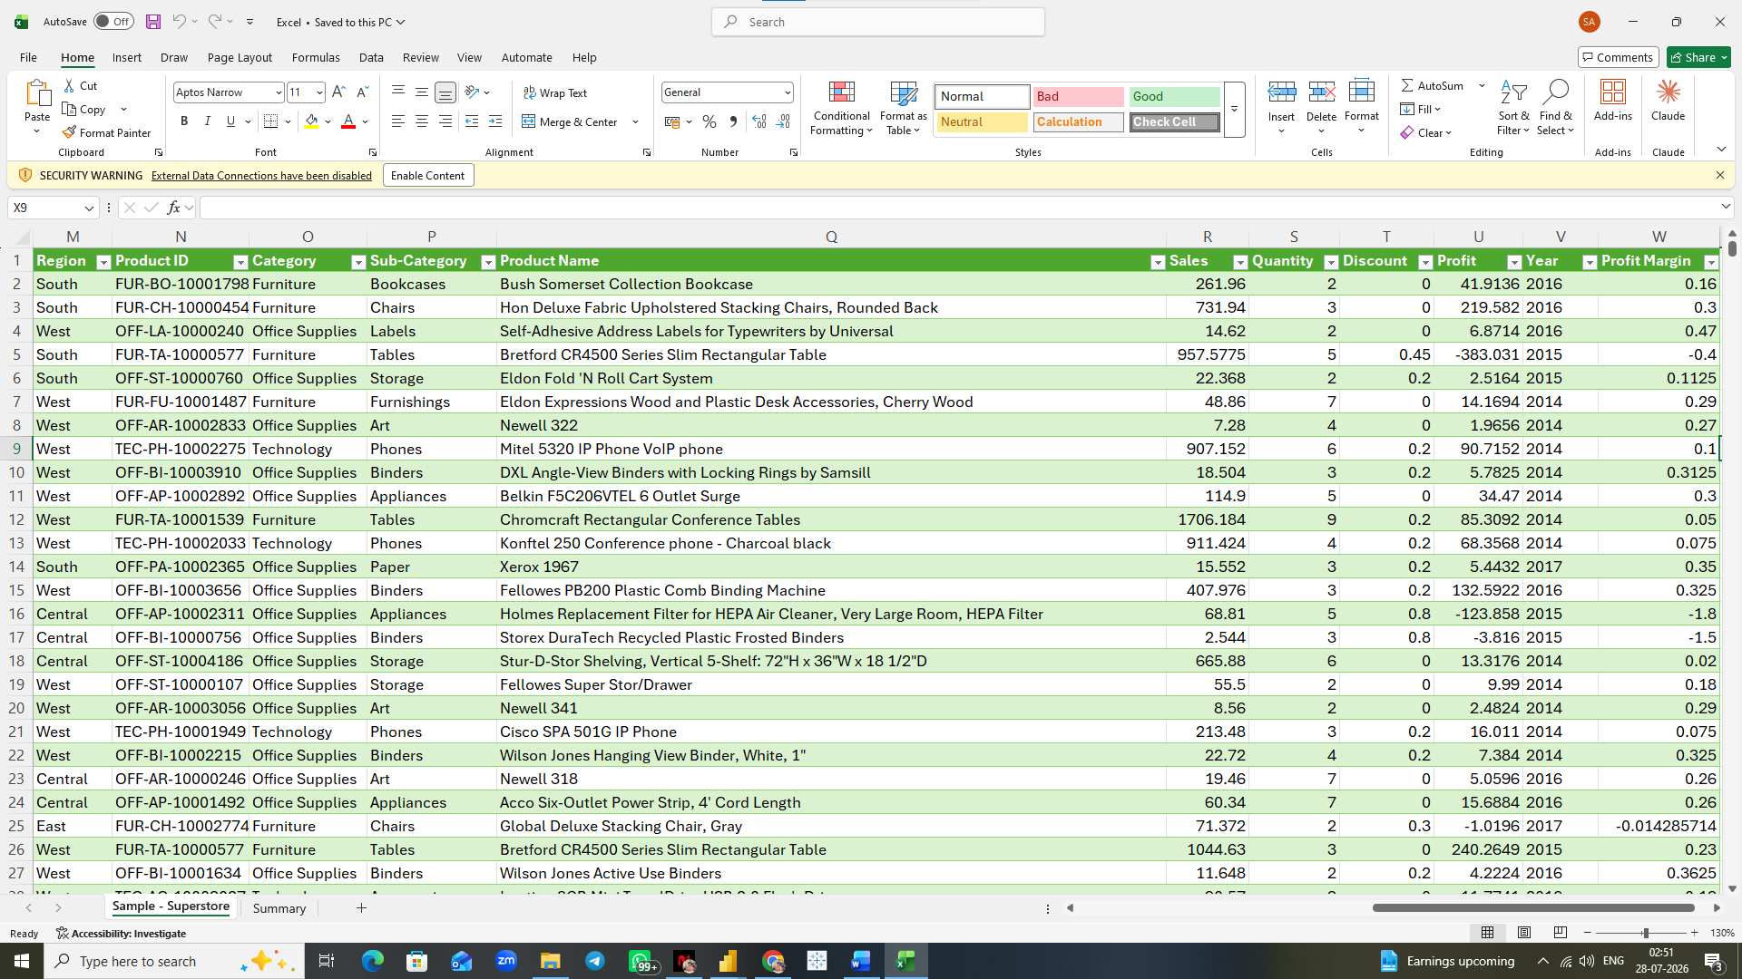
4. Data Analysis
Pivot tables were used to summarise and analyse the data efficiently.
Metrics Created:
- Total Sales
- Total Profit
- Total Orders
- Average Sales
- Average Profit
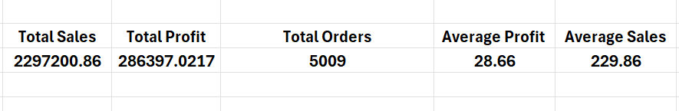
Analysis Performed:
- Region-wise Performance:
Analysed which region generates the highest sales and profit.
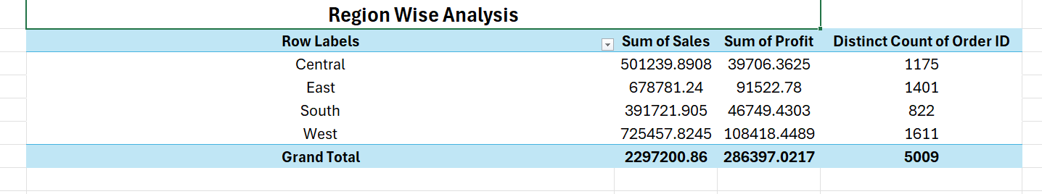

- Category-wise Analysis:
Compared performance across different product categories.
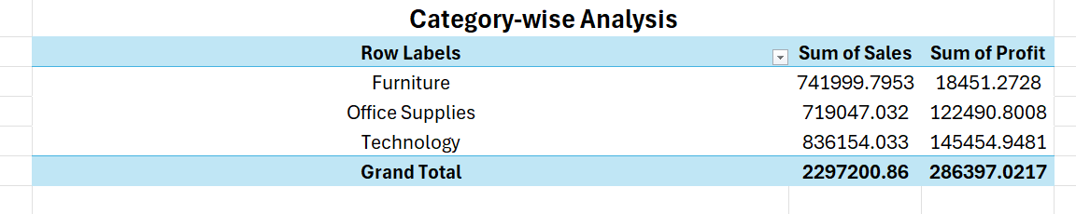

- Time-based Trends:
Studied monthly and yearly sales trends.
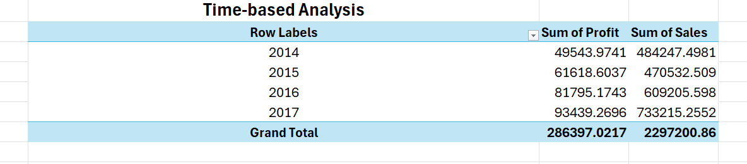

Pivot tables helped in quickly identifying patterns and summarising large data into meaningful insights.

5. Python Analysis
Python was used in this project to perform automated data analysis and generate meaningful insights from the Superstore sales dataset. Python helped in processing large amounts of data efficiently and reduced the dependency on manual calculations.
The analysis was performed using Google Colab with Python libraries such as Pandas, Matplotlib, and Seaborn.

Libraries Used
Pandas
Used for:
- Loading the dataset
- Data exploration
- Data cleaning
- Data transformation
- Performing calculations and aggregations

Matplotlib & Seaborn
Used for:
- Creating visualizations
- Understanding sales and profit patterns
- Representing analytical results graphically
Steps Performed Using Python
- Data Loading and Exploration
The dataset was imported into Python using Pandas. Initial exploration was performed to understand the structure of the dataset.
The following checks were performed:
- Displayed first few rows of data
- Checked number of rows and columns
- Verified column names
- Checked data types

II. Data Cleaning
Data quality checks were performed using Python:
- Checked for missing values using null value analysis
- Verified duplicate records
- Converted date columns into proper date format
- Ensured numerical columns such as Sales, Quantity, and Profit were correctly formatted
The cleaned dataset was then used for further analysis.

III. KPI Calculation
Python was used to calculate important business metrics:
- Total Sales
- Total Profit
- Total Orders
- Average Sales
- Average Profit
These metrics provided an overall understanding of business performance.
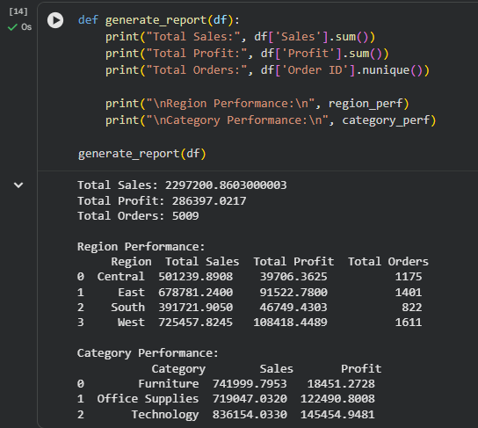

IV. Region-wise Performance Analysis
A group-by analysis was performed to compare sales and profit across different regions.
This analysis helped identify:
- Highest performing regions
- Profit contribution by region
- Regional sales patterns
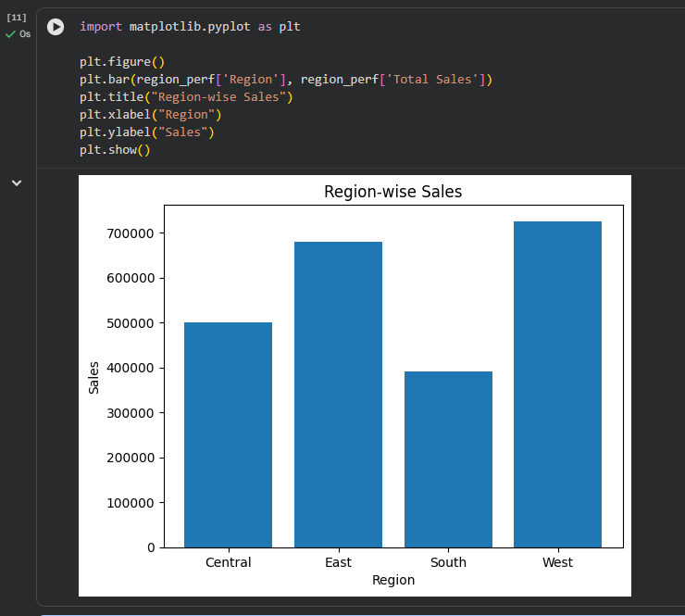

V. Category and Segment Analysis
The dataset was analysed based on:
- Product Category
- Customer Segment
This helped understand:
- Which categories generate higher revenue
- Which customer groups contribute more sales
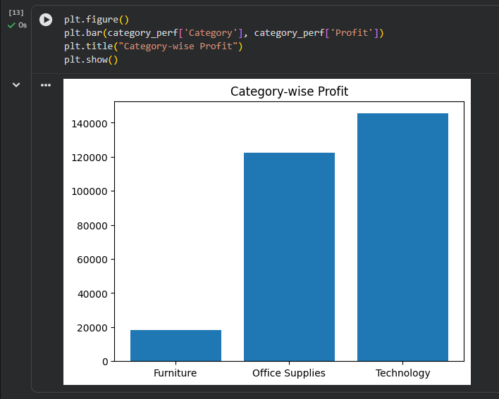

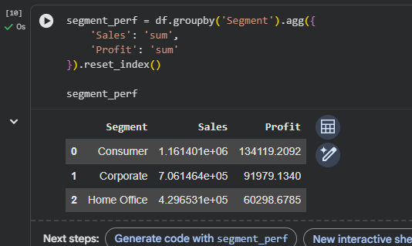
VI. Data Visualization
Charts were created using Python visualization libraries to represent:
- Sales performance by region
- Sales trends over time
- Category-wise comparison
- Profit analysis
These visualizations helped in identifying patterns and trends easily.
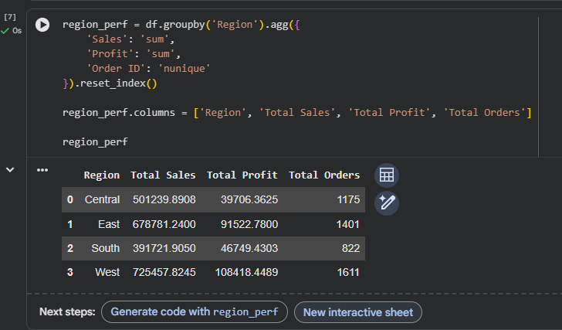

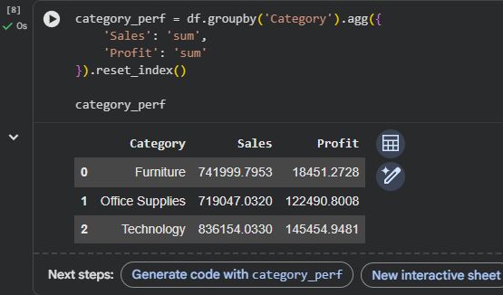

Python Analysis Outcome
The Python analysis provided automated calculations and visual insights from the dataset. The processed data was then exported and used in Power BI to create an interactive dashboard.

Python was used to automate data processing, perform analytical calculations, and generate visual insights. It improved efficiency and helped validate the findings obtained through Excel analysis.

6. Power BI Dashboard
An interactive dashboard was created in Power BI to present the analysis visually.
Dashboard Title:
Retail Sales Analysis & Reporting Dashboard

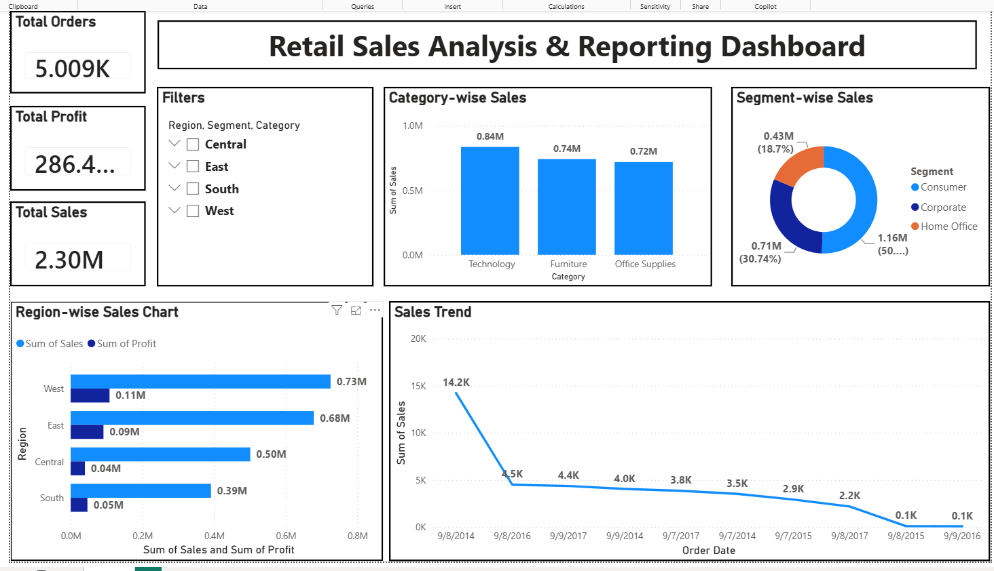

Key Performance Indicators (KPIs):
- Total Sales
- Total Profit
- Total Orders
- Average Sales

Visualizations Used:
- Line Chart:
Shows sales trend over time
- Bar Chart:
Displays sales by region
- Column Chart:
Represents sales by category
- Cards:
Highlights key metrics
- Slicer:
Allows filtering by Region, Segment, and Category

Features of Dashboard:
- Interactive filtering
- Clean and structured layout
- Easy-to-understand visuals
- Business-focused insights
The dashboard helps users quickly understand performance and make data-driven decisions.

7. Key Insights
- The West region generates the highest sales, indicating strong market demand.
- Some product categories have high sales but low profit, suggesting high discounting or costs.
- Discounts have a negative impact on profit, especially in certain categories.
- Sales show seasonal trends, with fluctuations over time.
- The Technology category is the most profitable among all categories.
These insights can help businesses optimise pricing, inventory, and regional strategies.

8. Conclusion
This project successfully analysed retail sales data using Excel, Python, and Power BI. It demonstrated how raw data can be cleaned, analysed, and transformed into meaningful insights.
The interactive dashboard provides a clear understanding of sales performance, profitability, and customer trends. This project highlights the importance of data analysis in making better business decisions.

9. Tools And Technologies
- Microsoft Excel
- Python (Google Colab)
- Power BI

10. Future Improvements
- Implement sales forecasting models
- Use SQL for data extraction and management
- Enhance dashboard with more advanced visuals
- Add customer segmentation analysis

