A Project Report On

PG HOSTEL MANAGEMENT SYSTEM

-: Submitted By :-

Mr. Suraj Aghav

**Acknowledgment**

I wish to express my sincere gratitude to God for his protection, providence, guidance and above all, for sustaining us.

I would like to express our special thanks of gratitude to our professor ‘Priti Mam’ who gave me the golden opportunity to do this wonderful **project** on the topic **‘PG Hostel Management System’** which also helped me in doing a lot of Research and gaining some precious.

**Index**

* **Introduction of Project**
* **Tools Used**
* **Input Output Screens**
* **Database Design**
* **Entity Relationship Diagram**

**Introduction Of Project**

The project, PG Hostel Management System is a desktop-based application that allows the PG owner to handle all PG activities online. Interactive GUI and the ability to manage various rooms, bed details, customers and their payment make this system very flexible and convenient. This application gives him the power and flexibility to manage the entire system from a single online system.

The Purpose of the whole process is to ease the daily or regular activities of the PG Hostel Management into an automatic computerized retrievable process. The daily activities includes the Room activities, Entering details of the new customer check in, To allocate a room as per the customer need and interest, Recording the checkout time and details, Releasing or Empty of room and to record the process in a computer system for future.

The application of the PG Hostel Management System bears the following functions to use by the Administrator:

* Add a new Room
* Add a new Customer
* Check room status
* Check all Customers details
* Update room status
* Check bed status and update
* Manage Customer (delete customer )

**Tools Used**

Software Requirements

* + Operating System : Windows 11
  + Programming Language : Java
  + Frontend : Java Swing
  + Backend : Java, MySQL ( Database )
  + IDE : intelliJ IDEA Community Edition
  + Version Control : GitHub

**Input Output Screens**

**1.Login Page**

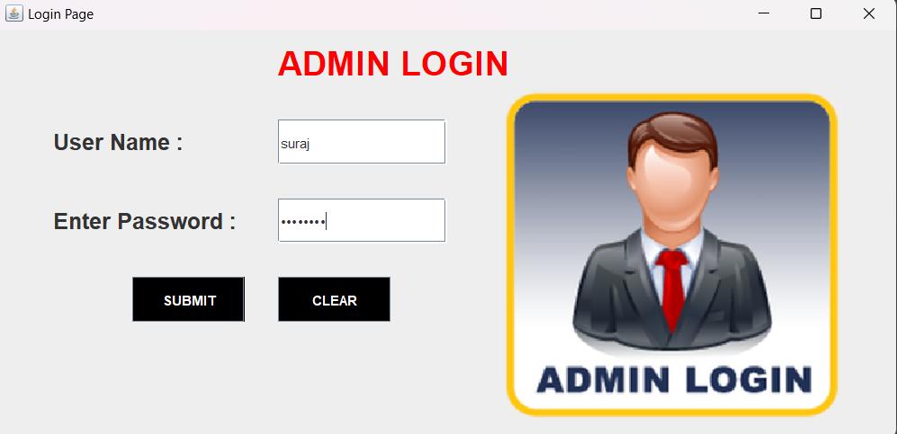

**2. Home Page**

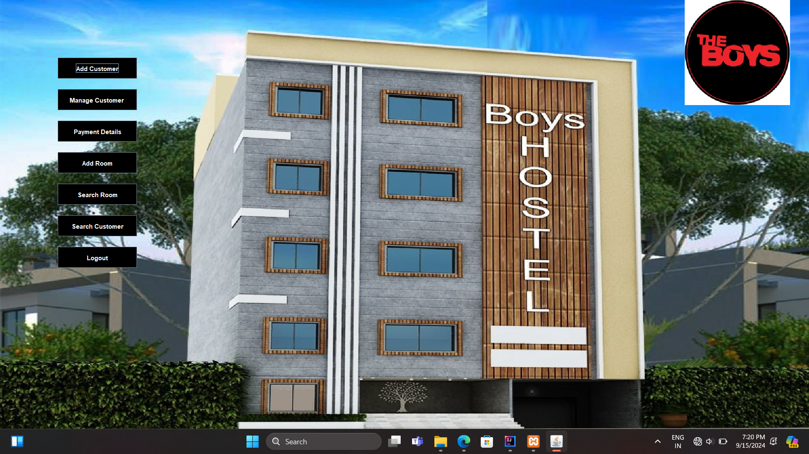

**3. Add Customer**

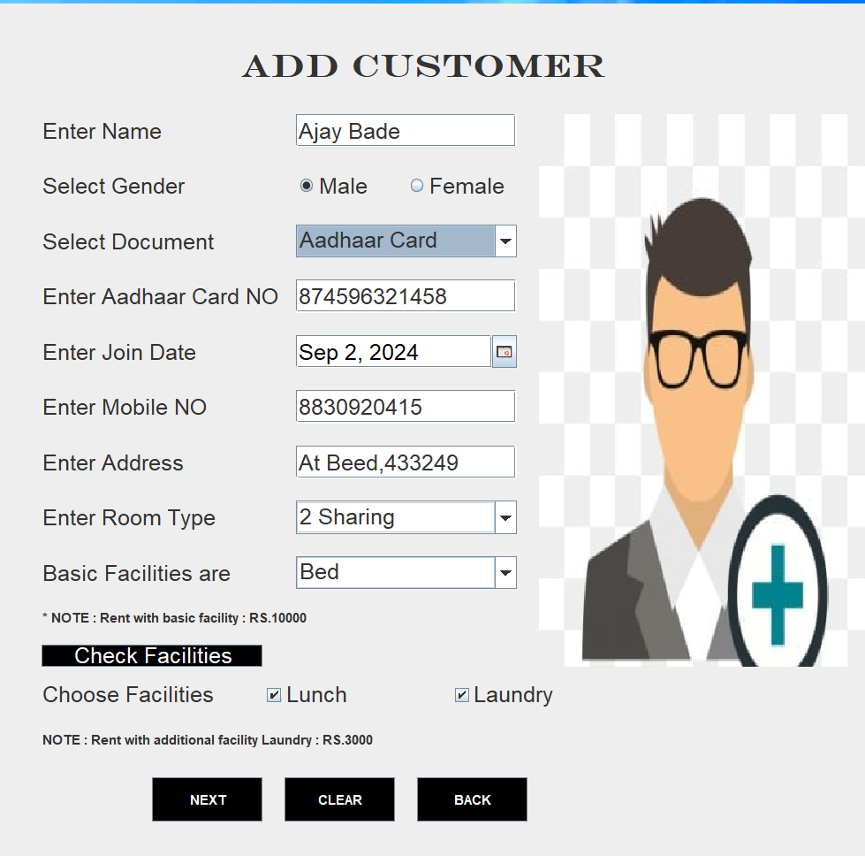

**4. Allocate Room**

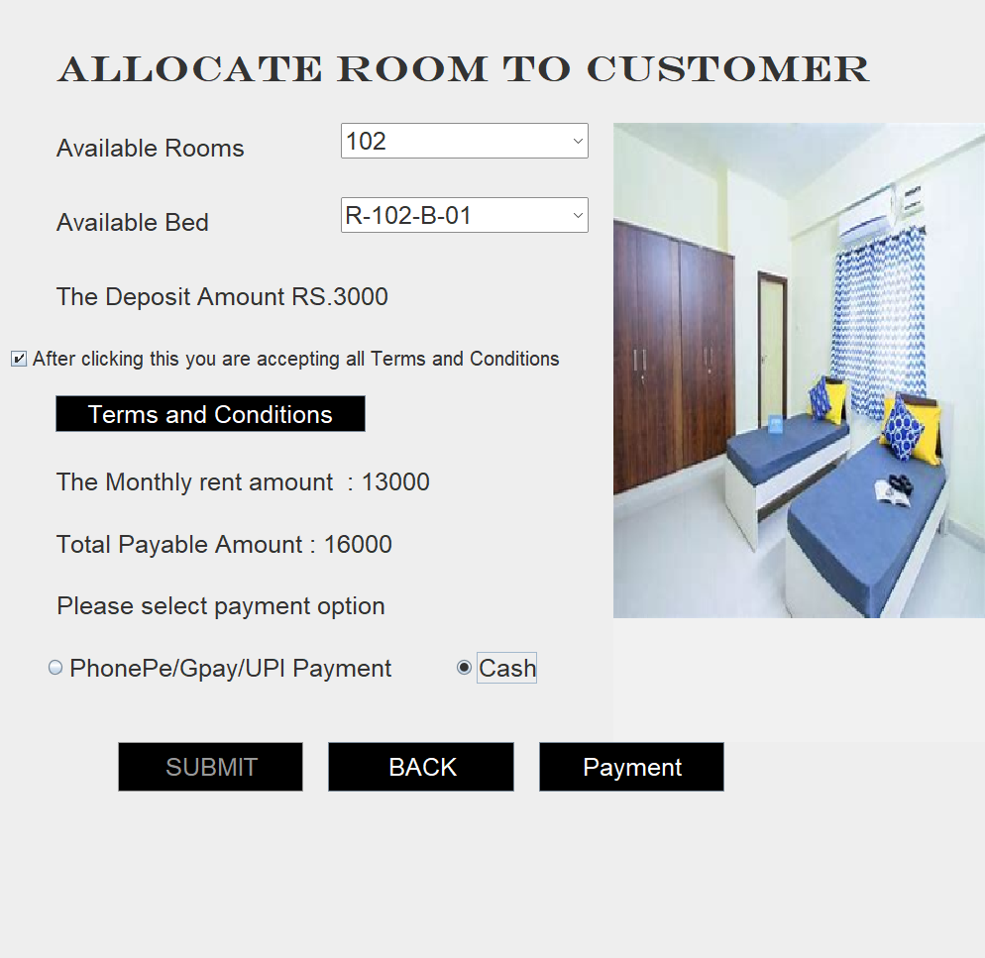

**5. Search Customer**

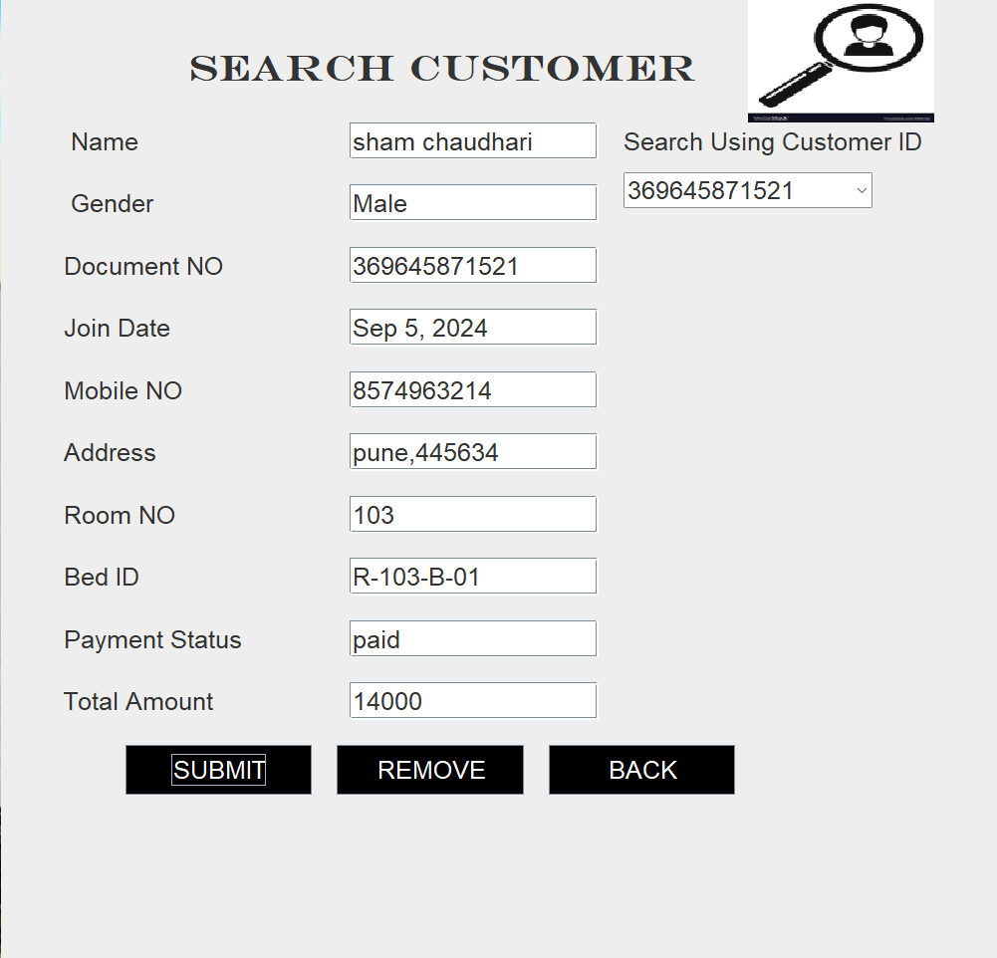

**6. Manage Customer (Delete Customer)**

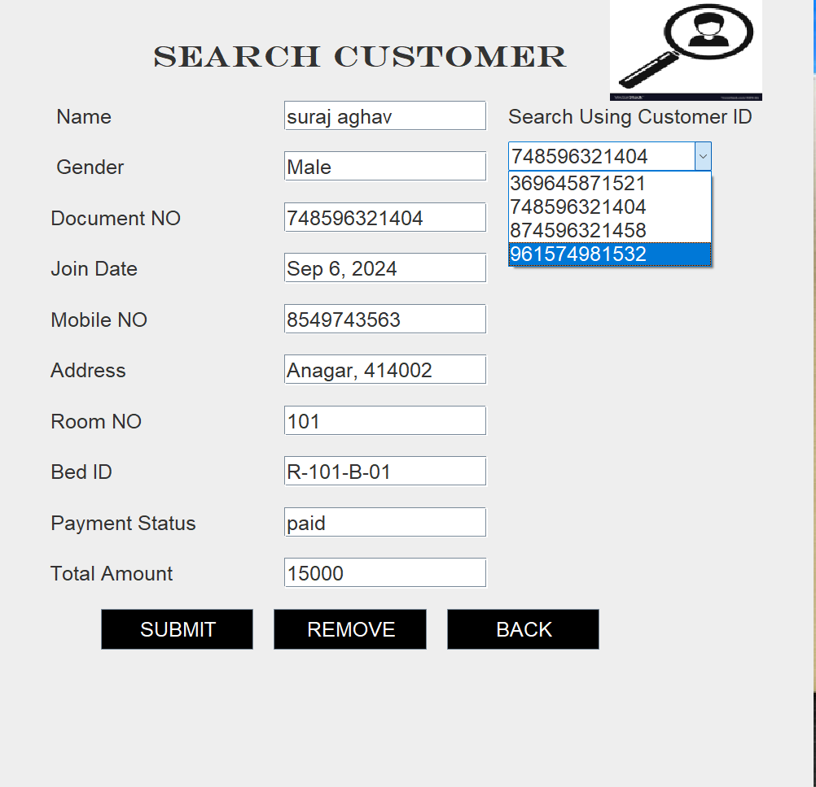

**Customer Deleted**

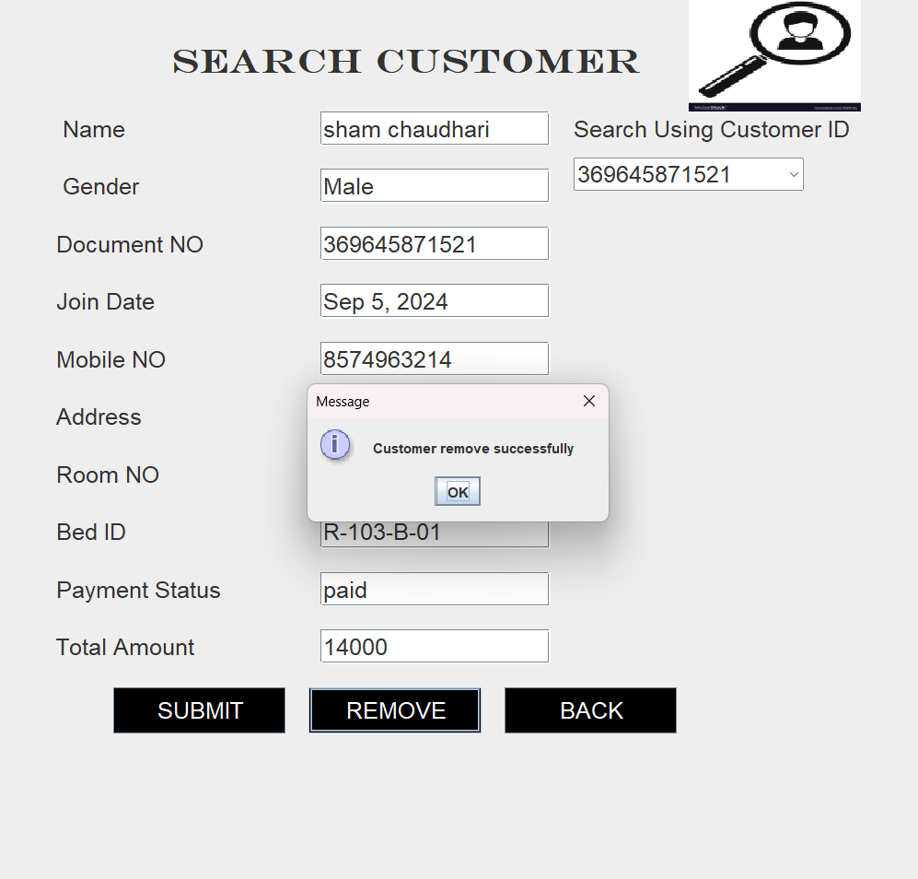

**7.Update Customer**

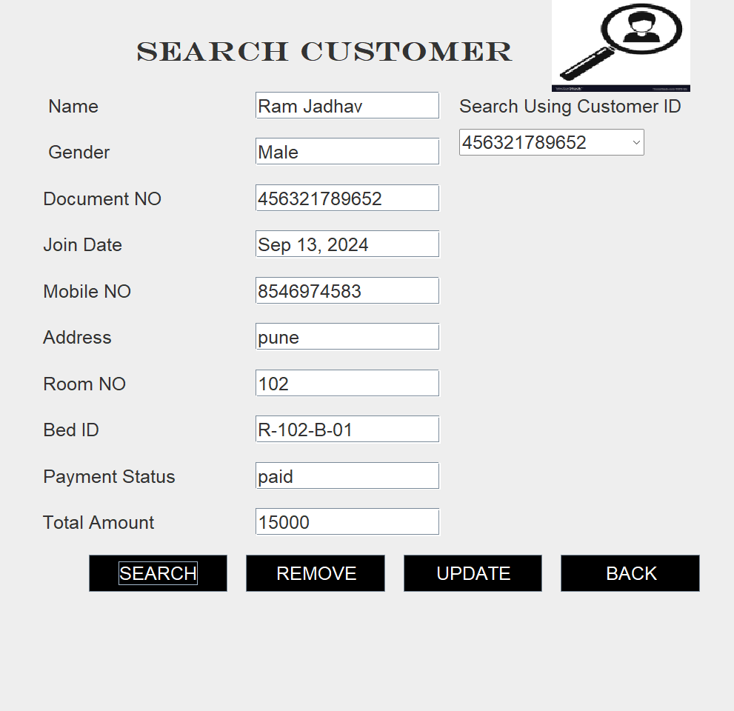

**Update Page**

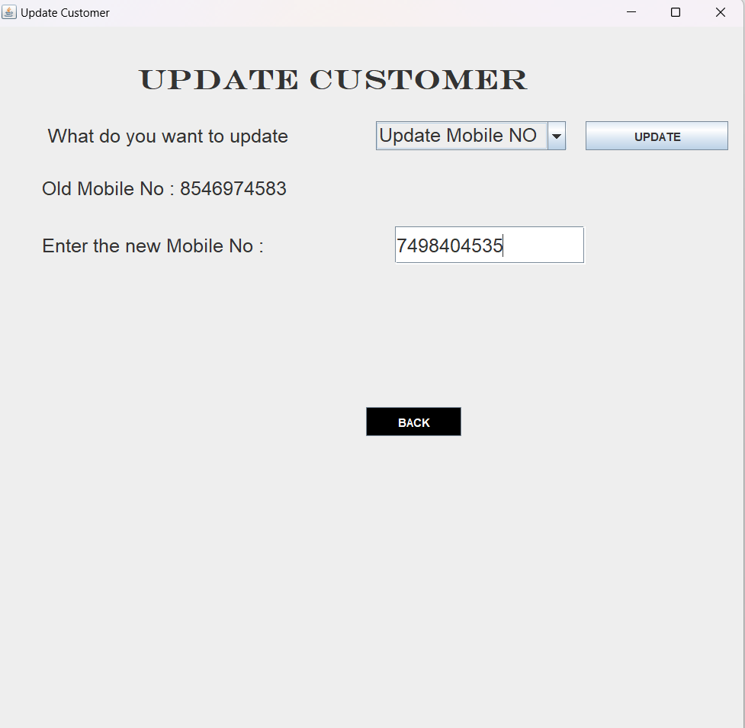

**Customer Updated Successfully**

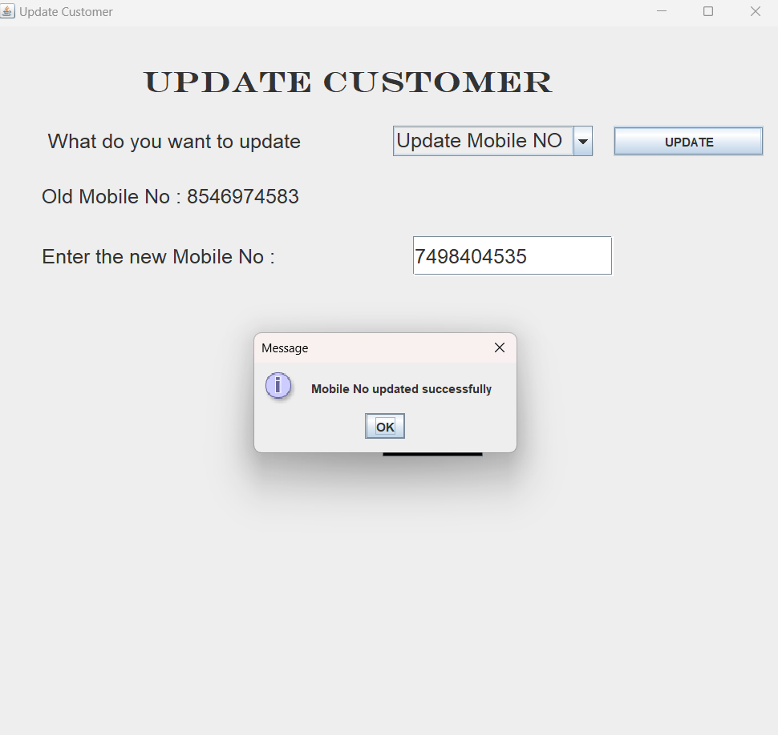

**8. Payment Details**

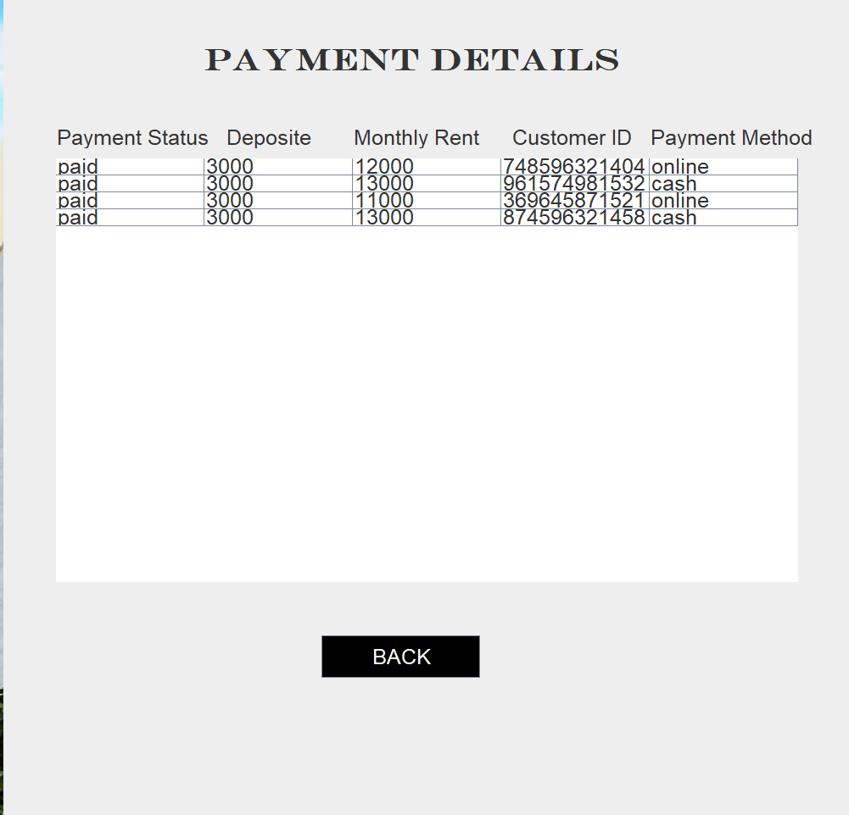

**9. Add Room OR Add Bed to The Room**

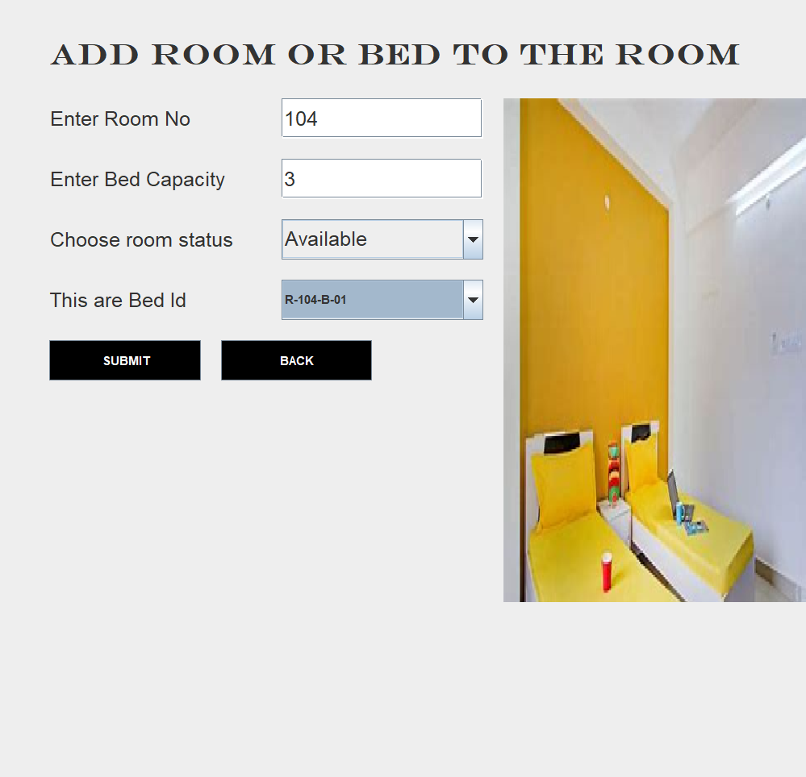

**Bed Inserted Successfully**

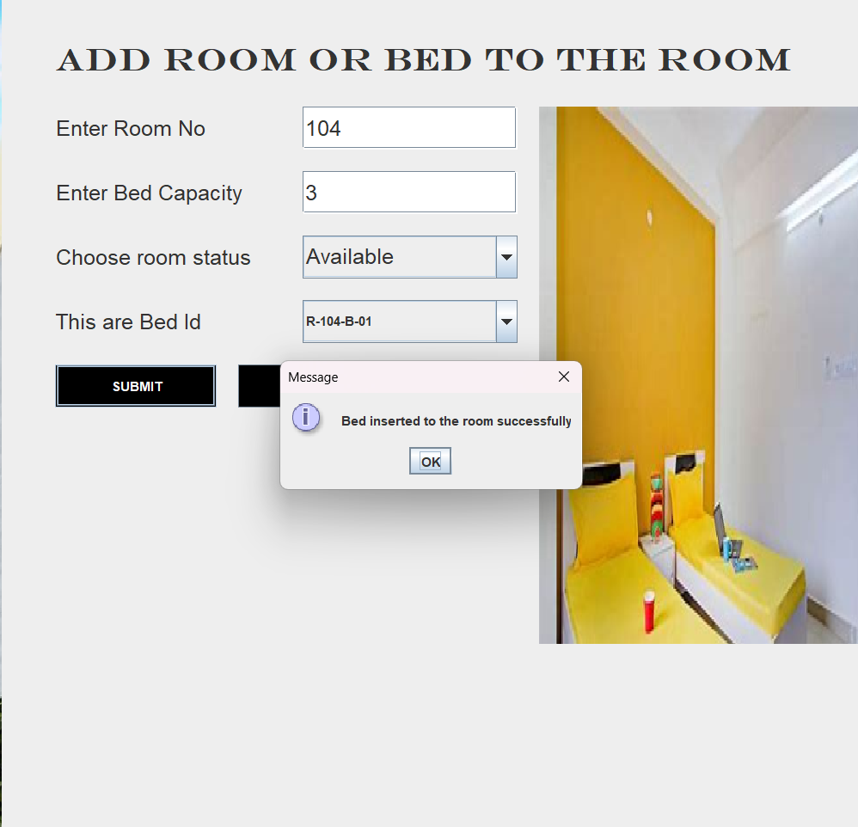

**10. Search Room**

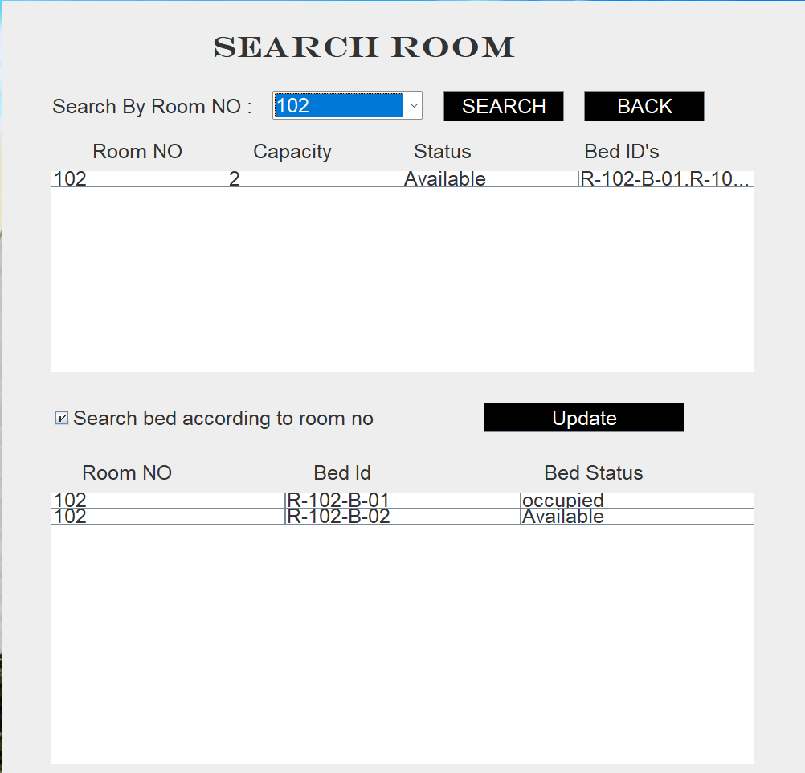

**ER Diagram**

customer

1

Admin

Register to PG

1

M

Allocate the Bed

1

Paid bill

Payment details

M

Allocate the room

Room

1

Bed

Has beds

|  |  |
| --- | --- |
| Customer | DataType |
| Customerid | Varchar(Primary) |
| Name | Varchar |
| Gender | Varchar |
| Doctype | Varchar |
| Dateofjoin | Varchar |
| Mobileno | Varchar |
| Address | Varchar |
| Facility | Varchar |
| Roomtype | varchar |
|  |  |

|  |  |
| --- | --- |
| Room | DataType |
| Roomno | Varchar(Primary) |
| Capacity | Varchar |
| Status | Varchar |
| Bedid | Varchar |

***DATABASE DESIGN***

|  |  |
| --- | --- |
| CustomerRoomDetail | DataType |
| Customerid | Varchar |
| Roomno | Varchar |
| Bedid | Varchar |
| Deposite | Varchar |
| MontyhlyRent | Varchar |
| Totalamount | Varchar |
| Paymentstatus | Varchar |

|  |  |
| --- | --- |
| Beddetail | DataType |
| Roomno | Varchar(foreign) |
| Bedid | varchar |
| Bedstatus | Varchar |

Roomno(foreign key)

Customerid (foreign key)

Customerid (foreign key)

|  |  |
| --- | --- |
| PaymentDetails | DataType |
| Paymentstatus | Varchar |
| Deposite | Varchar |
| Monthlyrent | Varchar |
| Customerid | Varchar(foreign) |
| Paymentmethod | Varchar |

Customerid (foreign key)

|  |  |
| --- | --- |
| Bed | DataType |
| Bedid | Varchar(primary) |
| Roomno | Varchar(foreign) |
| Customerid | Varchar(foreign) |
| Bedstatus | Varchar |

|  |  |
| --- | --- |
| RemoveCustomer | DataType |
| Customerid | Varchar(foreign) |
| Name | Varchar |
| Gender | Varchar |
| Mobileno | Varchar |
| Address | Varchar |
| Dateofjoin | Varchar |
| Dateofleave | varchar |