**PRDA – 04 Customer Segmentation Analysis**

Task:

1. How is the shopping distribution according to gender?
2. Which gender did we sell more products to?
3. Which gender generated more revenue?
4. Distribution of purchase categories relative to other columns?
5. How is the shopping distribution according to age?
6. Which age cat did we sell more products to?
7. Which age cat generated more revenue?
8. Distribution of purchase categories relative to other columns?
9. Does the payment method have a relation with other columns?
10. How is the distribution of the payment method?
11. Visualize the data using Tableau /PowerBI and derive insights and give your inputs/suggestions to the company.

About Dataset:

This dataset contains shopping information from 10 different shopping malls between 2021 and 2023. We have gathered data from various age groups and genders to provide a comprehensive view of shopping habits in Istanbul. The dataset includes essential information such as invoice numbers, customer IDs, age, gender, payment methods, product categories, quantity, price, order dates, and shopping mall locations.

Link for dataset:

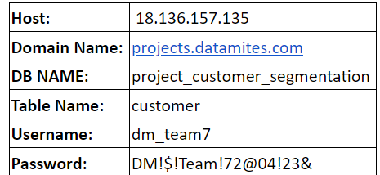

Attribute Information:

**invoice_no:** A combination of the letter 'I' and a 6-digit integer uniquely assigned to each operation.

**customer_id:** A combination of the letter 'C' and a 6-digit integer uniquely assigned to each operation.

**gender:** String variable of the customer's gender.

**age**: Positive Integer variable of the customers age.

**category:** String variable of the category of the purchased product.

**quantity:** The quantities of each product (item) per transaction.

**price:** Product price per unit in Turkish Liras (TL).

**payment_method:** String variable of the payment method (cash, credit card or debit card) used for the transaction.

**invoice_date:** The day when a transaction was generated.

**shopping_mall:** String variable of the name of the shopping mall where the transaction was made.

You can provide your inputs/solution as a PPT presentation and you can explain your project, record it and send it with the PPT file.