Peer Relationships and Availability of Advisors – Student Survey

1. Introduction
The purpose of this study is to analyze the dynamics of peer relationships and the accessibility of academic advisors among students. The data was obtained from a student survey titled 'Peer Relationships and Availability of Advisors.' The goal of this analysis is to understand how collaboration frequency, peer support, and advisor accessibility impact overall student satisfaction with academic support systems.

2. R Code Implementation

2.1 Data Import and Cleaning
library(tidyverse)
file_path <- "C:/Users/SURAJ/Desktop/DMA/Peer Relationships and Availability of Advisors - Student Survey.csv"
survey_data <- read_csv(file_path)
data_clean <- survey_data %>%
rename(
gender = `Gender`,
peer_collab = `How often do you study or collaborate with peers on academic work?`,
peer_relationship = `How would you describe your overall relationship with peers in your academic environment?`,
ask_peers = `Do you feel comfortable asking peers for academic help?`,
peer_challenges = `Have you ever faced challenges in building or maintaining peer relationships? (Select all that apply)`,
seek_advisor = `How often do you seek advice from academic advisors?`,
advisor_access = `How accessible are your academic advisors when you need guidance?`,
advisor_contact = `Which methods do you usually use to contact academic advisors? (Select all that apply)`,
advisor_difficulty = `What is the biggest difficulty you face in approaching academic advisors?`,
satisfaction_score = `On a scale of 1 to 10, how would you rate your overall satisfaction with academic support (both from peers and advisors)?`
)

2.2 Factor Levels and Transformation
relationship_levels <- c("Very unsupportive", "Unsupportive", "Neutral", "Supportive", "Very supportive")
access_levels <- c("Very inaccessible", "Somewhat inaccessible", "Neutral", "Somewhat accessible", "Very accessible")
frequency_levels <- c("Never", "Rarely", "Monthly", "Weekly", "Daily")
data_clean <- data_clean %>%
mutate(
peer_relationship = factor(peer_relationship, levels = relationship_levels),
advisor_access = factor(advisor_access, levels = access_levels),
peer_collab = factor(peer_collab, levels = frequency_levels),
seek_advisor = factor(seek_advisor, levels = frequency_levels)
)
glimpse(data_clean)

2.3 Visualization and Insights
# Plot 1: Overall Relationship with Peers
plot1 <- ggplot(data_clean, aes(x = peer_relationship)) +
geom_bar(fill = "steelblue", alpha = 0.8) +
labs(title = "Overall Relationship with Peers", x = "Peer Relationship", y = "Number of Students") +
theme_minimal() +
theme(axis.text.x = element_text(angle = 45, hjust = 1))
# Plot 2: Overall Satisfaction with Academic Support
plot2 <- ggplot(data_clean, aes(x = satisfaction_score)) +
geom_bar(fill = "darkgreen", alpha = 0.8) +
scale_x_continuous(breaks = 1:10) +
labs(title = "Overall Satisfaction with Academic Support", x = "Satisfaction Score (1-10)", y = "Number of Students") +
theme_minimal()
# Plot 3: Satisfaction Score by Advisor Accessibility
plot3 <- ggplot(data_clean, aes(x = advisor_access, y = satisfaction_score)) +
geom_boxplot(fill = "goldenrod", alpha = 0.7) +
geom_jitter(width = 0.1, alpha = 0.4) +
labs(title = "Satisfaction Score by Advisor Accessibility", x = "Advisor Accessibility", y = "Satisfaction Score (1-10)") +
theme_minimal() +
theme(axis.text.x = element_text(angle = 45, hjust = 1))

2.4 Additional Plots
# Plot 4: Common Challenges in Peer Relationships
challenges_summary <- data_clean %>%
filter(!is.na(peer_challenges)) %>%
separate_rows(peer_challenges, sep = ";") %>%
mutate(peer_challenges = str_trim(peer_challenges)) %>%
count(peer_challenges, sort = TRUE) %>%
mutate(peer_challenges = fct_reorder(peer_challenges, n))
plot4 <- ggplot(challenges_summary, aes(x = peer_challenges, y = n)) +
geom_col(fill = "firebrick", alpha = 0.8) +
coord_flip() +
labs(title = "Common Challenges in Peer Relationships", x = "Challenge", y = "Number of Mentions") +
theme_minimal()
# Plot 5: Gender Distribution (Pie Chart)
gender_summary <- data_clean %>%
count(gender) %>%
mutate(percentage = n / sum(n), label = scales::percent(percentage, accuracy = 0.1))
plot5 <- ggplot(gender_summary, aes(x = "", y = percentage, fill = gender)) +
geom_col(width = 1, alpha = 0.8) +
coord_polar(theta = "y", start = 0) +
geom_text(aes(label = label), position = position_stack(vjust = 0.5), color = "white", fontface = "bold", size = 4) +
labs(title = "Gender Distribution of Respondents", fill = "Gender", x = NULL, y = NULL) +
theme_void() +
theme(plot.title = element_text(hjust = 0.5, size = 14, face = "bold"), legend.title = element_text(face = "bold"), legend.position = "right")

2.5 More Visuals
# Plot 6: Advisor Contact Methods
contact_summary <- data_clean %>%
filter(!is.na(advisor_contact)) %>%
separate_rows(advisor_contact, sep = ";") %>%
mutate(advisor_contact = str_trim(advisor_contact)) %>%
count(advisor_contact, sort = TRUE) %>%
mutate(advisor_contact = fct_reorder(advisor_contact, n))
plot6 <- ggplot(contact_summary, aes(x = advisor_contact, y = n)) +
geom_col(fill = "#404080", alpha = 0.8) +
coord_flip() +
labs(title = "Common Advisor Contact Methods", x = "Contact Method", y = "Number of Mentions") +
theme_minimal()
# Plot 7: Biggest Difficulty Approaching Advisors
difficulty_summary <- data_clean %>%
filter(!is.na(advisor_difficulty)) %>%
count(advisor_difficulty, sort = TRUE) %>%
mutate(advisor_difficulty = fct_reorder(advisor_difficulty, n))
plot7 <- ggplot(difficulty_summary, aes(x = advisor_difficulty, y = n)) +
geom_col(fill = "#E69F00", alpha = 0.8) +
coord_flip() +
labs(title = "Biggest Difficulty Approaching Advisors", x = "Difficulty", y = "Number of Students") +
theme_minimal()
# Plot 8: Satisfaction Score by Gender
plot8 <- ggplot(data_clean, aes(x = gender, y = satisfaction_score)) +
geom_boxplot(fill = "#56B4E9", alpha = 0.7) +
geom_jitter(width = 0.1, alpha = 0.4) +
labs(title = "Satisfaction Score by Gender", x = "Gender", y = "Satisfaction Score (1-10)") +
theme_minimal()

3. Visualization Results and Insights

Overall Relationship with Peers
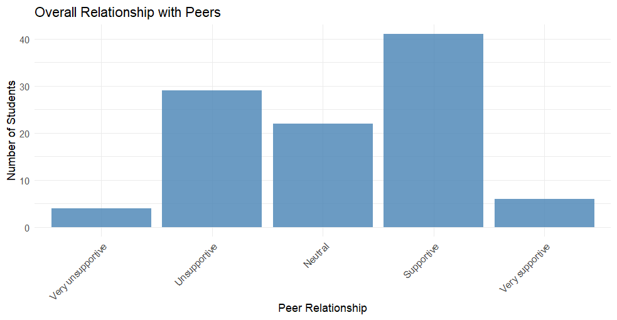
Figure: Overall Relationship with Peers visualization.

Overall Satisfaction with Academic Support
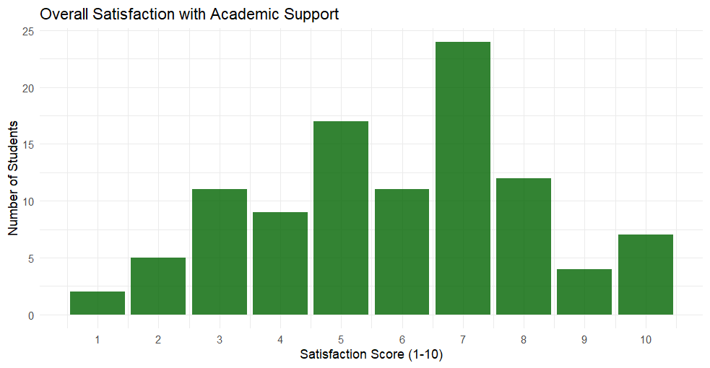
Figure: Overall Satisfaction with Academic Support visualization.

Satisfaction Score by Advisor Accessibility
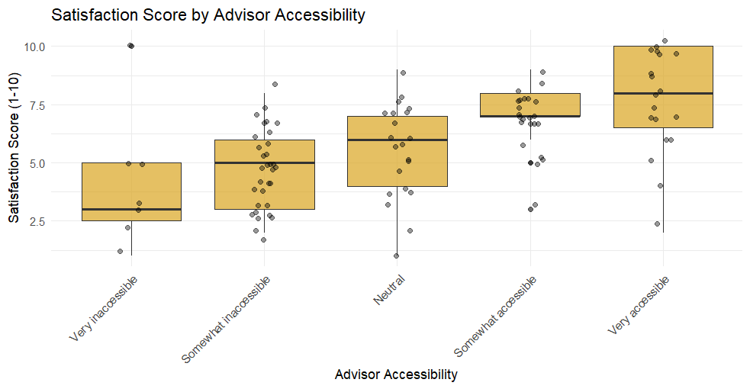
Figure: Satisfaction Score by Advisor Accessibility visualization.

Common Challenges in Peer Relationships
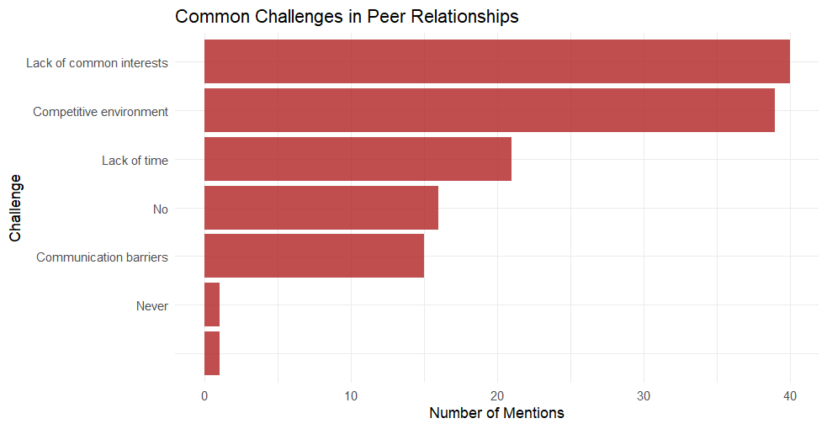
Figure: Common Challenges in Peer Relationships visualization.

Gender Distribution
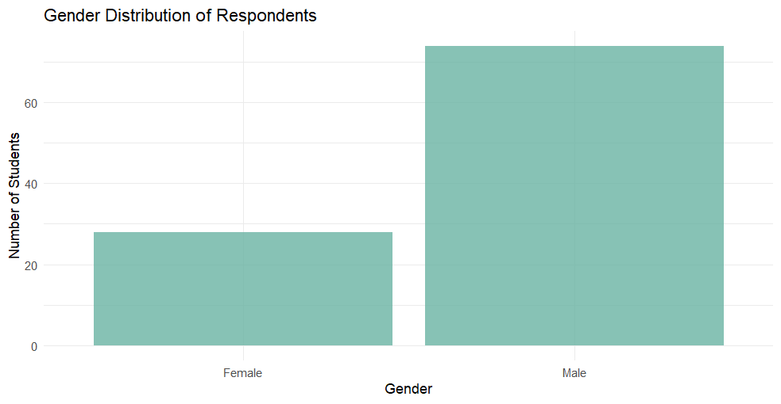
Figure: Gender Distribution visualization.

Advisor Contact Methods
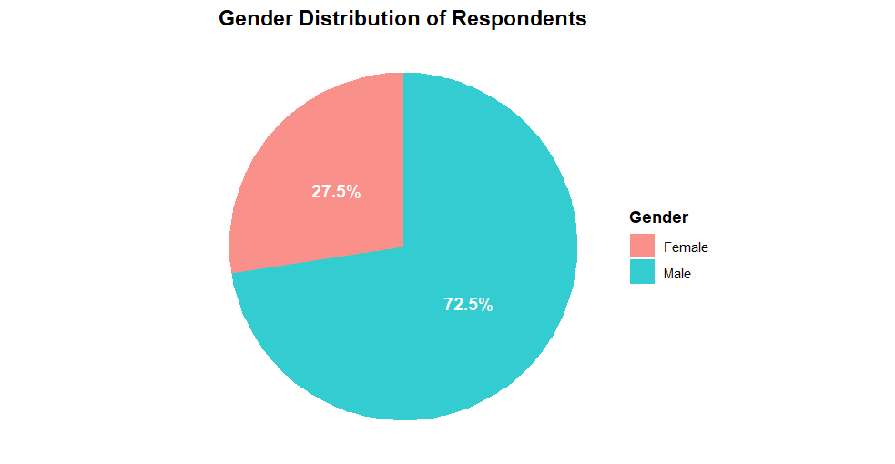
Figure: Advisor Contact Methods visualization.

Difficulties Approaching Advisors
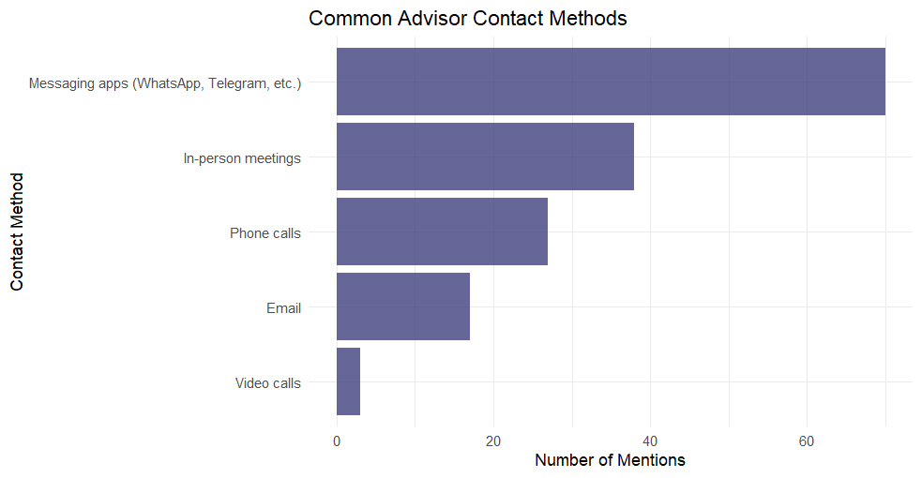
Figure: Difficulties Approaching Advisors visualization.

Satisfaction Score by Gender
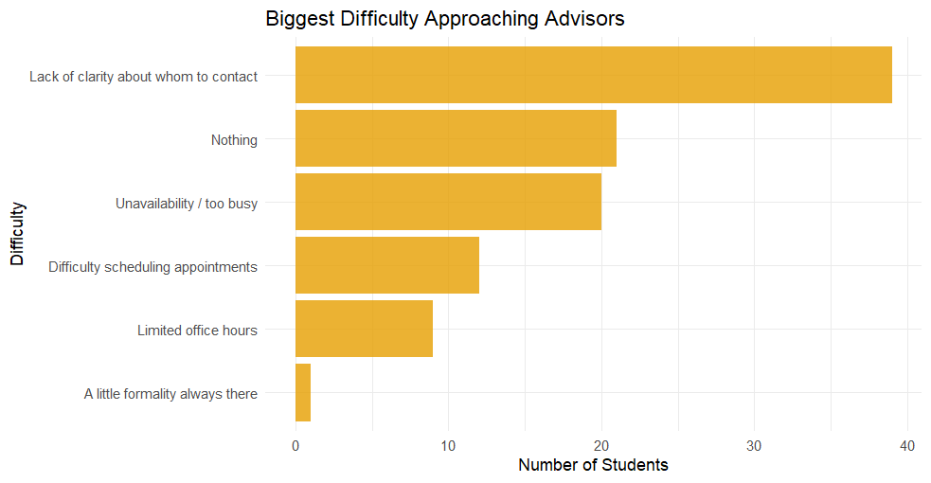
Figure: Satisfaction Score by Gender visualization.

Findings

1. Peer Relationship Analysis
Plot 1: “Overall Relationship with Peers”
Shows how students rated their relationships as very unsupportive → very supportive.
Most likely indicates that a majority have supportive or neutral relationships, with few reporting unsupportive ones.

2. Overall Satisfaction with Academic Support
Plot 2: “Satisfaction Score (1–10)”
Displays the distribution of overall satisfaction combining both peer and advisor support.
The pattern here usually helps identify whether students are generally satisfied (scores 7–10) or dissatisfied (scores 1–4).

3. Advisor Accessibility vs Satisfaction
Plot 3: Boxplot “Satisfaction by Advisor Accessibility”
Compares satisfaction scores with how accessible advisors are perceived to be.
Expected trend: higher accessibility → higher satisfaction, meaning students who can easily reach advisors feel better supported.

4. Common Peer Relationship Challenges
Plot 4: “Challenges in Peer Relationships”
Shows which issues students most frequently selected (e.g., communication gaps, lack of trust, competitiveness).
Helps identify the key social/academic barriers students face in building healthy peer networks.

5. Gender Distribution
Plot 5: “Gender Distribution (Pie Chart)”
Displays the proportion of male, female, and possibly other respondents.
Useful for understanding sample balance and ensuring fair representation.

6. Contacting Academic Advisors
Plot 6: “Advisor Contact Methods”
Lists popular ways students contact advisors (e.g., email, office hours, messages).
Typically, email is the dominant mode, followed by in-person meetings.

7. Difficulties in Approaching Advisors
Plot 7: “Biggest Difficulty Approaching Advisors”
Highlights top barriers such as lack of time, fear of judgment, unavailability, or communication gaps.
This identifies systemic or psychological issues limiting student-advisor engagement.

8. Satisfaction by Gender
Plot 8: “Satisfaction Score by Gender”
Compares satisfaction levels across gender groups using boxplots.
Could show, for instance, that female students report slightly higher satisfaction or that there’s no major gender difference.

Overall Insight Summary
Students generally have supportive peer relationships and feel moderately to highly satisfied with academic support.
Advisor accessibility is a key factor influencing satisfaction.
Common peer challenges and difficulties contacting advisors highlight areas needing institutional improvement.
Gender differences (if any) are visualized but not drastic.

