**Namaste React**

**Episode-01 || Inception :**

Write html: then hit the enter button : basic scalaton code for html

Hello world with html

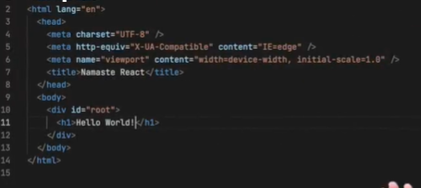

Hello world with javascript

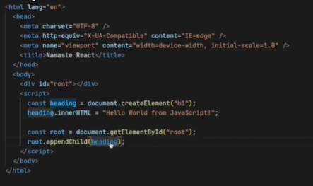

CDN :

These are the website where the react library is hosted. We are just fetching that react library where it is hosted, and using it by link.

Hello world in React using CDN link :

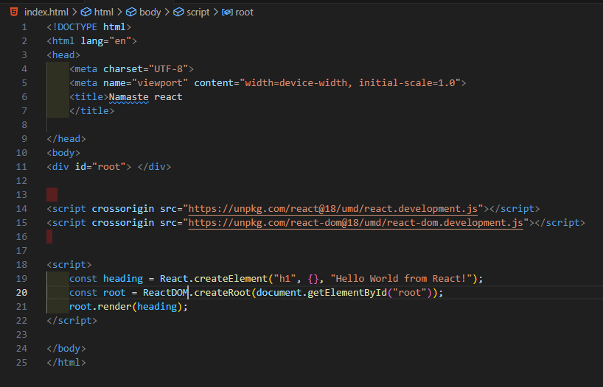

This {} empty object is use to give attribute name like {id : “heading” xyz : “abc”}.

NOTE : if there is content already inside the id (root) then it totally replaced by whatever passing the object inside heading(object). And if the content is present up and down from the is (root) then it will be show in the result.

Create nested html structure inside React :

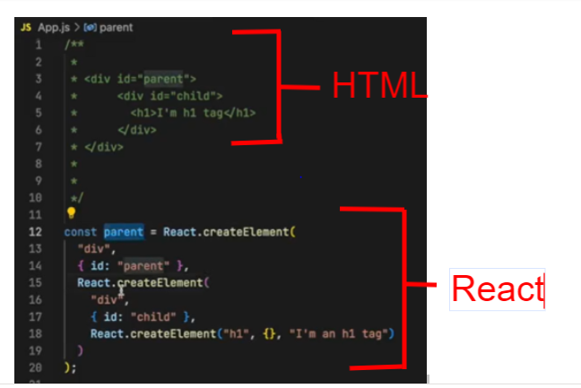

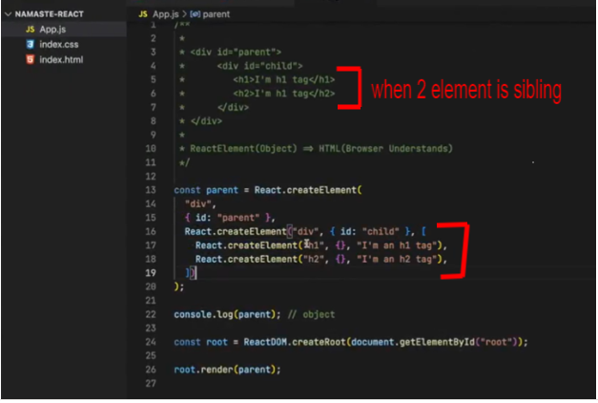

(this is too complex to create nested structure so we use jsx )

ReactElement(Object) => HTML(Browser understands) : here ReactElement creating object not a html .

While it is rendering into the DOM it converts into that HTML.