Personal Expense Tracker
A React Single-Page Application for Tracking Income and Spending in Nepali Rupees

Suraj Budhathoki
NP071284
Techspire College

Course: React.js — Frontend Web Development
Instructor: Saman Thakuri
Due: 2026/09/28

Contents
1. Project Introduction
2. Objectives
3. Technologies Used
4. System Requirements
5. Project Features
6. Project Structure
7. Application Screens and User Interface
8. React Concepts Used
9. Important Code Explanation
10. API Documentation
11. Application Flow
12. Challenges Faced
13. Testing
14. Limitations
15. Future Enhancements
16. Conclusion
17. References
18. GitHub Repository
Sections follow the order recommended in the course React Project Documentation Blueprint. Two sections that appear only in that blueprint's “Minimum Expected Documentation” list — Testing and References — have also been included.

Project Introduction
The Personal Expense Tracker is a React single-page application that records daily income and expenses and turns them into an immediate picture of the user’s financial position. Each entry takes an amount, a type, a category, a short description, and a date chosen from an in-app calendar. When an entry is saved, the application recalculates the month’s income, expenses, and running balance, redraws a chart of how spending is distributed, and updates the transaction list. All amounts are handled in Nepali Rupees and formatted with the lakh-crore grouping used in Nepal, so 1,234,567 is shown as NPR 12,34,567.00 rather than the NPR 1,234,567.00 the default en-US locale produces (Ecma International, 2023). The problem it addresses is that most people do not know where their money goes: a bank statement shows a total but rarely answers which category is eating the budget this month, and what is left after spending. Logging entries as they happen, and turning them into a per-month summary and a category chart, makes spending visible at a glance.
I chose this project because it exercises the core of React inside a small, self-contained package. It needs real state management, controlled forms with meaningful validation, derived data that must never be stored out of date, list rendering with stable keys, conditional rendering for empty states, and persistence across reloads. It also allowed the work to stay honest: rather than hiding the behaviour inside a charting or UI library, the calendar, the validation, and both charts are hand-written, so every line can be explained (Meta Open Source, 2026). The intended users are students, freelancers, and young professionals in Nepal who want a fast, private way to see monthly spending without creating an account. Because everything is kept in the browser’s own localStorage (World Wide Web Consortium, 2023), the application works offline and the data never leaves the machine.

Objectives
The objectives of this project were:
- Develop a user-friendly web application using React with functional components and hooks.
- Structure the application into reusable components, so each part of the interface has one clear responsibility.
- Implement state management with useState for local interface state and the Context API for the shared transaction list.
- Implement form handling with controlled inputs and a complete client-side validation layer.
- Build a reusable persistence layer with a custom useLocalStorage hook that keeps data across refreshes.
- Render lists and conditional content correctly, using map() with stable keys and explicit empty states.
- Display money correctly for Nepali users, using lakh-crore digit grouping and an NPR currency prefix.
- Visualise spending with charts — a bar chart and a donut chart — built without a charting library.
- Add a calendar-based date picker so dates are chosen visually and a future date cannot be selected.
- Create a responsive, accessible user interface that works at both desktop and mobile widths and keeps the design restrained, so colour carries meaning rather than decoration.
- Write clear technical documentation, covering the code, the design decisions, the testing carried out, and the challenges faced.

Technologies Used
Only technologies actually used are listed. There is no UI framework, charting library, form library, router, or state-management library, which follows the blueprint’s instruction not to claim unused technologies.
Table 1
Technologies Used in the Project
Technology | Version | Purpose
React.js and React DOM | 19.3 | Components, hooks, and rendering
JavaScript (ES modules) | ES2022 | Application logic
Vite | 8.3 | Development server and production build
HTML5 | 5 | Page structure
CSS3 (Grid, Flexbox, custom properties) | 3 | All styling; no CSS framework
Inline SVG | — | Rendering the donut chart
Intl.NumberFormat, en-IN | Built in | Nepali Rupee formatting with lakh-crore grouping
Web Storage API | HTML5 | Client-side persistence
Context API | 19.3 | Sharing state without prop drilling
ESLint and eslint-plugin-react-hooks | 10.11 | Static analysis
Git and GitHub | — | Version control and hosting

System Requirements
Table 2
Software and Hardware Required to Run the Project
Type | Requirement | Details
Software | Operating system | Windows 10 or 11, macOS 12+, or any current Linux distribution
Software | Node.js and npm | Node.js 18 or later with npm 9 or later; developed and tested on Node.js 24
Software | Code editor | Visual Studio Code, or any editor with the React and ESLint extensions
Software | Web browser | Chrome, Edge, Firefox, or Safari released within the last two years
Software | Git | Optional; required only to clone the repository from GitHub
Hardware | Processor and memory | Any current dual-core processor at 1 GHz or faster, and 4 GB of memory
Hardware | Storage and display | About 500 MB free, and any screen; the layout was checked from 360 px to 1440 px wide

From a terminal opened in the project folder:
Listing 1. Commands used to install, run, build, and check the project.
npm install # install dependencies
npm run dev # start the development server
npm run build # create a production build in dist/
npm run preview # serve the production build locally
npm run lint # run ESLint over the project

Project Features
Table 3
Features Provided by the System
Feature | Description
Add transactions | A controlled form captures amount, type, category, description, and date. Switching between Expense and Income resets the category when it no longer applies.
Running balance | Three summary cards show total income, total expenses, and the balance for the selected month, recalculated on every change. A negative balance is shown in red.
Calendar date picker | A month-grid calendar replaces the browser date input. Today is outlined, the selected day is filled, and days after today are disabled.
Input validation | Every field is validated. Errors appear under the relevant field once it has been touched, and an invalid submit is blocked.
Nepali Rupee formatting | Amounts use Intl.NumberFormat with the en-IN locale, so 1,234,567 is shown as NPR 12,34,567.00.
Transaction list | Every transaction of the selected month is listed with a coloured category dot, date, and signed amount, and can be deleted individually.
Filtering and sorting | The list can be filtered by type and category and sorted by newest, oldest, largest, or smallest amount. A live count reports how many match.
Bar and donut charts | Spending for the month is split by category and shown as horizontal bars or a donut, with a legend giving each share and amount.
Monthly view | Previous and next month navigation with a “This month” shortcut. Forward navigation is disabled at the current month.
Persistence | Transactions are saved on every change and restored on page load, so a refresh does not lose data.
Empty states and sample data | Three distinct empty states explain what is missing. A one-click demo data set lets the application be evaluated without entering data by hand.
Responsive and accessible | A two-column desktop layout collapses to one column on mobile. Controls are labelled, errors use role=“alert”, and focus rings are visible.
Reset all data | A single guarded action clears every transaction after a confirmation prompt.

Project Structure
The folder structure is shown below. Each folder has one job, and the split follows the shape of the data rather than being arbitrary.
Listing 2. Folder structure of the project. Each folder is described in Table 4.
expense-tracker/
|-- docs/
| |-- screenshots/
| `-- Expense-Tracker-Project-Documentation.docx
|-- src/
| |-- components/
| |-- context/
| |-- data/
| |-- hooks/
| |-- utils/
| |-- App.jsx
| |-- index.css
| `-- main.jsx
|-- index.html
|-- vite.config.js
|-- eslint.config.js
|-- package.json
`-- README.md

Table 4
Purpose of the Important Folders and Files
Path | Purpose
src/components/ | The ten reusable React components. Each is responsible for a single part of the interface and receives its data through props, except those that read the shared list from context.
src/context/ | The Context API files. ExpenseContext.js creates the context and the useExpenses() hook; ExpenseProvider.jsx owns the state and exposes the actions that change it.
src/hooks/ | Reusable stateful logic. useLocalStorage wraps useState so state is read from and written to Web Storage.
src/utils/ | Pure functions with no React dependency: money and date formatting, date arithmetic, the category list, and all validation rules.
src/App.jsx | The page component. It composes the layout, holds the view state (selected month and filters), and derives the summary totals and chart data with useMemo.
src/index.css | All styling, organised into commented sections and driven by CSS custom properties for colour, spacing, and radii.
src/main.jsx | The entry point. It creates the React root and wraps the app in the provider so the whole tree can read the transactions.
vite.config.js and eslint.config.js | Vite registers the React plugin so JSX is compiled with the fast automatic runtime; the flat ESLint config includes the react-hooks rules.

Application Screens and User Interface
The application is a single page, so the screens below are states of that page rather than separate routes.
Figure 1
The Complete Dashboard With the Sample Data Set Loaded
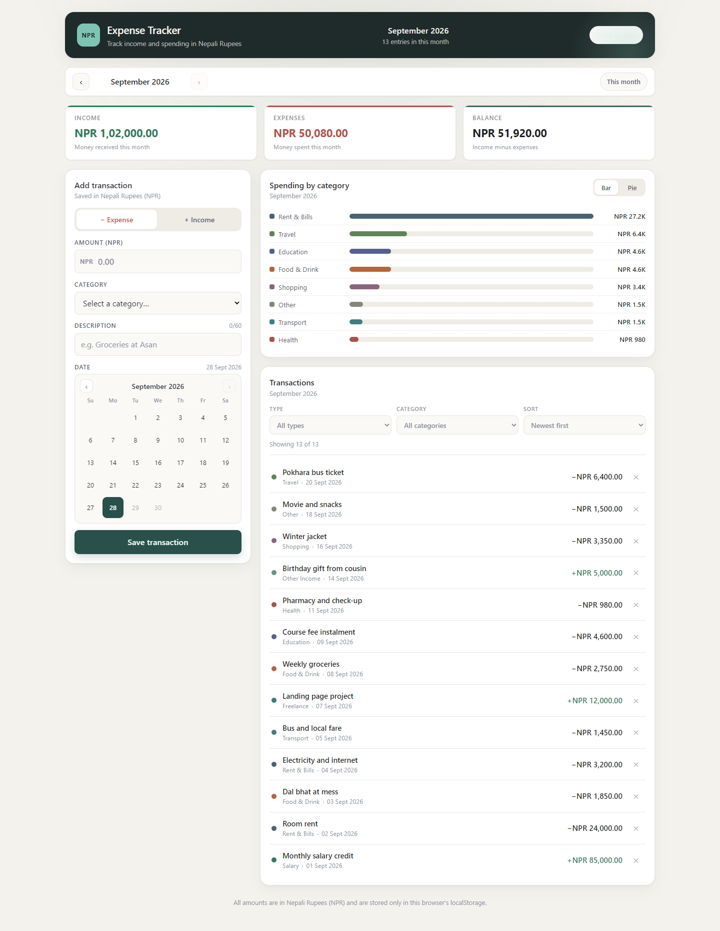

Figure 2
The Three Summary Cards

Figure 3
The Add-Transaction Form and Its Calendar
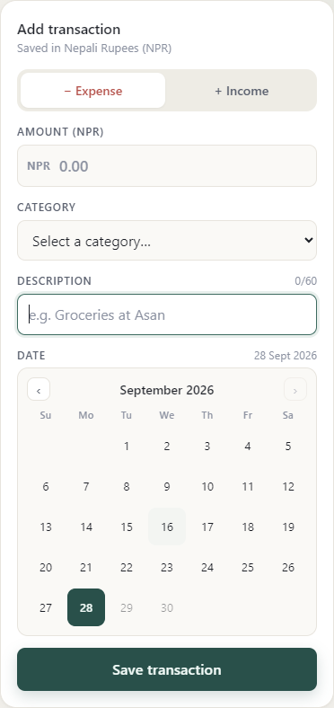

Figure 4
Spending by Category as a Bar Chart
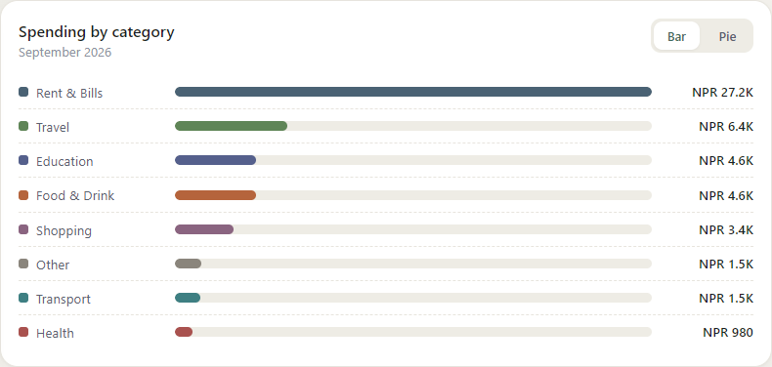

Figure 5
Spending by Category as a Donut Chart
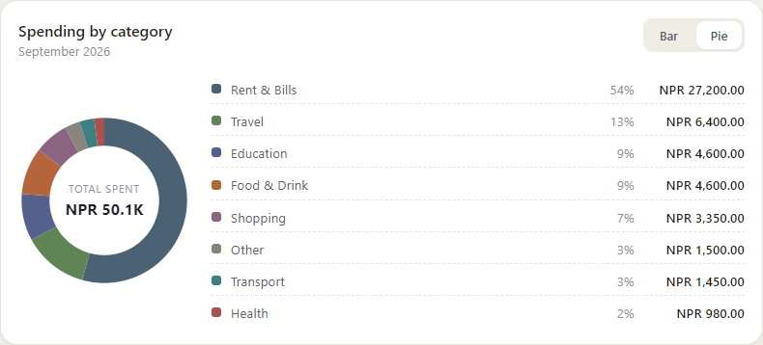

Figure 6
The Dashboard at a 414-Pixel Viewport
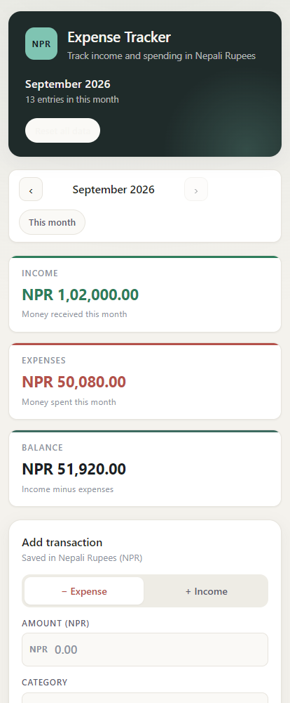

React Concepts Used

Components and Props
The application is built from ten functional components in src/components, each owning one well-defined piece of the interface, and App.jsx only composes them. The split follows the shape of the data: Header and MonthNav relate to the selected month; SummaryCards and CategoryChart relate to the month’s numbers; and TransactionForm, TransactionList, and TransactionItem relate to individual entries. EmptyState is the most reused component, because the list and the chart both render it, so the “nothing to show” design is defined once. Props push data down and callbacks up: SummaryCards receives three numbers and knows nothing about where they came from, and TransactionItem receives a transaction and an onDelete function and is reusable for any row, which keeps every component predictable in isolation.

State and Derived Data
useState is used in five places, each for a different kind of value (Meta Open Source, 2026). The provider holds transactions, the single source of truth. App holds monthKey and filters, which is view state. TransactionForm holds the current values, which fields have been touched, and whether a submit was attempted. Calendar holds which month its grid is showing, and CategoryChart holds which of the two renderings is visible. A key principle in this project is that derived values are never stored in state. Total income, total expenses, the balance, and the chart breakdown are all computed from transactions and monthKey with useMemo. Storing them would mean keeping two copies of the same truth in sync, and a single missed update would show a wrong balance. Because there is exactly one copy of the array, an entry added in the form, counted in the summary, plotted in the chart, and shown in the list are guaranteed to be the same entry, and the dependency array [transactions, monthKey] is an explicit statement of when the month’s data becomes stale.

useEffect
The application uses useEffect in one deliberate place: inside useLocalStorage, to write the current value back to storage whenever it changes. This is the textbook use of the hook, because it synchronises React state with an external system. The initial read from storage does not use an effect — it happens lazily inside the useState initialiser function, so storage is read once on mount rather than rendering an empty list first and then filling it in, which avoids a flash of empty content on every page load. There is no timer and no data-fetching effect, because there is no remote API.

Context API
Three sibling components — the summary cards, the chart, and the transaction list — all need the same array. Passing it through props would mean threading it through every intermediate component purely to reach them, which is the problem known as prop drilling. Instead ExpenseContext.js creates the context and a useExpenses() hook, and ExpenseProvider.jsx holds the state and publishes the actions.
Listing 3. The context object and the hook that reads it, from src/context/ExpenseContext.js and src/components/TransactionList.jsx.
export const ExpenseContext = createContext(null)

// read by a component, wherever it sits in the tree:
const { transactions } = useExpenses()

Event Handling and Controlled Inputs
Every interactive element has an explicit handler. Text inputs use onChange, because a controlled input must be updated on every keystroke; selects and calendar days use onClick; the form uses onSubmit with event.preventDefault() so the page is not reloaded. The transaction form is fully controlled: a single values object in state holds all five fields, each input receives its value as a prop, and the component re-renders on change. Nothing is read from the DOM at submit time, so what the user sees is exactly what gets validated and saved. The calendar follows the same contract through its value and onChange pair, so it is treated as just another field rather than a special case. The amount input passes through a sanitiser that keeps only digits, a single decimal point, and at most two decimal places, so a letter cannot be typed at all while the remaining validation rules still run on submit.

List Rendering, Keys, and Conditional Rendering
The transaction list, the filter options, the chart bars, and the legend are all rendered with map(). Each transaction is keyed by its generated identifier, which is stable for the life of the entry.
Listing 4. Rendering the list with stable keys, from src/components/TransactionList.jsx.
<ul className="txn-list">
{monthTransactions.map((transaction) => (
<TransactionItem
key={transaction.id}
transaction={transaction}
onDelete={onDelete}
/>
))}
</ul>

Using the array index as a key would be wrong here: deleting the first row would make React reuse the DOM of row 1 for row 2, and because rows are also sorted, the wrong amount could be shown against the wrong entry. Conditional rendering is used wherever the interface depends on the data — error messages render only when a field is invalid and has been touched, the chart renders one of two layouts, and the list renders either rows or an EmptyState. Neither React Router nor an HTTP client was used: the application has one screen, so navigation is not required, and it has no backend, so there is nothing to fetch. The browser APIs it does use are documented in the API Documentation section.

Important Code Explanation
The full source is not reproduced here. This section explains only the logic that carries the most weight in the application.

Adding a Transaction
Listing 5. addTransaction, from src/context/ExpenseProvider.jsx.
const addTransaction = useCallback((values) => {
const transaction = {
...values,
id: createId(),
amount: Number(values.amount),
description: values.description.trim(),
createdAt: Date.now(),
}
setTransactions((previous) =>
[transaction, ...previous].sort(byNewestFirst),
)
return transaction
}, [setTransactions])

The function normalises the incoming values: the amount is converted from the string the user typed into a Number, and the description is trimmed. It then adds a unique identifier and a timestamp. The important line is the functional update, setTransactions((previous) => [transaction, ...previous].sort(byNewestFirst)). The functional form is used so the new list is always built from the latest state rather than a potentially stale closure, and the sort keeps the list newest-first, so a freshly added entry appears at the top without extra logic in the list component. The function returns the created transaction so the caller can jump to the month it belongs to. Deletion is the mirror image: Array.prototype.filter with a predicate that keeps every entry whose identifier differs from the one being removed, which always returns a new array, so React re-renders.

The Running Balance
Listing 6. The monthly totals, computed with reduce in src/App.jsx.
() =>
monthTransactions.reduce(
(summary, item) => {
if (item.type === 'income') summary.income += item.amount
else summary.expense += item.amount
summary.balance = summary.income - summary.expense
return summary
},
{ income: 0, expense: 0, balance: 0 },
),
[monthTransactions],

The transactions are first narrowed to the selected month. Because every date is stored as a YYYY-MM-DD string, “2026-03” is simply the first seven characters, so the filter is item.date.slice(0, 7) === monthKey. No date parsing and no timezone conversion is involved, which means an entry always appears in the same month regardless of the viewer’s time zone. reduce() then walks the month’s entries once, adding each amount to income or expenses and recomputing the balance after every step. The initial accumulator value is what keeps the sum at zero for an empty month, which is why an empty month correctly shows NPR 0.00 rather than NaN.

Validation
Listing 7. The amount rules, from src/utils/validation.js.
const amount = String(values.amount ?? '').trim()
if (amount === '') {
errors.amount = 'Amount is required.'
} else if (!AMOUNT_PATTERN.test(amount)) {
errors.amount = 'Use numbers only, with up to 2 decimals (e.g. 1500 or 1500.50).'
} else if (Number(amount) <= 0) {
errors.amount = 'Amount must be greater than 0.'
} else if (Number(amount) > MAX_AMOUNT) {
errors.amount = `Amount cannot be more than ${MAX_AMOUNT.toLocaleString('en-IN')}.`
}

The validation function is pure: it takes the values and today’s date and returns a validity flag plus a map from field name to message. Keeping the rules outside the component means the form only has to render what comes back. The amount is coerced to a string first, so null and undefined cannot slip through, then tested against a regular expression that accepts only digits with at most two decimal places, followed by range and sign checks. The date is compared as a string against today, which works because the ISO format sorts chronologically. The separate sanitiser, used on every keystroke, removes any character that is not a digit or a dot, discards any dot after the first, and truncates the fractional part to two characters, which is friendlier than rejecting invalid keystrokes because the caret does not jump around.

Form Submission
Listing 8. handleSubmit, from src/components/TransactionForm.jsx.
function handleSubmit(event) {
event.preventDefault()
setSubmitted(true)

if (!isValid) {
setStatus({ kind: 'error', message: 'Please fix the highlighted fields.' })
return
}

onAdd({ ...values, amount: previewAmount })
setValues(emptyForm(today))
setTouched({})
setSubmitted(false)
setStatus({ kind: 'success', message: 'Transaction saved to this month.' })
}

The handler calls event.preventDefault() to stop the native submission and page reload, then sets a submitted flag so every error becomes visible, even on fields the user never touched. If the form is invalid it returns early and a banner explains that the highlighted fields need attention. If it is valid, the values are handed to the onAdd prop — note that only the validated values are passed, not the raw event — the form is cleared, the flags are reset, and a success message is shown. Clearing the form on success matters, because leaving stale values in place makes it easy to save the same entry twice.

Persistence With localStorage
Listing 9. The useLocalStorage hook, from src/hooks/useLocalStorage.js.
export function useLocalStorage(key, initialValue) {
const [value, setValue] = useState(() => {
try {
const stored = window.localStorage.getItem(key)
return stored === null ? initialValue : JSON.parse(stored)
} catch {
return initialValue
}
})

useEffect(() => {
try {
window.localStorage.setItem(key, JSON.stringify(value))
} catch {
/* storage unavailable or full - keep running in memory */
}
}, [key, value])

return [value, setValue]
}

The hook has two halves. The useState initialiser is a function, so React calls it once on the first render; inside it the stored JSON string is parsed and returned, or the initial value if nothing is stored. The useEffect then writes the value back whenever it changes. Both halves are wrapped in error handling, because localStorage throws in some private browsing modes and when the quota is full, so a storage failure should degrade to an in-memory application rather than crash the page.

Grouping Spending by Category
Listing 10. The data behind the chart, from src/App.jsx.
const byCategory = new Map()
monthTransactions.forEach((item) => {
if (item.type !== 'expense') return
// Group by the resolved id so an older stored category and its modern
// equivalent share one bar instead of splitting into two.
const id = resolveCategoryId(item.category)
byCategory.set(id, (byCategory.get(id) ?? 0) + item.amount)
})
return [...byCategory.entries()]
.map(([id, value]) => {
const category = findCategory(id) ?? FALLBACK_CATEGORY
return { id, value, label: category.label, color: category.color }
})
.sort((a, b) => b.value - a.value)

A Map is used as an accumulator so each category identifier is counted once, and income is skipped, since the chart shows where money is spent. The entries are mapped into objects holding an identifier, a label, a colour, and a value, and sorted largest first, which is why the bar chart can use the first value as its full-width reference. Because the category list has changed over the life of the project, the grouping uses a resolved identifier: a category that no longer exists is mapped onto the closest category that does, so a browser holding older data still produces one combined bar.

The Donut Chart Geometry
Listing 11. Slice offsets, from src/components/CategoryChart.jsx.
const prefixSums = data.reduce(
(sums, item) => [...sums, sums[sums.length - 1] + item.value],
[0],
)

const segments = data.map((item, index) => ({
...item,
length: (item.value / total) * CIRCUMFERENCE,
offset: (prefixSums[index] / total) * CIRCUMFERENCE,
}))

A donut is drawn as a set of circles on a single SVG, and each circle is limited to a slice using two attributes. The circumference of a circle of radius 64 is 2 × π × 64, which is 402.12. A category accounting for 48 percent of the total is given a stroke-dasharray of 192.6 209.5 — a dash of 192.6 followed by a gap covering the remainder. The stroke-dashoffset attribute then shifts the dash backwards by the sum of all previous slices, which places each segment correctly, and a rotation of −90 degrees about the centre turns the circle so the first slice starts at the top. This was verified in the browser: the slice lengths sum to exactly 402.12, so the donut has neither a gap nor an overlap.

API Documentation
This project does not use any web API or third-party service. There is no backend, no database, and no HTTP request anywhere in the code, so there are no endpoints, request bodies, response codes, or API keys to document, and no secrets to protect. The only external dependencies are the built-in browser APIs in Table 5.
Table 5
Browser APIs Used in the Project
API | Purpose | How it is used
localStorage.getItem(key) | Read a stored value as a string | Called once inside the useState initialiser in useLocalStorage.js to restore the array of transactions.
localStorage.setItem(key, value) | Write a value as a string | Called inside a useEffect whenever the transaction array changes; the value is serialised first, because Web Storage holds only strings.
JSON.parse / JSON.stringify | Convert between objects and strings | Applied on every read and write, since the stored list is an array of objects.
Intl.NumberFormat(‘en-IN’) | Format money | Gives 12,34,567.00 for 1234567.5, the lakh-crore grouping standard in Nepal, unlike en-US, which would give 1,234,567.50 (Ecma International, 2023). A compact variant gives 50.1K for the chart labels.
Intl.DateTimeFormat(‘en-GB’) | Format dates | Gives 12 Mar 2026 for 2026-03-12, avoiding the day/month confusion of US-style dates.

Application Flow
The application is a single page, so the flow is a loop rather than a sequence of pages: the user adds an entry, the dashboard recalculates, and the user reviews the result.
Listing 12. How state, the component tree, and persistence fit together.
main.jsx
|
<ExpenseProvider> state: transactions, restored from localStorage
|
<App> state: selected month, active filters
| derives with useMemo:
| month -> totals -> category breakdown -> filtered list
|
+--> <Header> month label, entry count, reset all data
+--> <MonthNav> ---> setMonthKey()
+--> <SummaryCards> income, expenses, balance
+--> <TransactionForm> <Calendar> picks the date; future days disabled
| |
| onSubmit -> validate
| invalid -> show per-field errors, stop
| valid -> addTransaction() -> context updates
| -> localStorage effect
| -> setMonthKey(month of the new entry)
| v
| the form resets
+--> <CategoryChart> bar or donut view of the month's expenses
+--> <TransactionList> <FilterBar> type, category, sort
<TransactionItem> ... delete -> deleteTransaction()
<EmptyState> when nothing matches

Two kinds of state move through this flow. View state, the selected month and the filters, lives in App and only affects what is displayed. Data state, the transactions, lives in the provider, is the only thing persisted, and is the single source of truth that the form, the summary, the chart, and the list all read from. The reset action bypasses the form and the validation entirely and clears the array directly.

Challenges Faced

Managing Shared Data Between Sibling Components
The summary cards, the chart, and the list all need the same array, but only the form writes to it. Passing it down as props meant threading it through every intermediate component purely to reach them. The list was placed in the Context API instead, which removed the prop passing entirely and, because the provider wraps its value in useMemo, means consumers only re-render when the data itself changes.

Keeping the Balance Correct
It is easy to store totals as state and then leave a stale number on screen after a delete or an add, and a wrong balance is worse than no balance at all. The solution was to store nothing derived: income, expenses, the balance, and the chart breakdown are all reduced from the selected month’s transactions on every change, so the cards, the chart, and the list cannot disagree.

React 19 Hook Rules and a Synchronised Calendar
The calendar originally re-aligned its visible month with a useEffect whenever the selected date changed. The react-hooks rules shipped with React 19 reject this, because calling a state setter synchronously inside an effect causes a cascading render and an extra pass over the tree. The adjustment was moved into the render phase using React’s documented pattern for adjusting state when a prop changes: the previous value is kept in state and compared during render, so React re-renders immediately and discards the output without a wasted commit. The same lint pass also flagged a mutable accumulator in the chart’s slice arithmetic, which became a pure reduce (OpenJS Foundation, 2026).

A Chart, a Calendar, and Nepali Money Without a Library
Adding a charting or date-picker library for two charts and one month grid would have meant a large dependency and code that is difficult to explain line by line. The bar chart became a list of elements with percentage widths, the donut one SVG circle per category, and the calendar a seven-column grid built by buildMonthGrid(), which returns a flat array of ISO date strings with null in the empty positions: the weekday on which the month begins decides how many nulls to push so the first date lands under the correct column, and the array is padded to a multiple of seven, which keeps the calendar the same size in every month so the form does not jump as the user pages between months. Separately, the default United States formatting turns 1,234,567 into “1,234,567.00”, which reads incorrectly to anyone used to lakh-crore grouping; Intl.NumberFormat with the en-IN locale was used instead of writing a custom formatter, which is both shorter and correct for the region.

Validation That Is Helpful Rather Than Noisy
Validating on every keystroke makes the form complain while the user is still typing the first digit on the way to 1500. Two mechanisms were used instead: errors are revealed only for fields the user has touched, or all at once after a submit attempt, and the amount field is sanitised so invalid characters cannot be entered at all. The result is a quiet form that is still strict.

Simplifying a Palette That Had Become a Rainbow
The first version had twelve expense categories and five income categories, each with its own distinct hue, so the chart read as a rainbow and the design lost its calm. Reducing the categories to the eight a student budget actually has, and choosing all eight expense colours at a similar lightness and warmth, made the chart read as one set. Because data already saved in a browser’s storage still referred to the removed categories, those identifiers are mapped onto the closest surviving category, so old data is kept and grouped correctly rather than being discarded or dumped into Other.

Testing
The application has no committed automated test suite, so testing was carried out by driving the running application in a real Chrome browser with the Puppeteer automation library and by inspecting the resulting layout geometry. Every check exercises the real user interface; nothing is stubbed or mocked.
Table 6
Summary of Test Coverage
Area tested | What was verified
Validation | An empty submit is blocked and three field-level errors appear with specific messages plus a banner; the amount field strips letters and caps the value at two decimals; a zero amount and a short description are both rejected.
Calendar | Exactly the days after today are unselectable and every day up to today is selectable; today is outlined; the month arrows page the grid forwards and back.
Entry creation and formatting | A valid submit adds one row, updates all three totals, and clears the form; switching the type resets the category; 1,234,567.50 renders as NPR 12,34,567.00; a negative balance shows a minus sign.
Filters, sorting, and deletion | The type filter narrows the list; an impossible filter combination shows the empty state; sorting by largest and smallest puts the correct row first; deleting the expense row leaves the income untouched.
Persistence and month navigation | The list survives a full page reload; the previous-month arrow changes the view and a data-less month shows the empty state; forward navigation is enabled in the past but disabled at the current month.
Charts | One bar per expense category, sorted largest first with the largest filling its track; the donut segments sum to exactly 402.12, the circumference of a radius-64 circle, so there is no gap and no overlap; the legend row count matches the segment count.
Data integrity | Entries saved under retired category names map onto their modern equivalents and merge into a single bar, with no “Uncategorised” labels.
Layout and colour | Zero horizontal page overflow and no clipped text at 360, 414, 768, 800, 1024, 1280, and 1440 pixels; every colour painted in the interface is one of the twenty-six defined tokens; the linter and the production build both pass.

Limitations
- Data is stored only in the current browser. Clearing site data, using a different browser, or opening the application on another device starts from an empty state, with no backup or synchronisation.
- There is no authentication, so anyone who can use the browser can see and change the data, and the data is not encrypted.
- An existing transaction cannot be edited, so a mistake has to be deleted and re-entered.
- There is no monthly budget or warning, which was one of the assignment’s optional stretch goals and was left out to keep the scope small.
- The currency is fixed to NPR, categories are defined in source code, and sorting and filtering are limited to a single type and a single category.
- There is no automated test suite in the repository. The behaviour was verified as described in the Testing section, but those scripts are not committed, so the project has no test command.
- The layout was checked at seven widths, but it has not been tested with assistive technology beyond correct labelling, roles, and visible focus rings.

Future Enhancements
- A monthly budget per category, with a warning banner when it is exceeded — the assignment stretch goal deliberately left out of the first version.
- An automated test suite using Vitest and React Testing Library, covering the validation rules, the totals, the category grouping, and the chart arithmetic.
- Editing an existing transaction in place instead of deleting and re-adding it.
- Import and export of transactions as CSV or JSON, so data can be moved between devices or backed up.
- Recurring transactions, such as rent and salary, generated automatically each month.
- Custom user-defined categories, and grouping by Nepali (Bikram Sambat) months alongside the Gregorian month.
- A dark theme toggle, a notes field and photo receipt per transaction, and deployment to Vercel, Netlify, or GitHub Pages.

Conclusion
I built a working personal expense tracker in React that logs income and expenses in Nepali Rupees, shows a live monthly balance, filters and sorts the history, and visualises spending by category with both a bar chart and a donut chart. Dates are chosen from an in-app calendar, every input is validated with a specific message, and the data set is persisted in localStorage so nothing is lost on refresh.
The most useful thing I learned was the boundary between state and derived data. The transaction array is the single source of truth, and totals, the balance, and the chart breakdown are always recomputed from it, which is why deleting a row is correct immediately with no synchronisation code anywhere. I also learned that component boundaries are a design decision rather than mere file splitting: the moment the same data was needed by three siblings, prop drilling turned into the Context API. Working within the stricter hook rules of React 19 pushed me to replace a state update inside an effect in the calendar with a render-phase adjustment, and building the chart and calendar by hand made the geometry and date logic something I can explain rather than hope works.
The second lesson was about restraint. The first version had seventeen distinct category colours and read as a rainbow; cutting it back to eight harmonised hues made the product calmer, and it surfaced a data problem worth solving properly: what to do with entries already saved under category names that no longer exist. The application builds and lints with no errors and no warnings, and its behaviour was verified end to end in a real browser across 53 checks and seven viewport widths. The main things still missing are a budget limit, the ability to edit an existing entry, and a committed test suite.

References
References follow the seventh edition of the Publication Manual of the American Psychological Association (American Psychological Association, 2020).
American Psychological Association. (2020). Publication manual of the American Psychological Association (7th ed.). https://doi.org/10.1037/0000165-000
Ecma International. (2023). ECMAScript 2023 language specification (ECMA-262, 14th ed.). https://ecma-international.org/publications-and-standards/standards/ecma-262/
Meta Open Source. (2026). React. https://react.dev/
Mozilla Developer Network. (2023). Using the Web Storage API. https://developer.mozilla.org/en-US/docs/Web/API/Web_Storage_API
Mozilla Developer Network. (2026). Intl.NumberFormat: Number formatting. https://developer.mozilla.org/en-US/docs/Web/JavaScript/Reference/Global_Objects/Intl/NumberFormat
OpenJS Foundation. (2026). ESLint. https://eslint.org/
Vite. (2026). Vite. https://vite.dev/
World Wide Web Consortium. (2023). Web Storage API (2nd ed.). https://www.w3.org/TR/webstorage-2/

GitHub Repository
GitHub Repository: https://github.com/surajbudhathokitheeta-byte/Expense-Tracker

The repository contains the complete source and documentation: the application code in src/, the setup instructions and screenshots in README.md, this document in docs/, and the project configuration in package.json, vite.config.js, and eslint.config.js. No environment file, API key, token, or password is included, because the application has no secrets of any kind. To run the project from a fresh clone, use git clone https://github.com/surajbudhathokitheota-byte/Expense-Tracker.git, change into the Expense-Tracker directory, then run npm install followed by npm run dev, as shown in Listing 1.

