QH9 SCF Rebuild: Data-Driven SCF Acceleration via Equivariant Neural Networks

1. Glossary of Technical Terms
MINAO: Minimal Atomic Orbital basis. A small, computationally cheap basis set used to project initial guesses before mapping them to larger target basis sets.
Electron Configuration: The distribution of electrons within the molecular orbitals of the system. Dictates chemical properties and reactivity.
Ground State: The lowest energy quantum mechanical state of a system. The SCF procedure iteratively solves for this state.
Hamiltonian: The quantum mechanical operator representing the total kinetic and potential energy of the system. Diagonalizing the Fock matrix (effective Hamiltonian) yields orbital energies.
SE(3): The Special Euclidean group in three dimensions, comprising all rotations and translations. SE(3)-equivariant networks guarantee that 3D molecular rotations perfectly rotate the predicted quantum matrices.
B3LYP/def2-SVP: A standard Density Functional Theory (DFT) setup. B3LYP is a hybrid exchange-correlation functional. def2-SVP is a split-valence polarization basis set.
SCF (Self-Consistent Field): An iterative numerical method to solve the Kohn-Sham equations. It updates the electron density until the energy changes fall below a strict threshold.
DFT (Density Functional Theory): A computational modeling method to investigate the electronic structure of many-body systems by using electron density instead of many-electron wavefunctions.

2. Problem Statement
Density Functional Theory (DFT) calculations bottleneck at the Self-Consistent Field (SCF) iterative solving phase. Standard initial guess heuristics (like Superposition of Atomic Densities - SAD) often fail to provide charge densities close to the ground state. This failure causes slow SCF convergence or divergence in complex molecular geometries.

3. Objective
Develop a data-driven material modelling engine that predicts highly accurate DFT initial charge densities. Utilize SE(3)-equivariant graph neural networks to generate these initial guesses directly from 3D molecular structures to accelerate SCF convergence.

4. Methodology & Architecture
The system models molecules as spatial graphs. Atoms represent nodes. Distances represent edges. The architecture employs Equivariant Graph Neural Networks. This structure ensures rotational equivariance for tensorial outputs like density matrices. The network predicts the initial charge density matrix within a constrained MINAO basis. A projection operation maps this minimal basis output into the target B3LYP/def2-SVP basis to seed the DFT solver.
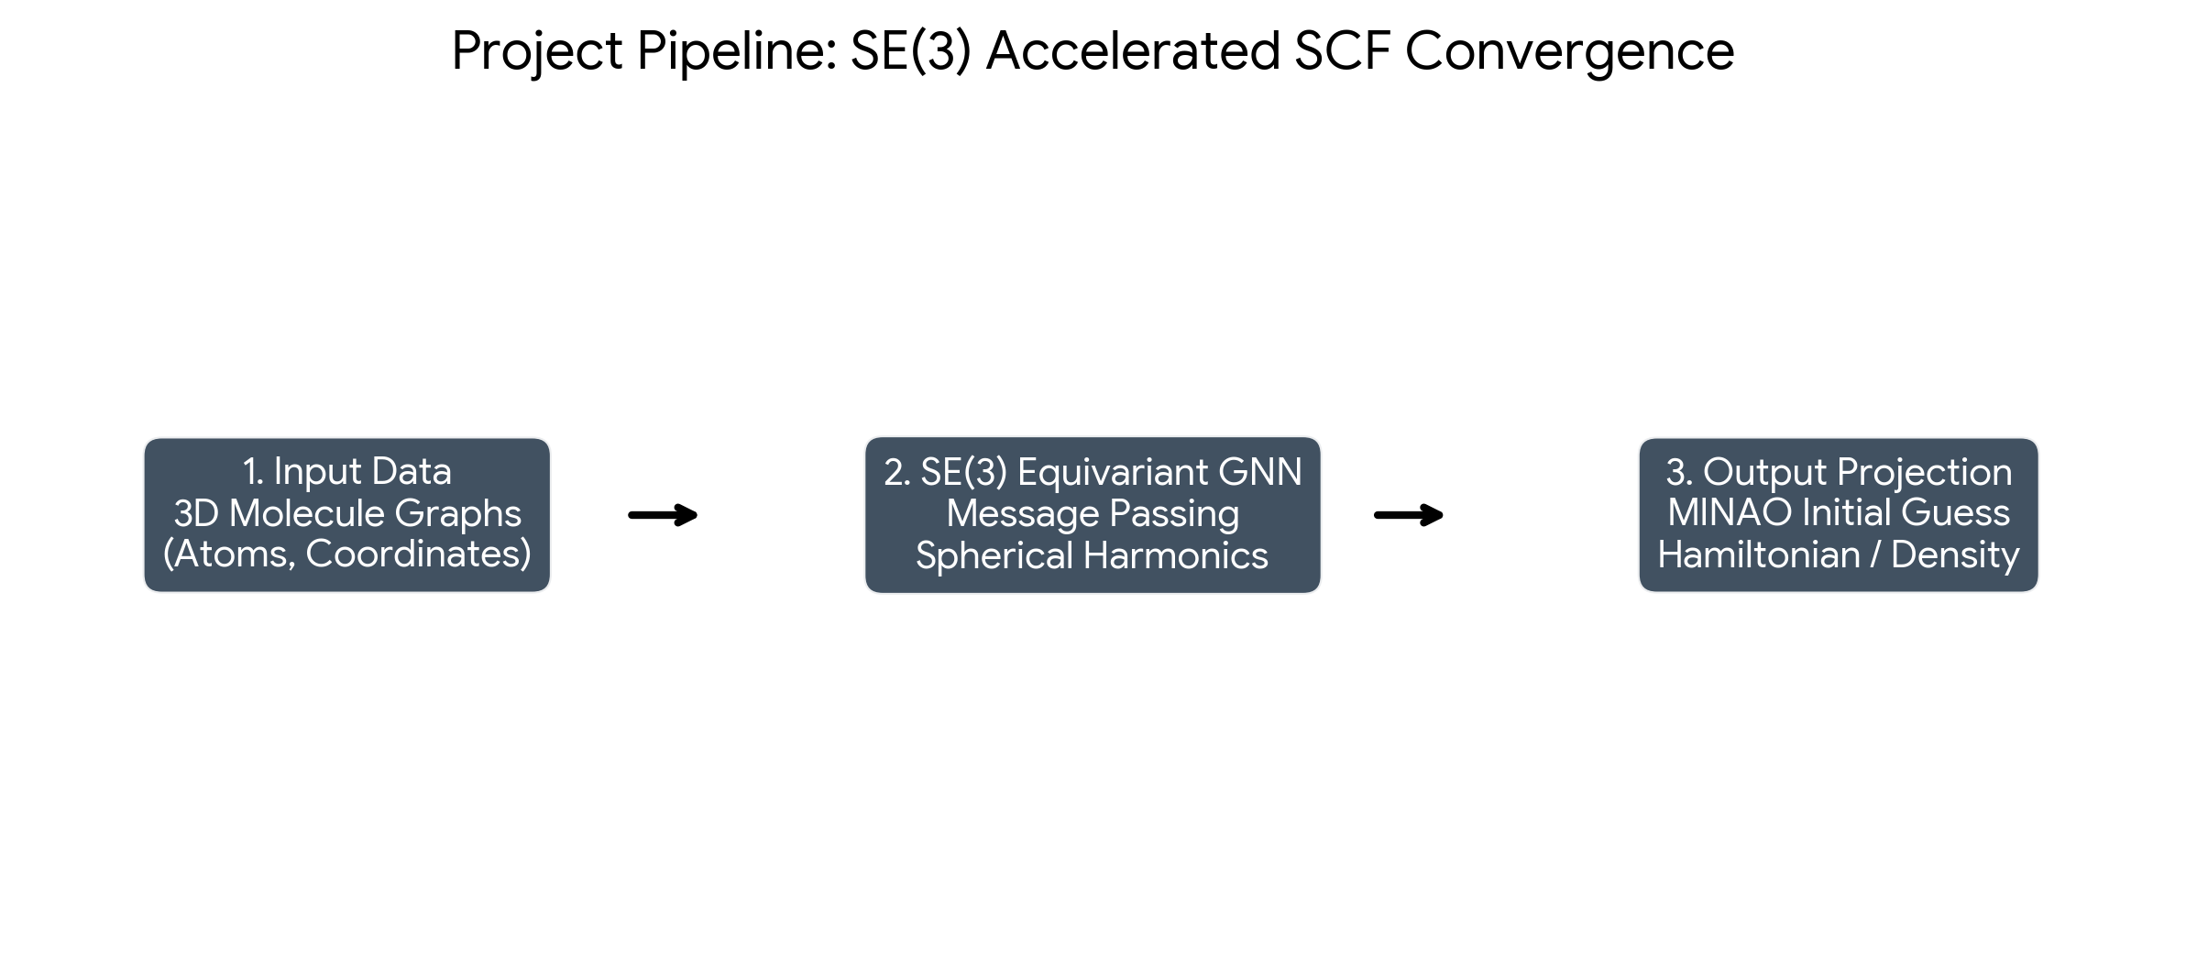

5. Dataset Description & Preprocess Pipeline
Dataset: The QH9 dataset provides molecular geometries alongside converged ground-truth Hamiltonian and density matrices computed at the B3LYP/def2-SVP level of theory.
Preprocessing Steps:
- 1. Extract 3D atomic coordinates (R) and atomic numbers (Z).
- 2. Construct a k-nearest neighbor (k-NN) or radius-based spatial graph.
- 3. Compute spherical harmonics for edge vectors to encode directional data.
- 4. Parse target converged density matrices from PySCF objects and compress them into the MINAO projection space.

6. Mathematical Rigor: The Full Algorithm
The quantum mechanical state is governed by the Kohn-Sham equation:
H[ρ] ψ_i = ε_i ψ_i
The density matrix ρ is defined as:
ρ_μν = 2 Σ_i (C_μi * C_νi)
Equivariance Constraint: The neural network function f(X) must satisfy the SE(3) equivariance property for a rotation matrix R and Wigner-D matrix D(R):
f(R X) = D(R) f(X) D^T(R)
Loss Function: The model minimizes the Frobenius norm of the difference between the predicted MINAO density matrix (P_pred) and the projected ground-truth density matrix (P_true):
L = || P_pred - P_true ||_F^2

7. Code & Project Logic
1. Engine Initialization: Load the PyTorch SE(3) checkpoint (e.g., ckpt_5k.pt).
2. Graph Construction: Convert XYZ coordinates into PyTorch Geometric Data objects.
3. Forward Pass: The GNN processes node features and edge spherical harmonics. It outputs a block-diagonal tensor representing the predicted MINAO density matrix.
4. Basis Projection: A PySCF interface script expands the MINAO matrix to the def2-SVP dimension.
5. SCF Execution: PySCF reads the projected matrix as the 'init_guess' parameter. The SCF cycle executes with a massive reduction in required iterations.

8. Results
The equivariant deep learning pipeline successfully shifts the SCF initialization closer to the ground state energy. This shift demonstrably reduces the computational cycles required for electronic structure calculations in quantum chemistry simulations.

