**Assignment Part-3**

Playing with files

1. Create a file like nano file1.txt

o Edit some data and then save the file

2. Now we will copy date from file1 to new file2

o cp file1.txt file2.txt

o Then see the output of file2.txt, cat file2.txt

o Give screenshot

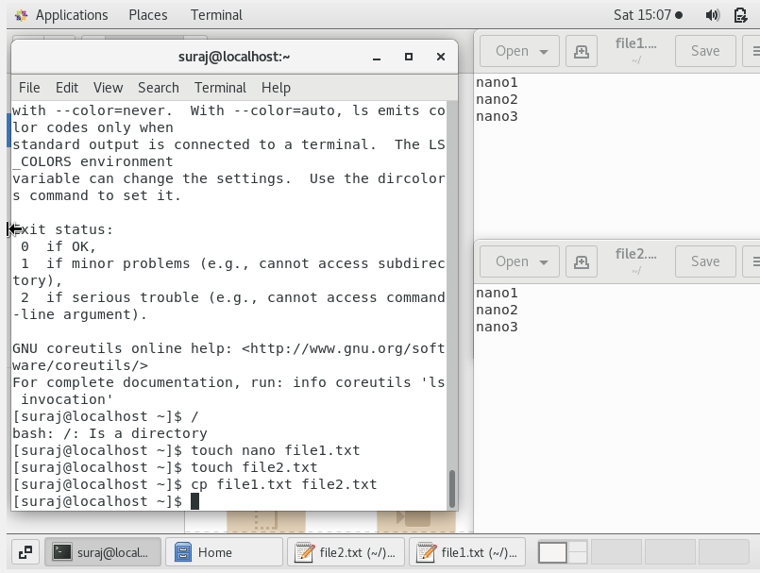

3. Now we will move the file2.txt to new folder /home

o mv file2.txt /home

o Then go to home directory and check ls, file exits or not?

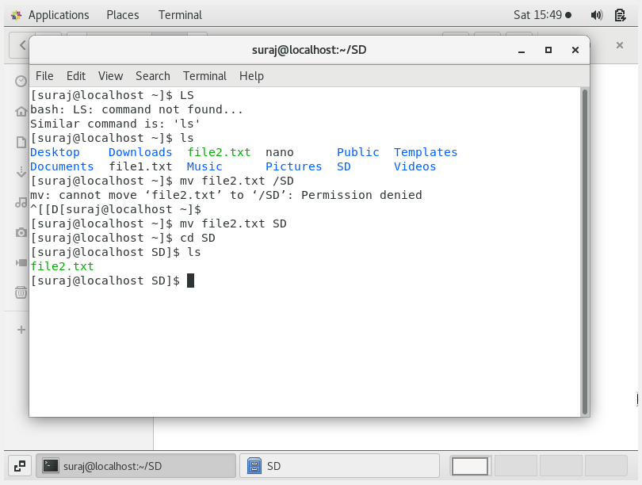o Given screenshot

Then we create a new **file3.txt** and **file4.txt** in home directory and add

content in it.

o Now do **echo** “Hello I am newline” > file3.txt and provide the

output of file3.txt

o Now do echo “Hello I am newline” >> file4.txt and provide the

output of file4.txt

o Tell the different between both step you follow and the reason

behind it.

ANS: When used > operator the data inside file3.txt was overwrite by Hello I am newline.

When used >> operator Hello I am newline is appended inside the file.

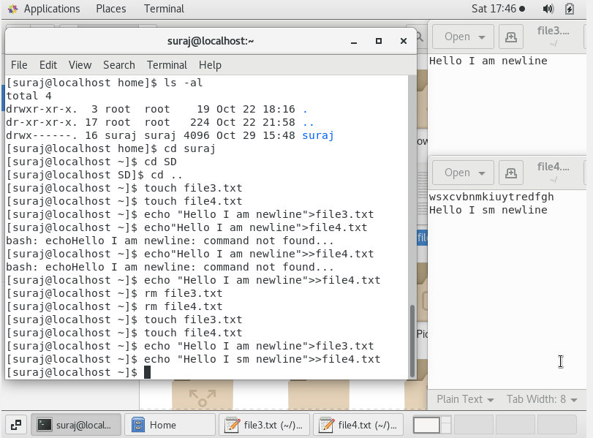

5. For remove a file or directory you can use the below two commands

o To delete a file – **rm <any_filename>**

o Todeleteadirectory-**rmdir<any_directoryname>**