
Ratan Tata Maharashtra State Skill University Pune

Department of Computer Technology
Project Report on

“Guest Lecture & Visit Management System”

Subject-: Capstone project

GUIDED BY: - 1. Shubhangi Kelkar
2. Rajesh Vartak

SUBMITTED BY: -

SR.No | Name | Seat Number | Elligibility No
1 | Suraj S. Dantarao |  | 2024000446
2 | Aryan D. Pratap |  | 2024000460



STUDENT’S DECLARATION
We hereby declare that the work being presented in this project entitled “Guest Lecture & Visit Management System” in partial fulfilment for the award of degree of Bachelor of Technology in Computer Technology and submitted at the Department of Computer Technology of Ratan Tata Maharashtra State Skills University is an authentic record of our work carried out under the guidance of Shubhangi Kelkar & Rajesh Vartak.

Student Name | PRN Number
- Suraj Sanjay Dantarao | 24103900134
- Aryan Dilip Pratap | 24103900148

Ratan Tata Maharashtra State Skill University Pune

CERTIFICATE

This is to certify that Mr. / Ms. Roll No of Sixth Semester degree in Computer Technology of Institute Ratan Tata Maharashtra state skill university Pune has completed the Final project Report on topic (Guest Lecture & Visitor Management System) in subject of Capstone Project Planning for academic year 2025 to 2026 as prescribed in the curriculum.

Place: -Pune Eligibility No: -

Date: -………………… Exam Seat No: -…………………
Examiners:
1.
2.

Guide Head of Department

Table of Contents

Sr.no. | Topic Name | Page No.
1 | Chapter 1: Abstract | 6-7
2 | Chapter 2: Introduction | 8-11
3 | Chapter 3: Requirement Analysis | 12-14
4 | Chapter 4: System Design | 15-28
5 | Chapter 5: Implementation | 29-37
6 | Chapter 6: Testing | 38-40
7 | Chapter 7: Future Scope | 41-42
8 | Chapter 8: Conclusion | 43
9 | Chapter 9: References | 44

Table Of Diagram

Sr.no. | Diagram | Page No.
1 | Architecture Diagram | 15
2 | Use Case Diagram | 17
3 | Sequence Diagram | 19
4 | Activity Diagram | 20
5 | ER Diagram | 21
6 | Visitor Flowchart | 31

Chapter No 01
ABSTRACT

The Guest Lecture & Visit Management System (GLVMS) is a web-based application developed to automate and streamline the process of managing campus visitors and organizing guest lectures in an educational institution. The system replaces traditional manual entry registers and unstructured coordination methods with a secure, efficient, and digital workflow. It addresses common challenges such as delays in visitor verification, lack of proper tracking, and inefficient management of guest lecture arrangements.

The primary objective of this project is to develop a centralized platform that enables visitors to request entry, administrators to manage approvals, and security personnel to verify access through a QR-based system. Visitors can register by filling out an online form with details such as name, purpose of visit, department, and identity proof. Once approved by the administrator, the system generates a unique QR code and sends it to the visitor as a digital entry pass. Security personnel can scan this QR code at the entry point to validate and record entry and exit details in real time.

The system is developed using modern web technologies, with the frontend built using React.js and Tailwind CSS to ensure a responsive and user-friendly interface. The backend is implemented using Node.js and Express.js, and MySQL is used as the database, managed through Sequelize ORM for efficient data handling and scalability. The modular architecture of the system separates functionalities such as authentication, visitor management, lecture management, and notification services, making the application maintainable and extensible.

In addition to visitor management, the system provides a dedicated module for managing guest lectures. Administrators can schedule lectures, assign coordinators, and manage venues. Staff members can track preparation tasks through checklists and record expenses related to the event. The system also allows participants to submit feedback after attending lectures, helping improve the quality of future events.

Key outcomes of the project include:
• A QR-based secure and contactless entry system for visitors
• Efficient management of guest lectures with checklist and expense tracking
• A centralized admin dashboard for monitoring and control
• Role-based access for Admin, Security, Staff, and Visitors
• Reliable data storage and management using MySQL and Sequelize ORM

In conclusion, the Guest Lecture & Visit Management System provides a comprehensive digital solution for managing campus visits and academic events. It enhances operational efficiency, reduces manual errors, and ensures real-time monitoring and control. The system is scalable and can be further extended with features such as advanced analytics, biometric verification, and integration with institutional systems, making it suitable for modern smart campus environments.

Chapter No 02
INTRODUCTION

2.1 Background of the Project
In many educational institutions, the process of managing campus visitors and organizing guest lectures is still handled manually. Visitor entries are recorded in physical registers, and approvals are often communicated through informal channels. This traditional approach leads to inefficiencies such as long waiting times, lack of proper record management, and increased chances of errors. Similarly, guest lecture coordination involves multiple departments and manual tracking of tasks, making the process time-consuming and difficult to manage.
With the advancement of digital technologies, there is a growing need to replace these outdated methods with automated systems. The Guest Lecture & Visit Management System (GLVMS) is developed to modernize these processes by providing a centralized, digital platform that ensures accuracy, security, and efficiency.

2.2 Motivation
The motivation behind this project arises from the real-world challenges faced in managing visitor entries and academic events within institutions. Manual systems are prone to human errors, miscommunication, and lack of real-time monitoring. Security concerns also increase due to improper verification of visitors.
The need to create a smart, secure, and user-friendly system that simplifies these operations motivated the development of GLVMS. The aim is to leverage modern technologies such QR code authentication, web-based interfaces, and automated workflows to improve overall efficiency and user experience.

2.3 Need of the System
The existing manual system has several limitations, including:
- Lack of real-time tracking of visitors
- Time-consuming entry and verification process
- Poor coordination in managing guest lectures
- High chances of data loss or duplication
- Limited transparency and accountability
To overcome these issues, a digital system is required that can:
- Automate visitor registration and approval
- Provide secure QR-based entry verification
- Maintain accurate and centralized records
- Streamline lecture management processes
- Improve communication between users
2.4 Problem Definition
The main problem addressed by this project is the inefficiency and lack of security in traditional visitor management and guest lecture coordination systems. Manual processes make it difficult to track visitor movements, ensure proper authorization, and manage event-related activities effectively.
There is a need for a system that can:
- Digitally manage visitor requests and approvals
- Provide secure and contactless entry using QR codes
- Enable efficient coordination of guest lectures
- Maintain structured data for analysis and reporting
The absence of such a system results in operational delays, reduced security, and poor management of institutional activities.

2.5 Project Scope
The scope of the Guest Lecture & Visit Management System (GLVMS) covers the design and development of a comprehensive web-based platform that automates and manages visitor entry and guest lecture coordination within an institution. The system is structured to support multiple user roles and ensures efficient handling of all related processes.
🔹 Core Scope of the System
• The system provides a web-based platform accessible through any modern browser, eliminating the need for manual record-keeping.
• It supports multiple user roles, including:
- Admin – Manages visitors and lectures
- Security – Verifies visitor entry using QR codes
- Staff/Coordinator – Handles lecture-related tasks
- Visitors – Request entry and provide feedback
• The system enables online visitor registration, where users can submit visit requests with necessary details such as name, purpose, department, and ID proof.
• It includes an approval workflow, allowing administrators to approve or reject visitor requests efficiently.
• Upon approval, the system generates a unique QR code that acts as a digital entry pass for visitors.
• The system provides QR-based entry and exit verification, allowing security personnel to scan and validate visitors in real time.
• It maintains automatic logging of entry and exit records, ensuring proper tracking and enhanced campus security.
🔹 Lecture Management Scope
• The system allows administrators to create, update, and manage guest lectures with details such as topic, speaker, venue, date, and time.
• It enables the assignment of staff coordinators for managing lecture activities.
• It includes a checklist management system, allowing staff to track and update preparation tasks for each lecture.
• The system supports expense tracking, enabling recording and monitoring of lecture-related costs.
• A feedback system is included, allowing participants to share their experience after attending lectures.

Chapter No 03
Requirement Analysis
3.1 Requirement Analysis
Requirement Analysis is the process of identifying and defining the functionalities and constraints of the system. It helps in understanding what the system should do (functional requirements) and how the system should perform (non-functional requirements).

🔹 Functional Requirements
These define the core operations and features of the system:
- User Registration and Authentication
  - Admin, Staff, and Security users can register and log in
  - Secure authentication mechanism is implemented
- Visitor Management
  - Visitors can fill out an online visit request form
  - Admin can approve or reject requests
  - Visitor data is stored in the database
- QR Code Generation
  - A unique QR code is generated after approval
  - The QR code acts as a digital entry pass
- QR Code Verification
  - Security personnel scan the QR code
  - System verifies authenticity
  - Entry and exit times are recorded
- Lecture Management
  - Admin can create, update, and delete lecture details
  - Lectures can be assigned to staff members
- Checklist Management
  - Staff can manage and update task checklists for lectures
- Expense Management
  - Staff can add and manage expenses related to lectures
- Feedback System
  - Visitors can submit feedback after attending lectures
- Dashboard
  - Admin dashboard provides an overview of visitors, lectures, and logs

🔹 Non-Functional Requirements
These define the quality and performance aspects of the system:
- Performance
  - The system should provide fast response times
  - QR verification should be real-time
- Security
  - User authentication must be secure
  - Sensitive data must be protected
- Usability
  - The interface should be simple and user-friendly
  - The system should be accessible on multiple devices
- Scalability
  - The system should support future enhancements
  - It should handle an increasing number of users
- Reliability
  - The system should operate consistently without failure
  - Data loss should be prevented
- Maintainability
  - The system should be easy to update and maintain
  - Code structure should be modular

3.2 Feasibility Study
A feasibility study is conducted to determine whether the project is practical and achievable from different perspectives.

🔹 Technical Feasibility
- The system uses modern technologies such as React.js, Node.js, and MySQL
- QR code integration is technically achievable
- The application is web-based, ensuring cross-platform compatibility
- Required technical skills and tools are available
Conclusion:
The system is technically feasible.

🔹 Economic Feasibility
- The project uses open-source technologies, reducing development cost
- Maintenance cost is low
- It is more cost-effective compared to manual systems
Conclusion:
The system is economically feasible.
🔹 Operational Feasibility
- The system is easy to use with a simple interface
- Staff and security personnel can adapt quickly
- Minimal training is required
- Suitable for real-world deployment in institutions
Conclusion:
The system is operationally feasible.

Chapter 04
System Design

4.1 Architecture Diagram
(Insert Block Diagram)

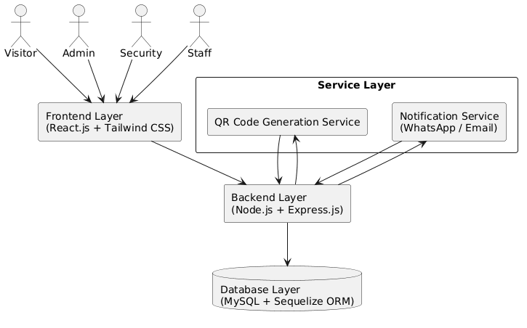
The above diagram represents the overall architecture of the Guest Lecture & Visit Management System (GLVMS). The system follows a layered architecture consisting of the User Layer, Frontend Layer, Backend Layer, Service Layer, and Database Layer, ensuring proper separation of concerns and efficient system design.
At the top level, four types of users—Visitor, Admin, Security, and Staff—interact with the system through the frontend interface. The Frontend Layer, developed using React.js and Tailwind CSS, provides a responsive and user-friendly interface for performing various operations such as visitor registration, lecture management, QR scanning, and dashboard access.
The frontend communicates with the Backend Layer, which is built using Node.js and Express.js. The backend handles all core functionalities including request processing, business logic, authentication, visitor approval, and lecture management. It acts as a bridge between the frontend and the database.
The system also includes a Service Layer, which provides additional functionalities. This layer consists of:
- QR Code Generation Service, which generates unique QR codes for approved visitors
- Notification Service (WhatsApp/Email), which sends QR codes and updates to users
These services are integrated with the backend to enhance automation and communication.
Finally, the Database Layer, implemented using MySQL with Sequelize ORM, stores all the system data including user details, visitor records, QR passes, entry/exit logs, lecture information, checklists, expenses, and feedback.
Overall, this architecture ensures a scalable, modular, and efficient system where each layer performs a specific role, enabling smooth communication and reliable system performance.

4.2 UML Diagrams
- Use Case Diagram
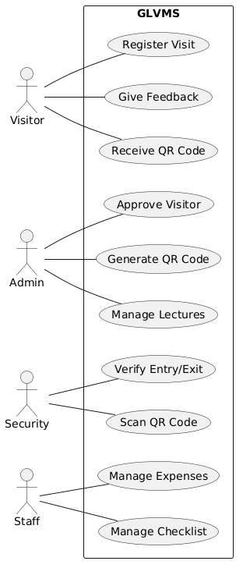

The above Use Case Diagram illustrates the interaction between different users and the Guest Lecture & Visit Management System (GLVMS). It represents how various actors interact with the system and the functionalities available to each role.
The system consists of four main actors: Visitor, Admin, Security, and Staff, each having specific responsibilities and access within the system.
- The Visitor interacts with the system to register a visit request, receive a QR code after approval, and provide feedback after attending the visit or lecture. This ensures a smooth and user-friendly experience for external users.
- The Admin plays a central role in controlling the system. The admin is responsible for approving or rejecting visitor requests, generating QR codes, and managing guest lectures such as scheduling, updating, and organizing events.
- The Security personnel are responsible for maintaining campus safety. They use the system to scan QR codes and verify visitor entry and exit, ensuring that only authorized visitors are allowed access.
- The Staff (Coordinator) manages lecture-related activities. They are responsible for managing checklists (task tracking) and handling expenses related to guest lectures.
The system boundary labeled GLVMS contains all the core functionalities, clearly showing that all interactions happen within this system. Each use case represents a specific operation that contributes to the overall workflow.
Overall, this diagram provides a high-level understanding of the system’s functionality and the roles of different users, making it easier to visualize how the system operates.

- Sequence Diagram

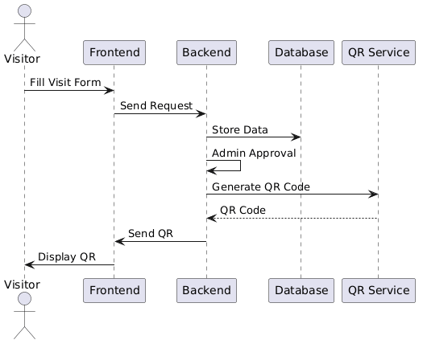

The above sequence diagram represents the step-by-step interaction between different components of the Guest Lecture & Visit Management System (GLVMS) during the visitor registration and QR code generation process. It illustrates how data flows between the Visitor, Frontend, Backend, Database, and QR Service in a sequential manner.
The process begins when the Visitor fills out the visit request form on the frontend interface. The Frontend Layer then sends this request to the Backend Layer for processing. The backend receives the request and stores the visitor’s data in the Database Layer.
After storing the data, the request undergoes an admin approval process, which is handled by the backend. Once the request is approved, the backend initiates the QR code generation process by sending a request to the QR Service.
The QR Service generates a unique QR code and sends it back to the backend. The backend then forwards this QR code to the frontend. Finally, the frontend displays the QR code to the visitor, which acts as a digital entry pass.
This diagram clearly shows the sequence of operations and the interaction between different system components, ensuring a smooth and structured workflow from visitor registration to QR code delivery.

- Activity Diagram
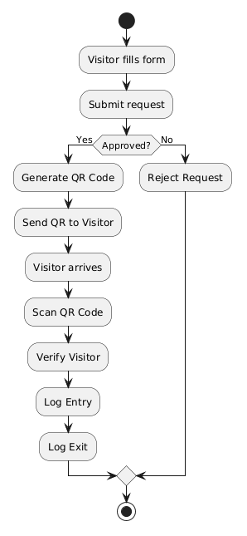
The above Activity Diagram represents the workflow of the Guest Lecture & Visit Management System (GLVMS), showing the sequence of activities involved in the visitor management process from registration to exit.
The process begins when a visitor fills out the visit request form and submits it through the system. Once the request is submitted, it goes through an approval decision process. If the request is approved, the system generates a QR code, which is then sent to the visitor as a digital entry pass. If the request is rejected, the process ends without further actions.
For approved requests, the visitor arrives at the campus and presents the QR code at the entry point. The security personnel scan the QR code, and the system verifies the visitor’s details. Upon successful verification, the system records the entry time of the visitor.
When the visitor leaves the campus, the QR code is scanned again to record the exit time, ensuring proper tracking of visitor movement. The process then reaches its final state, completing the workflow.
This diagram clearly illustrates the decision-making process and the flow of activities within the system, helping to understand how the system handles different scenarios efficiently.

4.3 Database Design
- ER Diagram
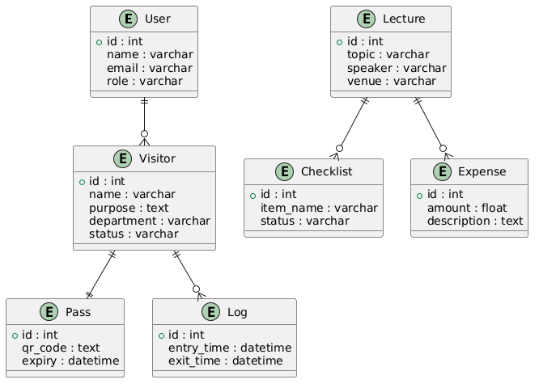

The above Entity Relationship (ER) Diagram represents the database structure of the Guest Lecture & Visit Management System (GLVMS). It illustrates the key entities, their attributes, and the relationships between them, providing a clear understanding of how data is organized and connected within the system.

The system consists of several main entities:
- The User entity stores details of system users such as Admin, Staff, and Security, including attributes like id, name, email, and role. A user can manage multiple visitor records, establishing a one-to-many relationship with the Visitor entity.
- The Visitor entity contains information about individuals requesting entry, including name, purpose, department, and status. Each visitor is associated with one Pass and can have multiple Log records.
- The Pass entity represents the QR code assigned to a visitor. It includes attributes such as qr_code and expiry, and it has a one-to-one relationship with the Visitor entity.
- The Log entity records the entry and exit details of visitors, including entry_time and exit_time. A visitor can have multiple logs, representing multiple visits or scans.
- The Lecture entity stores details of guest lectures such as topic, speaker, and venue. It is connected to both Checklist and Expense entities.
- The Checklist entity contains task-related information for lecture preparation, with attributes like item_name and status. Each lecture can have multiple checklist items.
- The Expense entity stores financial details related to lectures, including amount and description. Each lecture can have multiple expenses.
The relationships between these entities ensure proper data organization:
- One User can manage many Visitors
- One Visitor has one Pass
- One Visitor can have multiple Logs
- One Lecture can have multiple Checklist items and Expenses
Overall, the ER diagram provides a structured and relational view of the system’s database, ensuring efficient data storage, retrieval, and management.

- Table Structure
The table structure defines how data is organized in the database of the Guest Lecture & Visit Management System (GLVMS). Each table represents an entity, and fields represent attributes of that entity. Primary keys uniquely identify records, while foreign keys establish relationships between tables.

🔹 1. Users Table
Field Name | Data Type | Key | Description
id | INT | Primary Key | Unique user ID
name | VARCHAR | - | Name of the user
email | VARCHAR | Unique | User email address
password | VARCHAR | - | Encrypted password
role | VARCHAR | - | Role (Admin / Staff / Security)

🔹 2. Visitors Table
Field Name | Data Type | Key | Description
id | INT | Primary Key | Unique visitor ID
name | VARCHAR | - | Visitor name
purpose | TEXT | - | Purpose of visit
department | VARCHAR | - | Department to visit
status | VARCHAR | - | Status (Pending / Approved / Rejected)

🔹 3. Pass Table
Field Name | Data Type | Key | Description
id | INT | Primary Key | Unique pass ID
visitor_id | INT | Foreign Key | Linked visitor ID
qr_code | TEXT | - | Generated QR code
Expiry | DATETIME | - | Expiry date/time of QR

🔹 4. Log Table
Field Name | Data Type | Key | Description
id | INT | Primary Key | Unique log ID
visitor_id | INT | Foreign Key | Linked visitor ID
entry_time | DATETIME | - | Entry timestamp
exit_time | DATETIME | - | Exit timestamp

🔹 5. Lecture Table
Field Name | Data Type | Key | Description
id | INT | Primary Key | Unique lecture ID
topic | VARCHAR | - | Lecture topic
speaker | VARCHAR | - | Speaker name
venue | VARCHAR | - | Lecture venue

🔹 6. Checklist Table
Field Name | Data Type | Key | Description
id | INT | Primary Key | Unique checklist ID
lecture_id | INT | Foreign Key | Linked lecture ID
item_name | VARCHAR | - | Task name
status | VARCHAR | - | Status (Pending / Completed)

🔹 7. Expense Table
Field Name | Data Type | Key | Description
id | INT | Primary Key | Unique expense ID
lecture_id | INT | Foreign Key | Linked lecture ID
description | TEXT | - | Expense details
amount | FLOAT | - | Expense amount

- Data Dictionary
The Data Dictionary provides detailed information about each data element used in the database of the Guest Lecture & Visit Management System (GLVMS). It defines the meaning, type, and purpose of each field, ensuring clarity and consistency in data handling.
🔹 1. Users Table Data Dictionary
Field Name | Data Type | Description
id | INT | Unique identifier for each user
name | VARCHAR | Name of the user
email | VARCHAR | Email address used for login
password | VARCHAR | Encrypted password
role | VARCHAR | User role (Admin / Staff / Security)
🔹 2. Visitors Table Data Dictionary
Field Name | Data Type | Description
id | INT | Unique identifier for each visitor
name | VARCHAR | Name of the visitor
purpose | TEXT | Reason for the visit
department | VARCHAR | Department to be visited
status | VARCHAR | Approval status (Pending / Approved / Rejected)

🔹 3. Pass Table Data Dictionary
Field Name | Data Type | Description
id | INT | Unique identifier for each pass
visitor_id | INT | Reference to visitor
qr_code | TEXT | Generated QR code string
expiry | DATETIME | Expiry date and time of QR code
🔹 4. Log Table Data Dictionary
Field Name | Data Type | Description
id | INT | Unique identifier for each log record
visitor_id | INT | Reference to visitor
entry_time | DATETIME | Time of entry
exit_time | DATETIME | Time of exit

🔹 5. Lecture Table Data Dictionary
Field Name | Data Type | Description
id | INT | Unique identifier for each lecture
topic | VARCHAR | Title of the lecture
speaker | VARCHAR | Name of the speaker
venue | VARCHAR | Location of the lecture

🔹 6. Checklist Table Data Dictionary
Field Name | Data Type | Description
id | INT | Unique identifier for checklist item
lecture_id | INT | Reference to lecture
item_name | VARCHAR | Task or checklist item
status | VARCHAR | Status (Pending / Completed)

🔹 7. Expense Table Data Dictionary

Field Name | Data Type | Description
id | INT | Unique identifier for each expense
lecture_id | INT | Reference to lecture
description | TEXT | Details of expense
amount | FLOAT | Amount spent

Chapter N0 05
Implementation
5.1 Module Description
The Guest Lecture & Visit Management System (GLVMS) is divided into multiple modules to ensure a structured and maintainable system design. Each module performs a specific function and interacts with others to complete the workflow.
🔹 1. Authentication Module
- Handles user registration and login
- Supports role-based access (Admin, Staff, Security)
- Ensures secure access to the system
🔹 2. Visitor Management Module
- Allows visitors to submit visit requests
- Stores visitor details in the database
- Admin can approve or reject requests
🔹 3. QR Code Module
- Generates a unique QR code for approved visitors
- Acts as a digital entry pass
- Ensures secure and contactless verification
🔹 4. Security Verification Module
- Enables QR code scanning at the entry gate
- Verifies visitor authenticity
- Records entry and exit timestamps
🔹 5. Lecture Management Module
- Allows admin to create and manage guest lectures
- Assigns staff coordinators
- Stores lecture details (topic, speaker, venue, date)
🔹 6. Checklist Management Module
- Staff can track preparation tasks
- Tasks can be marked as completed or pending
🔹 7. Expense Management Module
- Records expenses related to lectures
- Helps in financial tracking
🔹 8. Feedback Module
- Visitors can submit feedback after attending lectures
- Helps improve future events.

5.2 Algorithm
🔹 Visitor Approval & QR Generation Algorithm
- Start
- Visitor fills and submits the visit request form
- System stores request in database with status = "Pending"
- Admin reviews the request
- If approved:
  - Generate unique QR code
  - Update status to "Approved"
  - Send QR code to visitor
- Else:
  - Update status to "Rejected"
- End

🔹 QR Verification Algorithm
- Start
- Security scans QR code
- System checks QR validity in database
- If valid:
  - Record entry time (if first scan)
  - Record exit time (if second scan)
- Else:
  - Show invalid QR message
- End

5.3 Flowcharts:
Visitor Flowchart:

The above activity diagram represents the workflow of the Guest Lecture & Visit Management System (GLVMS) for handling visitor requests from registration to exit.
The process begins when a visitor fills out the visit request form and submits it through the system. Once the request is submitted, it goes through a decision point where the admin evaluates whether the request is approved or rejected.
- If the request is approved, the system generates a unique QR code, which is then sent to the visitor as a digital entry pass. The visitor uses this QR code to access the campus.
- If the request is rejected, the process terminates without further actions.
For approved visitors, the next steps include:
- The visitor arrives at the campus
- The QR code is scanned by security personnel
- The system verifies the visitor’s details
- The system records the entry time
When the visitor leaves the campus, the QR code is scanned again to record the exit time, ensuring complete tracking of the visitor’s movement.
Finally, the process ends after logging the exit or rejection of the request.
This activity diagram clearly shows the decision-making process and the sequence of actions involved, helping in understanding the system’s workflow and operational logic.

QR Verification Flowchart:

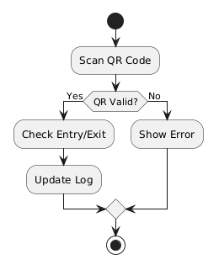

The above activity diagram represents the workflow of the QR Code Verification process in the Guest Lecture & Visit Management System (GLVMS). It illustrates how the system validates a visitor during entry and exit.
The process begins when the security personnel scans the QR code presented by the visitor. Once scanned, the system checks whether the QR code is valid through a decision point (QR Valid?).
- If the QR code is valid, the system proceeds to check whether the scan is for entry or exit. Based on this, the system updates the visitor’s record accordingly:
  - If it is the first scan, the entry time is recorded
  - If it is the second scan, the exit time is recorded
After verification, the system updates the log in the database, ensuring accurate tracking of visitor movement.
- If the QR code is invalid, the system displays an error message, preventing unauthorized access.
Finally, the process ends after either updating the log (valid case) or showing an error (invalid case).
This diagram clearly demonstrates the validation mechanism and ensures that only authorized visitors are allowed access while maintaining proper entry-exit records.
5.4 Screenshots of System:

Landing Page
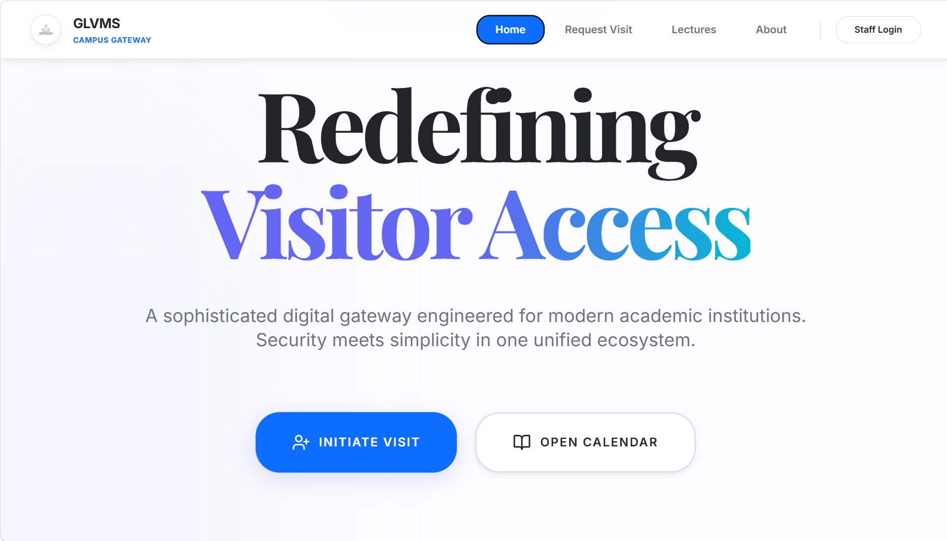

Login Page
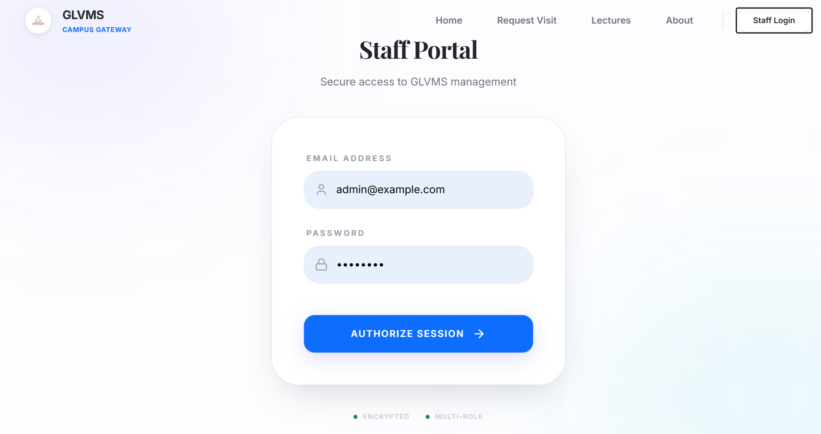

Visitor Registration Form
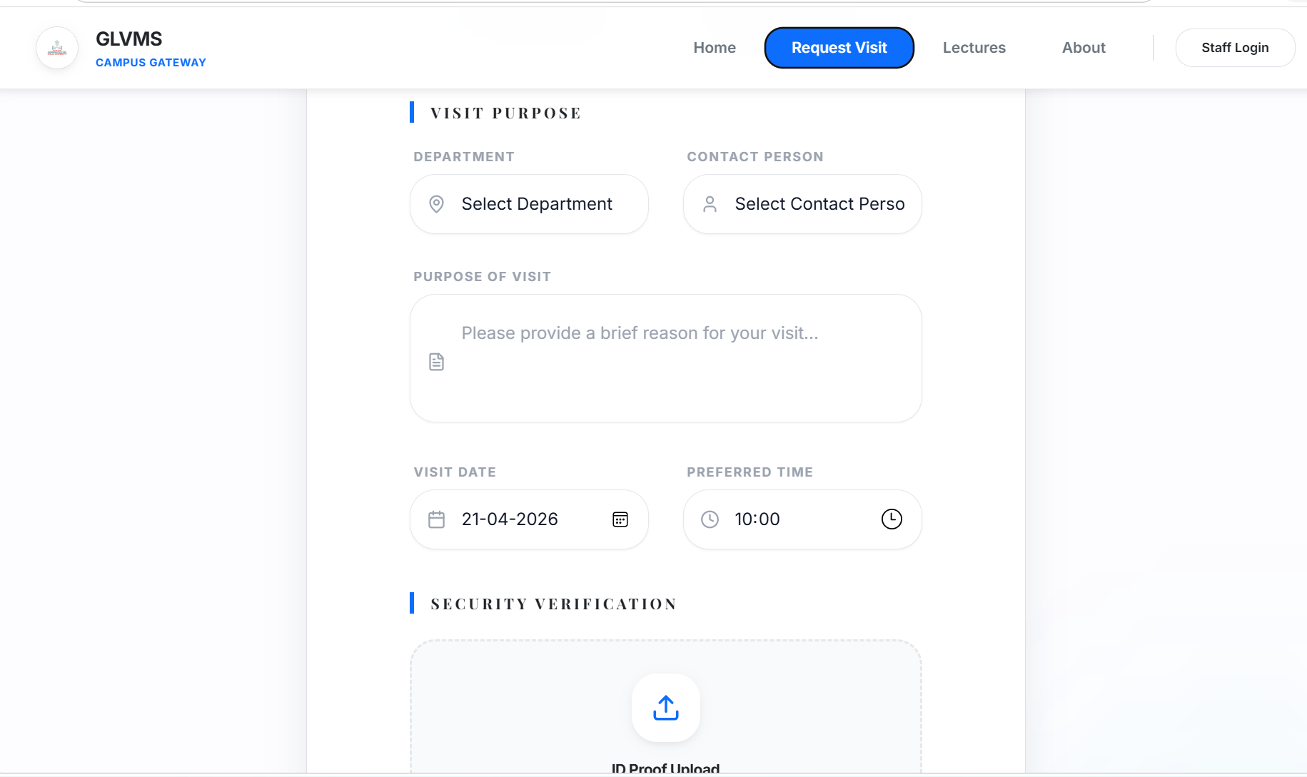

Admin Dashboard
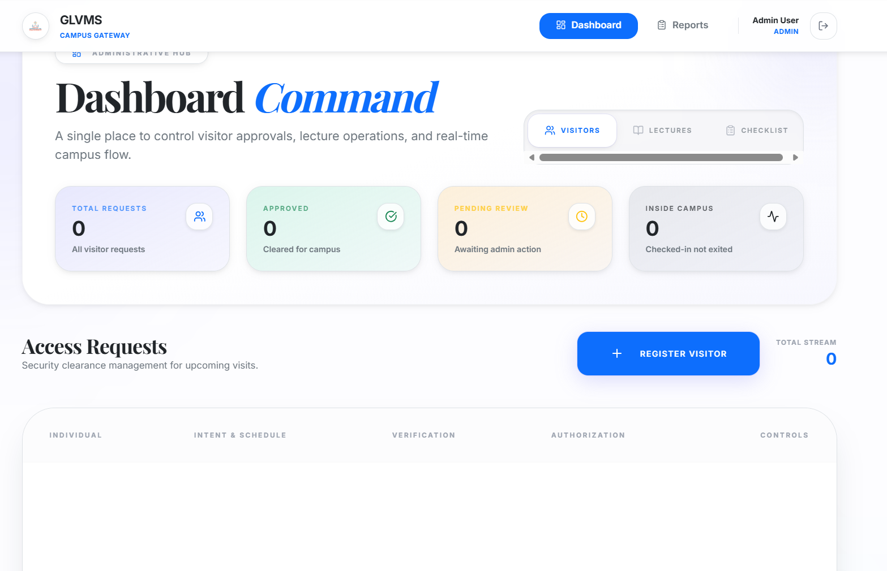

QR Scanner Page
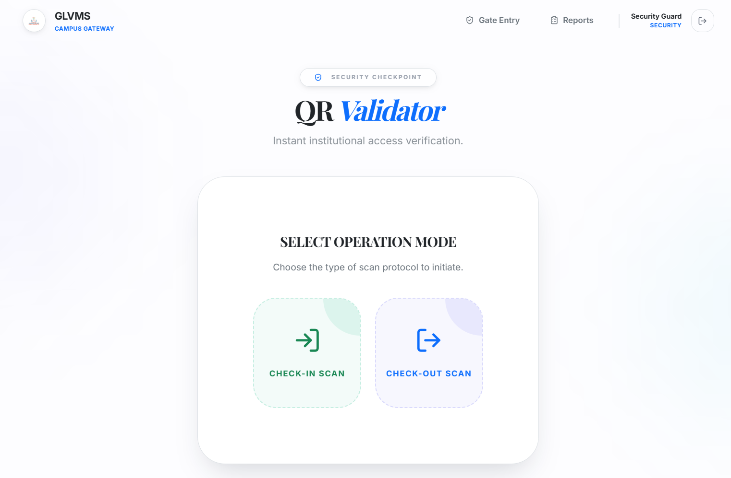

Lecture Management Page

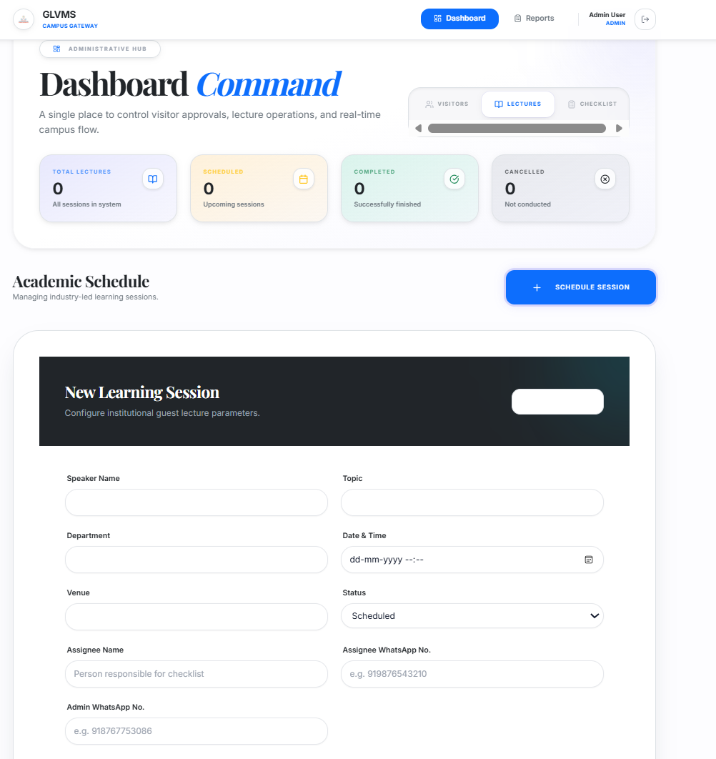

Checklist & Expense Page

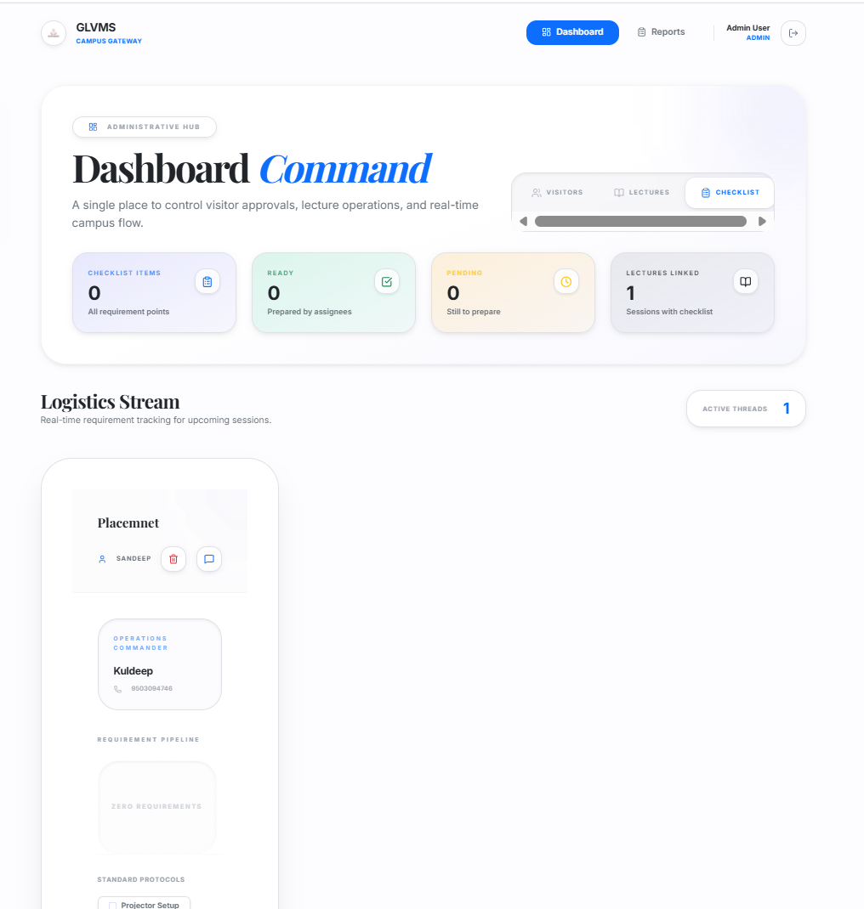

Chapter N0 06
Testing

6.1 Test Plan
The test plan defines the strategy and approach used to validate the functionality and performance of the Guest Lecture & Visit Management System (GLVMS). The main objective of testing is to ensure that all modules work correctly, meet the specified requirements, and are free from errors.

🔹 Testing Objectives
- To verify that all system functionalities work as expected
- To ensure secure and accurate QR-based verification
- To check system performance under normal usage
- To validate data storage and retrieval from the database

🔹 Testing Scope
The following modules are tested:
- Authentication Module
- Visitor Management Module
- QR Code Generation & Verification Module
- Lecture Management Module
- Checklist & Expense Module

🔹 Testing Approach
- Manual testing is performed for UI and workflows
- Functional testing is used to validate features
- End-to-end testing ensures complete system flow

6.2 Test Cases Table:
Test Case ID | Module | Input | Expected Output | Result
TC1 | Login | Valid credentials | User logged in successfully | Pass
TC2 | Login | Invalid credentials | Error message displayed | Pass
TC3 | Visitor Form | Valid data | Request submitted successfully | Pass
TC4 | Visitor Approval | Approve request | QR code generated | Pass
TC5 | QR Scan | Valid QR | Entry logged successfully | Pass
TC6 | QR Scan | Invalid QR | Error message displayed | Pass
TC7 | Lecture Module | Add lecture | Lecture added successfully | Pass
TC8 | Checklist | Update status | Status updated | Pass
TC9 | Expense Module | Add expense | Expense recorded | Pass
TC10 | Feedback | Submit feedback | Feedback saved | Pass

6.3 Types of Testing

🔹 1. Unit Testing
Unit testing is performed to test individual components or modules of the system independently. Each function or module is tested to ensure it works correctly.
Example:
- Testing login function
- Testing QR code generation

🔹 2. Integration Testing
Integration testing ensures that different modules of the system work together correctly. It checks data flow between components.
Example:
- Visitor request → Admin approval → QR generation
- QR scan → Database update

🔹 3. System Testing
System testing is performed on the complete system to verify that it meets all functional and non-functional requirements.
Example:
- Complete visitor flow from registration to exit
- Lecture creation to checklist completion

🔹 4. User Acceptance Testing (UAT)
User Acceptance Testing is performed by end users to ensure that the system meets real-world requirements and is easy to use.
Example:
- Admin testing dashboard usability
- Security testing QR scanning process
- Staff testing checklist and expense modules

Chapter N0 07
Future Scope
The Guest Lecture & Visit Management System (GLVMS) has been successfully developed to digitize visitor management and guest lecture coordination. However, there is significant scope for further enhancement to improve its functionality, security, scalability, and usability. The following points highlight the future scope of the system:

🔹 1. Biometric Authentication Integration
- The system can be enhanced by integrating biometric technologies such as fingerprint scanning and facial recognition
- This will provide an additional layer of security beyond QR codes
- It will help prevent misuse or duplication of QR codes
- Useful for high-security environments like research labs or restricted areas

🔹 2. Mobile Application Development
- A dedicated mobile application (Android/iOS) can be developed
- Visitors can register, receive QR codes, and track approvals directly from mobile
- Security personnel can scan QR codes more efficiently using mobile devices
- Improves accessibility and user experience

🔹 3. Advanced Notification System
- Integration with Email, SMS, and push notifications
- Real-time alerts for:
  - Visitor approval or rejection
  - Lecture scheduling updates
  - Entry reminders
- Improves communication between users

🔹 4. Cloud-Based Deployment
- The system can be deployed on cloud platforms (AWS, Azure, Google Cloud)
- Benefits include:
  - High availability
  - Data backup and recovery
  - Scalability for large user base
- Suitable for multi-campus or large institutions

🔹 5. Integration with Institutional Systems
- Integration with existing systems such as:
  - ERP systems
  - Student information systems
  - Faculty databases
- Reduces data duplication
- Enables seamless data exchange and automation

🔹 6. Advanced Analytics and Reporting
- Implementation of dashboards for:
  - Visitor statistics
  - Lecture performance analysis
  - Expense tracking reports
- Helps administrators in decision-making
- Can generate automated reports

🔹 7. Multi-Campus / Multi-Institution Support
- The system can be extended to support multiple campuses or institutions
- Centralized management for all branches
- Useful for universities with multiple locations

Chapter N0 08

CONCLUSION
7.1 Summary of Work
The Guest Lecture & Visit Management System (GLVMS) was successfully designed and developed as a web-based application to automate visitor entry management and guest lecture coordination within an institution. The system replaces traditional manual processes with a digital, structured, and efficient workflow.
The project includes key functionalities such as online visitor registration, admin approval system, QR code generation for secure entry, real-time entry and exit logging, and a dedicated module for managing guest lectures. Additional features like checklist management, expense tracking, and feedback collection enhance the overall usability and effectiveness of the system.
The system was developed using modern technologies including React.js for the frontend, Node.js and Express.js for the backend, and MySQL with Sequelize ORM for database management. A modular approach was followed to ensure scalability, maintainability, and smooth integration between different components.

7.2 Objectives Achieved
The project successfully achieved its intended objectives, including:
- Development of a centralized platform for visitor and lecture management
- Implementation of a secure QR-based entry system
- Automation of visitor approval and verification processes
- Efficient management of guest lectures, including scheduling and coordination
- Real-time tracking of visitor entry and exit
- Role-based access for Admin, Security, Staff, and Visitors
- Improved data accuracy and reduction in manual errors

7.3 Key Learnings
During the development of this project, several important technical and practical learnings were gained:
- Understanding of full-stack web development using React.js and Node.js
- Implementation of RESTful APIs and backend logic using Express.js
- Database design and management using MySQL and Sequelize ORM
- Integration of QR code technology for real-world applications
- Importance of modular system design for scalability and maintainability
- Experience in handling real-world problems and designing efficient solutions
- Improvement in debugging, testing, and problem-solving skills

Chapter 09
References
The following references were used during the development of the Guest Lecture & Visit Management System (GLVMS):

🔹 Books
- Web Technologies: HTML, CSS, JavaScript – Kogent Learning Solutions
- Node.js Web Development – David Herron
- Learning React – Alex Banks & Eve Porcello
- Database System Concepts – Abraham Silberschatz

🔹 Web Resources
- React Official Documentation – https://react.dev
- Node.js Official Documentation – https://nodejs.org
- Express.js Documentation – https://expressjs.com
- MySQL Documentation – https://dev.mysql.com/doc
- Sequelize ORM Documentation – https://sequelize.org
- Tailwind CSS Documentation – https://tailwindcss.com
- QR Code Generator Library – https://www.npmjs.com/package/qrcode

🔹 Tools & Platforms
- Visual Studio Code (Code Editor)
- Postman (API Testing Tool)
- GitHub (Version Control)
- MySQL Server (Database Management)
- Browser Developer Tools (Debugging)

🔹 Online Tutorials & Learning Platforms
- YouTube (Various educational channels)
- W3Schools – https://www.w3schools.com
- GeeksforGeeks – https://www.geeksforgeeks.org
- Stack Overflow – https://stackoverflow.com

