SmartBatch360
Industrial Batching Plant Management System
Project Overview • Module Structure • UI Preview
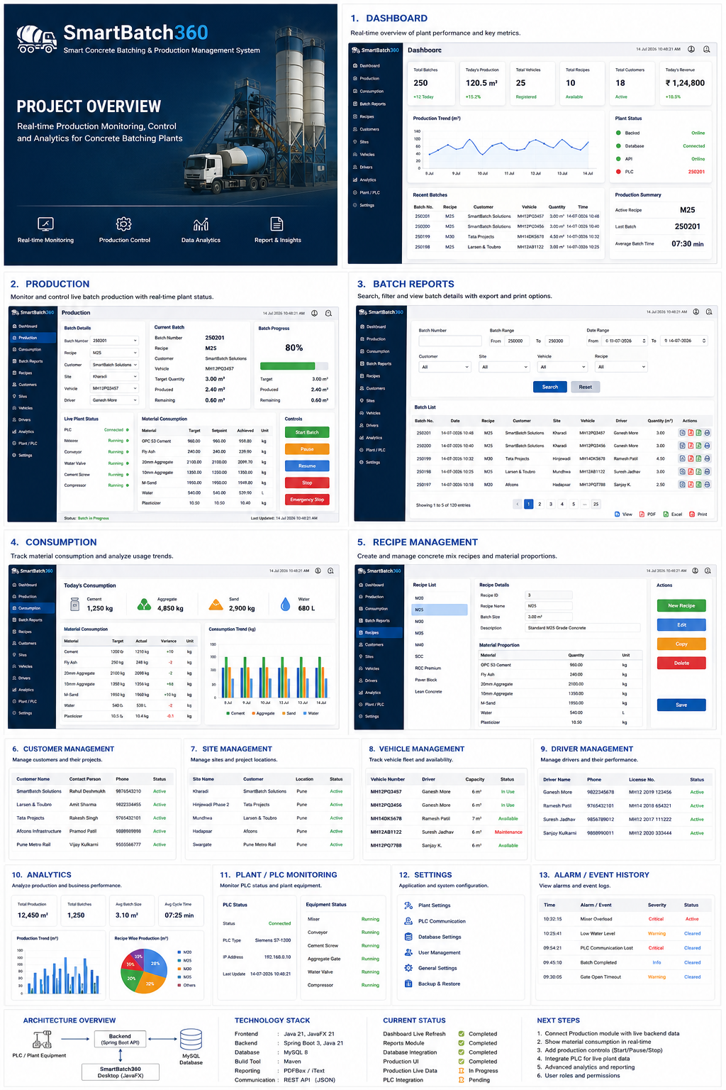
UI preview: The screenshots in this document are conceptual presentation mockups generated from the agreed SmartBatch360 module structure. They illustrate intended content and layout; they are not exact screenshots of the current running application.

1. Dashboard
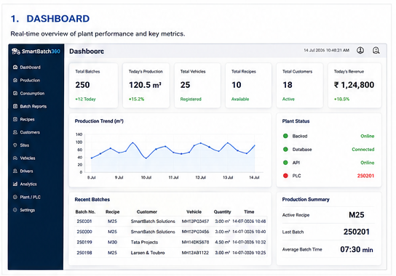
Purpose: Give operators and supervisors an immediate view of plant performance.
- KPI cards: total batches, today's production, vehicles, recipes, customers and revenue.
- Production trend and recent batch activity.
- Backend, database, API and PLC status.
- Active recipe, last batch and average batch time.
- Automatic refresh every 5 seconds in the current implementation.
UI preview: Conceptual dashboard layout showing the intended information hierarchy.

2. Production
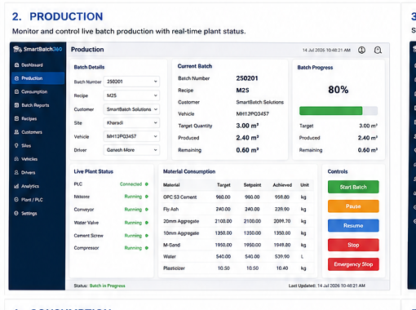
Purpose: Operate and monitor the current batch.
- Batch details: batch number, recipe, customer, site, vehicle and driver.
- Current batch target, produced and remaining quantity.
- Large production progress indicator.
- Live equipment status: mixer, conveyor, water valve, cement screw and compressor.
- Material target/setpoint/achieved values.
- Future batch controls: Start, Pause, Resume, Stop and Emergency Stop.
UI preview: The Production UI already exists in the project. Its current service uses sample data; the next step is connecting it to the existing backend.

3. Batch Reports
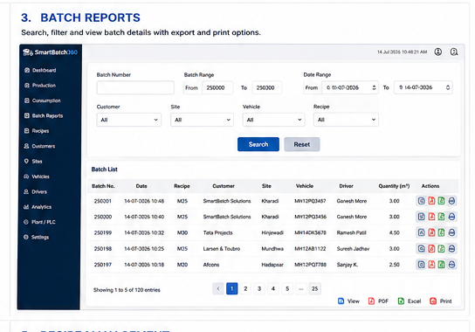
Purpose: Search, filter, review and export historical production.
- Batch number and batch-range filtering.
- Date range, customer, site, vehicle, driver and recipe filters.
- Pagination and sorting.
- Batch detail viewing.
- PDF, Excel and print actions as the reporting module is completed.
UI preview: The backend filtering foundation is already established around BatchData.

4. Material Consumption
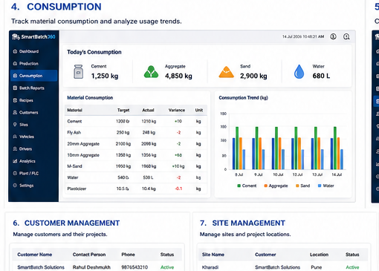
Purpose: Compare planned material usage with actual consumption.
- Daily, weekly and monthly consumption.
- Material-wise target versus actual.
- Variance and wastage analysis.
- Charts for cement, aggregates, sand, water and admixtures.
- Data sourced from the MAT1–MAT20 target/setpoint/achieved fields.

5. Recipe Management
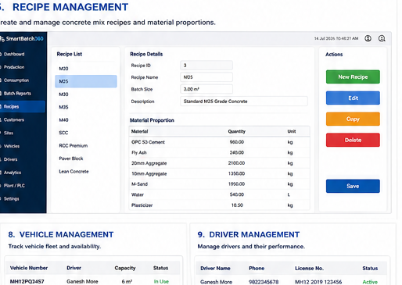
Purpose: Manage concrete mix recipes and material proportions.
- Recipe list and recipe details.
- Recipe ID, batch size and grade/description.
- Material proportions with quantities and units.
- Create, edit, copy and delete actions.
- Future recipe versioning and approval history.
UI preview: You already have a Recipe module; the presentation image shows the intended role of the module rather than replacing the existing implementation.

6. Master Data Modules
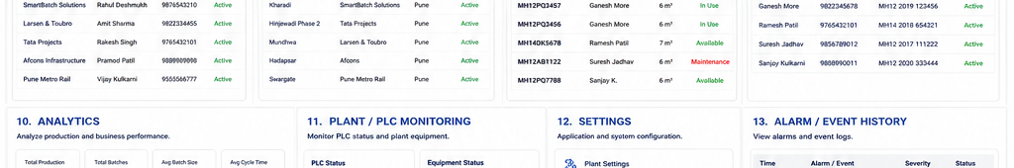
Customer, Site, Vehicle and Driver modules provide the master data used throughout production and reporting.
- Customers: customer details, projects and production history.
- Sites: project locations, customer relationship and site production.
- Vehicles: registration, capacity, driver assignment, status and history.
- Drivers: driver details, licence information, assignments and performance.

7. Analytics
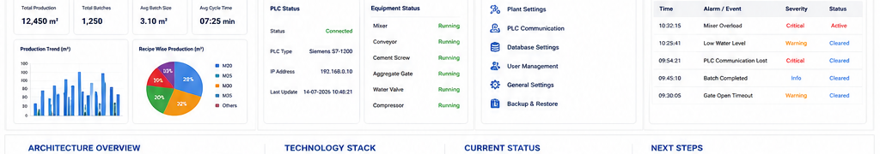
Analytics is intended for management-level production and efficiency analysis.
- Total production and batch count.
- Average batch size and cycle time.
- Production trends.
- Recipe-wise production.
- Customer-wise production.
- Plant efficiency and target-versus-actual analysis.

8. Plant / PLC Monitoring
- PLC connection status and diagnostics.
- Siemens S7-1200/S7-1500 and other communication methods as required.
- Mixer, conveyor, cement screw, aggregate gates, water valve and compressor status.
- Digital input/output and communication diagnostics.
- Live values will be connected after the software modules are stable.

9. Settings
Settings will centralize application and plant configuration.
- Plant information and capacity.
- PLC communication settings.
- Database and backup/restore settings.
- Application preferences and units.
- User management, roles and permissions.

10. Alarm / Event History
A dedicated operational history will record important plant events.
- Critical, warning and information events.
- Active and cleared status.
- Timestamped event history.
- Filtering by date, severity and event type.
- PLC and equipment alarms after PLC integration.

11. Architecture & Technology
Core architecture:
JavaFX Desktop → ApiClient / REST → Spring Boot → Spring Data JPA → MySQL
Future production integration:
PLC / Plant Equipment → Production/Backend layer → MySQL → REST API → JavaFX

12. Current Status & Next Steps
- Dashboard API connection: working.
- Dashboard JSON mapping: fixed.
- Dashboard live refresh: working at 5-second intervals.
- Batch Data / Reports backend: established.
- Production UI: built.
- Production backend connection: next major task.
- PLC integration: intentionally postponed until the software modules are stable.

SmartBatch360 — Project Overview

