COMPONENTS:-
1) PROPS : variables of component template(attributes and their values)
2) STATE : state of template , eg. heading state of form is "HARRY"
=>ES7 wala extension ko pdhna h for using shortcuts in react :
ifc=>import function base component
icc=>import class base component
=>Export : 1) by default 2) by name : using {a,b,c}
=Proptype :
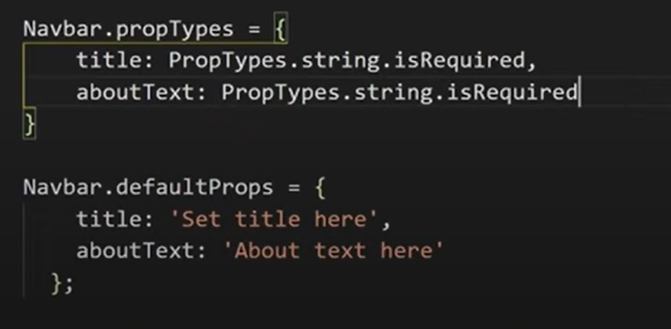
on 7th video

