Use case diagrams:-



Admin use case diagram:-



BOY USE CASE DIAGRAM:-



**Customer use case diagram:-**



**SEQUENCE DIAGRAMS:-**







**Collaboration diagram:-**







**Activity Diagrams:-**







**Component diagram:-**

**Component Diagram:**

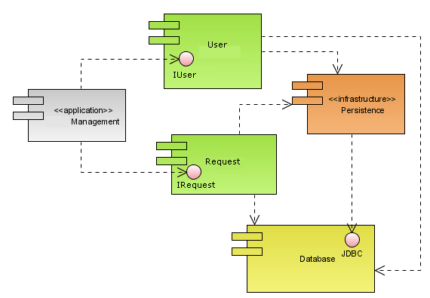

**Deployment Diagram**

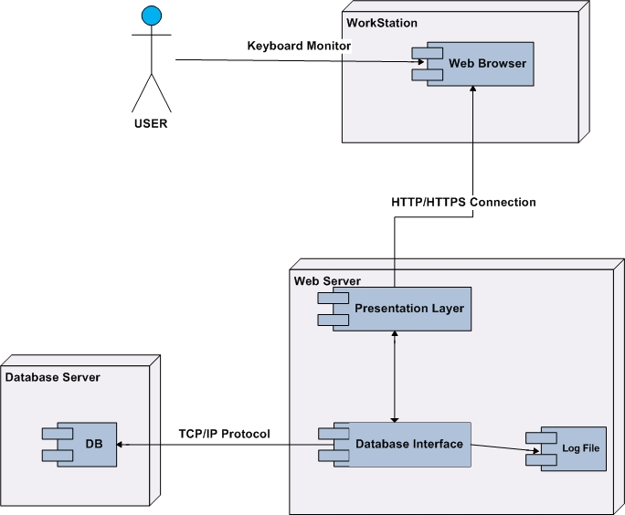

**Deployment diagram:-**

**Class diagram:-**

