(a) Auto grader

**my_learned_tree(max depth 3)**

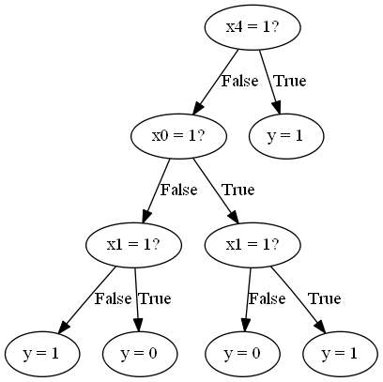

+-- [SPLIT: x4 = 1 False] Test Error of Monk-1 problem = 16.67%.

| +-- [SPLIT: x0 = 1 False] Training Error of Monk-1 problem= 8.87%.

| | +-- [SPLIT: x1 = 1 False]

| | | +-- [LABEL = 1]

| | +-- [SPLIT: x1 = 1 True]

| | | +-- [LABEL = 0]

| +-- [SPLIT: x0 = 1 True]

| | +-- [SPLIT: x1 = 1 False]

| | | +-- [LABEL = 0]

| | +-- [SPLIT: x1 = 1 True]

| | | +-- [LABEL = 1]

+-- [SPLIT: x4 = 1 True]

| +-- [LABEL = 1]

(b) Plots:

Monk’s-1

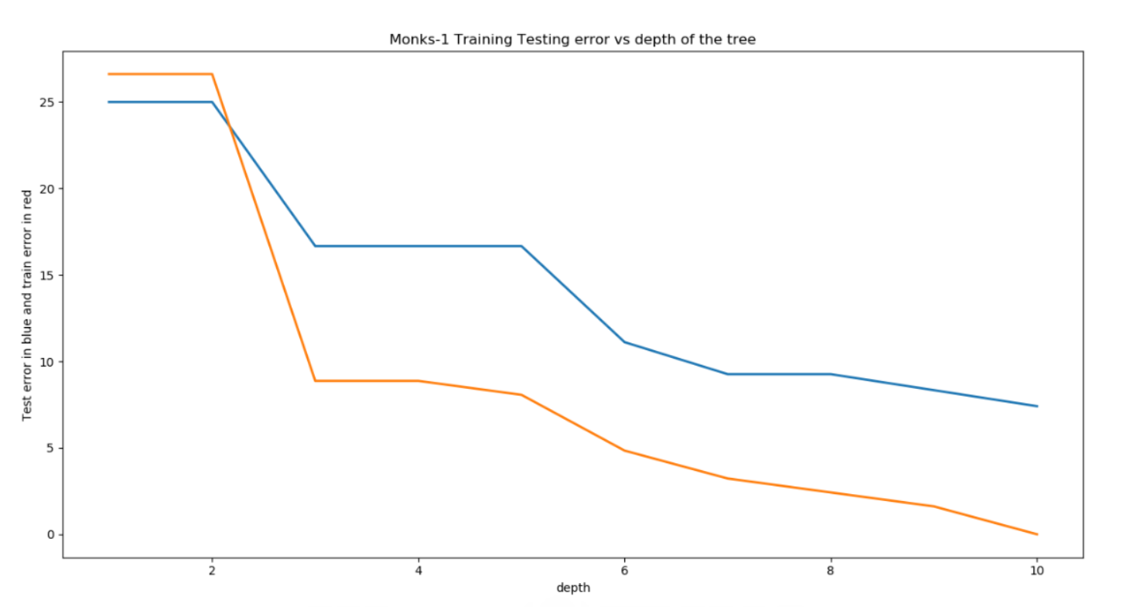

Monk’s-2

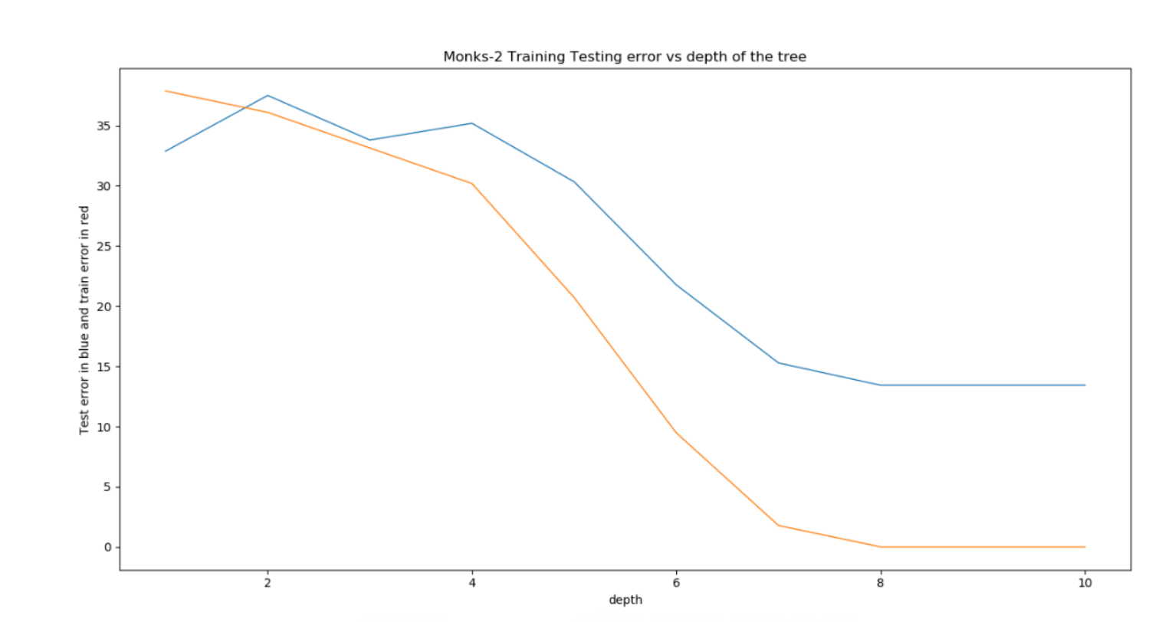

Monk’s -3

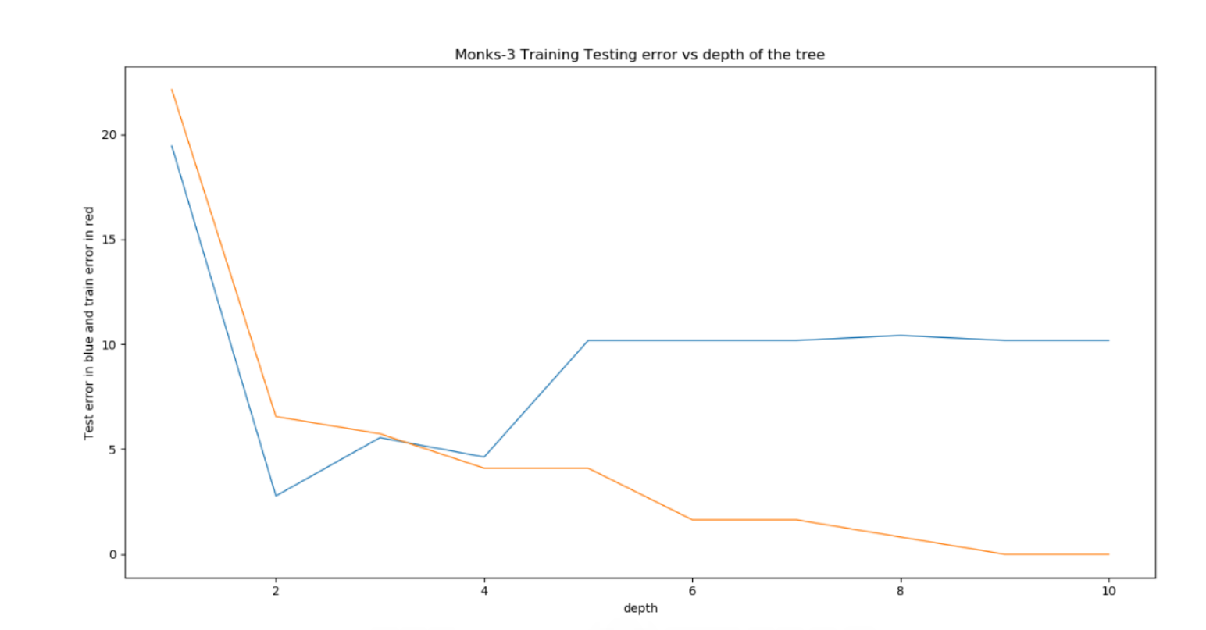

(c) Monk’s-1

Decision tree with depth 1:

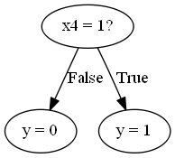

Confusion Matrix: Accuracy: 75.00%

[[216 0]

[108 108]]

Decision tree with depth 3:

Confusion Matrix:

[[144 72]

[ 0 216]]

Accuracy: 83.33%.

Decision Tree with depth 5:

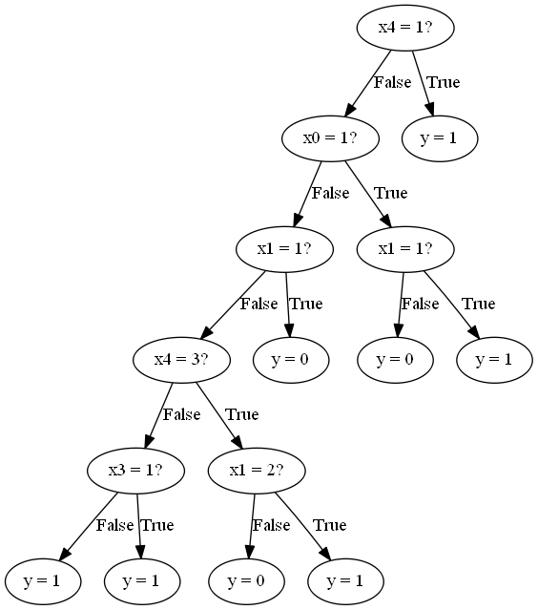

Confusion Matrix: Accuracy: 83.33%

[[156 60]

[ 12 204]]

(d) Scikit-Learn’s Decision Tree:

Tree with depth1:

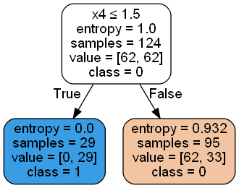 Confusion Matrix:

[[216 0]

[108 108]]

Accuracy: 75.0%

Tree with depth 3:

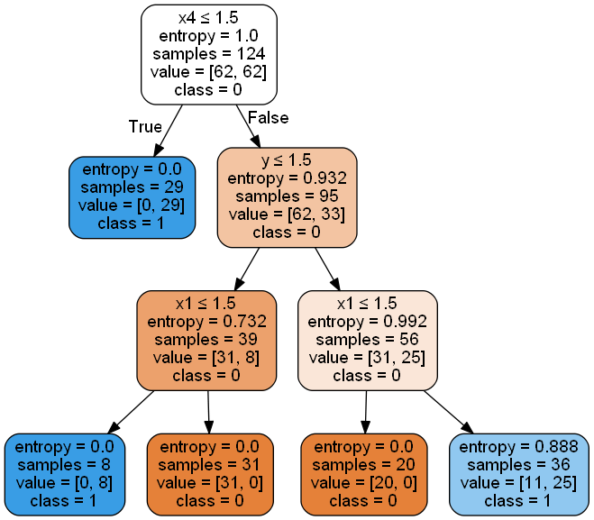

Confusion Matrix: Accuracy: 83.33%

[[144 72]

[0 216]]

Tree with Depth 5:

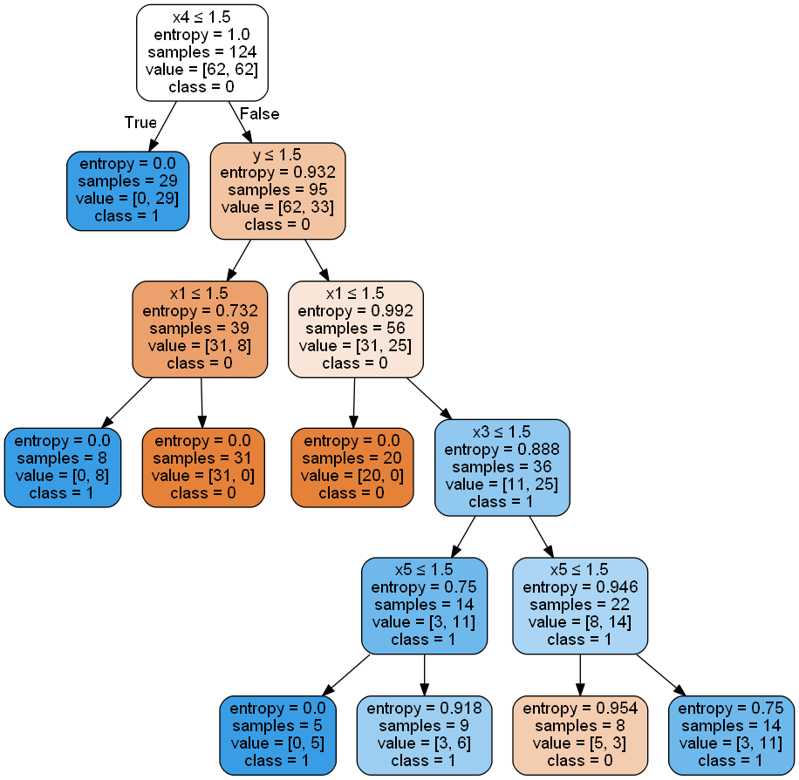

Confusion Matrix: Accuracy: 83.33%

[[168 48]

[ 24 192]]

(e) Other Data Sets(mushroom.test, mushroom.train):

My Learned Tree:

Depth 1:

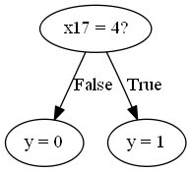 Confusion Matrix depth_1:

[[981 206]

[ 51 793]]

Accuracy = 87.35%.

Depth 3:

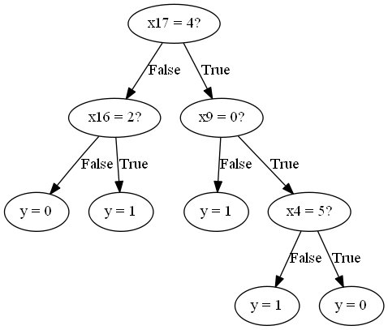

Confusion Matrix for mushroom_depth_3:

[[1130 57]

[ 29 815]]

Accuracy: 95.77%

Depth 5:

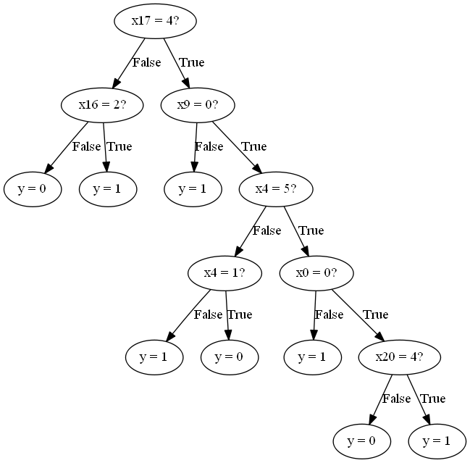

Confusion Matrix for mushroom_depth_5:

[[1183 4]

[0 844]]

Accuracy = 99.80%.

Scikit-Learn’s tree

Scikit_mushroom_depth_1:

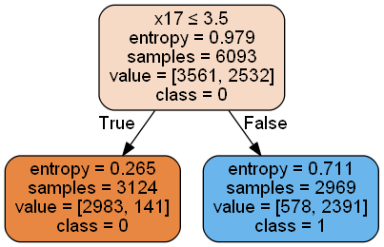

Accuracy : 87.34%

Confusion Matrix for depth:

[[981 206]

[ 51 793]]

Scikit_mushroom_depth_3:

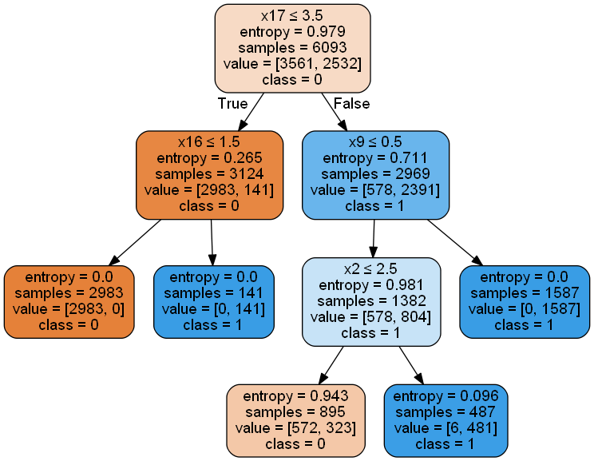

Accuracy for depth: 94.14%

Confusion Matrix :

[[1185 2]

[ 117 727]]

Scikit_mushroom_depth_5:

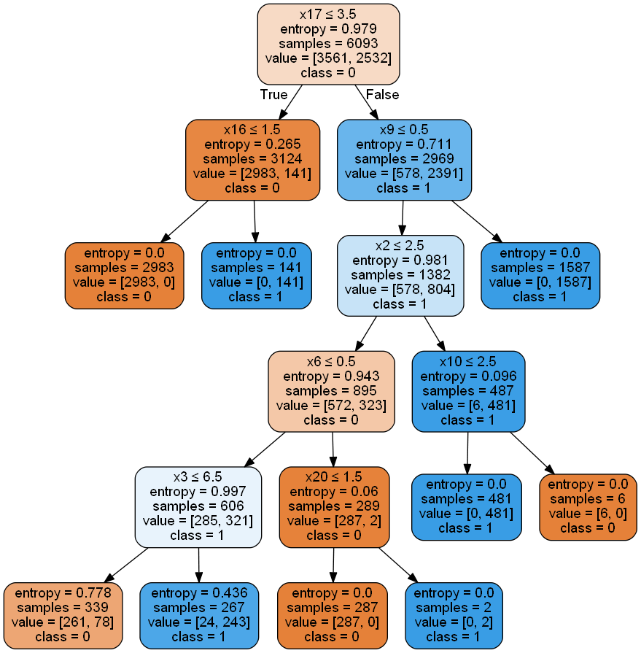

Accuracy for depth: 98.33%

Confusion Matrix:

[[1179 8]

[ 26 818]]

Discussion: For the monk’s data my learning tree and scikit learn tree have the same results. It validates our decision tree properly .For other data set also two learning has almost the same result.