HEART DISEASE PREDICTION SYSTEM
Name: SURAJIT GIRI
Group Members: SURAJIT GIRI & SURAJIT DAS
College: HALDIA INSTITUTE OF TECHNOLOGY

1. Introduction
This project aims to develop a machine learning based web application that predicts whether a person is likely to suffer from heart disease based on medical parameters.

2. Objectives
- Build ML model
- Create web frontend
- Predict disease
- Improve healthcare support

3. Dataset Description
The dataset contains medical attributes such as age, blood pressure, cholesterol, BMI, glucose etc.

4. Algorithm Used
Logistic Regression

5. System Architecture
User Input → Streamlit UI → ML Model → Prediction

6. Implementation Steps
1. Data Collection
2. Data Cleaning
3. Model Training
4. Saving Model
5. Frontend Development
6. Testing

7. Screenshots
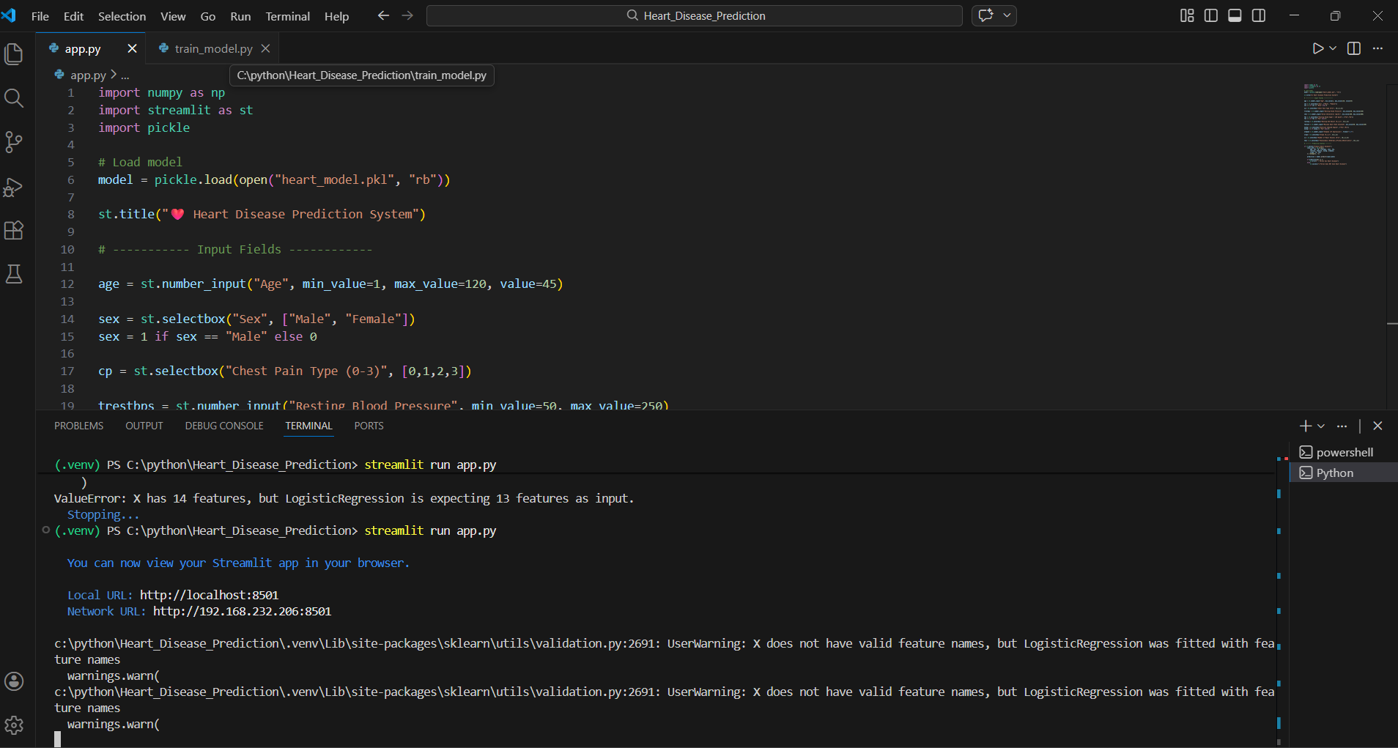
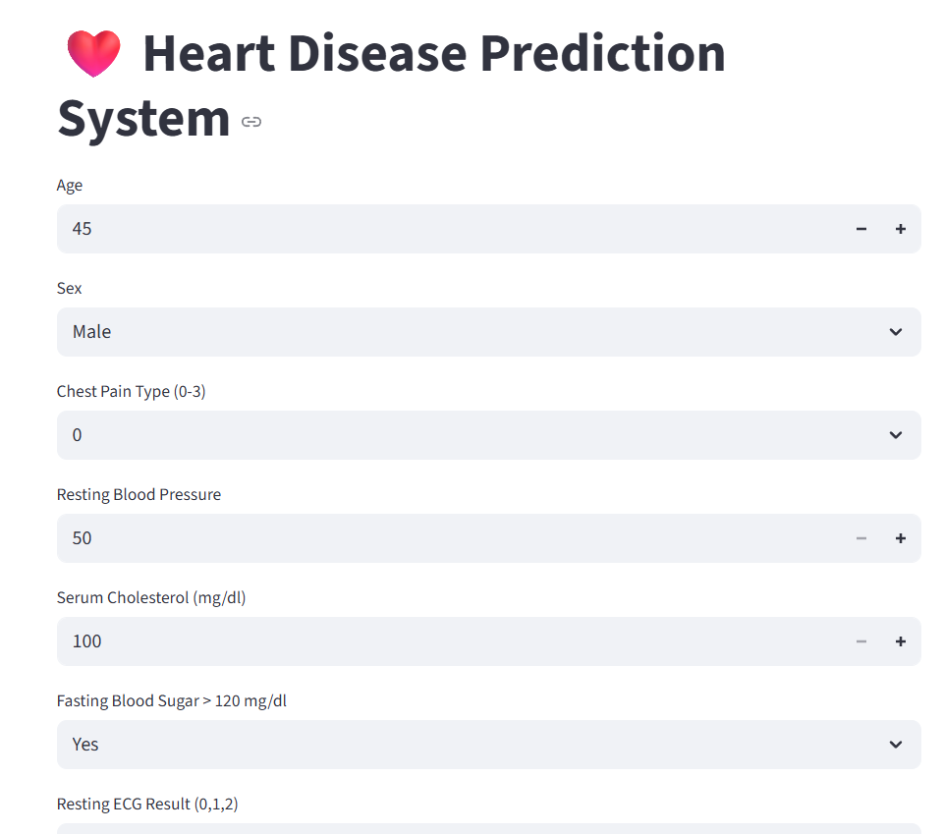
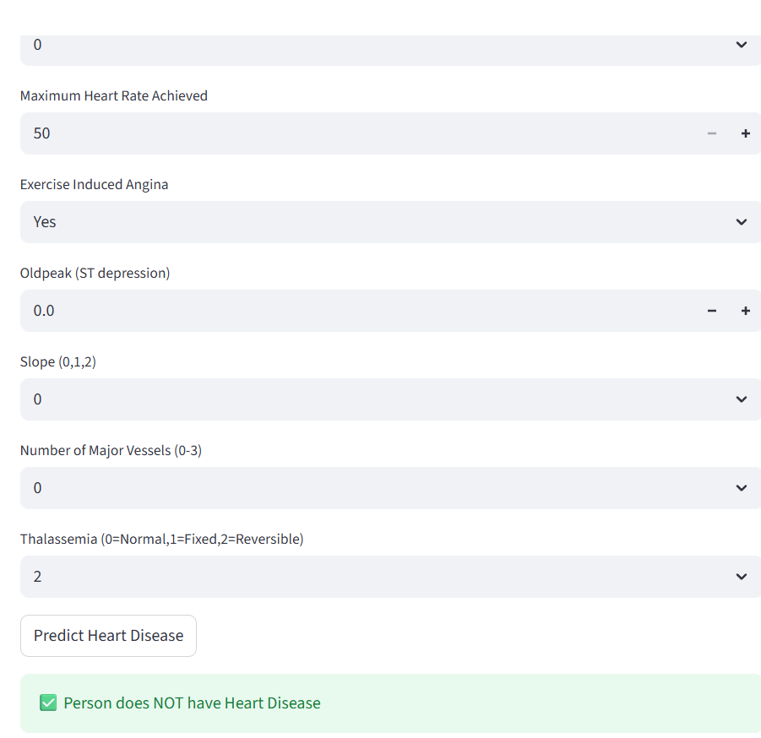

8. Performance Metrics
Accuracy: 87%
Precision: 85%
Recall: 86%
F1 Score: 85%

9. Future Scope
Deep learning, mobile app, cloud deployment

