SQL Aggregate Functions in SQL*Plus (Oracle) & MySQL

Aggregate functions perform calculations on multiple rows and return a **single** value. These functions are useful in **summarizing** data, such as totals, averages, counts, etc.

Below are detailed examples covering all aggregate functions in **SQL*Plus (Oracle)** and

**MySQL**.

# Aggregate Functions in SQL*Plus (Oracle)

## SUM() – Total of a Column

SELECT SUM(salary) AS total_salary FROM employees; -- Total salary of all employees

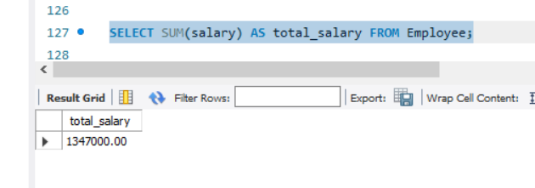

SELECT department_id, SUM(salary) FROM employees GROUP BY department_id; -- Total salary per department

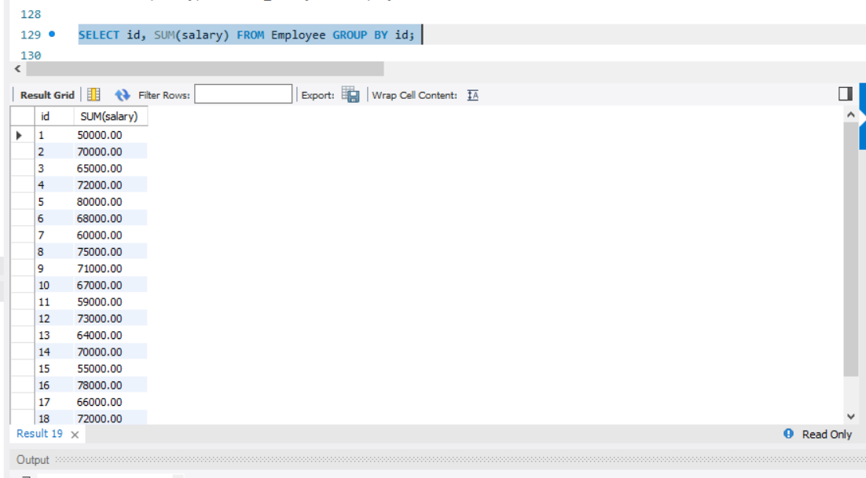

## AVG() – Average of a Column

SELECT AVG(salary) AS avg_salary FROM employees; -- Average salary

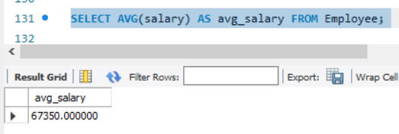

SELECT department_id, AVG(salary) FROM employees GROUP BY department_id; -- Average salary per department

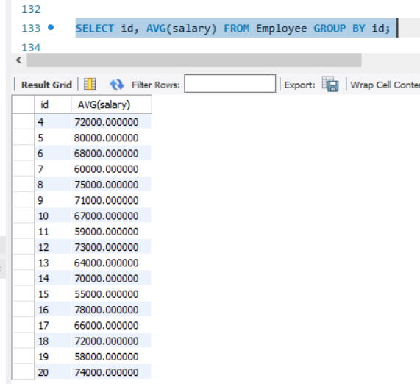

## COUNT() – Counting Rows

SELECT COUNT(*) FROM employees; -- Total number of employees

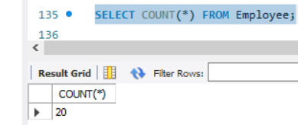

SELECT COUNT(employee_id) FROM employees WHERE department_id = 10; -- Count employees in department 10

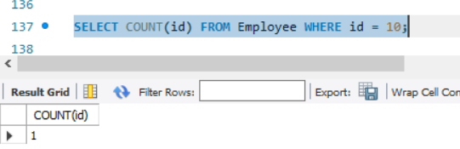

SELECT department_id, COUNT(*) FROM employees GROUP BY department_id;

-- Count per department

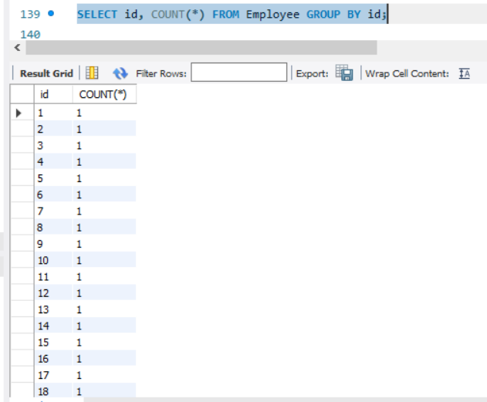

## MAX() – Maximum Value

SELECT MAX(salary) FROM employees; -- Highest salary in the company

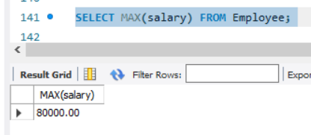

SELECT department_id, MAX(salary) FROM employees GROUP BY department_id; -- Highest salary per department

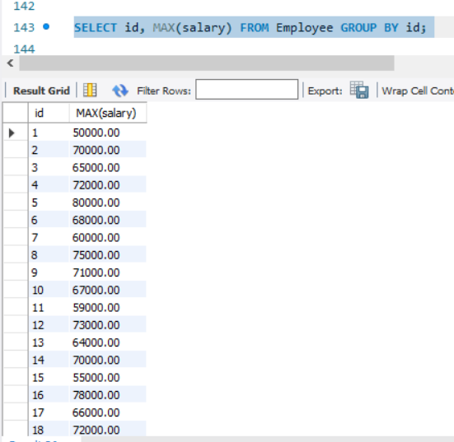

## MIN() – Minimum Value

SELECT MIN(salary) FROM employees; -- Lowest salary in the company

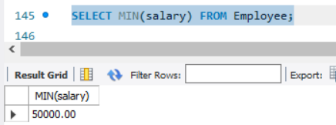

SELECT department_id, MIN(salary) FROM employees GROUP BY department_id; -- Lowest salary per department

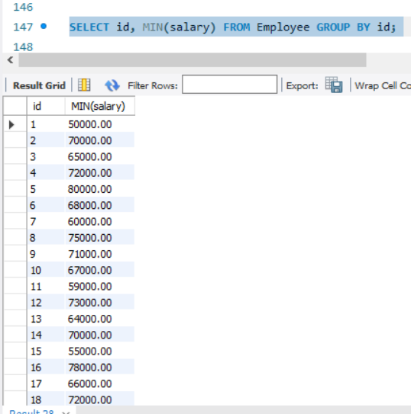

## MEDIAN() – Median Value (Oracle-Only)

SELECT MEDIAN(salary) FROM employees; -- Median salary of all employees

## STDDEV() – Standard Deviation

SELECT STDDEV(salary) FROM employees; -- Standard deviation of salaries

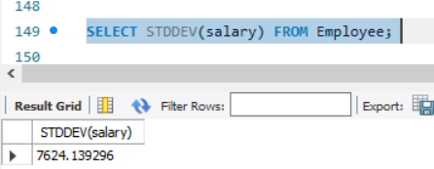

SELECT department_id, STDDEV(salary) FROM employees GROUP BY department_id; -- Std deviation per department

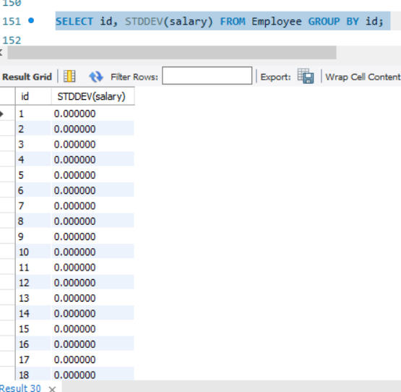

## VARIANCE() – Variance of a Column

SELECT VARIANCE(salary) FROM employees; -- Variance of salaries

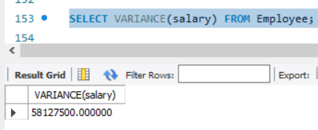

## GROUP BY with Aggregate Functions

SELECT department_id, COUNT(*), AVG(salary), MAX(salary), MIN(salary) FROM employees

GROUP BY department_id; -- Aggregate calculations per department

## HAVING Clause (Filtering Groups)

SELECT department_id, COUNT(*) AS employee_count FROM employees

GROUP BY department_id

HAVING COUNT(*) > 5; -- Only departments with more than 5 employees

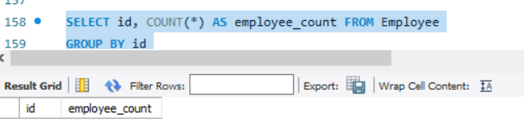

# Aggregate Functions in MySQL

## SUM() – Total of a Column

SELECT SUM(salary) AS total_salary FROM employees; -- Total salary of all employees

SELECT department_id, SUM(salary) FROM employees GROUP BY department_id; -- Total salary per department

## AVG() – Average of a Column

SELECT AVG(salary) AS avg_salary FROM employees; -- Average salary SELECT department_id, AVG(salary) FROM employees GROUP BY department_id; -- Average salary per department

## COUNT() – Counting Rows

SELECT COUNT(*) FROM employees; -- Total number of employees

SELECT COUNT(employee_id) FROM employees WHERE department_id = 10; -- Count employees in department 10

SELECT department_id, COUNT(*) FROM employees GROUP BY department_id;

-- Count per department

## MAX() – Maximum Value

SELECT MAX(salary) FROM employees; -- Highest salary in the company SELECT department_id, MAX(salary) FROM employees GROUP BY department_id; -- Highest salary per department

## MIN() – Minimum Value

SELECT MIN(salary) FROM employees; -- Lowest salary in the company SELECT department_id, MIN(salary) FROM employees GROUP BY department_id; -- Lowest salary per department

## STDDEV() – Standard Deviation

SELECT STDDEV(salary) FROM employees; -- Standard deviation of salaries

SELECT department_id, STDDEV(salary) FROM employees GROUP BY department_id; -- Std deviation per department

## VARIANCE() – Variance of a Column

SELECT VARIANCE(salary) FROM employees; -- Variance of salaries

## GROUP BY with Aggregate Functions

SELECT department_id, COUNT(*), AVG(salary), MAX(salary), MIN(salary) FROM employees

GROUP BY department_id; -- Aggregate calculations per department

## HAVING Clause (Filtering Groups)

SELECT department_id, COUNT(*) AS employee_count FROM employees

GROUP BY department_id

HAVING COUNT(*) > 5; -- Only departments with more than 5 employees

# Key Differences Between SQL*Plus (Oracle) and MySQL Aggregate Functions

|  |  |  |
| --- | --- | --- |
| **Feature** | **Oracle (SQL*Plus)** | **MySQL** |
| Basic Aggregate Functions | SUM(), AVG(), COUNT(), MAX(), MIN() | SUM(), AVG(), COUNT(), MAX(), MIN() |
| Median Calculation | MEDIAN() | Not available (requires workaround) |
| Standard Deviation | STDDEV() | STDDEV() |
| Variance Calculation | VARIANCE() | VARIANCE() |
| Handling NULL values | Ignores NULL values in aggregate functions | Ignores NULL values in aggregate functions |
| HAVING Clause | Used after GROUP BY | Used after GROUP BY |
| GROUP BY | Used to group and aggregate | Used to group and aggregate |

1. **Special Notes**

* **Oracle** provides the **MEDIAN()** function, but **MySQL does not**. In MySQL, median must be calculated using a workaround.
* **Both** ignore NULL values when computing aggregates unless explicitly handled.
* **HAVING** is used **after GROUP BY** to filter aggregated results in both Oracle and MySQL.