# SQL Date Data Types

**MySQL** comes with the following data types for storing a date or a date/time value in the database:

* DATE - format YYYY-MM-DD
* DATETIME - format: YYYY-MM-DD HH:MI:SS
* TIMESTAMP - format: YYYY-MM-DD HH:MI:SS
* YEAR - format YYYY or YY

**SQL Server** comes with the following data types for storing a date or a date/time value in the database:

* DATE - format YYYY-MM-DD
* DATETIME - format: YYYY-MM-DD HH:MI:SS
* SMALLDATETIME - format: YYYY-MM-DD HH:MI:SS
* TIMESTAMP - format: a unique number

Note: The date datatypes are chosen for a column when you create a new table in your database!

# SQL Working with Dates

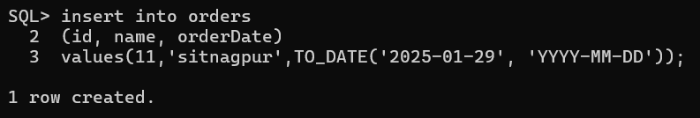You need to create table,or alter table with date attribute. Following is the query sample to use **date datatype**

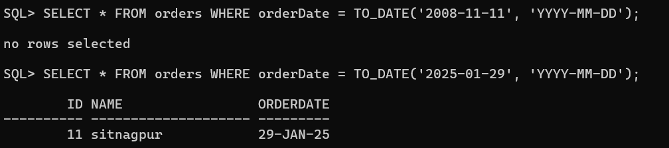

Look at the following table:

Orders Table

|  |  |  |
| --- | --- | --- |
| **OrderId** | **ProductName** | **OrderDate** |
| 1 | Geitost | 2008-11-11 |
| 2 | Camembert Pierrot | 2008-11-09 |
| 3 | Mozzarella di Giovanni | 2008-11-11 |
| 4 | Mascarpone Fabioli | 2008-10-29 |

Now we want to select the records with an OrderDate of "2008-11-11" from the table above.

We use the following SELECT statement:

SELECT * FROM Orders WHERE OrderDate='2008-11-11'

The result-set will look like this:

**OrderId ProductName OrderDate**

1 Geitost 2008-11-11

3 Mozzarella di Giovanni 2008-11-11

Note: Two dates can easily be compared if there is no time component involved!

Now, assume that the "Orders" table looks like this (notice the added time-component in the "OrderDate" column):

|  |  |  |
| --- | --- | --- |
| **OrderId** | **ProductName** | **OrderDate** |
| 1 | Geitost | 2008-11-11 13:23:44 |
| 2 | Camembert Pierrot | 2008-11-09 15:45:21 |

1. Mozzarella di Giovanni 2008-11-11 11:12:01
2. Mascarpone Fabioli 2008-10-29 14:56:59 If we use the same SELECT statement as above:

SELECT * FROM Orders WHERE OrderDate='2008-11-11'

we will get no result! This is because the query is looking only for dates with no time portion.

**Date Functions Samples for you to execute with all possible types:**

1. **ORACLE SQL (SQLPLUS) Date Functions**

## Getting the Current Date and Time

SELECT SYSDATE FROM dual; -- Returns the current date and time SELECT SYSTIMESTAMP FROM dual; -- Returns the current date and timestamp (including fractional seconds and time zone)

## Formatting Dates (TO_CHAR)

SELECT TO_CHAR(SYSDATE, 'YYYY-MM-DD HH24:MI:SS') FROM dual; -- Format

date as string

SELECT TO_CHAR(SYSDATE, 'DD-MON-YYYY') FROM dual; -- Example: 29-JAN-2025

SELECT TO_CHAR(SYSDATE, 'Day, Month DD, YYYY') FROM dual; -- Example:

Tuesday, January 29, 2025

## Converting Strings to Dates (TO_DATE)

SELECT TO_DATE('2025-01-29', 'YYYY-MM-DD') FROM dual; -- Convert

string to date

SELECT TO_DATE('29-JAN-25', 'DD-MON-RR') FROM dual; -- Uses RR format

for 2-digit year

## Date Arithmetic

SELECT SYSDATE + 7 FROM dual; -- Adds 7 days SELECT SYSDATE - 7 FROM dual; -- Subtracts 7 days

SELECT SYSDATE + INTERVAL '2' MONTH FROM dual; -- Adds 2 months SELECT SYSDATE + INTERVAL '5' YEAR FROM dual; -- Adds 5 years

## Extracting Date Parts

SELECT EXTRACT(YEAR FROM SYSDATE) FROM dual; -- Returns year SELECT EXTRACT(MONTH FROM SYSDATE) FROM dual; -- Returns month SELECT EXTRACT(DAY FROM SYSDATE) FROM dual; -- Returns day

## Finding the First and Last Day of the Month

SELECT TRUNC(SYSDATE, 'MM') FROM dual; -- First day of the current month

SELECT LAST_DAY(SYSDATE) FROM dual; -- Last day of the current month

## Difference Between Two Dates (MONTHS_BETWEEN)

SELECT MONTHS_BETWEEN(TO_DATE('2025-12-31', 'YYYY-MM-DD'), SYSDATE)

FROM dual; -- Returns the difference in months

## Adding Time Components

SELECT SYSTIMESTAMP + INTERVAL '5' HOUR FROM dual; -- Adds 5 hours SELECT SYSTIMESTAMP + INTERVAL '30' MINUTE FROM dual; -- Adds 30

minutes

SELECT SYSTIMESTAMP + INTERVAL '10' SECOND FROM dual; -- Adds 10

seconds

1. **MySQL Date Functions**

## Getting the Current Date and Time

SELECT NOW(); -- Current date and time

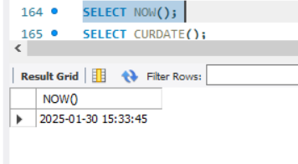

SELECT CURDATE(); -- Current date only

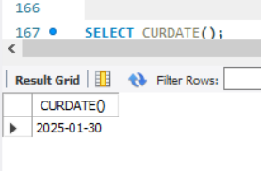

SELECT CURTIME(); -- Current time only

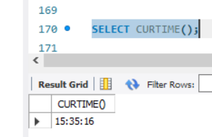

## Formatting Dates (DATE_FORMAT)

SELECT DATE_FORMAT(NOW(), '%Y-%m-%d %H:%i:%s'); -- Example: 2025-01-29

14:30:00

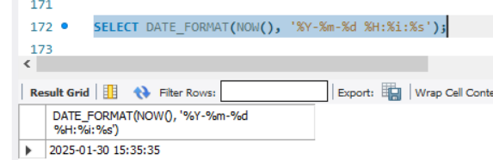

SELECT DATE_FORMAT(NOW(), '%W, %M %d, %Y'); -- Example: Tuesday,

January 29, 2025

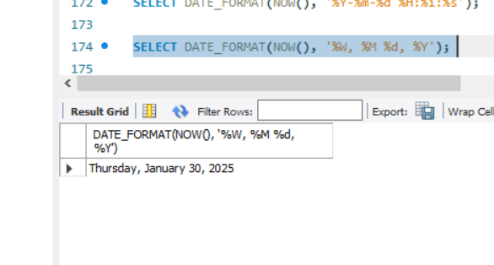

## Converting Strings to Dates (STR_TO_DATE)

SELECT STR_TO_DATE('29-01-2025', '%d-%m-%Y'); -- Convert string to

Date

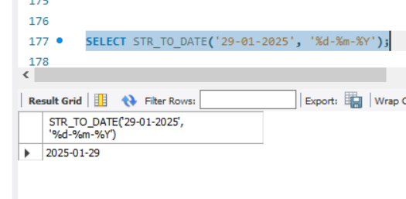

SELECT STR_TO_DATE('2025-01-29 14:30:00', '%Y-%m-%d %H:%i:%s'); --

Convert string to datetime

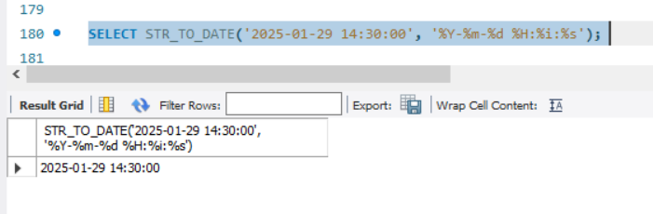

## Date Arithmetic

SELECT NOW() + INTERVAL 7 DAY; -- Adds 7 days

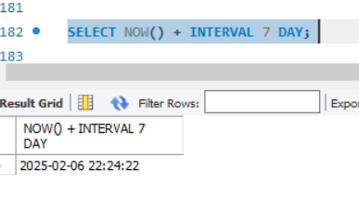

SELECT NOW() - INTERVAL 7 DAY; -- Subtracts 7 days

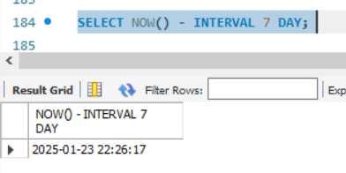

SELECT NOW() + INTERVAL 2 MONTH; -- Adds 2 months

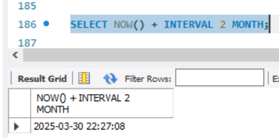

SELECT NOW() + INTERVAL 5 YEAR; -- Adds 5 years

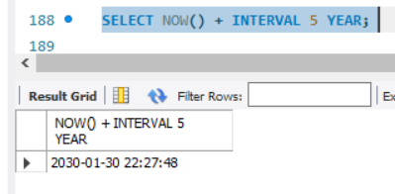

## Extracting Date Parts

SELECT YEAR(NOW()); -- Returns the current year

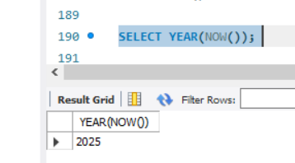

SELECT MONTH(NOW()); -- Returns the current month

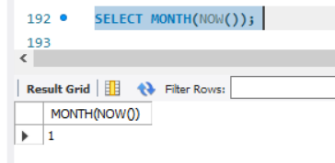

SELECT DAY(NOW()); -- Returns the current day

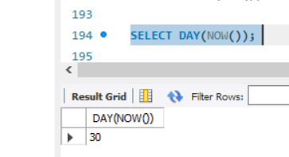

## Finding the First and Last Day of the Month

SELECT DATE_FORMAT(NOW(), '%Y-%m-01'); -- First day of the current month

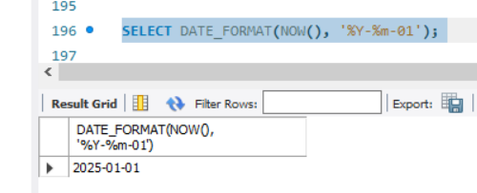

SELECT LAST_DAY(NOW()); -- Last day of the current month

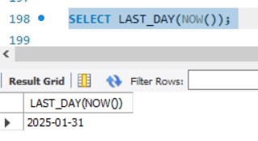

## Difference Between Two Dates (TIMESTAMPDIFF)

SELECT TIMESTAMPDIFF(MONTH, '2025-01-01', '2025-12-31'); -- Returns 11

Months

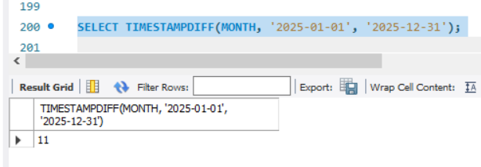

## Adding Time Components

SELECT NOW() + INTERVAL 5 HOUR; -- Adds 5 hours

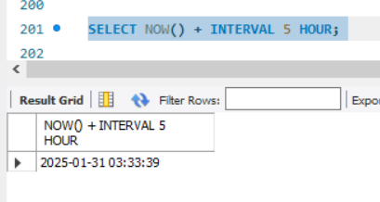

SELECT NOW() + INTERVAL 30 MINUTE; -- Adds 30 minutes

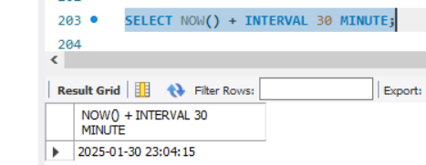

SELECT NOW() + INTERVAL 10 SECOND; -- Adds 10 seconds

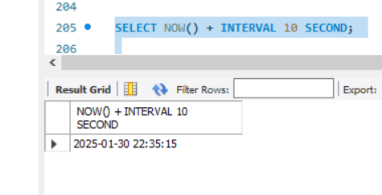

**Key Differences Between SQL*Plus (Oracle) and MySQL**

|  |  |  |
| --- | --- | --- |
| **Feature** | **Oracle (SQL*Plus)** | **MySQL** |
| Current Date | SYSDATE | NOW() |
| Formatting Dates | TO_CHAR(date, 'format') | DATE_FORMAT(date, 'format') |
| String to Date Conversion | TO_DATE(string, 'format') | STR_TO_DATE(string, 'format') |
| Date Arithmetic | SYSDATE + INTERVAL 'X' UNIT | NOW() + INTERVAL X UNIT |
| Extracting Date Parts | EXTRACT(part FROM date) | YEAR(), MONTH(), DAY() |
| First/Last Day of Month | TRUNC(SYSDATE, 'MM'), LAST_DAY(SYSDATE) | DATE_FORMAT(NOW(),  '%Y-%m-01'), LAST_DAY(NOW()) |