**Name.Surajit Halder**

**PRN.24070521509**

**SEC.B2**

**Simple Tasks for Practice**

**1.Write a BASIC LOOP to print numbers from 1 to 10.**

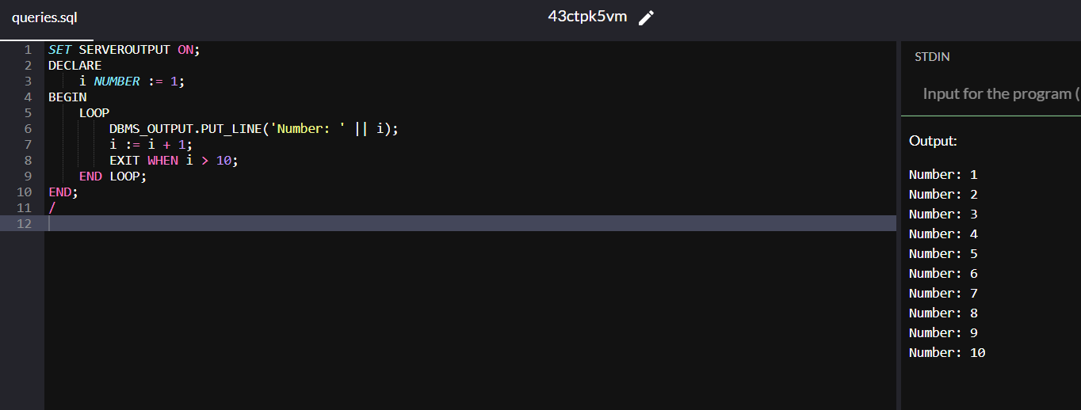

**2.Modify the WHILE LOOP to print even numbers from 2 to 10.**

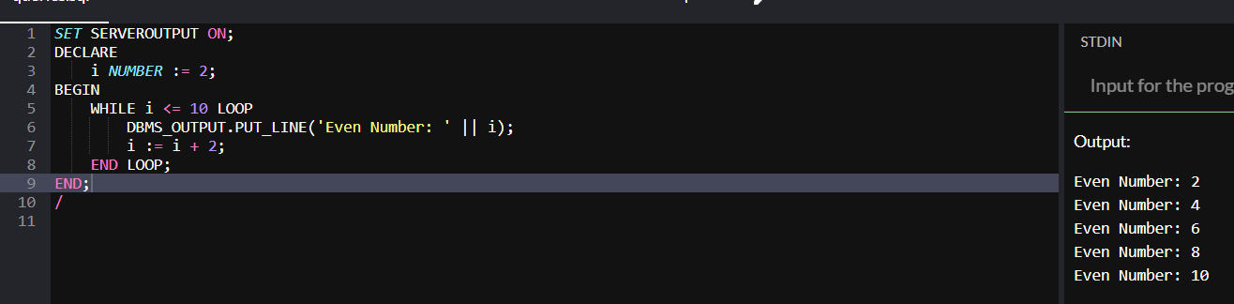

**3.Write a FOR LOOP to print the square of numbers from 1 to 5.**

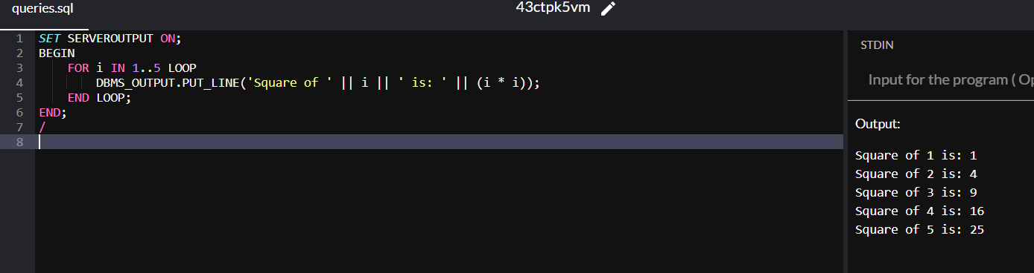

**4.Create a REVERSE FOR LOOP that prints numbers from 10 to 1.**

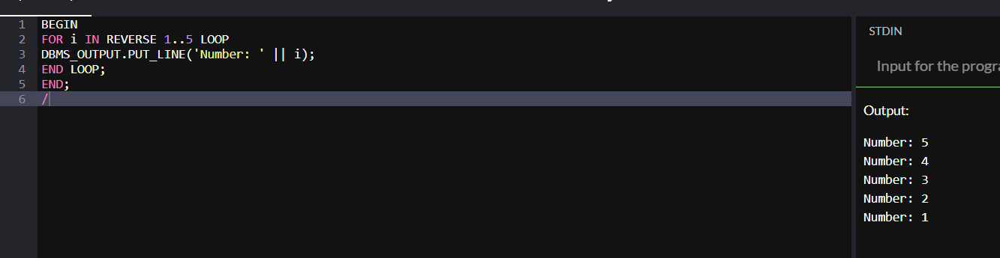

**5.Write a loop that calculates the sum of numbers from 1 to 5.**

