**NAME.SURAJIT HALDER**

**PRN.24070521509**

**SEC.B2**

**Task**

1. **Modify the function to display step-by-step conversion while calculating binary.**

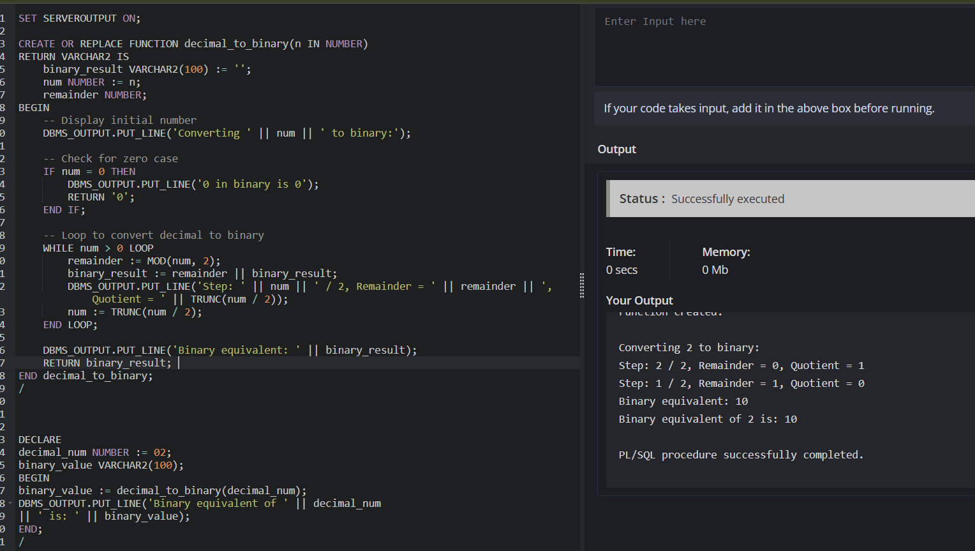

**2. Write a PL/SQL block to accept user input for the decimal number and call the**

**function.**

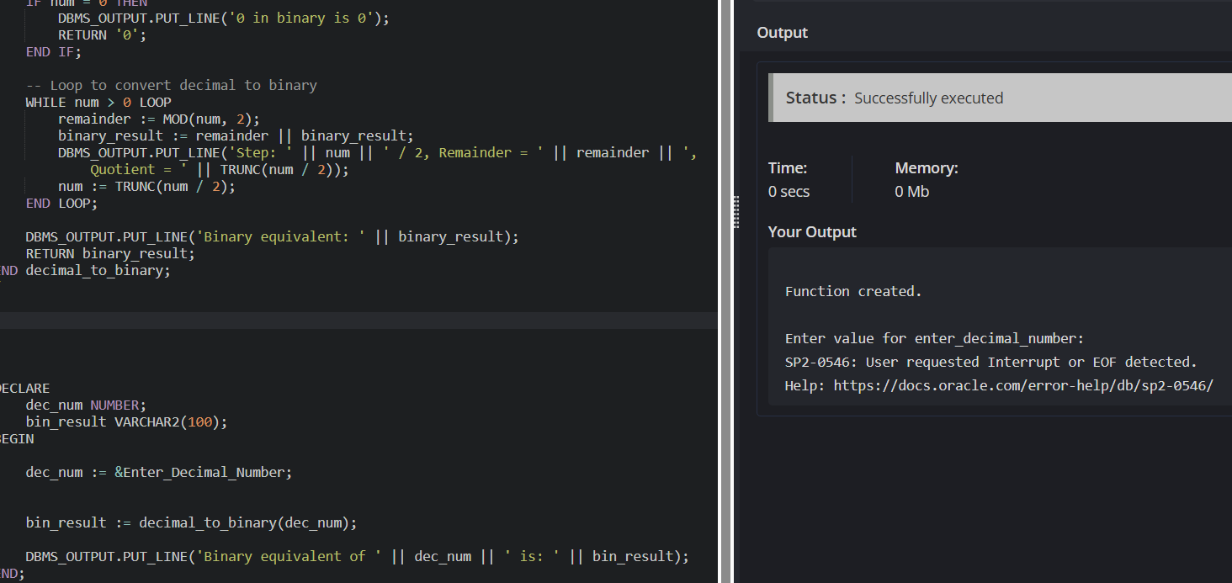

**3. Modify the function to store binary values in a table (binary_conversions).**