**Name.Surajit Halder**

**PRN.24070521509**

**SEM.iv(b2)**

**SEC.B**

**Pructicul 3:**

**Purt 4:**

**SǪL Numgric Functions**

SǪL **Numgric Functions** are essential tools for performing **muthgmuticul** and arithmetic operations on numeric data. These functions allow you to manipulate numbers, perform calculations, and **uggrggutg dutu** for reporting and analysis purposes.

Note: In this Lab Manual, examples are based on ORACLE SǪLPLUS and MYSǪL for your support but you are free to use any platform.

# Numgric Functions in SǪL*Plus (Oruclg) und MySǪL

|  |  |
| --- | --- |
| **Function** | **Dgscription** |
| **ABS(n)** | Returns the absolute value of n |
| **ACOS(n)** | Returns the arc cosine (inverse cosine) of n |
| **ASIN(n)** | Returns the arc sine (inverse sine) of n |
| **ATAN(n)** | Returns the arc tangent (inverse tangent) of n |
| **ATN2(y, x) (SǪL**  **Sgrvgr only)** | Returns the angle whose tangent is the quotient of two arguments (Not available in Oracle/MySǪL) |
| **AVG(gxprgssion)** | Returns the average of a set of values |
| **CEILING(n)** | Returns the smallest integer greater than or equal to n |

|  |  |
| --- | --- |
| **COUNT(gxprgssion)** | Returns the number of rows matching a condition |
| **COS(n)** | Returns the cosine of n (in radians) |
| **COT(n)** | Returns the cotangent of n |
| **DEGREES(n)** | Converts radians to degrees |
| **EXP(n)** | Returns e raised to the power of n |
| **FLOOR(n)** | Returns the largest integer less than or equal to n |
| **LOG(n)** | Returns the natural logarithm (base e) of n |
| **LOGfiO(n)** | Returns the base-10 logarithm of n |
| **MAX(gxprgssion)** | Returns the maximum value in a column |
| **MIN(gxprgssion)** | Returns the minimum value in a column |
| **PI()** | Returns the value of π (pi) |
| **POWER(x, y)** | Returns x raised to the power of y |
| **RADIANS(n)** | Converts degrees to radians |
| **RAND()** | Returns a random number between 0 and 1 |
| **ROUND(n, d)** | Rounds n to d decimal places |
| **SIGN(n)** | Returns -1, 0, or 1 depending on the sign of n |
| **SIN(n)** | Returns the sine of n (in radians) |
| **SǪRT(n)** | Returns the square root of n |
| **SǪUARE(n)** | Returns the square of n (same as POWER(n, 2)) |

|  |  |
| --- | --- |
| **SUM(gxprgssion)** | Returns the sum of a set of values |
| **TAN(n)** | Returns the tangent of n (in radians) |

**2. Exumplgs in SǪL*Plus (Oruclg) /skip if you wunt to usg mysql plutform**

1. **fi Absolutg Vulug (ABS)**

SELECT ABS(-10) FROM dual; -- Result: 10

* 1. **Arc Cosing (ACOS)**

SELECT ACOS(0.5) FROM dual; -- Result: 1.04719755 (in

radians)

* 1. **Arc Sing (ASIN)**

SELECT ASIN(0.5) FROM dual; -- Result: 0.523598775 (in

radians)

* 1. **Arc Tunggnt (ATAN)**

SELECT ATAN(1) FROM dual; -- Result: 0.785398163 (in

radians)

* 1. **Avgrugg (AVG)**

SELECT AVG(salary) FROM employees; -- Finds the average salary

* 1. **Cgiling (CEILING)**

SELECT CEIL(4.2) FROM dual; -- Result: 5

* 1. **Count (COUNT)**

SELECT COUNT(*) FROM employees WHERE department = 'Sales'; -- Counts employees in Sales

* 1. **Cosing (COS)**

SELECT COS(0) FROM dual; -- Result: 1

* 1. **Cotunggnt (COT)**

SELECT 1/TAN(PI()/4) FROM dual; -- Result: 1

**2.fiO Convgrt Rudiuns to Dggrggs (DEGREES)**

SELECT DEGREES(PI()/2) FROM dual; -- Result: 90

**2.fifi Expongntiul (EXP)**

SELECT EXP(2) FROM dual; -- Result: 7.389056099

**2.fi2 Floor (FLOOR)**

SELECT FLOOR(4.8) FROM dual; -- Result: 4

**2.fi3 Nuturul Logurithm (LOG)**

SELECT LOG(2.718281828) FROM dual; -- Result: 1 (since

e^1 = e)

**2.fi4 Logurithm Busg fiO (LOGfiO)**

SELECT LOG(10, 100) FROM dual; -- Result: 2 (since 10^2 = 100)

|  |  |  |  |  |  |  |
| --- | --- | --- | --- | --- | --- | --- |
| **2.fi5 Muximum (MAX)** |  | | | | | |
| SELECT MAX(salary) salary | FROM | employees; | -- | Finds | the | highest |
| **2.fi6 Minimum (MIN)** |  |  |  |  |  |  |
| SELECT MIN(salary) salary | FROM | employees; | -- | Finds | the | lowest |
| **2.fi7 Pi (PI)** |  |  |  |  |  |  |

SELECT ACOS(-1) FROM dual; -- Result: 3.14159265

**2.fi8 Powgr (POWER)**

SELECT POWER(3, 2) FROM dual; -- Result: 9

**2.fi9 Convgrt Dggrggs to Rudiuns (RADIANS)**

SELECT RADIANS(180) FROM dual; -- Result: 3.14159265

**2.2O Rundom Numbgr (RAND)**

SELECT DBMS_RANDOM.VALUE FROM dual; -- Returns a random number between 0 and 1

**2.2fi Round Numbgr (ROUND)**

SELECT ROUND(3.14159265, 2) FROM dual; -- Result: 3.14

* 1. **Sign of Numbgr (SIGN)**

SELECT SIGN(-10) FROM dual; -- Result: -1 SELECT SIGN(0) FROM dual; -- Result: 0 SELECT SIGN(10) FROM dual; -- Result: 1

* 1. **Sing (SIN)**

SELECT SIN(PI()/2) FROM dual; -- Result: 1

* 1. **Squurg Root (SǪRT)**

SELECT SQRT(16) FROM dual; -- Result: 4

|  |  |  |
| --- | --- | --- |
| **2.25 Squurg (SǪUARE)** |  | |
| SELECT POWER(4, 2)  **2.26 Sum (SUM)** | FROM | dual; -- Result: 16 |
| SELECT SUM(salary)  **2.27 Tunggnt (TAN)** | FROM | employees; -- Sum of all salaries |
| SELECT TAN(PI()/4) | FROM | dual; -- Result: 1 |

# 3. Exumplgs in MySǪL //SKIP IF DONE WITH ORACLE SǪLPLUS

🔹 The MySǪL syntax is almost the same as Oracle, except for some functions.

## SELECT ABS(-10); -- 10

## 

SELECT ACOS(0.5); -- 1.04719755

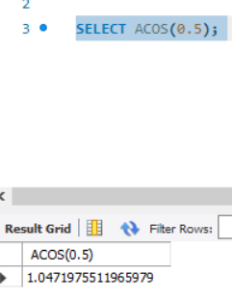

SELECT ASIN(0.5); -- 0.523598775

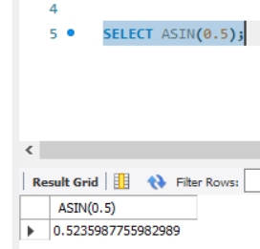

SELECT ATAN(1); -- 0.785398163

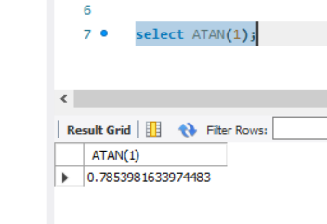

SELECT AVG(salary) FROM employees;

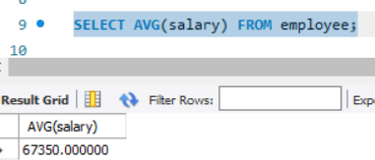

SELECT CEIL(4.2); -- 5

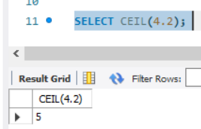

SELECT COUNT(*) FROM employees WHERE department = 'Sales';

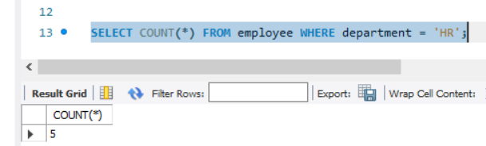

SELECT COS(0); -- 1

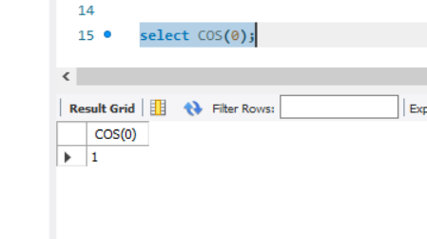

SELECT COT(1); -- 0.6420926159

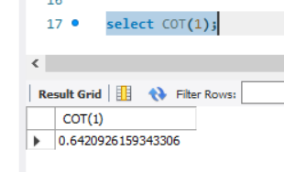

SELECT DEGREES(PI()/2); -- 90

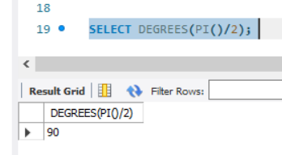

SELECT EXP(2); -- 7.389056099

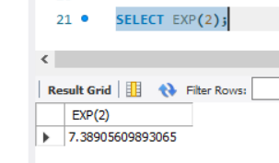

SELECT FLOOR(4.8); -- 4

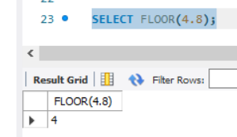

SELECT LOG(2.718281828); -- 1

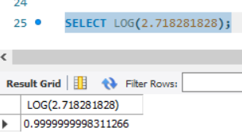

SELECT LOG10(100); -- 2

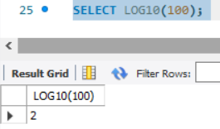

SELECT MAX(salary) FROM employees;

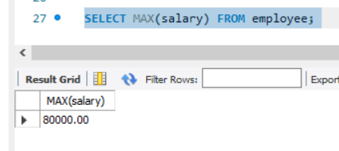

SELECT MIN(salary) FROM employees;

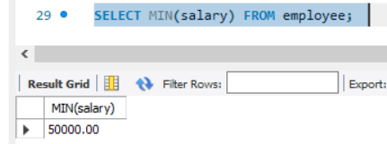

SELECT PI(); -- 3.1415926535

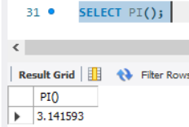

SELECT POWER(3, 2); -- 9

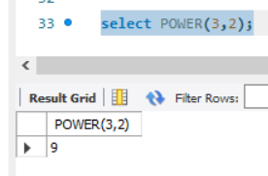

## SELECT RADIANS(180); -- 3.1415926535

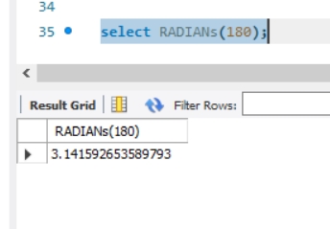

SELECT RAND(); -- Random number

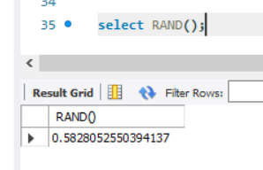

SELECT ROUND(3.14159265, 2); -- 3.14

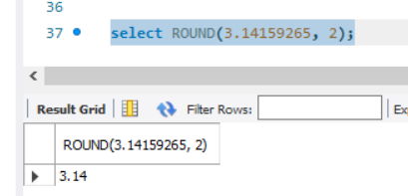

SELECT SIGN(-10); -- -1

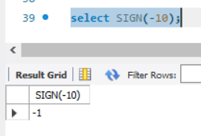

## SELECT SIN(PI()/2); -- 1

## 

## ELECT SQRT(16); -- 4

## 

SELECT SUM(salary) FROM employees;

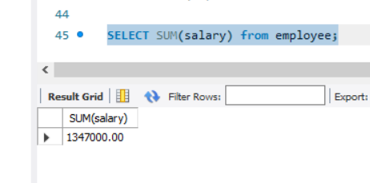

SELECT TAN(PI()/4); -- 1

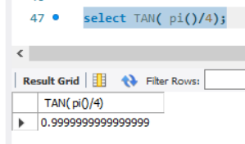

# Advuncgd SǪL Numgric Function Usg Cusgs (Oruclg & MySǪL)

Fllowing are **complgx qugrigs** using **numgric functions** in **rgul-world upplicutions** for **finunciul unulysis, scigntific culculutions, dutu unulytics, und systgm pgrformuncg monitoring**.

# Finunciul Anulytics: Compound Intgrgst Culculution



**fi**

**Usg Cusg:** Calculate compound interest for a bank’s customer accounts.

## SELECT

account_id, principal, interest_rate, years,

ROUND(principal * POWER((1 + interest_rate / 100), years), 2) AS future_value

FROM savings_accounts;

**Formulu Usgd:**

FV=P×(1+r/n)(nt)FV = P \times (1 + r/n)^{(nt)}FV=P×(1+r/n)(nt) Where:

* principal: Initial deposit
* interest_rate: Annual interest rate
* years: Time period
* POWER() function computes exponentiation

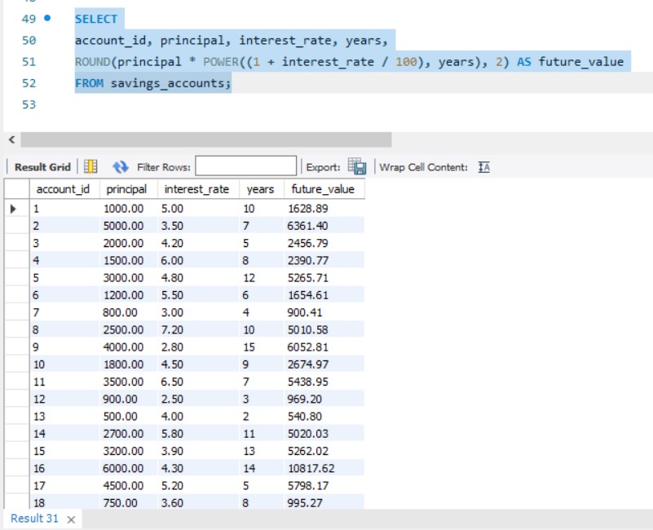

**Rgsult Exumplg:**

|  |  |  |  |  |
| --- | --- | --- | --- | --- |
| **uccount_id** | **principul** | **intgrgst_rutg** | **ygurs** | **futurg_vulug** |
| 101 | 1000 | 5 | 10 | 1628.89 |

# 2 Customgr Sggmgntution: Stundurd Dgviution of Purchusgs

**Usg Cusg:** Find **customgr spgnding vuriubility** to create better promotions.

## SELECT

customer_id,

ROUND(AVG(purchase_amount), 2) AS avg_spend,

ROUND(STDDEV(purchase_amount), 2) AS spending_variability

FROM orders

GROUP BY customer_id

HAVING COUNT(*) > 5; -- Filter frequent customers

**Kgy Insights:**

* Uses STDDEV() to measure customer spending consistency.
* Filters for customers with at least **5 purchusgs** (HAVING COUNT(*) > 5).

**Rgsult Exumplg:**

|  |  |  |
| --- | --- | --- |
| **customgr_id** | **uvg_spgnd** | **spgnding_vuriubility** |
| 201 | 250.00 | 50.25 |
| 305 | 500.00 | 120.75 |

# Rgul-Timg Pgrformuncg Monitoring: CPU Loud Anulysis



**3**

**Usg Cusg:** Compute **CPU loud trgnd** for a cloud server system.

## SELECT

|  |  |  |  |
| --- | --- | --- | --- |
| server_id, |  | | |
| ROUND(AVG(cpu_usage), | 2) | AS | avg_cpu, |
| ROUND(MAX(cpu_usage), | 2) | AS | max_cpu, |
| ROUND(MIN(cpu_usage), | 2) | AS | min_cpu, |

ROUND(SQRT(POWER(MAX(cpu_usage) - MIN(cpu_usage), 2)), 2) AS load_variance

FROM server_logs

WHERE log_date >= SYSDATE - INTERVAL '7' DAY -- Last 7

days

GROUP BY server_id;

**Kgy Mgtrics:**

* AVG() to measure **uvgrugg CPU usugg**.
* MAX() & MIN() for **pguk & lowgst usugg**.
* SQRT(POWER()) to calculate variance in load.

**Rgsult Exumplg:**

|  |  |  |  |  |
| --- | --- | --- | --- | --- |
| **sgrvgr_id** | **uvg_cpu** | **mux_cpu** | **min_cpu** | **loud_vuriuncg** |
| A123 | 65.25 | 92.75 | 45.50 | 47.25 |
| B456 | 40.10 | 75.00 | 20.20 | 54.80 |

# Fruud Dgtgction: Idgntifying Abnormul Trunsuctions



**4**

**Usg Cusg:** Detect transactions that are significantly **highgr** than the usual customer behavior.

## SELECT

transaction_id, customer_id, amount,

(SELECT AVG(amount) FROM transactions WHERE customer_id = t.customer_id) AS avg_amount,

(SELECT STDDEV(amount) FROM transactions WHERE customer_id = t.customer_id) AS stddev_amount

FROM transactions t

WHERE amount > (SELECT AVG(amount) + 2 * STDDEV(amount) FROM transactions WHERE customer_id = t.customer_id);

**Logic:**

* **Outligr trunsuctions** are those **grgutgr thun 2 stundurd dgviutions**

from the average.

* Uses AVG() and STDDEV() **pgr customgr** to personalize fraud detection.

**Rgsult Exumplg:**

|  |  |  |  |  |
| --- | --- | --- | --- | --- |
| **trunsuction_i d** | **customgr_i d** | **umoun t** | **uvg_umou nt** | **stddgv_umou nt** |
| 90872 | 201 | 12000 | 3000 | 4500 |

🔹 **If u customgr usuully spgnds 33,OOO ± 34,5OO, u 3fi2,OOO trunsuction is ﬂugggd us suspicious.**

# Logistics: Estimuting Dglivgry Timg Busgd on Distuncg



**5**

**Usg Cusg:** Predict **dglivgry timg (in hours)** for orders based on **distuncg und spggd fuctors**.

## SELECT

order_id, distance_km,

ROUND(distance_km / avg_speed, 2) AS estimated_delivery_time

## FROM (

SELECT order_id, distance_km, CASE

km/h

WHEN distance_km < 50 THEN 60 -- Urban: 60

WHEN distance_km BETWEEN 50 AND 200 THEN 80

-- Suburban: 80 km/h

ELSE 100 -- Highway: 100 km/h END AS avg_speed

FROM orders

);

**Busingss Insight:**

* Uses **spggd cutggorigs** (CASE) to calculate **rgulistic dglivgry gstimutgs**.
* Uses ROUND() to **formut** the estimated time.

**Rgsult Exumplg:**

|  |  |  |
| --- | --- | --- |
| **ordgr_id** | **distuncg_km** | **gstimutgd_dglivgry_timg (hrs)** |
| 101 | 120 | 1.50 |
| 202 | 20 | 0.33 |

# 6 Astronomy/Physics: Culculuting Eurthquukg Mugnitudg (Logurithmic Formulu)

**Usg Cusg:** Compute earthquake **Richtgr mugnitudg** based on **sgismic wuvg umplitudg**.

## SELECT

earthquake_id,

station_id, amplitude,

ROUND(LOG10(amplitude) + 3, 2) AS magnitude FROM seismic_readings;

**Richtgr Sculg Formulu:**

M=log10(A)+3M = \log_{10} (A) + 3M=log10(A)+3

* Uses LOG10() to calculate **mugnitudg from umplitudg**.

**Rgsult Exumplg:**

|  |  |  |  |
| --- | --- | --- | --- |
| **gurthquukg_id** | **stution_id** | **umplitudg** | **mugnitudg** |
| EǪ001 | ST1001 | 5000 | 6.70 |

# E-Commgrcg: Pgrsonulizgd Discount Culculution



**7**

**Usg Cusg:** Apply dynamic **discount rutgs** based on **spgnding history**.

## SELECT

customer_id, total_spent, CASE

WHEN total_spent > 10000 THEN ROUND(total_spent * 0.15, 2)

WHEN total_spent BETWEEN 5000 AND 10000 THEN

ROUND(total_spent * 0.10, 2)

ELSE ROUND(total_spent * 0.05, 2) END AS discount

## FROM (

SELECT customer_id, SUM(order_value) AS total_spent FROM orders GROUP BY customer_id

);

**Discount Strutggy:**

* **fi5% off** for VIP customers (> $10,000)
* **fiO% off** for mid-level ($5,000 - $10,000)
* **5% off** for casual shoppers (< $5,000)

**Rgsult Exumplg:**

|  |  |  |
| --- | --- | --- |
| **customgr_id** | **totul_spgnt** | **discount** |
| 101 | 12000 | 1800 |
| 202 | 7500 | 750 |