Surajit Halder(24070521509)(B2)

Practical 08

Aim: Form Handling & Validation: Access and validate HTML form fields. Implement events such as onsubmit, onblur, onchange. Build a gym admission form with live validation of inputs like name, email, and age.

Introduction:
Form handling and validation are essential in web development to ensure users submit correct and complete data. JavaScript provides events and validation techniques to check form input before sending it to the server.

JavaScript Form Properties
A <form> element in HTML can be accessed in JavaScript as: let form = document.forms["myForm"];
or
let form = document.getElementById("formId");

Form Validation Techniques

Required Field Validation
Ensures that a field is not left empty.

HTML5 way:

<input type="text" name="username" required>

JavaScript way:

if (username.trim() === "") { alert("Username is required"); return false;
}

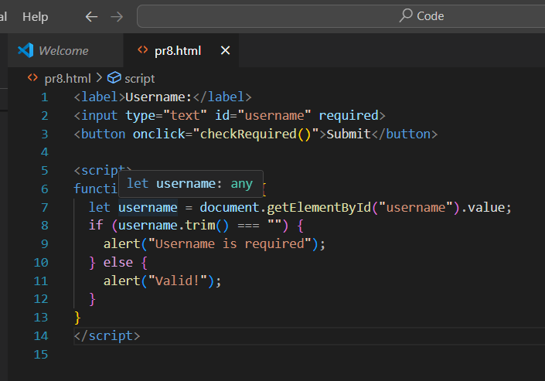

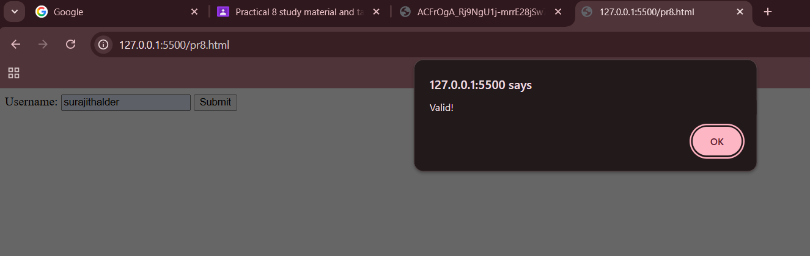

Data Type Validation
Makes sure the entered value is of the correct type. Example: checking if age is a number.
if (isNaN(age)) {
alert("Age must be a number");
}
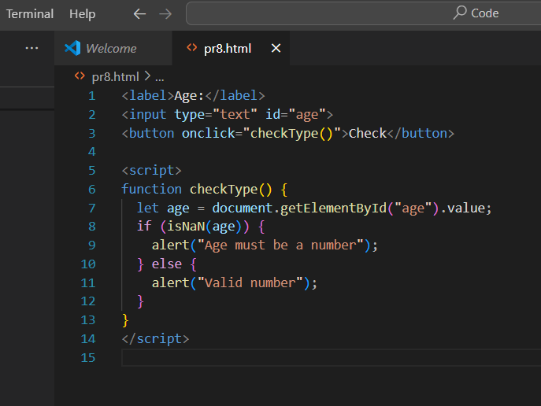
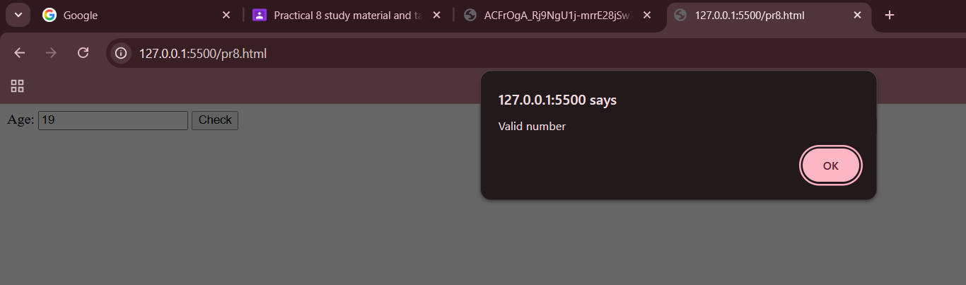

Length Validation
Checks minimum and maximum length of input (like password or name).

if (password.length < 6) {
alert("Password must be at least 6 characters");
}
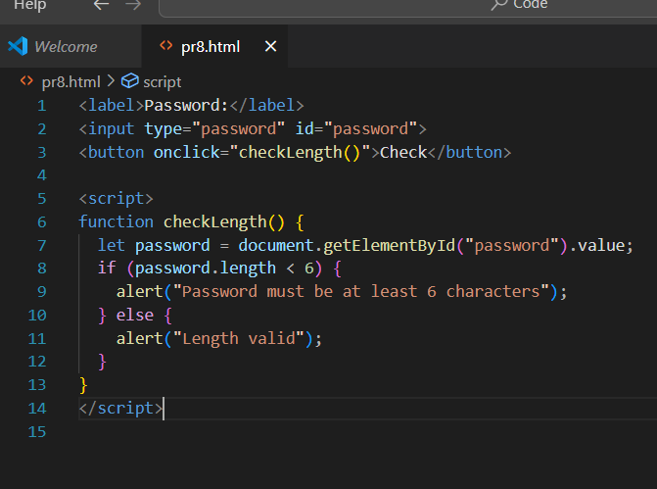

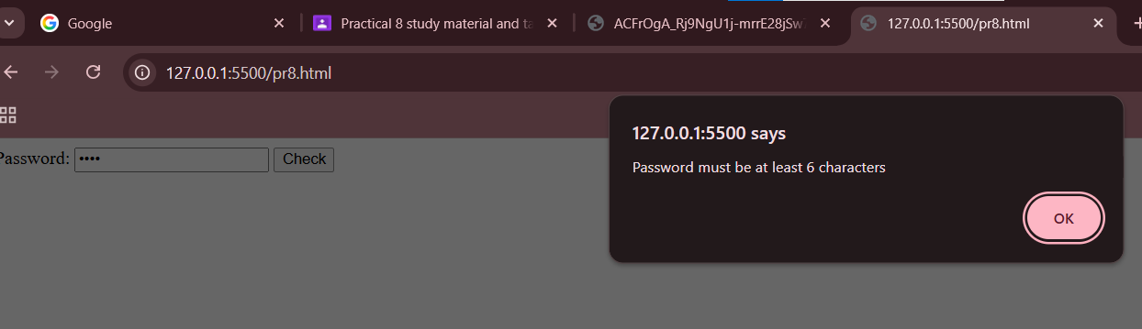

Range Validation
Ensures numeric values fall within a valid range. Example: age should be between 18 and 60.
if (age < 18 || age > 60) {
alert("Age must be between 18 and 60");
}
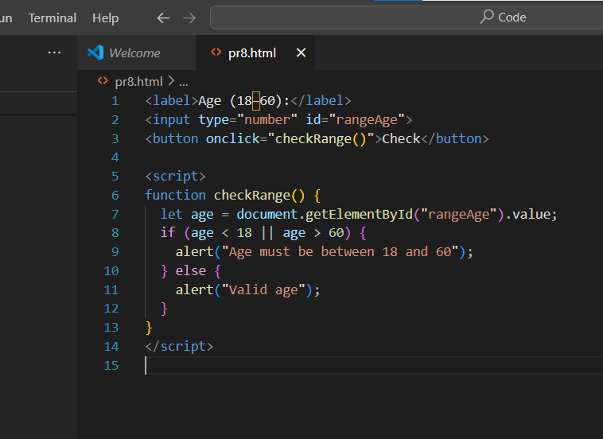
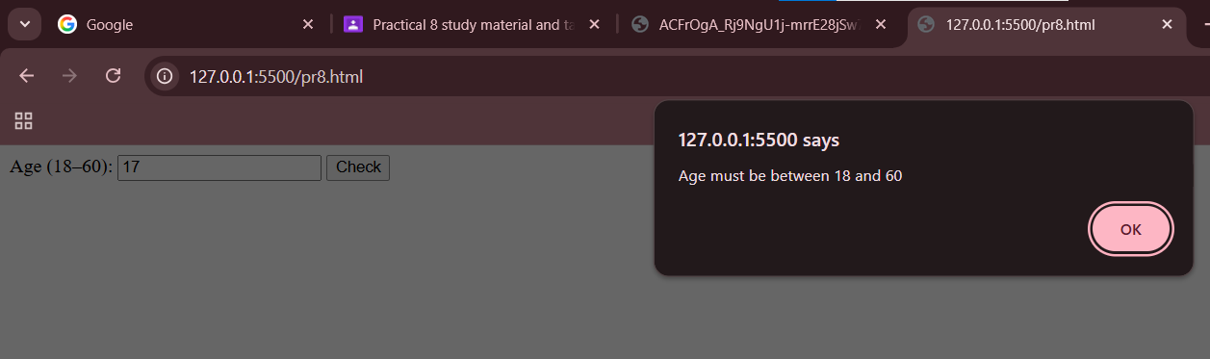

Pattern / Regular Expression Validation
Matches input against a pattern (regex). Example: Email validation.
let pattern = /^[^ ]+@[^ ]+\.[a-z]{2,3}$/; if (!email.match(pattern)) {
alert("Invalid email format");
}

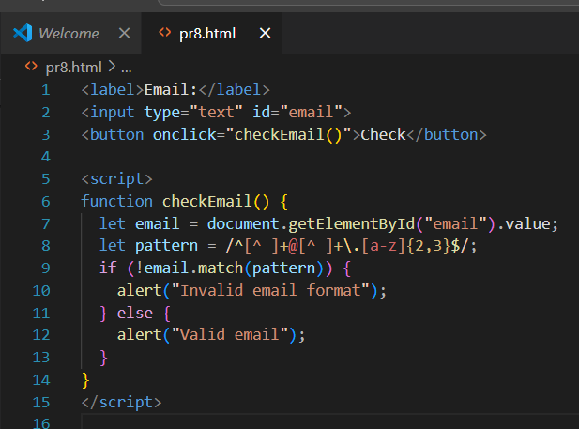

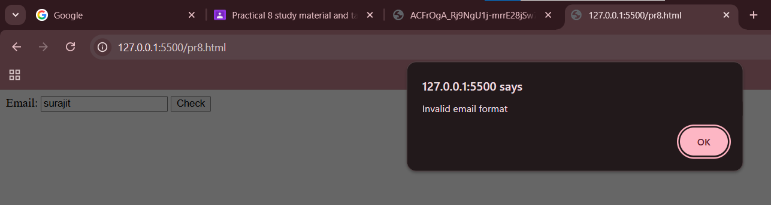

Compare Fields Validation
Ensures two fields match (like password & confirm password).

if (password !== confirmPassword) { alert("Passwords do not match");
}

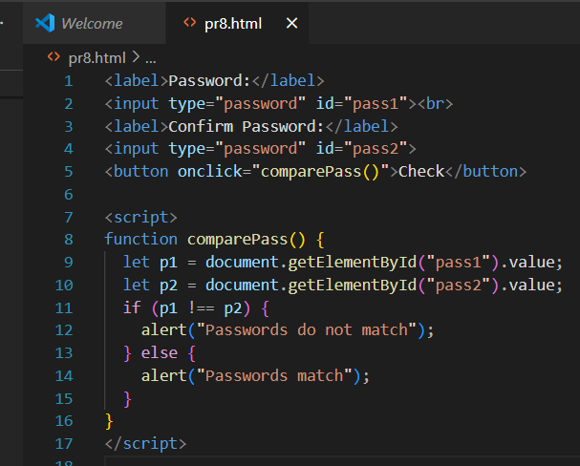
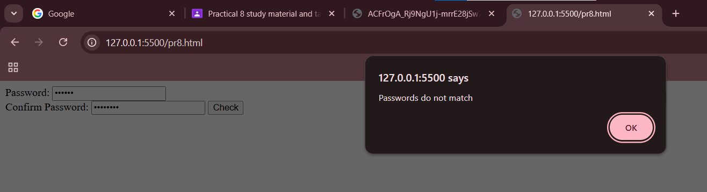

Numeric Validation
Ensures only numbers are entered (e.g., phone number). HTML5 way:
<input type="number" name="age"> JS way:
if (!/^[0-9]+$/.test(phone)) { alert("Phone must contain only digits");
}
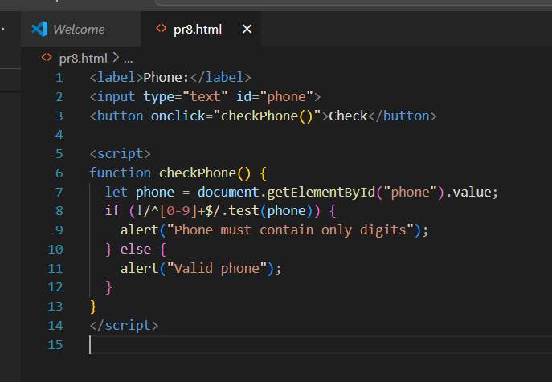

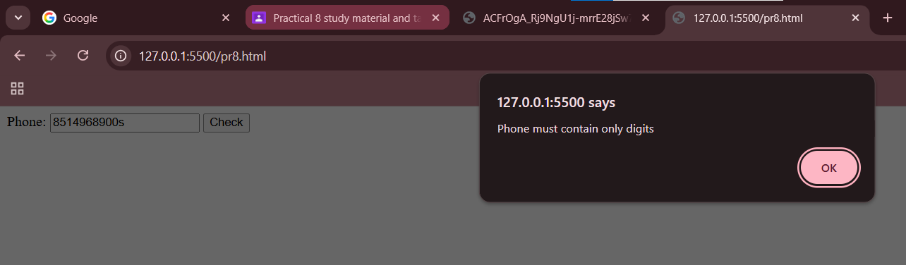

Email Validation
Ensures valid email format.

let pattern = /^[^ ]+@[^ ]+\.[a-z]{2,3}$/;

if (!email.match(pattern)) { alert("Invalid email address");
}

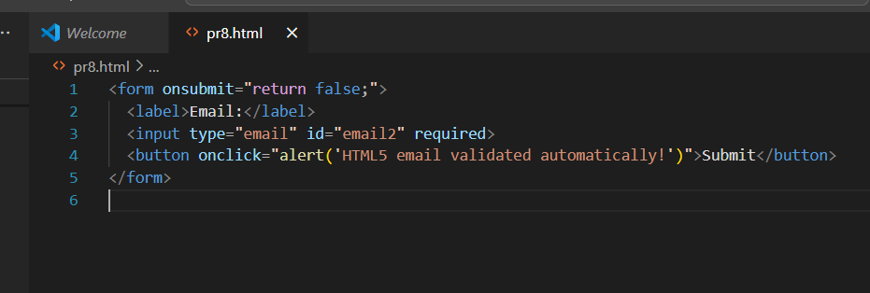

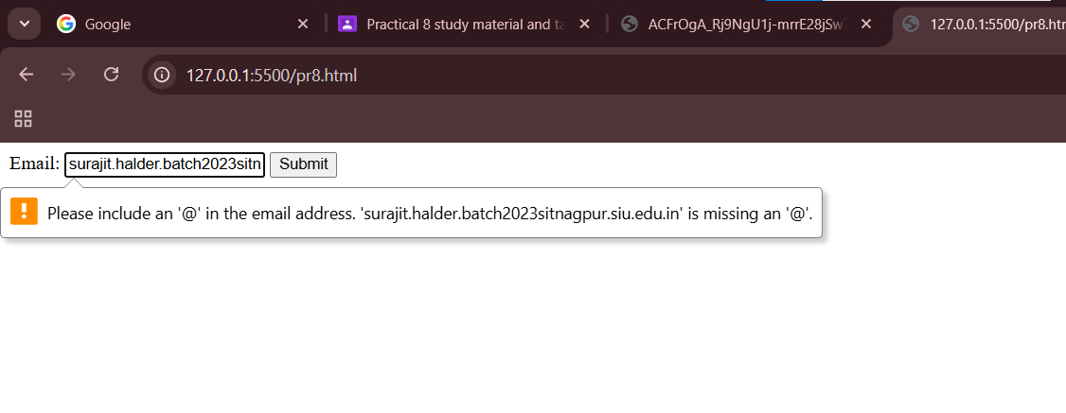

Password Strength Validation
Check for uppercase, lowercase, number, special character, and length.

let pattern = /^(?=.*[A-Z])(?=.*[a-z])(?=.*[0-9])(?=.*[@#$%^&+=]).{8,}$/; if (!password.match(pattern)) {
alert("Weak password. Use uppercase, lowercase, number & special char.");
}

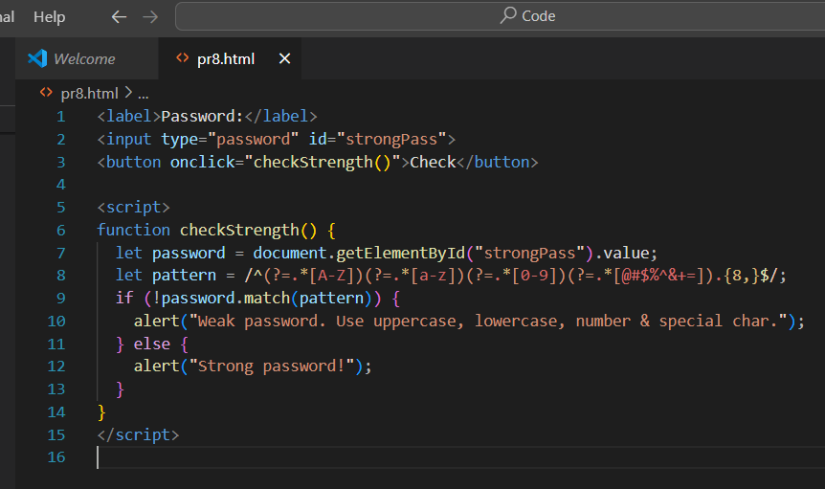

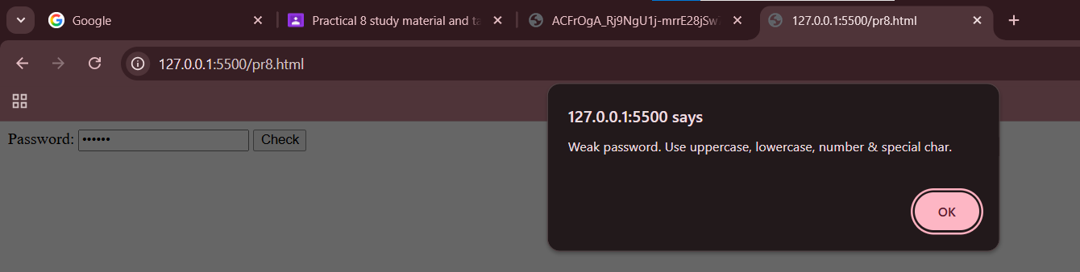

Checkbox / Radio Validation
Ensures the user selects an option.

if (!document.querySelector('input[name="gender"]:checked')) { alert("Please select your gender");
}

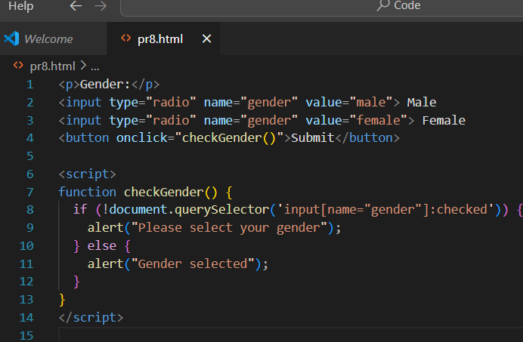

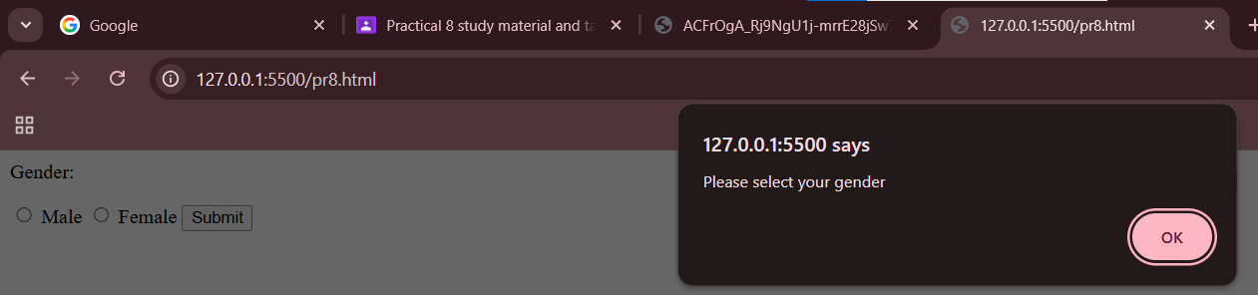

Dropdown Validation
Ensures a valid option is selected (not the default).

if (document.getElementById("city").value === "") { alert("Please select a city");
}

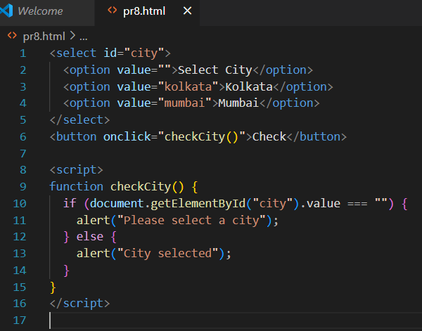

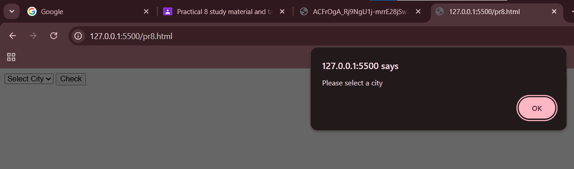

Date Validation
Ensures valid date format and logic (like DOB not in the future).

let dob = new Date(document.getElementById("dob").value); let today = new Date();
if (dob > today) {
alert("Date of Birth cannot be in the future");
}

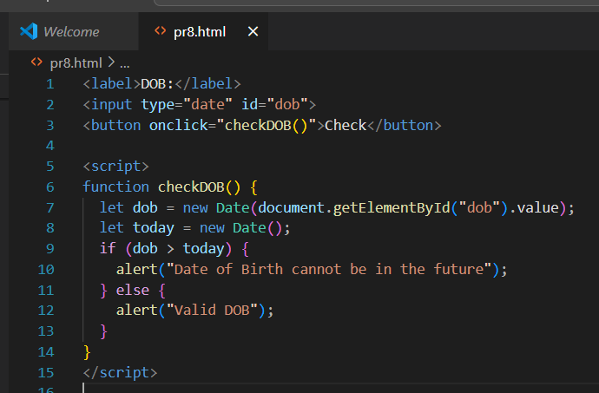

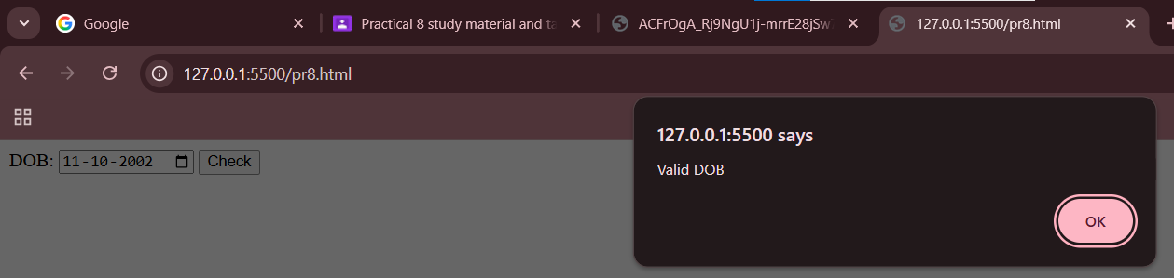

File Upload Validation
Ensures file type, size, and extension are valid.

let file = document.getElementById("resume").files[0]; if (file.size > 2 * 1024 * 1024) { // 2MB
alert("File too large");
}
if (!file.name.endsWith(".pdf")) { alert("Only PDF allowed");
}
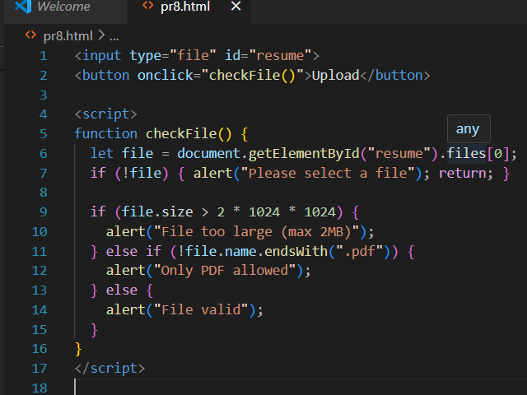

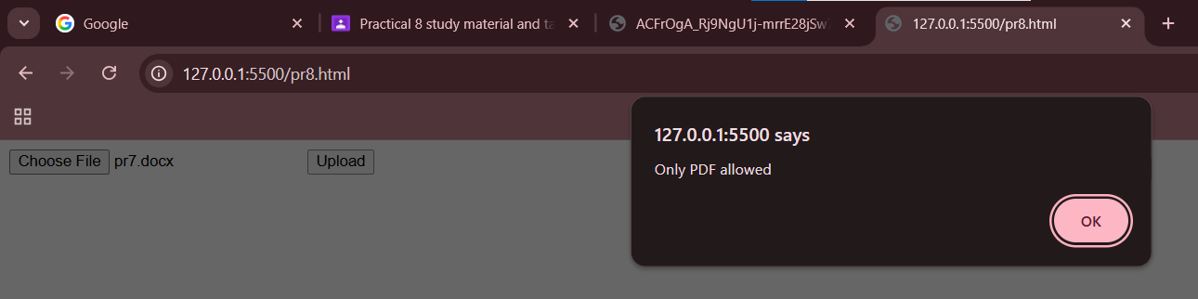

Custom Validation using oninvalid
HTML5 has built-in validation error messages. You can override them.

<input type="email" required oninvalid="this.setCustomValidity('Enter a valid email!')">

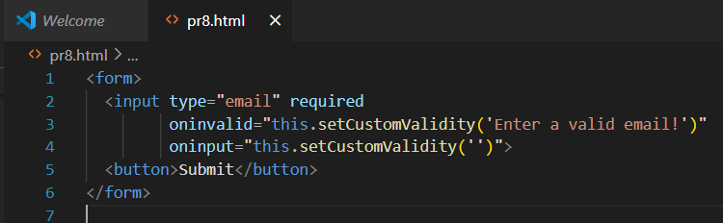

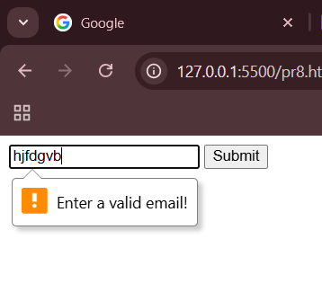

Real-time (Live) Validation
Use oninput or onkeyup to check values as the user types.

document.getElementById("username").oninput = function() { if (this.value.length < 3) {
document.getElementById("error").innerText = "Must be at least 3 characters";
} else {
document.getElementById("error").innerText = "";
}
}

