Task 1: Dynamic Student Report Card Using Destructuring and
Template Literals
Problem Statement:
You are given a student object that contains the details of a student
including name, roll number, and marks in 5 subjects.
Using object and array destructuring and template literals, write a
program to generate a formatted report card in the console.
Your program should:
● Calculate the total and percentage.
● Use destructuring to extract the marks.
● Use template literals to display a multi-line summary like:
Report Card for Riya (Roll No: 101)
-----------------------------------
Subjects: Math: 85, Science: 90, English: 78, History: 88, Art: 92
Total Marks: 433
Percentage: 86.6%
Hint: You must decide the structure of the object and choose how to destructure it
effectively.
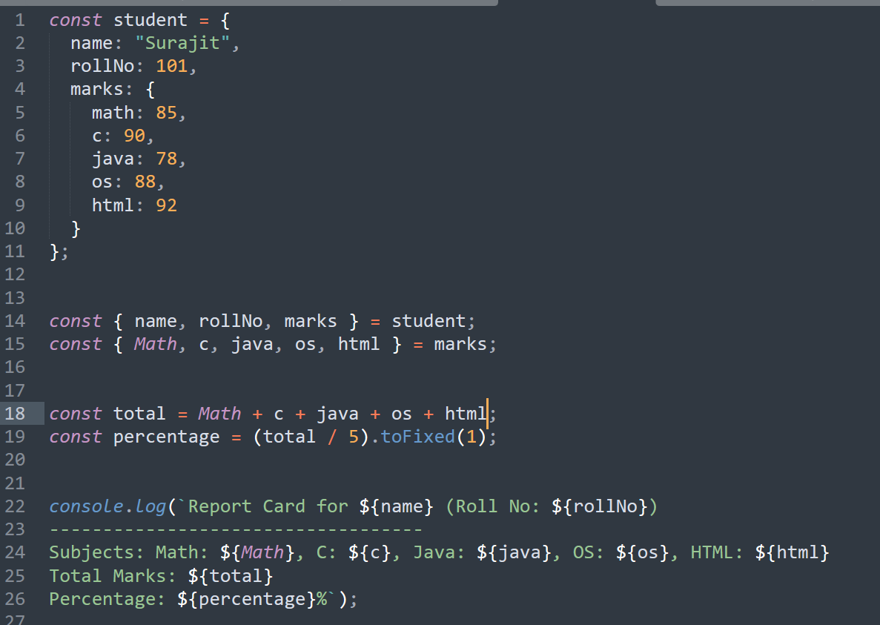

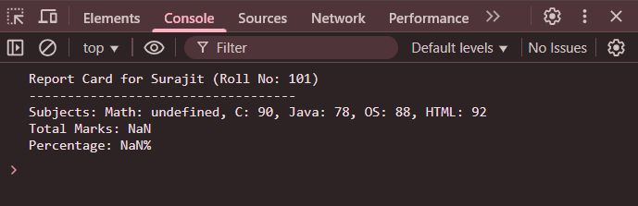
Task 2: Build a Custom Greeting Generator with Default
Parameters and Arrow Functions
Problem Statement:
● Write a function named generateGreeting that:
● Takes in name, role, and location as parameters (all with default
values).
● Uses an arrow function to return a greeting like:
&quot;Hello [name]! Your role is [role] and you are currently in [location].&quot;

Requirements:
● Do not use function keyword.
● Use template literals for message construction.
● Call the function with different combinations of arguments and no
arguments.
● Only one function should handle all variations without breaking.

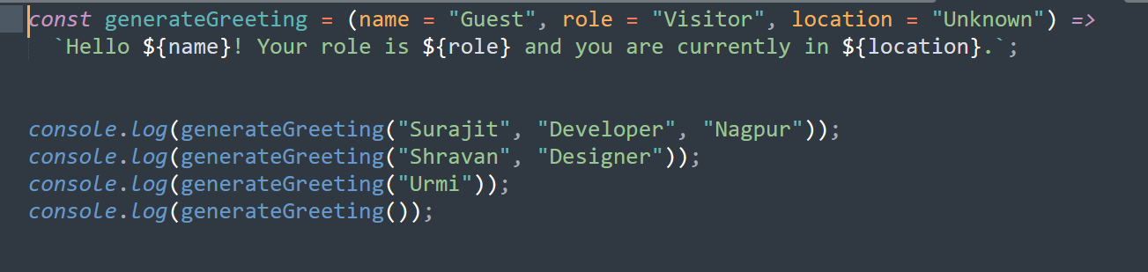

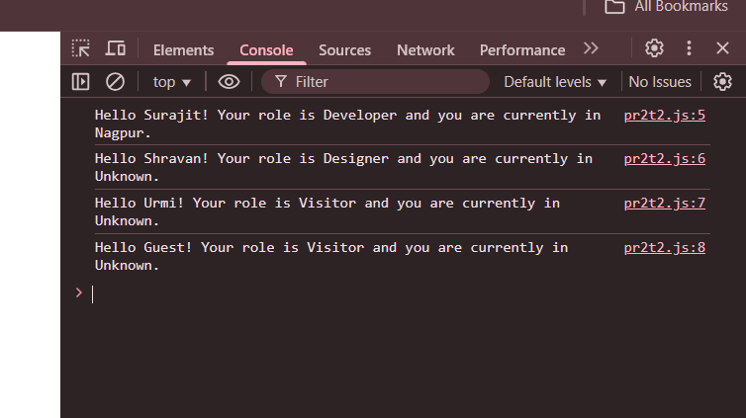

Task 3: Implement a Data Type Analyzer (without typeof)
Problem Statement:
Create a function analyzeData that takes any input and prints:
● What kind of primitive or reference type it is (without using
typeof).
● Whether it’s mutable or immutable.
● A summary message.
You cannot use typeof, but must still determine if it&#39;s:
● string, number, boolean, undefined, null, symbol, bigint
● array, object, function
You must figure out creative ways to determine the type, such as using
constructor checks, Array.isArray, etc.

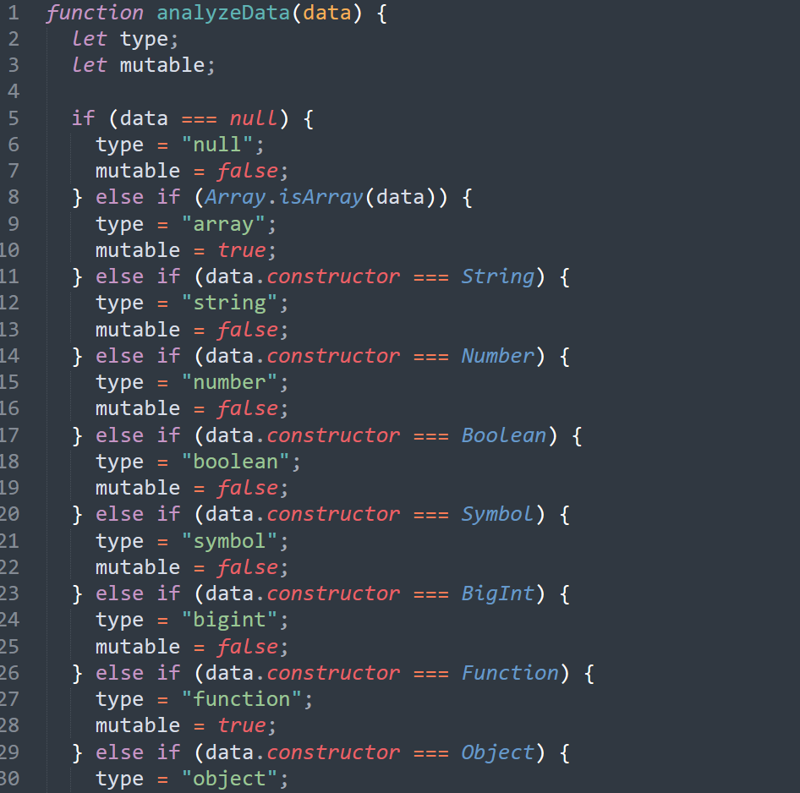

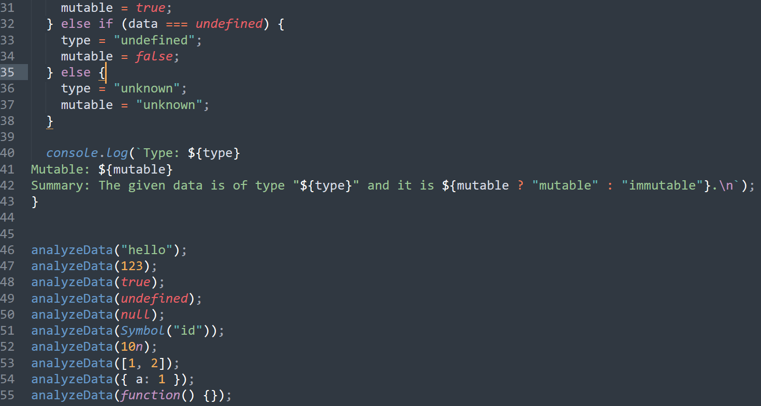
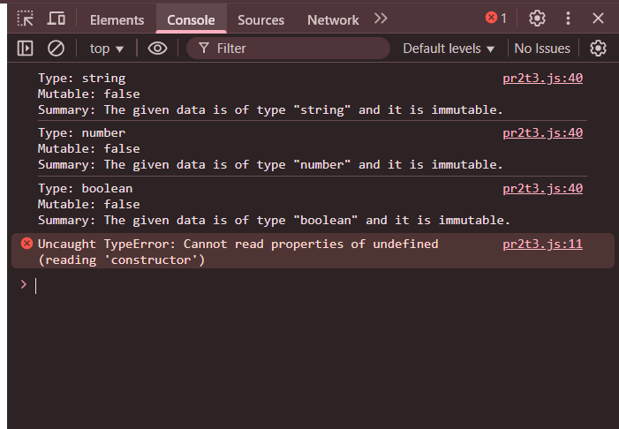

Task 4: Color Mixer using Destructuring and Spread/Rest
Operators
Problem Statement:
Write a program that:
● Takes two arrays of colors from the user (e.g., [&quot;red&quot;, &quot;green&quot;] and
[&quot;blue&quot;, &quot;yellow&quot;]).
● Merges the arrays using the spread operator into a new array called
palette.

● Extract the first and last colors from the palette using array
destructuring.
● Collect the middle colors using the rest operator.
● Display a message like:
&quot;Main colors: Red and Yellow. Others in the palette: Green, Blue.&quot;
You are not allowed to use loops or array indexing manually.
