Name.Surajit Halder
PRN.24070521509
SEC.B2, SEM. 5th

1. Write a program to check if a number is positive, negative, or

zero using if...else.
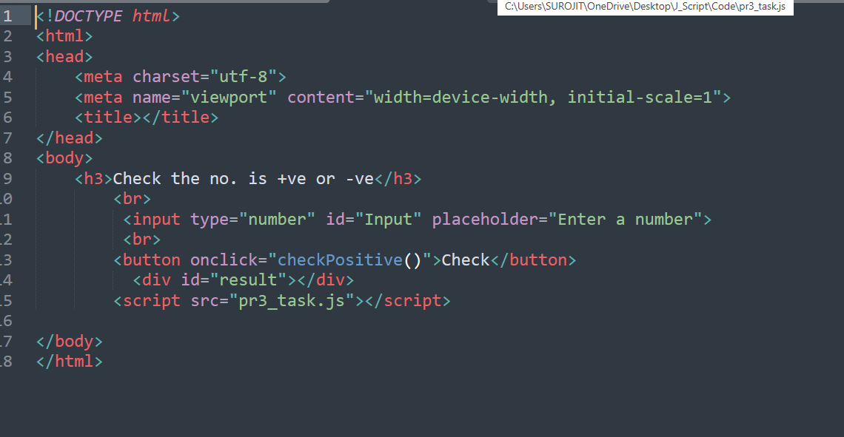

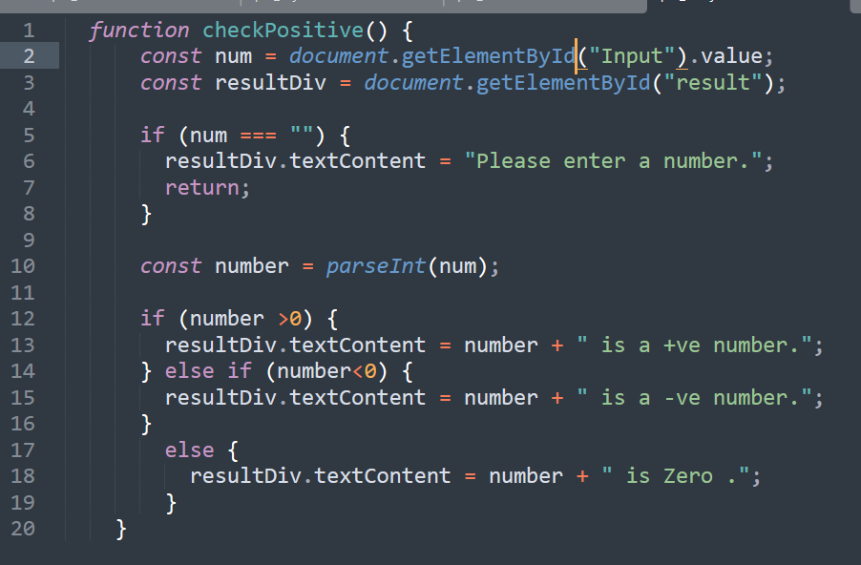
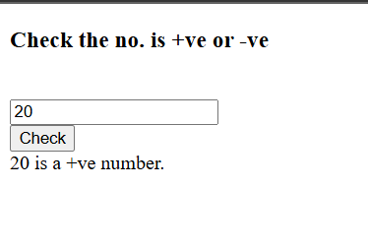

2. Accept user input (via prompt()) for the day of the week and display a message using switch.
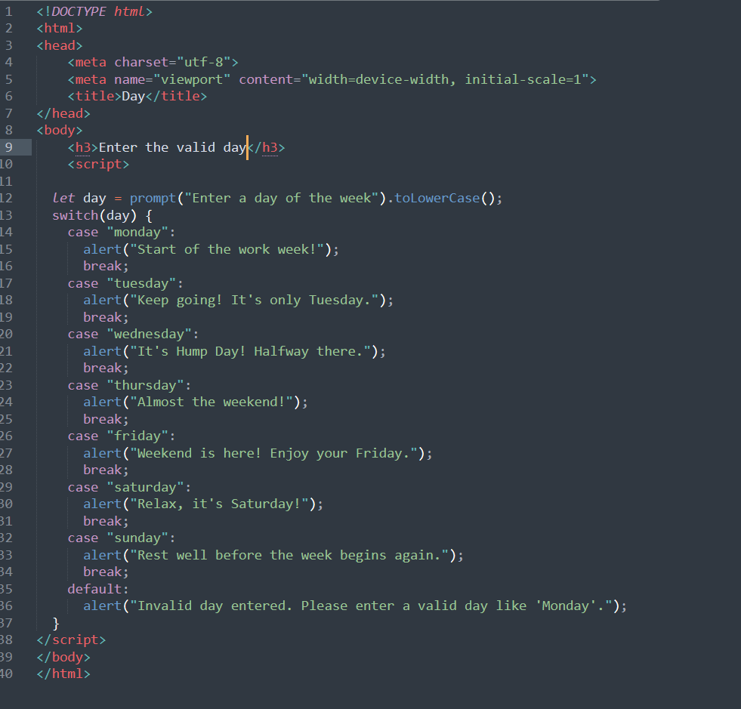

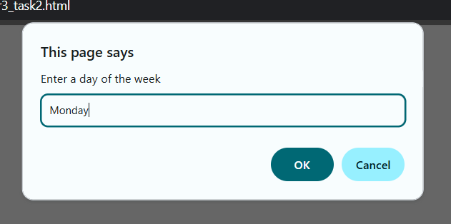
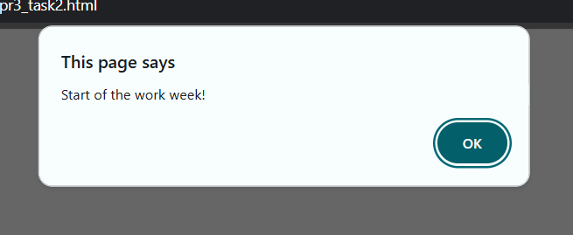
3. Create a traffic light simulator using switch (Red → Stop, Yellow → Wait, Green → Go).
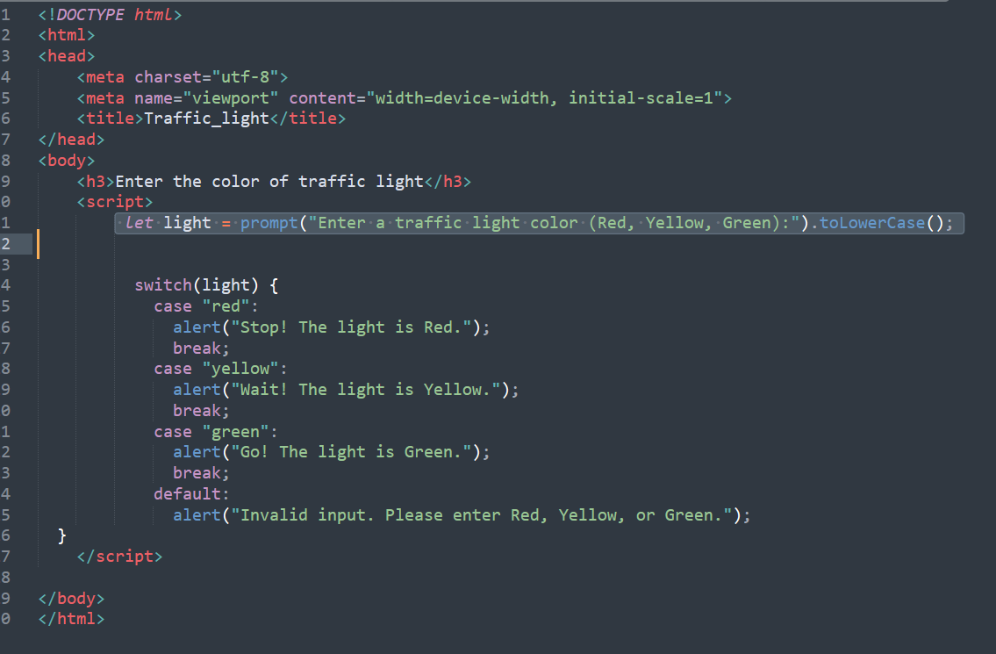
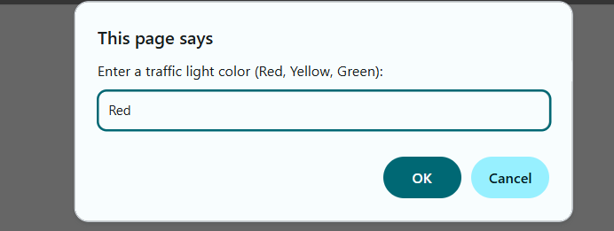
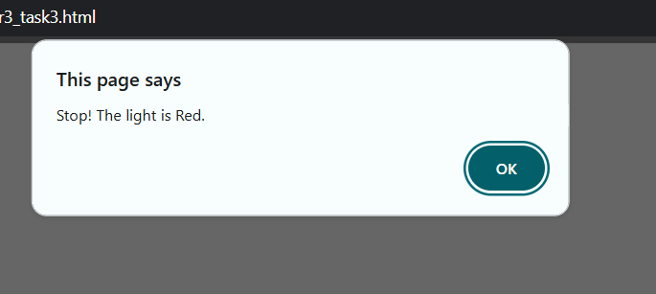

4. ATM Simulator

Ask the user for a transaction type:
● &quot;withdraw&quot;: Ask for amount; if less than balance, deduct and show
new balance.
● &quot;deposit&quot;: Ask for amount; add to balance and show it.
● &quot;balance&quot;: Show current balance.
● Default: &quot;Invalid transaction type&quot;

