Name.Surajit Halder
PRN.24070521509
Sec.B2(5th sem)

Student Tasks for Part 1
1. Write a function declaration that takes two numbers and returns the greater
number.
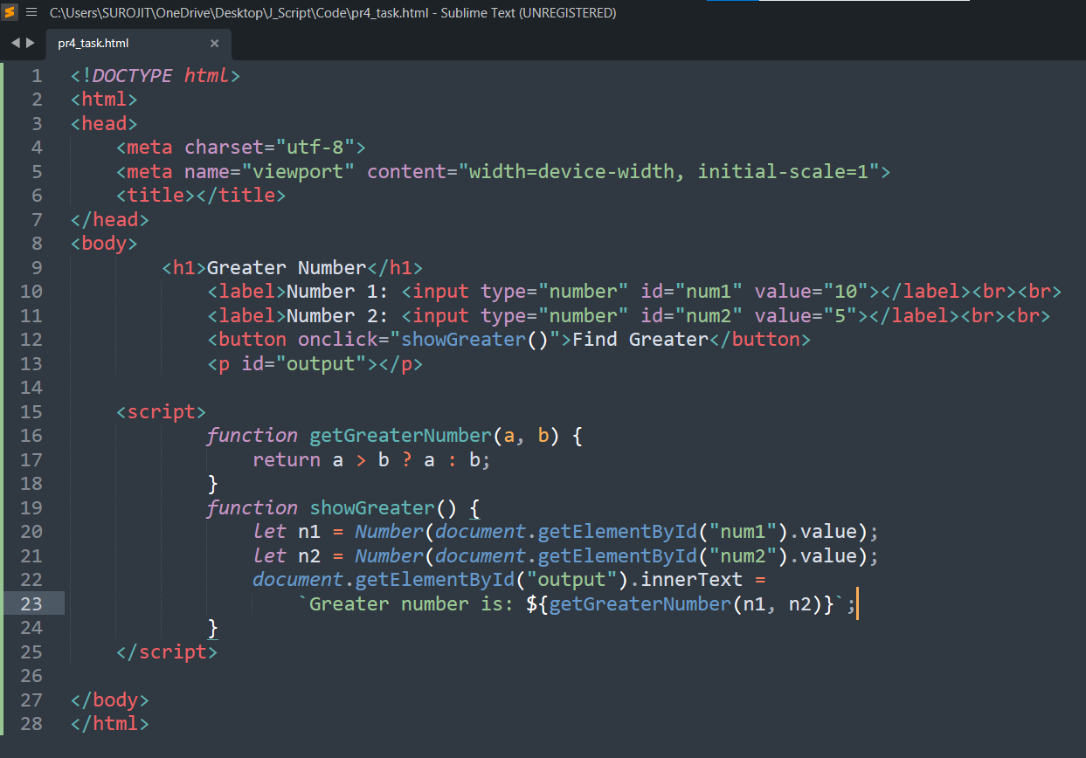

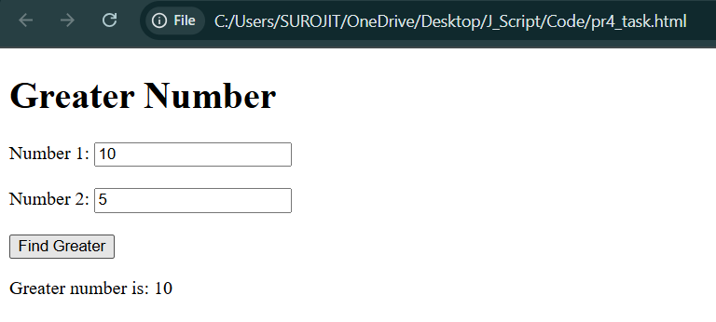
2. Write a function expression that calculates the factorial of a number.
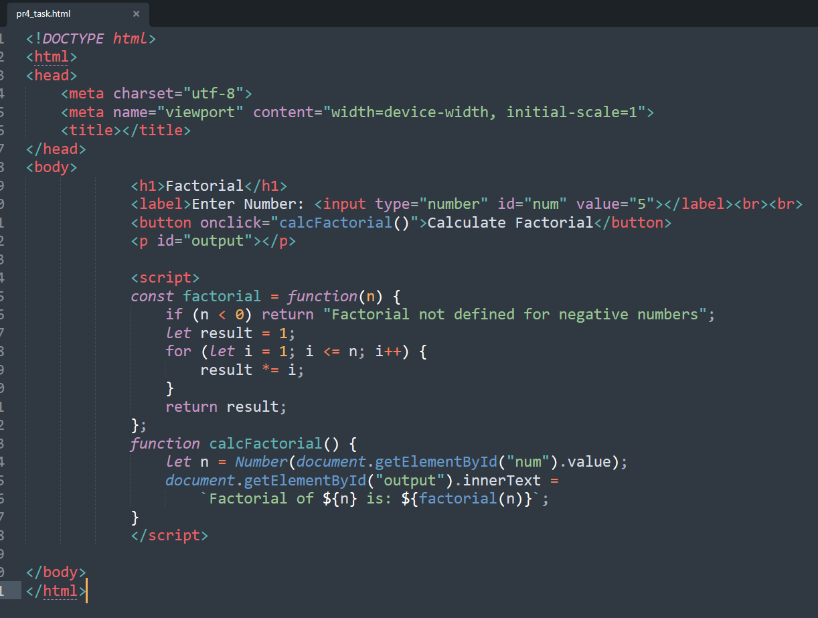

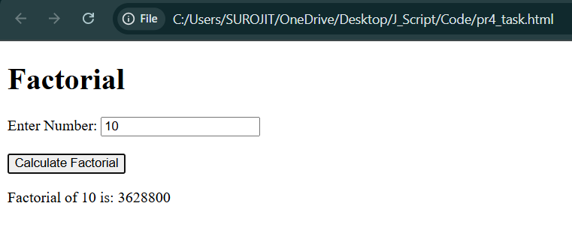

3. Write an arrow function that checks if a given string contains the word
JavaScript.
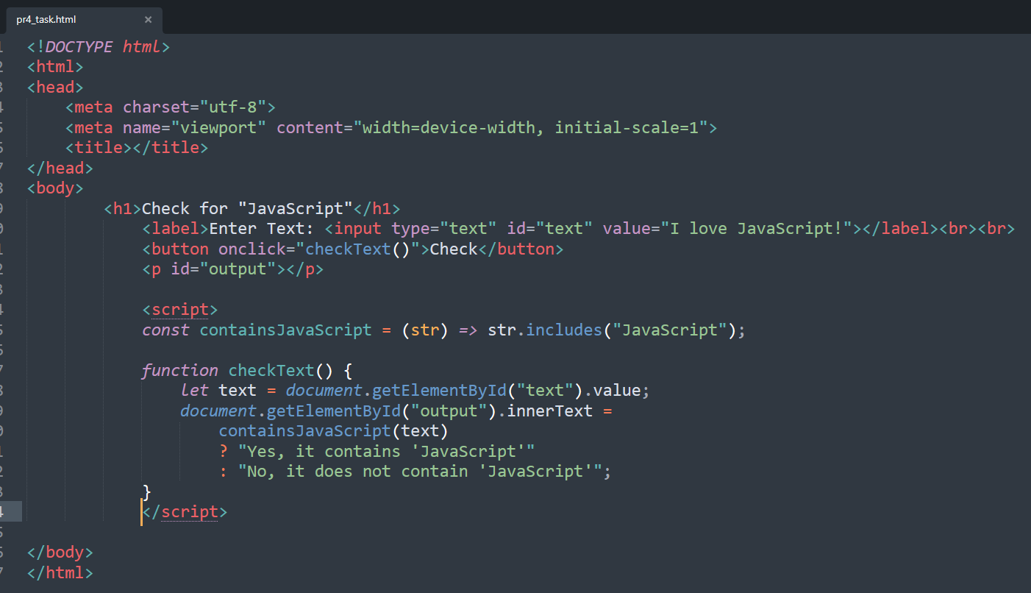
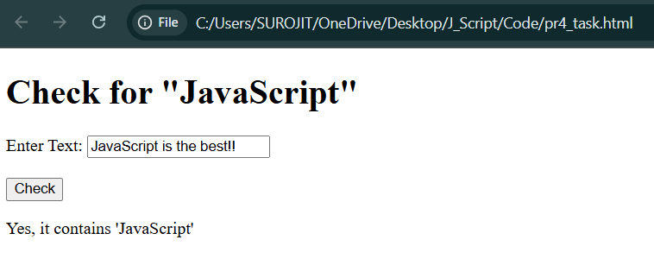
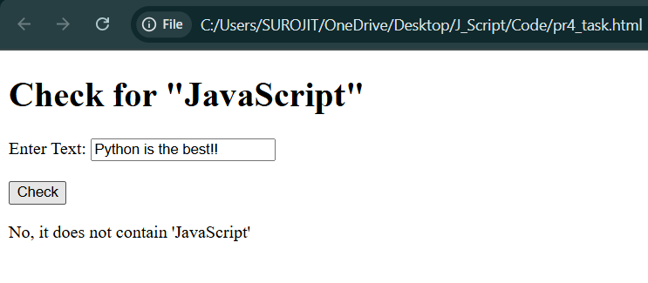

4. Create a closure that stores a secret message and returns it only when a password
matches.

