Surajit Halder
PRN.24070521509
Sec.B2
Sem.5th
Final Problem Statement of Practical 1:
Design and develop an interactive college department webpage for the SIT Nagpur Computer Science Department that displays a welcome message using JavaScript and links to a student information page. On the student page, prompt the user for their name, display it using an alert, log it in the browser console, and dynamically update the content on the page using DOM manipulation. The solution must demonstrate the use of both internal and external JavaScript in a modular structure.

Code(index.html):
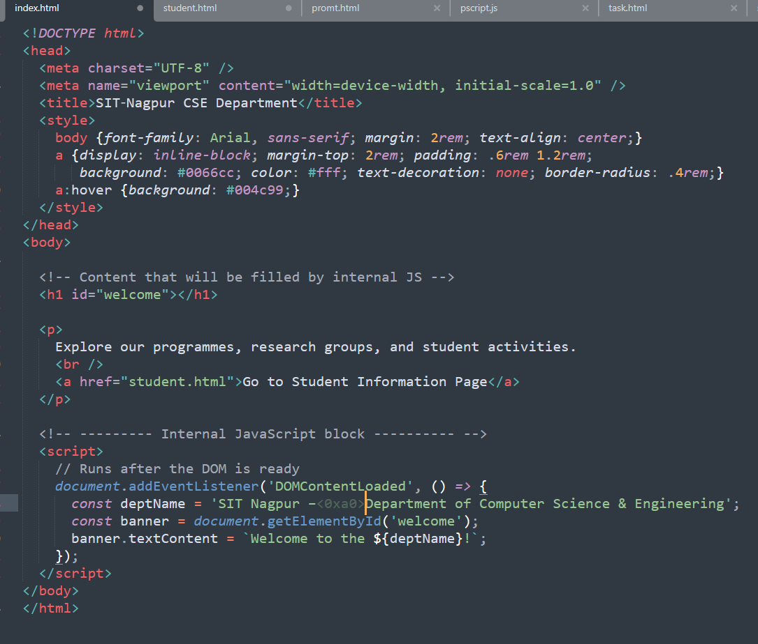
Code(Student.html): 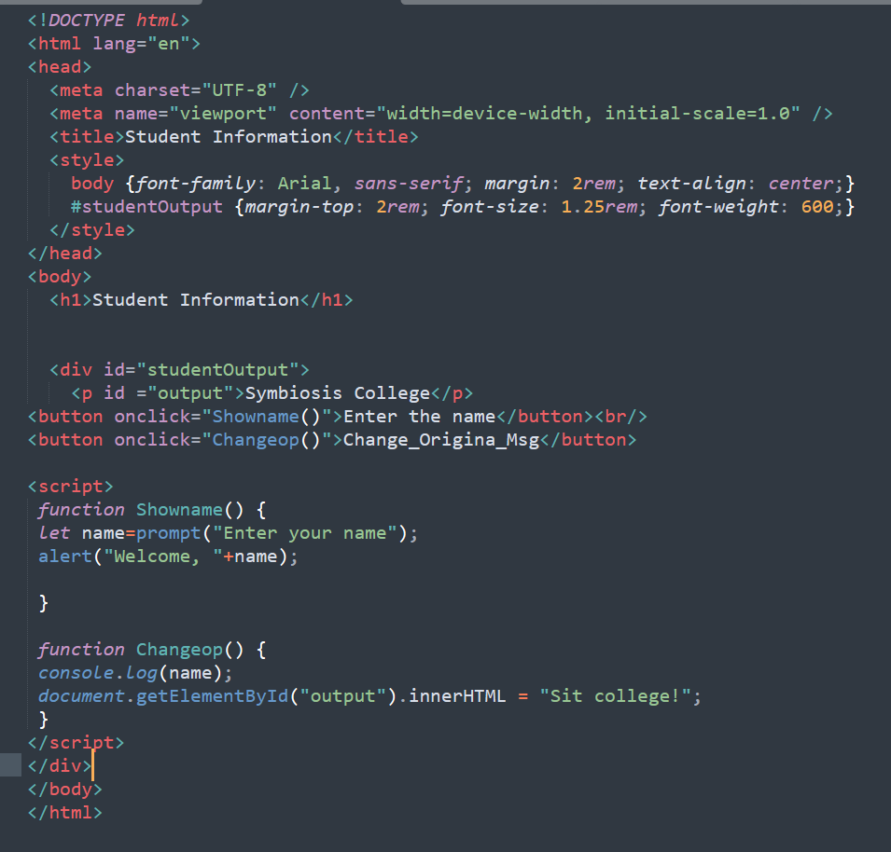
Output(Index):
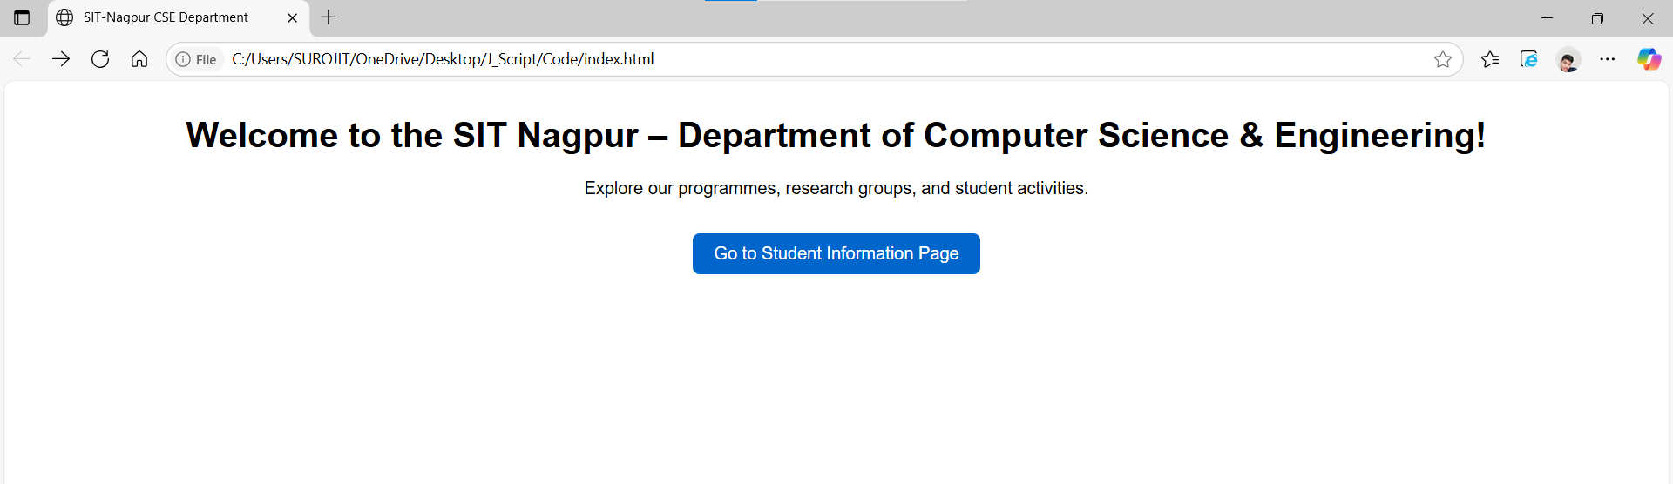
Output(Student): 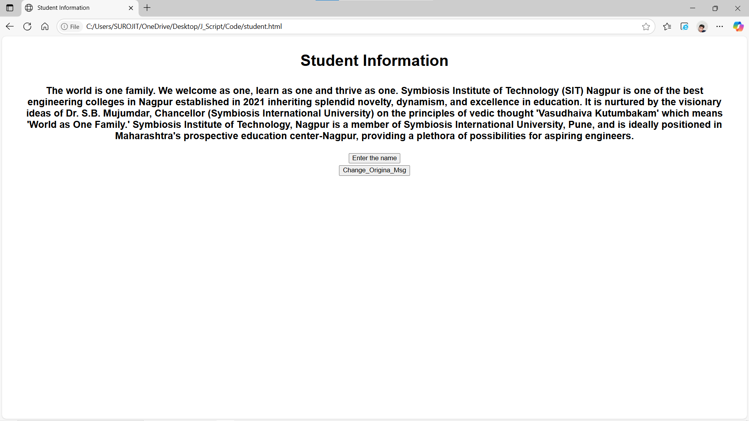
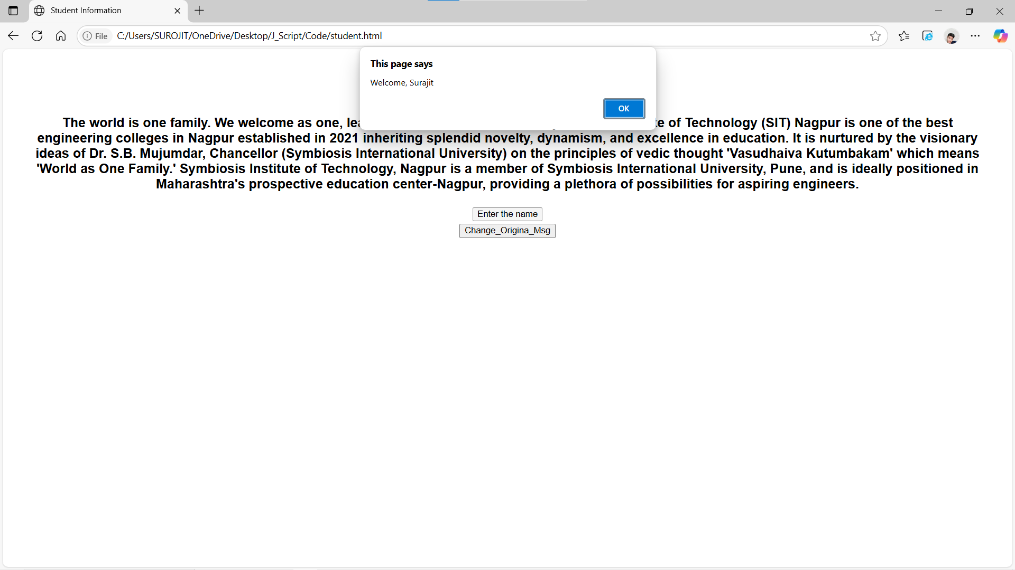

Output(After change the content):
