**BILL SPLITTER**

Submitted in partial fulfillment of the requirements

of the syllabus of

**Android Apps Development Lab**

in

**Information Technology**

by

**AANCHAL MANI 118A3001**

**RABIYA IDRISHI 118A3017**

**SURAJ IYER 118A3020**

Under the guidance of

**Ms. Bushra Shaikh** 

**Department of Information Technology**

**SIES Graduate School of Technology, Nerul**

**2021-2022**

**CERTIFICATE**

This is to certify that the project entitled **“Bill Splitter”** is a bonafide work of the following students, submitted to the University of Mumbai in partial fulfillment of the requirement of the syllabus of **Android Apps Development Lab** in **Information Technology.**

**AANCHAL MANI 118A3001**

**RABIYA IDRISHI 118A3017**

**SURAJ IYER 118A3020**

### Ms. Bushra Shaikh Dr. K. Lakshmi Sudha Dr. Atul N Kemkar

### **Internal Guide Head of Department Principal**

**PROJECT REPORT APPROVAL**

This project report entitled **Bill Splitter** by following students is approved for the requirement of the syllabus of **Android Apps Development Lab** in **Information Technology.**

**AANCHAL MANI 118A3001**

**RABIYA IDRISHI 118A3017**

**SURAJ IYER 118A3020**

## **Name of External Examiner: ---------------------------**

**Signature:---------------------------**

**Name of Internal Examiner: ---------------------------**

**Signature:---------------------------**

**Date:**

**Place:**

**DECLARATION**

I declare that this written submission represents my ideas in my own words and where others’ ideas or words have been included, I have adequately cited and referenced the original sources. I also declare that I have adhered to all principles of academic honesty and integrity and have not misrepresented or fabricated or falsified any idea/data/fact/source in my submission. I understand that any violation of the above will be cause for disciplinary action by the Institute and can also evoke penal action from the sources which have thus not been properly cited or from whom proper permission has not been taken when needed.

**AANCHAL MANI 118A3001**  ____________

**RABIYA IDRISHI 118A3017** ____________

**SURAJ IYER 118A3020 _**___________

Signature

**Date:**

**ACKNOWLEDGEMENT**

It gives us immense pleasure to thank Dr. Atul N Kemkar, our Principal for extending his support to carry out and develop the project. We also thank our Head of Department Dr. Lakshmi Sudha for her support in completing the project. We wish to express our deep sense of gratitude and thank our Internal Guide, Ms. Bushra Shaikh for her guidance, help and useful suggestions, which helped in completing our project work in time.

We would like to thank the entire faculty of the Information Technology Department for their valuable ideas and timely assistance in this project. Last but not least, we would like to thank our non-teaching staff members of our college for their support, in facilitating timely completion of this project.

**Project Team**

AANCHAL MANI 118A3001

RABIYA IDRISHI 118A3017

SURAJ IYER 118A3020

**ABSTRACT**

Mobile applications have become a part of our day-to-day life. Today, the availability of mobile apps is on the increase such that it is producing a noticeable change in the way humans feel and experience computing. Mobile apps are unlimited in number with usage that cuts across all walks of life and with people wanting more and more of these apps for easy lifestyle and living. The idea of developing the bill splitter application struck us due to the frequent problems we faced while splitting bills during a meet-up or a trip. Splitting expenses among groups is confusing and maintaining the personal expense is a big deal. Many applications are available that help users manage personal and group expenses but they are not very reliable and they do not fulfil the user requirements. In this project, we have curated a mobile application that manages user expenses, the personal contribution of the user towards the group expenses, etc. It provides information of "who owes who and by how much", location services so that the user remembers where exactly the money was spent and also an in-built camera to capture the picture of the bill . The proposed application will eliminate confusions and data inconsistency problems while recording and splitting of expenses. With our application user can manage expenses more effectively. We aim to provide users the best approach to share expenses effectively and accurately.

**CONTENTS**

|  |  |  |
| --- | --- | --- |
|  |  | **Page No.** |
| **Chapter 1** | **Introduction** | **8** |
| **Chapter 2** | **Survey of Existing Apps** | **9** |
| **Chapter 3** | **Report on Present Investigation** | **11-12** |
|  | 3.1 Problem Statement | **11** |
|  | 3.2 Source of Problem Statement | **11** |
| **Chapter 4** | **Design and Implementation of Android Apps Components** | **13-25** |
|  | 4.1 Layouts | **13** |
|  | 4.2 Intents | **14** |
|  | 4.3 Activity | **15** |
|  | 4.4 Database | **16** |
|  | 4.5 Camera | **18** |
|  | 4.6 Location API | **19** |
|  | 4.7 Generate APK file | **20** |
| **Chapter 5** | **Report on Proposed System and its Implementation** | **26** |
|  | 5.1 Block Diagram | **26** |
|  | 5.2 Hardware | **26** |
| **Chapter 6** | **Results and Discussions** | 27-31 |
|  | 6.1 Summary of Screenshots with Navigational Flow | 27 |
| **Chapter 7** | **Conclusions** | **32** |

**CHAPTER 1**

**INTRODUCTION**

Bill Splitter is a mobile application intended to run on android devices. It is designed to help users by reducing the efforts for settlement of bills among groups. We aim to provide users the best approach to share expenses effectively and accurately. This application will help users and their companions to have a detailed view of expenses and to settle them. It provides information of "who owes who and by how much", location services so that the user remembers where exactly the money was spent and also an in-built camera to capture the picture of the bill. The proposed application will eliminate confusions and data inconsistency problems while recording and splitting of expenses. With our application user can manage expenses more effectively.

**CHAPTER 2**

**SURVEY ON EXISTING APPS**

**1.SPLITWISE:**

Splitwise is an application used to organize group bills for households, trips, and more. It can be used by Roommates for splitting rent and apartment bills.

**Features:**

* Multi-platform support for Android, iOS, and web
* Expense categorization  
  Calculate group totals
* Add multiple payers on a single expense
* See total balances with a person across multiple groups and private expenses
* Any deleted group or bill can be restored easily

**2.SPLITBILL:**

SplitBill App can be used for any activity with friends and colleagues: travel, holiday trips, week-end dinner, etc. Couples can split the expenses of household costs, groceries etc. Can be used to split money immediately and securely.

**Features:**

* Totally free App
* Attractive interface that is super easy to use
* Available in both iOS and Android
* Create group totals
* Add multiple users on a single bill

**3.SPLITTR:**

Splittr helps you to split group expenses on vacations, with your roommates or any other group activity. Users can simply add expenses and Splittr will prompt who owes who how much.

**Features:**

* Works offline
* Super-fast and easy user interface
* Categorize your expenses
* No registration needed
* Statistics about your group

**CHAPTER 3**

**REPORT ON PRESENT INVESTIGATION**

**3.1.PROBLEM STATEMENT:**

The applications available in the market are useful to the users and reduce human effort but are not very reliable and lack certain features. Bill Splitter is an application which has a great scope in daily life. There are similar applications available but lack many important aspects which we have added to make our application unique and make it stand apart. It is intended to assist users by minimizing the time and effort required to settle expenses among groups. We want to give people the most efficient and accurate way to split expenses. This plan will equip users and their companions in getting a thorough view of their expenses and settling them. It includes information on "who owes who and how much," as well as location services to help the user recall where the money was spent and an in-built camera to take a photo of the bill. While recording and splitting expenses, the proposed application will eliminate confusion and data inconsistency issues. Our app allows users to  manage their costs better.

**3.2.SOURCE OF PROBLEM STATEMENT:**

Splitting the expenses among groups is confusing and maintaining the personal expense is a big deal. The idea of developing the bill splitter application struck us due to the frequent problems we faced while splitting bills during a meet-up or a trip. There are different methods that can be used to manage the expenses like making use of sticky notes, spreadsheets, etc. These methods are problematic in areas like data consistency, also there are chances where critical inputs can be missed and manual errors might creep in. These days people believe in a solution that can be used on a mobile application to handle these problems. This app is capable enough to record the data, split-bills, show the exact location where expenses were made, capture a bill snap-shot, etc. It is also intelligent enough to show : ‘ Who owes who ?And by how much ??’

**CHAPTER 4**

**DESIGN AND IMPLEMENTATION OF ANDROID APPS COMPONENTS**

**4.1.LAYOUTS**

Android **Layout** is used to define the user interface that holds the UI controls or widgets that will appear on the screen of an android application or activity screen. Generally, every application is a combination of View and View Group. There are eight types of layouts in android namely: Linear Layout, Relative Layout, Constraint Layout, Frame Layout, Table Layout, Web View, List View and Grid View.

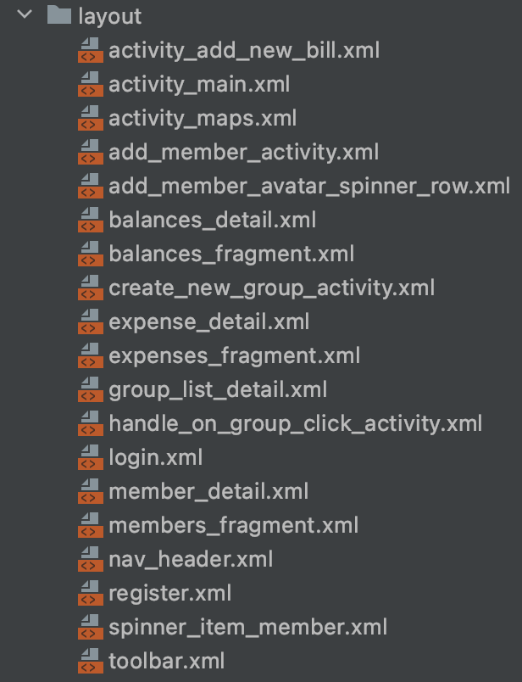

**4.2.INTENTS**

Android Intent is the message that is passed between components such as activities, content providers, broadcast receivers, services etc. It is generally used with the startActivity() method to invoke activity, broadcast receivers etc. The LabeledIntent is the subclass of android.content.Intent class. Android Intents are mainly used to:Start the service, launch an activity, display a web page, display a list of contacts, broadcast a message, dial a phone call etc. There are two types of intents in android: implicit and explicit.

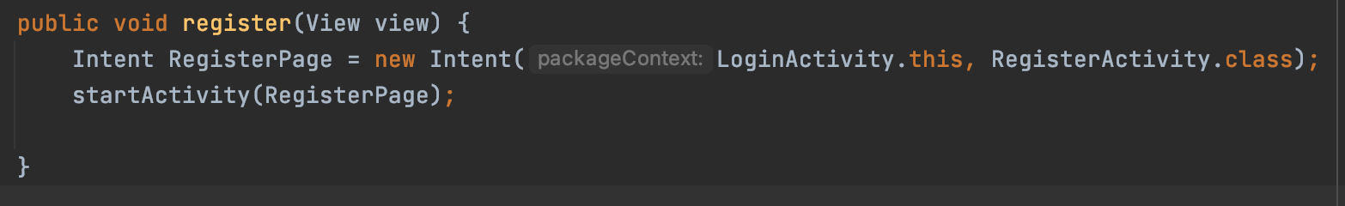

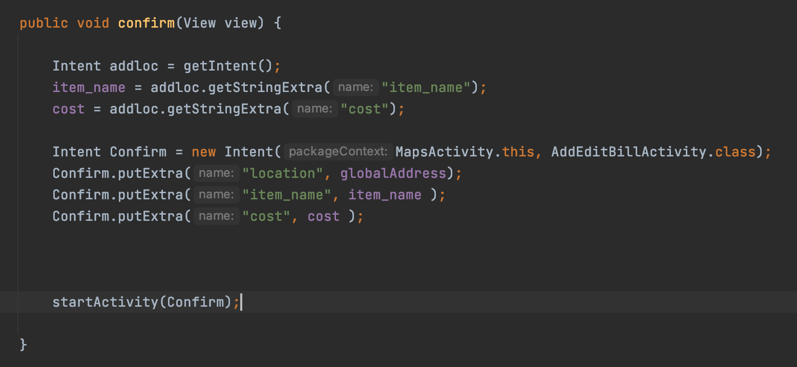

**4.3.ACTIVITY**

An activity is a single, focused thing that the user can do. Almost all activities interact with the user, so the Activity class takes care of creating a window for you in which you can place your UI with [setContentView(View)](https://developer.android.com/reference/android/app/Activity" \l "setContentView(android.view.View)). While activities are often presented to the user as full-screen windows, they can also be used in other ways: as floating windows (via a theme with [R.attr.windowIsFloating](https://developer.android.com/reference/android/R.attr" \l "windowIsFloating) set), Multi-Window mode or embedded into other windows. There are two methods almost all subclasses of Activity will implement: [onCreate(Bundle)](https://developer.android.com/reference/android/app/Activity#onCreate(android.os.Bundle)) is where you initialize your activity and [onPause()](https://developer.android.com/reference/android/app/Activity#onPause()) is where you deal with the user pausing active interaction with the activity. To be of use with [Context.startActivity()](https://developer.android.com/reference/android/content/Context" \l "startActivity(android.content.Intent)), all activity classes must have a corresponding [<activity>](https://developer.android.com/reference/android/R.styleable#AndroidManifestActivity) declaration in their package's AndroidManifest.xml.

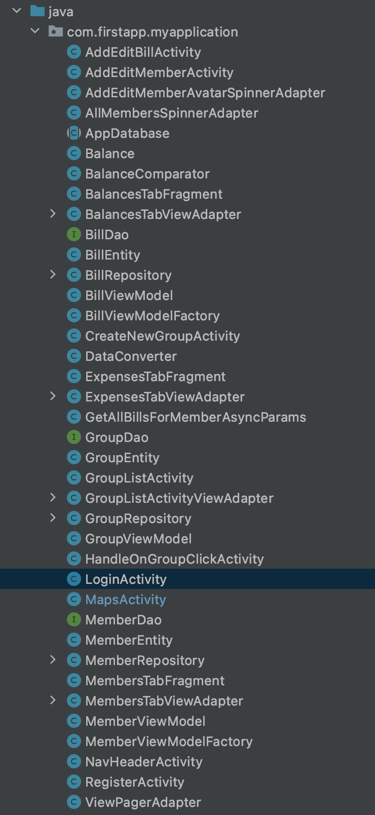

**4.4.DATABASE**

We have used the room database for the major activities in our app. Apps that handle non-trivial amounts of structured data can benefit greatly from persisting that data locally. The most common use case is to cache relevant pieces of data so that when the device cannot access the network, the user can still browse that content while they are offline.

The Room persistence library provides an abstraction layer over SQLite to allow fluent database access while harnessing the full power of SQLite. In particular, Room provides the following benefits:

a)Compile-time verification of SQL queries.

b)Convenience annotations that minimize repetitive and error-prone boilerplate code.

c)Streamlined database migration paths.

For our login and register modules we have used Firebase. Firebase (a NoSQLjSON database) is a real-time database that allows storing a list of objects in the form of a tree. We can synchronize data between different devices. Google Firebase is Google-backed application development software which allows developers to develop **Android, IOS,** and **Web apps**. For reporting and fixing app crashes, tracking analytics, creating marketing and product experiments, firebase provides several tools. Firebase has three main services, i.e., a real-time database, user authentication, and hosting.

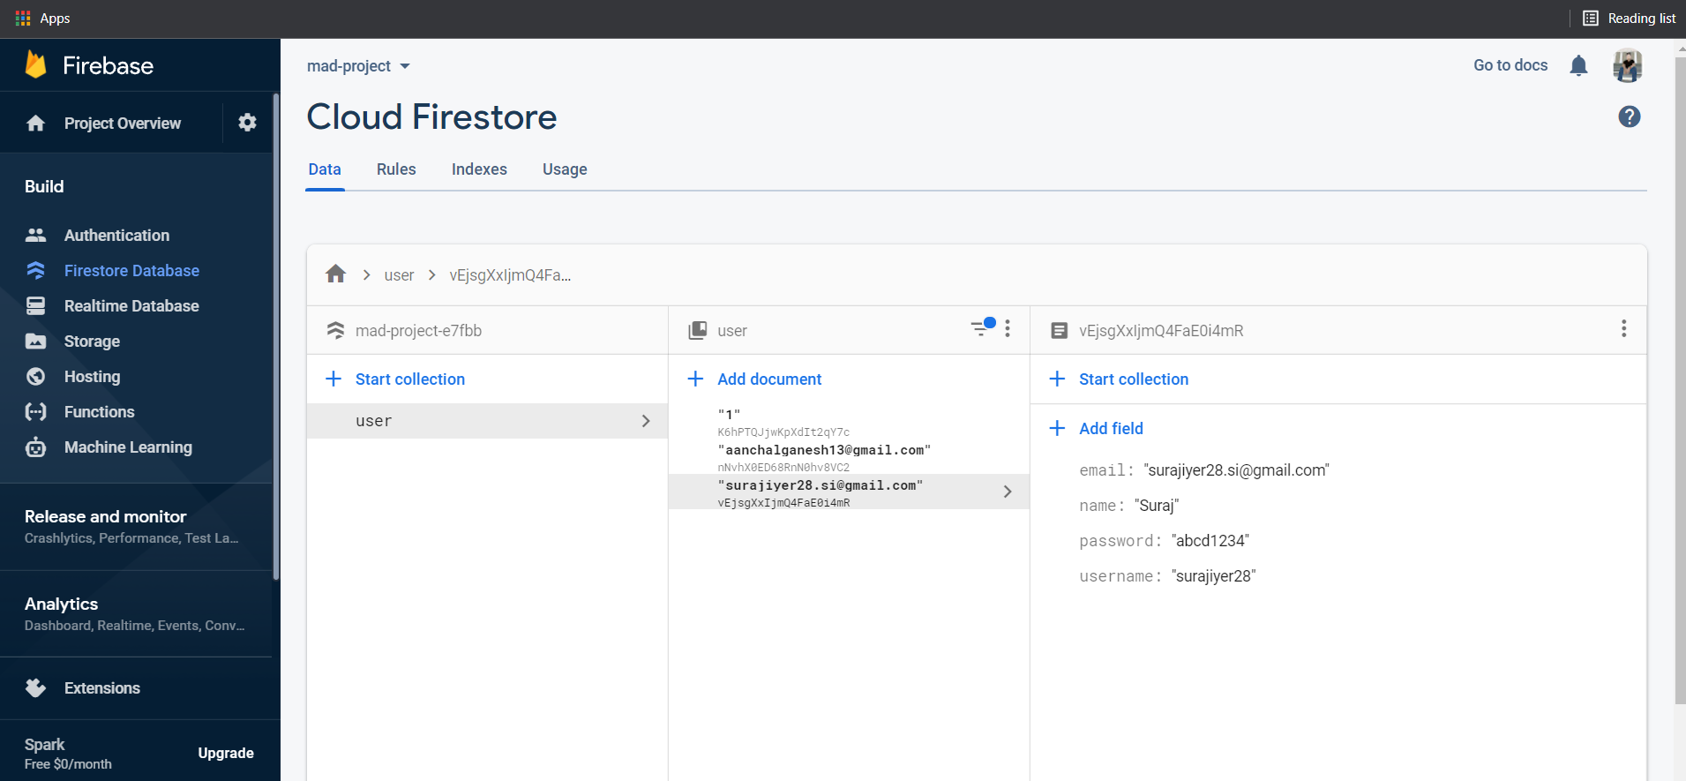

**4.5.CAMERA**

Camera is mainly used to capture picture and video. We can control the camera by using methods of camera api. Android provides the facility to work on camera by 2 ways: By Camera Intent and by Camera API.

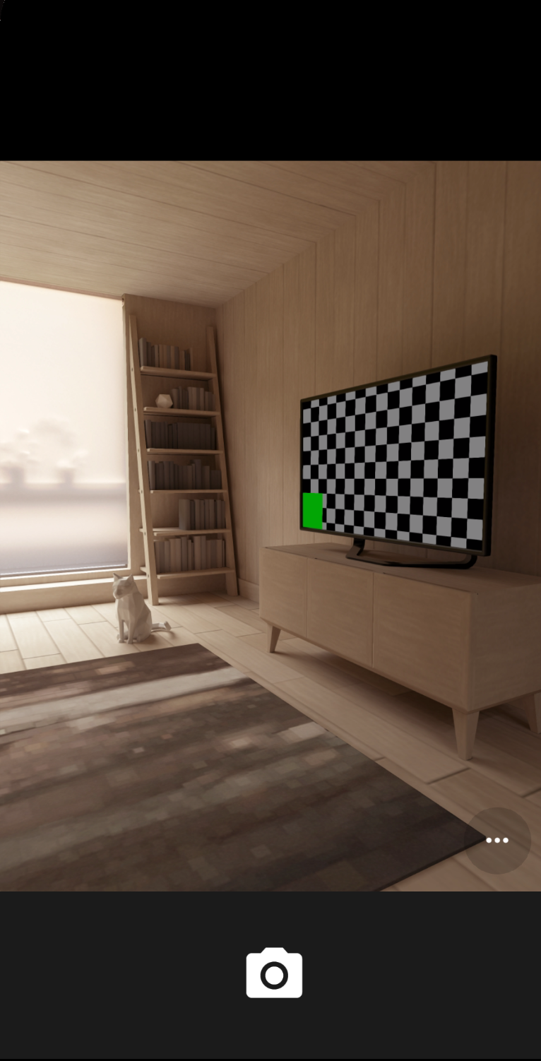

**4.6.LOCATION API**

One of the unique features of mobile applications is location awareness. Mobile users take their devices with them everywhere, and adding location awareness to your app offers users a more contextual experience. The location APIs available in Google Play services facilitate adding location awareness to your app with automated location tracking, wrong-side-of-the-street detection, geofencing, and activity recognition.

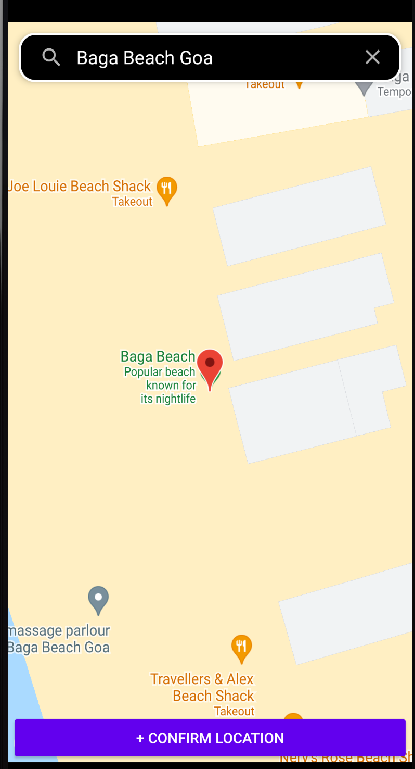

**4.7. GENERATE APK**

**Step1: Go to Build -> Generate Signed Bundle/APK..**

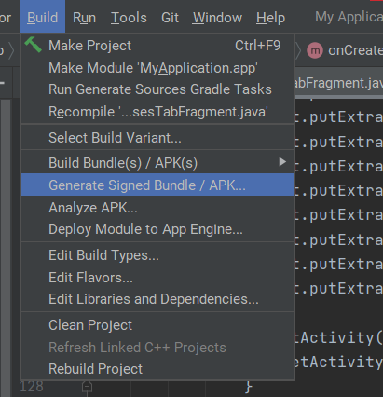

**Step 2: Select APK and then click on Next**

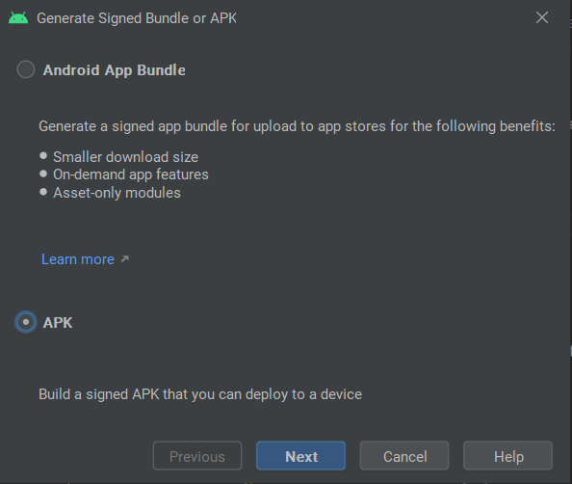

**Step 3: Choose the directory**

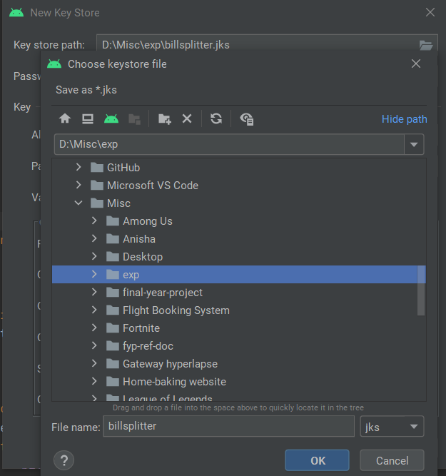

**Step 4: Enter all the details**

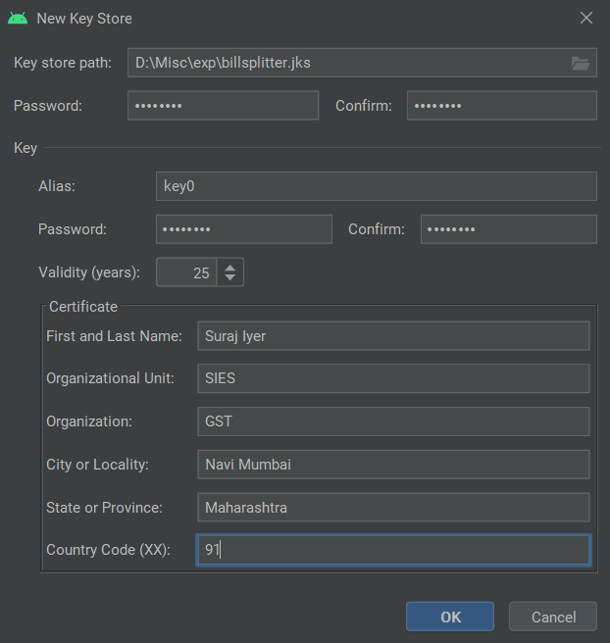

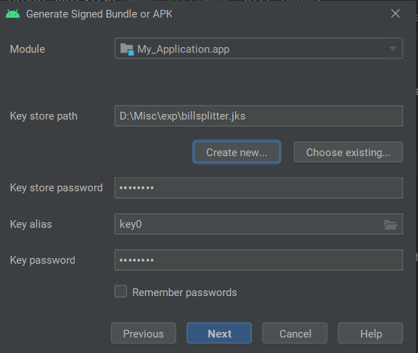

**Step 5: Select Both the Variants and then click on “Finish”.**

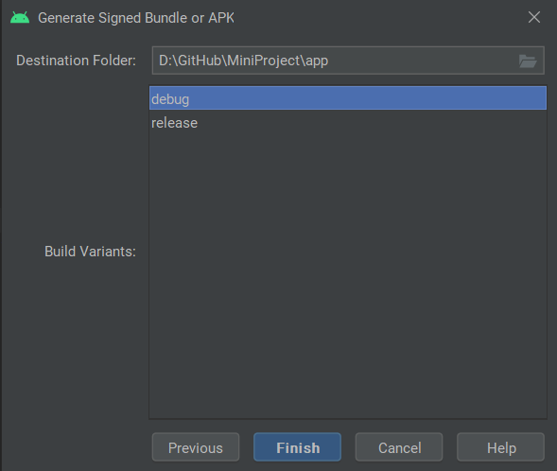

**CHAPTER 5**

**REPORT ON PROPOSED SYSTEM AND ITS IMPLEMENTATION**

**5.1 BLOCK DIAGRAM**

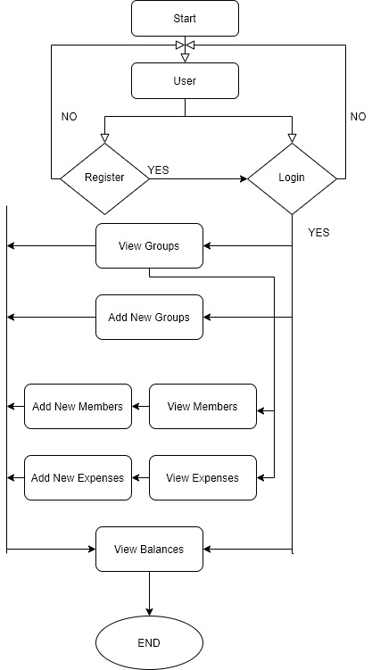

**5.2 HARDWARE**

* Android Device
* GPS
* Internet
* Camera

**CHAPTER 6**

**RESULTS AND DISCUSSIONS**

**Module A:**

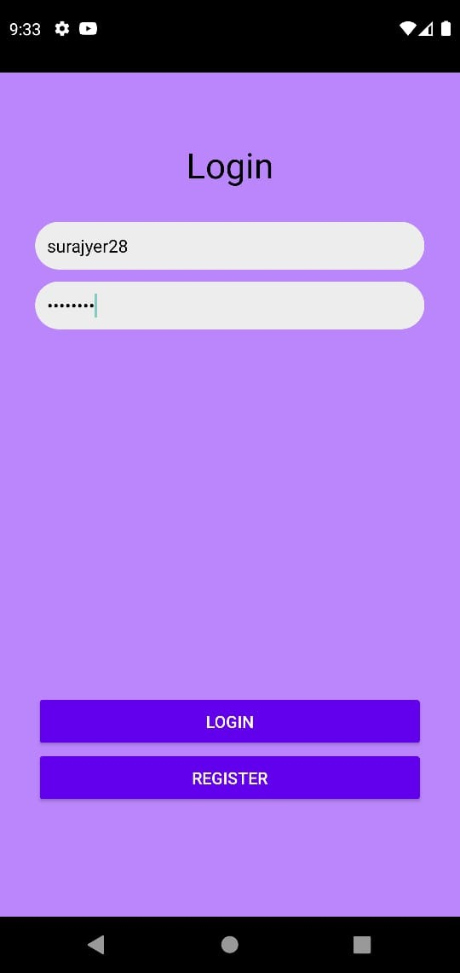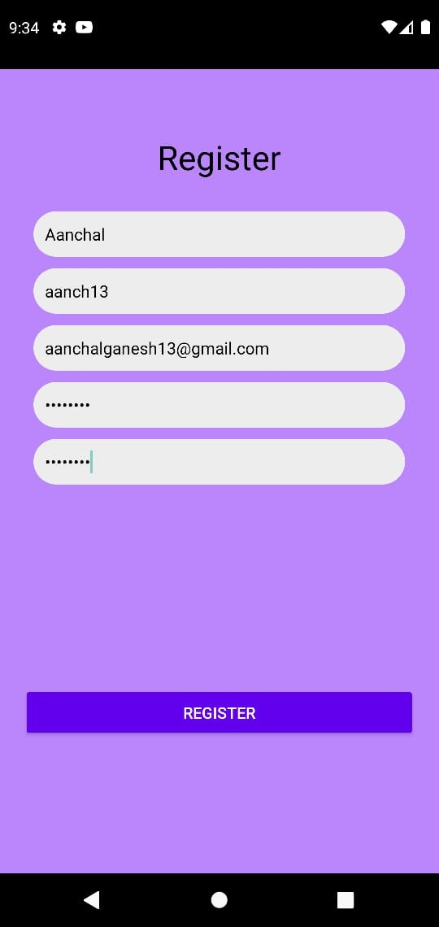

This module consists of the Login Page where users have to enter their username and password. If they are a new user, they have an option to register as a new user. This leads them to the registration page. Here, the users will register themselves to the app by providing information such as their Email Id , password and username. Once registered, the user can now Login and start using the app

**Module B:**

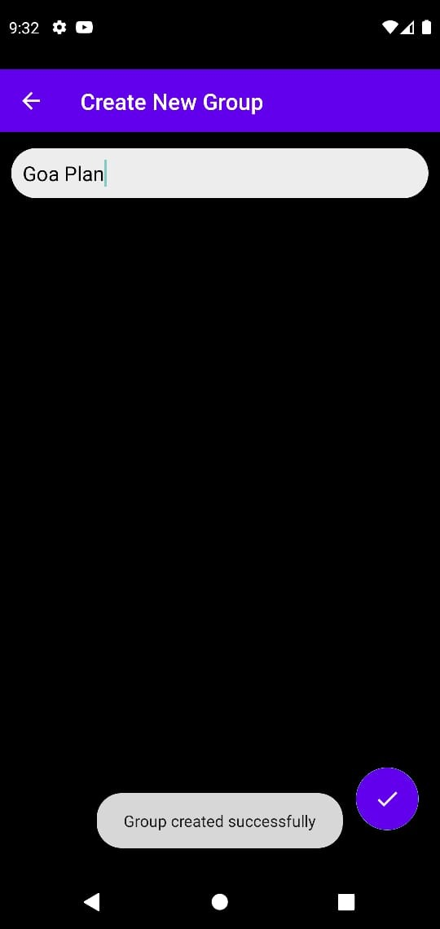 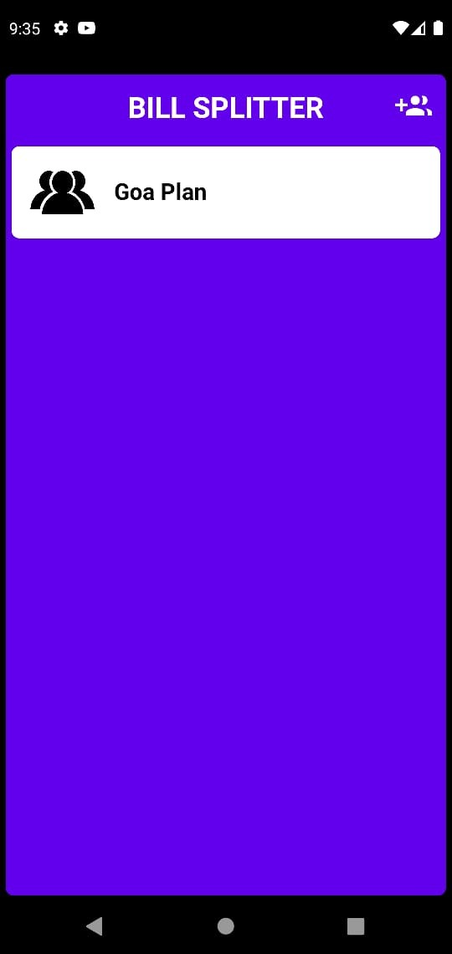

After Logging In, the user lands on the home page which displays the groups that they have added. If they have not formed any groups yet, they can create a new group and the group will appear on this page. Multiple such groups can be added by the user.

**Module C:**

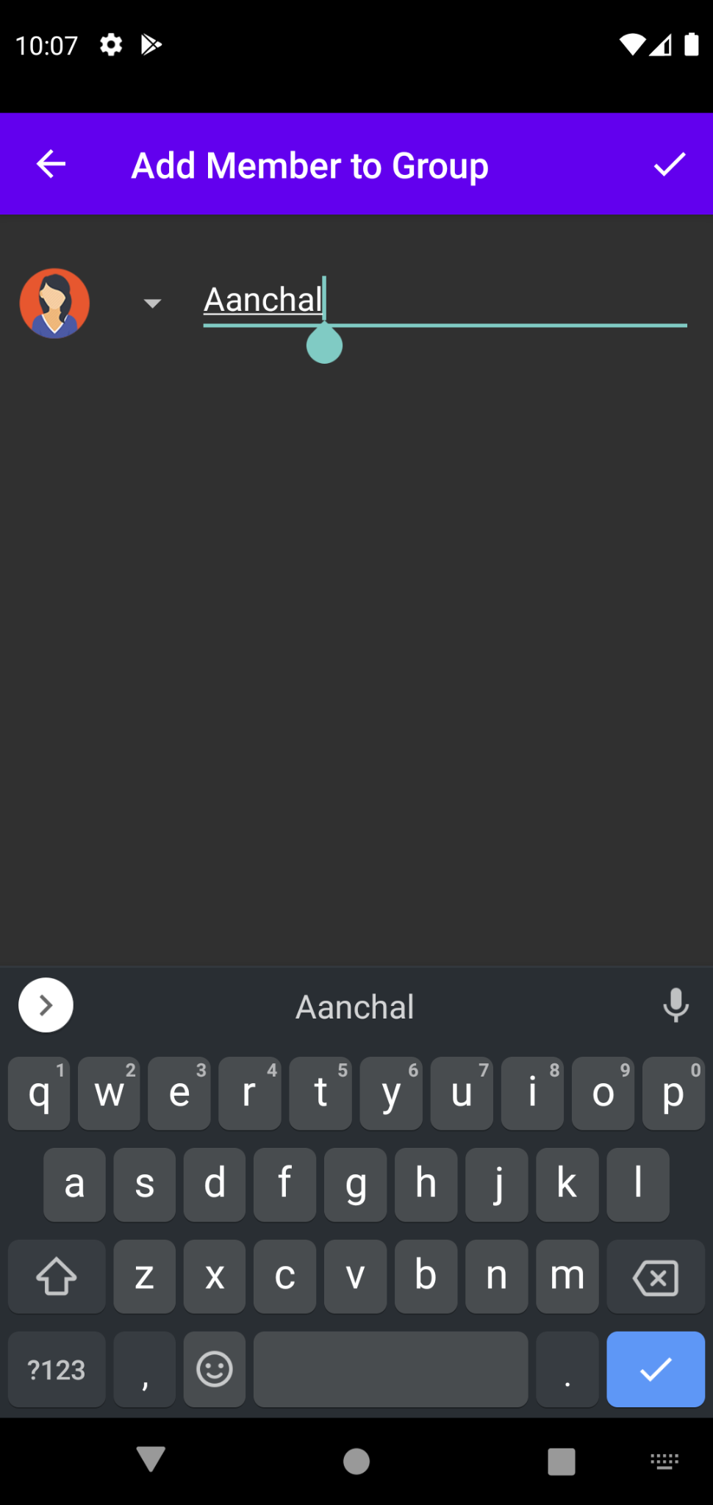 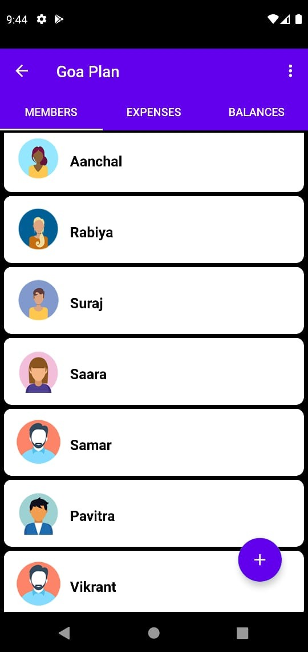

After selecting a group, the users are redirected to the members page where they can add members to their group.

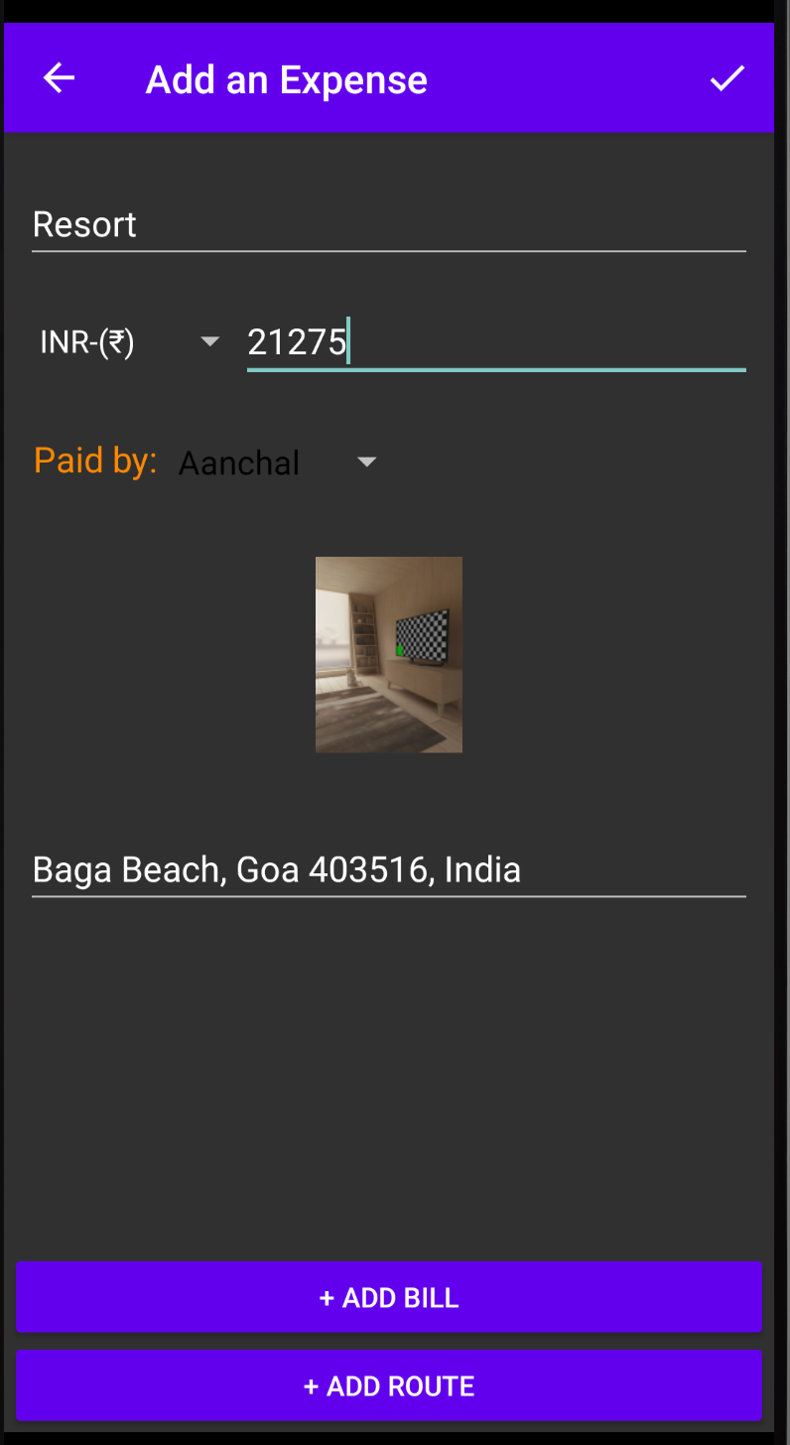 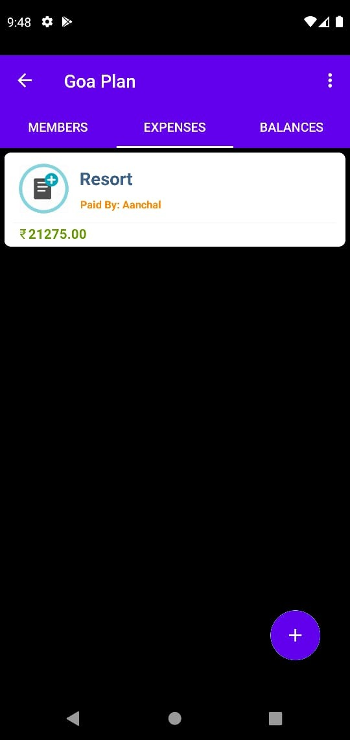

In this Module a user can add an expense that has been shared by all the members of the group. Here, the user has to enter the name of the item, it’s cost and currency, the name of the member who paid the bill , a picture of the bill and the location of the expenditure.

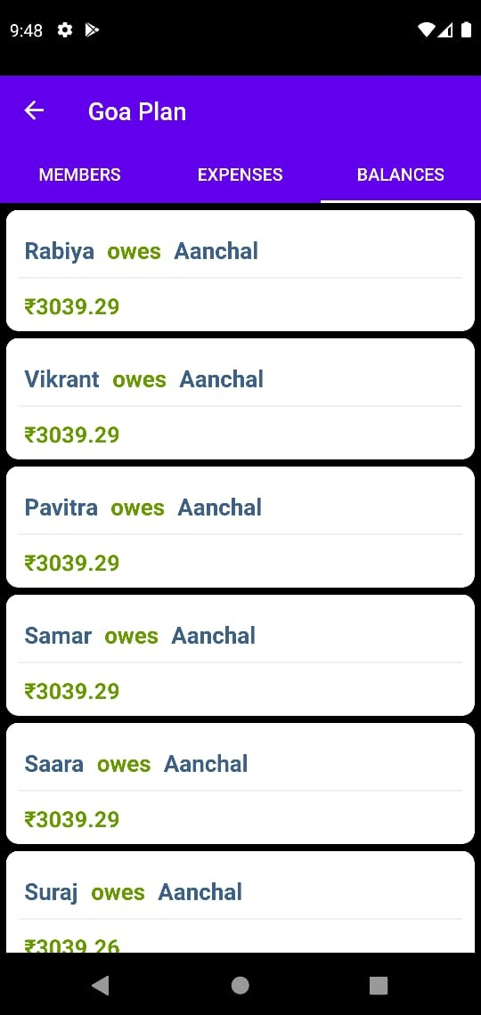

Here, the user can take a look at the balances of the group. This page will display the names of the users who owe money, with the names of the users whom they owe the money to.

**CHAPTER 7**

**CONCLUSION**

Bill Splitter is a mobile application for Android phones and tablets. It is intended to assist users by minimizing the time and effort required to settle invoices among groups. We want to give people the most efficient and accurate way to split expenses. This program will assist customers and their companions in getting a thorough view of their expenses and settling them. It includes information on "who owes who and how much," as well as location services to help the user recall where the money was spent and an in-built camera to take a photo of the bill. While recording and splitting expenses, the proposed application will eliminate confusion and data inconsistency issues. With our application user can manage expenses more effectively.

**REFERENCES**

**[1] https://firebase.google.com/docs/android/setup**

**[2] Firebase authentication, setup, storage, google-signin and notifications documentation.**

**[3] https://developer.android.com/training/data-storage/room**

**[4] Firebase Cloud Messaging Tutorials to implement the recent changes done in the FCM functions.**

**[5] https://developer.android.com/guide/topics/media/camera**

**[6] https://developer.android.com/training/location/permissions**