Suraj Iyer
suraiyer@iu.edu
Project Report: World Bank Indicators Data Pipeline

Introduction
The project focuses on demonstrating an ETL pipeline created for World Bank Global Economic Indicators from 2010 to 2025. The dataset includes a total of 11 key macroeconomic indicators like Inflation, GDP, Unemployment rate, etc; for 200+ countries over a period of 15 years. The objective of the project is to use distributed data processing through cloud native services to transform the data and analyze it for meaningful insights using Big Query and Looker. The project directly connects to the module on Big and Complex Data Processing and Analytics with the raw data first being loaded into GCS followed by Big Query after applying transformations using PySpark.

Background
Analyzing Economic indicators or metrics with big or complex data enables researchers, policymakers, political or business leaders and economists to extract relevant insights crucial for making well informed decisions, that may directly or indirectly impact on the citizens of an economy by shaping policies or guiding economic strategies. Although the project utilizes a relatively small dataset, working with economic data involves distributed computing for processing transformations on large scale datasets, for example, using PySpark. It would also involve Cloud data warehousing and Pipeline concepts to aggregate data over time/geographically and produce reproducible data processing workflows that can be scaled as needed.

Methodology
The Project was implemented on Google Cloud Platform using a combination of distributed data processing and cloud native tools.
  - Tools/Technologies:
- PySpark in Google Colab
- Google Cloud Storage
- Google Big Query
- Looker Studio
  - Dataset:
The dataset used was collected from the World Bank Open Data API and includes yearly macroeconomic indicators for over 200 counties from 2010 to 2025. It includes 16 columns, 13 of which are the indicators listed below with brief descriptions of each:
- Inflation (CPI %) – Percentage change in pricing of goods and services
- GDP (Current USD) – Total market value of all goods and services produced within a country
- GDP per Capita (Current USD) – Market value of goods and services per person (GDP divided by the population)
- Unemployment Rate (%) – Percentage of labor force that is not employed
- Interest Rate (Real, %) – Rate reflecting the real cost of borrowing or yield on savings
- Inflation (GDP Deflator, %) – Inflation at the overall economy level
- GDP Growth (% Annual) – Percentage increase or decrease in GDP
- Current Account Balance (% GDP) – Percentage of GDP indicating the difference between a country’s income and expenditure/investments
- Government Expense (% of GDP) – Government expenditure as a percentage of GDP
- Government Revenue (% of GDP) – Government earnings (other than taxes) as a percentage of GDP
- Tax Revenue (% of GDP) – Government earnings (from taxes) as a percentage of GDP
- Gross National Income (USD) – Total Income of the nation (including foreign nationals)
- Public Debt (% of GDP) – Amount of money owed by the government as a percentage of GDP

  - Design Steps:
- Data Ingestion: The raw CSV data file was imported into a Google cloud storage bucket
- Distributed Processing: A PySpark session was created, followed by loading data from cloud storage to apply required cleaning and transformation steps including column name transformations, dropping years with missing data, dropping sparse fields, etc.
- Data Storage: The cleaned data stored in Parquet format was then loaded into Big Query
- Analysis: The data stored in Big Query was analyzed by running queries and creating visualizations in Looker Studio
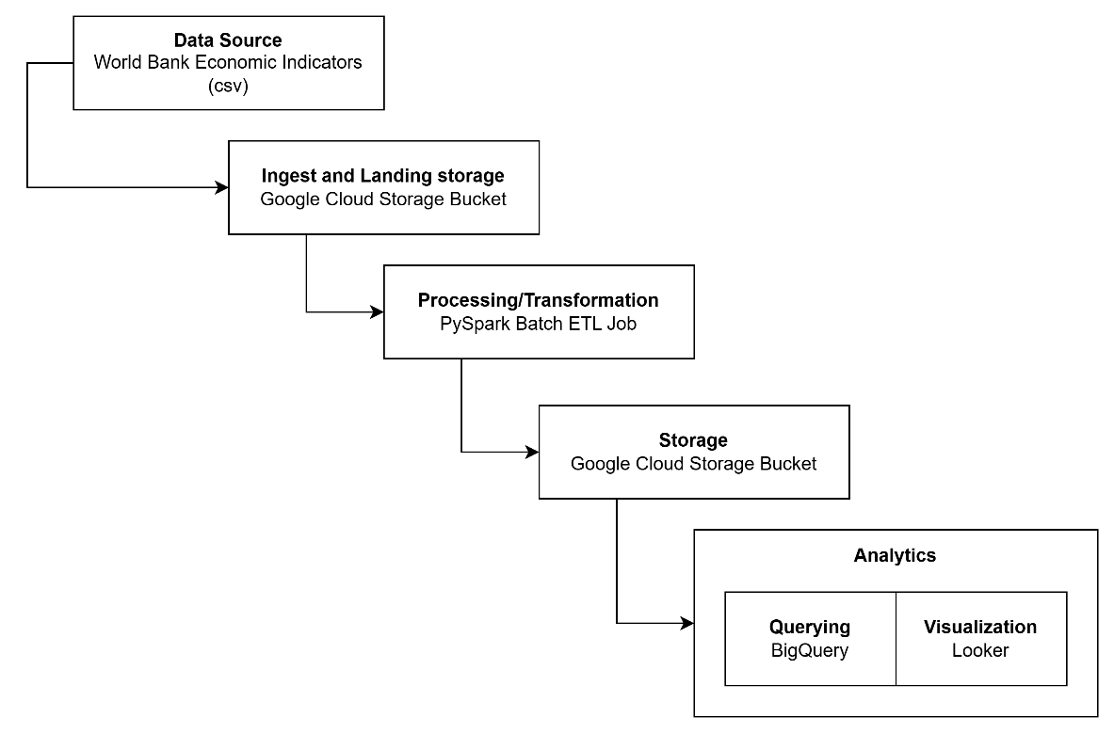
Fig 3.1 - ETL Pipeline for World Bank Economic Indicators

Results
There were five targeted analytical queries designed to uncover some interesting insights. The queries and some key observations are listed below. How the observations were derived (if applicable) and an interpretation of each observation has been described in the Appendix. The steps in the pipeline implemented prior to these analytics steps are also described in the Appendix below.
Queries for analysis along with key observations:
- Top 10 countries with their long-term economic growth in terms of GDP Growth rate
The key observations from the visualization were the dips in GDP growth rate experienced by all major economies in 2020 due to Covid 19 and the overall maximum consistent growth rate exhibited by India and China.
- Tax trends in top 10 major economies
Tax trends are relatively stable over time for major economies, however major European economies like UK, Italy and France maintain a consistently high tax to GDP ratio. The consistency over time indicates maturity in terms of tax policies and systems.
- Average Unemployment rate by country by year
Overall, the data shows that Italy and France have high unemployment for many years, Brazil’s unemployment rises sharply after 2014, and countries like India and China keep much lower unemployment because their job markets are growing faster.
- Inflation Rate for top 10 major economies by year
Emerging economies like India, Brazil, and Russia consistently face much higher inflation than developed countries such as the US, UK, Germany, and Japan, showing a clear divide between unstable and stable economic environments.
- Countries by Average GDP per capita over 2010 to 2023
The data shows a lot of variances with extremely high GDP per capita concentrated in few small countries while most countries remain far behind with a mid or lower GDP per capita.

Discussion
The project successfully demonstrated an end to end ETL pipeline highlighting three core big data concepts from the course including
- Distributed Computing by using PySpark in Google Colab for efficiently processing/transforming the dataset and
- Cloud Data Warehousing via BigQuery to allow running complex analytical queries across temporal and geographical dimensions.
The concept of Data Pipelines was also demonstrated through the systematic workflow as described in the methodology to create a reproducible architecture. The analysis results revealed interesting economic insights that helped validate the effectiveness of the pipeline

A few challenges faced during the project included
- I had initially planned to use Cloud Data Fusion, specifically for transformations using the wrangler but faced some issues configuring Compute Quotas.
- Inconsistencies in the data such as missing values and incompatible column names required additional PySpark transformatons.

Conclusion
The World Bank Economic Indicators pipeline project successfully demonstrates how distributed computing and cloud analytics enable analysis of vast quantities of data collected over the years across multiple countries, to reveal interesting economic patterns. By combining these concepts using tools like PySpark, BigQuery and Looker the pipeline makes it possible to clean, transform, and visualize global economic indicators at scale easily. This end-to-end workflow not only highlights meaningful trends across countries but also shows how modern data engineering tools can turn raw datasets into actionable economic insights.

References
- Google Cloud Platform Documentation: BigQuery Data Warehousing and Analytics.
- Apache Spark Documentation: PySpark DataFrame API for Distributed Data Processing.
- Global Economic Indicators (2010–2025)- World bank– Kaggle (Sourced from World Bank API)
- Google Cloud Storage: Data Lake Architecture Best Practices.
- Looker Studio: Business Intelligence and Data Visualization Platform.
- INFO-I535 Management, Access and Use of Big Data Course Materials and Skill Boost Labs

Appendix
GitHub Repository: https://github.com/surajiyer28/mgmt-access-big-data-project.git
Appendix A: Data Preprocessing using PySpark on Google Colab (code files also accessible on GitHub)
from google.colab import drive
drive.mount('/content/drive')

!pip install pyspark
from pyspark.sql import SparkSession
spark = (
SparkSession.builder
.appName("WorldBankEconomicIndicators")
.getOrCreate()
)
#paths
gcs_path = "gs://suraj-world-bank-etl/world_bank_data_2025.csv"
local_path = "/content/drive/MyDrive/world_bank_data_2025.csv"
df = spark.read.option("header", "true").option("inferSchema", "true").csv(local_path)
df.printSchema()
df.show(5)

# Updating the column names
from pyspark.sql.functions import col, regexp_replace
df = (df
.withColumnRenamed("country_name", "country_name")
.withColumnRenamed("country_id", "country_id")
.withColumnRenamed("year", "year")
.withColumnRenamed("Inflation (CPI %)", "inflation_cpi_percent")
.withColumnRenamed("GDP (Current USD)", "gdp_current_usd")
.withColumnRenamed("GDP per Capita (Current USD)", "gdp_per_capita_usd")
.withColumnRenamed("Unemployment Rate (%)", "unemployment_rate_percent")
.withColumnRenamed("Interest Rate (Real, %)", "interest_rate_percent")
.withColumnRenamed("Inflation (GDP Deflator, %)", "inflation_gdp_deflator_percent")
.withColumnRenamed("GDP Growth (% Annual)", "gdp_growth_annual_percent")
.withColumnRenamed("Current Account Balance (% GDP)", "current_account_balance_percent_gdp")
.withColumnRenamed("Government Expense (% of GDP)", "government_expense_percent_gdp")
.withColumnRenamed("Government Revenue (% of GDP)", "government_revenue_percent_gdp")
.withColumnRenamed("Tax Revenue (% of GDP)", "tax_revenue_percent_gdp")
.withColumnRenamed("Gross National Income (USD)", "gross_national_income_usd")
.withColumnRenamed("Public Debt (% of GDP)", "public_debt_percent_gdp")
)

# Handling missing values
from pyspark.sql.functions import col, sum as spark_sum, when
missing_row = sum([when(col(c).isNull(),1).otherwise(0) for c in df.columns])
total_missing_per_year = (df.withColumn("null_count", missing_row).groupBy("year").agg(spark_sum("null_count").alias("total_nulls")).orderBy("year"))
total_missing_per_year.show()

# dropping 2024 and 2025 due to lot of incomplete data
df_cleaned = df.filter(df.year <= 2023)

# gdp, gross_income cannot have negative values
invalid_negative_cols = [
"gdp_current_usd",
"gdp_per_capita_usd",
"gross_national_income_usd"
]
for c in invalid_negative_cols:
df_cleaned = df_cleaned.filter((col(c) >= 0) | col(c).isNull())

from pyspark.sql.functions import count
df_cleaned.select([
count(when(col(c).isNull(), c)).alias(c + "_nulls")
for c in df_cleaned.columns
]).show(truncate=False)
df_cleaned = df_cleaned.drop("public_debt_percent_gdp")
df_cleaned.show(10)

# Saving the cleaned data
output_path = "/content/drive/MyDrive/economic_indicators_cleaned"
df_cleaned.write.mode("overwrite").parquet(output_path)
!gsutil -m cp -r /content/drive/MyDrive/economic_indicators_cleaned gs://suraj-world-bank-etl

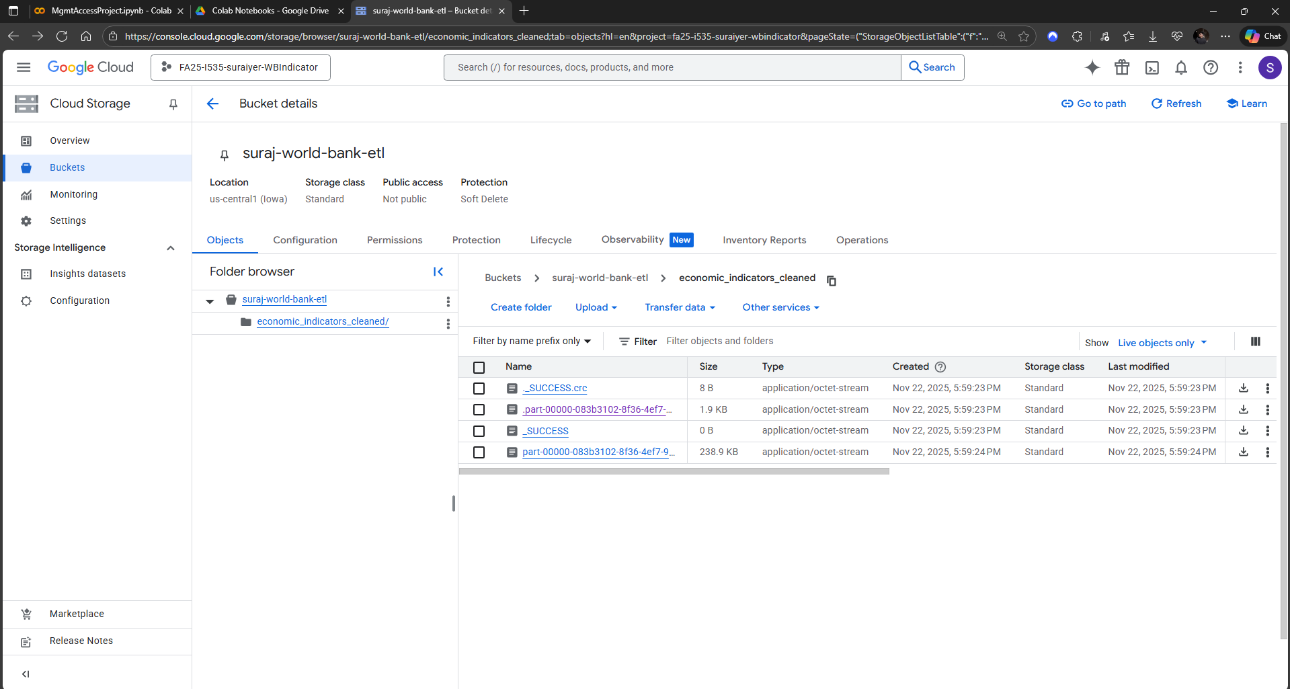
Fig A.1 - Cleaned file Stored in GCS bucket
Appendix B: BigQuery table creation on Google Cloud Platform


Fig B.1 - Creating a dataset

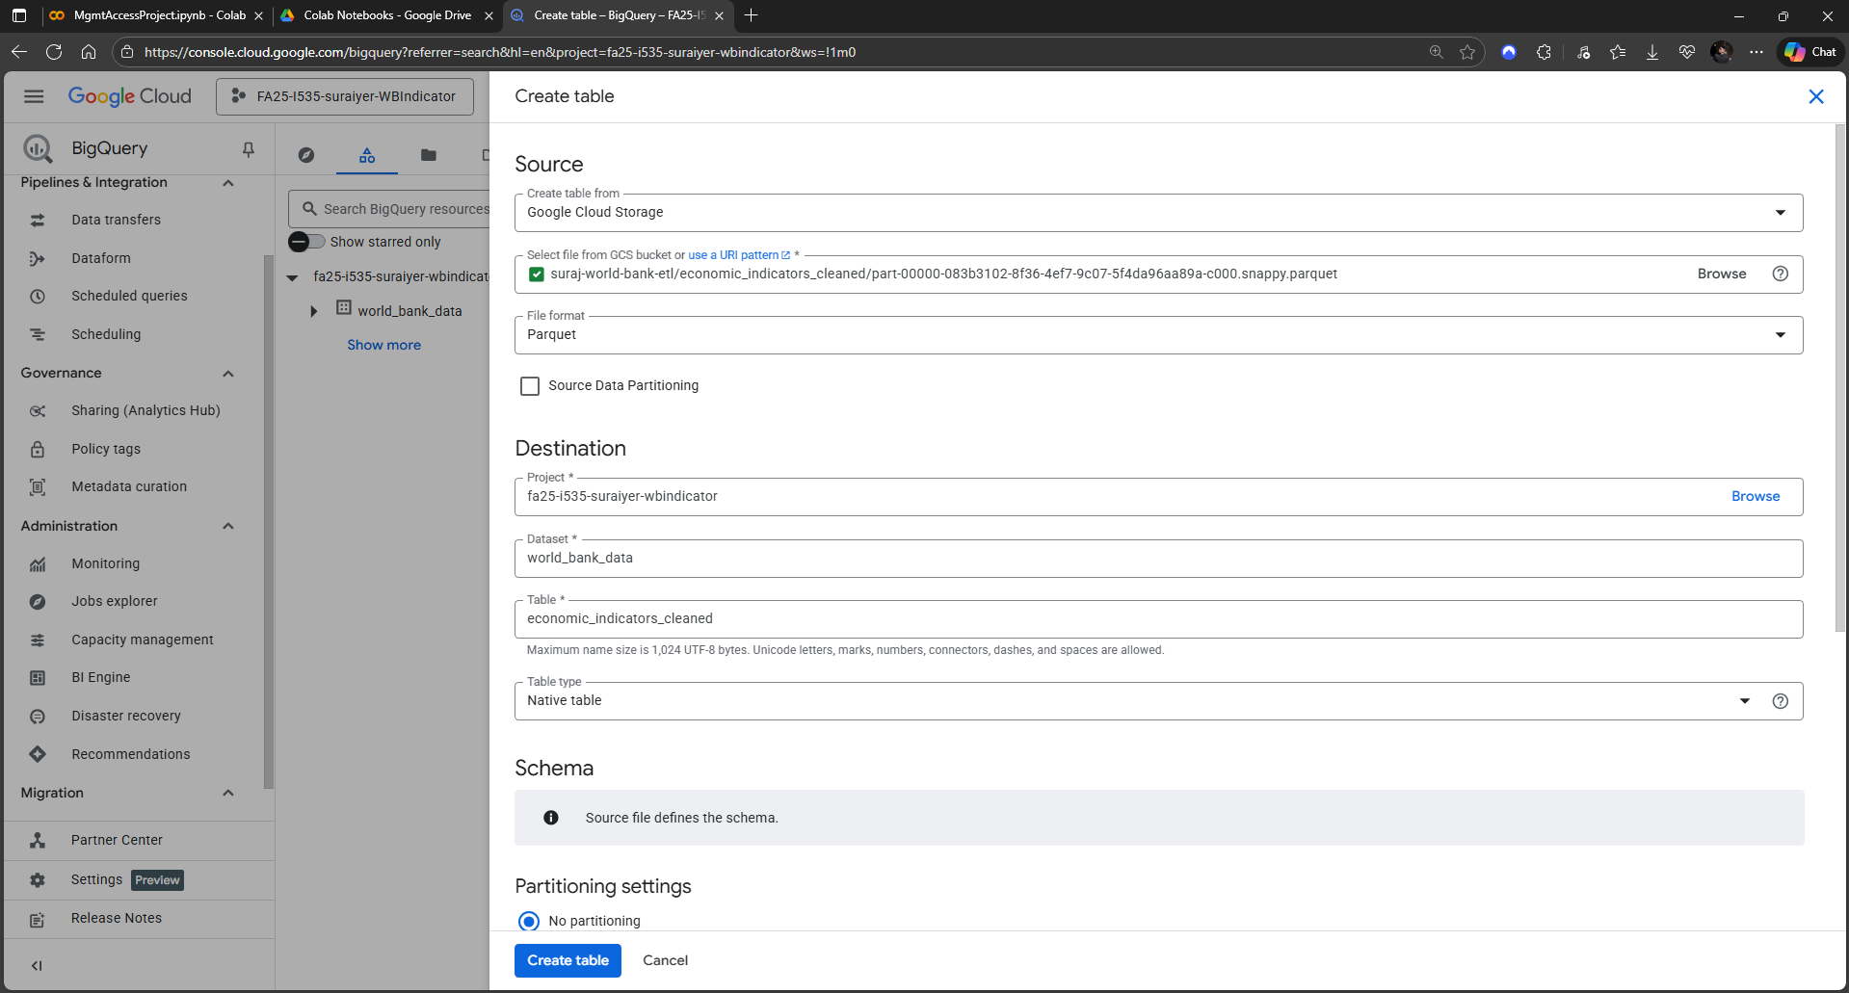
Fig B.2 - Creating a table with the cleaned data file (schema auto-detected for native tables)
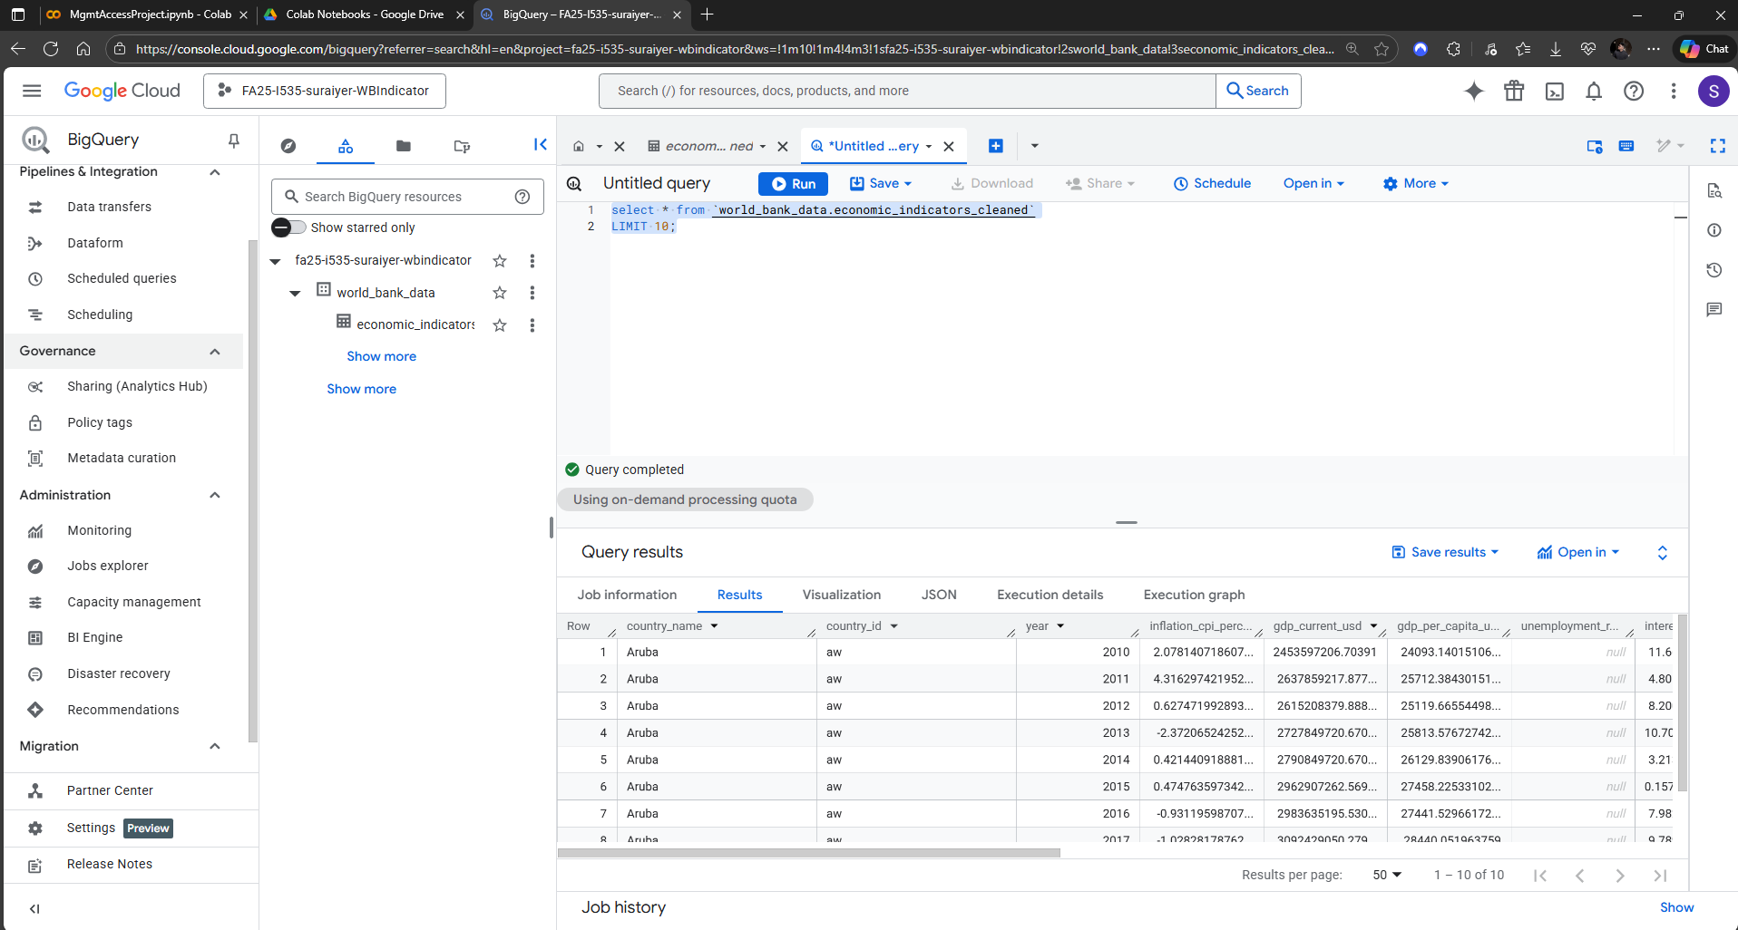
Fig B.3 - Created table “economic_indicators_cleaned”

Appendix C: Analysis using SQL and Looker
- Top 10 countries with their long-term economic growth in terms of GDP Growth rate: The query calculates the average annual GDP growth for each country to find out the top 10 fastest growing economies as per the annual GDP growth rate indicator.
SELECT
country_name,
year,
AVG(gdp_growth_annual_percent) AS avg_growth_rate
FROM `fa25-i535-suraiyer-wbindicator.world_bank_data.economic_indicators_cleaned`
WHERE gdp_growth_annual_percent IS NOT NULL
AND country_name in (
SELECT
country_name
FROM `fa25-i535-suraiyer-wbindicator.world_bank_data.economic_indicators_cleaned`
GROUP BY country_name
ORDER BY SUM(gdp_current_usd) DESC
LIMIT 10
)
GROUP BY country_name,year
ORDER BY year DESC, avg_growth_rate DESC;

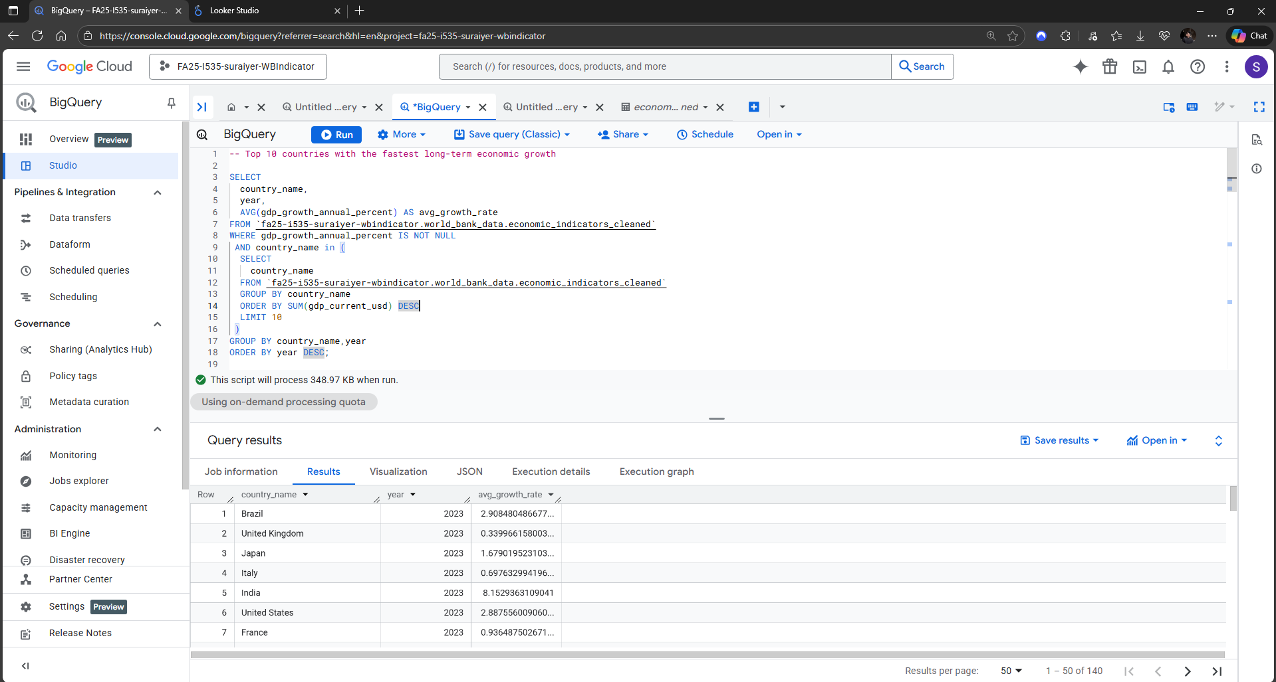
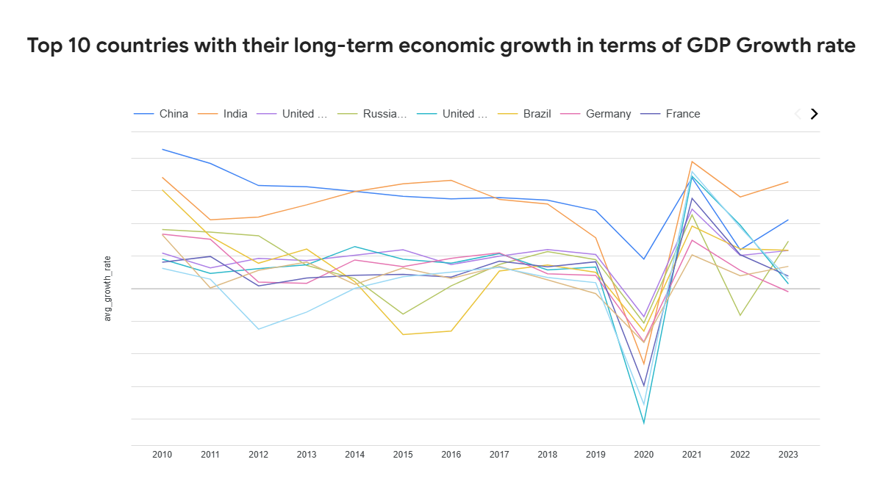
How it was built:
- X-axis represents year
- Y-axis represents the GDP Growth rate %
- Line color represents the country
Interpretation:
- All major economies show a shark dip in GDP growth for the year 2020, reflecting the global economic dip caused by COVID-19 in 2020
- India and China show consistent long-term growth demonstrating their continued fast economic growth and success.

- Tax trends in top 10 major economies: This query finds the top 10 countries in 2023 with the highest tax revenue as a percentage of GDP, along with their current account balance for the same year.
SELECT
country_name,
year,
tax_revenue_percent_gdp
FROM `fa25-i535-suraiyer-wbindicator.world_bank_data.economic_indicators_cleaned`
WHERE tax_revenue_percent_gdp IS NOT NULL
AND country_name in (
SELECT
country_name
FROM `fa25-i535-suraiyer-wbindicator.world_bank_data.economic_indicators_cleaned`
GROUP BY country_name
ORDER BY SUM(gdp_current_usd) DESC
LIMIT 10
)
ORDER BY year DESC,tax_revenue_percent_gdp DESC;

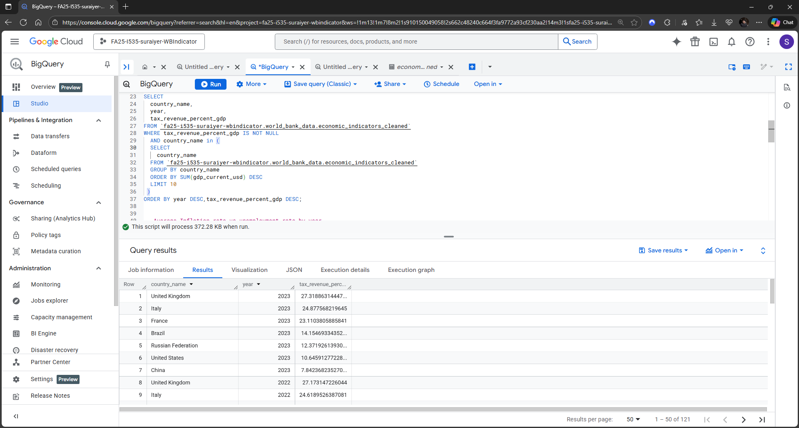
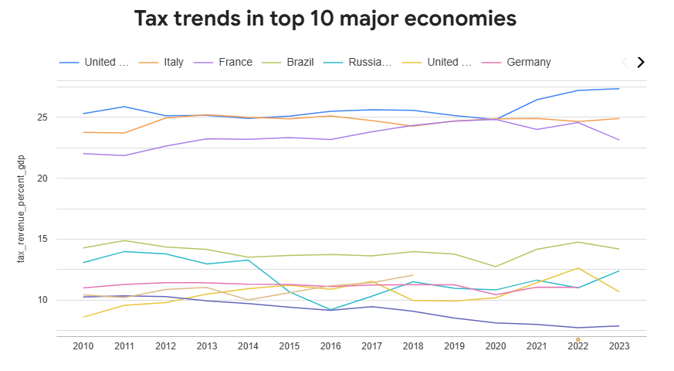
How it was built:
- X-axis represents the year
- Y-axis represents the Tax Revenue rate
- Line color represents the country
Interpretation:
- European economies like UK, Italy and France consistently maintain high tax to GDP ratios as compared to other major economies
- Countries with high tax revenue do not necessarily correlate with countries showing high GDP growth

- Average Unemployment rate by country by year: This query finds the average unemployment rate by country for each year for the top 10 major economies
SELECT
country_name,
year,
AVG(unemployment_rate_percent) AS unemployment_rate_percent
FROM `fa25-i535-suraiyer-wbindicator.world_bank_data.economic_indicators_cleaned`
WHERE unemployment_rate_percent IS NOT NULL
AND country_name in (
SELECT
country_name
FROM `fa25-i535-suraiyer-wbindicator.world_bank_data.economic_indicators_cleaned`
GROUP BY country_name
ORDER BY SUM(gdp_current_usd) DESC
LIMIT 10
)
GROUP BY country_name,year
ORDER BY year DESC, unemployment_rate_percent DESC;

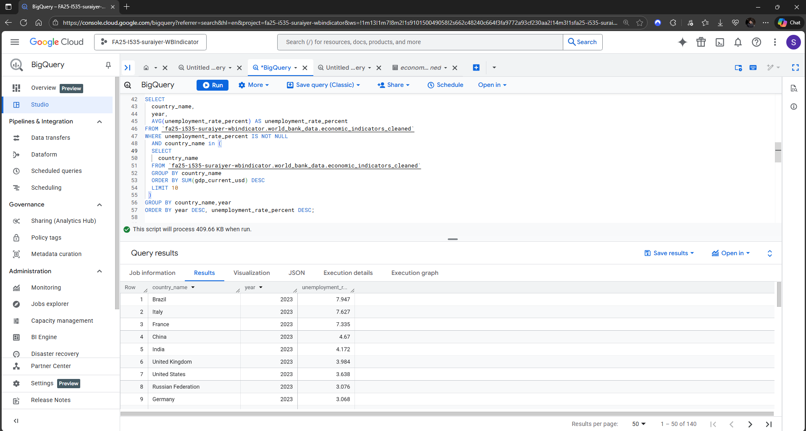

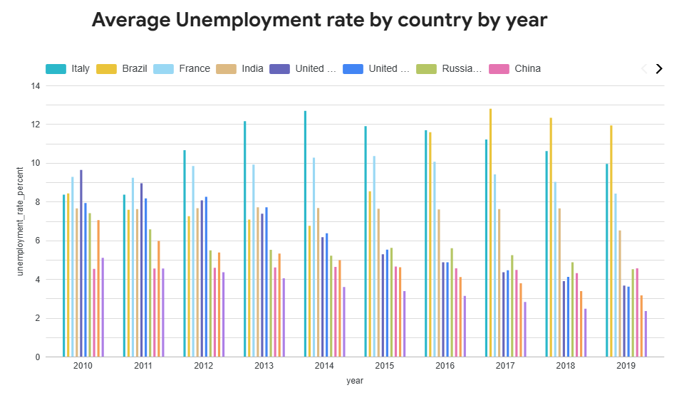
How it was built:
- X-axis represents the year
- Y-axis represents the Unemployment rate percentage
- Line color represents the country
Interpretation:
- Southern European countries like Italy and France consistently show a higher unemployment rate as compared to other top economies, highlighting long term labor market issues which can be attributed to rigid employment regulations.
- Brazil shows a strong growing trend of unemployment after 2014 which reflects the economic recession during that period.
- Economies like India and China consistently show lower unemployment rates indicating a flourishing job market due which can be attributed to the expanding industrial and service sectors in these rapidly growing economies.

- Inflation Rate for top 10 major economies by year: This query returns the inflation CPI percent for all the years for the top 10 economies.
SELECT
country_name,
year,
inflation_cpi_percent
FROM `fa25-i535-suraiyer-wbindicator.world_bank_data.economic_indicators_cleaned`
WHERE inflation_cpi_percent IS NOT NULL
AND country_name in (
SELECT
country_name
FROM `fa25-i535-suraiyer-wbindicator.world_bank_data.economic_indicators_cleaned`
GROUP BY country_name
ORDER BY SUM(gdp_current_usd) DESC
LIMIT 10
)
GROUP BY country_name, year, inflation_cpi_percent
ORDER BY year ASC, inflation_cpi_percent DESC;

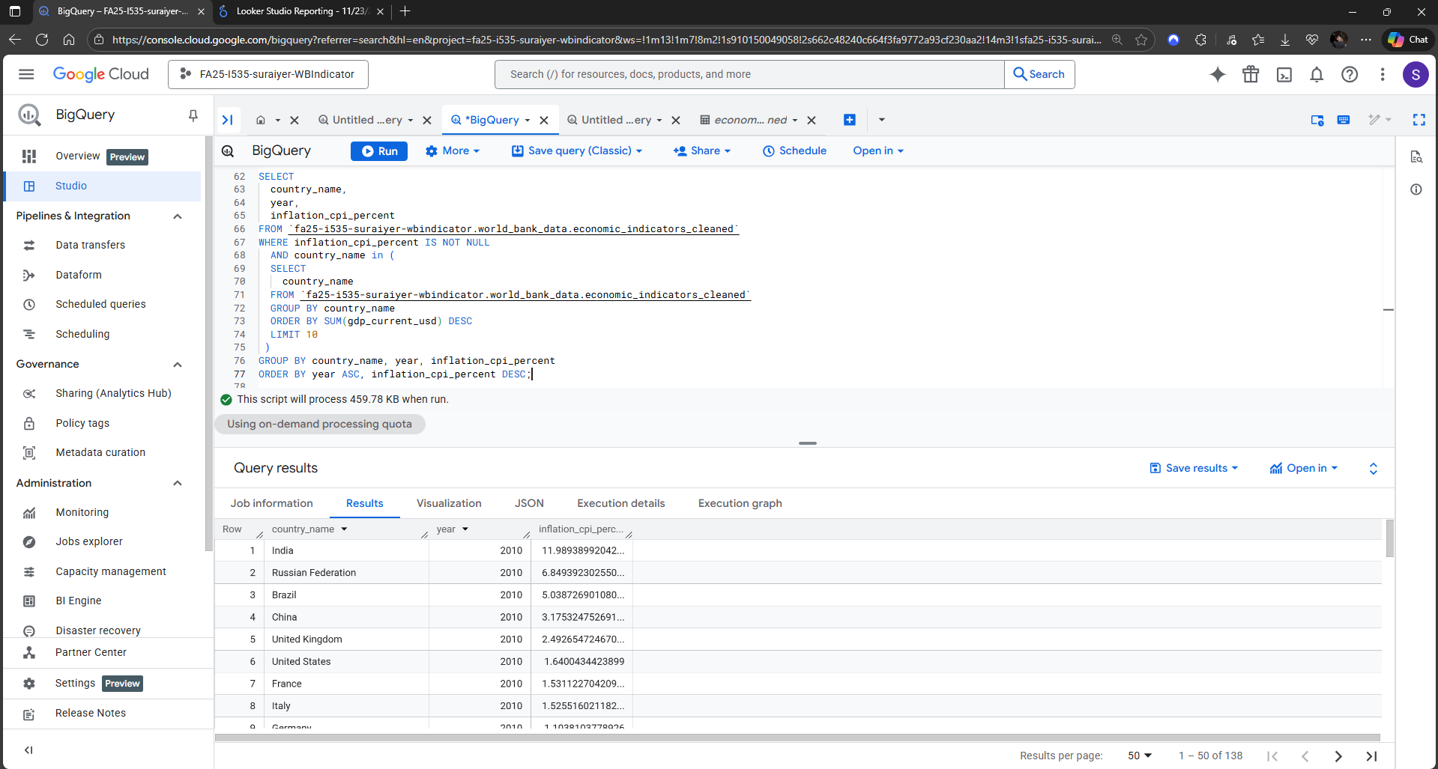
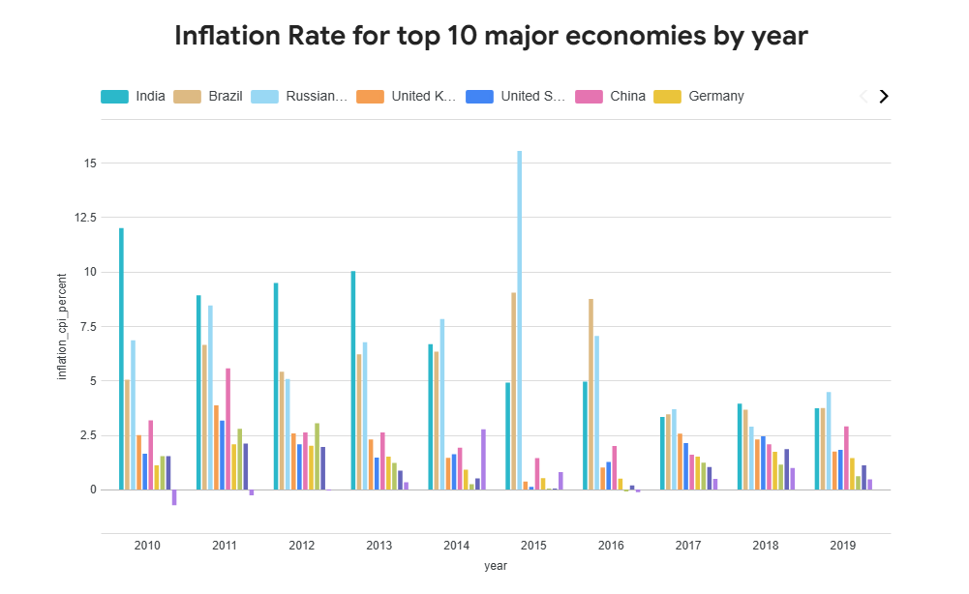
How it was built:
- X-axis represents the year
- Y-axis represents the Inflation CPI percentage
- Line color represents the country
Interpretation:
- Emerging economies like India, Brazil, Russia show high inflation which are typical in emerging markets like these countries that have less stable currencies
- In contrast, more developed economies like US, UK, France, Italy, Japan show low inflation rates due to predictability.

- Countries by Average GDP per capita over 2010 to 2023: This query shows the average GDP per capita for each country aggregated over 2010-2023.
SELECT
country_name,
AVG(gdp_per_capita_usd) AS gdp_per_capita_usd
FROM `fa25-i535-suraiyer-wbindicator.world_bank_data.economic_indicators_cleaned`
WHERE gdp_per_capita_usd IS NOT NULL
GROUP BY country_name
ORDER BY gdp_per_capita_usd DESC;

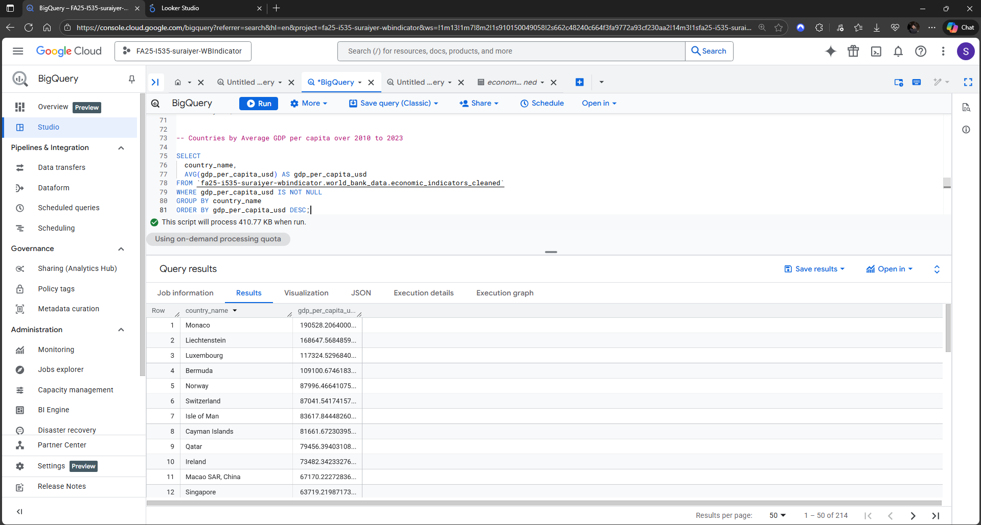
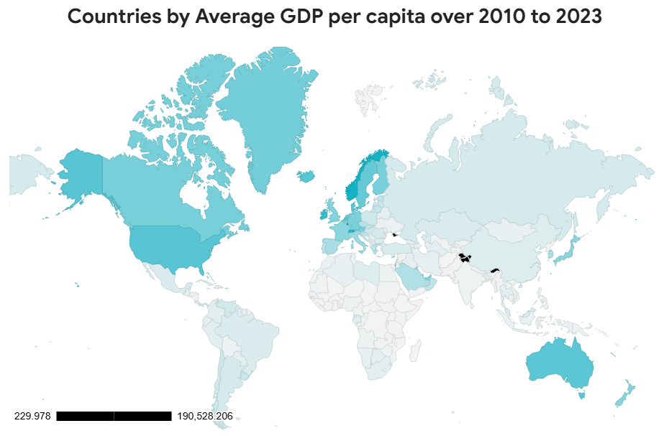
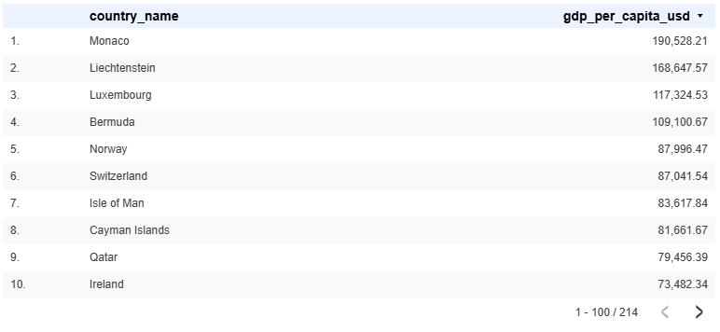
How it was built:
- The colored Geo Chart shows the average GDP per capita across all countries over the 2010-2023 period. The data is aggregated and averaged for each country over the years. The shade of each country represents how high or low the average GDP per capita is for that country.
Interpretation:
- The Geo Chart reflects the distribution of high-income, mid-income and low-income regions across the world, with Countries like Monaco, Liechtenstein, Luxembourg and Bermuda dominating with over $100,000 in average GDP per capita. This clearly indicates how these countries benefit from their small populations and favorable tax laws.
- The Chart along with the table also shows the extreme global inequality in income distribution with a trend showing higher concentration of wealth in developed regions or financial hubs.

