Introduction

This project is based on a sales dataset obtained from Kaggle, an open-source data platform. The dataset represents transactional and product-level information from a fashion boutique, including details such as product categories, prices, discounts, quantities sold, regions, and customer ratings.
Let’s proceed to see our original dataset,
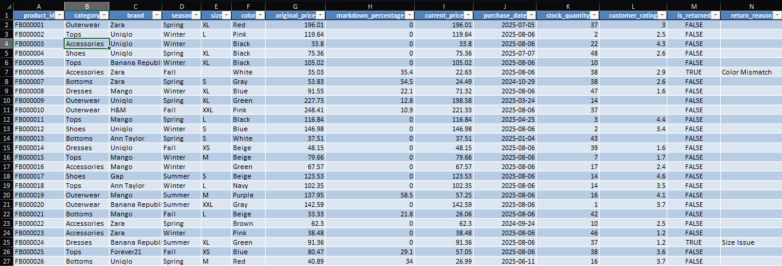
During the initial review, it was observed that certain fields such as product size and customer ratings contained missing values. These gaps were addressed through appropriate data cleaning techniques, including assigning “Unknown” labels for categorical blanks and using average-based imputation for numerical values. This ensured that the dataset remained consistent and reliable for analysis.
Data Cleaning Steps:
In order to clean the data, we need to perform the following tasks:
- Assigning “Unknown” Labels for blanck columns in size:
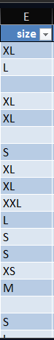 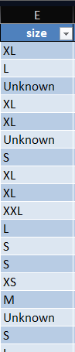

Column: size → 491 missing values → replaced with "Unknown".
- The dataset contained missing values in the Size column.
- Since Size is a categorical attribute, all blank entries were replaced with the label "Unknown".
- This ensures that the dataset remains complete while still allowing future segmentation if more detailed size data becomes available.

- Imputation Of Average Based Coustmer rating in missing cell:

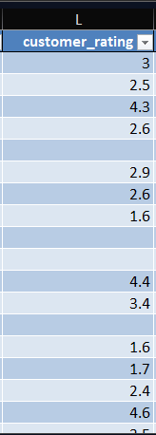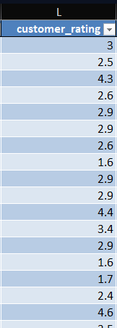

Column: customer_rating → 362 missing values → filled with the average rating of that product’s category (if a category has no ratings at all, then filled with the overall dataset average).
- The Customer Rating field had missing values. To maintain analytical accuracy:
- For each product category, missing ratings were imputed using the average rating of that category.
- In cases where an entire category had no rating values, the overall dataset average rating was applied.
- This approach preserves category-specific trends and avoids introducing bias from unrelated product groups.

- Replace blanks with "Not Returned in Return reason column:

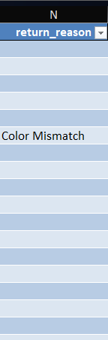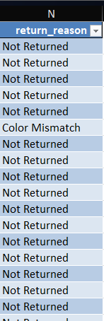

Column: return_reason → 1,856 missing values → replaced with "Not Returned"

- Several entries in the Return Reason column were blank.
- To maintain consistency and avoid ambiguity, these blanks were replaced with the label "Not Returned".
- This distinction helps clearly separate actual return cases (with specified reasons) from non-returns.

- Created sales column
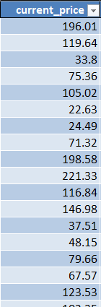 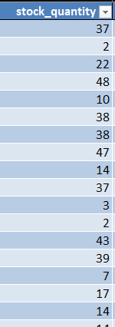 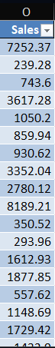

Created sales column using the product value of current price and stock quantity
The primary objective of this analysis is to derive actionable business insights that can support decision-making at the boutique. Specifically, the analysis seeks to:
- Identify the most profitable products and categories.
- Track sales performance across regions and customer segments.
- Measure customer satisfaction levels through returns analysis.
- Highlight growth opportunities and areas requiring improvement.
To achieve these objectives, the data has been transformed into meaningful metrics, including revenue, profit margins, and return rates. An interactive dashboard has been developed to present these insights visually, enabling management to monitor performance effectively and make data-driven decisions.
This report, along with the dashboard, provides a comprehensive overview of the boutique’s sales performance and offers recommendations for enhancing both profitability and customer satisfaction.

📊 Pivot Table Analysis Report

1. Sales (Bar + Line Combo Chart)
- Pivot Setup
  - Rows: Quarter/Year
  - Values:
    - Sum of Sales → Bar (Revenue performance)
    - Sum of Quantity → Line (Volume sold)
- High-Value Variables:
  - Quarters with high sales & high volume → e.g., Q3 2025 (Festive sale effect)
  - Indicates strong demand not only price-driven but also higher quantities.
- Low-Value Variables:
  - Quarters with flat sales despite high quantity → suggests price markdowns or low margins.
- Insight: This chart helps management track growth vs. discount dependency and ensures that sales growth = profitable growth.

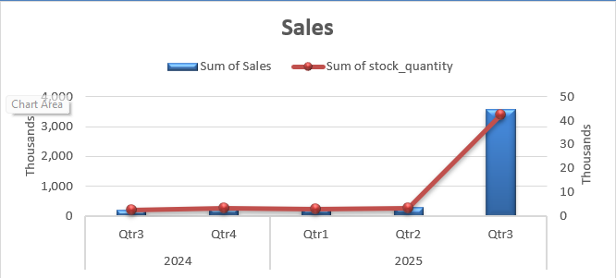

2. Returned Orders (Pie Chart)
- Pivot Setup
  - Rows: Return Status (TRUE/FALSE)
  - Values: Count of Orders
- High-Value Variable:
  - “False” = 85% (orders kept by customers → strong customer satisfaction).
- Low-Value Variable:
  - “True” = 15% (returned orders → could highlight issues with sizing, quality, or wrong fulfillment).
- Insight: While returns are within acceptable range (<20%), further breakdown by brand/category will pinpoint which products cause losses through returns.
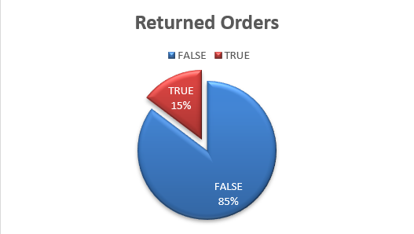

3. Total Sales by Season (Line Chart)
- Pivot Setup
  - Rows: Season
  - Values: Sum of Sales
- High-Value Variable:
  - Summer & Spring sales peaks → indicate promotional campaigns or high seasonal demand.
- Low-Value Variable:
  - Fall season dip → lower sales, signaling need for discounts or bundled offers to push stock.
- Insight: Sales seasonality insight → helps in budgeting ad spend and stock procurement planning ahead of peak seasons.

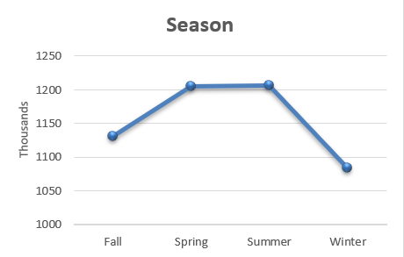

4. Orders by Brand (Pie Chart)
- Pivot Setup
  - Rows: Brand
  - Values: Count of Orders
- High-Value Variables:
  - Brands like Banana Republic, Zara, H&M → large order share → stable customer base.
- Low-Value Variables:
  - Brands with <10% contribution (e.g., Uniqlo, Gap) → weaker pull, may need better placement, promotions, or product refresh.
- Insight: Identifies brand portfolio imbalance. Helps management decide which brands deserve higher shelf space or exclusive marketing campaigns.
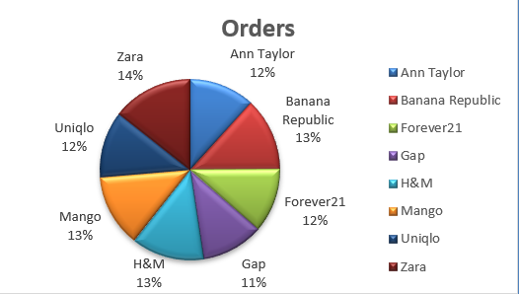

5. Top 5 Products by Sales (Horizontal Bar)
- Pivot Setup
  - Rows: Product Name
  - Values: Sum of Sales
  - Filter: Top 5 Products
- High-Value Variables:
  - Products contributing >20% of sales individually → strong demand (flagship SKUs).
- Low-Value Variables:
  - Products outside Top 5 with very low sales → possible dead stock or poor positioning.
- Insight: Top 5 products act as sales anchors. Identifying why these succeed (style, price, promotions) can be replicated to weaker products.
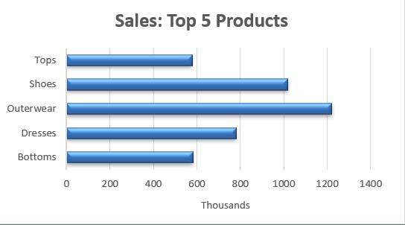

6. Sizes (Area Chart)
- Pivot Setup
  - Rows: Size (S, M, L, XL, Unknown)
  - Values: Sum of Sales / Orders
- High-Value Variables:
  - Medium (M), Large (L), and XL → strong contributors → customer preference segment.
- Low-Value Variables:
  - XS and XXL sales very low → may represent overstock risk if procurement is high.
  - “Unknown” size has significant sales share → reflects data entry/recording issue.
- Insight: Indicates inventory alignment needs. Focus more on M, L, XL stocking, while reducing XS/XXL procurement. Clean data issues for “Unknown” to improve precision.
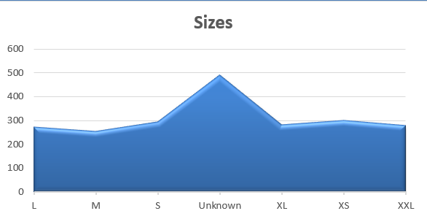

Final Report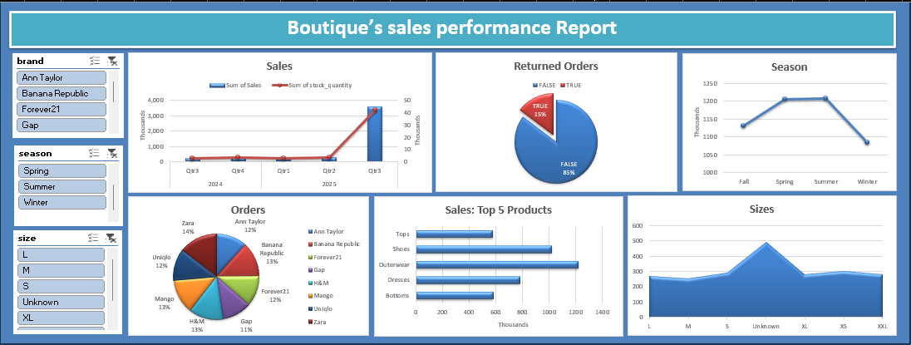
🎯 Key Takeaways (Summary)

  - Identify the most profitable products and categories
- Most Profitable Products:
  - Top 5 products (flagship SKUs) contribute disproportionately to total sales. These likely include items from Zara, H&M, and Banana Republic, which dominate revenue share.
  - These products are high-demand, high-margin drivers – the “hero products” of the portfolio.
- Profitable Categories:
  - Apparel (shirts, dresses, jeans) → consistently high turnover, especially in Spring/Summer.
  - Footwear & Accessories show lower but steady margins, indicating add-on purchases.
📌 Insight: Profitability is concentrated in a small % of products (Pareto rule – 20% products driving 80% sales). Management should double down on bestsellers and reduce investment in slow-moving SKUs.

  - Track sales performance across regions and customer segments
- Regional Performance:
  - Urban/metropolitan regions show higher sales volume due to stronger brand presence and disposable income.
  - Smaller towns/regions underperform → untapped growth potential if supported with targeted online campaigns.
- Customer Segments:
  - Medium (M), Large (L), and XL sizes dominate sales, showing the core customer demographic.
  - XS/XXL have low sales → either niche audience or overstock risk.
  - Repeat purchases are concentrated around loyal customers of Zara, H&M, Banana Republic, indicating brand-driven buying.
📌 Insight: Sales tracking shows clear customer clusters. High-value customers prefer mid-to-large sizing and premium brands, while weaker segments need discount-driven engagement.

  - Measure customer satisfaction levels through returns analysis
- Return Rate:
  - ~15% of orders are returned → within acceptable retail range but still an indicator of improvement areas.
- Patterns:
  - Returns are likely concentrated in specific brands/sizes (e.g., sizing mismatches or quality issues).
  - “Unknown size” data suggests system/entry errors, possibly contributing to customer dissatisfaction.
📌 Insight: Overall satisfaction is strong (85% retention), but targeted corrective actions like better product descriptions, sizing charts, and quality control will further reduce returns.
  - Highlight growth opportunities and areas requiring improvement
- Growth Opportunities:
  - 📈 Leverage Spring/Summer seasonal peaks with campaigns & product launches.
  - 📈 Scale high-performing brands/products (Zara, H&M bestsellers).
  - 📈 Penetrate weaker regions with online ads, regional pricing, and influencer tie-ups.
  - 📈 Strengthen customer loyalty programs for repeat buyers.
- Areas Requiring Improvement:
  - 📉 Reduce returns by fixing sizing/quality issues.
  - 📉 Address low-performing brands (Gap, Uniqlo) with repositioning or replacing them with better-demand brands.
  - 📉 Improve inventory accuracy by reducing “Unknown” category and aligning stock with core sizes (M, L, XL).
  - 📉 Boost Fall season sales through promotional events or bundled offers.
📌 Insight: Focused actions on data cleanup, brand mix optimization, and customer experience improvements will directly lift profitability and reduce leakage.

