#include <stdio.h>

#include <stdlib.h>

#include<cstring>

#include<string.h>

struct StudentInfo {

    int rollNo;

    char studName[20];

    int marks;

    //default constructor definiton

    StudentInfo() {

        this->rollNo=0;

        strcpy(this->studName,"NULL");

        this->marks=0;

    }

    //parameterized constructor definition

    StudentInfo(int roll,char\* name,int marks) {

        this->rollNo=roll;

        strcpy(this->studName,name);

        this->marks=marks;

    }

    //setters definition

    void setRollNo(int roll) {

        this->rollNo=roll;

    }

    void setStudName(char\* name) {

        strcpy(this->studName,name);

    }

    void setMarks(int marks) {

        this->marks=marks;

    }

    //getters

    int getRollNo() {

        return this->rollNo;

    }

    char\* getStudName() {

        return this->studName;

    }

    int getMarks() {

        return this->marks;

    }

    void display() {

        printf("\nDisplay function");

        printf("\nRollNo   = %d",this->rollNo);

        printf("\nStudName = %s",this->studName);

        printf("\nMarks    = %d",this->marks);

    }

};

int main() {

    //Object creation

    StudentInfo s1,s2,s3(30,"Arnav",

                         95);       //default constructors called for s1,s2 for s3 parameterized called

    //setters

    s1.setRollNo(10);

    s1.setStudName("Suraj");

    s1.setMarks(80);

    //getters

    printf("\ns1 values using setters");

    printf("\nRollNo   = %d",s1.getRollNo());

    printf("\nStudName = %s",s1.getStudName());

    printf("\nMarks    = %d",s1.getMarks());

    //defaultconstructor values

    printf("\n\ns2 values using default constructor");

    printf("\nRollNo   = %d",s2.getRollNo());

    printf("\nStudName = %s",s2.getStudName());

    printf("\nMarks    = %d",s2.getMarks());

    //parameterized constructor values

    printf("\n\ns3 values using parameterized constructor");

    printf("\nRollNo   = %d",s3.getRollNo());

    printf("\nStudName = %s",s3.getStudName());

    printf("\nMarks    = %d",s3.getMarks());

    s1.display();

    s2.display();

    s3.display();

}

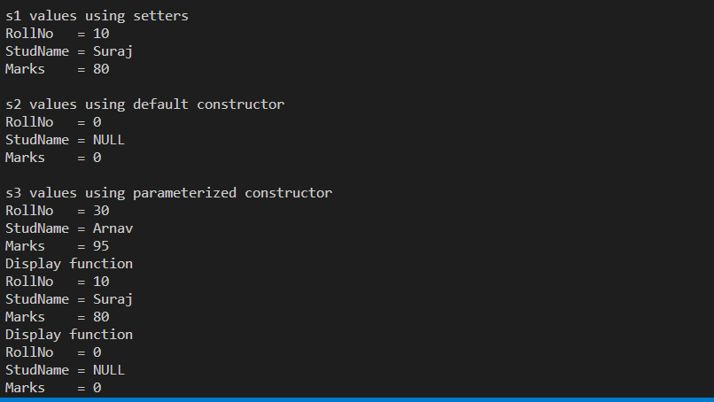

#include <stdio.h>

#include <string.h>

#include <stdlib.h>

#include<cstdio>

struct EmployeeInfo {

    int empId;

    char empName[20];

    double empSalary;

    //setters

    setempId(int id) {

        this->empId=id;

    }

    setempName(char\* name) {

        strcpy(this->empName,name);

    }

    setempSalary(int sal) {

        this->empSalary=sal;

    }

//      getters

    int getempId() {

        return this->empId;

    }

    char\* getempName() {

        return this->empName;

    }

    double getempSalary() {

        return this->empSalary;

    }

    //default constructor

    EmployeeInfo() {

        printf("\ndefault");

        this->empId=0;

        strcpy(this->empName,"NULL");

        this->empSalary=0;

    }

    //parameterized constructor

    EmployeeInfo(int id,char\* name, double sal) {

        printf("\nPara");

        this->empId=id;

        strcpy(this->empName,name);

        this->empSalary=sal;

    }

    void display() {

        printf("\nDisplay");

        printf("\nId     = %d",this->empId);

        printf("\nName   = %s",this->empName);

        printf("\nSalary = %.1lf",this->empSalary);

    }

};

int main() {

    EmployeeInfo e1,e2,e3(30,"vishankh",45000);

    e1.setempId(10);

    e1.setempName("Shekhar");

    e1.setempSalary(30000);

    printf("\ne1 values");

    printf("\nId     = %d",e1.getempId());

    printf("\nName   = %s",e1.getempName());

    printf("\nSalary = %.1lf",e1.getempSalary());

    printf("\n\ne2 values");

    printf("\nId     = %d",e2.getempId());

    printf("\nName   = %s",e2.getempName());

    printf("\nSalary = %.1lf",e2.getempSalary());

    printf("\n\ne3 values");

    printf("\nId      = %d",e3.getempId());

    printf("\nName    = %s",e3.getempName());

    printf("\nSalary  = %.1lf",e3.getempSalary());

    e1.display();

    e2.display();

    e3.display();

}



#include <stdio.h>

#include <string.h>

#include <stdlib.h>

#include<cstdio>

struct AdminInfo {

    int adminId;

    char adminName[20];

    double adminSalary;

    double adminAllowance;

    void setAdminId(int id) {

        this->adminId=id;

    }

    void setAdminName(char\* name) {

        strcpy(this->adminName,name);

    }

    void setAdminSalary(double sal) {

        this->adminSalary=sal;

    }

    void setAdminAllowance(double allow) {

        this->adminAllowance=allow;

    }

    int getAdminId() {

        return this->adminId;

    }

    char\* getAdminName() {

        return this->adminName;

    }

    double getAdminSalary() {

        return this->adminSalary;

    }

    double getAdminAllowance() {

        return this->adminAllowance;

    }

    AdminInfo() {

        this->adminId=0;

        strcpy(this->adminName,"NULL");

        this->adminSalary=0;

        this->adminAllowance=0;

    }

    AdminInfo(int id,char\* name,double sal,

              double allow) {

        this->adminId=id;

        strcpy(this->adminName,name);

        this->adminSalary=sal;

        this->adminAllowance=allow;

    }

    void display() {

        printf("\nDisplay");

        printf("\nAdmin Id     = %d",this->adminId);

        printf("\nAdmin Name   = %s",this->adminName);

        printf("\nAdmin Salary = %.1lf",

               this->adminSalary);

        printf("\nAllowance    = %.1lf",

               this->adminAllowance);

    }

};

int main() {

    AdminInfo ad1,ad2,ad3(30,"Nihal",45000,3000);

    ad1.setAdminId(10);

    ad1.setAdminName("Srikant");

    ad1.setAdminSalary(30000);

    ad1.setAdminAllowance(4000);

    printf("\nAdmin 1 info");

    printf("\nAdmin Id     = %d",ad1.getAdminId());

    printf("\nAdmin Name   = %s",ad1.getAdminName());

    printf("\nAdmin Salary = %.1lf",

           ad1.getAdminSalary());

    printf("\nAllowance    = %.1lf",

           ad1.getAdminAllowance());

    printf("\n\nAdmin 2 info");

    printf("\nAdmin Id     = %d",ad2.getAdminId());

    printf("\nAdmin Name   = %s",ad2.getAdminName());

    printf("\nAdmin Salary = %.1lf",

           ad2.getAdminSalary());

    printf("\nAllowance    = %.1lf",

           ad2.getAdminAllowance());

    printf("\n\nAdmin 3 info");

    printf("\nAdmin Id     = %d",ad3.getAdminId());

    printf("\nAdmin Name   = %ss",ad3.getAdminName());

    printf("\nAdmin Salary = %.1lf",

           ad3.getAdminSalary());

    printf("\nAllowance    = %.1lf",

           ad3.getAdminAllowance());

           ad1.display();

           ad2.display();

           ad3.display();

}



#include <stdio.h>

#include <string.h>

#include <stdlib.h>

#include <cstdio>

struct HRInfo

{

    int HRId;

    const char  HRName[20];

    double HRSalary;

    double HRCommision;

    void setHRId(int id)

    {

        this->HRId = id;

    }

    void setHRName(char \*name)

    {

        strcpy(this->HRName, name);

    }

    void setHRSalary(double sal)

    {

        this->HRSalary = sal;

    }

    void setHRCommision(double com)

    {

        this->HRCommision = com;

    }

    int getHRId()

    {

        return this->HRId;

    }

    char \*getHRName()

    {

        return this->HRName;

    }

    double getHRSalary()

    {

        return this->HRSalary;

    }

    double getHRCommision()

    {

        return this->HRCommision;

    }

    HRInfo()

    {

        this->HRId = 0;

        strcpy(this->HRName, "NULL");

        this->HRSalary = 0;

        this->HRCommision = 0;

    }

    HRInfo(int id, char \*name, double sal,

           double com)

    {

        this->HRId = id;

        strcpy(this->HRName, name);

        this->HRSalary = sal;

        this->HRCommision = com;

    }

    void display()

    {

        printf("\nDisplay");

        printf("\nHR Id     = %d",this->HRId);

        printf("\nHR Name   = %s",this->HRName);

        printf("\nHR Salary = %.1lf", this->HRSalary);

        printf("\nHR Comm   = %.1lf",this->HRCommision);

    }

};

int main()

{

    HRInfo h1, h2, h3(30, "Suraj", 40000, 5000);

    h1.setHRId(10);

    h1.setHRName("Tiger");

    h1.setHRSalary(35000);

    h1.setHRCommision(2500);

    printf("\nHR1 Info");

    printf("\nHR Id     = %d", h1.getHRId());

    printf("\nHR Name   = %s", h1.getHRName());

    printf("\nHR Salary = %.1lf", h1.getHRSalary());

    printf("\nHR Comm   = %.1lf", h1.getHRCommision());

    printf("\n\nHR2 Info");

    printf("\nHR Id     = %d", h2.getHRId());

    printf("\nHR Name   = %s", h2.getHRName());

    printf("\nHR Salary = %.1lf", h2.getHRSalary());

    printf("\nHR Comm   = %.1lf", h2.getHRCommision());

    printf("\n\nHR3 Info");

    printf("\nHR Id     = %d", h3.getHRId());

    printf("\nHR Name   = %s", h3.getHRName());

    printf("\nHR Salary = %.1lf", h3.getHRSalary());

    printf("\nHR Comm   = %.1lf", h3.getHRCommision());

}

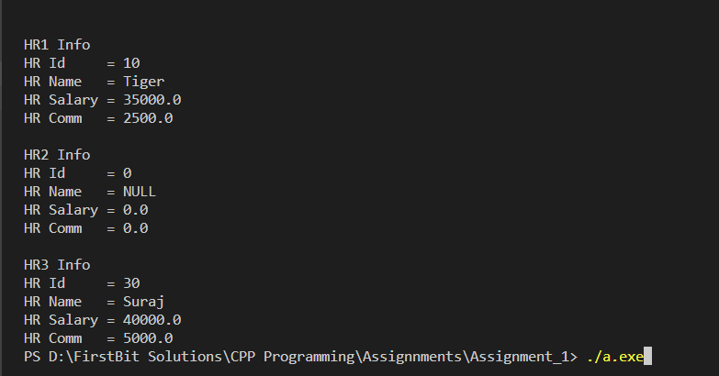

#include <stdio.h>

#include <string.h>

#include <stdlib.h>

#include <cstdio>

struct SalesManagerInfo

{

    int smId;

    char smName[20];

    double smSalary;

    double smIncentive;

    int smTarget;

    // setters

    void setSmId(int id)

    {

        this->smId = id;

    }

    void setSmName(char\* name)

    {

        strcpy(this->smName, name);

    }

    void setSmSalary(double sal)

    {

        this->smSalary = sal;

    }

    void setSmIncentive(double inc)

    {

        this->smIncentive = inc;

    }

    void setSmTarget(int tar)

    {

        this->smTarget = tar;

    }

    // getters

    int getSmId()

    {

        return this->smId;

    }

    char \*getSmName()

    {

        return this->smName;

    }

    double getSmSalary()

    {

        return this->smSalary;

    }

    double getSmIncetive()

    {

        return this->smIncentive;

    }

    int getSmTarget()

    {

        return this->smTarget;

    }

    // default constructor

    SalesManagerInfo()

    {

        this->smId = 0;

        strcpy(this->smName ,"NULL");

        this->smSalary = 0;

        this->smIncentive = 0;

        this->smTarget = 0;

    }

    //parameterized constructor

    SalesManagerInfo(int id,char\* name,double sal,double inc, int target)

    {

        this->smId=id;

        strcpy(this->smName,name);

        this->smSalary=sal;

        this->smIncentive=inc;

        this->smTarget=target;

    }

    void display()

    {

        printf("\n\nDisplay");

        printf("\nSMId = %d",this->smId);

        printf("\nSMName = %s",this->smName);

        printf("\nSMSalary = %.0lf",this->smSalary);

        printf("\nSMIncentive = %.0lf",this->smIncentive);

        printf("\nSMTarget = %.0lf",this->smTarget);

    }

};

int main()

{

    // SalesManagerInfo s1,s2,s3(30,"Srihari",80000,4000,40);

    SalesManagerInfo s1,s2,s3(30,"Shreya",45000,2000,120);

    s1.setSmId(10);

    s1.setSmName("Nikhil");

    s1.setSmSalary(65000);

    s1.setSmIncentive(5000);

    s1.setSmTarget(156);

    s1.display();

    s2.display();

    s3.display();

}

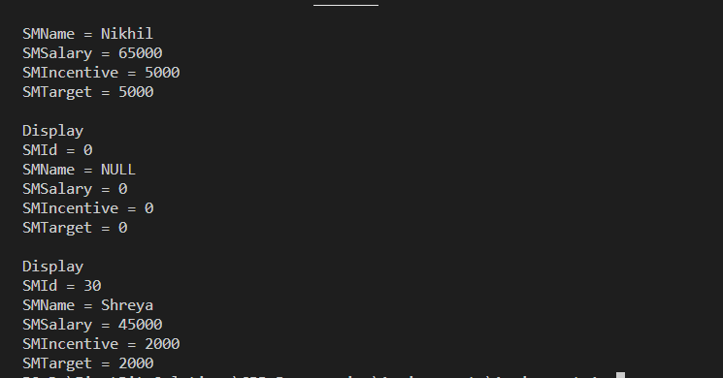

#include <stdio.h>

#include <string.h>

#include <stdlib.h>

#include <cstdio>

struct DateInfo

{

    int day;

    int month;

    int year;

    // setters

    void setDay(int day)

    {

        this->day = day;

    }

    void setMonth(int month)

    {

        this->month = month;

    }

    void setYear(int year)

    {

        this->year = year;

    }

    // getters

    int getDay()

    {

        return this->day;

    }

    int getMonth()

    {

        return this->month;

    }

    int getYear()

    {

        return this->year;

    }

    // default

    DateInfo()

    {

        this->day = 0;

        this->month = 0;

        this->year = 0;

    }

    DateInfo(int day, int month, int year)

    {

        this->day = day;

        this->month = month;

        this->year = year;

    }

    void display()

    {

        printf("\nDisplay");

        printf("\nDay   = %d", this->day);

        printf("\nMonth = %d", this->month);

        printf("\nYear  = %d", this->year);

    }

};

int main()

{

    DateInfo d1, d2, d3(25, 10, 2023);

    d1.setDay(22);

    d1.setMonth(1);

    d1.setYear(1994);

    printf("\nDate 1 Info");

    printf("\nDay   = %d", d1.getDay());

    printf("\nMonth = %d", d1.getMonth());

    printf("\nYear  = %d", d1.getYear());

    printf("\nDate 2 Info");

    printf("\nDay   = %d", d2.getDay());

    printf("\nMonth = %d", d2.getMonth());

    printf("\nYear  = %d", d2.getYear());

    printf("\nDate 3 Info");

    printf("\nDay   = %d", d3.getDay());

    printf("\nMonth = %d", d3.getMonth());

    printf("\nYear  = %d", d3.getYear());

    d1.display();

    d2.display();

    d3.display();

}



#include <stdio.h>

#include <string.h>

#include <stdlib.h>

#include <cstdio>

struct TimeInfo

{

    int hour;

    int minute;

    int seconds;

    // setters

    void setHour(int h)

    {

        this->hour = h;

    }

    void setMinute(int m)

    {

        this->minute = m;

    }

    void setSeconds(int s)

    {

        this->seconds = s;

    }

    // getters

    int getHour()

    {

        return this->hour;

    }

    int getMinute()

    {

        return this->minute;

    }

    int getSeconds()

    {

        return this->seconds;

    }

    // default

    TimeInfo()

    {

        this->hour = 0;

        this->minute = 0;

        this->seconds = 0;

    }

    // parameterized

    TimeInfo(int h, int m, int s)

    {

        this->hour = h;

        this->minute = m;

        this->seconds = s;

    }

    void display()

    {

        printf("\nDisplay");

        printf("\nHours   = %d", this->hour);

        printf("\nMinutes = %d", this->minute);

        printf("\nSeconds = %d", this->seconds);

    }

};

int main()

{

    TimeInfo t1, t2, t3(11, 23, 53);

    t1.setHour(10);

    t1.setMinute(20);

    t1.setSeconds(33);

    printf("\nT1 info");

    printf("\nHours   = %d",t1.getHour());

    printf("\nMinutes = %d",t1.getMinute());

    printf("\nSeconds = %d", t1.getSeconds());

    printf("\nT2 info");

    printf("\nHours   = %d",t2.getHour());

    printf("\nMinutes = %d",t2.getMinute());

    printf("\nSeconds = %d", t2.getSeconds());

    printf("\nT3 info");

    printf("\nHours   = %d",t3.getHour());

    printf("\nMinutes = %d",t3.getMinute());

    printf("\nSeconds = %d", t3.getSeconds());

    t1.display();

    t2.display();

    t3.display();

}



#include <stdio.h>

#include <string.h>

#include <stdlib.h>

#include <cstdio>

struct DistanceInfo

{

    int feet;

    int inch;

    // setters

    void setFeet(int f)

    {

        this->feet = f;

    }

    void setInch(int i)

    {

        this->inch = i;

    }

    // getters

    int getFeet()

    {

        return this->feet;

    }

    int getInch()

    {

        return this->inch;

    }

    DistanceInfo()

    {

        this->feet = 0;

        this->inch = 0;

    }

    DistanceInfo(int f, int i)

    {

        this->feet = f;

        this->inch = i;

    }

    void display()

    {

        printf("\nDisplay");

        printf("\nFeet = %d", this->feet);

        printf("\nInch = %d", this->inch);

    }

};

int main()

{

    DistanceInfo d1, d2, d3(10, 20);

    d1.setFeet(9);

    d1.setInch(22);

    printf("\nDistance 1 Info");

    printf("\nFeet = %d", d1.getFeet());

    printf("\nIncg = %d", d1.getInch());

    printf("\nDistance 2 Info");

    printf("\nFeet = %d", d2.getFeet());

    printf("\nIncg = %d", d2.getInch());

    printf("\nDistance 3 Info");

    printf("\nFeet = %d", d3.getFeet());

    printf("\nIncg = %d", d3.getInch());

    d1.display();

    d2.display();

    d3.display();

}

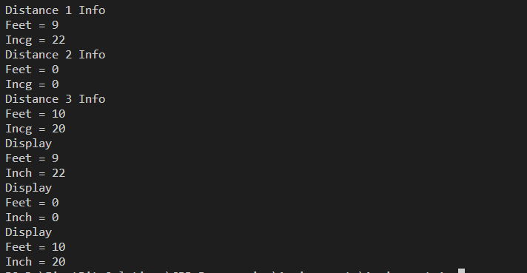

#include <stdio.h>

#include <string.h>

#include <stdlib.h>

#include <cstdio>

struct ComplexInfo

{

    int real;

    int imaginary;

    // SETTERS

    void setReal(int real)

    {

        this->real = real;

    }

    void setImaginary(int img)

    {

        this->imaginary = img;

    }

    // getters

    int getReal()

    {

        return this->real;

    }

    int getImaginary()

    {

        return this->imaginary;

    }

    // default

    ComplexInfo()

    {

        this->real = 0;

        this->imaginary = 0;

    }

    // parameterized

    ComplexInfo(int real, int img)

    {

        this->real = real;

        this->imaginary = img;

    }

    void display()

    {

        printf("\n\nDisplay");

        printf("\nReal      = %d", this->real);

        printf("\nImaginary = %di", this->imaginary);

    }

};

int main()

{

    ComplexInfo c1, c2, c3(20, 5);

    c1.setReal(10);

    c1.setImaginary(9);

    printf("\nC1");

    printf("\nReal      = %d", c1.getReal());

    printf("\nImaginary = %di", c1.getImaginary());

    printf("\nC2");

    printf("\nReal      = %d", c2.getReal());

    printf("\nImaginary = %di", c2.getImaginary());

    printf("\nC3");

    printf("\nReal      = %d", c3.getReal());

    printf("\nImaginary = %di", c3.getImaginary());

    c1.display();

    c2.display();

    c3.display();

}

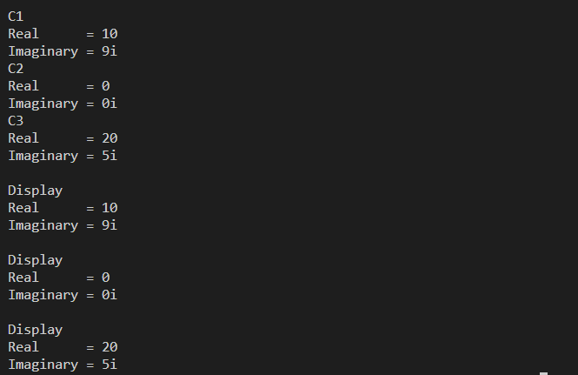

#include <stdio.h>

#include <string.h>

#include <stdlib.h>

#include <cstdio>

struct ProductInfo

{

    int productId;

    char productName[20];

    int productQty;

    double productPrice;

    // setters

    void setProductId(int id)

    {

        this->productId = id;

    }

    void setProductName(const char \*name)

    {

        strcpy(this->productName, name);

    }

    void setProductQty(int qty)

    {

        this->productQty = qty;

    }

    void setProductPrice(double price)

    {

        this->productPrice = price;

    }

    // getters

    int getProductId()

    {

        return this->productId;

    }

    char \*getProductName()

    {

        return this->productName;

    }

    int getProductQty()

    {

        return this->productQty;

    }

    double getProductPrice()

    {

        return this->productPrice;

    }

    // default

    ProductInfo()

    {

        this->productId = 0;

        strcpy(this->productName,"NULL");

        this->productQty = 0;

        this->productPrice = 0;

    }

    // parameterized

    ProductInfo(int id,const char \*name, int qty, double price)

    {

        this->productId = id;

        strcpy(this->productName, name);

        this->productQty = qty;

        this->productPrice = price;

    }

    void display()

    {

        printf("\n\nDisplay");

        printf("\nProductId    = %d", this->productId);

        printf("\nProductName  = %s", this->productName);

        printf("\nProductQty   = %d", this->productQty);

        printf("\nProductPrice = %1lf", this->productPrice);

    }

};

int main()

{

    ProductInfo p1, p2, p3(30, "Television", 1, 45000);

    p1.setProductId(10);

    p1.setProductName("mobile");

    p1.setProductQty(2);

    p1.setProductPrice(80000);

    printf("\nP1");

    printf("\nProductId    = %d", p1.getProductId());

    printf("\nProductName  = %s", p1.getProductName());

    printf("\nProductQty   = %d", p1.getProductQty());

    printf("\nProductPrice = %1lf", p1.getProductPrice());

    printf("\n\nP2");

    printf("\nProductId    = %d", p2.getProductId());

    printf("\nProductName  = %s", p2.getProductName());

    printf("\nProductQty   = %d", p2.getProductQty());

    printf("\nProductPrice = %1lf", p2.getProductPrice());

    printf("\n\nP3");

    printf("\nProductId    = %d", p3.getProductId());

    printf("\nProductName  = %s", p3.getProductName());

    printf("\nProductQty   = %d", p3.getProductQty());

    printf("\nProductPrice = %1lf", p3.getProductPrice());

    p1.display();

    p2.display();

    p3.display();

}

