**Final Project**

**Rampur Travels**

**2024W CSD 2103 1 [B226] Front-End Web Development II**

**SUBMITTED BY**

**Group Rampur Toli**

**2024 APRIL 19**

**Group Members Name and ID:**

**Ramik Dhungana C0903166**

**Pranish KC C0919041**

**Suraj Kc C0911011**

**Kushal Nepal C0905480**

**Aanuj Ghimire C0903032**

How we felt working on this project?

Throughout this project, we encountered a mix of challenges and achievements. At times, it felt like navigating through uncharted territory, especially when delving into aspects like form validation and responsive design. We had to ensure that the website not only looked good but also functioned seamlessly across various devices, from desktops to mobile phones.

One of the most fulfilling aspects was seeing our ideas come to life. Designing the navigation bars and content sections, implementing pop-ups for login and registration success messages, and integrating form validation were all steps that required attention to detail and collaboration within our group. Each feature added brought us closer to our vision of a user-friendly and engaging website.

However, there were moments of frustration, particularly when dealing with bugs or compatibility issues. Ensuring that the send button worked correctly, handling form submissions accurately, and addressing responsiveness challenges demanded patience and persistence. Yet, overcoming these obstacles together strengthened our problem-solving skills and deepened our understanding of web development.

Overall, this project was a valuable learning experience. It allowed us to apply our HTML, CSS, and JavaScript knowledge in a practical setting, honing our abilities to create functional and visually appealing web interfaces. The sense of accomplishment we felt when everything came together successfully made all the effort worthwhile.

**CSS STYLES WE USED IN OUR PROJECT.**

Here are some CSS styles that we used in our project:

1. Background Styles:

- `background-image`

- `background-size`

- `background-repeat`

- `background-attachment`

2. Header and Navigation Styles:

- Header background color and text color

- Navigation bar styling including text color, font size, and spacing

- Menu button styling

3. Content Section Styles:

- Styling for different content sections such as adventure ideas, packages, and contact forms

- Box container styling for organizing content

4. Form Styles:

- Input field styling including width, padding, margin, border, and border-radius

- Button styles for form submission and navigation

5. Popup Styles:

- Popup background color and opacity

- Popup content styling including text color, padding, border-radius, and button styles

6. Footer Styles:

- Footer section styling including background color, padding, and text color

- Box container styling for organizing footer content

7. General Styles:

- Font-family for the entire website

- Color schemes for text and backgrounds

- Padding, margin, and spacing adjustments for layout and readability

These styles were implemented to create a visually appealing and functional website with a responsive design across different devices.

**PROBLEMS WE FACED AND SOLUTIONS WE FOUND DURING THE PROJECT**:

1. **Responsive Design**: Initially, we faced issues with making the website responsive across different devices. We resolved this by using media queries in our CSS to adjust the layout and styling based on the screen size.
2. **Form Validation**: Implementing form validation was crucial to ensure that users enter valid information. We used JavaScript to validate form fields and provide error messages if required information was missing or entered incorrectly.
3. **Popup Messages**: We wanted to display pop-up messages for login and registration success. This involved creating modal pop-ups using HTML, CSS, and JavaScript to show messages and handle user interactions with the pop-ups.
4. **Handling Form Submissions**: We needed to handle form submissions, particularly for package purchases. JavaScript was used to process form data, simulate data submission (in our case), and display success messages or redirect users appropriately.
5. **Navigation Bar Styling**: Ensuring consistent and visually appealing navigation bars across pages required careful styling using CSS. We applied styles such as colors, hover effects, and spacing to enhance the user experience.
6. **Background Image**: Incorporating background images in a way that didn't interfere with content readability posed a challenge. We utilized CSS background properties like background-size, background-repeat, and background-attachment to achieve the desired look without compromising readability.
7. **Form Styling**: Designing and styling forms to be user-friendly and aesthetically pleasing involved CSS techniques like input field styling, button styling, and overall form layout adjustments.

Overall, these challenges provided valuable learning experiences, and finding solutions together as a team strengthened our skills in web development and collaboration.

WEBSITE MAP

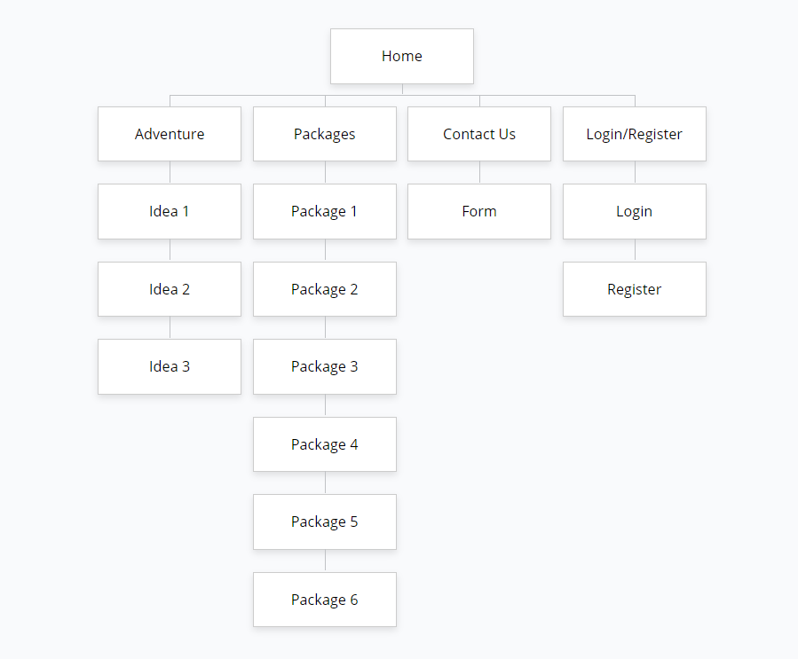

Table regarding our 10 mobile specific HTML, CSS or JavaScript features:

Here's a table outlining 10 mobile-specific HTML, CSS, or JavaScript features we implemented in our project:

| **Feature** | **Description** |
| --- | --- |
| Responsive Design | Ensured the website layout adjusts seamlessly across various mobile devices using media queries and flexible units like percentages and viewport widths. |
| Touch Events | Utilized touch events such as touch start, touch move, and touch end in JavaScript to create interactive elements that respond to touch gestures on mobile devices. |
| Viewport Meta Tag | Included the viewport meta tag in the HTML head to control the layout on mobile browsers, ensuring proper scaling and viewport width for optimal viewing. |
| CSS Flexbox | Employed CSS Flexbox for flexible and responsive layouts, making it easier to create complex mobile layouts with dynamic resizing and alignment of elements. |
| Mobile Navigation | Designed a mobile-friendly navigation menu using CSS for collapsible or off-canvas menus that are accessible and intuitive on smaller screens. |
| Geolocation API | Leveraged the Geolocation API in JavaScript to access the device's GPS capabilities, enabling location-based features or services in the web application. |
| Form Input Type Attributes | Utilized HTML5 form input type attributes such as tel, email, and number for better mobile form input handling, providing specific keyboard layouts and validation for different input types. |
| CSS Transitions and Animations | Integrated CSS transitions and animations to create smooth and visually appealing mobile interactions, enhancing user experience with subtle animations for elements like buttons, menus, or images. |
| Mobile-Friendly Media Queries | Implemented mobile-friendly media queries in CSS to target specific screen sizes or device orientations, optimizing styles and layout adjustments for mobile devices while maintaining a cohesive design. |
| Offline Storage (Local Storage) | Used the local Storage API in JavaScript to store data locally on the user's device, enabling offline functionality such as caching user preferences, form data, or other persistent data that enhances the user experience even without an internet connection. |
| Mobile-specific Event Handlers | Employed mobile-specific event handlers like orientation change or device orientation in JavaScript to detect changes in device orientation or motion, allowing for dynamic adjustments or interactions based on how the user holds or moves their device. |