AI BASED SALES FORECASTING IN RETAIL BUSINESSES

Abstract
Forecasting retail sales isn't just about selecting the latest model. It starts with knowing the behavior of sales and what information is actually available prior to a sales forecast. The problem addressed in this study is explored in this case with the Dunnhumby dataset, which comprises 2.6 million transactions over 711 days. Auto ARIMA, Decision Tree Regression, Gradient Boosting and LSTM models were used to predict the daily total sales. Historical sales, operational data and lagged sales promotions were converted to forecasting features, and chronological validation was applied to ensure that no future information went into the model development. The results show that the daily persistence is strong, and a distinct weekly trend is evident. The Gradient Boosting model got the lowest RMSE of 3,057.318 during the primary test period, which is 23.94% lower than the Seasonal Naïve model. But it wasn't much better than the historical-only LSTM. The LSTM had the lowest RMSE of 2,885.973 when the incomplete transaction-coverage anomaly on Day 643 was not considered. However, promotional features were not always more effective at enhancing the forecasting accuracy. So the results imply that the historical information is a more important source of information than simply making the model more complicated or adding new predictors. The research emphasizes the importance of building features that are safe from leakage and chronologically assessing and testing robustness in reliable forecasting of retail sales.
Keywords: Retail sales forecasting, Dunnhumby dataset, time-series forecasting, machine learning, deep learning, Auto ARIMA, Decision Tree Regression, Gradient Boosting, LSTM, feature engineering, promotional activity, forecasting accuracy, temporal data leakage

Table of Contents
1. Introduction 7
1.1 Background 7
1.2 Aim and Objectives 8
1.3 Research Question 9
1.4 Problem Statement 9
1.5 Rationale 9
1.6 Scope 10
1.7 Structure of Dissertation 11
2. Literature Review 12
2.1 Introduction 12
2.2 Development from Statistical Forecasting to AI-Based Forecasting 12
2.3 Statistical Models: ARIMA and SARIMA 14
2.4 Machine Learning for Retail Sales Forecasting 16
2.4.1 Decision Tree Approaches 16
2.4.2 Random Forest 17
2.4.3 Gradient Boosting, XGBoost and LightGBM 18
2.4.4 Computational Efficiency 19
2.5 Deep Learning and LSTM Forecasting 19
2.5.1 LSTM for Sequential Retail Demand 19
2.5.2 Evidence Supporting LSTM 19
2.5.3 Evidence against Neural Model Superiority 20
2.5.4 Implications for Model Comparison 21
2.6 Hybrid and Comparative Forecasting Approaches 21
2.6.1 Hybrid Approaches 21
2.6.2 Comparative Evidence and Conflicting Results 22
2.7 Feature Engineering and Information Used in Retail Forecasting 23
2.8 Critical Synthesis, Research Gaps and Position of the Current Study 24
3. Methodology 27
3.1 Research Design 27
3.2 Dataset Structure and Target Definition 27
3.3 Data Quality Assessment and Preprocessing 28
3.4 Dataset Integration 29
3.5 Exploratory Data Analysis 29
3.6 Time-Series Construction and Feature Engineering 30
3.6.1 Lag Features 30
3.6.2 Rolling Features 30
3.6.3 Calendar Features 31
3.6.4 Promotional and Discount Features 31
3.7 Prevention of Data Leakage 31
3.8 Forecasting Model Development 32
3.8.1 Auto ARIMA 32
3.8.2 Decision Tree Regression 32
3.8.3 Gradient Boosting/XGBoost 33
3.9 LSTM Development 33
3.10 Model Evaluation 34
3.11 Comparative Analysis 35
Chapter 4: Results and Analysis 37
4.1 Dataset and Data Quality Findings 37
4.2 Exploratory Time-Series Findings 39
4.3 Predictive Relationships and Feature Engineering 41
4.4 Promotional Information and Forecasting Features 43
4.5 Forecasting Model Performance and Comparison 43
4.5.1 Baseline performance 44
4.5.2 Auto ARIMA 44
4.5.3 Decision Tree and Gradient Boosting 45
4.5.4 LSTM 46
4.6 Promotion Ablation and Robustness Analysis 47
4.7 Overall Discussion 49
Chapter 5: Conclusion 51
5.1 Conclusions in Relation to the Research Objectives 51
5.2 Research Contribution 52
5.3 Limitations 53
5.4 Recommendations and Future Research 53
References 55
Appendix 58

List of Figures
Figure 1.1: The global artificial intelligence in retail market size was estimated at USD 11.61 billion in 2024 and is projected to reach USD 40.74 billion by 2030, growing at a CAGR of 23.0% from 2025 to 2030 8
Figure 1.2: Dissertation structure 11
Figure 2.1: Process of data analysis using ARIMA and SARIMA Models 15
Figure 2.2: Random Forest Algorithm architecture 18
Figure 2.3: Architecture of Gradient Boosting Decision Tree 18
Figure 4.1: Daily sales across the 711-day observation period 39
Figure 4.2: First difference of daily sales 40
Figure 4.3: Autocorrelation function of daily SALES_VALUE 40
Figure 4.4: ACF of the first-differenced sales series 41
Figure 4.5: Historical-sales correlations with and without coverage anomalies 42
Figure 4.6: Baseline performance 44
Figure 4.7: Baseline performance without Day 643 44
Figure 4.8: Auto-ARMIA model performance 45
Figure 4.9: Auto-ARMIA performance metrics 45
Figure 4.10: Test-period model comparison 47
Figure 4.11: Sensitivity analysis excluding day 643 47
Figure 4.12: Promotion feature ablation on primary test period 48
Figure 4.13: Promotion feature ablation excluding Day 643 48
Figure 4.14: Robustness analysis 50

List of Tables
Table 2.1: Evolution of Retail Sales Forecasting 14
Table 2.2: Retail Features Identified in the Literature 24
Table 2.3: Research Gaps and Response 26
Table 4.1: Summary of the daily forecasting dataset 37

1. Introduction

1.1 Background
Retailers have to make operating decisions before knowing future demand and that is where sales forecasting becomes an important component of retail planning. The forecasting problem is more complex if demand varies over time, and if multiple factors impact sales simultaneously. Patterns may be complicated by seasonality, promotions, shifts in buying patterns and product differences. Traditional statistical techniques are still significant because they still model the relationship between observations over time, as in the case of the ARIMA model. However, more recent studies have suggested that the more complicated nature of retail demand may require statistical models to be replaced. For instance, Falatouri et al. (2022) highlighted that the performance of the methods varied when predicting retail sales, in both accuracy and efficiency. Another approach to the problem comes from machine learning methods, as they can model the relationships between sales and explanatory variables that are nonlinear. To forecast large-scale retail sales, Massaro et al. (2021) used XGBoost and added promotional conditions and various parameters to the forecasting process. The results of their work showed that gradient boosting could be used when sales in the past weren't the only factor affecting retail sales. Likewise, studies of disaggregate retail forecasting have indicated that forecasting demand at product and store level is challenging because retailers have many products, stores and promotional activities. Gradient boosting techniques can use such diverse information sources and model the complex demand behaviour. Falatouri et al. (2022) evaluated SARIMA and LSTM with actual retail sales data and concluded that LSTM is efficient in predicting the actual demand for products having stable demand, while SARIMA is efficient in predicting the actual demand for products having seasonal behaviour. These researchers also discovered that their incorporation of promotional information (SARIMAX) enhanced their forecasting for products impacted by promotions.
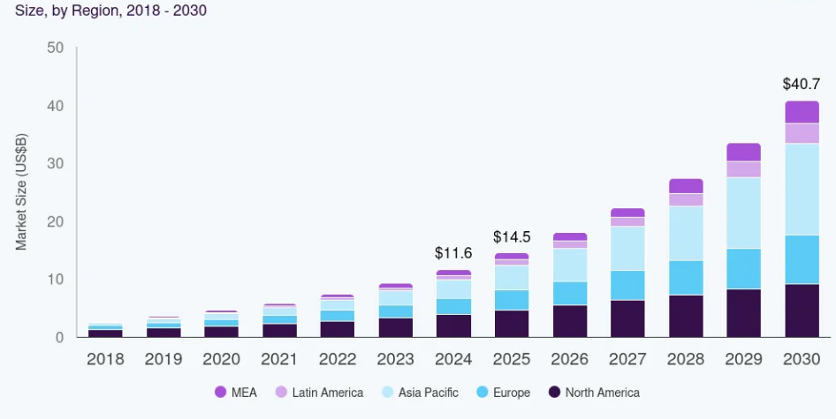

Figure 1.1: The global artificial intelligence in retail market size was estimated at USD 11.61 billion in 2024 and is projected to reach USD 40.74 billion by 2030, growing at a CAGR of 23.0% from 2025 to 2030
(Source: grandviewresearch.com, 2024)

1.2 Aim and Objectives
Aim
This study aims to create and compare statistical, machine learning and deep learning models for retail sales forecasting and find the most accurate model of future sales.
Objectives
- To investigate the historical patterns of sales, quantity, discounts, product features, store activity and promotional activity.
- To explore the time series characteristics of retail sales data and establish the relation between past sales and future sales.
- To develop a forecasting framework using Auto ARIMA, Decision Tree Regression, Gradient Boosting and LSTM.
- To engineer relevant forecasting features, including lagged sales, rolling averages and appropriate promotional variables while preventing future information from entering the training data.
- To evaluate and compare the forecasting models using MAE, RMSE, MAPE and R².

1.3 Research Question
RQ: To what extent can daily retail sales be predicted from historical sales patterns, operational activity and promotional information?

1.4 Problem Statement
Forecasting retail sales is a modelling problem because there are no one-size-fits-all methods to be used. There may be trends and repeated time behavior in historical sales and other changes such as promotions, discounts, products and store conditions. A model that fits one type of demand pattern can thus yield poor performance if the demand structure shifts. This is illustrated in the recent literature. The study by Falatouri et al. (2022) revealed that there was a significant difference in the performance of the LSTM and SARIMA models depending on the product demand characteristics, and the promotional information enhanced the forecasts for some products. Further studies have been conducted on XGBoost, which have found that applying gradient boosting to forecast retail sales could be an improvement if historical sales and other explanatory variables are included.
One of the problems that this research aims to solve is how to identify the most suitable forecasting method to best capture the temporal and nonlinear evolution of retail sales. Instead of taking for granted that the statistical models, machine learning or deep learning models are better, the study will compare the different approaches in the same forecasting conditions.

1.5 Rationale
The study is justified because of the controversial results that have been reported in the recent literature on retail forecasting. The results have been found to be quite good with LSTM in several studies, while statistical or tree based models are found to be better in specific demand situations. For instance, Falatouri et al. (2022) noted that SARIMA was more successful for certain seasonal demand series, while LSTM was more effective for products with more stable demands. There are also studies that have found LightGBM to be more effective than LSTM using actual retail data, and XGBoost to improve over simpler forecasting methods in other studies. This gives the incentive to make comparisons of models instead of choosing a model before it is done. There is also three modelling principles included in the proposed comparison. Auto ARIMA is a statistical time-series forecasting method, Decision Tree and Gradient Boosting are machine learning methods, and LSTM is a deep learning method. A comparison of these approaches will indicate if the extra complexity that machine learning or deep learning bring to the table yields a meaningful improvement over a statistical benchmark.

1.6 Scope
The study will be focused on transaction data, product data, household data and promotional data. The sales distributions, quantity sold, discounts, store behaviour, product department, and pattern of sales over time will be explored. Transaction data will then be mapped into a time-series forecasting architecture, where a daily level of forecasting will be the primary level of forecasting and a weekly level of data will be used to analyze the more general patterns in sales. Lagged sales, rolling statistics and explanatory variables from the past will be added as feature engineering. A train-test design will be employed which is chronological, meaning that the models will be trained and not tested again on the same data later. The study will be based on comparing Auto ARIMA with Decision Tree Regression, Gradient Boosting and LSTM with MAE, RMSE, MAPE and R².
The study will not attempt a causal relationship between promotions and discounts/sales. These variables will be considered in terms of their usefulness for prediction. It will also not build a full inventory management system, or try to forecast what each customer will buy. The results will be an empirical comparison of the forecasting methods and a discussion of the best model for the problem of retail sales forecasting.

1.7 Structure of Dissertation

Figure 1.2: Dissertation structure

2. Literature Review

2.1 Introduction
The research in retail sales forecasting has shifted from models that rely solely on historical sales to ones that include promotions, product attributes, store data and complex time series. None of the reviewed studies has a clear overall recommendation for which of these approaches is most effective. SARIMA and LSTM models were found to be different based on the demand behaviour (Falatouri et al., 2022), and recent studies have shown high performance of Random Forest, XGBoost, LightGBM and other special boosting models. As such, model comparison in this study is motivated by the methodological uncertainty that has been identified in these developments.

2.2 Development from Statistical Forecasting to AI-Based Forecasting
The retail forecasting has evolved from sales history modeling to modeling broader retail information structure. This shift is reflected in the level of forecasting difficulties that have been encountered recently. There are multiple factors that sales can respond to. The importance of statistical forecasting is due to the fact that it incorporates temporal dependence directly. The ARIMA and SARIMA model patterns include autoregression, differencing and seasonality. SARIMAX is an extension of this structure which includes external variables. Despite the rise of machine learning, they are still in use in recent retail research, meaning statistical forecasting hasn't gone out of style.
However, the forecasting premise of machine learning is different. Tree-based models can learn the relations among sales and multiple predictors, which are not primarily tied to the inner structure of the sales sequence. The advantage of Decision Trees is that they have a relatively interpretable nonlinear structure, and the advantage of Random Forest is that it decreases the dependence of one fitted tree by ensemble learning. Gradient Boosting builds trees in turn and focuses subsequent learning on past prediction errors. The same goes for bigger structured data sets, as in XGBoost and LightGBM. Recent retail research shows that this change is worthwhile. The M5 winning solution involved LightGBM and retail, calendar and promo information. Hobor et al. (2026) give more recent evidence. The study included 446 stores, 46,841 SKU level daily series, and product, store, price, promotion and temporal information. They obtained the RMSE of their XGBoost model as 4.833.
One of the reasons for deep learning models, such as LSTM models to be introduced to retail forecasting was the ability to have information from previous observations retained through a recurrent structure. This feature is useful when there are temporal relationships in demand patterns, not just immediate lags. The trend towards deep learning has, however, given rise to an open question and not a definitive answer. There is no compelling evidence that LSTM generally performs better than statistical or tree based techniques. Falatouri et al. (2022) discovered that the performance of the models varied depending on the characteristics of the products. Their findings showed that LSTM worked better for stable demand and SARIMA for seasonal demand. In addition, there were enhancements in the promotional information, which also aided in forecasting some products. Thus, retail forecasting can be considered as an expansion of modelling competencies instead of the substitution of one technique for the other. Temporal structure is represented by statistical models. Machine learning processes the nonlinear relationships among features. Deep learning is trying to learn complicated sequential relationships.
Forecasting approach | Main information used | Main strength | Main limitation | Relevance to current study
ARIMA/SARIMA | Historical sales | Captures temporal and seasonal structure | Limited representation of wider retail predictors | Statistical benchmark
Decision Tree | Historical and explanatory features | Nonlinear relationships and interpretability | Overfitting risk | Basic ML benchmark
Random Forest | Multiple explanatory features | Robust ensemble learning | Greater computational complexity | Evidence for tree-based methods
Gradient Boosting/XGBoost | Sales + retail predictors | Strong nonlinear prediction | Parameter tuning required | Main ML approach
LightGBM | Large-scale retail features | Efficient large-scale forecasting | More complex interpretation | Evidence from M5
LSTM | Sequential sales observations | Learns temporal dependencies | Computational complexity | Deep-learning comparison

Table 2.1: Evolution of Retail Sales Forecasting
(Source: Self-developed)

2.3 Statistical Models: ARIMA and SARIMA
The relevance of ARIMA is that information regarding their past behaviour is contained in the retail sales. Autoregressive terms: relationships with previous observations; non-stationary behaviour: differencing. The moving-averages terms include information from past forecast errors. SARIMA extends this to seasonal patterns as well that occur regularly. When there is a recognizable temporal behavior in the sales, this makes statistical modeling useful. When retail conditions are the same, their value becomes evident in research on forecasting. You need a statistical model, to set a benchmark that you can use to compare whether machine learning is actually a step up. If no such reference is provided, it is difficult to understand if a complex model would give a higher predictive accuracy. A good machine-learning performance can just be due to using more predictors, not necessarily to modelling the sales sequence itself.
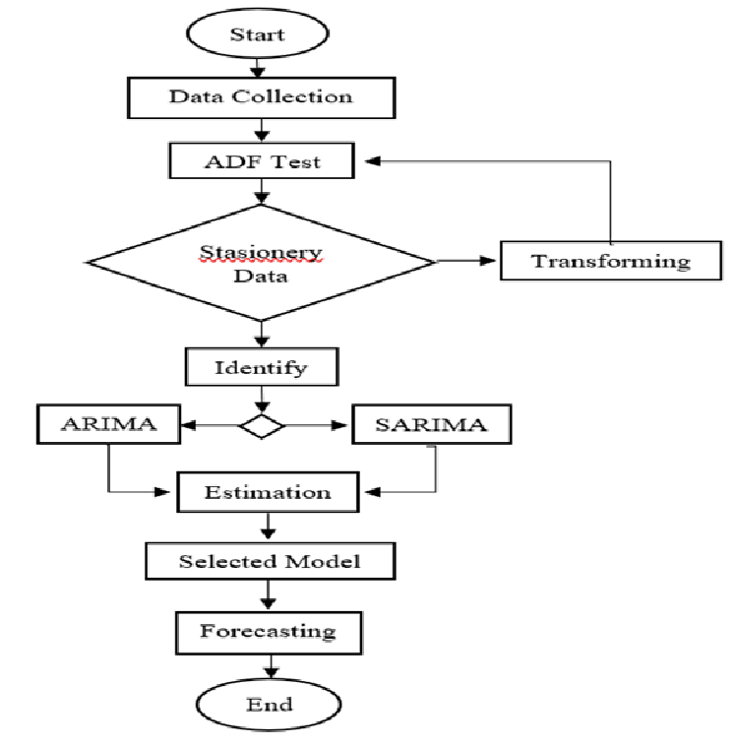

Figure 2.1: Process of data analysis using ARIMA and SARIMA Models
(Source: Hedi et al., 2022)
The assumption that newer methods have to replace statistical forecasts is challenged by Falatouri et al. (2022). They applied the retail demand data and investigated the performance of their study models: SARIMA, LSTM and SARIMAX. This depended on the nature of the demand behaviour. LSTM worked well for products with more stable demand, while SARIMA exhibited better performance for the products showing a seasonal behaviour. Promotional information also was included in the forecasting using SARIMAX, which improved forecasting for products that are influenced by promotional activity. This discovery is helpful to bring into the literature. The model could be effective if it is similar in time dimension to a specific product. In another model, the demand may be of another species. This casts doubt on LSTM's ability to outperform SARIMA. It, however, suggests that the choice of model should be based on the demand structure.
ARIMA and SARIMA, however, restrict the information structure compared to models of the machine-learning class that are subject of the present research. The strength of their core is based on the time series. Product characteristics, store activity, discounts and promotional conditions may also be included in retail forecasting. This information may include predictive signals which are not entirely embodied in the sales sequence of the past. These extra variables have been shown to be important in recent large-scale forecasting research. In addition to sales data, the M5 data contained price, promotion, calendar and special events data. Hobor et al (2026) also added product, store, price and promotion data to their forecasting model. The restriction is not ARIMA is not suitable for retail sales. The restriction is its scope of information that it can represent in the problem proposed for forecasting.
Auto ARIMA then has a specific role in the method in the present study. It will offer a statistic based on data and not a competing ‘old’ way. Its performance will demonstrate the degree of improvement using the framework of prediction from the temporal modelling stage to the nonlinear feature-based learning and sequential deep learning stage. This is significant when using the final results. Competitive performance of Auto ARIMA would suggest that the sales series has significant temporal structure that is not being better utilized by more complex models. If the two types of models make significantly fewer mistakes, the result would support that extra retail data or more flexible temporal representations would add predictive value. So, the complexity of the model is tested by comparison, but not by any measure assuming that complexity is the hallmark of progress.

2.4 Machine Learning for Retail Sales Forecasting
Machine learning has revolutionized the field of retail forecasting by enabling models to leverage multiple predictors in addition to historical sales. The dependence in the sales sequence is generally the only one that is captured in statistical models. Tree models can also be used to represent relationships between sales and retail conditions that are not linear. This is important if the demand is changing due to promotions and discounts, product changes and store changes. Recent research has demonstrated the effectiveness of Random Forest, XGBoost and LightGBM. However, their findings do not identify one universally superior method.

2.4.1 Decision Tree Approaches
One relatively straightforward way of forecasting retail nonlinearity is Decision Tree Regression. It can be used to model relationships between forecasting variables without assuming a linear relationship. This is suitable for retail data where sales can vary with any number of combinations of quantity, discount, product features and time. It is also easier to understand than more complicated models. But when it comes to an individual tree it can get very close to training observations. Overfitting is still a significant restriction, however. This has helped ease the difficulty in comparing Auto ARIMA with ensemble-based models in the context of machine learning in the present research. The comparison may suggest whether or not there is a meaningful added predictive gain with the added complexity of the ensemble.

2.4.2 Random Forest
Ensemble learning is used to mitigate some of the misspellings of the single tree in the Random Forest. Ganguly and Mukherjee (2024) have compared the performance of Random Forest with Gradient Boosting, Support Vector Regression and XGBoost. The best result they reported in their experiment was an R² of 0.945 from their optimised Random Forest. This discovery introduces a new conflict over the literature. In many retail experiments, XGBoost has shown to be successful, but it wasn't the best in this experiment. The study implies that it is not enough to determine model performance by algorithm. The ranking may be affected by the structure of the data set, the choice of features, and feature optimisation (or feature engineering).
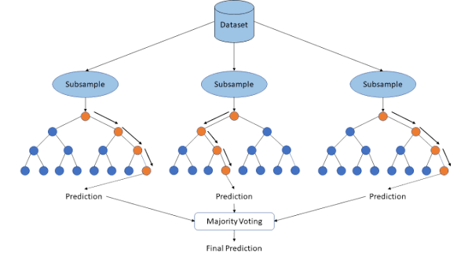

Figure 2.2: Random Forest Algorithm architecture
(Source: Padovese and Padovese, 2019)

2.4.3 Gradient Boosting, XGBoost and LightGBM
Gradient boosting builds the trees one by one, prior trees solve the errors of prior trees. This architecture enables boosted models to be used for complex relationships between sales and multiple predictors. This value has been shown by Massaro et al. (2021), using XGBoost and promotional and other retail data. Their research shows that historical sales data and other variables related to demand can be of assistance in forecasting. There is also recent evidence that supports this. Using XGBoost, Dankorpho (2024) found a 29.23% decrease in MAE and a 34.54% decrease in RMSE in comparison to the original forecasting method. The M5 competition is another example of importance. Its winning accuracy applied to LightGBM on various hierarchy levels in retail and added price, promotions and calendar features.
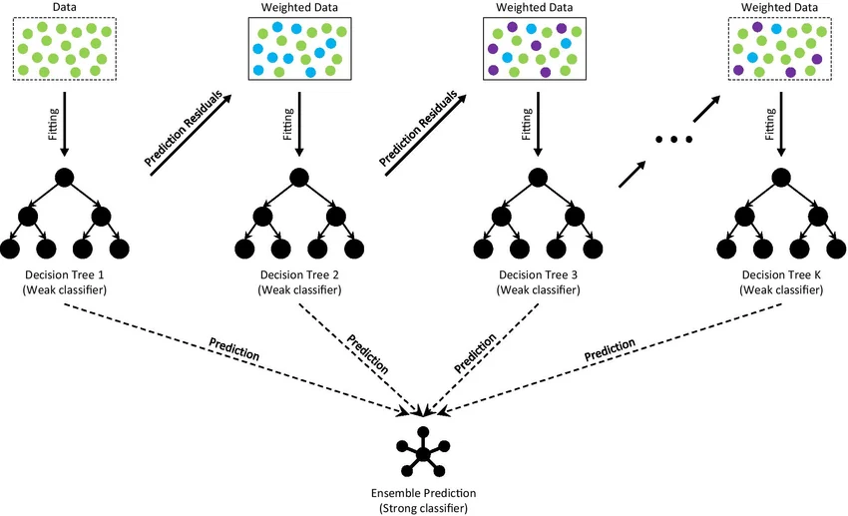

Figure 2.3: Architecture of Gradient Boosting Decision Tree
(Source: Dend et al., 2021)
More recent evidence is relevant and is provided by Hobor et al. (2026). They had 46,841 SKU-level series for 446 stores and product, store, price and promotional data. XGBoost also did the best job for this data set with an RMSE of 4.833 and beat the assessed neural methods in their configuration. This result is not a proof of the superiority of XGBoost. Optimised Random Forest gave better performance as reported by Ganguly and Mukherjee (2024). The conflicting results suggest that the outcome of these models varies with the behaviour of the demand, the features available to the experimental design, and other factors.

2.4.4 Computational Efficiency
There are other factors to consider when evaluating forecasting models that don't measure accuracy. Wellens et al. (2022) studied computational efficiency in M5 forecasting context. By using their transfer-learning techniques, they were able to save about 23.16–26.35% training time compared to the original recursive LightGBM approach and keep the forecasting accuracy close to the original approach. This discovery brings a new facet to model comparisons. A complicated model can give a more accurate result, but need significantly more computing power. While the main interest of the present study lies in predictive performance, computational complexity is also an issue when determining whether a model is viable compared with simpler models.

2.5 Deep Learning and LSTM Forecasting

2.5.1 LSTM for Sequential Retail Demand
Deep learning has opened the door to new types of models for retail forecasting. The relevance to LSTMs is because the sales observations are an ordered sequence. Demand information can be included in earlier observations. The purpose of LSTM is to remember important information from one time step to the next. This skill makes it useful when the relationships between events or objects are not just those that are immediately observed, but also those that are temporally related. The strength of LSTM is not just that it is an improved algorithm, but that it also has the ability to represent sequential dependence. However, there are mixed findings in the literature. LSTM has been found to work well in certain situations of demand, but recent studies indicate its universal superiority over statistical or tree-based techniques is not proven.

2.5.2 Evidence Supporting LSTM
Falatouri et al. (2022) present evidence on the conditional performance of LSTM. Their research experiment involved comparing the performance of SARIMA, LSTM and SARIMAX, all on retail demand data. LSTM has proven to be useful for products that have relatively stable demand. SARIMA was more powerful when products exhibited seasonal characteristics. Forecasts of products affected by promotions were also improved by the inclusion of promotional information in SARIMAX. The results are surprising and contradict the notion that it is not necessary to replace statistical forecasting with recurrent neural networks. This, however, suggests that the suitability of the model is related to the demand characteristics. A model with a stable sequential behaviour may not have the same benefit in the case where there is strong seasonal influence.
There is additional support from the wider literature for exploring the use of deep learning within retail forecasting. Ensafi et al. (2022) investigated various forecasting methods and showed that deep-learning models can be performant even in the presence of complex patterns in the demand. Besides, Punia and Shankar (2022) place deep learning in retail forecasting for decision-support. The exercise they do supports the need to learn complex demand relationships for business forecasting. These studies should be considered in conjunction with others in which different families of models are more successful, however. Thus, the literature demonstrates that LSTM has been a valid forecasting method as rather than a known optimal method.

2.5.3 Evidence against Neural Model Superiority
Hobor et al. (2026) give especially compelling evidence to resist the assumption of neural superiority. They had set up a large-scale retail experiment with 446 stores and 46,841 SKU series, comparing the tree-based and neural forecasting models. In their retail environment, the authors were able to show that localized tree-based methods performed better than the neural architectures that they tested, with XGBoost having an RMSE of 4.833. The finding is important due to the large retail complexity in the data set. It proposes that structured features can be carefully designed to give good predictive information without needing a recurrent architecture.
However, Wang et al. (2024), offer another counter-argument to the notion that temporal information is naturally suited for LSTM. They compared their spatial-temporal gradient boosting method with three other methods, namely, ARIMA, LSTM, GBDT, and XGBoost. The optimum ST-GBT configuration that achieved the lowest MAE was 5.641, RMSE 11.358 and MASE 0.587. It thus achieves better results than LSTM and traditional boosting methods in their experiments. This discovery indicates that temporal dependence doesn't always need to be deep learning. Also, when the forecasting design reflects the temporal information, tree-based methods can incorporate it.

2.5.4 Implications for Model Comparison
Although LSTM presents an effective way of learning temporal dependencies, the extra complexity of the network does not necessarily mean it can produce more accurate predictions. Recently, there have been indications of a more contingent interpretation. In some cases, retail data may include structured information like promotions, price, store attributes, and engineered temporal features, which can benefit tree-based models. However, LSTM is still significant due to its recurrent structure, which allows it to capture sequential dependencies. Hence, it is hardly surprising that its incorporation into the current study enables them to compare the value of learned temporal representation directly with the performance of Auto ARIMA, Decision Tree Regression and Gradient Boosting under the same forecasting conditions.

2.6 Hybrid and Comparative Forecasting Approaches

2.6.1 Hybrid Approaches
The past few years, research in retail forecasting has turned to ensemble methods and hybrid methods rather than simply comparing different models. The rationale behind this is that the type of algorithm reflects the type of demand characteristics. Tree-based models can represent a nonlinear relationship between predictors; neural networks can represent more complex patterns. These attributes may then convey more power when forecasts are based on a combination of these properties, rather than solely on one model. Mitra et al. (2022) studied the Random Forest, XGBoost, Gradient Boosting, AdaBoost and Artificial Neural Networks along with the hybrid approaches. In their research they found that the combination of the model capabilities can achieve competitive forecasting performance. These results cast doubt on the notion that there are only two mutually exclusive model families.
Islam et al. (2024) offer some newer evidence by comparing Random Forest, XGBoost, Gradient Boosting, AdaBoost, ANN and a hybrid model of Random Forest, XGBoost and LR. The hybrid model was reported as having an R² of 0.9651. The result indicates that it is possible to increase the amount of variance accounted for by the model by merging several predictive structures. The paper however reports an inconsistency in the reported MSE value. This report corresponds to an MSE of 4.89 × 10⁻⁴ for the hybrid model and 4.72 × 10⁻⁵ for XGBoost. But the hybrid model is still the stronger model, but with a numerically bigger MSE. This is a deficiency that weakens the evidentiary support and conveys the importance that model results be viewed by multiple metrics.

2.6.2 Comparative Evidence and Conflicting Results
There is more evidence in the wider literature for comparison than for a universal model hierarchy. Hasan et al. (2022) showed that SARIMA and LSTM were different in terms of the demand characteristics. However, Massaro et al. (2021) showed that adding other explanatory variables such as promotions yields significant benefits of using XGBoost. Ganguly and Mukherjee (2024) achieved an R² of 0.945 with optimised Random Forest, which was better than the other models tested by them. In comparison, Dankorpho (2024) observed significant gains using XGBoost, and their MAE decreased by 29.23%, while their RMSE reduced by 34.54%.
This is further confirmed by more recent studies. Their spatial-temporal gradient boosting approach was better than the other models used, including ARIMA, LSTM, GBDT and XGBoost, with the best performing configuration having an RMSE of 11.358. This is well similar to Hobor et al. (2026) who also determined that XGBoost performed best in their large-scale retail comparison, with an RMSE of 4.833. The M5 competition is another sign of the success of LightGBM in large scale retail forecasts.
Analytically, it is significant that these studies disagree. They have different data sets and have different structures. They also have different forecasting horizons, levels of aggregation and predictor variables. There are studies that predict products per person and others that work at store or hierarchical product level. Therefore, the performance results in the literature cannot be used to draw conclusions about the universal ranking of ARIMA, tree-based learning and LSTM. The question isn't really about which algorithm seems to be the most promising in the literature, however. It's about whether a specific model is best when tested against each other under the same conditions. This uncertainty can be alleviated by conducting a controlled comparison on the same dataset, forecasting the same target, the same chronological test period and evaluation measures.

2.7 Feature Engineering and Information Used in Retail Forecasting
Feature engineering is significant as retail forecasting relies on current demand, in addition to longer-term sales dynamics. Hobor et al. (2026) added lags up to weekly, monthly and yearly rolling statistics. These provide a way for a model to capture recent demand and still have larger time-related trends. Another source of predictive information is through promotional information. For products that affect promotional activity, Falatouri et al (2022) showed that the promotion variables were effective as predictive factors. The incorporation of promotional conditions in forecasting procedures has also been introduced by Massaro et al. (2021) in the context of the XGBoost model. The Dunnhumby data contains a number of useful variables, such as RETAIL_DISC, COUPON_DISC, COUPON_MATCH_DISC and details about the campaign. These variables are thus suitable to be evaluated for their predictive contribution. The inclusion of these does not mean and should not be interpreted as a causal relationship with sales.
Feature category | Examples | Evidence in literature | Role in current study
Historical sales | Lag 1, 7, 28 | Hobor et al. | Forecasting features
Rolling demand | Weekly/monthly averages | Hobor et al. | Smooth short-term variation
Promotions | Campaigns, promotion indicators | Falatouri; Massaro | Predictive variables
Discounts | Retail/coupon discounts | Retail studies | Predictive variables
Product | Department, category, SKU | Hobor et al. | Product-level context
Store | Store characteristics | Hobor et al. | Store-level context
Calendar | Day, week, season | M5/Hobor | Temporal features

Table 2.2: Retail Features Identified in the Literature
(Source: Self-developed)

2.8 Critical Synthesis, Research Gaps and Position of the Current Study
Recent studies show that there is a lot of progress in retail sales forecasting, but no clear one that is superior. Falatouri et al. (2022) concluded that the SARIMA model yielded good results for the seasonal demand and the LSTM model for relatively stable demands. Ganguly and Mukherjee (2024) reported an R² of 0.945 for optimised Random Forest; Dankorpho (2024) reported significant improvement of XGBoost. Hobor et al. [2026] concluded that XGBoost is their best model, and Wang et al. [2026] reported that the ST-GB model performed the best among the models, which includes ARIMA, LSTM and conventional XGBoost. The conflicting results show that the forecasting performance is related to the nature of each retail problem.
The second gap is related to the comparability of the published results. Different data sets, forecasting horizons, ways of aggregation, predictors and evaluation procedures are used for different studies. Some studies employ considerably different store configurations, such as Hobor et al. (2026), which accounted for 46,841 SKU-level series in 446 stores. So, if a child performs well in one context, it is not a guarantee of their performance in another. Other treatment is also given to temporal and explanatory information in literature. Prediction can be further improved using promotions, product characteristics, store characteristics and store prices; however, their contribution may differ depending on the level of demand.
Another issue is that of comparing the model families fairly. There are multiple studies that use various error measures and train-test designs. Therefore, it will be hard to compare the numbers directly. This work is relevant to this question, as it is based on the same Dunnhumby data set, target, test period and assessment metrics and utilizes a controlled experiment. The four algorithms (Auto ARIMA, Decision Tree Regression, Gradient Boosting and LSTM) will be compared under the same set of conditions. It is not the intent of this study to suggest that AI or deep learning will be superior to statistical forecasting. Rather, it's an investigation of whether the additional flexibility in modelling yields a tangible forecasting benefit in a uniform retail setting.
Identified gap | Evidence from literature | Response in current study
No consistent model winner | Different studies report SARIMA, LSTM, RF, XGBoost and ST-GBT as strongest | Compare four model families
Studies use different datasets | Retail datasets vary in scale and structure | Use one consistent Dunnhumby dataset
Different evaluation procedures | MAE, RMSE, MAPE, MASE and R² used inconsistently | Use common evaluation measures
Different forecasting structures | Product, store and aggregate levels vary | Establish a defined daily forecasting target
Temporal leakage risk | Future information can enter feature construction | Use chronological train-test split
Promotional effects vary | Promotion improves some forecasts but not universally | Test promotional variables for predictive value
Model complexity may not improve accuracy | Tree models sometimes outperform neural models | Compare accuracy against model complexity

Table 2.3: Research Gaps and Response
(Source: Self-developed)

3. Methodology

3.1 Research Design
A quantitative experimental design is applied to evaluate statistical, machine-learning and deep-learning approaches for retail sales forecasting. This experiment utilizes the Dunnhumby Complete Journey dataset and predicts future retail sale transactions. The central modelling problem is to predict future sales based on information prior to the forecasting period. Four forecasting approaches will be evaluated which are Auto ARIMA, Decision Tree Regression, Gradient Boosting/XGBoost and LSTM. The models are based on various assumptions concerning the sales-generating sequence. The sales series is characterized by temporal dependence in the data, which is captured by Auto ARIMA models. Nonlinear relationships between engineered predictors and sales are captured by a model called Decision Tree Regression. Gradient Boosting is an extension of tree based learning with sequential error correction. For sequential dependencies, LSTM models the structure using recurrent neural representations.
The experiment follows seven stages:

Chronological test period is used in the design. Future observations will not be used for feature construction or model training as the goal is not to replicate known sales values. It is to determine the accuracy of each model in predicting sales beyond the training period.

3.2 Dataset Structure and Target Definition
The primary transaction data set has 2,595,732 records and 12 variables. Preliminary analysis identified 2,500 households, 92,339 products, 582 stores, 276,484 baskets, 711 days and 102 weeks. SALES_VALUE is the target variable. At the transaction level, it is the monetary amount of each transaction record. The forecasting target will be built at daily level of aggregation instead of forecasting each row of transactions.
For day t, total sales will be calculated as:
$$Y_{t}=\sum_{i=1}^{N_{t}}{{SALES_VALUE}_{i,t}}$$
Where:
- $Y_{t}$ = total sales on day t;
- $N_{t}$ = number of transaction records on day t;
- ${SALES_VALUE}_{i,t}$ = sales value of transaction record ion day t.
The transaction records are aggregated on a daily basis to generate a day-to-day chronological forecasting series. In addition, weekly aggregation will be generated for descriptive analysis:
$$Y_{ω}=\sum_{tϵω}{Y_{t}}$$
Where, $Y_{ω}$ represents total sales during week$ω$.
The primary modelling target will be to model daily sales, as there are 711 days of observed data. Longer term movement of demand will be analysed from the weekly sales and this will aid in the interpretation of the seasonal behaviour.

3.3 Data Quality Assessment and Preprocessing
The transaction data will first be assessed for missing values, duplicate records, invalid numerical values and inconsistent identifiers. The initial audit did not detect any duplicate transaction records, nor did it detect any missing observations in the main transaction table. In contrast, the numerical variables need to be interpreted and not deleted for unusual values. QUANTITY contains no negative observations. SALES_VALUE also contains no negative observations. However, 14,466 records have zero quantity and 18,850 records have zero sales. Further investigation showed that 4,451 zero-sales records contain positive quantity, while 14,399 contain both zero sales and zero quantity. These records will therefore be retained initially and examined as part of the data-quality analysis.
The discount variables have to be treated differently. RETAIL_DISC, COUPON_DISC and COUPON_MATCH_DISC contain negative values. These values are not negative sales, but discount adjustments. They will therefore not be removed as invalid observations. Where categorical product variables (such as DEPARTMENT, BRAND, COMMODITY_DESC and SUB_COMMODITY_DESC) are used as variables in machine-learning models, they will be considered categorical predictors. In tree-based models, numerical variables will keep their original scale, as there is no need for the predictors to be standardised for tree splitting.
Scaling will be required for the LSTM model. The statistics used for continuous input variables will then be determined from the training period only and will be used to transform the continuous variables. Min-max scaling can be expressed as:
$$\acute{x}=\frac{x-x_{min}}{x_{max}-x_{min}}$$
Where, $x_{min}$ and $x_{max}$ are calculated from the training data. The same transformation parameters will then be used with validation and test observations. This ensures that information from the test period is not fed into preprocessing.

3.4 Dataset Integration
The dataset of transactions and the dataset of products were joined based on PRODUCT_ID. There are 92,339 unique product identifiers in the transaction table, and 92,353 unique product identifiers in the product table. There were no products that did not have product-master records in the transaction data. Many-to-one merge was used to validate the relationship. Since product integration did not result in removal of transaction observations, all 2,595,732 were retained in the merge.
The product data provided more details regarding department, brand, commodity, sub-commodity, product size and manufacturer. These variables were not directly fed to the final daily forecasting models but used in support of data understanding and aggregation. The household dataset contained information for 801 households compared with 2,500 households in the transaction data. It was therefore considered supporting data and not the whole set of the transaction population. The datasets for the campaign, coupons and promotions were analyzed independently because they were not the same as the transaction data, as they were not necessarily the same products, and the coverage and structure varied. Only where it could be used for forecasting (without incorporating future information) was promotional information incorporated. Product-store-week level promotional activity data were aggregated before being transformed to daily forecasting features.

3.5 Exploratory Data Analysis
For developing the model, exploratory data analysis was first performed to determine the statistical and temporal nature of the daily sales. Sales and some key measures of transactions were analyzed using descriptive statistics and distributional analysis. The sales data for each day of the time period was then plotted and changes in sales level, variation and any unusual observations were identified. Longer term movement in the series was given additional context using weekly summaries. The time-series analysis emphasised the link between the present day sales and past observations. To look for the persistence and repeated seasonal behavior, autocorrelation was studied at daily and weekly lags. The stationarity test was conducted on the sales series and the first differences of the sales series with Augmented Dickey-Fuller test. The autocorrelation structure of the differenced series was also analyzed to check if the weekly dependence was still present after removing the short-term persistence.
Pearson correlations were also conducted to explore the relationships between daily sales and previous operational indicators (quantity, transactions, baskets, active household, active product, and active stores). Other discount measures from the historical periods were also analyzed as predictive variables. The relationships between these were interpreted as associations, not evidence of causal effects. The EDA results informed the choice of the lagged sales, rolling statistics, operational features and the seven-day seasonal structure that were included in the subsequent forecasting models.

3.6 Time-Series Construction and Feature Engineering

3.6.1 Lag Features
For the daily sales series Yt, lag variables will represent previous sales observations:
$$L_{1,t}=Y_{t-1}$$
$$L_{7,t}=Y_{t-7}$$
$$L_{28,t}=Y_{t-28}$$
The one day lag is used to represent the immediate persistence in the demand. Seven days lag is a weekly repetition. The 28-day lag time is the equivalent of about four weeks of past demand. If there is meaningful temporal dependence, then additional lagged features may be added.

3.6.2 Rolling Features
The rolling statistics will record recent demand behaviour and minimise reliance on one previous observation. The 7 day rolling mean can be computed as:
$$R_{7,t}=\frac{1}{7}\sum_{j=1}^{7}{Y_{t-j}}$$
$$R_{28,t}=\frac{1}{28}\sum_{j=1}^{28}{Y_{t-j}}$$
A 28-day rolling mean will similarly be calculated as:
This observation will not be used in these calculations. This will prevent the target value from being fed into its own predictor.
Rolling standard deviation may also be used:
$$σ_{ω,t}=\sqrt{\frac{1}{ω-1}\sum_{j=1}^{ω}{{(Y_{t-j}-Rω,t)}^{2}}}$$
This feature is an indicator of recent volatility.

3.6.3 Calendar Features
The DAY and WEEK_NO fields were converted to temporal predictors. DAY_TREND was the position of the observation in the study period and WEEK_NO was the position of the observation within a week. DAY_OF_WEEK_CYCLE was created from the DAY index to provide the 7-day cycle that is repeated in the dataset. The advantage of these variables was that the tree-based models were able to incorporate temporal conditions as opposed to simply using the D-day index as a numeric sequence.

3.6.4 Promotional and Discount Features
The transaction data contains RETAIL_DISC, COUPON_DISC and COUPON_MATCH_DISC. These variables will be consolidated on a regular basis in line with sales forecasts.
For example, total daily retail discount can be represented as:
$$D_{t}=\sqrt{\sum_{i=1}^{N_{t}}{{RETAIL_DISC}_{i,t}}}$$
Product-store-week promotional records were used to determine the promotional activity. Display and mailer codes were translated into binary code that would indicate if each promotional condition was in effect or not. The product-store-week records were then aggregated to produce one measure of promotional activity for each product-store-week. Then, all the weekly promotional activities were identified and lagged and introduced into the forecasting models. This meant only information about promotions before the forecast date was taken into account. Records of formal campaigns were studied individually for contextual information, and were not considered to be a comprehensive sample of all campaign promotion.

3.7 Prevention of Data Leakage
One of the big methodological risks of this study is data leakage which occurs when many engineered features are based on sales history.
For every forecasting point t, the feature vector must satisfy:
$$X_{t}=f(Y_{1},Y_{2},….,Y_{t-1})$$
For example, the seven-day rolling mean for day t must use days, t−1 through t−7. It must not include Yt.
The train-test split will also be chronological:
$$D_{train}=\{1,…,T_{train}\}$$
$$D_{test}=\{T_{train}+1,…,T\}$$
No random shuffling will be used. Chronological split was used to maintain direction from past-to-future. The model configurations for the Decision Tree and Gradient Boosting models were determined by the RMSE of the validation period, and the model order for the Auto ARIMA model was determined by its internal information-criterion search. The LSTM did not systematically search for hyperparameters, but rather used validation loss for early stopping. No cross validation was done because it was a fixed chronological forecasting split.

3.8 Forecasting Model Development

3.8.1 Auto ARIMA
Auto ARIMA will provide the statistical benchmark. An ARIMA model can be represented as:
$$∅\left(B\right){\left(1-B\right)}^{d}Y_{t}=θ(B)ϵ_{t}$$
Where:
- B is the backshift operator;
- d is the differencing order;
- $∅\left(B\right)$represents autoregressive terms;
- $θ(B)$ represents moving-average terms;
- $ϵ_{t}$represents the forecast error.
Auto ARIMA will choose information criterion (like AIC) to search for candidate parameter combinations and pick the right one. Where the EDA supports it, seasonal structure will be considered. The main input to ARIMA will be the historical sales sequence. It will thus serve as a benchmark to assess the significance of improvements by feature-based machine learning.

3.8.2 Decision Tree Regression
Decision Tree Regression will model:
$$\hat{Y_{t}}=f(X_{t})$$
Where, $X_{t}$contains the engineered predictors.
The algorithm uses a recursive partitioning technique according to which the feature space is divided into areas that reduce the prediction error. A typical split for regression will minimize within-node squared error:
$$SSE=\sum_{i=1}^{n}{{(y_{i}-\hat{y})}^{2}}$$
To control model complexity, different maximum tree depths and minimum samples per leaf were examined using the validation period. The best validation RMSE was chosen for the final model. The final Decision Tree had a minimum leaf size of 10 and a maximum depth of 3, with a tie in validation RMSE with a minimum leaf size of 5.

3.8.3 Gradient Boosting
The approach of decision tree will be extended to Gradient Boosting, which is an ensemble of sequential decision trees.
The prediction after mm boosting stages can be represented as:
$${\hat{Y}}_{t}^{(m)}= {\hat{Y}}_{t}^{(m-1)}+ ηh_{m}(X_{t})$$
Where:
- $h_{m}(X_{t})$ is the newly fitted tree;
- $η$ is the learning rate;
- m is the boosting iteration.
The new tree is fitted to reduce the residual error from the previous ensemble.
Gradient Boosting configurations were tested on the validation period. The search varied learning rate, number of estimators, maximum tree depth and minimum samples per leaf. The configuration that yielded the lowest validation RMSE was used and refitted to the training and validation observations prior to evaluation on the untouched test period. No cross validation was performed.

3.9 LSTM Development
The deep-learning model will be represented by LSTM. Unlike tree-based models, LSTM will have observations in sequential windows.
For a sequence length pp, the model input can be represented as:
$$X_{t}=[Y_{t-p}, Y_{t-p+1},..,Y_{t-1}]$$
With the objective:
$$\hat{Y_{t}}=f(X_{t})$$
The LSTM cell uses three main gates. The forget gate is:
$$f_{t}=σ\left(W_{f}\left[h_{t-1},x_{t}\right]\right)+ b_{f}$$
The input gate is:
$$i_{t}=σ\left(W_{i}\left[h_{t-1},x_{t}\right]\right)+ b_{i}$$
The candidate cell state is:
$$\tilde{C_{t}}=tanh\left(W_{c}\left[h_{t-1},x_{t}\right]\right)+ b_{C}$$
The cell state becomes:
$$C_{t}=f_{t}C_{t-1}+i_{t}\tilde{C_{t}}$$
The output gate is:
$$o_{t}= σ(W_{o}\left[h_{t-1},x_{t}\right]+ b_{o})$$
And the hidden state is:
$$h_{t}=o_{t} tanh⁡(C_{t})$$
The sequence output will then pass through a dense layer to produce the sales forecast.
For LSTM, parameters will be used that were determined during training. The final LSTM used a fixed sequence length of 28 days, 32 LSTM units and a dropout rate of 0.2. Adam optimizer and Mean Squared Error loss function were used in the model. The features and the target were scaled during the training period only. The loss for validation data was tracked at training and early stopping was applied to prevent overfitting by restoring the set of weights that performed best on that data. The LSTM did not use a systematic hyperparameter search or cross validation.

3.10 Model Evaluation
Mean Absolute Error
$$MAE= \frac{1}{n}\sum_{i=1}^{n}{| y_{i}-\hat{y_{i}}|}$$
MAE measures the average absolute forecasting error.
Root Mean Square Error
$$RMSE= \sqrt{\frac{1}{n}\sum_{i=1}^{n}{{{(y}_{i}-\hat{y_{i}})}^{2}}}$$
RMSE gives greater influence to large prediction errors.
Mean Absolute Percentage Error
$$MAPE= \frac{100}{n}\sum_{i=1}^{n}{| \frac{y_{i}-\hat{y_{i}}}{y_{i}}|}$$
The dataset includes zero sales observations, so it is not safe to calculate the conventional MAPE for all observations. The study will then calculate the MAPE on the subset of actual-sales that is not zero, and the rule will be clearly stated in the results chapter.
Coefficient of Determination
$$R^{2}= 1- \frac{\sum_{i}{{(y_{i}-\hat{y_{i}})}^{2}}}{\sum_{i}{{(y_{i}-\overline{y})}^{2}}}$$
R² will indicate how much variation in observed sales is explained by the predictions.
There will be no one correct answer as to which model is a winner. These are the measures of prediction error, so that MAE and RMSE will be given special consideration. MAPE will give a percentage interpretation, and R² will give further information about the amount of variation explained.

3.11 Comparative Analysis
All similar forecasting methods were analysed with the same chronological test observations. The models were estimated during the training period and model selection (with parameter alternatives) was performed during the validation period. Two configurations, Decision Tree and Gradient Boosting, were compared based on the validation-period RMSE and Auto ARIMA took care of the order selection by employing information-criterion procedure. Validation loss was used for early stopping in the LSTM, but not for an exhaustive hyperparameter search. The final models selected were then tested once on the pristine test period. The study did not use any cross-validation. RMSE was the main comparison metric used, with MAE, MAPE, sMAPE, WAPE and R² used as supplementary metrics of forecast accuracy.
An historic-only model versus promotion-enhancing model promotion ablation analysis was conducted separately. The 30 historical forecasting features were enhanced with 5 lagged promotion features to create the promotion enhanced models. This comparison compared the added predictive value of the available promotional information when the model was the same. In addition, a sensitivity analysis without Day 643 was performed due to the fact that this observation was determined as an anomaly involving incomplete transactions coverage. As opposed to being removed from the original data set, the observation was kept in the main test evaluation. The sensitivity analysis then tested whether the anomaly materially impacted the reported model rankings and error measures. In interpreting the models emphasis was placed on predicting the results and not on causal influences, especially for discount and promotion variables.

Chapter 4: Results and Analysis

4.1 Dataset and Data Quality Findings
The Dunnhumby dataset offers a huge transaction volume, but a short forecasting period. There are 2,595,732 records in the transaction file for 711 days and 102 weeks. These transactions involve 2,500 households, 92,339 products and 582 stores. The supporting files provide information about products, households, coupons, campaigns and promotional activity. The structure will provide a helpful contrast for the forecasting task. The cross sectional breadth of the dataset is wide, while the temporal depth is shallow. This does not provide sufficient observations to support a long-horizon product-level forecasting exercise, but supports detailed daily aggregation. The study then sets daily total SALES_VALUE as the target to be forecasted. The value of transaction level records is still significant as they are required to build daily activity and historical predictors.
Measure | Result
Transaction records | 2,595,732
Observation period | 711 days
Calendar weeks represented | 102
Households | 2,500
Transaction products | 92,339
Stores | 582
Daily observations | 711
Mean daily sales | 11,332.58
Minimum daily sales | 2.99
Maximum daily sales | 24,760.10
Days without recorded sales | 0

Table 4.1: Summary of the daily forecasting dataset
Daily aggregation resulted in 711 full daily observations. There were no missing daily sales, and no day with zero sales. There were also no missing values in the loaded datasets. The quality control identified several unusual transaction level values. Quantity showed a strong right tail and some transactions contained very high quantities. There were also negative values for discount variables. The discount fields are not used as standard positive-valued measurements, so these values were not automatically considered to be errors. There were also repeated product-store-week combinations on both coupon and causal records. These records turned out to be multiple promotions, and not just replicated rows. It could therefore be possible to remove valid promotional information if they are removed without verifying the structure. Such observations were retained in the quality assessment, but transformed to a suitable aggregated forecasting variable.
The most important data-quality issue concerned Days 278 and 643. These observations were not like the normal high/low sales days. Day 278 contained only six transaction rows, one basket, one household and one store. It had recorded sales of just 22.49. Day 643 was more intense. It had two rows of transactions for two baskets, one household and one store. Sales were only 2.99 days recorded. The days surrounding the event had significantly more transactions. Day 642 recorded 238,480 transactions and sales of 16,005.20. Day 644 recorded 361,352 transactions and sales of 11,830.28. The pattern is, therefore, a sign of a lack of transaction coverage, not of an economically significant drop in sales. These two observations were kept as such in the main analysis and marked for further analysis as possible incomplete-transaction-coverage anomalies. A sensitivity analysis was performed later that excluded day 643. The method does not alter the original data and determines if the anomaly really impacts on results.
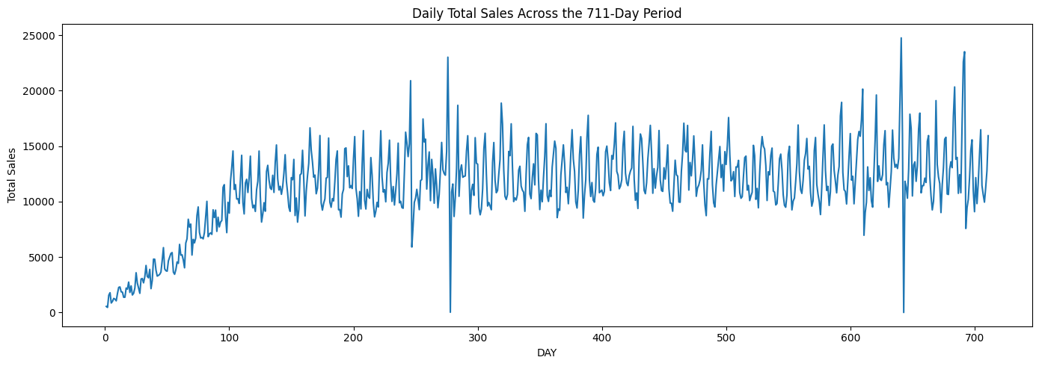

Figure 4.1: Daily sales across the 711-day observation period
The dataset is complete enough for day-to-day forecasting, but it does not lack any coverage related irregularities. The majority of the lower values of transactions were kept as it could be a legitimate retail transaction. The two daily coverage anomalies were treated separately because they have better evidence to show incomplete capture due to a combination of surrounding transaction counts. This is significant for the assessment of the model. A forecast error on a typical sales day is a different type of error than an error caused by an incomplete transaction record. Because of this, the main test period is able to maintain the observed data and the sensitivity analysis would serve as a second representation of model performance without Day 643.

4.2 Exploratory Time-Series Findings
Daily retail demand is not independent across time as seen in the sales series. Sales were comparatively low during the beginning of the observation period and increased as the dataset progressed. The latter periods tended to have higher daily sales and to be more stable around the mean. The series also showed variation throughout the period, making it difficult to consider it as a simple upward trend. Changes in the sales pattern seem to indicate short-term regressive, or periodic, behaviour and long-term movement as illustrated using Figure 4.1. The significance of the pattern is related to its forecasting implication. Evidence from past observations can be helpful in later sales.
This dependence is more clearly indicated from the autocorrelation results. The correlation between current sales and sales one day earlier was 0.731. The lag-7 correlation was higher at 0.752. The correlations were high at longer lags, at lag 14 with 0.741, and at lag 28 with 0.726. The pattern is important in that it demonstrates that sales behaviour is not simply a daily persistence. The week's position is especially valuable in terms of up to date sales information. The finding supports the use of lagged sales variables in the machine-learning models. It also offers empirical support to investigate a seven-day seasonal structure in the statistical model. This link does not imply that when sales occur in the past, sales occur in the future. Instead, it reveals information in the historical observation, which can be used for prediction.
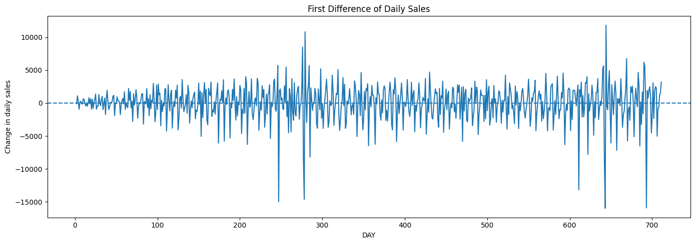

Figure 4.2: First difference of daily sales
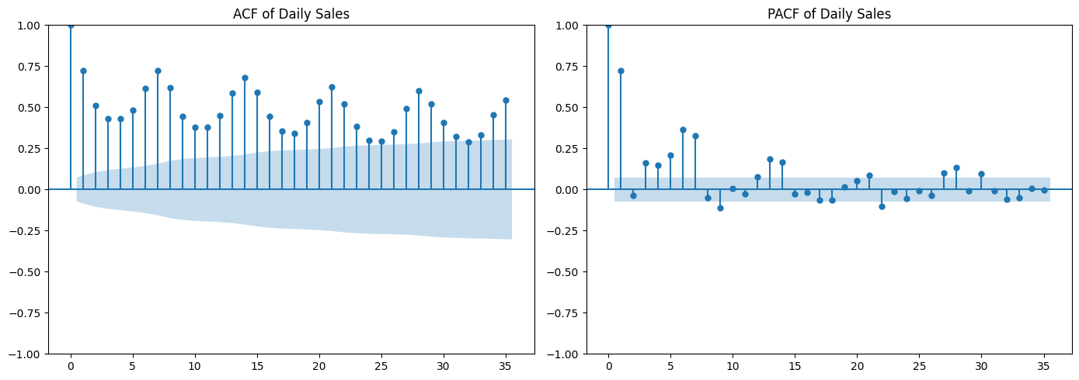

Figure 4.3: Autocorrelation function of daily SALES_VALUE
Stationarity diagnostics give a more detailed description of the series. The original series of sales was tested using the Augmented Dickey-Fuller statistic which yielded a value of −4.3174, with a corresponding p-value of 0.0004. The result indicates that there was no evidence of a unit root at a conventional level of significance for this series. First differencing was also examined instead of taking the original series as being enough for diagnosis. The differenced series produced an ADF statistic of −8.8202 with p < 0.001. Differencing gave, therefore, a clearly stationary series. But this does not imply that first differencing should be applied in the forecasting model without further thought. Stationarity had already been shown from the original series. The appropriate approach, however, was to let the Auto ARIMA procedure decide the needed differencing structure, instead of trying to transform in advance.
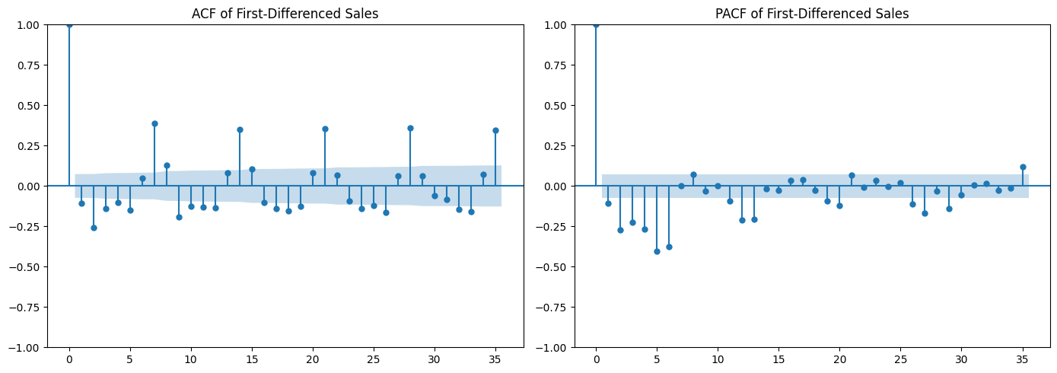

Figure 4.4: ACF of the first-differenced sales series
The differenced ACF adds an important detail to the interpretation. Differencing reduces the strength of the short-term dependence, especially at the initial lags. The weekly dependence is still present at lag 7, and it is present at later weekly lags as well. The differenced series thus reduces some of the short-term persistence without destroying the weekly periodicity in the series. This discovery establishes an immediate connection on the part of exploratory analysis and forecasting design. The 7-day pattern is used for Auto ARIMA with a seasonal periodicity of 7. It also adds lag-7, lag-14 and lag-28 sales features to the machine-learning models. Historical measures were also included as measures that could be rolled. These features are not included in the analysis merely because they are frequently used in forecasting.

4.3 Predictive Relationships and Feature Engineering

The exploratory results indicated that historical retail activity contains useful information for forecasting subsequent sales. The relationship was not confined to the previous sales prices. Operational measures also had significant relationships with future sales. Households, baskets and transactions were closely following sales on previous-day and previous-week activities. Positive relationships between products and stores were also observed for active products and stores. There was historical quantity for further predictive information. Negative associations were observed among the discount measures and sales. But these relationships were not interpreted as causal effects. The direction of the discount amounts recorded and the way they are summed up over transactions also influence the interpretation.
The feature set therefore focussed on four types of historical information. Historical sales features were taken at lags 1, 7, 14 and 28 days. Rolling features represented recent sales level and variation through 7-, 14- and 28-day means and 7- and 28-day standard deviations. Operational features captured lagged quantity, transactions, baskets, active households, active products and active stores. Discount features represented previous retail, coupon and coupon-match discount activity. Three temporal variables were also included. These represented the day trend, week number and position within the seven-day cycle. The two groups created a combined output of 30 historical forecasting features.
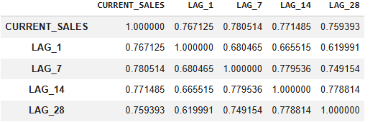

Figure 4.5: Historical-sales correlations with and without coverage anomalies
The design of the feature construction was based on information available at the forecast point. Rolling statistics took place after sales values were shifted. The rolling measures have therefore been based on earlier observations, without incorporating the sales value to be predicted. Operating and discount measures that are currently in place were also not included in the forecasting matrices. The distinction is significant because the data from the transactions would have been available only after the forecast day. The inclusion of such information may lead to overly good model performance and reduce the relevance of the comparison.
The final feature matrices provided further evidence that the construction was controlled. The historical model had 450 observations of training, 97 observations of validation, and 97 observations of testing, and 30 predictors for each period. There were no missing or infinite values in the matrices. No current day variables were found via an explicit leakage check either. The feature engineering process thus demonstrated a significant risk management concern in a retail forecasting process. Predictive performance could be assessed using information that would have been available before the target sales value was observed. This gives a better footing for comparing the statistical approach with the machine-learning and deep-learning approaches.

4.4 Promotional Information and Forecasting Features
Another source of potential predictive value was added to the promotional information. Promotional data included product-store-week conditions coded as display and mailer codes. These codes were translated into binary codes (Yes/No) for display activity and mailer activity. The repeated product-store-week records were then rolled-up to create one record for each product-store-week combination even if promotional activity was present, instead of the number of repeated records. This was a regular weekly representation of the conditions of promotions that was used for forecasting purposes.
Promotional information was fairly complete, but incomplete in terms of the transaction environment. 115 of the 582 transaction stores were part of the causal dataset. But the total transaction sales accounted for around 98.49% of the total sales, mainly from these stores. In terms of geographic or store counts, the coverage was limited, but it was good in terms of sales observed. The coverage of products was less comprehensive. This distinction allowed for use of the promotional information as a reasonable additional predictor but did not allow it to be used as a complete representation of all promotional activity within the retail data set. It was also revealed that there were differences between promoting and keeping formal campaign records. The promotional data included product-store-week conditions which were not tied directly to any formal campaign data. Campaign records were thus useful in context but could not be taken as an indicator of all the promotional conditions that existed during the transaction.
Only lagged promotional information was introduced into the forecasting models. Five variables were created from the previous week's promotional conditions. These captured display rate, mailer rate, promoted-product counts, display-active combinations and mailer-active combinations. These five variables were added to the 35-feature 30 historical predictors, making a 35-feature promotion-enhanced model. It was not intended to claim that promotion is an improvement on forecasting. Rather, the same modelling approach could be used to determine if historical promotional activity would have added predictive value.

4.5 Forecasting Model Performance and Comparison

4.5.1 Baseline performance
The naïve forecasts are useful as a starting point since they do not involve estimated model parameters. The seasonal naïve approach relied on sales data for the last seven days and hence captured the weekly trend that was found in the exploratory analysis. The naïve forecast had an RMSE of 4,197.674, and the seasonal naïve forecast had an RMSE of 4,019.818, during the test period. Thus, the seasonal benchmark gave a better RMSE value than the other two. Furthermore, it had a less negative R² than the naïve approach. This finding lends credence to the existence of significant weekly persistence in the sales time series. It also sets a more stringent standard for the predictive models. A model should not just outperform a previous day's forecast, but improve on this time-of-season trend. The final ARIMA model was refitted using the training and validation observations before testing. Its test RMSE was 3,740.455. The 6.95% improvement was compared to the seasonal naïve RMSE of 4,019.818. The last test period was therefore used to capture additional temporal information, due to ARIMA. There is still a moderate improvement. For the test, it yielded an R² of −0.079, again a low explanatory power in comparison with the mean of the test period. The results indicated the usefulness of ARIMA for temporal dependence and at the same time, it did not always provide a better fit to the simpler seasonal structure.
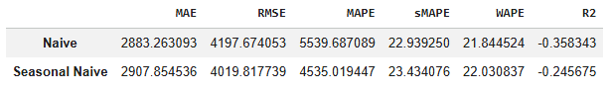

Figure 4.6: Baseline performance
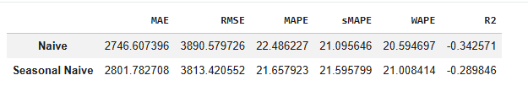

Figure 4.7: Baseline performance without Day 643

4.5.2 Auto ARIMA
The best model chosen by Auto ARIMA was ARIMA(1,0,0)(2,0,1)[7] with an intercept. The seven day seasonal period was similar to the observed weekly dependence. The Auto ARIMA procedure selected the model order using the training observations and its information-criterion search. This selected specification was then assessed during the validation period and re-fitted with the combined training period and validation period observations for final test evaluation of the selected specimen. Its validation RMSE was 2,263.320. The seasonal naïve benchmark had the best performance during the validation period with an RMSE of 1,685.967. This does not imply that the quality of the statistical structure in the data ensures superior short-term forecasts than persistence forecasts. Refitting the final ARIMA model is done prior to testing with training and validation observations. Its test RMSE was 3,740.455. This was an increase of 6.95% compared to the seasonal naïve RMSE of 4,019.818. During the final test period ARIMA was able to collect more temporal information. The improvement is still moderate. It also had a test R² value of −0.079, suggesting low explanatory power when compared to the test-period mean. The findings indicate that the ARIMA was useful in modeling the temporal dependency but it was not always superior to the simpler seasonal structure.
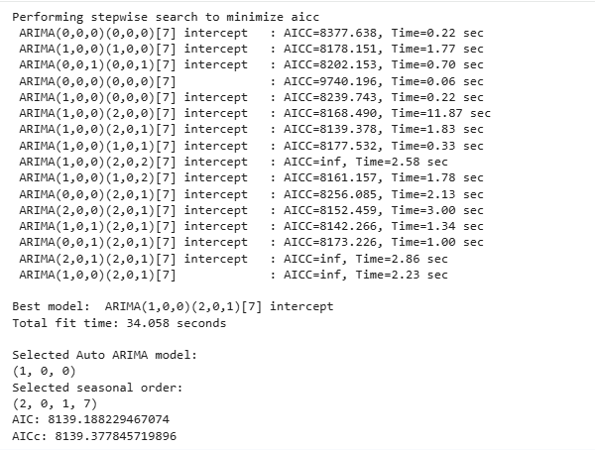

Figure 4.8: Auto-ARMIA model performance


Figure 4.9: Auto-ARMIA performance metrics

4.5.3 Decision Tree and Gradient Boosting
The Decision Tree results show that a more complex tree was not necessary for this forecasting problem. The best validation configuration was achieved with maximum depth of 3 and minimum leaf size of 10. It achieved a valid RMSE of 1,397.630. The RMSE for the corresponding test rose to 3,212.891. Even after this decline, the Decision Tree had a higher score on the last test period than the Auto ARIMA. The difference between validation and test performance also indicates that good validation performance does not necessarily yield the same performance at later observations. Gradient Boosting had the highest result in the initial test. The validation RMSE for the historical-only configuration was 1,184.334 while the test RMSE for the same configuration was 3,057.318. Its test R² was 0.279. Compared with the seasonal naïve benchmark this is a 23.94% decrease in RMSE. Gradient Boosting is thus the main winner of the test-period under the primary evaluation criterion of the study. Its outcome also illustrates the benefits of using historical sales data in conjunction with operational predictors. The result should not, however, be seen as a clear-cut distinction between the other advanced models. Only the LSTM with historical data obtained a test RMSE of 3,067.962. The difference is just around 10.64 RMSE units. Gradient Boosting achieved the lowest error, but its advantage was small.
The hyperparameter search using validation resulted in simple configurations for both the tree-based models. For the Decision Tree, the lowest validation RMSE of 1,397.630 was obtained with a maximum depth of 3. Minimum leaf size of 5 and 10 both gave an equal RMSE for validation and minimum leaf size of 10 was chosen as it was the more conservative configuration. The Gradient Boosting model (historical only) was run with a learning rate of 0.03, 200 estimators, maximum depth of 2 and minimum samples per leaf of 10. With this setting, the RMSE for validation was 1,184.334. The promoted Gradient Boosting model with learning rate of 0.10, 50 estimators, max depth of 2 and min samples/leaf of 10 resulted in a validation RMSE of 1,183.509. The results of the validation were therefore in favor of shallow trees over increased model complexity.

4.5.4 LSTM
The LSTM models used a 28-day sequence length to represent recent temporal behaviour. Input features and the target were scaled using information from the training period. Validation and test sequences were designed to preserve the full 97-day validation and test periods, by using historical boundary observations. Additionally, early stopping was employed to prevent overfitting and to avoid unnecessary training of the model. The test RMSE value for the final historical-only LSTM was 3,067.962. The promotion enriched version resulted in an RMSE of 3,072.466. Slightly better overall performance was thus obtained in the primary test period in the historical-only model. The addition of the LSTM results provides an additional qualification on model ranking. Despite the increased modelling complexity, the neural network did not clearly outperform the other two approaches (statistical approach and tree-based approach). The LSTM was quite close to the lowest primary test RMSE, with Gradient Boosting having the lowest. The results thus do not support an unconditional progression from more to more complex and more accurate forecasts. Rather, model performance seems to rely on the quality of the representation of the historical data in each approach. This finding strengthens the comparison across model families. It explains why it is more useful to have a common framework of evaluation based on chronology than to automatically take for granted that the more sophisticated is the better predictor.
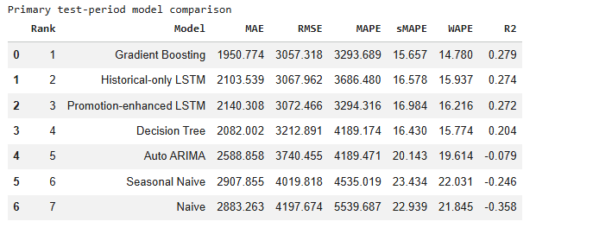

Figure 4.10: Test-period model comparison
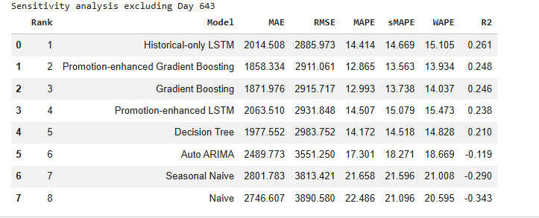

Figure 4.11: Sensitivity analysis excluding day 643

4.6 Promotion Ablation and Robustness Analysis
The promotion ablation results do not show a consistent forecasting benefit from adding lagged promotional information. The comparison was made with the same model structure and time period of evaluation. During the first test period, the Decision Tree RMSE was the same with and without the promotion features. Gradient Boosting also experienced a slight decline. Its RMSE increased from 3,057.318 to 3,078.385, representing a 0.69% increase. The LSTM showed a smaller deterioration. Its RMSE increased from 3,067.962 to 3,072.466, or approximately 0.15%. In each case, however, the promotion-enhanced model was not necessarily an improvement over the models that had been used historically.
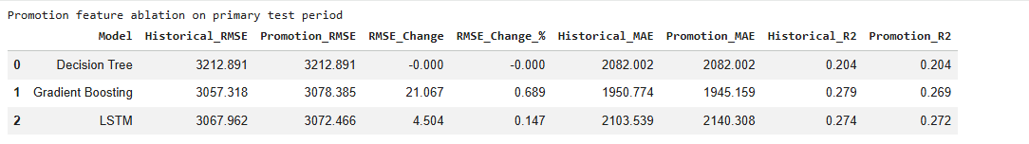

Figure 4.12: Promotion feature ablation on primary test period
Sensitivity analysis without Day 643 yields a slightly different answer, but does not affect the interpretation. Using Gradient Boosting with promotion, the RMSE was decreased from 2,915.717 to 2,911.061. The improvement was just a bit more than 0.16%. The LSTM, which was enhanced by promotions, went in the other direction. Its RMSE increased from 2,885.973 to 2,931.848, representing 1.59% deterioration. There were no changes in Decision Tree performance. These differences are minor compared to the errors in forecasting in the test period. The results, therefore, offer little consistent and significant evidence of the benefits of the available lagged promotional variables in daily aggregate sales forecasting. That doesn't mean sales are unaffected by promotions. It means only that the lagged promotion measures that were made available did not always have a predictive effect in the framework tested.
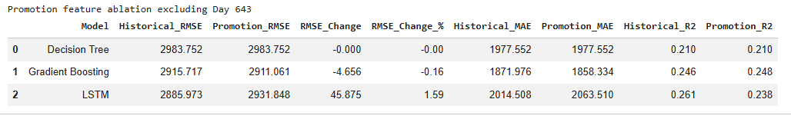

Figure 4.13: Promotion feature ablation excluding Day 643
Day 643 is an important robustness check as only 2.99 days worth of sales were recorded. The lack of coverage for the transactions resulted in a very high forecasting error for models that forecasted a normal level of transactions. This resulted in a strong distortion of MAPE, and also raised the RMSE. Removing the observation yielded more meaningful percentage errors in the model and altered the model ranking. The best model on the main test period was Gradient Boosting. The lowest RMSE was obtained by LSTM when the data from Day 643 was removed for which the value was 2,885.973. The outcomes are thus not definitive of the superior performance of Gradient Boosting overall. Indeed, the best results were obtained from Gradient Boosting under the conditions of the primary test period, and from the historical LSTM under the conditions of the sensitivity analysis excluding anomalies..

4.7 Overall Discussion
The findings show that the historical sales behaviour was the most important basis for forecasting the aggregate in this data set. The lagged correlations and weekly structure suggest that there was some information in past sales and operational activity that is useful for forecasting. The model comparison revealed lower RMSE values during the test period for the feature-based machine-learning models than for the simple persistence and statistical models. Gradient Boosting had the lowest RMSE value of 3,057.318 during the primary test period, an improvement of 23.94% over the Seasonal Naïve benchmark. However, the difference was not that substantial considering the historical-only LSTM's RMSE of 3,067.962. In the sensitivity analysis, the historical-only LSTM had the smallest RMSE for the remaining 642 days of 2,885.973. Promotional features were not shown to consistently improve the models. These results suggest that more complex models or extra predictors are not necessarily better at predicting. Instead, feature construction, chronological validation and robustness testing were important elements of the forecasting framework.
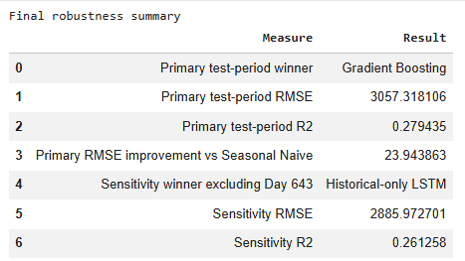

Figure 4.14: Robustness analysis

Chapter 5: Conclusion

5.1 Conclusions in Relation to the Research Objectives
The first objective focused on historical sales patterns and quantity, discounts, product activity, store activity and promotional information. The analysis revealed that there was evident temporal dependence in the daily sales. A correlation of 0.731 was found between previous day sales and today's sales. The correlation of lag-7 was higher at 0.752. Positive relationships were also seen for lags 14 and 28 with correlations of 0.741 and 0.726 respectively. Operational measures also had significant associations with subsequent sales. The results are consistent with the fact that there is historical information in retail demand within the dataset. They also rationalize the use of past sales and operating activity for forecasting.
The second objective was to understand the time-series structure of retail sales, and to examine the relationship between past and future observations. The Augmented Dickey-Fuller test provided evidence against a unit root in the original sales series. First differencing also resulted in a stationary series. More importantly, the different ACF retained a weekly pattern. The evidence was thus consistent with a seven day seasonal structure. The discovery were used to guide the Auto ARIMA specification as well as the weekly lag features in the machine-learning algorithms. The analysis demonstrates that temporal diagnostics were not treated as a separate descriptive exercise. They directly impacted the forecasting framework.
The third objective was to develop and compare Auto ARIMA, Decision Tree Regression, Gradient Boosting and LSTM models. The outcomes indicated that there were significant differences between the methods. Gradient Boosting had the lowest primary test RMSE value, which was 3,057.318. It achieved 23.94% improvement in RMSE when compared to the Seasonal Naïve model. The Decision Tree was also more effective on the test period compared to Auto ARIMA. The performance on the Seasonal Naïve model was further improved by 6.95% using Auto ARIMA, but still outperformed by the machine-learning models. The historical-only LSTM was close to Gradient Boosting, with a test RMSE of 3,067.962.
The fourth objective addressed feature engineering and prevention of temporal leakage. The study generated 30 historical forecasting features including sales lags, rolling behaviour, operational activity, discount activity and temporal structure. Models with promotion enhancement included five lagged promotional variables. There were shifts in sales values prior to the rolling calculations, and there were no current-day predictors. No leakage was seen in the final feature matrices in explicit checks. This offers a methodological contribution as the performance of the forecasts was tested with information available prior to the target day.
The fifth objective included comparing the models by using MAE, RMSE, MAPE and R². The findings show the need to focus on more than one indicator to get a full picture. Day 643 was actually a partial transaction-coverage day, as opposed to a typical low-sales day. It had actual daily sales of 2.99 which yielded very high percent error and significantly influenced the MAPE. Thus, the RMSE was used as a primary rank indicator, and MAE, sMAPE and WAPE and R² were used as supporting rank indicators. The rank was changed after the sensitivity analysis on day 643. Historically-only LSTM was the best model based on RMSE with 2885.973. The results thus depend on the period of the evaluation and on the treatment of the anomaly in coverage that has been identified and must not, therefore, be seen as a general indicator of model superiority.

5.2 Research Contribution
The study makes several contributions to the field of retail forecasting studies. One is that it affords a controlled comparison of various model families in a common forecasting environment. Forecasts published in the literature frequently differ in regard to datasets, aggregation levels and evaluation designs. Direct comparisons can therefore be difficult. The current research addresses this issue by comparing the performance of different statistical-based, machine-learning and deep-learning models on the same daily target, chronological split and evaluation measures. Secondly, the study demonstrates the importance of constructing leakage-safe forecasting features. The choice of the historical predictors was made explicitly using information prior to the forecast day. This is more methodologically controlled than just throwing in highly correlated variables in a forecasting model.
Third, the study considers promotional information as a subtractive assessment rather than making the assumption that more variables will result in better prediction. The models which were enhanced by promotions did not always perform better. Adding promotion features into the model resulted in a 0.69% increase in primary-test RMSE for Gradient Boosting. LSTM worsened by 0.15%. The performance of Decision Tree was not affected. Moreover, the robustness analysis adds value by separating unusual data coverage from genuine demand variation. Day 643 was not omitted from the primary analysis, but was retained. This was then separately tested without its inclusion.

5.3 Limitations
The results should be interpreted with the following limitations in mind. The first concerns temporal depth. The data spans 711 days, offering valuable information on variations within a day but not as extensive as needed for detailed long-term forecasting analysis. It is important to note that the results should not be extrapolated to longer forecasting periods without first examining the data. The second limitation is in the form of promotion coverage. The 115 stores in the promotional dataset had about 98.49% of the transaction sales, even though they contained only 115 of the 582 transaction stores. There was also only partial product level promotional coverage. Additionally, the coverage of products was limited. The potential contribution of promotion features may have been reduced due to the lack of consistent promotion information throughout the retail system.
A further limitation concerns the aggregation level. The goal was total sales, not product-store or household demand, per day. Aggregate forecasting is a way to simplify the prediction problem. It is also possible that it may mask patterns at more detailed levels. Lastly, the anomalies found in the incomplete transaction-coverage data indicate that some of the data recorded at the retail level may suffer from certain limitations in recording that are not necessarily due to true variations in demand.

5.4 Recommendations and Future Research
The study should be extended to the forecasting of product-stores in the future. Such a design could decide the usefulness of promotional information when the prediction target is nearer to the level of where promotions are applied. Also, richer representations of promotion could be explored in future research. Promotion type, duration, intensity and product-specific promotional exposure could be investigated in future research where reliable information is available. These variables may better reflect promotional circumstances than the overall activity rates in the current study.
More data would enable researchers to check for model stability over several seasons and retail scenarios. Additional forecasting horizons could also be examined. A multi-step forecast would give a better indication of the value of practical planning. Future studies might involve comparing the current models with more sophisticated boosting and sequence-based models and keeping the strict chronological validation.
The operational findings suggest that very few external predictors be added to the mix when more reliable historical sales and activity data exist. Promotional variables should be tested and not presumed to be beneficial for improving accuracy. Before drawing conclusions on model performance, data-quality monitoring should detect that the transactions are not fully covered. The strongest practical lesson is therefore not that one algorithm should always be selected. Representative data, leakage-safe predictors, and chronological testing and robustness checks should be used to evaluate forecasting systems.

References
Journals
Chen, X., Zhang, Y. and Wen, J.R., 2022. Measuring" why" in recommender systems: A comprehensive survey on the evaluation of explainable recommendation. arXiv preprint arXiv:2202.06466.
Dankorpho, P., 2024. Sales forecasting for retail business using xgboost algorithm. Journal of Computer Science and Technology Studies, 6(2), pp.136-141.
Deng, H., Zhou, Y., Wang, L. and Zhang, C., 2021. Ensemble learning for the early prediction of neonatal jaundice with genetic features. BMC medical informatics and decision making, 21(1), p.338.
Douaioui, K., Oucheikh, R., Benmoussa, O. and Mabrouki, C., 2024. Machine learning and deep learning models for demand forecasting in supply chain management: A critical review. Applied system innovation, 7(5), p.93.
Elahi, M., Kholgh, D.K., Kiarostami, M.S., Oussalah, M. and Saghari, S., 2023. Hybrid recommendation by incorporating the sentiment of product reviews. Information Sciences, 625, pp.738-756.
Ensafi, Y., Amin, S.H., Zhang, G. and Shah, B., 2022. Time-series forecasting of seasonal items sales using machine learning–A comparative analysis. International journal of information management data insights, 2(1), p.100058.
Falatouri, T., Darbanian, F., Brandtner, P. and Udokwu, C., 2022. Predictive analytics for demand forecasting–a comparison of SARIMA and LSTM in retail SCM. Procedia Computer Science, 200(2019), pp.993-1003.
Ganguly, P. and Mukherjee, I., 2024, October. Enhancing retail sales forecasting with optimized machine learning models. In 2024 4th International Conference on Sustainable Expert Systems (ICSES) (pp. 884-889). IEEE.
Hasan, M.R., Kabir, M.A., Shuvro, R.A. and Das, P., 2022. A comparative study on forecasting of retail sales. arXiv preprint arXiv:2203.06848.
Hobor, L., Brčić, M., Polutnik, L. and Kapetanović, A., 2026. Comparative analysis of modern machine learning models for retail sales forecasting. Croatian operational research review, 17(2), pp.0-0.
Islam, M.T., Ayon, E.H., Ghosh, B.P., Shahid, R., Rahman, S., Bhuiyan, M.S. and Nguyen, T.N., 2024. Revolutionizing retail: A hybrid machine learning approach for precision demand forecasting and strategic decision-making in global commerce. Journal of Computer Science and Technology Studies, 6(1), pp.33-39.
Makridakis, S. and Spiliotis, E., 2021. The M5 competition and the future of human expertise in forecasting. Foresight: The International Journal of Applied Forecasting, 60, pp.33-37.
Massaro, A., Panarese, A., Giannone, D. and Galiano, A., 2021. Augmented data and xgboost improvement for sales forecasting in the large-scale retail sector. Applied Sciences, 11(17), p.7793.
Mitra, A., Jain, A., Kishore, A. and Kumar, P., 2022, September. A comparative study of demand forecasting models for a multi-channel retail company: a novel hybrid machine learning approach. In Operations research forum (Vol. 3, No. 4, p. 58). Cham: Springer International Publishing.
Musto, C., De Gemmis, M., Semeraro, G. and Lops, P., 2017, August. A multi-criteria recommender system exploiting aspect-based sentiment analysis of users' reviews. In Proceedings of the eleventh ACM conference on recommender systems (pp. 321-325).
Ni, J., Li, J. and McAuley, J., 2019, November. Justifying recommendations using distantly-labeled reviews and fine-grained aspects. In Proceedings of the 2019 conference on empirical methods in natural language processing and the 9th international joint conference on natural language processing (EMNLP-IJCNLP) (pp. 188-197).
Osman, N.A., Mohd Noah, S.A., Darwich, M. and Mohd, M., 2021. Integrating contextual sentiment analysis in collaborative recommender systems. Plos one, 16(3), p.e0248695.
Padovese, B.T. and Padovese, L.R., 2019. A machine learning approach to the recognition of Brazilian Atlantic Forest Parrot species. bioRxiv, pp.2019-12.
Punia, S. and Shankar, S., 2022. Predictive analytics for demand forecasting: A deep learning-based decision support system. Knowledge-Based Systems, 258, p.109956.
Wang, J., Chong, W.K., Lin, J. and Hedenstierna, C.P.T., 2024. Retail demand forecasting using spatial-temporal gradient boosting methods. Journal of Computer Information Systems, 64(5), pp.652-664.
Wellens, A.P., Udenio, M. and Boute, R.N., 2022. Transfer learning for hierarchical forecasting: Reducing computational efforts of M5 winning methods. International Journal of Forecasting, 38(4), pp.1482-1491.
Xie, Z., Singh, S., McAuley, J. and Majumder, B.P., 2023, June. Factual and informative review generation for explainable recommendation. In Proceedings of the AAAI Conference on Artificial Intelligence (Vol. 37, No. 11, pp. 13816-13824).
Websites
grandviewresearch.com, 2024. Available at: https://www.grandviewresearch.com/industry-analysis/ai-retail-market-report[Accessed on: 22.08.2026]

Appendix

