AI BASED SALES FORECASTING IN RETAIL BUSINESSES

Table of Contents
1. Introduction 3
1.1 Background 3
1.2 Aim and Objectives 4
1.3 Research Question 5
1.4 Problem Statement 5
1.5 Rationale 5
1.6 Scope 6
1.7 Structure of Dissertation 7
2. Literature Review 8
2.1 Introduction 8
2.2 Development from Statistical Forecasting to AI-Based Forecasting 8
2.3 Statistical Models: ARIMA and SARIMA 10
2.4 Machine Learning for Retail Sales Forecasting 12
2.4.1 Decision Tree Approaches 12
2.4.2 Random Forest 13
2.4.3 Gradient Boosting, XGBoost and LightGBM 14
2.4.4 Computational Efficiency 15
2.5 Deep Learning and LSTM Forecasting 15
2.5.1 LSTM for Sequential Retail Demand 15
2.5.2 Evidence Supporting LSTM 15
2.5.3 Evidence against Neural Model Superiority 16
2.5.4 Implications for Model Comparison 17
2.6 Hybrid and Comparative Forecasting Approaches 17
2.6.1 Hybrid Approaches 17
2.6.2 Comparative Evidence and Conflicting Results 18
2.7 Feature Engineering and Information Used in Retail Forecasting 19
2.8 Critical Synthesis, Research Gaps and Position of the Current Study 20
References 22

List of Figures
Figure 1.1: The global artificial intelligence in retail market size was estimated at USD 11.61 billion in 2024 and is projected to reach USD 40.74 billion by 2030, growing at a CAGR of 23.0% from 2025 to 2030 6
Figure 1.2: Dissertation structure 9
Figure 2.1: Process of data analysis using ARIMA and SARIMA Models 13
Figure 2.2: Random Forest Algorithm architecture 16
Figure 2.3: Architecture of Gradient Boosting Decision Tree 16

List of Tables
Table 2.1: Evolution of Retail Sales Forecasting 12
Table 2.2: Retail Features Identified in the Literature 22
Table 2.3: Research Gaps and Response 24

1. Introduction

1.1 Background
Retailers have to make operating decisions before knowing future demand and that is where sales forecasting becomes an important component of retail planning. The forecasting problem is more complex if demand varies over time, and if multiple factors impact sales simultaneously. Patterns may be complicated by seasonality, promotions, shifts in buying patterns and product differences. Traditional statistical techniques are still significant because they still model the relationship between observations over time, as in the case of the ARIMA model. However, more recent studies have suggested that the more complicated nature of retail demand may require statistical models to be replaced. For instance, Falatouri et al. (2022) highlighted that the performance of the methods varied when predicting retail sales, in both accuracy and efficiency. Another approach to the problem comes from machine learning methods, as they can model the relationships between sales and explanatory variables that are nonlinear. To forecast large-scale retail sales, Massaro et al. (2021) used XGBoost and added promotional conditions and various parameters to the forecasting process. The results of their work showed that gradient boosting could be used when sales in the past weren't the only factor affecting retail sales. Likewise, studies of disaggregate retail forecasting have indicated that forecasting demand at product and store level is challenging because retailers have many products, stores and promotional activities. Gradient boosting techniques can use such diverse information sources and model the complex demand behaviour. Falatouri et al. (2022) evaluated SARIMA and LSTM with actual retail sales data and concluded that LSTM is efficient in predicting the actual demand for products having stable demand, while SARIMA is efficient in predicting the actual demand for products having seasonal behaviour. These researchers also discovered that their incorporation of promotional information (SARIMAX) enhanced their forecasting for products impacted by promotions.
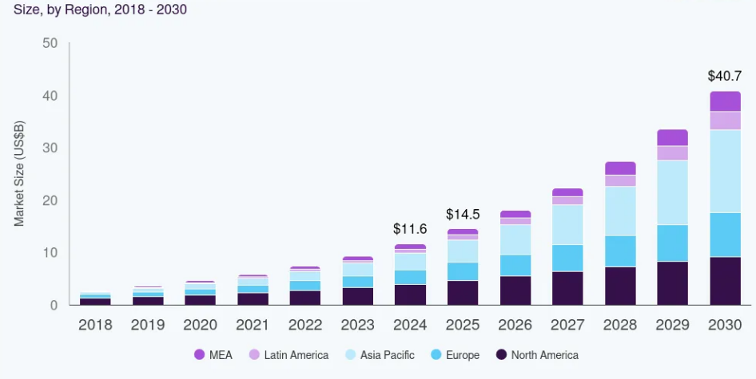

Figure 1.1: The global artificial intelligence in retail market size was estimated at USD 11.61 billion in 2024 and is projected to reach USD 40.74 billion by 2030, growing at a CAGR of 23.0% from 2025 to 2030
(Source: grandviewresearch.com, 2024)

1.2 Aim and Objectives
Aim
This study aims to create and compare statistical, machine learning and deep learning models for retail sales forecasting and find the most accurate model of future sales.
Objectives
- To investigate the historical patterns of sales, quantity, discounts, product features, store activity and promotional activity.
- To explore the time series characteristics of retail sales data and establish the relation between past sales and future sales.
- To develop a forecasting framework using Auto ARIMA, Decision Tree Regression, Gradient Boosting and LSTM.
- To engineer relevant forecasting features, including lagged sales, rolling averages and appropriate promotional variables while preventing future information from entering the training data.
- To evaluate and compare the forecasting models using MAE, RMSE, MAPE and R².

1.3 Research Question
RQ. What is the accuracy of Auto ARIMA, Decision Tree Regression, Gradient Boosting and LSTM in predicting future Retail Sales and which is most accurate?

1.4 Problem Statement
Forecasting retail sales is a modelling problem because there are no one-size-fits-all methods to be used. There may be trends and repeated time behavior in historical sales and other changes such as promotions, discounts, products and store conditions. A model that fits one type of demand pattern can thus yield poor performance if the demand structure shifts. This is illustrated in the recent literature. The study by Falatouri et al. (2022) revealed that there was a significant difference in the performance of the LSTM and SARIMA models depending on the product demand characteristics, and the promotional information enhanced the forecasts for some products. Further studies have been conducted on XGBoost, which have found that applying gradient boosting to forecast retail sales could be an improvement if historical sales and other explanatory variables are included.
One of the problems that this research aims to solve is how to identify the most suitable forecasting method to best capture the temporal and nonlinear evolution of retail sales. Instead of taking for granted that the statistical models, machine learning or deep learning models are better, the study will compare the different approaches in the same forecasting conditions.

1.5 Rationale
The study is justified because of the controversial results that have been reported in the recent literature on retail forecasting. The results have been found to be quite good with LSTM in several studies, while statistical or tree based models are found to be better in specific demand situations. For instance, Falatouri et al. (2022) noted that SARIMA was more successful for certain seasonal demand series, while LSTM was more effective for products with more stable demands. There are also studies that have found LightGBM to be more effective than LSTM using actual retail data, and XGBoost to improve over simpler forecasting methods in other studies. This gives the incentive to make comparisons of models instead of choosing a model before it is done. There is also three modelling principles included in the proposed comparison. Auto ARIMA is a statistical time-series forecasting method, Decision Tree and Gradient Boosting are machine learning methods, and LSTM is a deep learning method. A comparison of these approaches will indicate if the extra complexity that machine learning or deep learning bring to the table yields a meaningful improvement over a statistical benchmark.

1.6 Scope
The study will be focused on transaction data, product data, household data and promotional data. The sales distributions, quantity sold, discounts, store behaviour, product department, and pattern of sales over time will be explored. Transaction data will then be mapped into a time-series forecasting architecture, where a daily level of forecasting will be the primary level of forecasting and a weekly level of data will be used to analyze the more general patterns in sales. Lagged sales, rolling statistics and explanatory variables from the past will be added as feature engineering. A train-test design will be employed which is chronological, meaning that the models will be trained and not tested again on the same data later. The study will be based on comparing Auto ARIMA with Decision Tree Regression, Gradient Boosting and LSTM with MAE, RMSE, MAPE and R².
The study will not attempt a causal relationship between promotions and discounts/sales. These variables will be considered in terms of their usefulness for prediction. It will also not build a full inventory management system, or try to forecast what each customer will buy. The results will be an empirical comparison of the forecasting methods and a discussion of the best model for the problem of retail sales forecasting.

1.7 Structure of Dissertation

Figure 1.2: Dissertation structure

2. Literature Review

2.1 Introduction
The research in retail sales forecasting has shifted from models that rely solely on historical sales to ones that include promotions, product attributes, store data and complex time series. None of the reviewed studies has a clear overall recommendation for which of these approaches is most effective. SARIMA and LSTM models were found to be different based on the demand behaviour (Falatouri et al., 2022), and recent studies have shown high performance of Random Forest, XGBoost, LightGBM and other special boosting models. As such, model comparison in this study is motivated by the methodological uncertainty that has been identified in these developments.

2.2 Development from Statistical Forecasting to AI-Based Forecasting
The retail forecasting has evolved from sales history modeling to modeling broader retail information structure. This shift is reflected in the level of forecasting difficulties that have been encountered recently. There are multiple factors that sales can respond to. The importance of statistical forecasting is due to the fact that it incorporates temporal dependence directly. The ARIMA and SARIMA model patterns include autoregression, differencing and seasonality. SARIMAX is an extension of this structure which includes external variables. Despite the rise of machine learning, they are still in use in recent retail research, meaning statistical forecasting hasn't gone out of style.
However, the forecasting premise of machine learning is different. Tree-based models can learn the relations among sales and multiple predictors, which are not primarily tied to the inner structure of the sales sequence. The advantage of Decision Trees is that they have a relatively interpretable nonlinear structure, and the advantage of Random Forest is that it decreases the dependence of one fitted tree by ensemble learning. Gradient Boosting builds trees in turn and focuses subsequent learning on past prediction errors. The same goes for bigger structured data sets, as in XGBoost and LightGBM. Recent retail research shows that this change is worthwhile. The M5 winning solution involved LightGBM and retail, calendar and promo information. Hobor et al. (2026) give more recent evidence. The study included 446 stores, 46,841 SKU level daily series, and product, store, price, promotion and temporal information. They obtained the RMSE of their XGBoost model as 4.833.
One of the reasons for deep learning models, such as LSTM models, to be introduced to retail forecasting was the ability to have information from previous observations retained through a recurrent structure. This feature is useful when there are temporal relationships in demand patterns, not just immediate lags. The trend towards deep learning has, however, given rise to an open question and not a definitive answer. There is no compelling evidence that LSTM generally performs better than statistical or tree based techniques. Falatouri et al. (2022) discovered that the performance of the models varied depending on the characteristics of the products. Their findings showed that LSTM worked better for stable demand and SARIMA for seasonal demand. In addition, there were enhancements in the promotional information, which also aided in forecasting some products. Thus, retail forecasting can be considered as an expansion of modelling competencies instead of the substitution of one technique for the other. Temporal structure is represented by statistical models. Machine learning processes the nonlinear relationships among features. Deep learning is trying to learn complicated sequential relationships.
Forecasting approach | Main information used | Main strength | Main limitation | Relevance to current study
ARIMA/SARIMA | Historical sales | Captures temporal and seasonal structure | Limited representation of wider retail predictors | Statistical benchmark
Decision Tree | Historical and explanatory features | Nonlinear relationships and interpretability | Overfitting risk | Basic ML benchmark
Random Forest | Multiple explanatory features | Robust ensemble learning | Greater computational complexity | Evidence for tree-based methods
Gradient Boosting/XGBoost | Sales + retail predictors | Strong nonlinear prediction | Parameter tuning required | Main ML approach
LightGBM | Large-scale retail features | Efficient large-scale forecasting | More complex interpretation | Evidence from M5
LSTM | Sequential sales observations | Learns temporal dependencies | Computational complexity | Deep-learning comparison

Table 2.1: Evolution of Retail Sales Forecasting
(Source: Self-developed)

2.3 Statistical Models: ARIMA and SARIMA
The relevance of ARIMA is that information regarding their past behaviour is contained in the retail sales. Autoregressive terms: relationships with previous observations; non-stationary behaviour: differencing. The moving-averages terms include information from past forecast errors. SARIMA extends this to seasonal patterns as well that occur regularly. When there is a recognizable temporal behavior in the sales, this makes statistical modeling useful. When retail conditions are the same, their value becomes evident in research on forecasting. You need a statistical model, to set a benchmark that you can use to compare whether machine learning is actually a step up. If no such reference is provided, it is difficult to understand if a complex model would give a higher predictive accuracy. A good machine-learning performance can just be due to using more predictors, not necessarily to modelling the sales sequence itself.
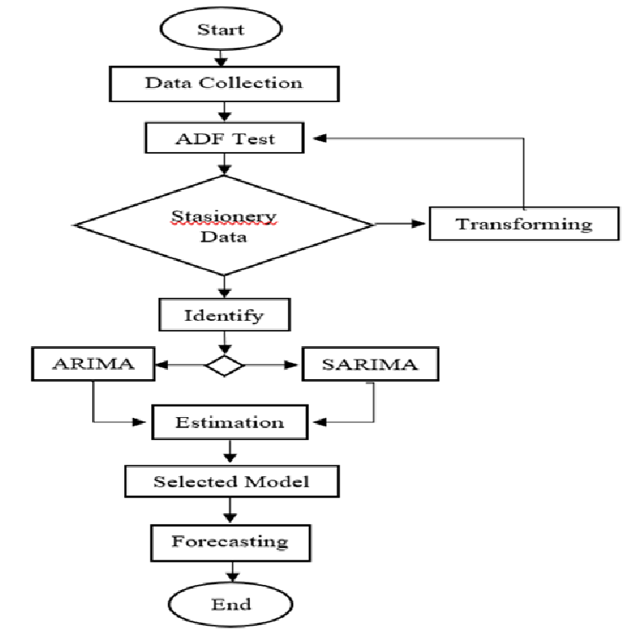

Figure 2.1: Process of data analysis using ARIMA and SARIMA Models
(Source: Hedi et al., 2022)
The assumption that newer methods have to replace statistical forecasts is challenged by Falatouri et al. (2022). They applied the retail demand data and investigated the performance of their study models: SARIMA, LSTM and SARIMAX. This depended on the nature of the demand behaviour. LSTM worked well for products with more stable demand, while SARIMA exhibited better performance for the products showing a seasonal behaviour. Promotional information also was included in the forecasting using SARIMAX, which improved forecasting for products that are influenced by promotional activity. This discovery is helpful to bring into the literature. The model could be effective if it is similar in time dimension to a specific product. In another model, the demand may be of another species. This casts doubt on LSTM's ability to outperform SARIMA. It, however, suggests that the choice of model should be based on the demand structure.
ARIMA and SARIMA, however, restrict the information structure compared to models of the machine-learning class that are subject of the present research. The strength of their core is based on the time series. Product characteristics, store activity, discounts and promotional conditions may also be included in retail forecasting. This information may include predictive signals which are not entirely embodied in the sales sequence of the past. These extra variables have been shown to be important in recent large-scale forecasting research. In addition to sales data, the M5 data contained price, promotion, calendar and special events data. Hobor et al (2026) also added product, store, price and promotion data to their forecasting model. The restriction is not ARIMA is not suitable for retail sales. The restriction is its scope of information that it can represent in the problem proposed for forecasting.
Auto ARIMA then has a specific role in the method in the present study. It will offer a statistic based on data and not a competing ‘old’ way. Its performance will demonstrate the degree of improvement using the framework of prediction from the temporal modelling stage to the nonlinear feature-based learning and sequential deep learning stage. This is significant when using the final results. Competitive performance of Auto ARIMA would suggest that the sales series has significant temporal structure that is not being better utilized by more complex models. If the two types of models make significantly fewer mistakes, the result would support that extra retail data or more flexible temporal representations would add predictive value. So, the complexity of the model is tested by comparison, but not by any measure assuming that complexity is the hallmark of progress.

2.4 Machine Learning for Retail Sales Forecasting
Machine learning has revolutionized the field of retail forecasting by enabling models to leverage multiple predictors in addition to historical sales. The dependence in the sales sequence is generally the only one that is captured in statistical models. Tree models can also be used to represent relationships between sales and retail conditions that are not linear. This is important if the demand is changing due to promotions and discounts, product changes and store changes. Recent research has demonstrated the effectiveness of Random Forest, XGBoost and LightGBM. However, their findings do not identify one universally superior method.

2.4.1 Decision Tree Approaches
One relatively straightforward way of forecasting retail nonlinearity is Decision Tree Regression. It can be used to model relationships between forecasting variables without assuming a linear relationship. This is suitable for retail data where sales can vary with any number of combinations of quantity, discount, product features and time. It is also easier to understand than more complicated models. But when it comes to an individual tree it can get very close to training observations. Overfitting is still a significant restriction, however. This has helped ease the difficulty in comparing Auto ARIMA with ensemble-based models in the context of machine learning in the present research. The comparison may suggest whether or not there is a meaningful added predictive gain with the added complexity of the ensemble.

2.4.2 Random Forest
Ensemble learning is used to mitigate some of the misspellings of the single tree in the Random Forest. Ganguly and Mukherjee (2024) have compared the performance of Random Forest with Gradient Boosting, Support Vector Regression and XGBoost. The best result they reported in their experiment was an R² of 0.945 from their optimised Random Forest. This discovery introduces a new conflict over the literature. In many retail experiments, XGBoost has shown to be successful, but it wasn't the best in this experiment. The study implies that it is not enough to determine model performance by algorithm. The ranking may be affected by the structure of the data set, the choice of features, and feature optimisation (or feature engineering).
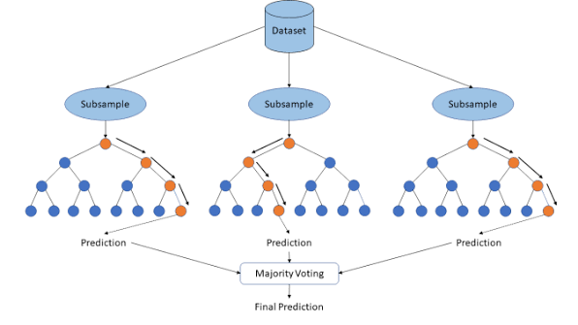

Figure 2.2: Random Forest Algorithm architecture
(Source: Padovese and Padovese, 2019)

2.4.3 Gradient Boosting, XGBoost and LightGBM
Gradient boosting builds the trees one by one, prior trees solve the errors of prior trees. This architecture enables boosted models to be used for complex relationships between sales and multiple predictors. This value has been shown by Massaro et al. (2021), using XGBoost and promotional and other retail data. Their research shows that historical sales data and other variables related to demand can be of assistance in forecasting. There is also recent evidence that supports this. Using XGBoost, Dankorpho (2024) found a 29.23% decrease in MAE and a 34.54% decrease in RMSE in comparison to the original forecasting method. The M5 competition is another example of importance. Its winning accuracy applied to LightGBM on various hierarchy levels in retail and added price, promotions and calendar features.
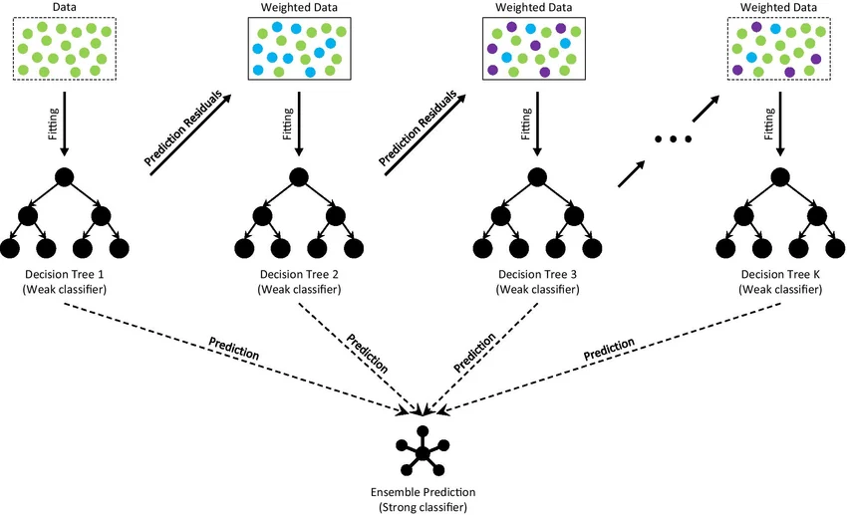

Figure 2.3: Architecture of Gradient Boosting Decision Tree
(Source: Dend et al., 2021)
More recent evidence is relevant and is provided by Hobor et al. (2026). They had 46,841 SKU-level series for 446 stores and product, store, price and promotional data. XGBoost also did the best job for this data set with an RMSE of 4.833 and beat the assessed neural methods in their configuration. This result is not a proof of the superiority of XGBoost. Optimised Random Forest gave better performance as reported by Ganguly and Mukherjee (2024). The conflicting results suggest that the outcome of these models varies with the behaviour of the demand, the features available to the experimental design, and other factors.

2.4.4 Computational Efficiency
There are other factors to consider when evaluating forecasting models that don't measure accuracy. Wellens et al. (2022) studied computational efficiency in M5 forecasting context. By using their transfer-learning techniques, they were able to save about 23.16–26.35% training time compared to the original recursive LightGBM approach and keep the forecasting accuracy close to the original approach. This discovery brings a new facet to model comparisons. A complicated model can give a more accurate result, but need significantly more computing power. While the main interest of the present study lies in predictive performance, computational complexity is also an issue when determining whether a model is viable compared with simpler models.

2.5 Deep Learning and LSTM Forecasting

2.5.1 LSTM for Sequential Retail Demand
Deep learning has opened the door to new types of models for retail forecasting. The relevance to LSTMs is because the sales observations are an ordered sequence. Demand information can be included in earlier observations. The purpose of LSTM is to remember important information from one time step to the next. This skill makes it useful when the relationships between events or objects are not just those that are immediately observed, but also those that are temporally related. The strength of LSTM is not just that it is an improved algorithm, but that it also has the ability to represent sequential dependence. However, there are mixed findings in the literature. LSTM has been found to work well in certain situations of demand, but recent studies indicate its universal superiority over statistical or tree-based techniques is not proven.

2.5.2 Evidence Supporting LSTM
Falatouri et al. (2022) present evidence on the conditional performance of LSTM. Their research experiment involved comparing the performance of SARIMA, LSTM and SARIMAX, all on retail demand data. LSTM has proven to be useful for products that have relatively stable demand. SARIMA was more powerful when products exhibited seasonal characteristics. Forecasts of products affected by promotions were also improved by the inclusion of promotional information in SARIMAX. The results are surprising and contradict the notion that it is not necessary to replace statistical forecasting with recurrent neural networks. This, however, suggests that the suitability of the model is related to the demand characteristics. A model with a stable sequential behaviour may not have the same benefit in the case where there is strong seasonal influence.
There is additional support from the wider literature for exploring the use of deep learning within retail forecasting. Ensafi et al. (2022) investigated various forecasting methods and showed that deep-learning models can be performant even in the presence of complex patterns in the demand. Besides, Punia and Shankar (2022) place deep learning in retail forecasting for decision-support. The exercise they do supports the need to learn complex demand relationships for business forecasting. These studies should be considered in conjunction with others in which different families of models are more successful, however. Thus, the literature demonstrates that LSTM has been a valid forecasting method as rather than a known optimal method.

2.5.3 Evidence against Neural Model Superiority
Hobor et al. (2026) give especially compelling evidence to resist the assumption of neural superiority. They had set up a large-scale retail experiment with 446 stores and 46,841 SKU series, comparing the tree-based and neural forecasting models. In their retail environment, the authors were able to show that localized tree-based methods performed better than the neural architectures that they tested, with XGBoost having an RMSE of 4.833. The finding is important due to the large retail complexity in the data set. It proposes that structured features can be carefully designed to give good predictive information without needing a recurrent architecture.
However, Wang et al. (2024), offer another counter-argument to the notion that temporal information is naturally suited for LSTM. They compared their spatial-temporal gradient boosting method with three other methods, namely, ARIMA, LSTM, GBDT, and XGBoost. The optimum ST-GBT configuration that achieved the lowest MAE was 5.641, RMSE 11.358 and MASE 0.587. It thus achieves better results than LSTM and traditional boosting methods in their experiments. This discovery indicates that temporal dependence doesn't always need to be deep learning. Also, when the forecasting design reflects the temporal information, tree-based methods can incorporate it.

2.5.4 Implications for Model Comparison
Although LSTM presents an effective way of learning temporal dependencies, the extra complexity of the network does not necessarily mean it can produce more accurate predictions. Recently, there have been indications of a more contingent interpretation. In some cases, retail data may include structured information like promotions, price, store attributes, and engineered temporal features, which can benefit tree-based models. However, LSTM is still significant due to its recurrent structure, which allows it to capture sequential dependencies. Hence, it is hardly surprising that its incorporation into the current study enables them to compare the value of learned temporal representation directly with the performance of Auto ARIMA, Decision Tree Regression and Gradient Boosting under the same forecasting conditions.

2.6 Hybrid and Comparative Forecasting Approaches

2.6.1 Hybrid Approaches
The past few years, research in retail forecasting has turned to ensemble methods and hybrid methods rather than simply comparing different models. The rationale behind this is that the type of algorithm reflects the type of demand characteristics. Tree-based models can represent a nonlinear relationship between predictors; neural networks can represent more complex patterns. These attributes may then convey more power when forecasts are based on a combination of these properties, rather than solely on one model. Mitra et al. (2022) studied the Random Forest, XGBoost, Gradient Boosting, AdaBoost and Artificial Neural Networks along with the hybrid approaches. In their research they found that the combination of the model capabilities can achieve competitive forecasting performance. These results cast doubt on the notion that there are only two mutually exclusive model families.
Islam et al. (2024) offer some newer evidence by comparing Random Forest, XGBoost, Gradient Boosting, AdaBoost, ANN and a hybrid model of Random Forest, XGBoost and LR. The hybrid model was reported as having an R² of 0.9651. The result indicates that it is possible to increase the amount of variance accounted for by the model by merging several predictive structures. The paper however reports an inconsistency in the reported MSE value. This report corresponds to an MSE of 4.89 × 10⁻⁴ for the hybrid model and 4.72 × 10⁻⁵ for XGBoost. But the hybrid model is still the stronger model, but with a numerically bigger MSE. This is a deficiency that weakens the evidentiary support and conveys the importance that model results be viewed by multiple metrics.

2.6.2 Comparative Evidence and Conflicting Results
There is more evidence in the wider literature for comparison than for a universal model hierarchy. Hasan et al. (2022) showed that SARIMA and LSTM were different in terms of the demand characteristics. However, Massaro et al. (2021) showed that adding other explanatory variables such as promotions yields significant benefits of using XGBoost. Ganguly and Mukherjee (2024) achieved an R² of 0.945 with optimised Random Forest, which was better than the other models tested by them. In comparison, Dankorpho (2024) observed significant gains using XGBoost, and their MAE decreased by 29.23%, while their RMSE reduced by 34.54%.
This is further confirmed by more recent studies. Their spatial-temporal gradient boosting approach was better than the other models used, including ARIMA, LSTM, GBDT and XGBoost, with the best performing configuration having an RMSE of 11.358. This is well similar to Hobor et al. (2026) who also determined that XGBoost performed best in their large-scale retail comparison, with an RMSE of 4.833. The M5 competition is another sign of the success of LightGBM in large scale retail forecasts.
Analytically, it is significant that these studies disagree. They have different data sets and have different structures. They also have different forecasting horizons, levels of aggregation and predictor variables. There are studies that predict products per person and others that work at store or hierarchical product level. Therefore, the performance results in the literature cannot be used to draw conclusions about the universal ranking of ARIMA, tree-based learning and LSTM. The question isn't really about which algorithm seems to be the most promising in the literature, however. It's about whether a specific model is best when tested against each other under the same conditions. This uncertainty can be alleviated by conducting a controlled comparison on the same dataset, forecasting the same target, the same chronological test period and evaluation measures.

2.7 Feature Engineering and Information Used in Retail Forecasting
Feature engineering is significant as retail forecasting relies on current demand, in addition to longer-term sales dynamics. Hobor et al. (2026) added lags up to weekly, monthly and yearly rolling statistics. These provide a way for a model to capture recent demand and still have larger time-related trends. Another source of predictive information is through promotional information. For products that affect promotional activity, Falatouri et al (2022) showed that the promotion variables were effective as predictive factors. The incorporation of promotional conditions in forecasting procedures has also been introduced by Massaro et al. (2021) in the context of the XGBoost model. The Dunnhumby data contains a number of useful variables, such as RETAIL_DISC, COUPON_DISC, COUPON_MATCH_DISC and details about the campaign. These variables are thus suitable to be evaluated for their predictive contribution. The inclusion of these does not mean and should not be interpreted as a causal relationship with sales.
Feature category | Examples | Evidence in literature | Role in current study
Historical sales | Lag 1, 7, 28 | Hobor et al. | Forecasting features
Rolling demand | Weekly/monthly averages | Hobor et al. | Smooth short-term variation
Promotions | Campaigns, promotion indicators | Falatouri; Massaro | Predictive variables
Discounts | Retail/coupon discounts | Retail studies | Predictive variables
Product | Department, category, SKU | Hobor et al. | Product-level context
Store | Store characteristics | Hobor et al. | Store-level context
Calendar | Day, week, season | M5/Hobor | Temporal features

Table 2.2: Retail Features Identified in the Literature
(Source: Self-developed)

2.8 Critical Synthesis, Research Gaps and Position of the Current Study
Recent studies show that there is a lot of progress in retail sales forecasting, but no clear one that is superior. Falatouri et al. (2022) concluded that the SARIMA model yielded good results for the seasonal demand and the LSTM model for relatively stable demands. Ganguly and Mukherjee (2024) reported an R² of 0.945 for optimised Random Forest; Dankorpho (2024) reported significant improvement of XGBoost. Hobor et al. [2026] concluded that XGBoost is their best model, and Wang et al. [2026] reported that the ST-GB model performed the best among the models, which includes ARIMA, LSTM and conventional XGBoost. The conflicting results show that the forecasting performance is related to the nature of each retail problem.
The second gap is related to the comparability of the published results. Different data sets, forecasting horizons, ways of aggregation, predictors and evaluation procedures are used for different studies. Some studies employ considerably different store configurations, such as Hobor et al. (2026), which accounted for 46,841 SKU-level series in 446 stores. So, if a child performs well in one context, it is not a guarantee of their performance in another. Other treatment is also given to temporal and explanatory information in literature. Prediction can be further improved using promotions, product characteristics, store characteristics and store prices; however, their contribution may differ depending on the level of demand.
Another issue is that of comparing the model families fairly. There are multiple studies that use various error measures and train-test designs. Therefore, it will be hard to compare the numbers directly. This work is relevant to this question, as it is based on the same Dunnhumby data set, target, test period and assessment metrics and utilizes a controlled experiment. The four algorithms (Auto ARIMA, Decision Tree Regression, Gradient Boosting and LSTM) will be compared under the same set of conditions. It is not the intent of this study to suggest that AI or deep learning will be superior to statistical forecasting. Rather, it's an investigation of whether the additional flexibility in modelling yields a tangible forecasting benefit in a uniform retail setting.
Identified gap | Evidence from literature | Response in current study
No consistent model winner | Different studies report SARIMA, LSTM, RF, XGBoost and ST-GBT as strongest | Compare four model families
Studies use different datasets | Retail datasets vary in scale and structure | Use one consistent Dunnhumby dataset
Different evaluation procedures | MAE, RMSE, MAPE, MASE and R² used inconsistently | Use common evaluation measures
Different forecasting structures | Product, store and aggregate levels vary | Establish a defined daily forecasting target
Temporal leakage risk | Future information can enter feature construction | Use chronological train-test split
Promotional effects vary | Promotion improves some forecasts but not universally | Test promotional variables for predictive value
Model complexity may not improve accuracy | Tree models sometimes outperform neural models | Compare accuracy against model complexity

Table 2.3: Research Gaps and Response
(Source: Self-developed)

References
Journals
Chen, X., Zhang, Y. and Wen, J.R., 2022. Measuring" why" in recommender systems: A comprehensive survey on the evaluation of explainable recommendation. arXiv preprint arXiv:2202.06466.
Dankorpho, P., 2024. Sales forecasting for retail business using xgboost algorithm. Journal of Computer Science and Technology Studies, 6(2), pp.136-141.
Deng, H., Zhou, Y., Wang, L. and Zhang, C., 2021. Ensemble learning for the early prediction of neonatal jaundice with genetic features. BMC medical informatics and decision making, 21(1), p.338.
Douaioui, K., Oucheikh, R., Benmoussa, O. and Mabrouki, C., 2024. Machine learning and deep learning models for demand forecasting in supply chain management: A critical review. Applied system innovation, 7(5), p.93.
Elahi, M., Kholgh, D.K., Kiarostami, M.S., Oussalah, M. and Saghari, S., 2023. Hybrid recommendation by incorporating the sentiment of product reviews. Information Sciences, 625, pp.738-756.
Ensafi, Y., Amin, S.H., Zhang, G. and Shah, B., 2022. Time-series forecasting of seasonal items sales using machine learning–A comparative analysis. International journal of information management data insights, 2(1), p.100058.
Falatouri, T., Darbanian, F., Brandtner, P. and Udokwu, C., 2022. Predictive analytics for demand forecasting–a comparison of SARIMA and LSTM in retail SCM. Procedia Computer Science, 200(2019), pp.993-1003.
Ganguly, P. and Mukherjee, I., 2024, October. Enhancing retail sales forecasting with optimized machine learning models. In 2024 4th International Conference on Sustainable Expert Systems (ICSES) (pp. 884-889). IEEE.
Hasan, M.R., Kabir, M.A., Shuvro, R.A. and Das, P., 2022. A comparative study on forecasting of retail sales. arXiv preprint arXiv:2203.06848.
Hobor, L., Brčić, M., Polutnik, L. and Kapetanović, A., 2026. Comparative analysis of modern machine learning models for retail sales forecasting. Croatian operational research review, 17(2), pp.0-0.
Islam, M.T., Ayon, E.H., Ghosh, B.P., Shahid, R., Rahman, S., Bhuiyan, M.S. and Nguyen, T.N., 2024. Revolutionizing retail: A hybrid machine learning approach for precision demand forecasting and strategic decision-making in global commerce. Journal of Computer Science and Technology Studies, 6(1), pp.33-39.
Makridakis, S. and Spiliotis, E., 2021. The M5 competition and the future of human expertise in forecasting. Foresight: The International Journal of Applied Forecasting, 60, pp.33-37.
Massaro, A., Panarese, A., Giannone, D. and Galiano, A., 2021. Augmented data and xgboost improvement for sales forecasting in the large-scale retail sector. Applied Sciences, 11(17), p.7793.
Mitra, A., Jain, A., Kishore, A. and Kumar, P., 2022, September. A comparative study of demand forecasting models for a multi-channel retail company: a novel hybrid machine learning approach. In Operations research forum (Vol. 3, No. 4, p. 58). Cham: Springer International Publishing.
Musto, C., De Gemmis, M., Semeraro, G. and Lops, P., 2017, August. A multi-criteria recommender system exploiting aspect-based sentiment analysis of users' reviews. In Proceedings of the eleventh ACM conference on recommender systems (pp. 321-325).
Ni, J., Li, J. and McAuley, J., 2019, November. Justifying recommendations using distantly-labeled reviews and fine-grained aspects. In Proceedings of the 2019 conference on empirical methods in natural language processing and the 9th international joint conference on natural language processing (EMNLP-IJCNLP) (pp. 188-197).
Osman, N.A., Mohd Noah, S.A., Darwich, M. and Mohd, M., 2021. Integrating contextual sentiment analysis in collaborative recommender systems. Plos one, 16(3), p.e0248695.
Padovese, B.T. and Padovese, L.R., 2019. A machine learning approach to the recognition of Brazilian Atlantic Forest Parrot species. bioRxiv, pp.2019-12.
Punia, S. and Shankar, S., 2022. Predictive analytics for demand forecasting: A deep learning-based decision support system. Knowledge-Based Systems, 258, p.109956.
Wang, J., Chong, W.K., Lin, J. and Hedenstierna, C.P.T., 2024. Retail demand forecasting using spatial-temporal gradient boosting methods. Journal of Computer Information Systems, 64(5), pp.652-664.
Wellens, A.P., Udenio, M. and Boute, R.N., 2022. Transfer learning for hierarchical forecasting: Reducing computational efforts of M5 winning methods. International Journal of Forecasting, 38(4), pp.1482-1491.
Xie, Z., Singh, S., McAuley, J. and Majumder, B.P., 2023, June. Factual and informative review generation for explainable recommendation. In Proceedings of the AAAI Conference on Artificial Intelligence (Vol. 37, No. 11, pp. 13816-13824).
Websites
grandviewresearch.com, 2024. Available at: https://www.grandviewresearch.com/industry-analysis/ai-retail-market-report[Accessed on: 22.08.2026]

