At first you need to create database with name master_project after creating database you can import master_project.sql file in the database and this file under the database folder.

You can change database name , username, password and server in the db.php file.

Home page

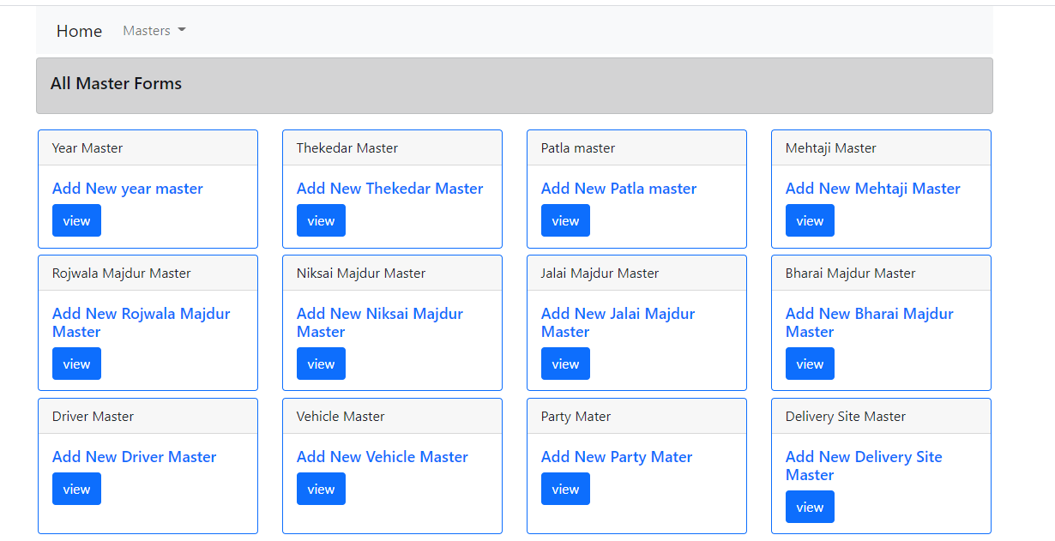

Click masters in navbar

All masters pages

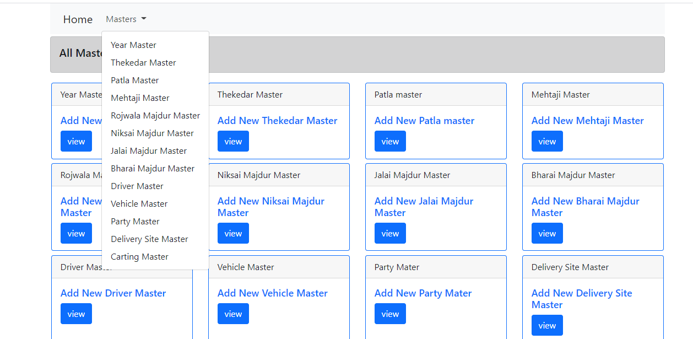

And also you click view button for add new master or update or delete and showing all details .

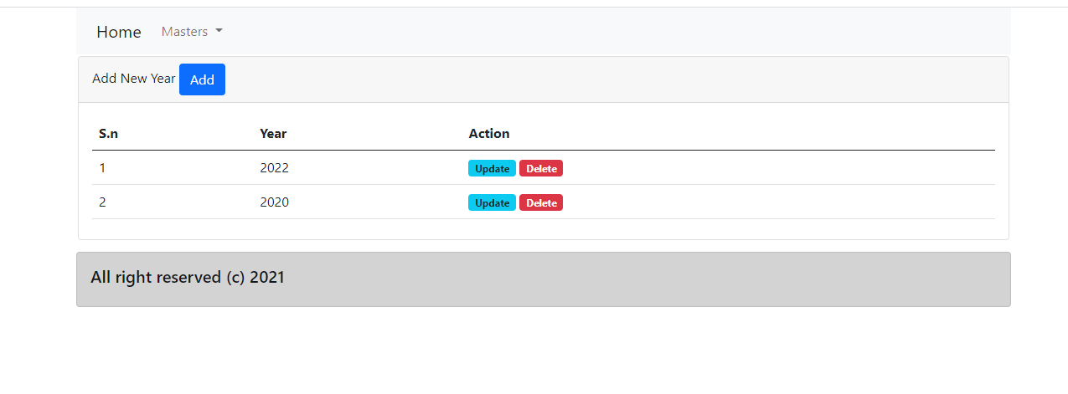

Add new master click add button for add new details

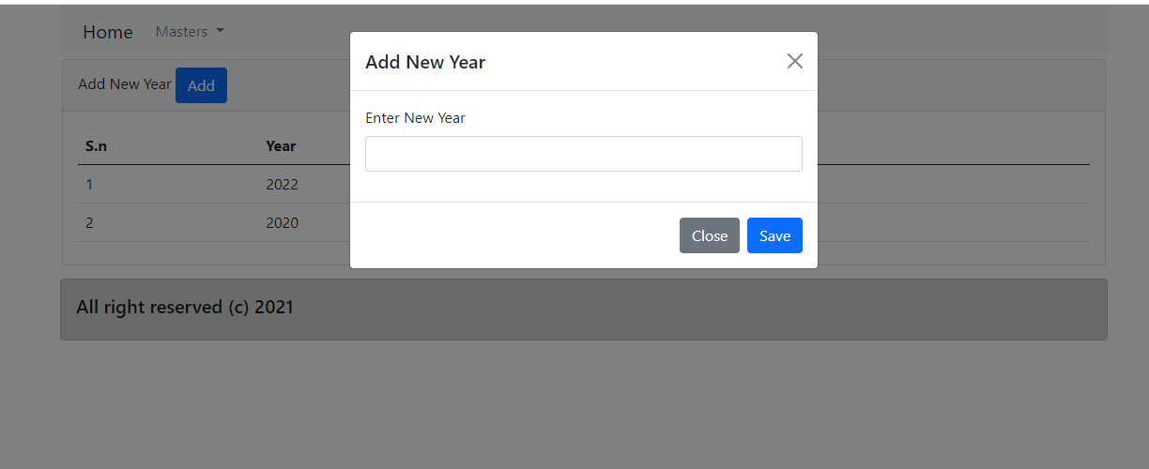

After adding new details , you can update or delete the details



delete

update