Bricks Sales Form

1. At first you need to create database with name master_project.
2. And than import master_project (1) sql file
3. Home page

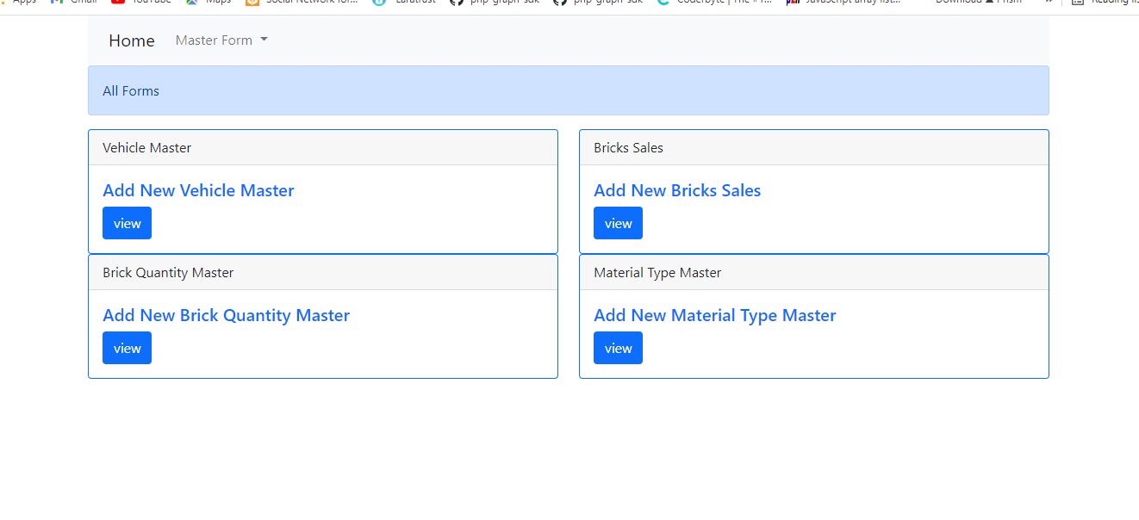

Click master form menu in menubar

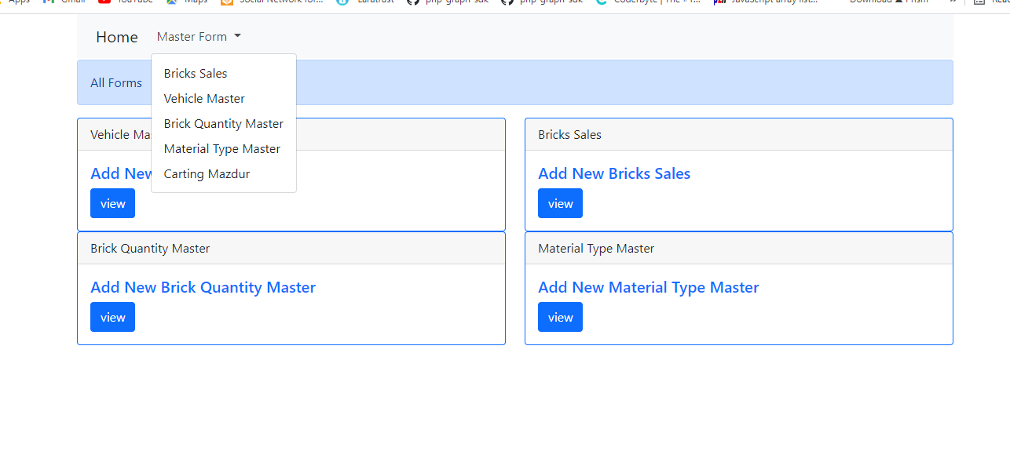

Click any of master form menu options

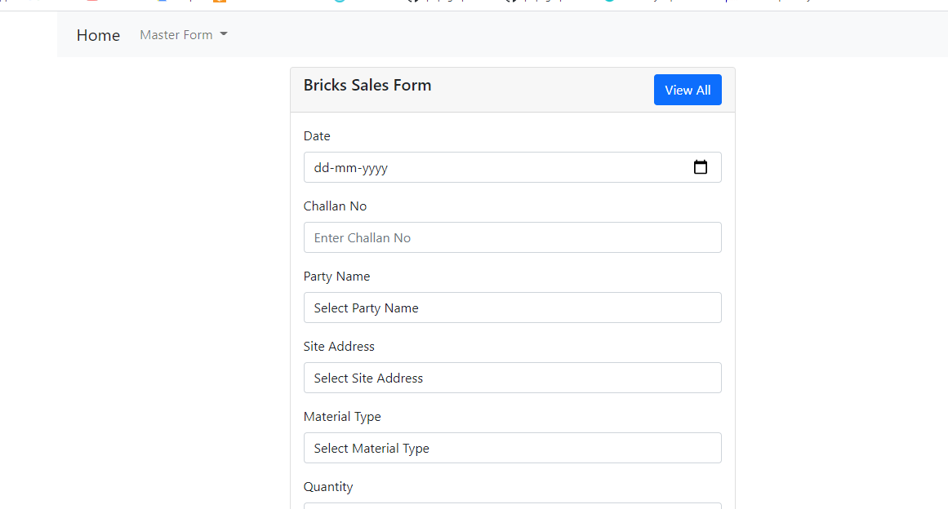

Add new record and after submitted data you can check submitted data simply click view all option in right site of the form

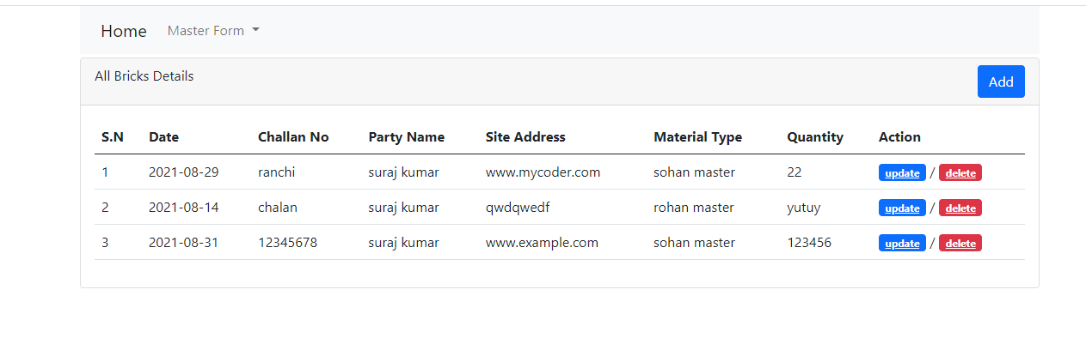

You can update or delete simply clicking update or delete button.