Renal Project

Login page

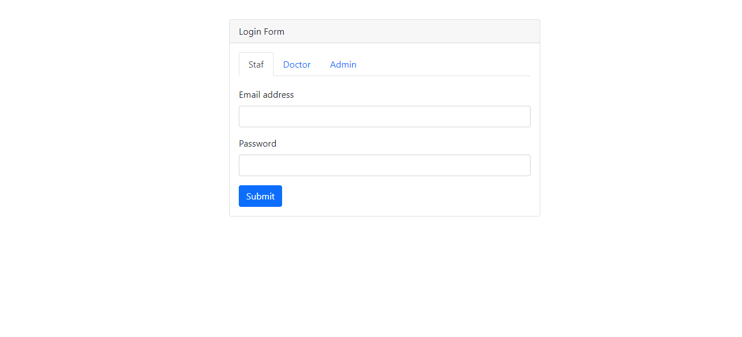

This is the login page where staf , doctor and admin can login .

Admin dashboard

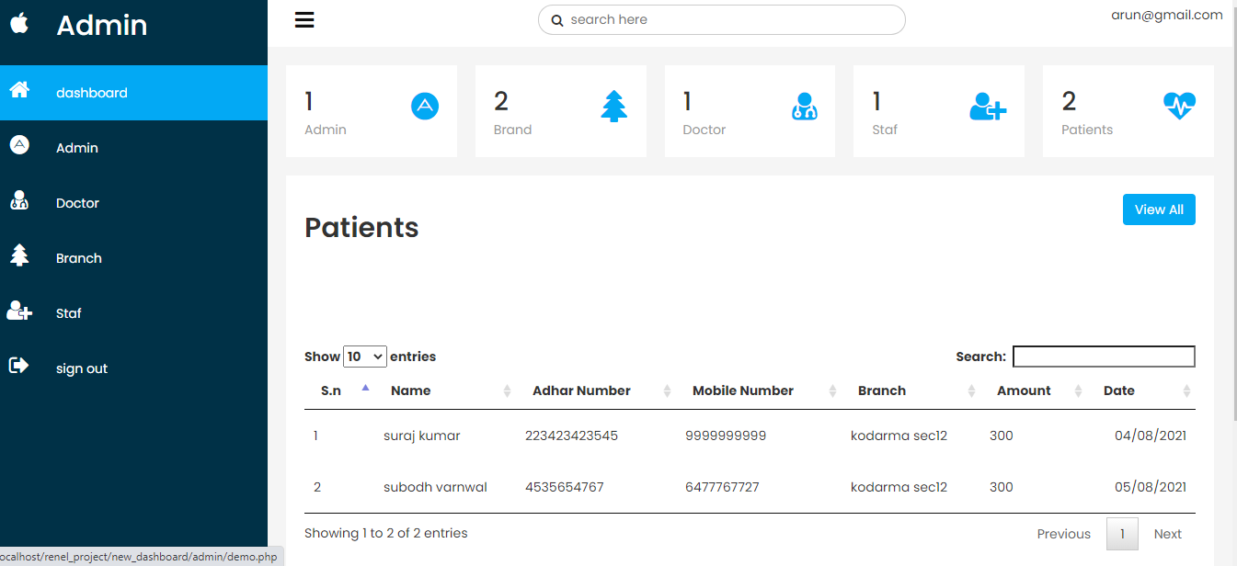

This is admin dashboard , there are some menus.

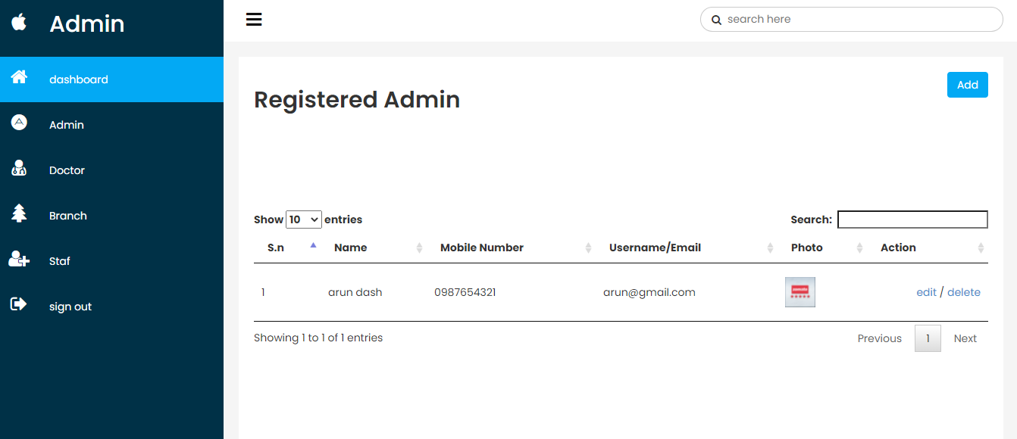

This is admin section , where admin can create new admin simiply click to add button and also you can edit details of registered admin or want to delete.

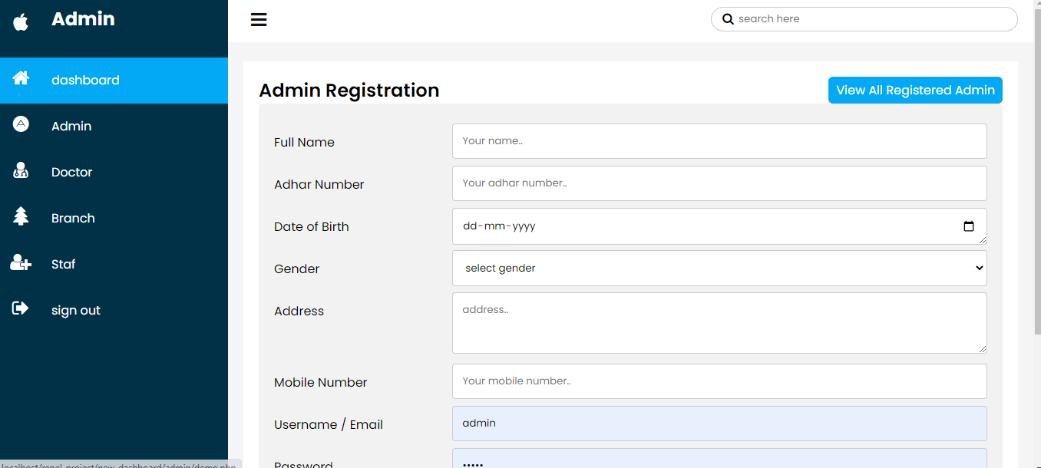

This is the section where you can add new admin.

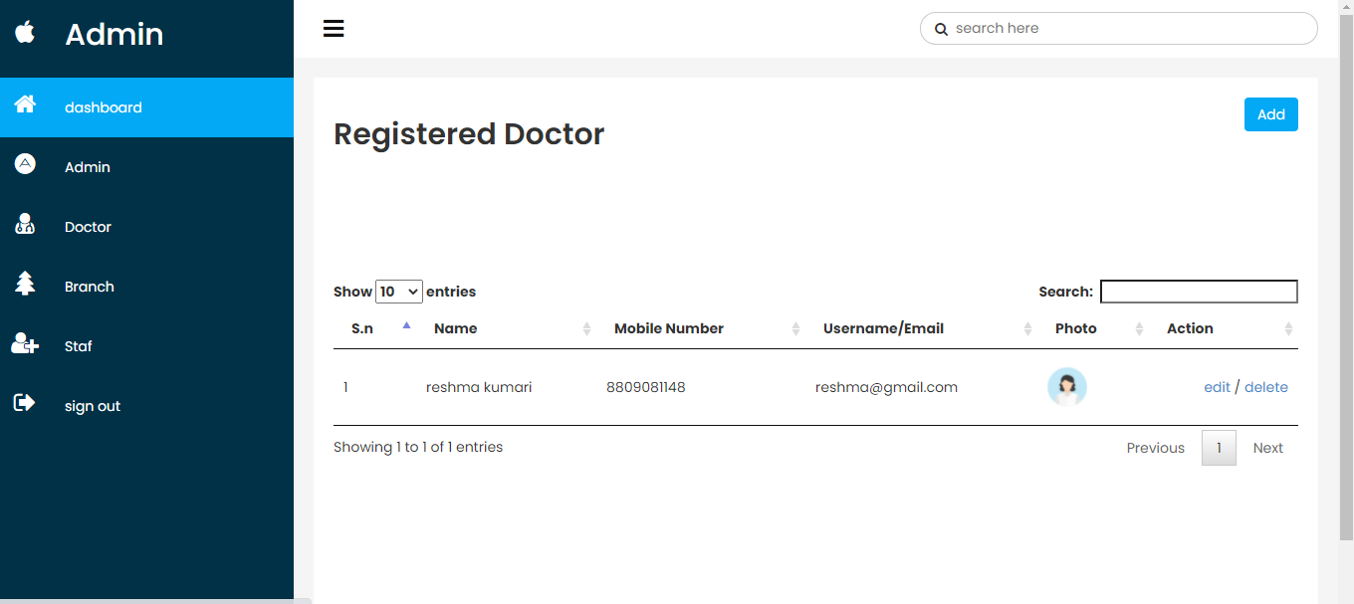

This is the doctor section where you can add new doctor and also you can edit or delete the details of doctor.

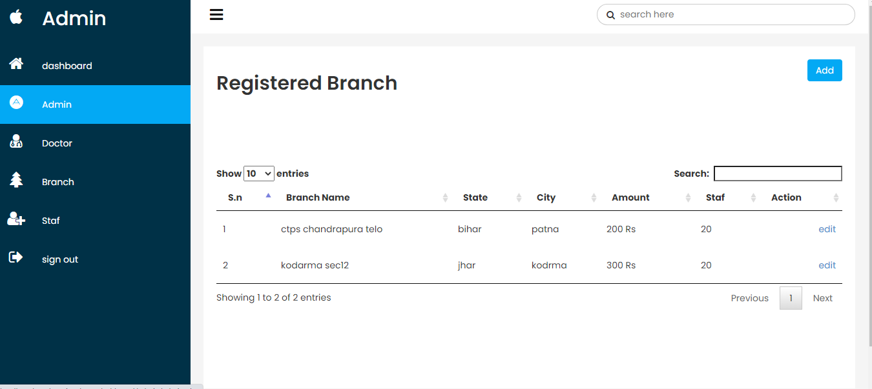

This is the branch section where you can create new branch by simply clicking add button and also you edit the details of branch .

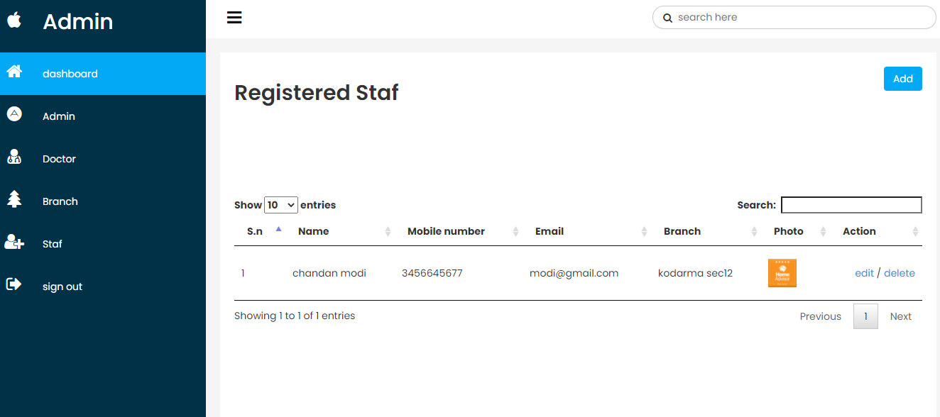

This is the staf section where you can registered new staf and also you can edit or delete the details of staf.

Staf Dashboard

after login

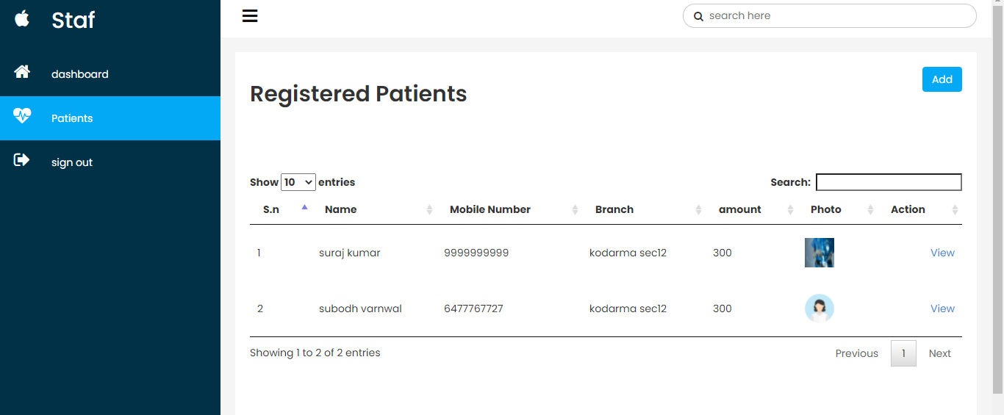

This is staf dashboard , where you can add new patient according to there branch simply clicking add button and you can view all details of patients.

After registration for patients staf can only see the details .

And after all work done you can logout .

Doctor Section

After login

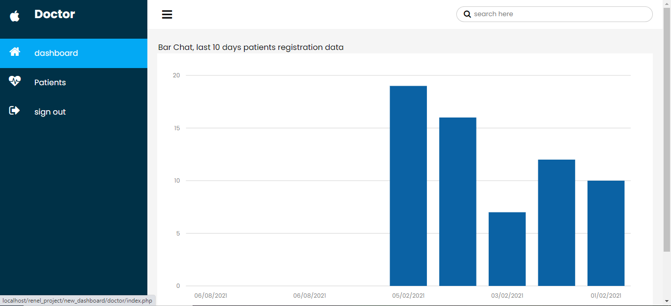

**This is doctor section where doctor can see the last 10 days patient registration graph .**

**Simply move the cursor over the bar chat it display the total number registered patient in the givien date.**

**This is simple bar chat that everyone can easily understand the details shown by the chat .**

**Note:- at first you create database with name renal_project and import the sql file**

**And login as a admin**

**Username:-** [**arun@gmail.com**](mailto:arun@gmail.com)

**Password:- 12345**

**Login and create doctor , branch, staf as you want check the all functionality that you want , I tried full fill all your requirement that you mention in the assessment .**

**If you give me the change to do your work than I can add more functionality that full fill your requirement.**