Documentation

1. At first you need to create database.
2. Second set the database configuration like database name , server, username, password in the db.php file.
3. Third import the project1.sql file in database which is in the database folder.

Now run the project

Index.html

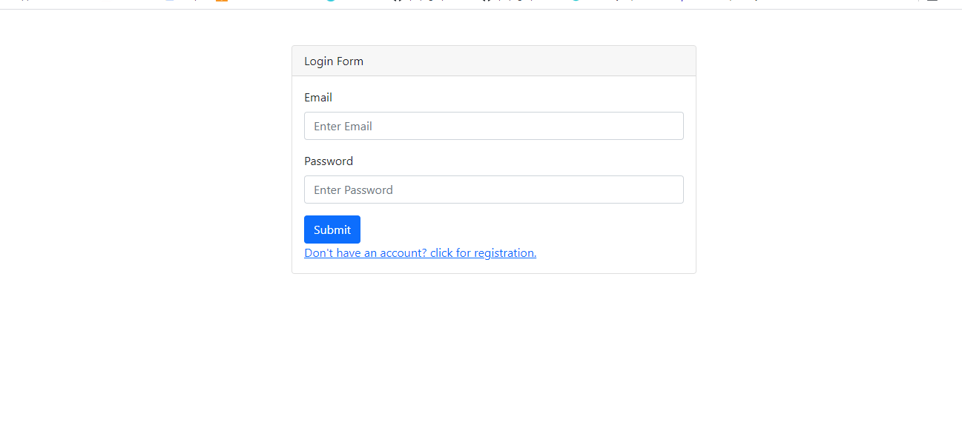

This is the login page where you can login with email and password but first you need to register by clicking ([Don't have an account? click for registration.](http://localhost/practiced/sk_info/registration.html)) it will redirect to registration page.

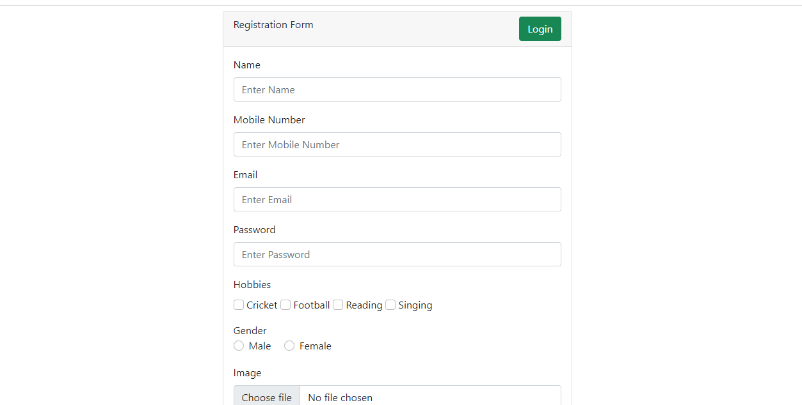

This is the registration page where you can register . in this form image uploaded with extention (jpg, jpeg and png) type not other images are uploaded.

And also click login button in the top right corner and I will redirect to login page.

After login

You will redirect to the dashboard page where you can see the all details .

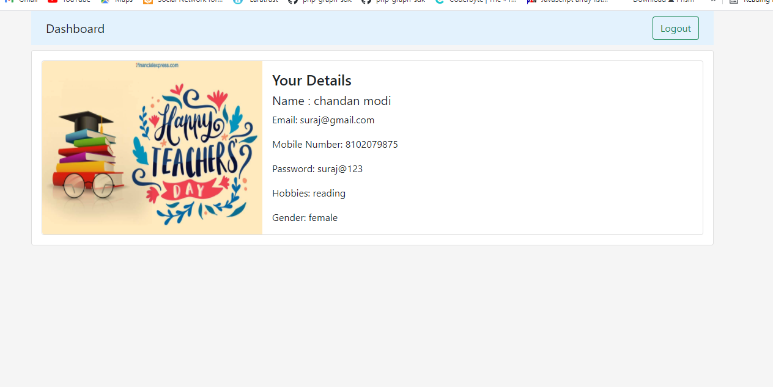

Click on the logout button it will redirect to the login page.

Note :- if you login then you will redirect to the dashboard page but you want to access directly dashboard page then it will not happen and it will redirect to the login page.

this was the assignment you gave me and i am adding all functionalies that you have explained.

If you hire me then I will give you my best .