Name: Suraj Kumar Karna
Regd. No.: 17bce2397

Team 2:
Members:
- 17BCE2393-BIBEK SINGH
- 17BCE2394-ABISHEK SHAH
- 17BCE2397-SURAJ KUMAR KARNA
- 18BCE0042-RONGALA VINOD BALAJI
- 18BCE0129-SHASHANK KESHAV
- 18BCE0302-ANURAJ
- 18BCE0336-CHIRAG KATHURIA
- 18BCE0338-KUMAR DHRUV ROY
- 18BCE0353-NADEEM KAISAR
- 18BCE0378-SAURABH KUMAR PAL

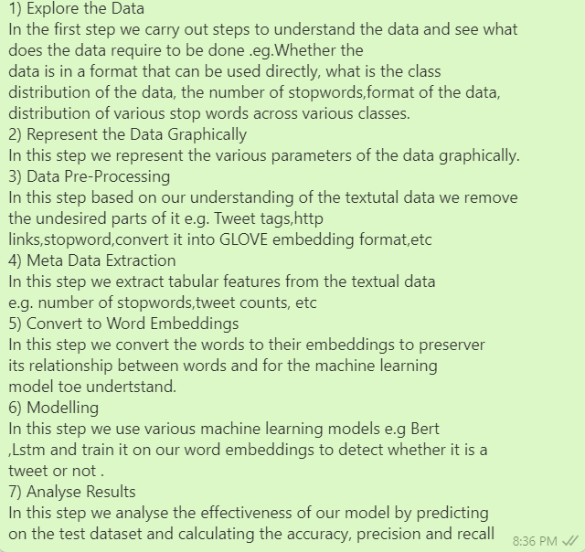
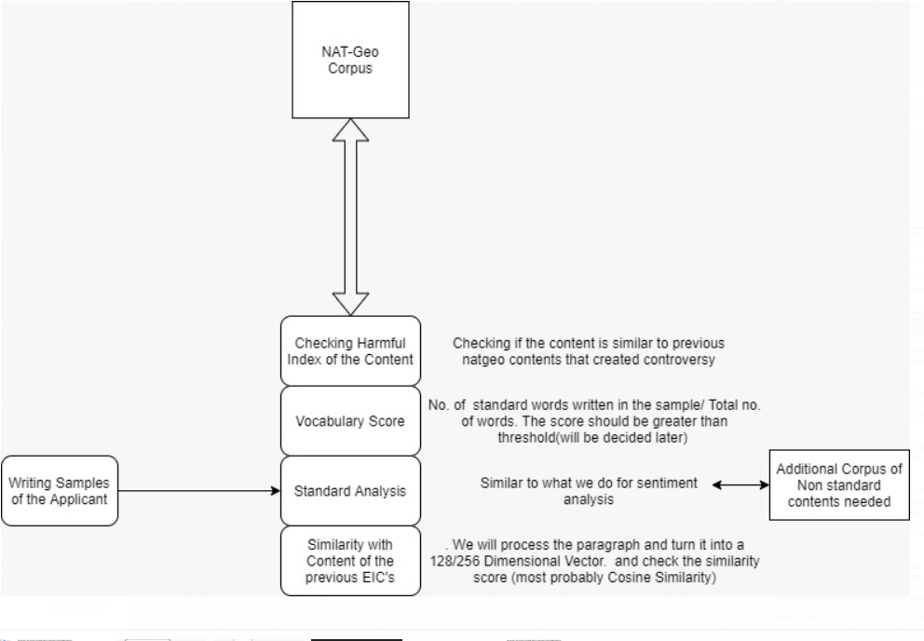
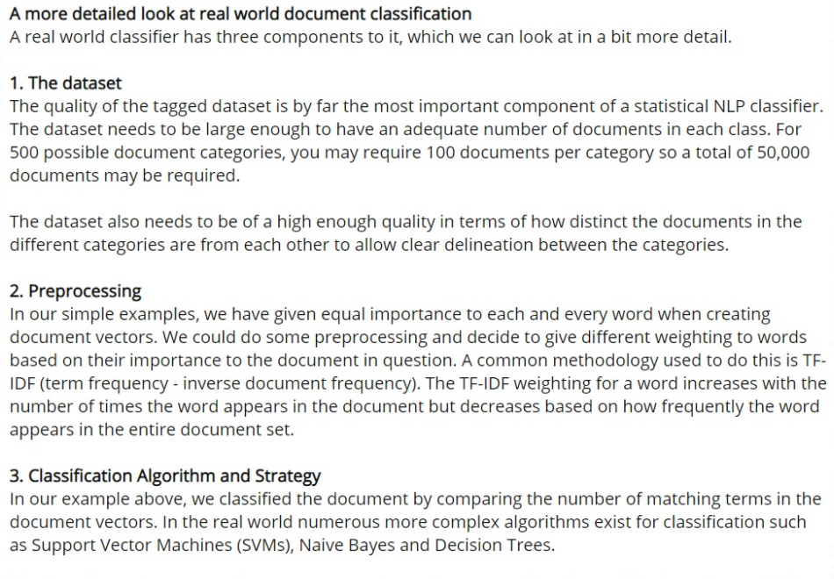

Fig: my work

