Ques 1 :

……………………………………………………………………………………………………………………………………………………………

…………………………………………………………………………………………………………………………………………………………….

Command :

……………………………………………………………………………………………………………………………………………………………

…………………………………………………………………………………………………………………………………………………………….

Use :

……………………………………………………………………………………………………………………………………………………………

…………………………………………………………………………………………………………………………………………………………….

…………………………………………………………………………………………………………………………………………………………….

Output :



Ques 2 :

……………………………………………………………………………………………………………………………………………………………

…………………………………………………………………………………………………………………………………………………………….

Command :

……………………………………………………………………………………………………………………………………………………………

…………………………………………………………………………………………………………………………………………………………….

Use :

……………………………………………………………………………………………………………………………………………………………

…………………………………………………………………………………………………………………………………………………………….

…………………………………………………………………………………………………………………………………………………………….

Output :



Ques 3 :

……………………………………………………………………………………………………………………………………………………………

…………………………………………………………………………………………………………………………………………………………….

Command :

……………………………………………………………………………………………………………………………………………………………

…………………………………………………………………………………………………………………………………………………………….

Use :

……………………………………………………………………………………………………………………………………………………………

…………………………………………………………………………………………………………………………………………………………….

…………………………………………………………………………………………………………………………………………………………….

Output :



Ques 4 :

……………………………………………………………………………………………………………………………………………………………

…………………………………………………………………………………………………………………………………………………………….

Command :

……………………………………………………………………………………………………………………………………………………………

…………………………………………………………………………………………………………………………………………………………….

Use :

……………………………………………………………………………………………………………………………………………………………

…………………………………………………………………………………………………………………………………………………………….

…………………………………………………………………………………………………………………………………………………………….

Output :



Ques 5 :

……………………………………………………………………………………………………………………………………………………………

…………………………………………………………………………………………………………………………………………………………….

Command :

……………………………………………………………………………………………………………………………………………………………

…………………………………………………………………………………………………………………………………………………………….

Use :

……………………………………………………………………………………………………………………………………………………………

…………………………………………………………………………………………………………………………………………………………….

…………………………………………………………………………………………………………………………………………………………….

Output :

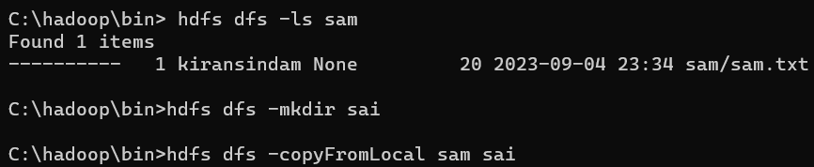





Ques 6 :

……………………………………………………………………………………………………………………………………………………………

…………………………………………………………………………………………………………………………………………………………….

Command :

……………………………………………………………………………………………………………………………………………………………

…………………………………………………………………………………………………………………………………………………………….

Use :

……………………………………………………………………………………………………………………………………………………………

…………………………………………………………………………………………………………………………………………………………….

…………………………………………………………………………………………………………………………………………………………….

Output :



Ques 7 :

……………………………………………………………………………………………………………………………………………………………

…………………………………………………………………………………………………………………………………………………………….

Command :

……………………………………………………………………………………………………………………………………………………………

…………………………………………………………………………………………………………………………………………………………….

Use :

……………………………………………………………………………………………………………………………………………………………

…………………………………………………………………………………………………………………………………………………………….

…………………………………………………………………………………………………………………………………………………………….

Output :



Ques 8 :

…………………………………………………………………………………………………………………………………………………………

…………………………………………………………………………………………………………………………………………………………….

Command :

……………………………………………………………………………………………………………………………………………………………

…………………………………………………………………………………………………………………………………………………………….

Use :

……………………………………………………………………………………………………………………………………………………………

…………………………………………………………………………………………………………………………………………………………….

…………………………………………………………………………………………………………………………………………………………….

Output :



Ques 9 :

……………………………………………………………………………………………………………………………………………………………

…………………………………………………………………………………………………………………………………………………………….

Command :

……………………………………………………………………………………………………………………………………………………………

…………………………………………………………………………………………………………………………………………………………….

Use :

……………………………………………………………………………………………………………………………………………………………

…………………………………………………………………………………………………………………………………………………………….

…………………………………………………………………………………………………………………………………………………………….

Output :



Ques 10 :

……………………………………………………………………………………………………………………………………………………………

…………………………………………………………………………………………………………………………………………………………….

Command :

……………………………………………………………………………………………………………………………………………………………

…………………………………………………………………………………………………………………………………………………………….

Use :

……………………………………………………………………………………………………………………………………………………………

…………………………………………………………………………………………………………………………………………………………….

…………………………………………………………………………………………………………………………………………………………….

Output :

