Ques 1 :

……………………………………………………………………………………………………………………………………………………………

……………………………………………………………………………………………………………………………………………………………

…………………………………………………………………………………………………………………………………………………………….

Command :

……………………………………………………………………………………………………………………………………………………………

…………………………………………………………………………………………………………………………………………………………….

Uses : ……………………………………………………………………………………………………………………………………………………………

…………………………………………………………………………………………………………………………………………………………….

……………………………………………………………………………………………………………………………………………………………

Output :



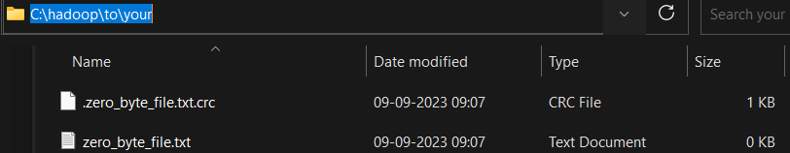

Ques 2 :

……………………………………………………………………………………………………………………………………………………………

…………………………………………………………………………………………………………………………………………………………….

…………………………………………………………………………………………………………………………………………………………….

Command :

……………………………………………………………………………………………………………………………………………………………

…………………………………………………………………………………………………………………………………………………………….

Uses :

……………………………………………………………………………………………………………………………………………………………

…………………………………………………………………………………………………………………………………………………………….

……………………………………………………………………………………………………………………………………………………………

Output :

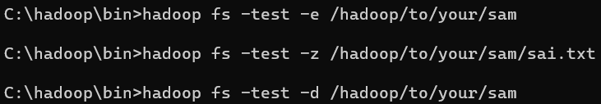

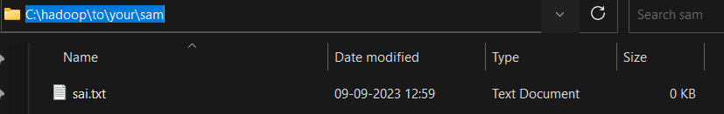

Ques 3 :

……………………………………………………………………………………………………………………………………………………………

…………………………………………………………………………………………………………………………………………………………….

…………………………………………………………………………………………………………………………………………………………….

Command :

……………………………………………………………………………………………………………………………………………………………

…………………………………………………………………………………………………………………………………………………………….

Uses :

……………………………………………………………………………………………………………………………………………………………

…………………………………………………………………………………………………………………………………………………………….

……………………………………………………………………………………………………………………………………………………………

Output :



Ques 4 :

……………………………………………………………………………………………………………………………………………………………

…………………………………………………………………………………………………………………………………………………………….

…………………………………………………………………………………………………………………………………………………………….

Command :

……………………………………………………………………………………………………………………………………………………………

…………………………………………………………………………………………………………………………………………………………….

Uses :

……………………………………………………………………………………………………………………………………………………………

…………………………………………………………………………………………………………………………………………………………….

……………………………………………………………………………………………………………………………………………………………

Output :



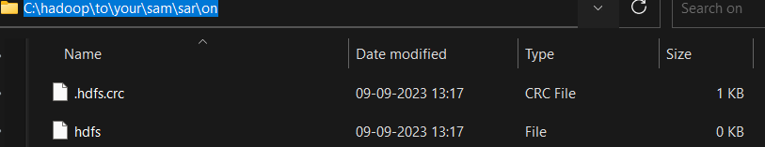



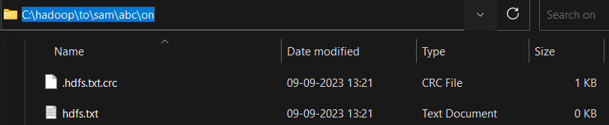

Ques 5 :

……………………………………………………………………………………………………………………………………………………………

…………………………………………………………………………………………………………………………………………………………….

…………………………………………………………………………………………………………………………………………………………….

Command :

……………………………………………………………………………………………………………………………………………………………

…………………………………………………………………………………………………………………………………………………………….

Uses :

……………………………………………………………………………………………………………………………………………………………

…………………………………………………………………………………………………………………………………………………………….

……………………………………………………………………………………………………………………………………………………………

Output :



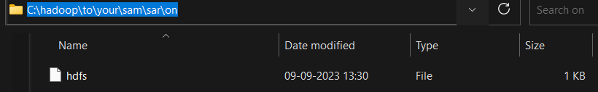

Ques 6 :

……………………………………………………………………………………………………………………………………………………………

…………………………………………………………………………………………………………………………………………………………….

…………………………………………………………………………………………………………………………………………………………….

Command :

……………………………………………………………………………………………………………………………………………………………

…………………………………………………………………………………………………………………………………………………………….

Uses :

……………………………………………………………………………………………………………………………………………………………

…………………………………………………………………………………………………………………………………………………………….

……………………………………………………………………………………………………………………………………………………………

Output :



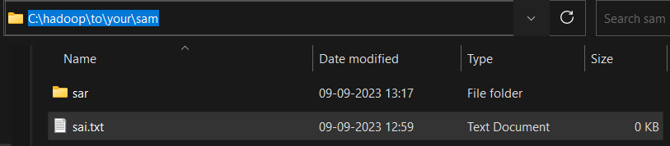

Ques 7 :

……………………………………………………………………………………………………………………………………………………………

…………………………………………………………………………………………………………………………………………………………….

…………………………………………………………………………………………………………………………………………………………….

Command :

……………………………………………………………………………………………………………………………………………………………

…………………………………………………………………………………………………………………………………………………………….

Uses :

……………………………………………………………………………………………………………………………………………………………

…………………………………………………………………………………………………………………………………………………………….

……………………………………………………………………………………………………………………………………………………………

Output :



Ques 8 :

……………………………………………………………………………………………………………………………………………………………

…………………………………………………………………………………………………………………………………………………………….

…………………………………………………………………………………………………………………………………………………………….

Command :

……………………………………………………………………………………………………………………………………………………………

…………………………………………………………………………………………………………………………………………………………….

Uses :

……………………………………………………………………………………………………………………………………………………………

…………………………………………………………………………………………………………………………………………………………….

……………………………………………………………………………………………………………………………………………………………

Output :

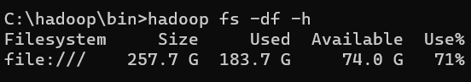

Ques 9 :

……………………………………………………………………………………………………………………………………………………………

…………………………………………………………………………………………………………………………………………………………….

…………………………………………………………………………………………………………………………………………………………….

Command :

……………………………………………………………………………………………………………………………………………………………

…………………………………………………………………………………………………………………………………………………………….

Uses :

……………………………………………………………………………………………………………………………………………………………

…………………………………………………………………………………………………………………………………………………………….

……………………………………………………………………………………………………………………………………………………………

Output : 

Ques 10:

……………………………………………………………………………………………………………………………………………………………

…………………………………………………………………………………………………………………………………………………………….

…………………………………………………………………………………………………………………………………………………………….

Command :

……………………………………………………………………………………………………………………………………………………………

…………………………………………………………………………………………………………………………………………………………….

Uses :

……………………………………………………………………………………………………………………………………………………………

…………………………………………………………………………………………………………………………………………………………….

……………………………………………………………………………………………………………………………………………………………

Output :



