Ques 1 :

Write a Hadoop command to make a directory on an HDFS environment .

……………………………………………………………………………………………………………………………………………………………

…………………………………………………………………………………………………………………………………………………………….

Command : ………………………………………………………………………………………………………………………………………………………………………………………………………………………………………………………………………………………………………………………….

Output :



Ques 2 :

Write a Hadoop command to list the directories present under a specific directory in an HDFS system.

……………………………………………………………………………………………………………………………………………………………

…………………………………………………………………………………………………………………………………………………………….

…………………………………………………………………………………………………………………………………………………………….

Command : ………………………………………………………………………………………………………………………………………………………………………………………………………………………………………………………………………………………………………………………….

Output :

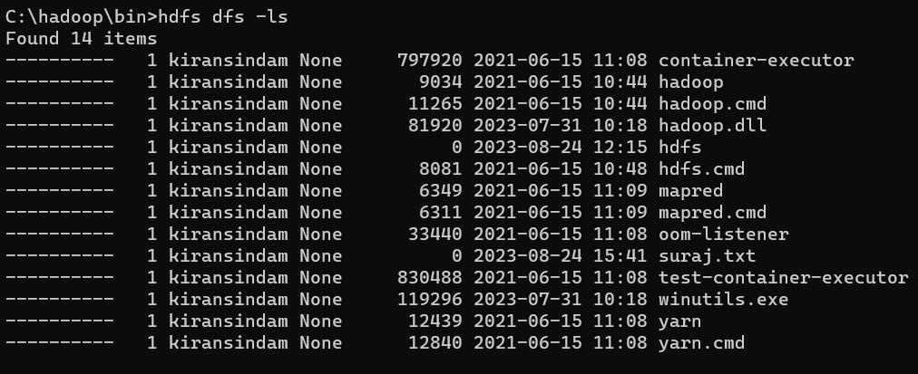

Ques 3 :

Write a Hadoop command to copy files from the local file system to the HDFS filesystem.

……………………………………………………………………………………………………………………………………………………………

…………………………………………………………………………………………………………………………………………………………….

…………………………………………………………………………………………………………………………………………………………….

Command : ………………………………………………………………………………………………………………………………………………………………………………………………………………………………………………………………………………………………………………………….

Output :



Ques 4 :

Write a Hadoop command to copy files from HDFS file system to the local file system.

……………………………………………………………………………………………………………………………………………………………

……………………………………………………………………………………………………………………………………………………………

…………………………………………………………………………………………………………………………………………………………….

Command : ………………………………………………………………………………………………………………………………………………………………………………………………………………………………………………………………………………………………………………………….

Output : 

Ques 5 :

Write a Hadoop command to display the contents of a file on the console.

……………………………………………………………………………………………………………………………………………………………

…………………………………………………………………………………………………………………………………………………………….

Command :

………………………………………………………………………………………………………………………………………………………………………………………………………………………………………………………………………………………………………………………….

Output :

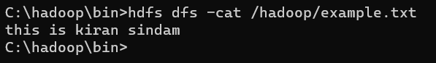

Ques 6 :

Write a Hadoop command to copying files from one directory to another directory within the HDFS file system.

……………………………………………………………………………………………………………………………………………………………

…………………………………………………………………………………………………………………………………………………………….

…………………………………………………………………………………………………………………………………………………………….

Command : ………………………………………………………………………………………………………………………………………………………………………………………………………………………………………………………………………………………………………………………….

Output :



Ques 7 :

Write a Hadoop command to for moving a file from one directory to another directory within the HDFS file system.

……………………………………………………………………………………………………………………………………………………………

…………………………………………………………………………………………………………………………………………………………….

…………………………………………………………………………………………………………………………………………………………….

Command : ………………………………………………………………………………………………………………………………………………………………………………………………………………………………………………………………………………………………………………………….

Output :



Ques 8 :

Write a Hadoop command to remove a file from the HDFS file system.

……………………………………………………………………………………………………………………………………………………………

……………………………………………………………………………………………………………………………………………………………

Command : ………………………………………………………………………………………………………………………………………………………………………………………………………………………………………………………………………………………………………………………….

Output :



Ques 9 :

Write a Hadoop command to merge a list of files in a directory on the HDFS filesystem into a single local file on the local filesystem.

……………………………………………………………………………………………………………………………………………………………

……………………………………………………………………………………………………………………………………………………………

…………………………………………………………………………………………………………………………………………………………….

Command : ………………………………………………………………………………………………………………………………………………………………………………………………………………………………………………………………………………………………………………………….

Output :



Ques 10 :

Write a Hadoop command to change the replication factor of a file to a specific count instead of the default replication factor for the remaining in the HDFS file system.

……………………………………………………………………………………………………………………………………………………………

…………………………………………………………………………………………………………………………………………………………….

…………………………………………………………………………………………………………………………………………………………….

Command …………………………………………………………………………………………………………………………………………………………………………………………………………………………………………………………………………………………………………………………

Output :

