**WEEK 1 assignment**

**Suraj Kumar(**[**surajkum1198@gmail.com**](mailto:surajkum1198@gmail.com)**)**

**NIT Patna**

**Create local Repository**

**git init folder_Name**

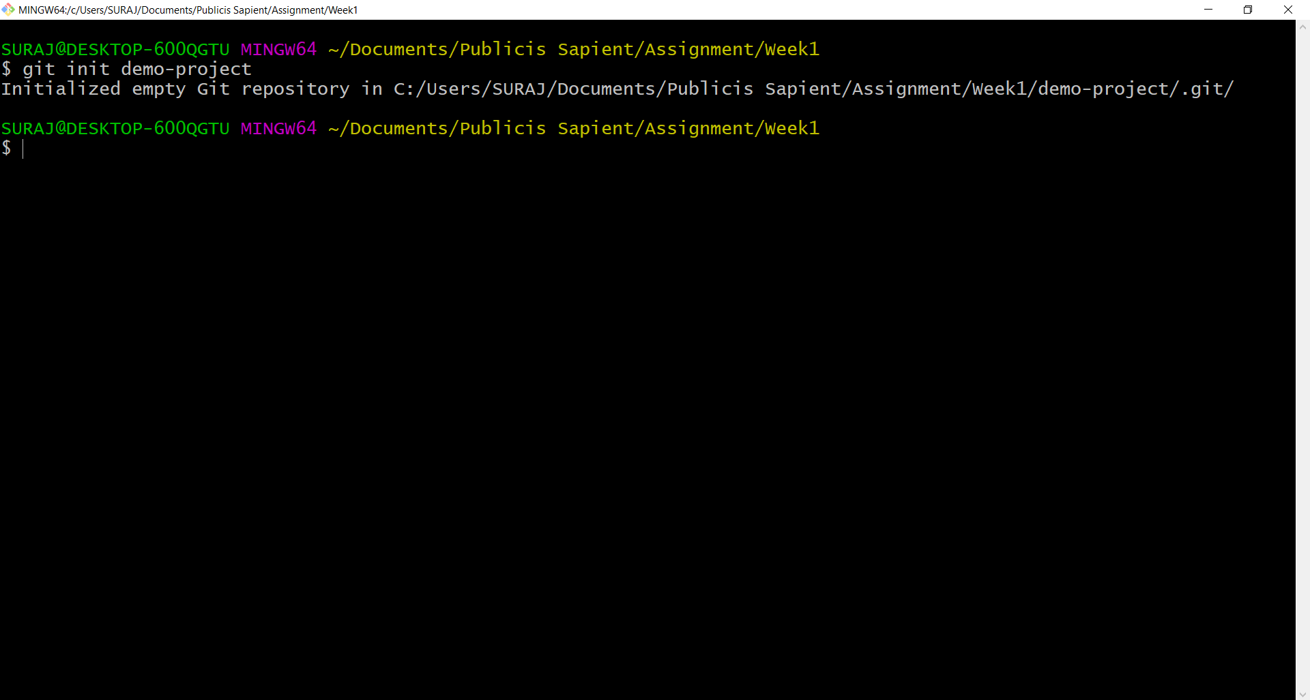

**Create Remote Repository**

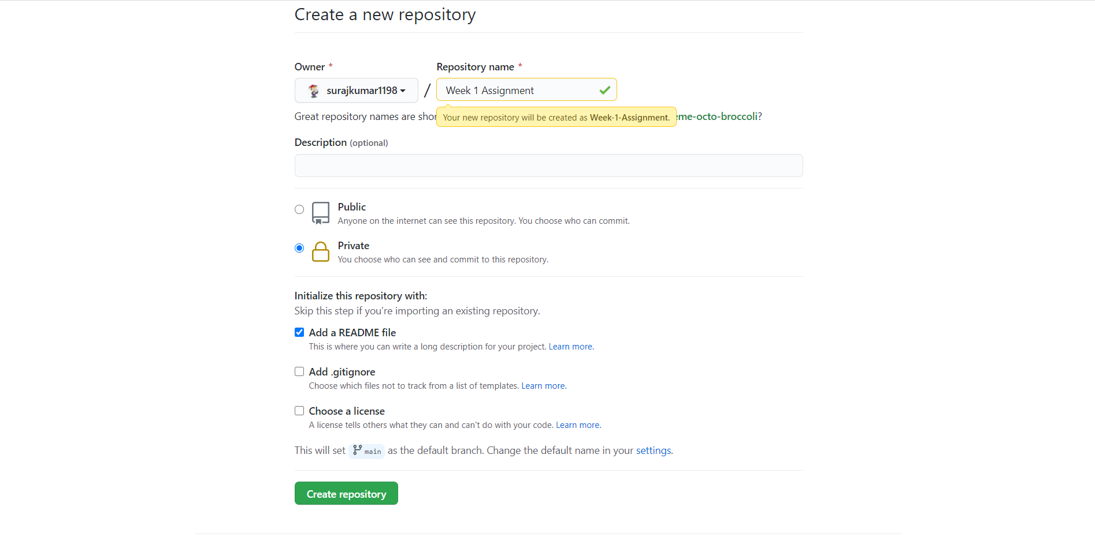

**Create Local Branches**

git branch branch_name

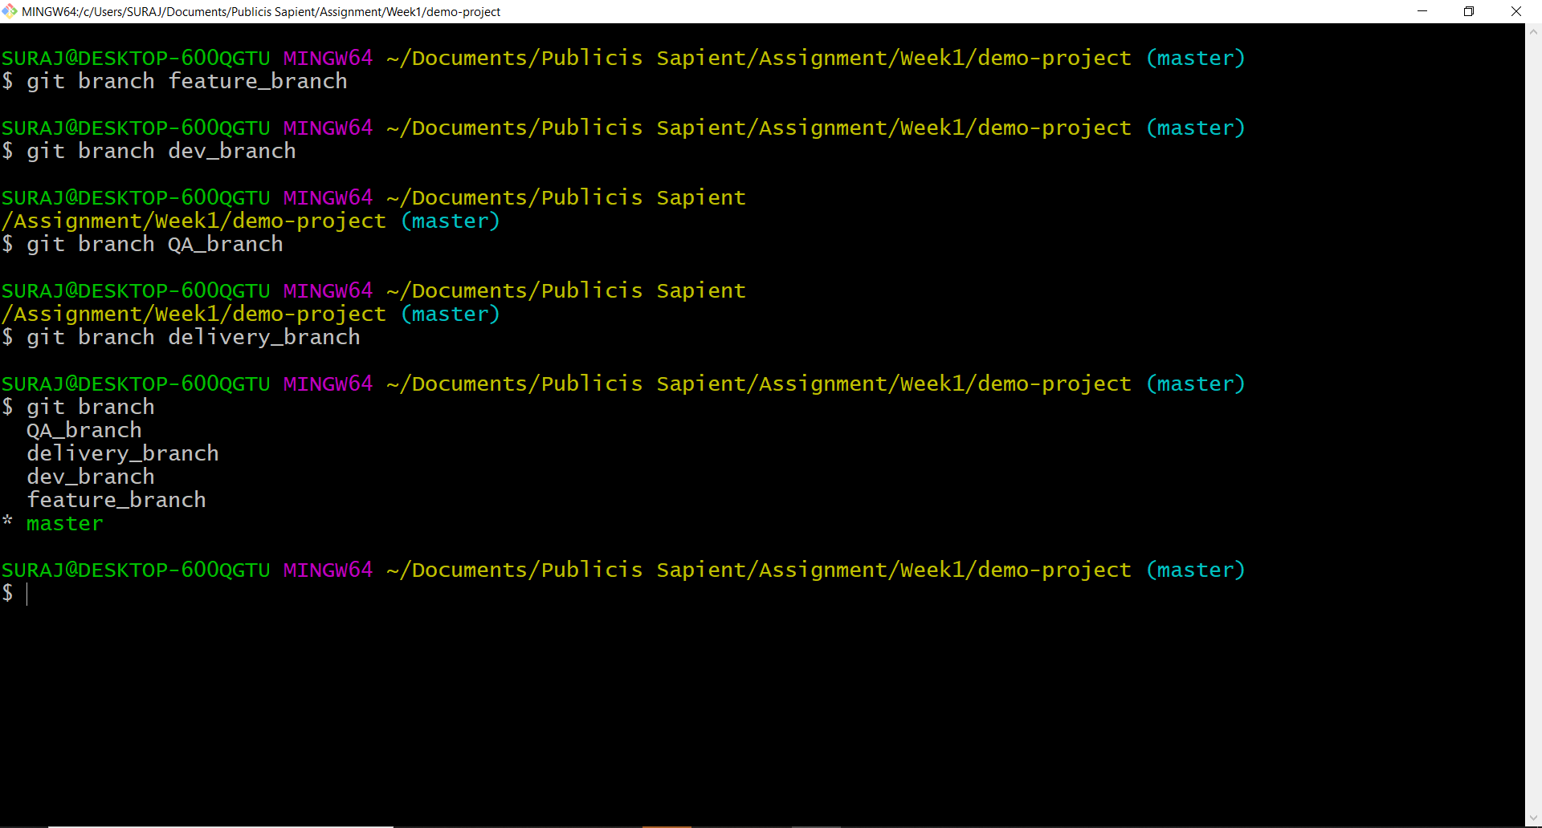

**Add files and folders to staging area**

**git status**

**git add .**

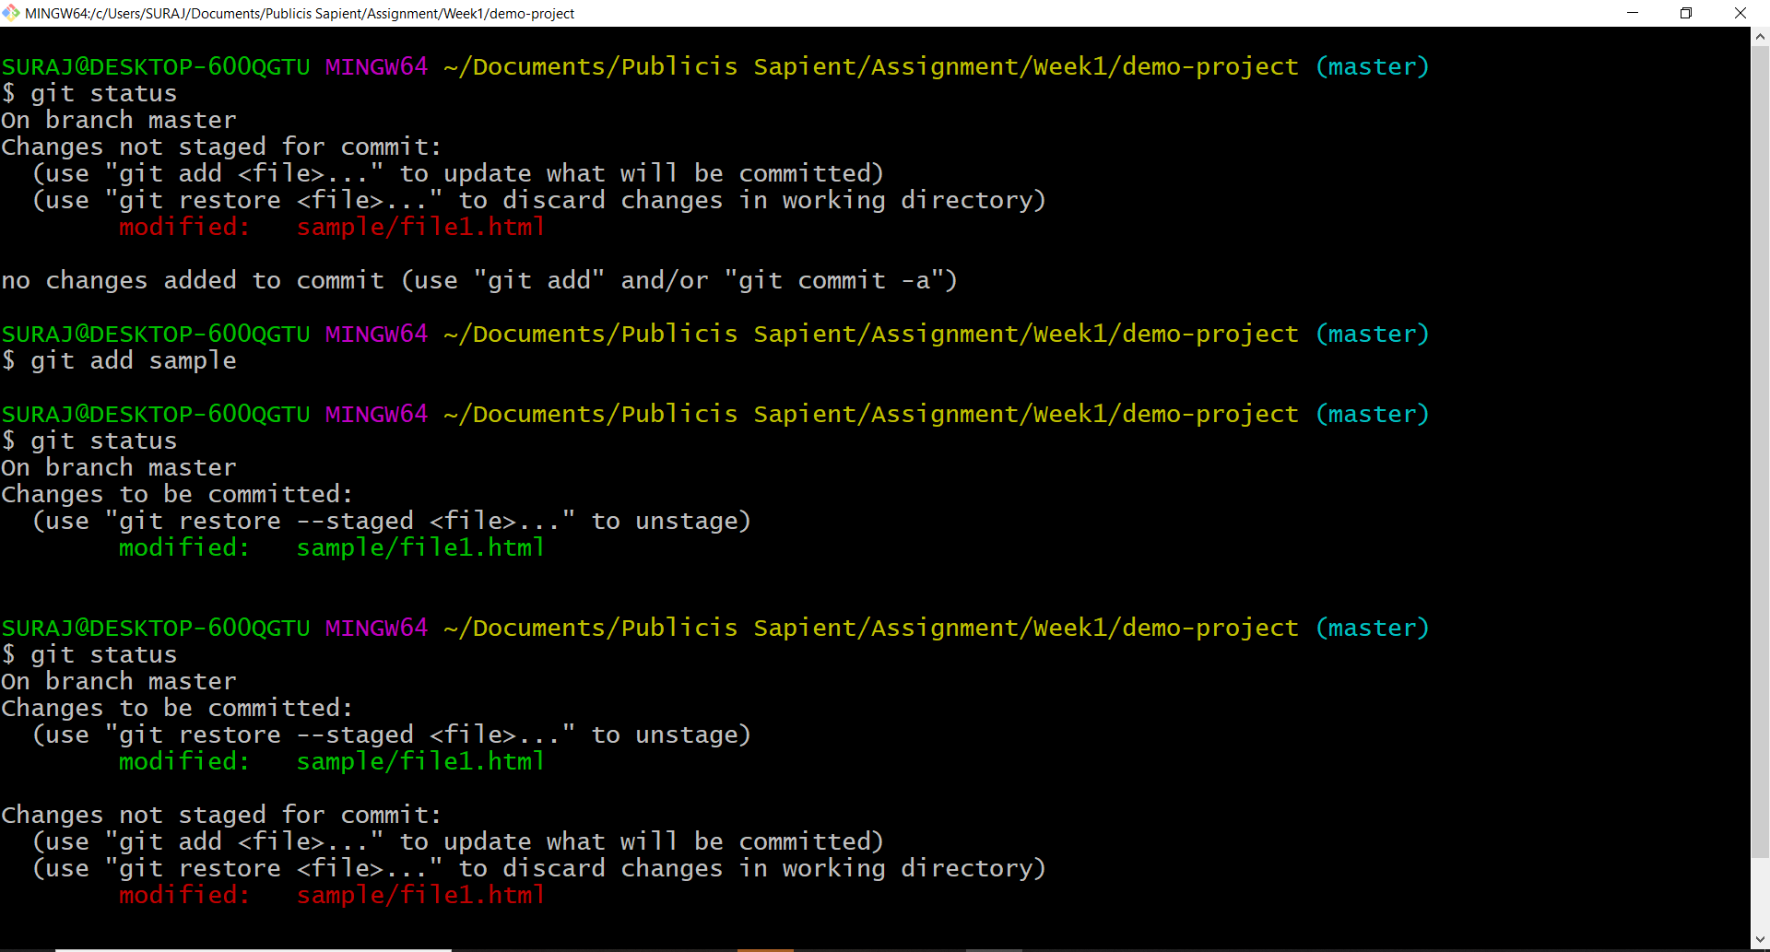

**Make changes to existing files**

**Initial file** 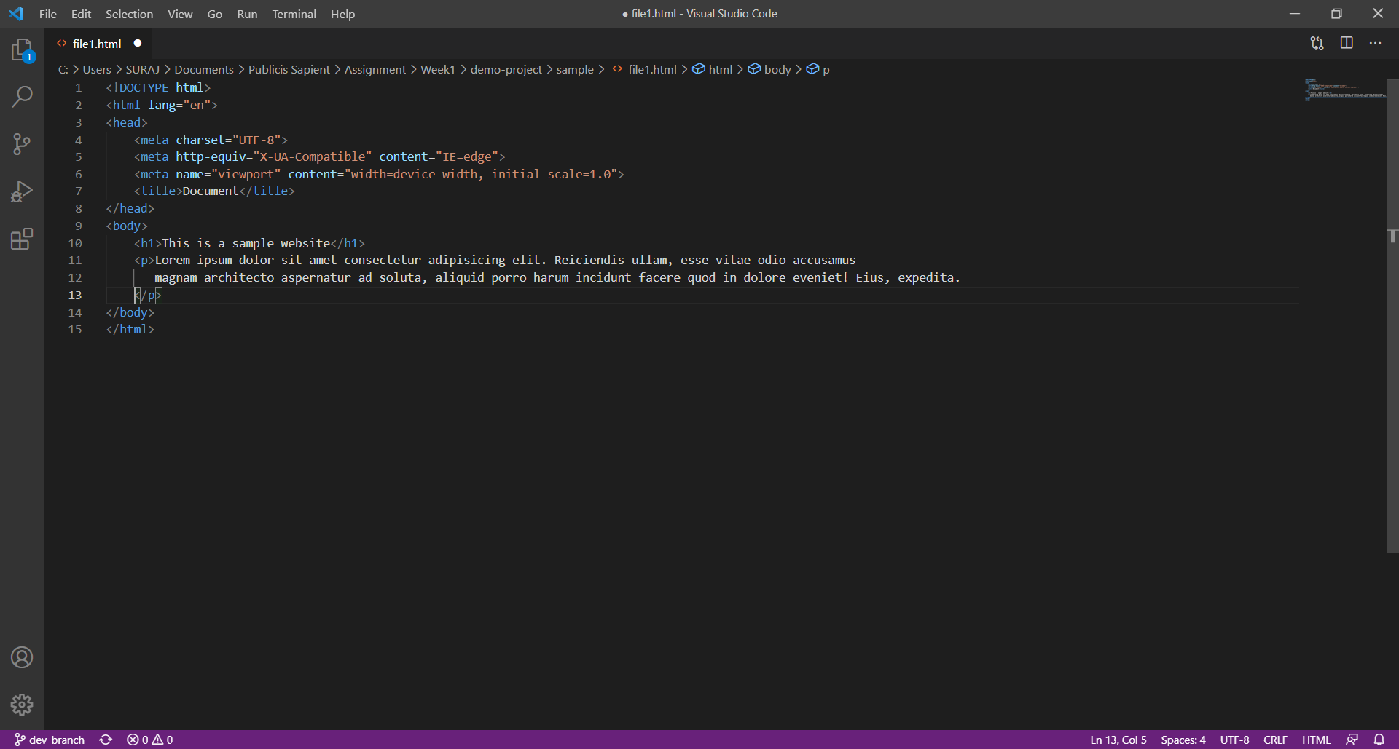

**File after making changes**

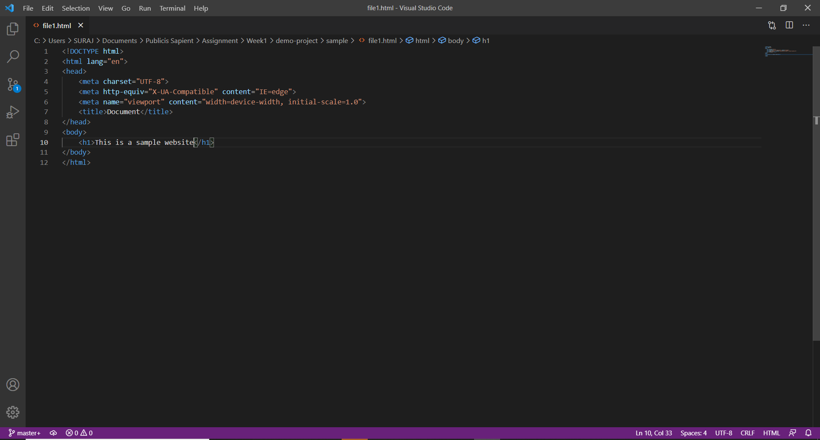

**Remove files and folders from staging area**

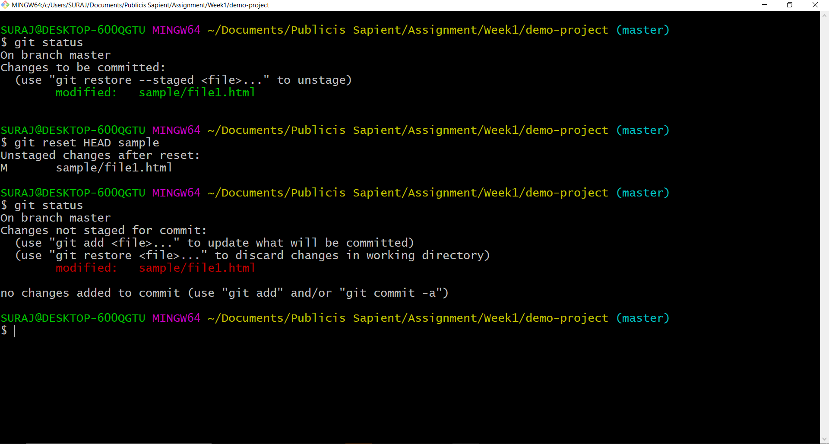

**Checkin push files to feature branch**

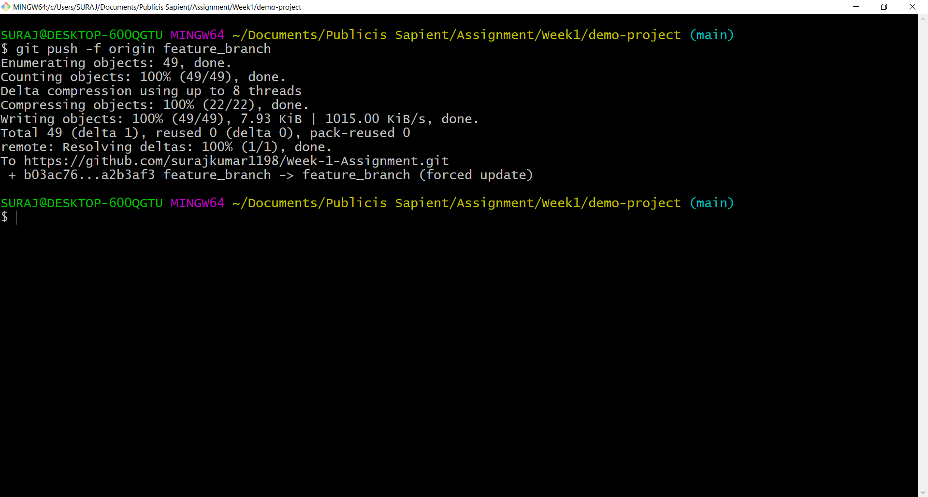

**Promote code from feature branch to dev branch via pull request**

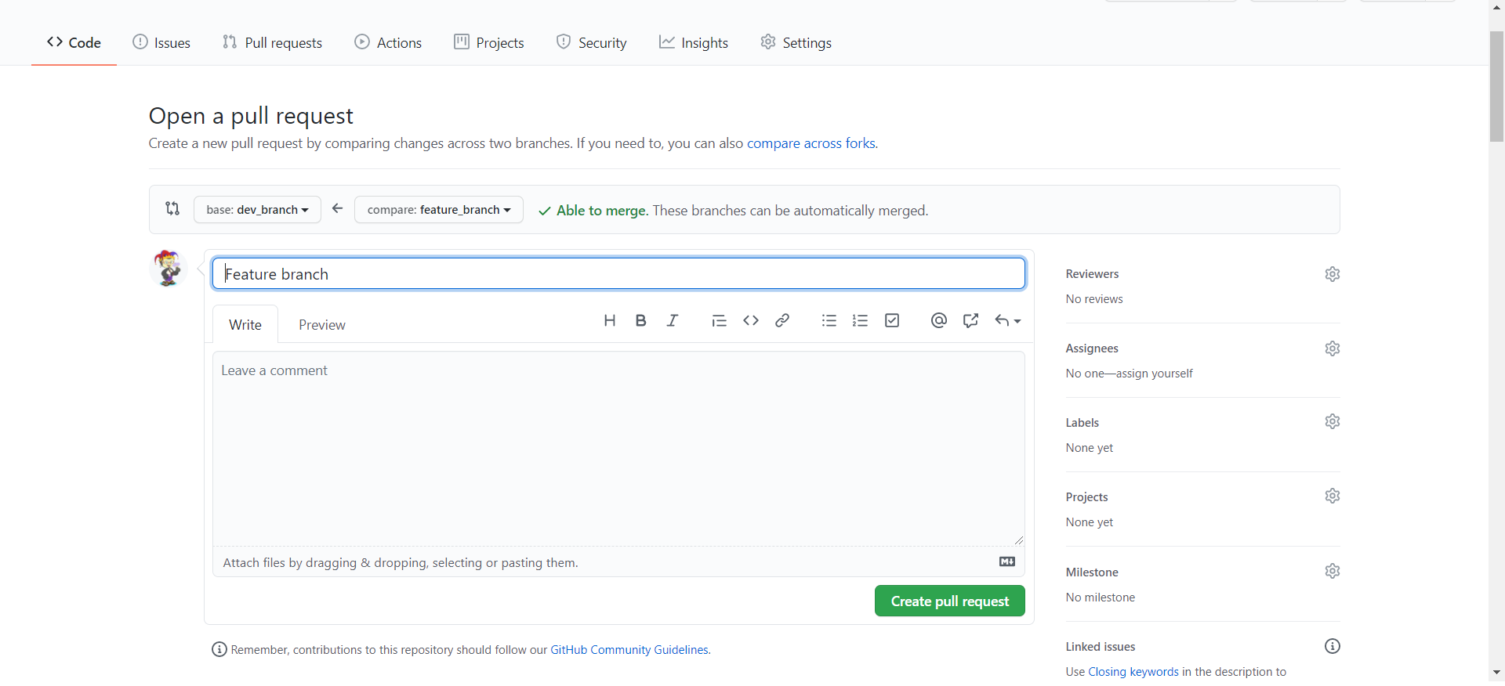

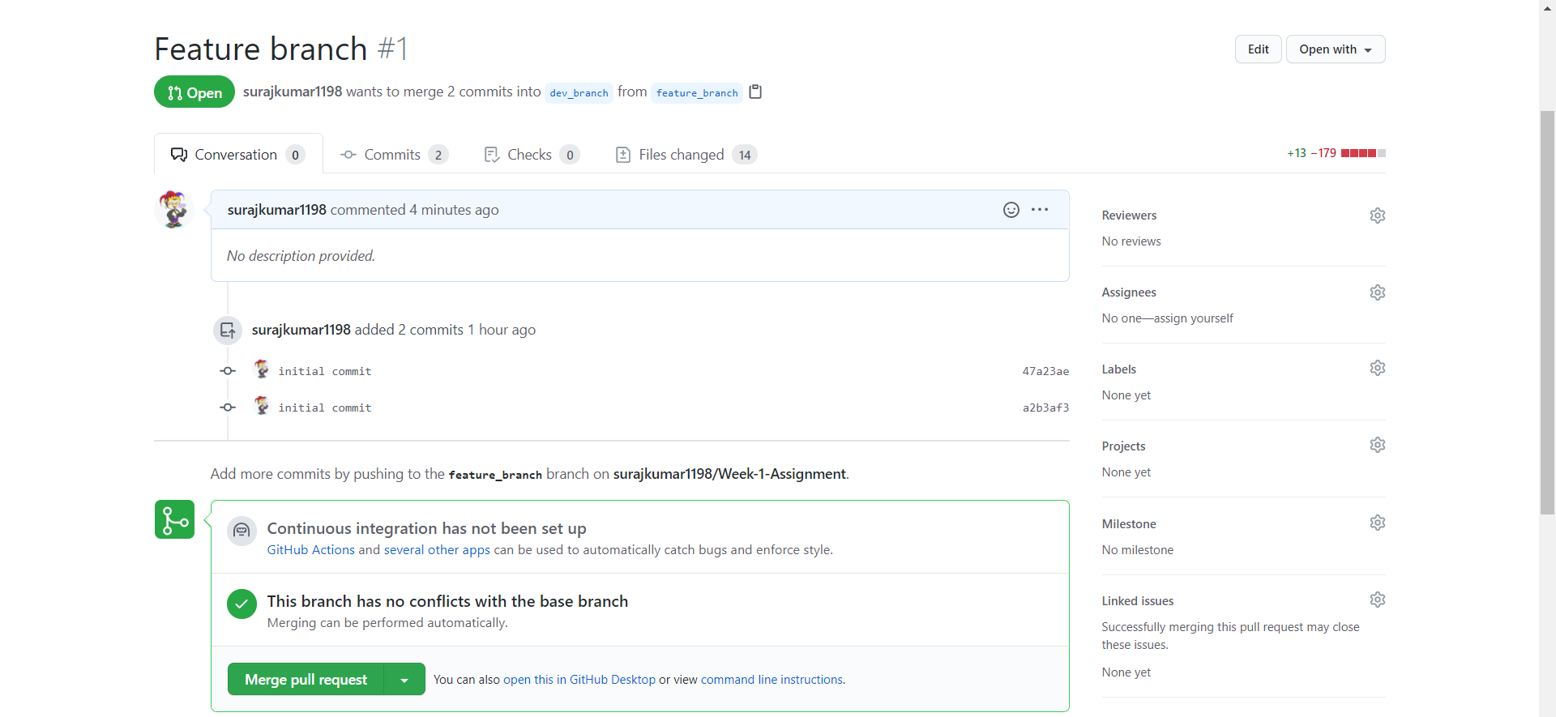

**Checkout latest code from remote branch to local branch**



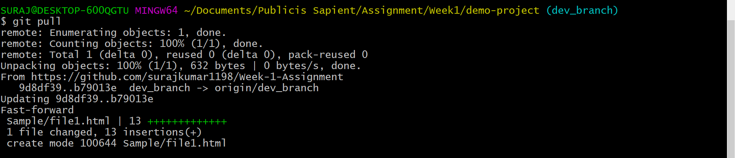

**Explore the difference between checkout vs  pull**

git pull contacts the remote repository identified by origin and looks for updates. It

fetches any updates and then merges the changes into the target branch. It does

not create a new branch.

git checkout -b <branch> origin/<branch> creates a new branch based on

origin/<branch>, and does not contact the remote repository. It looks at

origin/<branch> as it currently exists in your local repository.

The two commands perform very different actions; spending some quality time

with the git-pull and git-checkout man pages might help clarify things.

**Handle Merge conflicts**

**Created a new feature branch named feature1_branch edited the same file**

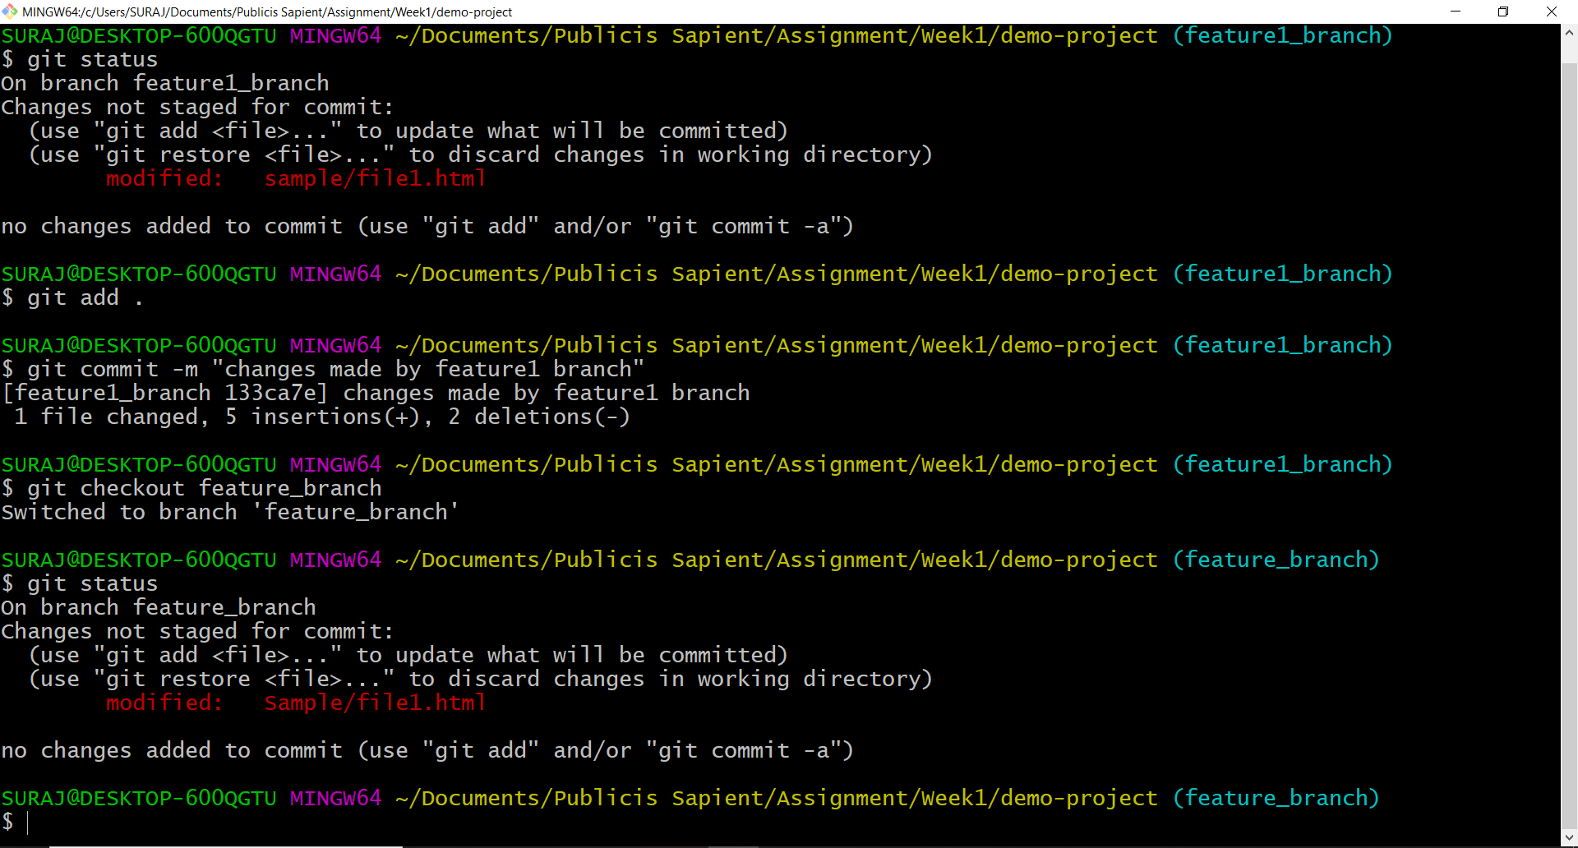

git merge

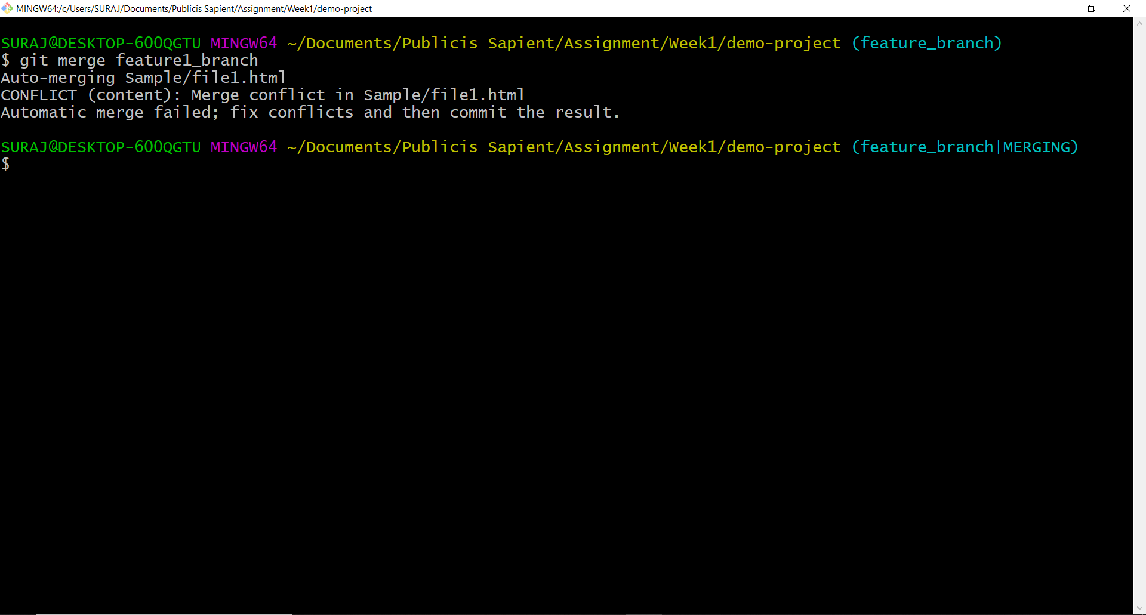

Merge Conflict

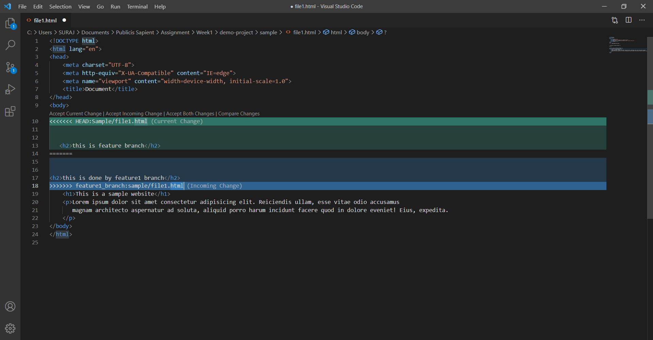

Resolved Merge conflict

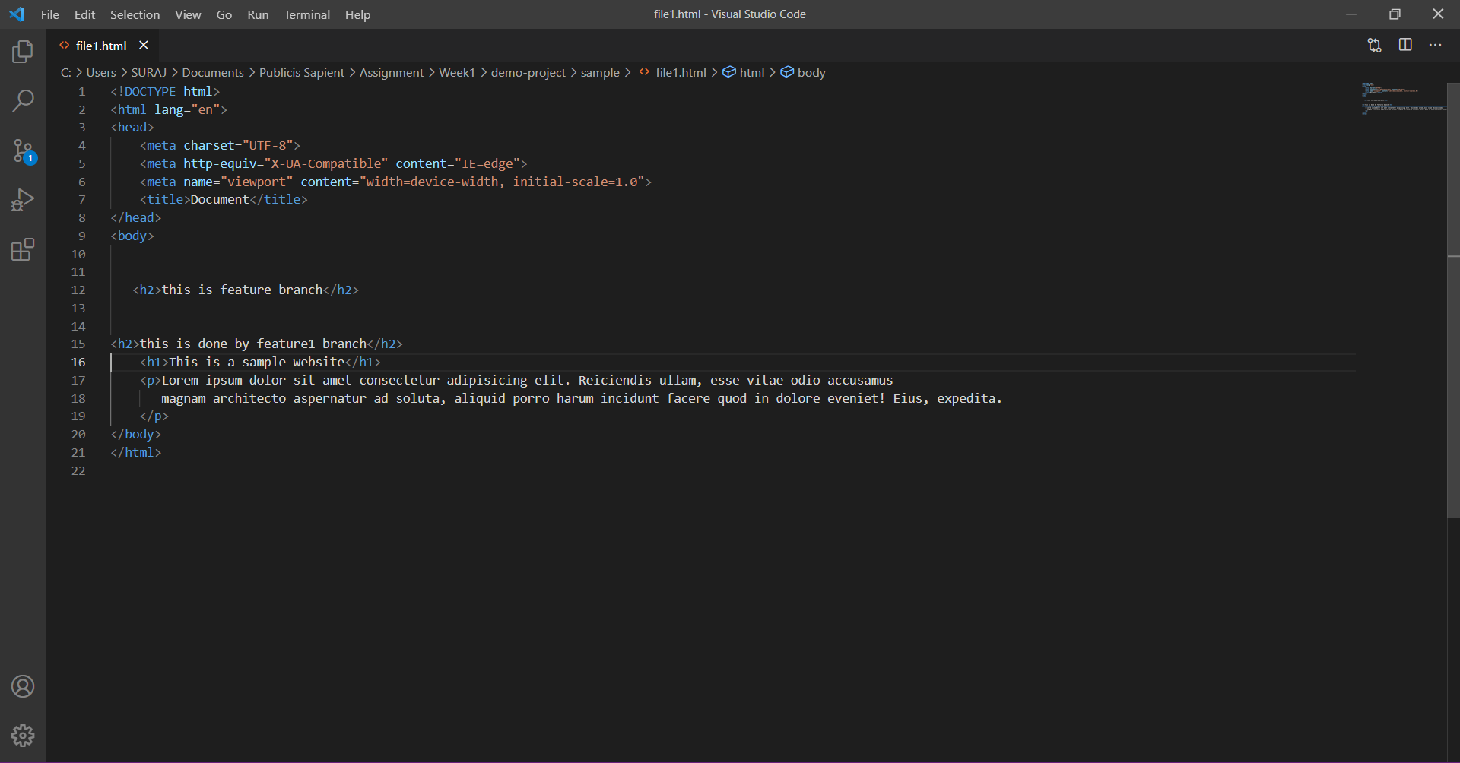

Pushed merged to remote

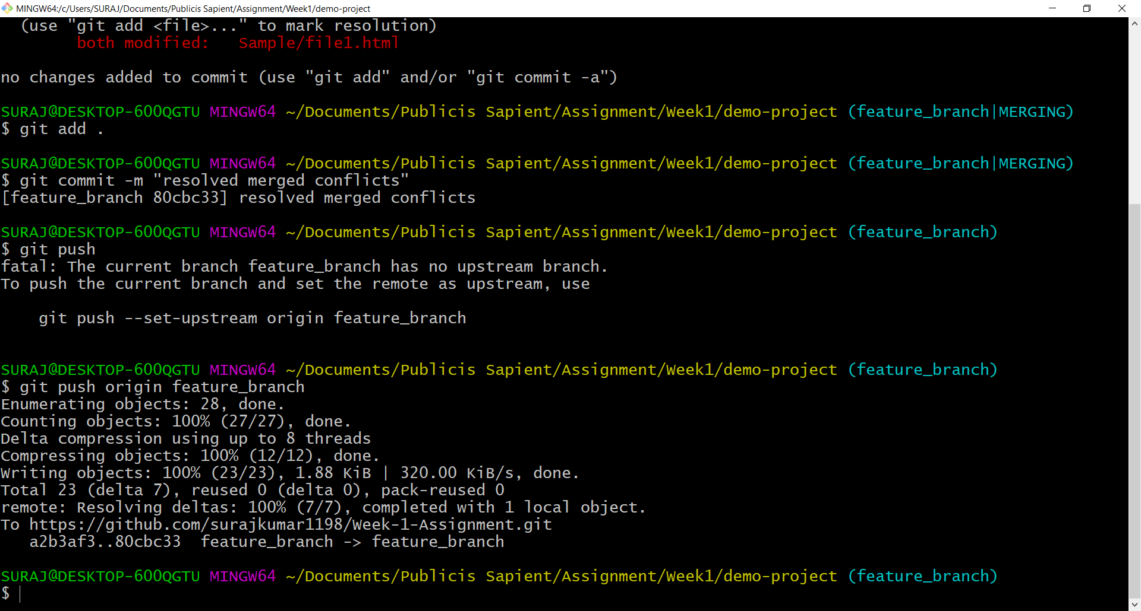

**git log**

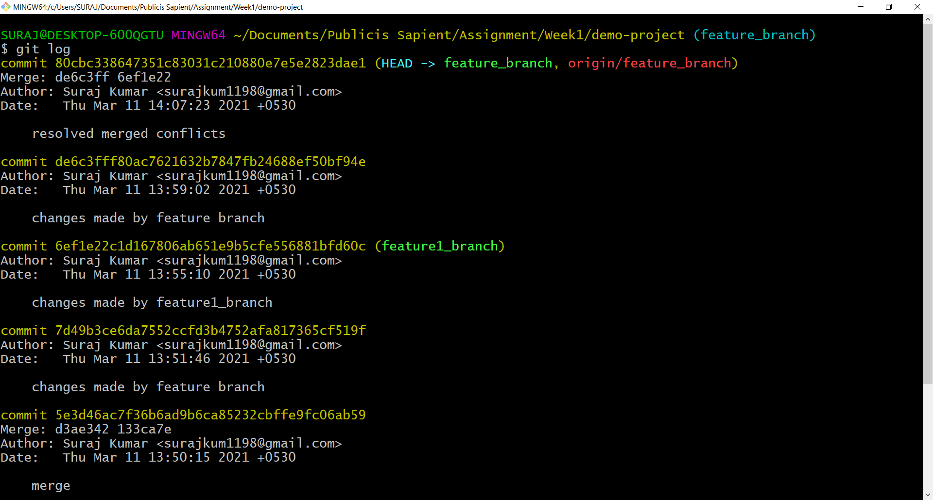

**Git status and git reflog**

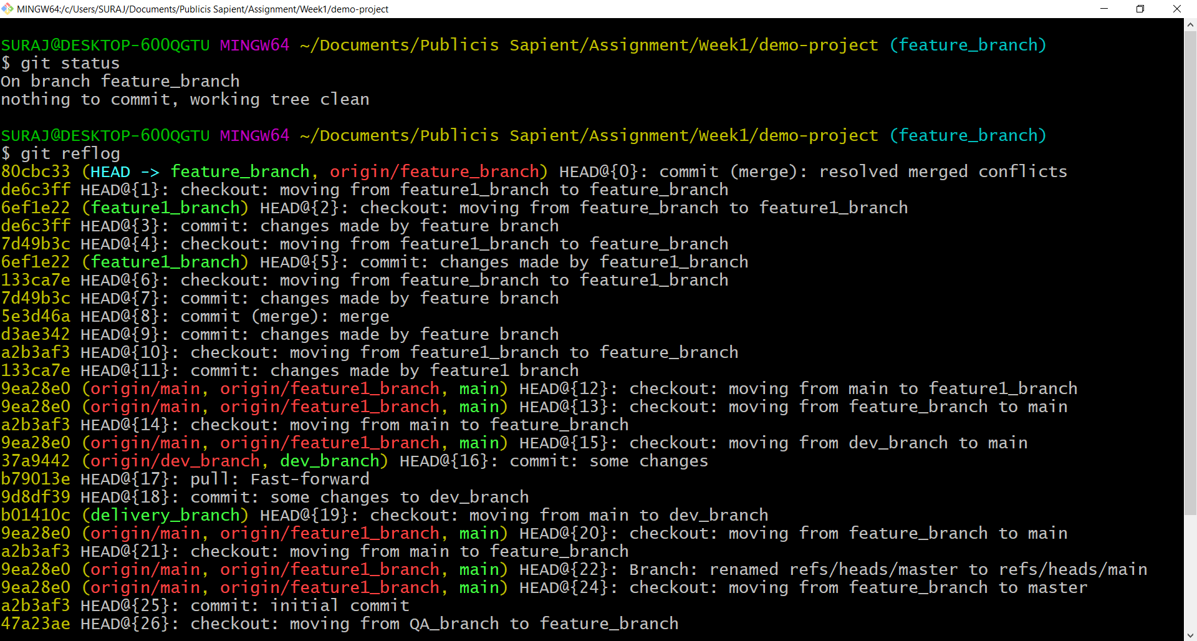

**GUI Client**

gui local branch

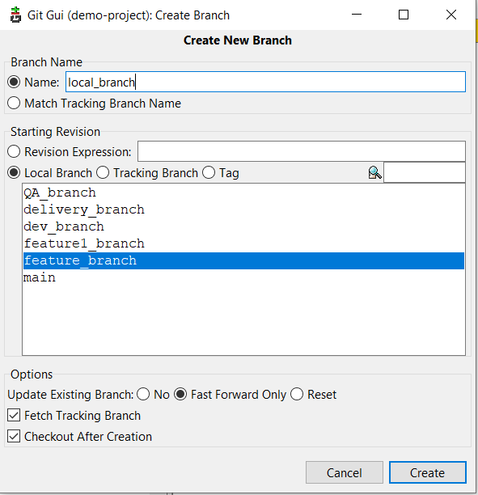

gui remote branch

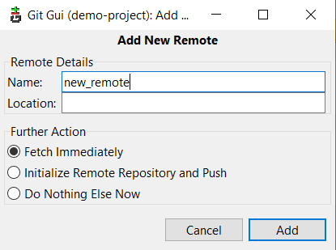

Staging

Commit

Push

Unstaged changes

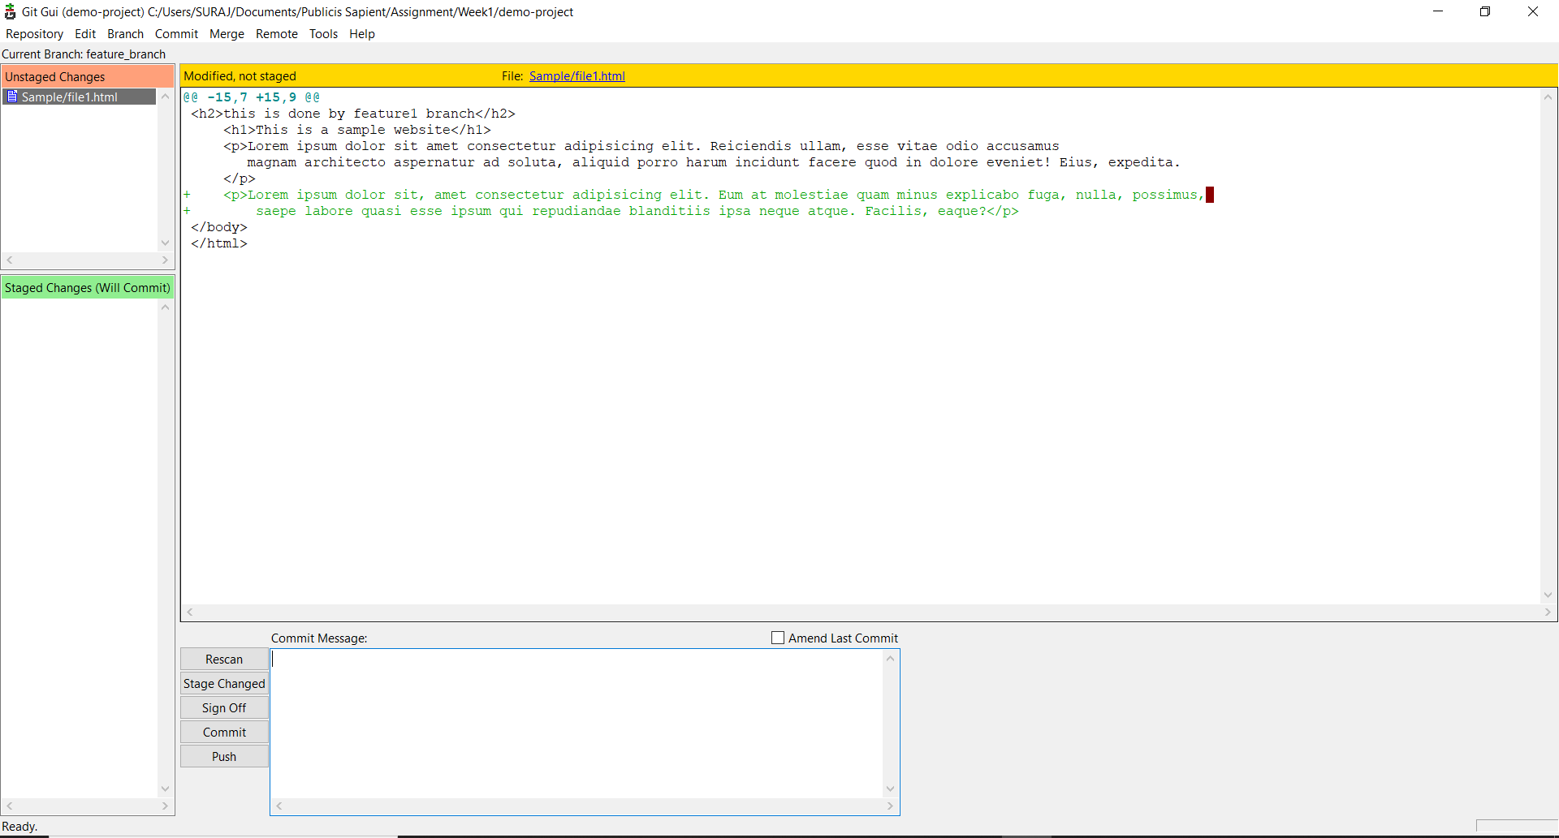

Push changes

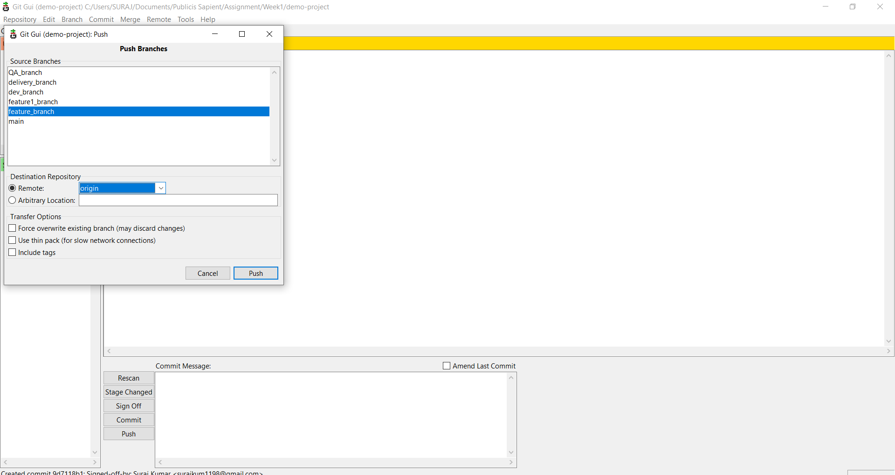

changes 