| **Analysis** | **Key Finding** |
| --- | --- |
| Top-selling product | Category: Furniture (1,12,139 units) |
| Best store overall | Store ID: S003 (20,22,696 units sold) |
| Month with highest demand | July |
| Month with lowest demand | February |
| Average inventory per store | ~274 units |
| Top performing store by category | Store: S005 in Furniture (415620 units) |

Retail Store Inventory DB

Summary

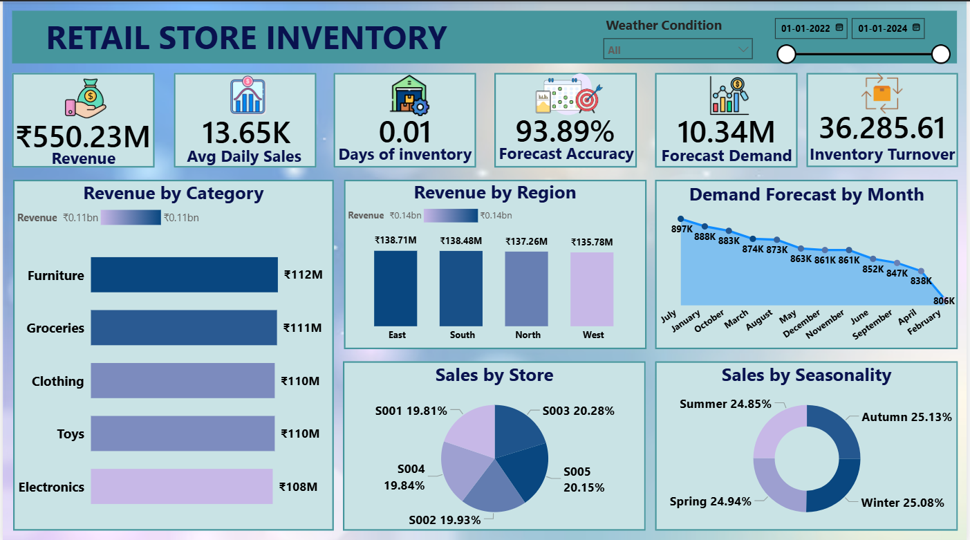

"I led a personal project to transform raw transactional data into a key operational tool for retail inventory management.

**🎯 The Challenge (Situation & Task)**

"The core business challenge was a lack of visibility into working capital efficiency. I needed to move a high-volume, granular inventory dataset -- which I extracted from SQL—into a dynamic Power BI dashboard. The critical technical task was accurately calculating the **Inventory Turnover Ratio (ITR)** and **Days Sales of Inventory (DSI)**, as the raw aggregation was misleading."

**⚙️ My Action (Technical Solution)**

"I built a complete data pipeline, starting with data retrieval via Excel to Power BI. My primary focus was on the DAX modelling layer. To solve the ITR accuracy issue (which initially showed a meaningless 36,000+ turnover), I engineered custom DAX measures using the **Beginning-of-Period/End-of-Period (BOP/EOP)** logic. This ensured that the ratio was financially sound and adjusted correctly based on the user's date filters."

**✅ The Result (Impact)**

"The final **Retail Inventory Dashboard** is a single source of truth that measures **Efficiency** (Accurate ITR), **Risk** (Stock-Out Rate), and **Demand Accuracy**. The result is a tool that allows managers to proactively identify high-risk product categories, quantify the cost of forecast errors, and make data-driven decisions to optimise purchasing and reduce inventory carrying costs."