Low Level Design

**Analyze International Debt Statistics**

|  |  |
| --- | --- |
| **Written By** | Suraj Kumar,  Kumar Prem Ranjan |
| **Document Version** | 0.1 |
| **Last Revised Date** |  |

**DOCUMENT CONTROL**

**Change Record:**

|  |  |  |  |  |
| --- | --- | --- | --- | --- |
| **VERSION** | **DATE** | **AUTHOR** |  | **COMMENTS** |
| 0.1 | 10-April-2023 | Suraj Kumar |  |  |
| 0.1 | 10-April-2023 | Kumar Prem Ranjan |  |  |
|  |  |  |  |  |
|  |  |  |  |  |

**Reviews:**

|  |  |  |  |
| --- | --- | --- | --- |
| **VERSION** | **DATE** | **REVIEWER** | **COMMENTS** |
|  |  |  |  |

**Approval Status:**

|  |  |  |  |  |  |
| --- | --- | --- | --- | --- | --- |
| **VERSION** | **REVIEW DATE** | **REVIEWED BY** |  | **APPROVED BY** | **COMMENTS** |
|  |  |  |  |  |  |

**Contents**

1. Introduction 04
   1. What is Low-Level Design Document? 04
   2. Scope 04
2. Architecture 05
3. Architecture Description 07
   1. Data Description 07
   2. Data Transformation 08
   3. Data insertion into database 08
   4. Connection with MYSQL server 08

# Introduction

## What is Low-Level design document?

The goal of the LDD or Low-level design document (LLDD) is to give the internal logic design of the actual program code for the Analyze International Debt Statistics. LDD describes the class diagrams with the methods and relations between classes and programs specs. It describes the modules so that the programmer can directly code the program from the document.

* 1. **Scope**

Low-level design (LLD) is a component-level design process that follows a step-by-step refinement process. The process can be used for designing data structures, required software architecture, source code and ultimately, performance algorithms. Overall, the data organization may be defined during requirement analysis and then refined during data design work.

# Architecture

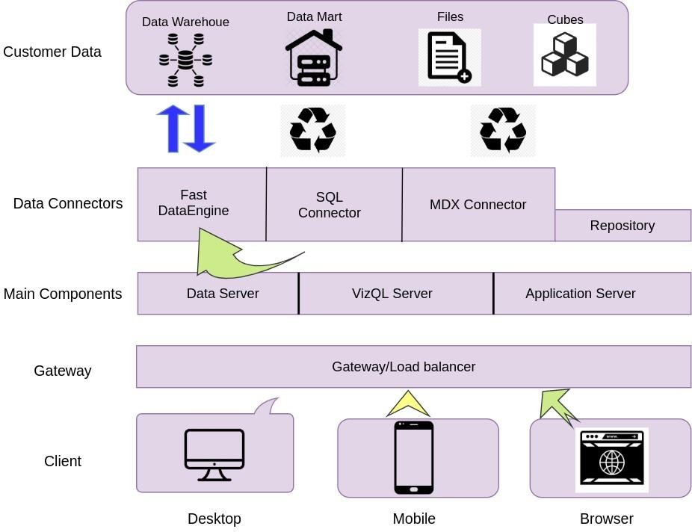

**Power BI Server Architecture**

Power BI has a highly scalable, n-tier client-server architecture that serves mobile clients, web clients and desktop-installed software. Power BI Server architecture supports fast and flexible deployments.



The following diagram shows Power BI Server’s architecture:

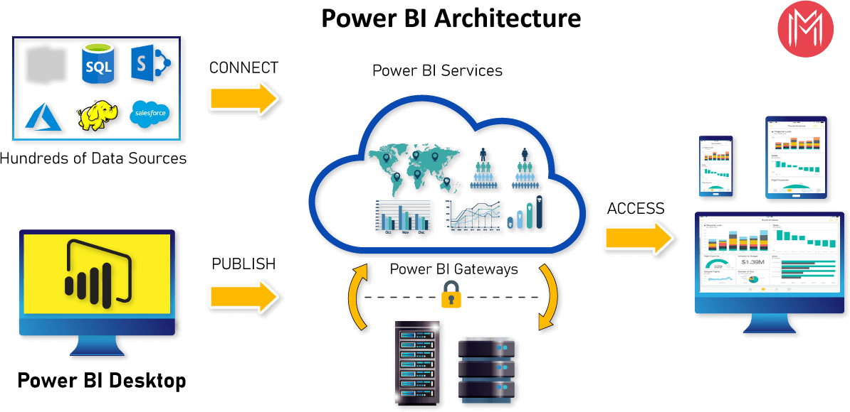

Power BI Server is internally managed by the multiple server processes.

**1. Gateway/Load Balancer**

It acts as an Entry gate to the Power BI Server and also balances the load to the Server if multiple Processes are configured.

**2) Application Server :-**

Application Server processes handle browsing and permissions for the Power BI Server web and mobile interfaces. When a user opens a view in a client device, that user starts a session on Power BI Server. This means that an Application Server thread starts and checks the permissions for that user and that view.

**3) Repository :-**

Power BI Server Repository is a MYSQL database that stores server data. This data includes information about Power BI Server users, groups and group assignments, permissions, projects, data sources, and extract metadata and refresh information.

1. **VIZQL Server :-**

Once a view is opened, the client sends a request to the VizQL process (vizqlserver.exe). The VizQL process then sends queries directly to the data source, returning a result set that is rendered as images and presented to the user. Each VizQL Server has its own cache that can be shared across multiple users

1. **Data Engine: -**

It Stores data extracts and answers queries.

1. **Backgrounder: -**

The backgrounder Executes server tasks which includes refreshes scheduled extracts, tasks initiated from Power BI and manages other background tasks.

1. **Data Server: -**

Data Server Manages connections to Power BI Server data sources

It also maintains metadata from Power BI Desktop, such as calculations, definitions, and groups.

# Architecture Description

## Data Description

The data used in this project is provided by The World Bank. It contains both national and regional debt statistics for several countries across the globe as recorded from 1970 to 2015.

We examine statistics on global debt gathered by The World Bank in this study. The dataset includes data on the total amount of debt (in US dollars) owing by developing nations in several categories.

We discover solutions to issues like:

1. The World Bank's international debt data
2. Finding the number of distinct countries
3. Finding out the distinct debt indicators
4. Totaling the amount of debt owed by the countries
5. Country with the highest debt
6. Average amount of debt across indicators
7. The highest amount of principal repayments
8. The most common debt indicator
9. Other viable debt issues and conclusion
   1. **Data Transformation**

In the Transformation Process, we will convert our original datasets with other necessary attributes format. And will merge it with the Scrapped dataset.

* 1. **Data Insertion into Database**

1. Database Creation and connection - Create a database with name passed. If the database is already created, open the connection to the database.
2. Table creation in the database.
3. Insertion of files in the table

**3.4 Make the MYSQL connection and set up the data source**

### Step 1: Configuring Power BI

left. This will open a dialogue box where you need to provide the connection details for MYSQL Server.

To connect with Power BI, you will need to provide information about the server which hosts your database. If you want to connect to a contained database, you can also specify the name of the database.

To connect with MySQL server, you need to specify the server’s name and database name as follows:

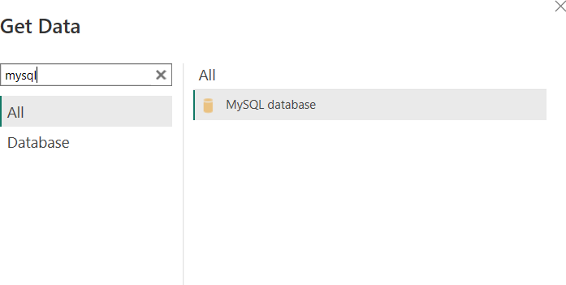

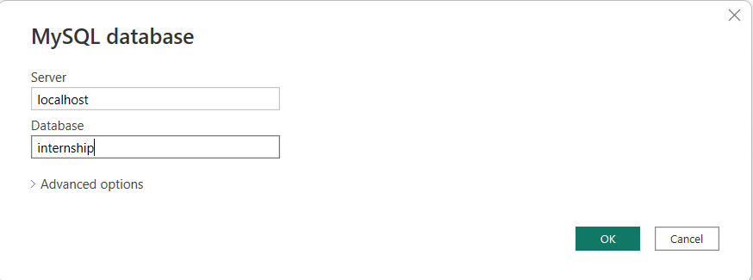

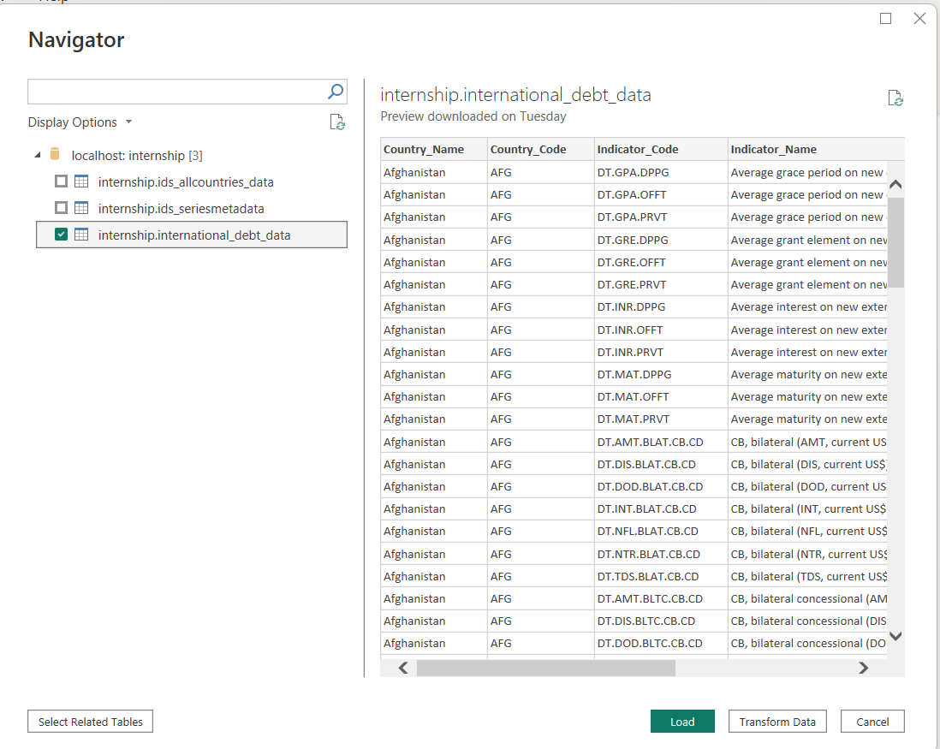

#### Step 2: Configuring Data Source

The data source page loads up after configuring the Power BI connector and successfully signing in. This is how the page looks like:

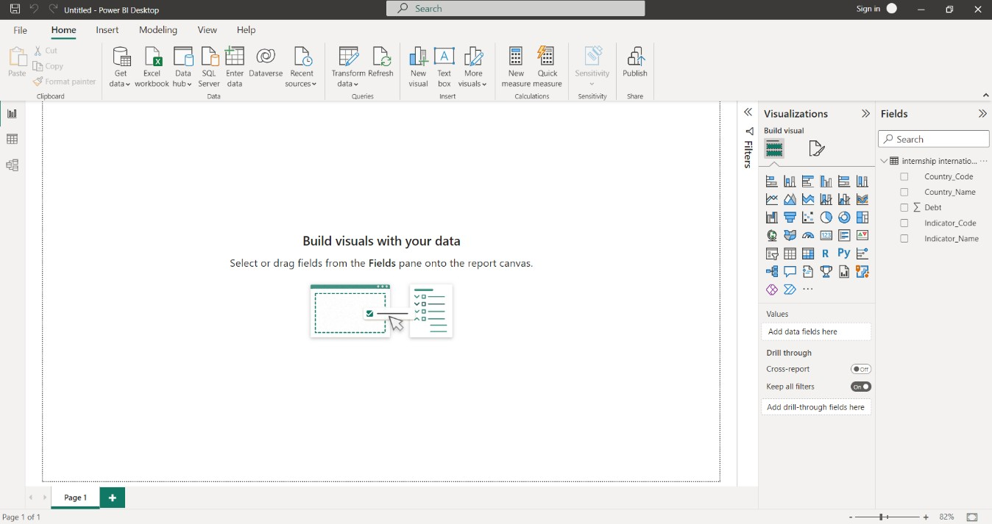

#### Step 3: Final Dashboard Creation and KPI Visualization:

