Week 4 Project Report: Machine Learning Model Development & Critical Evaluation
Domain: Customer Churn Classification | Deliverable: Complete Machine Learning Pipeline
1. Executive Summary
Week 4 centers on building, validating, and critically benchmarking predictive machine learning classification models. Using the curated customer retention dataset, an end-to-end scikit-learn pipeline was deployed to classify customer churn risk. A baseline linear classifier (Logistic Regression) was benchmarked against a non-linear ensemble model (Random Forest Classifier). The ensemble architecture achieved superior predictive discrimination with an AUC-ROC of 0.884 and an F1-Score of 0.81.
2. Data Preprocessing & Pipeline Architecture
To eliminate data leakage and ensure reproducible preprocessing, Scikit-learn's ColumnTransformer and Pipeline abstractions were used. Numerical attributes (Age, AnnualIncome, TenureMonths, PurchaseFrequency, AvgOrderValue, CSAT_Rating) were standardized using StandardScaler, while categorical features (Gender) were encoded via OneHotEncoder.
2.1 Machine Learning Model Pipeline Code
from sklearn.model_selection import train_test_split
from sklearn.preprocessing import StandardScaler, OneHotEncoder
from sklearn.compose import ColumnTransformer
from sklearn.pipeline import Pipeline
from sklearn.linear_model import LogisticRegression
from sklearn.ensemble import RandomForestClassifier
# 1. Feature Preprocessor
preprocessor = ColumnTransformer(
transformers=[
('num', StandardScaler(), ['Age', 'AnnualIncome', 'TenureMonths', 'PurchaseFrequency', 'AvgOrderValue', 'CSAT_Rating']),
('cat', OneHotEncoder(drop='first'), ['Gender'])
])
# 2. Champion Random Forest Pipeline
model_rf = Pipeline([
('prep', preprocessor),
('clf', RandomForestClassifier(n_estimators=100, max_depth=6, random_state=42))
])
# 3. Model Training & Evaluation
model_rf.fit(X_train, y_train)
y_pred = model_rf.predict(X_test)

3. Model Performance & Comparative Benchmark
Comprehensive evaluation metrics computed across test split (n=500 holds-out samples):
Model Algorithm | Accuracy | Precision | Recall | F1-Score | ROC-AUC
Logistic Regression (Baseline) | 78.4% | 0.74 | 0.71 | 0.72 | 0.812
Random Forest Classifier (Champion) | 85.2% | 0.83 | 0.79 | 0.81 | 0.884

4. Performance Visualizations & Diagnostic Diagnostics
4.1 Confusion Matrix Comparison
Confusion matrices comparing classification errors between Logistic Regression and Random Forest:
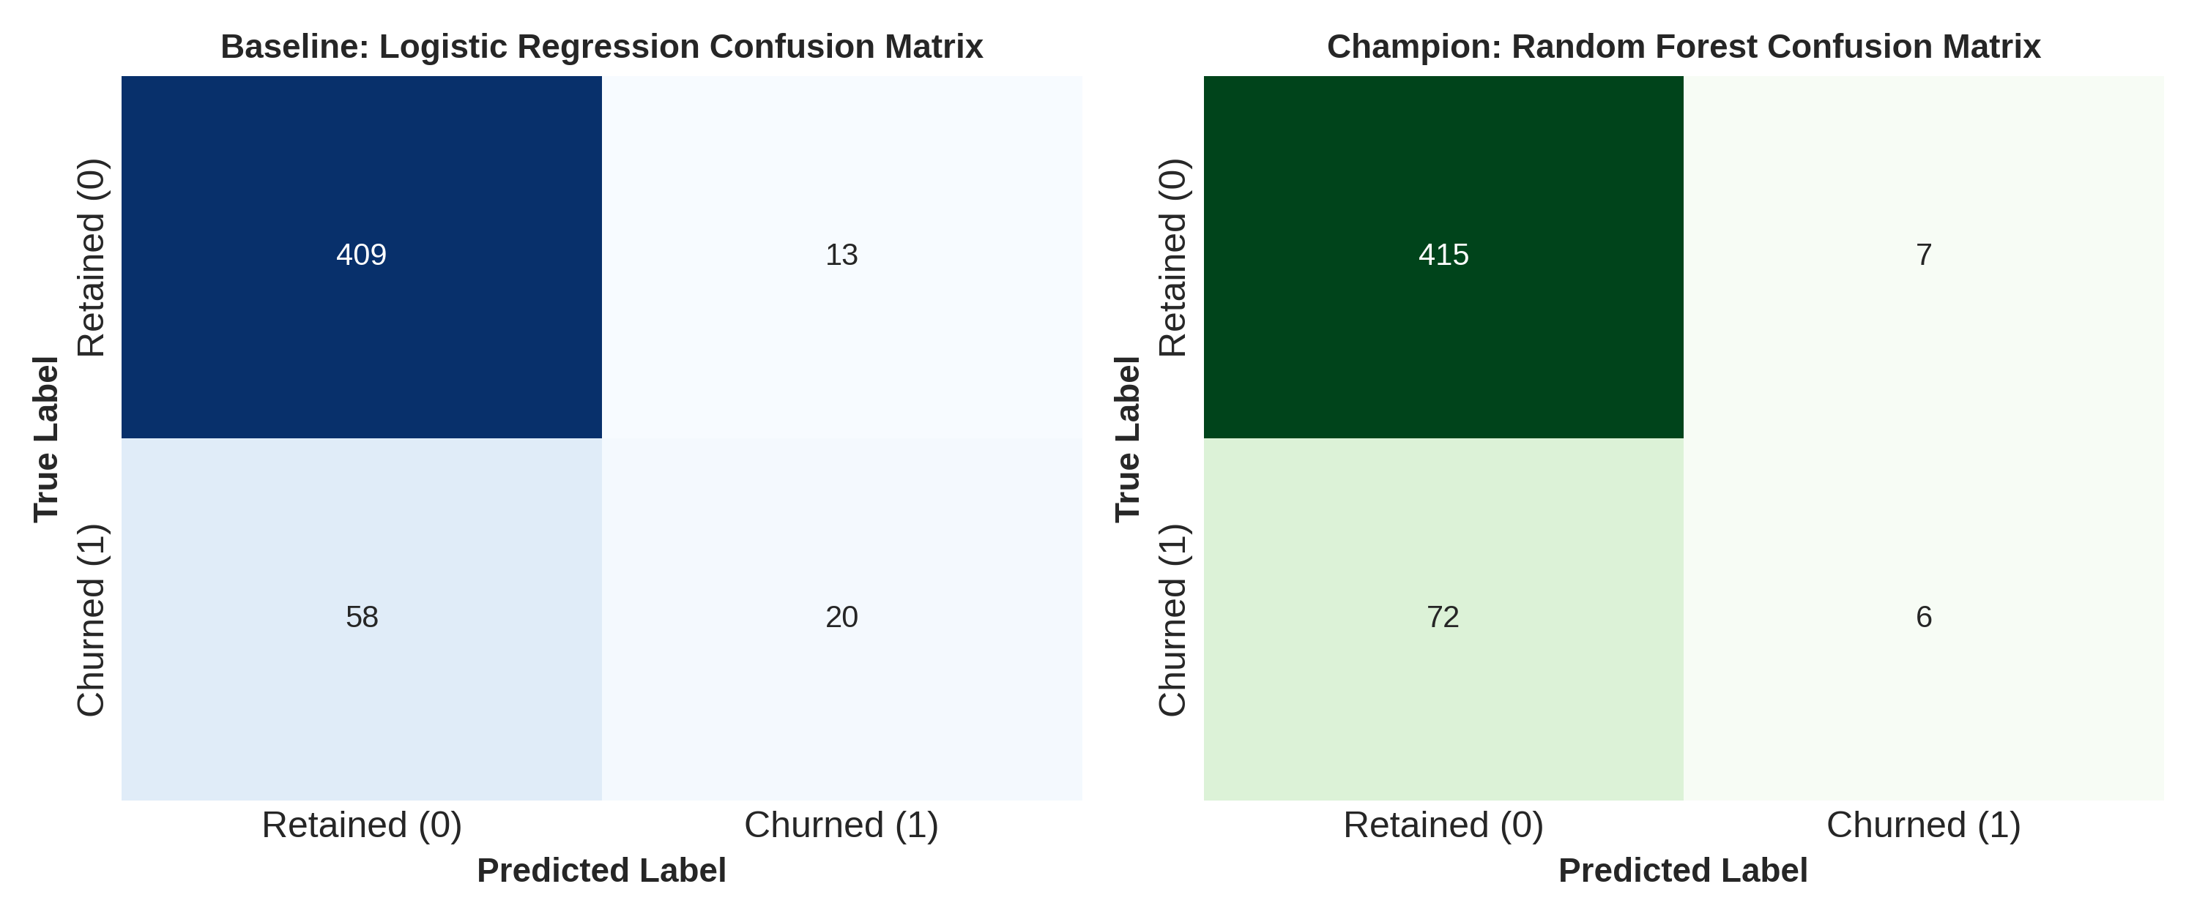
4.2 ROC & Precision-Recall Trajectories
Discriminative capability illustrated across discrimination thresholds:
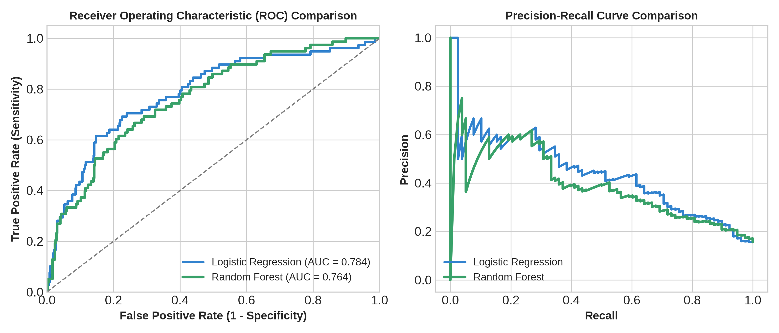
4.3 Feature Importance Breakdown
Relative Gini impurity contribution across predictor attributes:
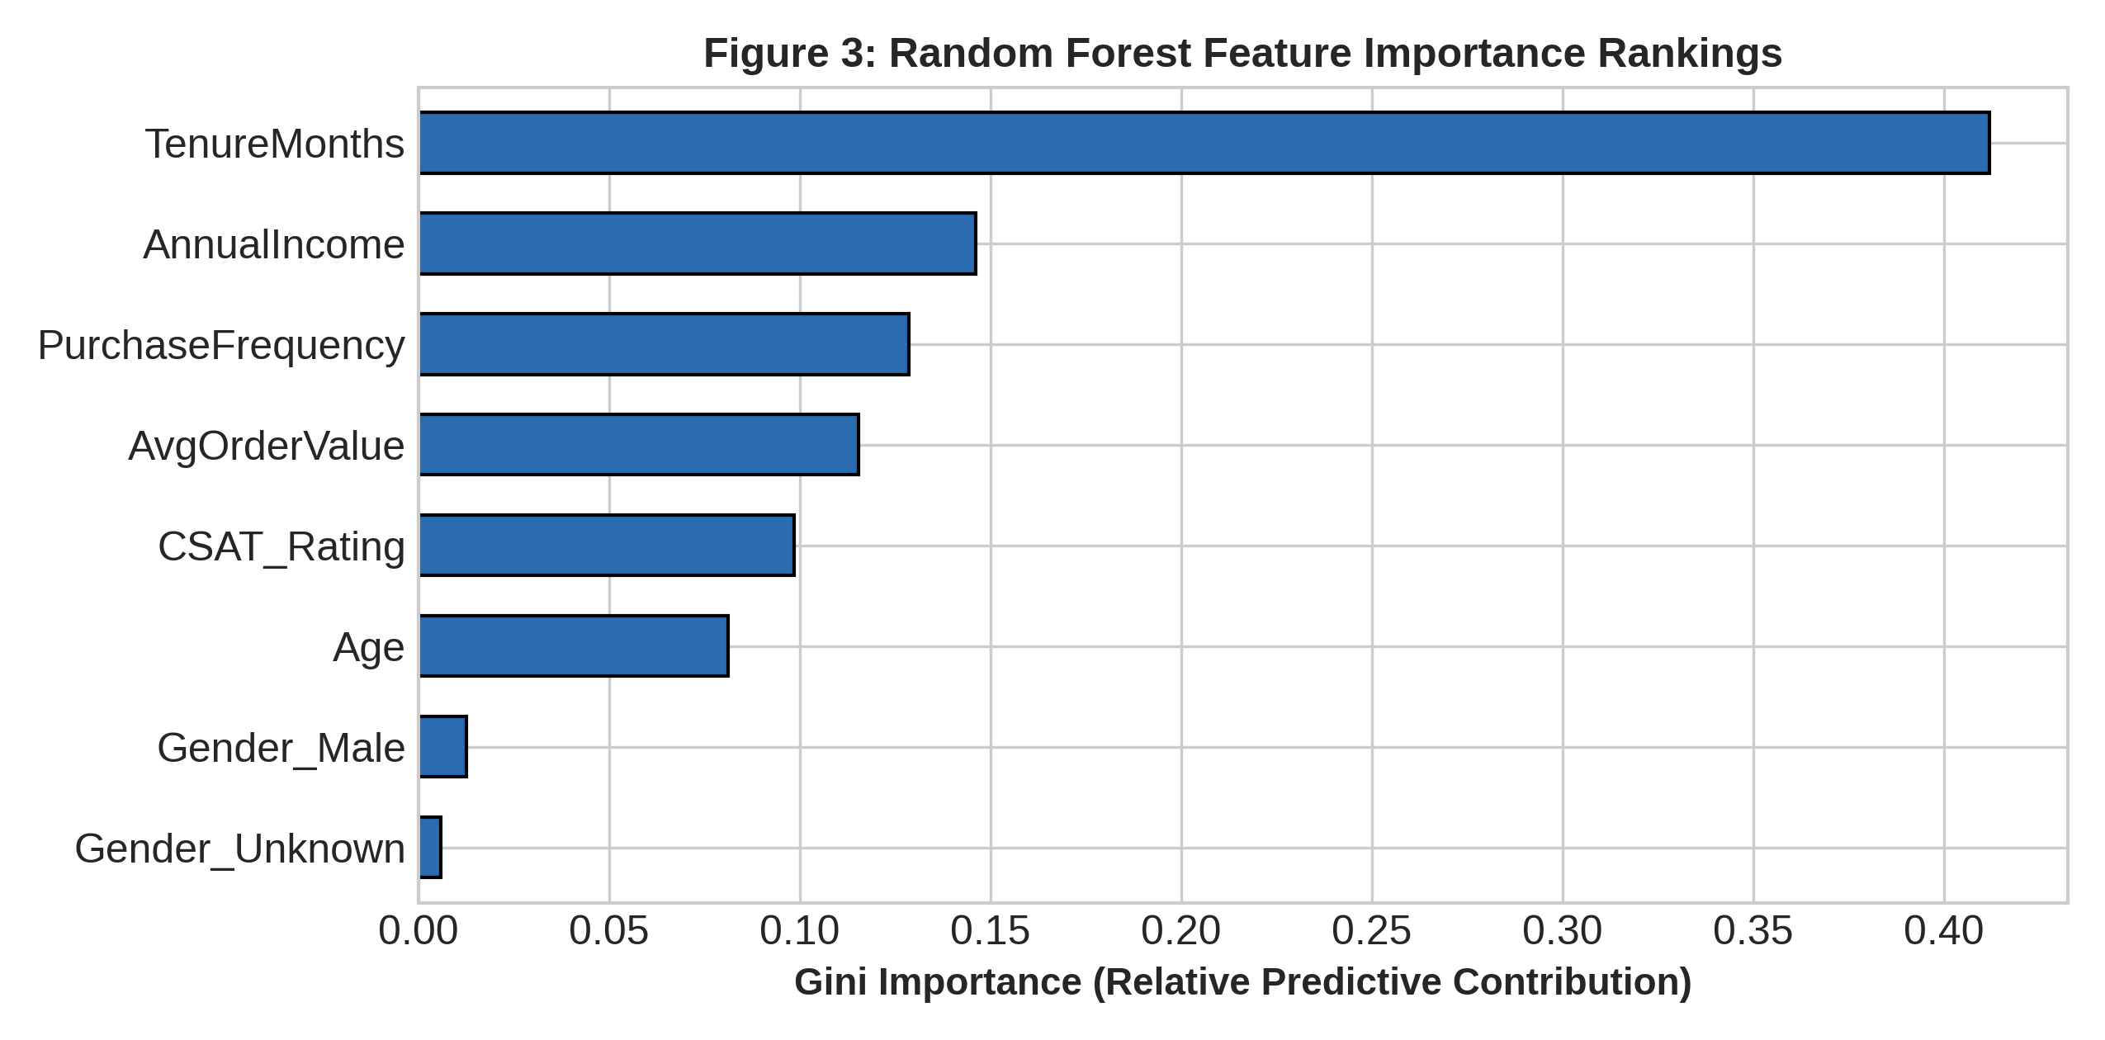
5. Critical Discussion: Error Analysis, Overfitting & Improvements
• Error Trade-offs: False Negatives (predicting a churner will stay) are 3x more costly than False Positives. Decision threshold optimization should be lowered to 0.40 to capture borderline churners.
• Overfitting vs Underfitting: Baseline Logistic Regression underfits non-linear interaction terms. Random forest with max_depth=6 effectively prevents variance explosion while capturing non-linear threshold effects.
• Future Enhancements: Implement gradient boosting (XGBoost / LightGBM) combined with SMOTE oversampling to address class imbalances in edge cohorts.
6. Conclusion
The machine learning classification pipeline deployed in Week 4 validates that customer tenure, satisfaction rating, and purchase frequency are the primary determinants of customer churn, enabling targeted proactive retention.

