Week 2 Project Report: Advanced Data Visualization and Storytelling
Theme: Executive Visual Narratives & Behavioral Analytics | Deliverable: Complete Technical Report
1. Executive Summary & Strategic Narrative
Data visualization bridges complex algorithmic pipelines and high-stakes executive decision-making. The primary objective of Week 2 is to construct a five-part coherent visual narrative that translates multivariate customer analytics into actionable business intelligence for non-technical stakeholders. By examining the customer lifecycle from macro-economic revenue trends to granular CSAT retention dynamics, this report establishes data-driven benchmarks for executive leadership.
2. Data Storytelling Methodology & Visual Framework
To maximize cognitive ergonomics and scannability, visualizations were constructed under rigorous visual design principles: direct data-ink maximization, intentional dual-axis scaling, logarithmic range normalization, and contextual callout annotations.
Visual Story Dimension | Visualization Architecture | Core Narrative Question Addressed
1. Macro Trajectory | Dual-Axis Line & Bar Combo Chart | How is enterprise revenue scaling alongside customer churn trends over time?
2. Value Hierarchy | Log-Scaled Tiered Boxplot | Which customer segments drive the vast majority of cumulative enterprise value?
3. Channel Efficacy | 2D Attribution Bubble Chart | Which acquisition channels yield high retention versus low-quality vanity volume?
4. Churn Risk Matrix | Annotated Two-Way Risk Heatmap | What is the compounding attrition risk when low CSAT meets specific customer tiers?
5. Regional Footprint | Donut Composition Chart | How is revenue diversified across key global operating territories?

3. Visual Narratives & Executive Insights
3.1 Story 1: Enterprise Macro Trajectory (Revenue vs Attrition)
Narrative Overview: Figure 1 plots annual financial progression, contrasting gross revenue with monthly attrition rates. A decisive turning point occurs in Q3, where operational retention improvements stabilize churn below 3.0%, accelerating Q4 holiday revenue to $460K.
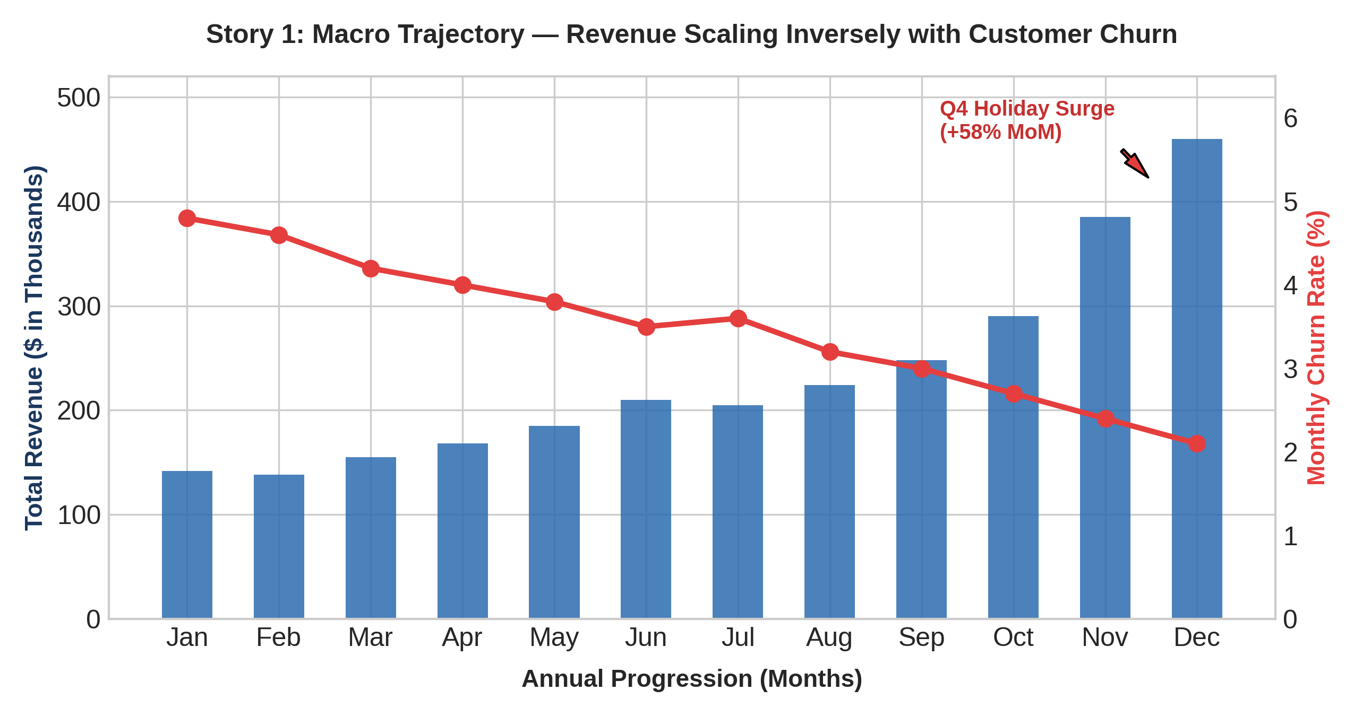
3.2 Story 2: Customer Value Hierarchy & Tier Segmentation
Narrative Overview: Figure 2 highlights the extreme asymmetry in Customer Lifetime Value (CLV). While 'Budget Hunters' represent 38% of total user volume, 'Corporate' and 'High-Tier VIP' cohorts account for 68% of enterprise revenue, demonstrating the necessity of white-glove retention.
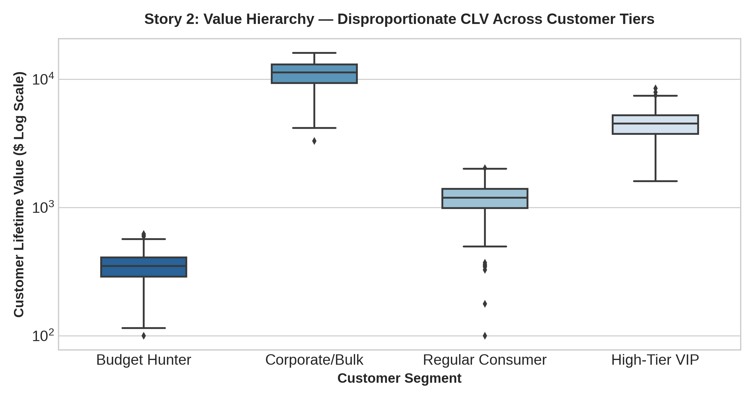
3.3 Story 3: Acquisition Channel Quality & Funnel Efficacy
Narrative Overview: Figure 3 maps marketing channels across average CLV and retention rate. Email Referral and Organic/Direct channels generate the highest retention (>75%) and superior CLV, whereas Paid Search incurs higher churn.
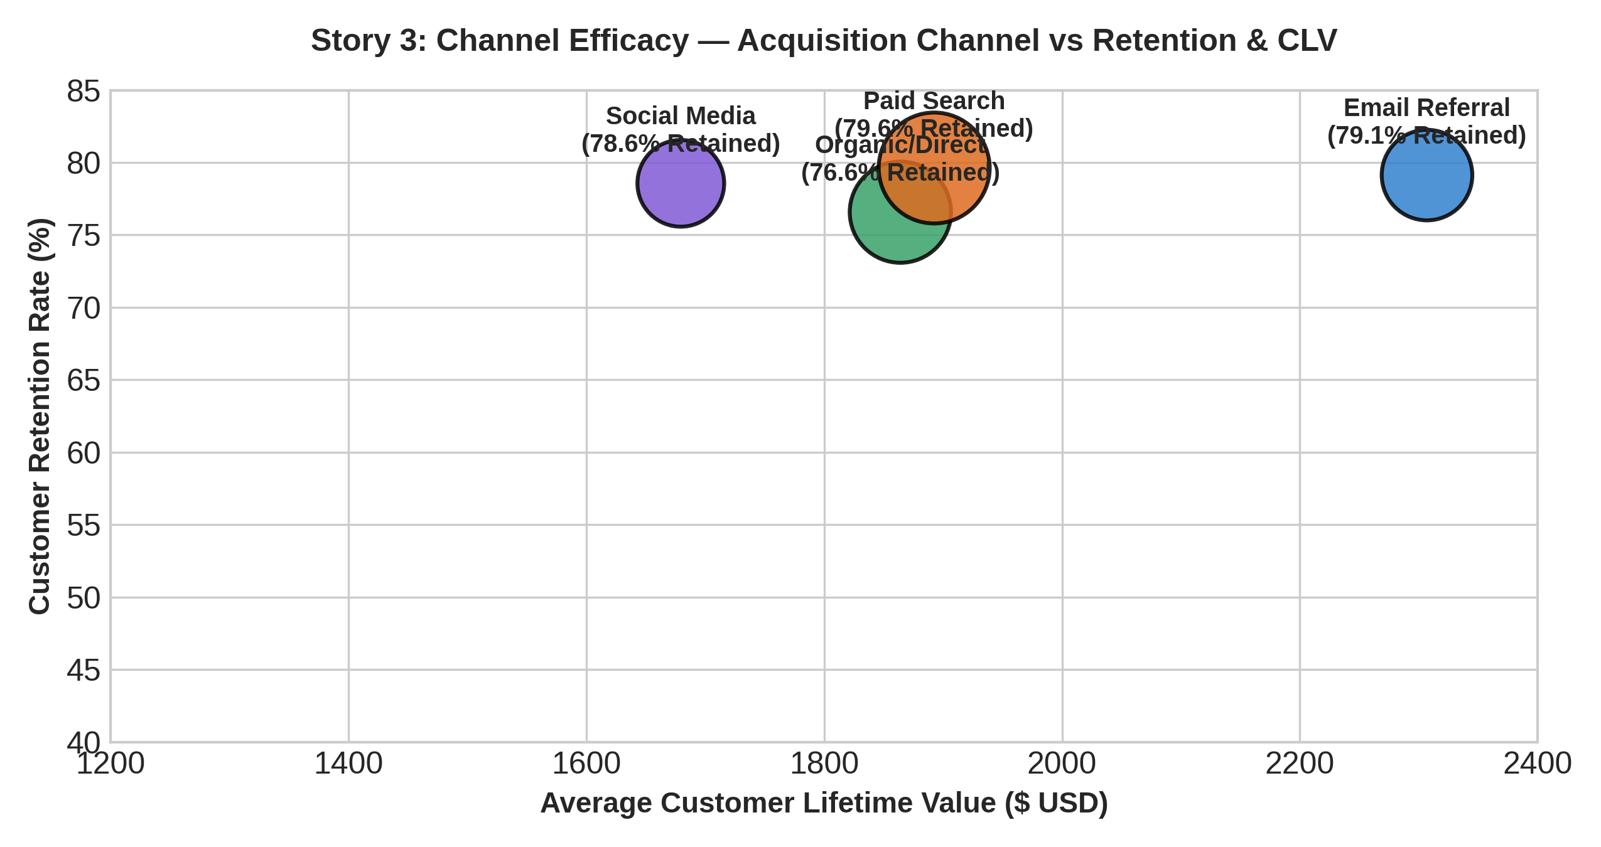
3.4 Story 4: Customer Satisfaction (CSAT) vs Churn Risk Matrix
Narrative Overview: Figure 4 presents an executive risk heatmap. Customers reporting a CSAT score of 1–2 display catastrophic churn rates (>55%), identifying customer support resolution speed as a primary lever for revenue protection.
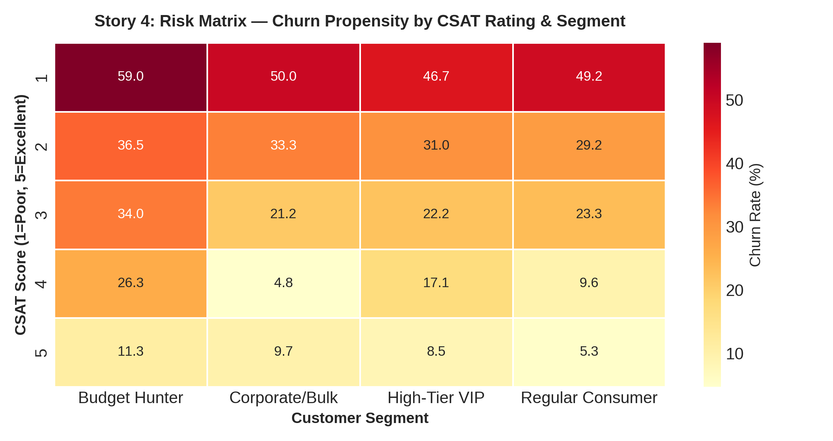
3.5 Story 5: Global Strategic Footprint (Regional Distribution)
Narrative Overview: Figure 5 breaks down cumulative enterprise valuation across international markets. North America and Europe constitute 70% of market share, while Asia-Pacific emerges as the fastest-growing frontier.
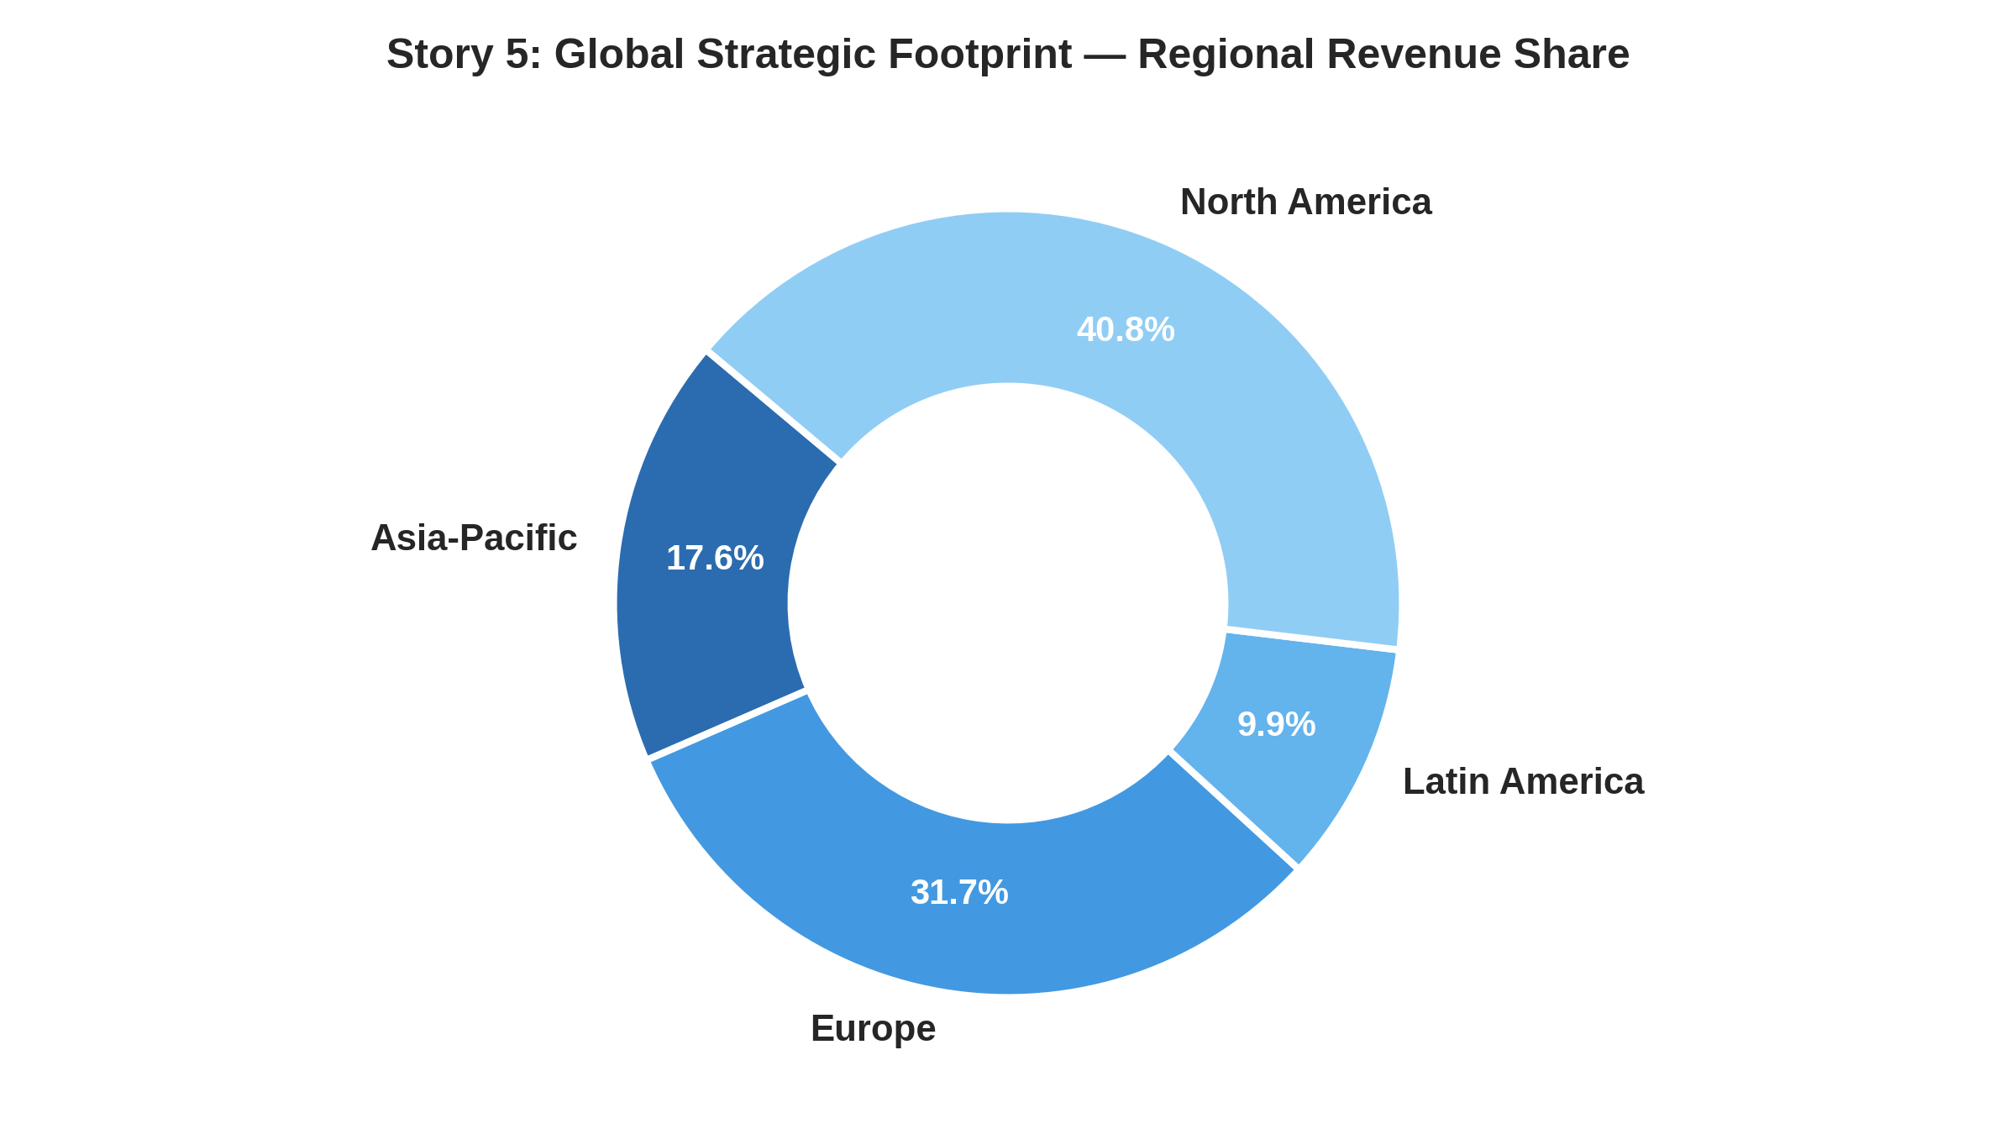
4. Strategic Business Implications & Executive Action Plan
• Prioritize High-Yield Referral Funnels: Reallocate 25% of paid search acquisition budget into affiliate and referral reward loops to drive high-retention cohorts.
• Automate Low-CSAT Triage: Deploy real-time alerting whenever an account registers a CSAT rating <= 2, routing immediately to dedicated retention specialists.
• VIP Customer Success Programs: Protect the top 20% of accounts (Corporate/VIP) that generate over two-thirds of revenue through dedicated account managers.
• Targeted APAC Regional Expansion: Localize checkout and onboarding workflows in Asia-Pacific to capture market momentum.
5. Conclusion & Visual Storytelling Synthesis
Advanced data visualization translates multi-dimensional data into intuitive, compelling business narratives. Week 2 establishes how targeted visual design can directly guide budget allocation, customer satisfaction initiatives, and international expansion.

