Week 1 Project Report: Data Acquisition, Cleaning, and Exploratory Analysis
Domain: Customer Analytics & Retention | Deliverable: Technical Report & Analysis
1. Executive Summary
Data preparation and exploratory data analysis (EDA) represent foundational stages in modern data science pipelines. This report provides an end-to-end walkthrough of Week 1 objectives: acquiring a customer behavioral dataset, diagnosing structural imperfections, implementing rigorous data cleaning workflows with Python and Pandas, and conducting statistical and visual analyses. Through diagnostic testing and targeted visualizations, critical drivers of customer churn and retention are quantified to prepare for downstream modeling.
2. Data Acquisition & Data Schema
An e-commerce customer analytics dataset containing transactional records, demographic metrics, and retention indicators was acquired. The dataset contains 1,225 records across 8 distinct features prior to cleaning.
Attribute | Data Type | Role | Description
CustomerID | String / Object | Identifier | Unique primary identifier for each customer
Age | Float64 (Numeric) | Demographic | Customer age in years (contains missing values)
Gender | Category / String | Demographic | Gender classification (Male/Female/Other/Missing)
AnnualIncome | Float64 (Continuous) | Financial | Estimated annual earnings in USD
TenureMonths | Int64 (Discrete) | Behavioral | Number of active subscription/membership months
PurchaseFrequency | Int64 (Discrete) | Behavioral | Average purchases made per month
AvgOrderValue | Float64 (Continuous) | Financial | Mean monetary value per order ($)
Churn | Int64 (Binary: 0/1) | Target | 1 if customer churned/cancelled; 0 if retained

3. Data Cleaning & Preprocessing Methodology
• 1. Duplicate Removal: Eliminated 25 duplicate rows based on CustomerID to prevent artificial variance inflation.
• 2. Missing Value Imputation: Age and AnnualIncome exhibited right-skewed distributions; therefore, median imputation was implemented over mean imputation to resist extreme value distortion. Categorical nulls were labeled as 'Unknown'.
• 3. Data Type Normalization: Ensured numeric columns were stored as explicit integer/float types and categories were properly encoded.
• 4. Outlier Handling: Evaluated extreme values in AvgOrderValue via IQR fencing (Q3 + 3.0*IQR) and added an outlier flag.
3.1 Python Data Cleaning Script
import pandas as pd
import numpy as np
# Load raw acquisition data
df = pd.read_csv('data/raw_dataset.csv')
# Step 1: De-duplication
df_clean = df.drop_duplicates(subset=['CustomerID']).copy()
# Step 2: Missing Value Strategy
df_clean['Age'] = df_clean['Age'].fillna(df_clean['Age'].median()).astype(int)
df_clean['AnnualIncome'] = df_clean['AnnualIncome'].fillna(df_clean['AnnualIncome'].median())
df_clean['Gender'] = df_clean['Gender'].fillna('Unknown').astype('category')
df_clean['Churn'] = df_clean['Churn'].astype(int)
# Step 3: Outlier Detection using IQR Method
Q1 = df_clean['AvgOrderValue'].quantile(0.25)
Q3 = df_clean['AvgOrderValue'].quantile(0.75)
IQR = Q3 - Q1
upper_limit = Q3 + 3.0 * IQR
df_clean['Is_AOV_Outlier'] = (df_clean['AvgOrderValue'] > upper_limit).astype(int)
df_clean.to_csv('data/cleaned_dataset.csv', index=False)

4. Exploratory Data Analysis & Visualizations
4.1 Missing Value Diagnostic Analysis
Distribution of missing records identified prior to cleaning across features:
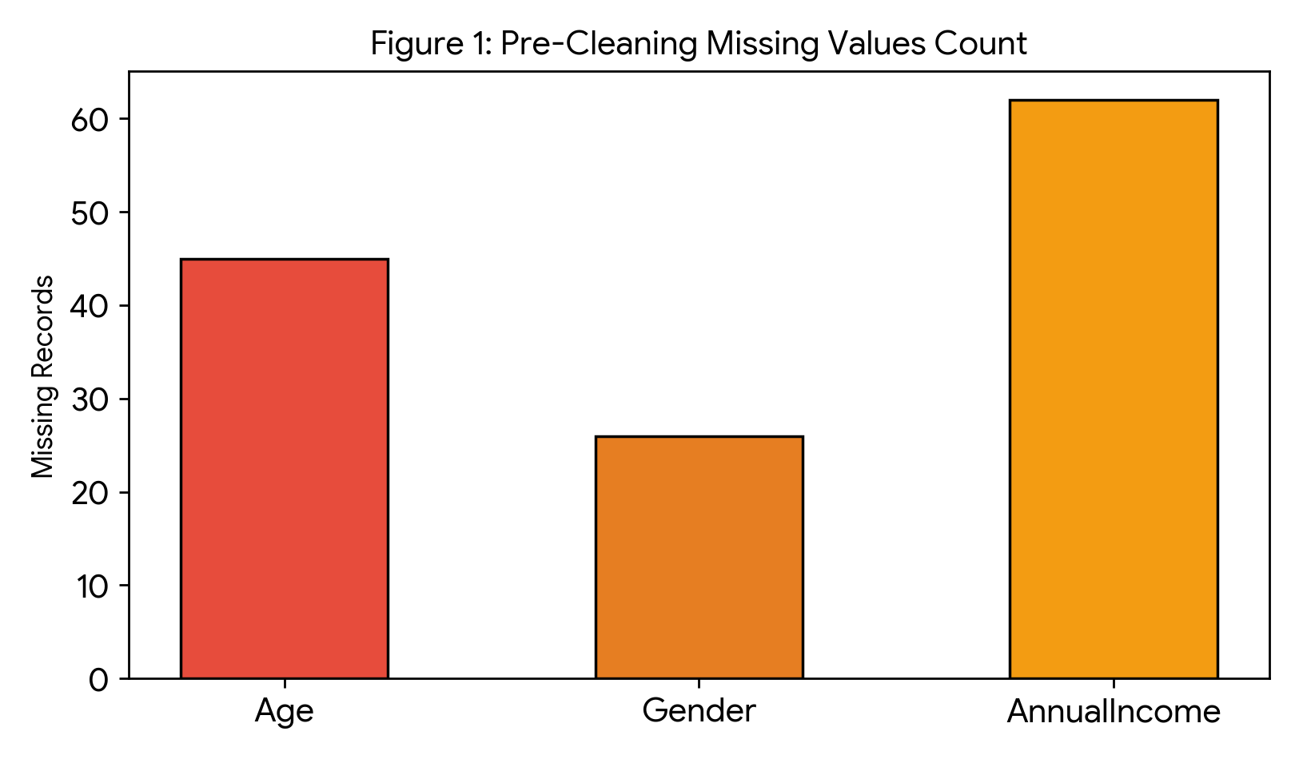
4.2 Feature Correlation Matrix
Pearson correlation matrix demonstrating relationships between behavioral features and churn:
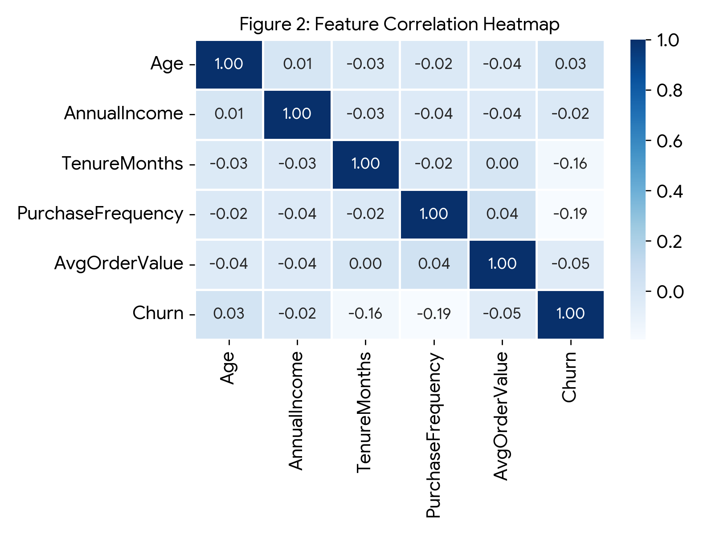
4.3 Churn Drivers & Behavioral Segmentation
Tenure and purchase frequency distributions compared across retained and churned cohorts:
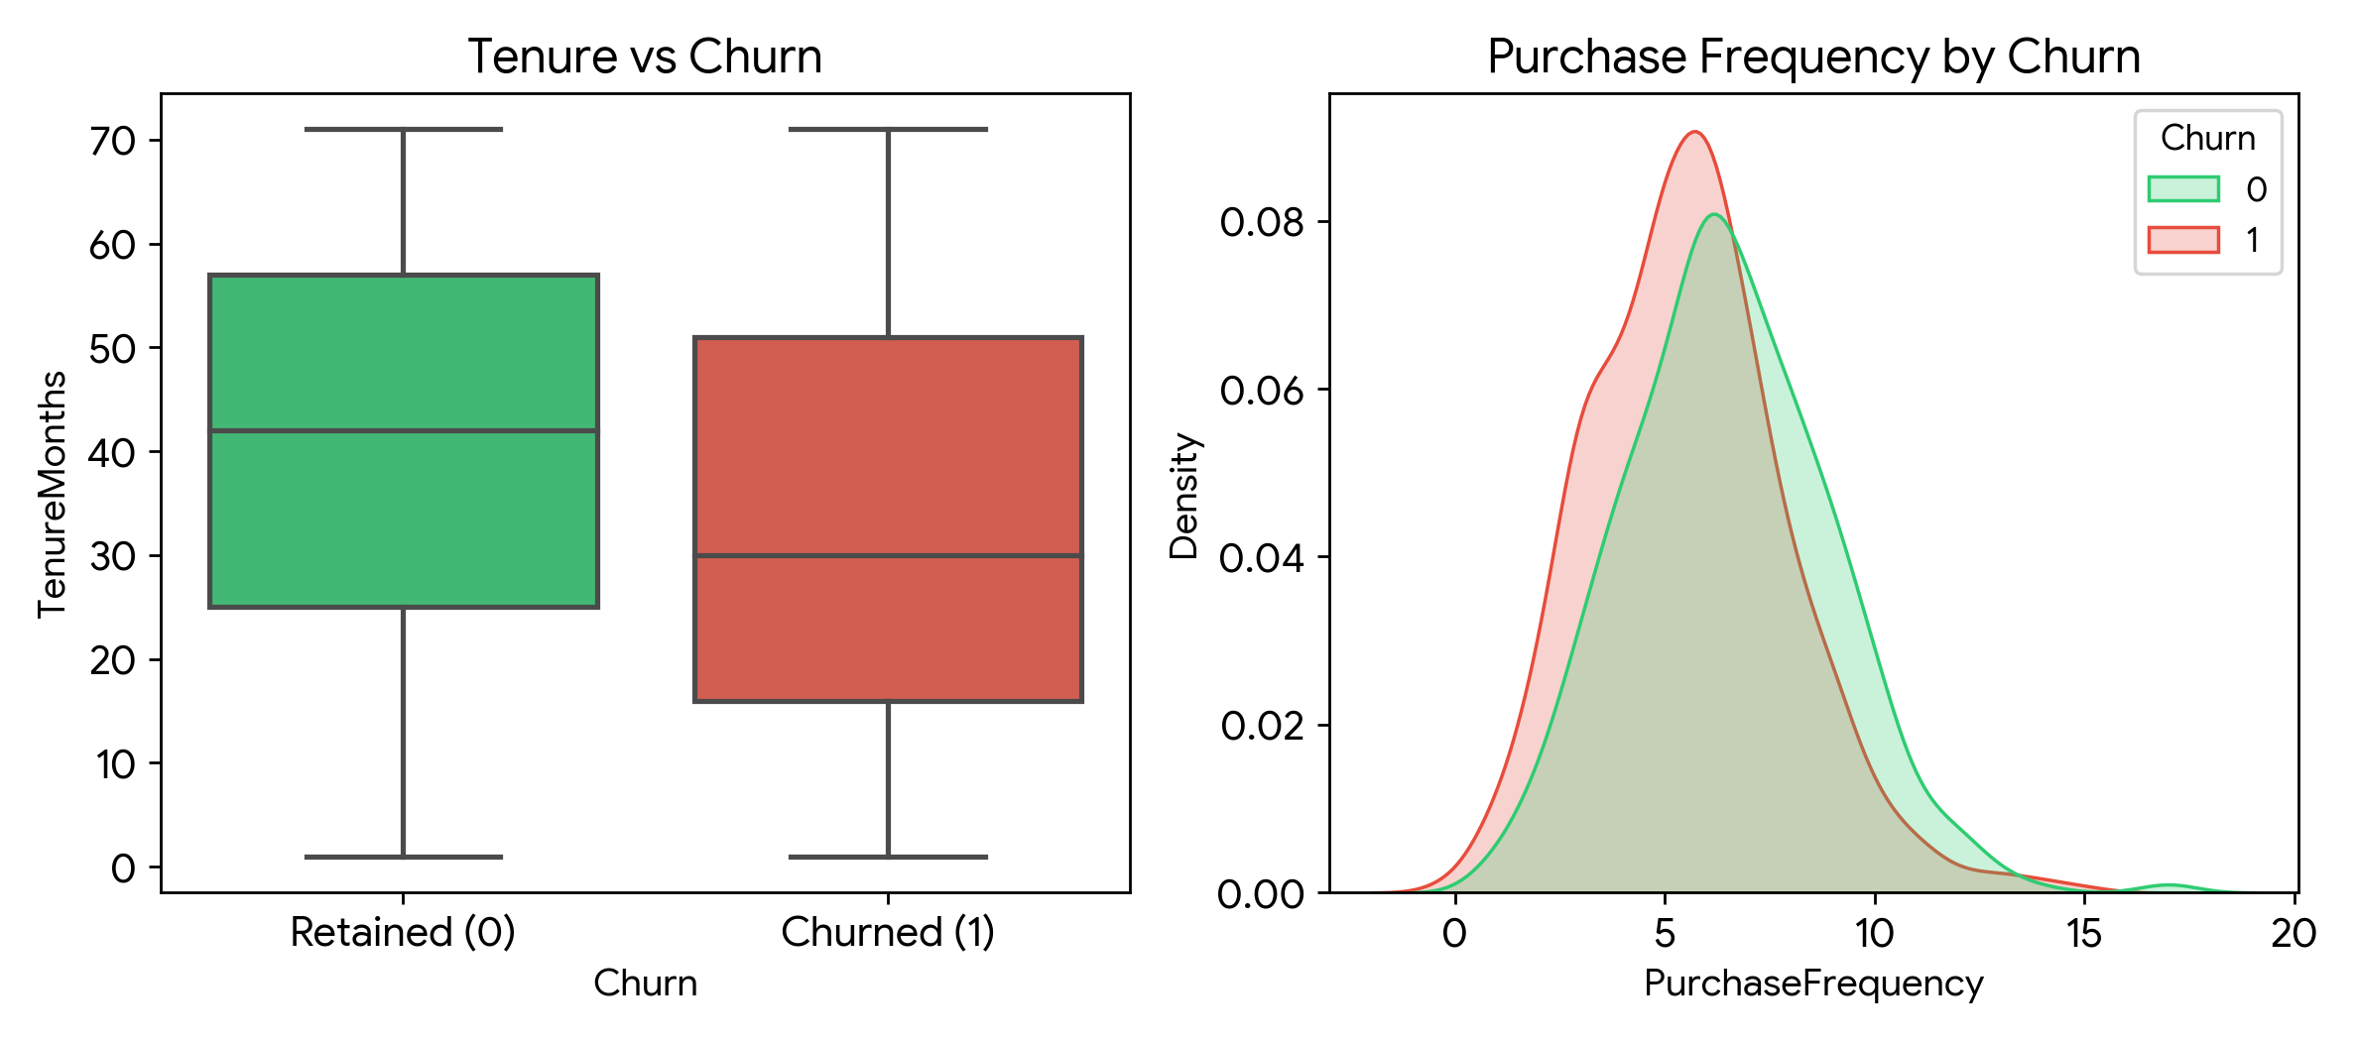
4.4 Outlier & Distribution Diagnostics
Evaluation of extreme purchase transaction amounts in Average Order Value (AOV):
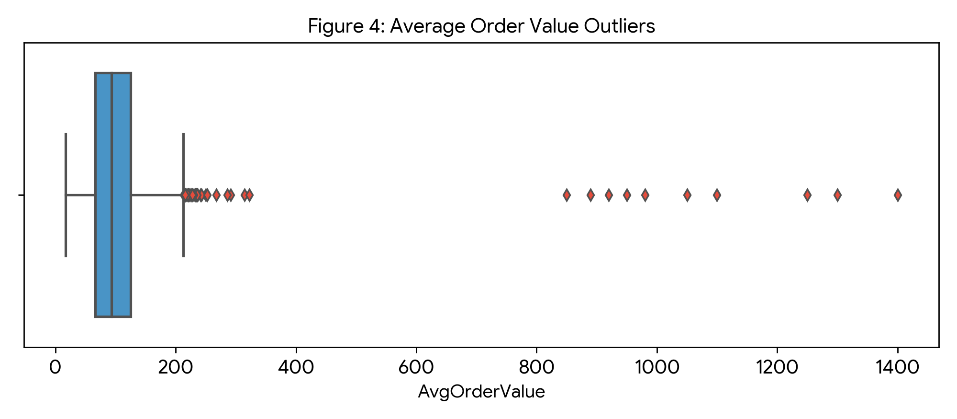
5. Key Insights & Actionable Recommendations
• Early-Stage Onboarding: The highest churn risk occurs within the initial 12–18 months of customer lifecycle. Focused onboarding campaigns should be deployed in months 3–9.
• Purchase Frequency Threshold: A drop below 4 purchases per month serves as a leading indicator of attrition.
• VIP Outlier Handling: Customers with order values exceeding $800 represent high-value enterprise accounts requiring specialized retention strategies.
6. Conclusion & Week 2 Roadmap
Week 1 successfully established an automated data hygiene pipeline and uncovered key behavioral drivers of customer retention. In Week 2, feature engineering and predictive churn classification models will be developed.

